Year 9 Chemical Science - Quick Reference Sheet – For Visual Learners
+1 |  | +2 |  | +3 |  | +4
Hydrogen H⁺  Sodium Na⁺  Potassium K⁺  Silver Ag⁺  Copper(I) Cu⁺  Ammonium NH₄⁺ |  | Cobalt(II) Co²⁺  Magnesium Mg²⁺  Calcium Ca²⁺  Barium Ba²⁺  Iron(II) Fe²⁺  Copper(II) Cu²⁺  Zinc Zn²⁺  Mercury(II) Hg²⁺  Tin(II) Sn²⁺  Lead(II) Pb²⁺  Nickel(II) Ni²⁺ |  | Aluminium Al³⁺  Iron(III) Fe³⁺  Chromium(III) Cr³⁺  Gold(III) Au³⁺ |  | Tin(IV) Sn⁴⁺  Lead(IV) Pb⁴⁺
-1 |  | -2 |  | -3 |  | -4
Hydride H⁻  Fluoride F⁻  Chloride Cl⁻  Bromide Br⁻  Iodide I⁻  Hydroxide OH⁻  Nitrate NO₃⁻  Nitrite NO₂⁻  Hydrogencarbonate HCO₃⁻  Hydrogensulfate HSO₄⁻  Ethanoate (acetate) CH₃COO⁻  Permanganate MnO₄⁻  Cyanide CN⁻ |  | Oxide O²⁻  Sulfide S²⁻  Carbonate CO₃²⁻  Sulfate SO₄²⁻  Sulfite SO₃²⁻  Chromate CrO₄²⁻  Peroxide O₂²⁻ |  | Nitride N³⁻  Phosphide P³⁻  Phosphate PO₄³⁻

Common Acids |  | Common Bases |  | Common Compounds
Hydrochloric HCl  Sulfuric H₂SO₄  Nitric HNO₃  Phosphoric H₃PO4  Ethanoic/Acetic CH₃COOH |  | Any ionic compound with a hydroxide ion (OH⁻) |  | Water H₂O  Carbon Dioxide Gas CO₂  Hydrogen Gas H₂  Oxygen Gas O₂  Glucose C₆H₁₂O₆
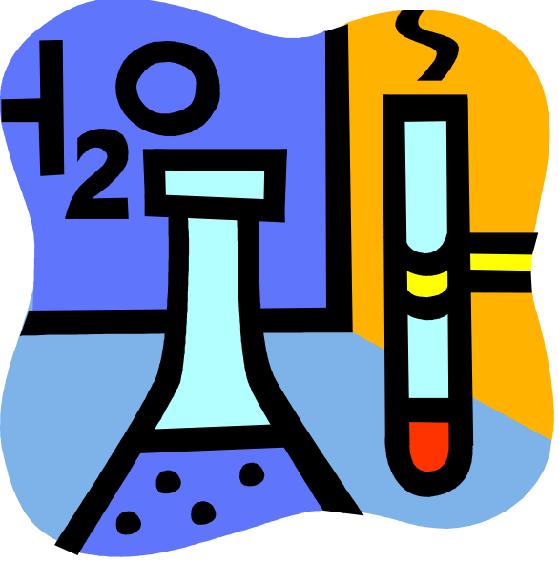

Common Reaction Types
Acid-Metal
Acid + Metal → Hydrogen Gas + Metal Salt

Acid-Carbonate
Acid + Carbonate → Water + Carbon Dioxide + Metal Salt

Acid-Base
Acid + Base → Water + Metal Salt

Metal Ion Replacement
Metal(1) + Metal(2) Salt → Metal(2) + Metal(1) Salt

Notes

