RRD Creation Quick Reference

If no new data is supplied for more than 1200 seconds, the value becomes *UNKNOWN*.
RDD Starting Point And Data Interval
--start N=Now --step every 300Sec

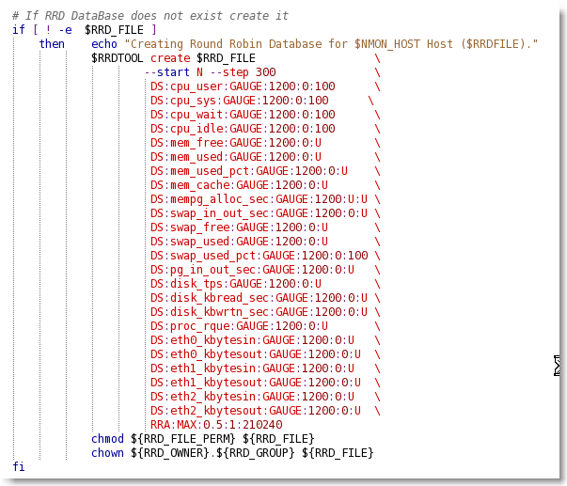
DS=Data Source Name (cpu_busy)
DS Minimum (0) and Maximum Value (100)
GAUGE, is for things like temperatures or number of people in a room or the value of a RedHat share.

Round Robin Archive - An archive consists of a number of data values or statistics for each of the defined data-sources (DS) and is defined with an RRA line.
The data is also processed with the consolidation function (CF) of the archive. There are several consolidation functions that consolidate primary data points via an aggregate function: AVERAGE, MIN, MAX, LAST.
AVERAGE the average of the data points is stored.
MINthe smallest of the data points is stored.
MAXthe largest of the data points is stored.
LASTthe last data points are used.
rows defines how many generations of data values are kept in an RRA. Obviously, this has to be greater than zero.
24Hr*60Min*60Sec = 86400 Sec in a day
86400 sec / 300 sec Interval = 288 Value per day
(288 Value per Day * 365) * 2 Years in RRD = 210,240 rows

steps defines how many of these primary data points are used to build a consolidated data point which then goes into the archive.
xff The xfiles factor defines what part of a consolidation interval may be made up from *UNKNOWN* data while the consolidated value is still regarded as known. It is given as the ratio of allowed *UNKNOWN* PDPs to the number of PDPs in the interval. Thus, it ranges from 0 to 1 (exclusive).
0.5 = No more than half of the consolidation values could contain UNKNOWN to be consider a valid value.

Jacques Duplessis – May 2013
RRD Update
# If RRD file doesn't exist, Create it
#------------------------------------------------------------------------------------------------
echo -e "RRD Value calculated ...$RRD_VALUE..." # Display Value
if [ ! -w $RRD_FILE ] ; then create_rrd ; fi # Create RRD File if not exist

# Update the RRD File
#------------------------------------------------------------------------------------------------
WYEAR=`date +%Y` ; WMONTH=`date +%m` ; WDAY=`date +%d` # Date of the RRD Update
WHRS=`date +%H` ; WMIN=`date +%M` ; WSEC=`date +%S` # Time of the RRD Update
TIME_STAMP=`$EPOCH "$WYEAR $WMONTH $WDAY $WHRS $WMIN $WSEC"`# Current time Stamp in Epoch
echo "$RRDTOOL update $RRD_FILE ${TIME_STAMP}:${RRD_VALUE}"# Display Update Command
$RRDTOOL update $RRD_FILE ${TIME_STAMP}:${RRD_VALUE} # Update RRD File

SYNOPSIS
rrdtool {update | updatev} filename [--template|-t ds-name[:ds-name]...] [--daemon address] [--] N|timestamp:value[:value...] at-timestamp@value[:value...] [timestamp:value[:value...] ...]
rrdtool update file.rrd

By default, the update function expects its data input in the order the data sources are defined in the RRD.
The template switch allows you to specify which data sources you are going to update and in which order. If the data sources specified in the template are not available in the RRD file, the update process will abort with an error message.

#!/bin/bash
MESHRRD=/home/user/meshdata.rrd
MESHIF=eth0
MESHIN=`ifconfig "${MESHIF}" |grep bytes|awk -F ":" '{print $2}'|awk '{print $1}'`
MESHOUT=`ifconfig "${MESHIF}" |grep bytes|awk -F ":" '{print $3}'|awk '{print $1}'`
rrdupdate "${MESHRRD}" -t meshin:meshout N:"${MESHIN}":"${MESHOUT}

