Jquery:

**Download jquery:**

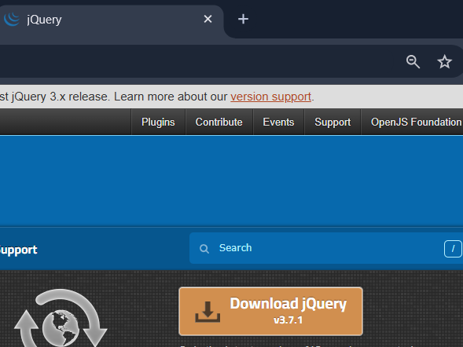

Save as at your jquery folder:

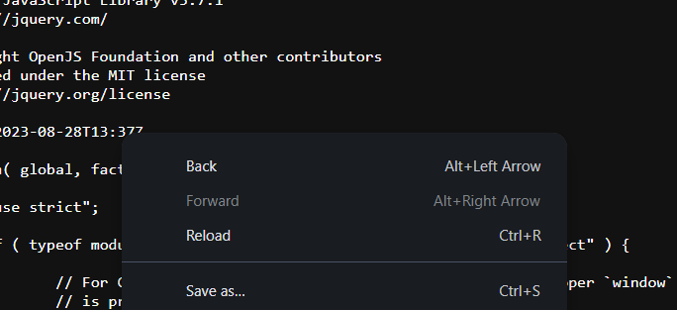

At last after body :

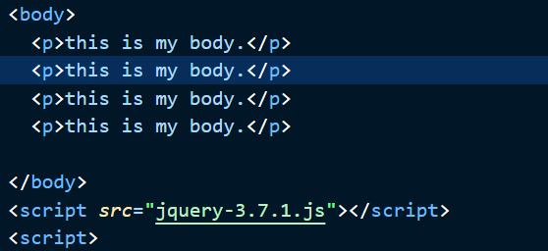

Basics

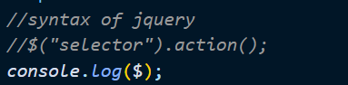

do this when click:

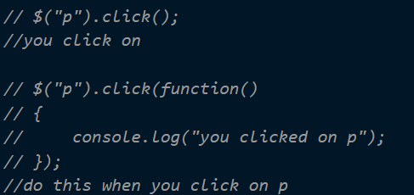

hide particular:

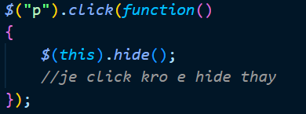

if perticuar:

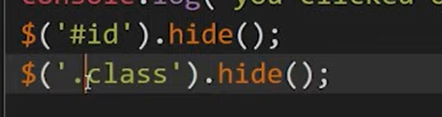

html late load thay ne e pela js load na thay etle:

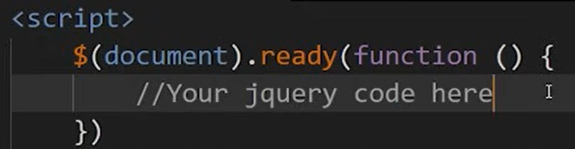

Type of selector

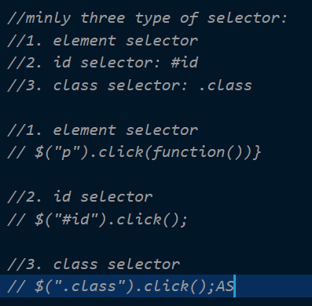

Html content:

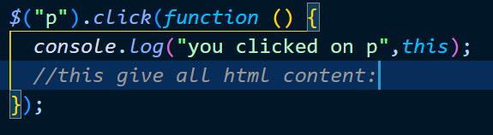

Other selector:



Now copy all to new js file separate code :

Events in jq:

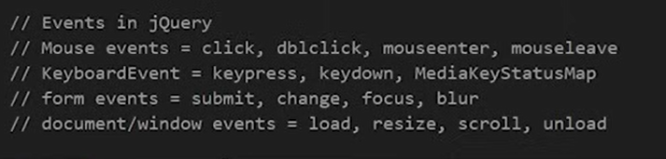

On method in jq:

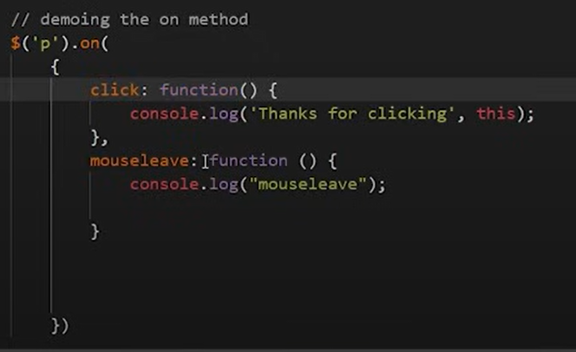

Hide and show:

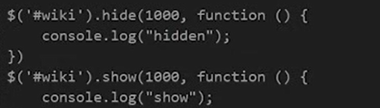

Toggle: hide-> show // show->hide

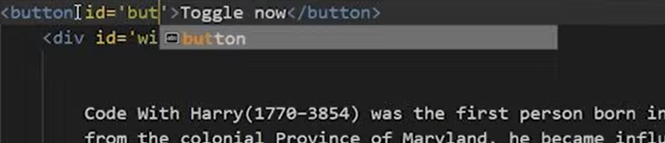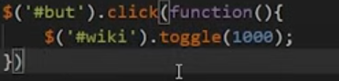

*//fadeOUT-to hide in 3 sec*

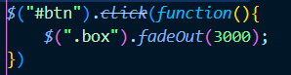

*//fadeIN-to show in 1 sec*

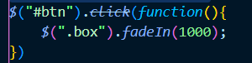

//fadetoggle:

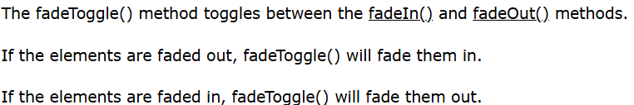

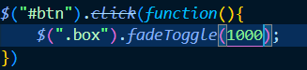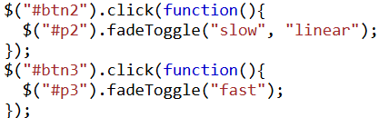

//fade to:->added opacity only:



Slide: -> animate text up hide and down show:

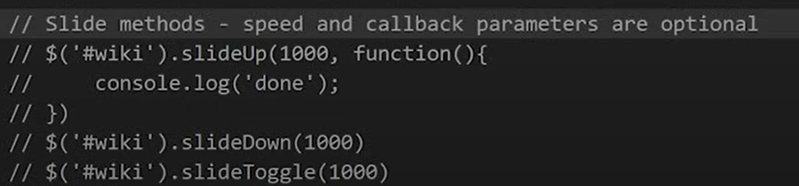

Animate:

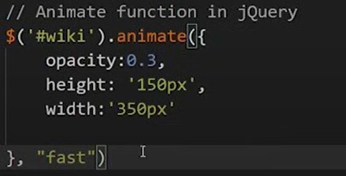

To stop animation:

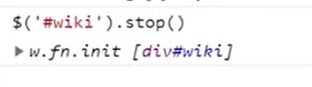

Form:

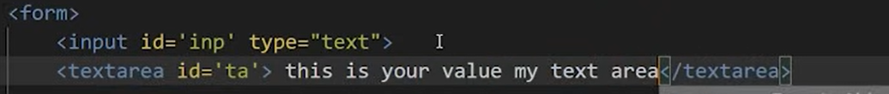

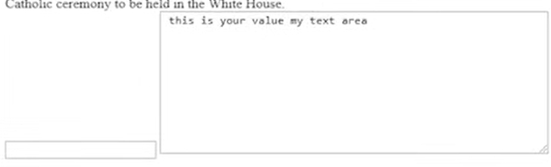

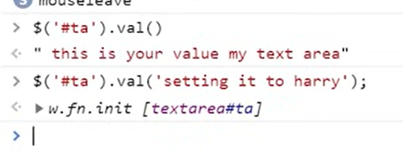

Also empty any element:

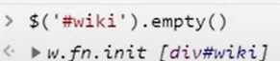

To change element text:

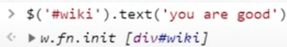

To remove rom body element:

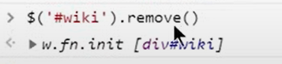

ALSO FOR class:

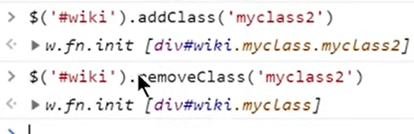

Css:\

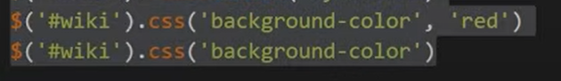

AJAX:

