BACHELOR/MASTER's Final Project
BUSINESS PLAN

Stride: A Business Plan for an Athlete Monetisation Platform Built on Analytics
MSc Programmes in Management
Course 2025-2026

Student: Jad Zoghaib
Tutor: Ignacio Gallardo Albajar

This work is licensed under a Creative Commons Attribution-NonCommercial-NoDerivatives 4.0 International License.

Contents
1. Executive summary 6
2. The company 7
2.1 Business description 7
2.2 Mission, vision and objectives 7
2.3 The entrepreneurial team 8
3. Opportunity and business model 8
3.1 Client and market 8
3.2 Value proposition 14
3.3 Key success factors 16
3.4 Costs and investment required 16
3.5 Revenue sources 16
4. Marketing plan 17
4.1 Product strategy 17
4.2 Pricing strategy 17
4.3 Communication strategy 18
4.4 Channel strategy 18
4.5 Sales forecast 18
4.6 Sales plan 19
5. Operations plan 20
6. Organization and human resources 25
7. Financial plan 29
7.1 Assumptions 29
7.2 Profit and loss 29
7.3 Pro forma balance sheet 30
7.4 Pro forma cash flow 30
7.5 Cash position and financing 31
7.6 Break-even and sensitivity 32
7.7 Valuation 33
8. Legal aspects and intellectual property 33
9. Critical risks and contingency plans 35
10. Growth and business development strategy 36
11. Conclusions 38
12. Bibliography 38
Appendix A: Revenue Model 41
Why OnlyFans is the right reference, and where the analogy stops 41
The eight revenue streams 41
Fan tiers 42
Sponsor plans 42
Take rate: benchmarked 43
Revenue mix over time 46
The cold-start problem, and the answer 46
Appendix B: Cost Model 47
The fixed-fee problem 47
The egress trap 47
AWS build-up 48
People (Spain) 49
Compliance and moderation 49
Customer acquisition 50
Cost structure at maturity (Y7) 51
Appendix C: Seven-Year Financial Model 52
Drivers 52
Retention and acquisition 52
The two segments 53
Marketplace volume (GMV) 54
Net revenue 54
Profit and loss 54
Cash 55
Scenarios 56
What the model deliberately excludes 56
Appendix D: Capital & Valuation 58
Internal capital, priced honestly 58
Funding stages, gated on evidence 58
Spanish instruments: non-dilutive capital first 59
Valuation 60
The anchor athlete 61
Dilution path 61
Appendix E: Product Gaps 63
The headline 63
Gap register 63
What already exists and shortens the path 65
Campaign measurement: shipped 65
The age model 67
Sequenced build 68
Appendix F: Market Strategy 70
Why niche sports come first 70
Why popular sports come second, not never 71
Sequenced go-to-market 71
Which niche sports, concretely 71
What this means for the rest of the plan 72
Appendix G: Decisions & Open Questions 73
Settled 73
Still open 73
New questions raised by the decisions just made 75
Appendix H: Sport Opportunity Index 76
Method 76
Results 77
Three product uses 77
Data provenance and refresh 78
Appendix I: Analytics Strategy 80
The rule 80
Four phases 80
The trap nobody warns you about 81
Build versus buy 82
What this costs 82
The honest summary 82
Appendix J: Competitive read: TEKTA 83
What it validates 83
Where they structurally cannot reach 83
What Stride should take from this 84
Integrations this suggests 85
Business-model implications 85
The one-line read 85
Appendix K: Admission, Club Eligibility and Matching 86
The decision everything else follows from 86
Three rules the arithmetic enforces 86
Formulas 87
Matching 88
Why there is no learned ranker yet 89
Stress test 89
What the policy costs in humans 91
Built, and not 92
The interface 92
Appendix L: Evidence Base: Where Every Assumption Comes From 94
17.1 What the model is built on 94
17.2 The assumptions, in full 94
17.3 How this table is kept true 101
Appendix M: Product Walkthrough: The Deployed Demo 102
18.1 What is actually built 102
18.2 Sign in 102
18.3 Athlete dashboard 103
18.4 Public athlete profile 104
18.5 Sponsor workspace 105
18.6 Club HQ 106
18.7 Admission queue 107

Word populates this table on opening the document: right-click anywhere in it and choose Update Field, or press F9.

1. Executive summary
Stride is a creator platform with a sponsorship feature.
Athletes are creators with a second payer. OnlyFans proved that direct fan monetisation beats ad-share; nobody has built it for athletes, who, unlike lifestyle creators, also have sponsors, clubs, and a competitive record that makes their audience measurable. Fan revenue leads and funds the early years. Sponsorship compounds behind it, and the analytics engine earns its keep by making the second payer possible, which a general creator platform cannot do.
The wedge is the athletes nobody serves. The segmentation that matters is not which sport but whether an intermediary already exists. In popular sports an agent takes 10 to 20% of an endorsement to make an introduction; in niche sports there is no agent at all, and the athlete's alternative to Stride is nothing. A trail runner with 25,000 followers has an inbox of unanswered brand DMs and no idea what a fair rate is. Nobody is fighting us for her, and what we learn there generalises upward. Football does not generalise downward.
A working demo exists, not a slide deck. It carries connected platform analytics, versioned marketability scoring, an admission gate, campaign matching with explainable ranking, offers, deals and delivery measurement. All of it is deployed, with an audit log, a resilience drill, and a test suite that runs on two databases in continuous integration. Appendix M shows the screens.
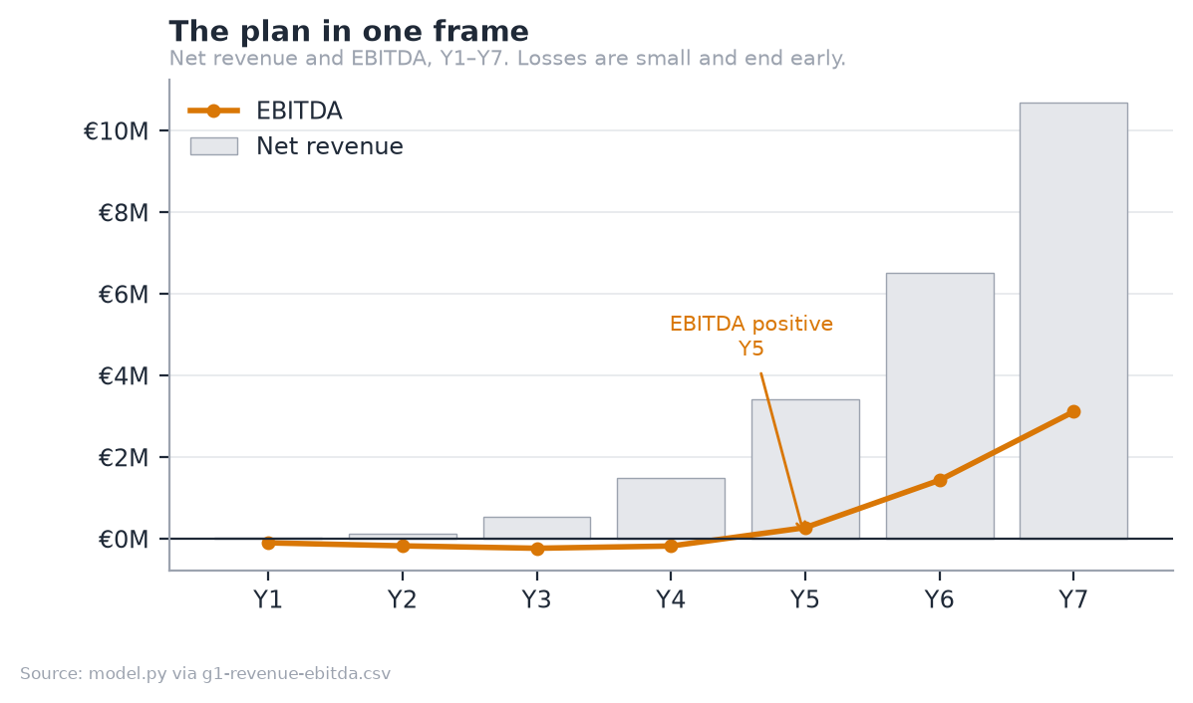
Figure 1: Net revenue and EBITDA, Y1 to Y7. The company is loss-making for four years, and the losses are small.
 | Y3 | Y7
Net revenue | €535k | €10.70M
EBITDA | €-228k | €3.12M
Active athletes | 3,000 | 22,000
Paying fans | 25,288 | 321,288
Gross margin | 64% | 70%

EBITDA turns positive in Y5. Take rates are published and fixed: 15% on fan revenue, 10% on sponsorship, with no monthly athlete fee. Gross margin climbs from 64% in Y3 to 71% by Y10 rather than reaching a SaaS 80%+, because the payment rail is real and no amount of engineering removes it.
The ask is €600k at €2.5M pre-money. The plan needs €649k, a €464k cash trough in Y4 plus a 40% buffer, so the pre-seed clears the trough itself with €136k to spare. That is what asking for €600k rather than €400k buys: the seed becomes optional. It brings a second market forward; it is not the thing standing between the company and running out of cash.
One assumption carries the plan: that niche-sport fans churn 45% slower than the Patreon benchmark. Nothing in the product proves it and no further engineering will. Three months of real subscription data from one anchor athlete answers it, which is why that, not a feature, is the pre-seed gate.

2. The company

2.1 Business description
Stride is a two-sided marketplace, incorporated in Spain as a Sociedad Limitada, connecting athletes in under-served sports with two sources of income: fans, through paid subscriptions to training content and access, and sponsors, through campaigns matched on measured audience evidence rather than on an agent's contact list.
The company earns a take rate on both sides and a software subscription from sponsors. It holds no inventory, employs no athletes, and does not represent them. It is infrastructure, not an agency.

2.2 Mission, vision and objectives
Mission. To give every athlete with an audience a route to earn from it, regardless of whether their sport has an industry around it.
Vision. That within ten years, a semi-professional athlete in a niche sport in Europe treats income from their own audience as normal, in the way a lifestyle creator does today.
Objectives, each measurable and each tied to a funding gate:
Horizon | Objective | Measured by
Year 1 | Prove fans pay | 3 months of real subscription revenue from one anchor athlete
Year 1 | Supply density in one market | 400 active athletes in Spain
Year 3 | A functioning two-sided market | 3,000 athletes, 39 sponsors paying SaaS, €0.53M net revenue
Year 5 | Self-funding | EBITDA positive, without a Series A
Year 7 | Category position in Europe | 22,000 athletes across three or more markets, €10.70M net revenue

Social impact is the business model, not a programme attached to it. The commercial objective and the social one point the same way: the largest single source of growth in the model is athletes who currently earn nothing beginning to earn, though revenue also grows as athletes already monetising gain fans. That alignment is worth stating plainly, because it is what keeps the ethical position stable under commercial pressure. A model that made money by extracting more from already-monetised stars would face a trade-off here. This one does not.
Three design decisions carry it, and each is argued where it is made rather than asserted here. Matching scores measured engagement rather than name recognition (Appendix K, which documents the scoring), which is structurally fairer to under-monetised segments, women's sport most of all. Admission verifies that a person actually competes, not that they are already popular (§5). And the plan commits to reporting athlete earnings as a headline figure alongside revenue, so the claim stays falsifiable. The UN Sustainable Development Goals this maps to, principally SDG 8 and SDG 5, are set out with the equality and non-discrimination commitments in §6.

2.3 The entrepreneurial team
Jad Zoghaib, founder. The venture sits at the intersection of three things he has done: competitive sport, financial modelling of early-stage ventures, and building data products.
- Athlete. Capped by the Lebanese national rugby team, with international tournament experience. He is not researching this market from the outside; he is in the segment the plan describes, and the athlete relationships that make the primary research in §3.1.4 possible are his own.
- Four years in management consulting across MENA, strategy at Alamiya Filmed Entertainment in Dubai, and consulting at Euromena and PFC-International in Beirut. The directly transferable work: feasibility studies for industrial ventures in the $5–15M range, DCF modelling with NPV, IRR and payback across scenarios, an OpEx reorganisation for a Saudi telecom that delivered SAR 650M of capital optimisation, and end-to-end process mapping of the filmmaking lifecycle as a process-mining initiative, the same discipline applied to the process map in §5.1.
- MSc in Business Analytics, ESADE (9.1/10), with a BSc in Economics from the Lebanese American University. Python, SQL, AWS and the modelling stack behind both the financial model and the product itself.
- He built the product. The deployed demo, the analytics engine and the financial model are his own work, which is why the plan can make claims about the technology that are checkable rather than aspirational.
What the team lacks, stated plainly. There is no co-founder, and the two capabilities the plan most needs from outside are sports-industry commercial relationships and a senior engineer. Both are the first hires (§6.2), and the 2% advisory grant at the pre-seed is reserved for a sports-industry profile rather than a technical one, because the code is not the weak point.

3. Opportunity and business model

3.1 Client and market

3.1.1 The client
Three customers, one of whom pays for two different things.
Customer | What they want | What they pay
The athlete | Income from an audience they already have, without an agent | Nothing. They are the supply
The fan | Access, training content, proximity to an athlete they follow | €4.99, €9.99 or €24.99 a month, or €89 a year
The sponsor | Athletes matched on evidence, and proof the campaign was delivered | 10% of deal value, plus SaaS

The athlete is the constraint. Fans and sponsors follow supply, and supply in this market is not scarce; it is unserved.

3.1.2 Market size
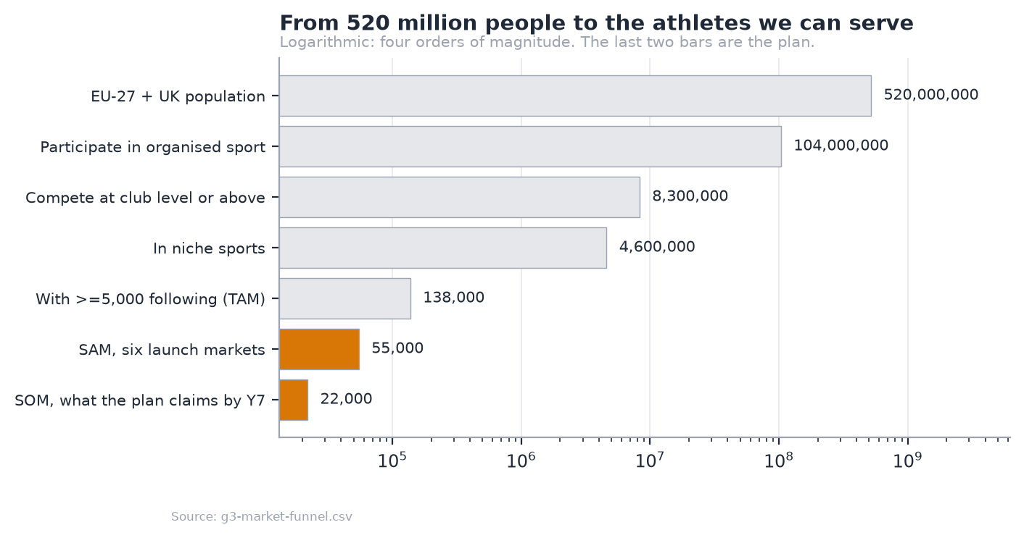
Figure 2: From 520 million people to the athletes the plan can serve. Logarithmic; four orders of magnitude.
The funnel narrows from the EU-27 and UK population to a TAM of 138,000 athletes with 5,000 or more followers in niche sports, a SAM of 55,000 across six launch markets, and a Y7 target of 22,000, 40% of the serviceable market after seven years.
The softest number in the plan, named as such
The 3% step from "competes at club level" to "has 5,000 followers" is an estimate, not a measurement. It is the number most likely to be wrong, and the federation licence data in Appendix G is what would replace it.

3.1.3 Segmentation
The segmentation that decides strategy is agent density, not sport or country.
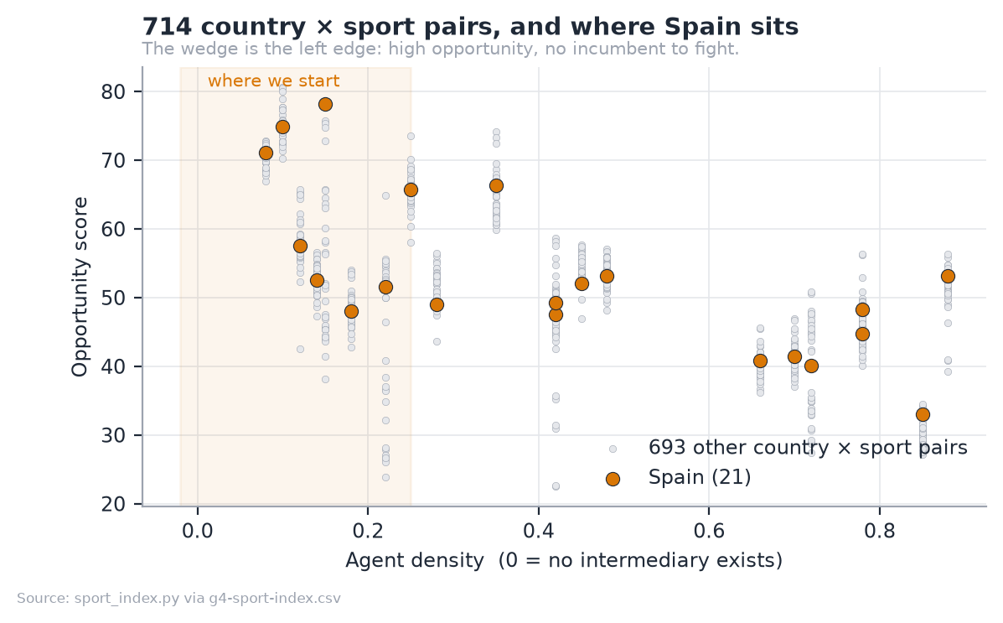
Figure 3: 714 country by sport pairs scored on opportunity against agent density. The wedge is the left edge.
 | Popular sports | Niche sports
Does an agent exist? | Yes, for the top. The tail is ignored | No
The athlete's alternative | An agent taking 10–20%, if one will take them | Nothing
What we sell | Disintermediation: 10%, matched on evidence | Market creation: monetise at all
Customer acquisition cost | Higher: an incumbent relationship to beat | Lower: no incumbent

We start where there is no incumbent. The sport index scores 714 country × sport pairs on supply, demand, appetite and agent density; Spain in niche endurance and combat sports is the opening position. Full method in Appendix H.

3.1.4 Market research
Two strands of primary research: an expert interview inside Olympic broadcasting, and conversations with athletes in the target segment. Full method, limitations and findings follow in §3.1.5.
Expert, Íñigo Cristóbal Losada, AI Lead at olympics.com after eleven years at Olympic Broadcasting Services, where he was Broadcaster Services Manager through Tokyo 2020 and Beijing 2022. He liked the idea, and gave three pieces of advice. Two changed the plan.
The research changed the product, which is the point of doing it
The idea was originally pitched to him as a product for the IOC, open only to Olympic athletes. He rejected that framing: open registration to everyone, but build a filtering mechanism so that not anyone can register as an athlete. The admission gate exists because of that conversation. What was built as a result, and is live in the demo, is an application flow with automated proof-checking, a human review queue, versioned marketability scoring, and club nomination as a second route. Nothing self-verifies.
He also advised phasing: prioritise the content side, and roll the sponsorship layer out as data accumulates. That independently matches the revenue sequencing the model already had. And he pointed to the IOC's Athlete365 programme as a future partnership route; its Business Accelerator serves elite athletes transitioning out of sport, which makes it adjacent rather than competitive.
The full method, the athlete findings, the limitations and the research roadmap follow in §3.1.5. In summary, the athlete conversations, rugby league players in Spain and Lebanon and top-ranked Lebanese CrossFit athletes, produced four findings:
- Current earnings are zero. Not low. Nothing.
- The inequity is felt. Influencers producing far less demanding content earn more than competing athletes do.
- Sponsorship arrives despite the sport, not because of it. The one athlete who does have a sponsor did not get it as a rugby league player, because no route exists by which the sport itself produces the relationship.
- The suppression loop. Athletes do not invest in building an audience because there is no return on doing so. The absence of monetisation suppresses the supply of audience in the first place.
That fourth finding matters for sizing: the TAM above counts athletes who already have 5,000 followers, which measures the market under current incentives. The plan does not claim the expansion, but the honest error direction is understatement.

3.1.5 Primary research in full
ESADE outline §5.1.4. Two strands of qualitative primary research: one expert interview inside Olympic broadcasting, and conversations with athletes in the segment the plan targets. This section reports what was said, what it changed, and what it does not settle.

3.1.5.1 Method, and what it can support
 | Strand A | Strand B
Who | Íñigo Cristóbal Losada, AI Lead at olympics.com | Rugby league players in Spain and Lebanon; top-ranked Lebanese CrossFit athletes, one competing at Asian level
Why them | A decade inside Olympic broadcast operations and rights-holder relationships | They are the target segment, not a proxy for it
When | July 2026 | Through 2026
Format | Unstructured conversation | Unstructured conversations
Sample | 1 | 5

This is a convenience sample and it is reported as one. Both strands come from the founder's own network. The findings below are directional and qualitative; none of them is a statistically representative measurement, and the plan does not treat them as one. What a sample like this can do is two things a survey cannot: surface a mechanism nobody thought to ask about, and change a product decision. Both happened.
The Lebanon question, answered before it is asked
The sample spans both countries: the rugby league players include athletes competing in Spain, the launch market, alongside those in Lebanon, and the CrossFit athletes are Lebanese. So the gap is narrower than it looks, and it is still real, because five people recruited through one network cannot represent a market whichever country they sit in. The finding those conversations produced is structural, not national: in a sport with no agent layer, there is no route from having an audience to earning from it. The sport index in 08 measures agent density across 714 country × sport pairs and finds that absence is a property of niche sports rather than of any one country. Be precise about what the index does and does not contain: neither Lebanon nor rugby league is in it. It covers 34 countries and 21 sports, and an examiner checking against 08 would find both missing. What transfers is the mechanism, not a cell in the matrix, where no agent layer exists, no route runs from audience to income, and the index is the evidence that this condition is set by a sport's economics rather than by its geography. What a sample of five cannot support is anything about Spanish willingness to pay, sponsor budgets, or market size. None of those claims rests on it. The Spanish market sizing is desk research, and it is labelled as such.

3.1.5.2 Expert interview: Olympic broadcasting
Íñigo Cristóbal Losada is AI Lead at olympics.com (Olympic Channel Services), following eleven years at Olympic Broadcasting Services, where he was Broadcaster Services Manager through Tokyo 2020 and Beijing 2022 and managed venue broadcast operations at the Tokyo Paralympic Games. He holds an Executive Master in Digital Business from ESADE. He discussed the idea from the perspective of the Olympic Channel in Europe.
The headline: he liked it. Three pieces of substantive advice followed, and two of them changed the plan.

Finding 1: Phase it. Content first, sponsorship second.
His advice was to prioritise the content side, and to roll out the sponsorship and business layer as real data accumulated or once a reasonable athlete base existed. He suggested the two could even be treated as separable products.
Effect on the plan: confirmatory. The revenue thesis already sequences fan monetisation ahead of sponsorship, and 01 states that fan revenue leads and funds the early years while sponsorship compounds behind it. The interview independently reached the same ordering from an operator's perspective rather than a financial one.
It also exposes an inconsistency worth naming: the deployed demo shows the sponsorship engine, not the fan product. That is deliberate, because the matching engine is what proves the analytics are real, but it means the thing a viewer clicks is the second-phase product. The build sequence in 5.11 corrects the order; the demo has not caught up.

Finding 2: Open it to everyone, but filter it
The idea was originally pitched to him as a product for the IOC, in which only Olympic athletes could participate. He rejected that framing. His position: open registration to everyone, but build a filtering mechanism so that not anyone can register as an athlete.
This is the finding that changed the product
The admission gate exists because of this conversation. It is not a feature that was designed and then justified; it is a direct response to expert advice that a closed, elite-only platform solves the wrong problem while an unfiltered open one has no sponsor-side value at all. What was built as a result, and is live in the demo today: an application flow with automated proof-checking, a human review queue, versioned marketability scoring, and club nomination as a second admission route. Nothing self-verifies, a club scoring above the verification bar still waits for a person to open its roster page, and a rejected proof cannot be cleared by re-submitting the form. The full model is in 11. The admission rate the model plans for rises from 20.0% in Y1 to 30.5% by Y7 as the funnel improves, which is a filter, not a formality.
This also settled the market-entry question. An IOC-only product would have inherited the IOC's athlete population: elite, already represented, and largely already monetised. The segment with the actual problem sits below that tier, which is where the plan now starts.

Finding 3: Look at Athlete365, and at partnership
He pointed to the IOC's own athlete programmes, in particular Athlete365, as both a reference and a possible future partnership route.
Athlete365 is the IOC's athlete community brand. Its Business Accelerator, run with Alibaba.com, supports Olympians, Paralympians and elite athletes transitioning to life after sport, through online modules on business fundamentals, financial planning, branding and marketing, plus mentoring, with prizes including promotional packages and Alibaba.com credit.
Read carefully: this is adjacent rather than competitive, and the distinction matters:
 | Athlete365 Business Accelerator | Stride
Who | Olympians and elite athletes | The tier below, where no agent exists
When in a career | Transitioning out of sport | During the competitive career
What it provides | Education, mentoring, credit | Revenue, from fans and sponsors
Business model | IOC-funded programme | Marketplace take rate

That the IOC funds a programme at all is evidence the problem is recognised at the top of the sport. That the programme teaches entrepreneurship to retiring elite athletes confirms it is not addressing the athlete this plan targets.
As a partnership, the relevant asset is credibility and reach into national federations, which is exactly the channel 10.4 plans to open at Y3. It is listed as an opportunity, not as a dependency.

3.1.5.3 Athlete interviews: the segment itself
Conversations with five athletes: rugby league players competing in Spain and in Lebanon, and top-ranked Lebanese CrossFit athletes, one of them at Asian level. The founder is capped by the Lebanese national rugby team, which is how this access exists and why the conversations were candid rather than performative.

Finding 1: Current earnings are zero, not low
Not "modest", not "inconsistent". Nothing. The athletes spoken to earn no income from their sport or their audience.
This matters for the plan's framing: the alternative to Stride for this athlete is not a worse deal. It is no deal. That is the market-creation argument in 06, stated by the people it describes.

Finding 2: The inequity is visible, and it is felt
The comparison that came up unprompted: influencers producing far less demanding content earn more than competing athletes do. The grievance is not that sport should pay more in the abstract. It is that the monetisation infrastructure available to a lifestyle creator has no equivalent for someone whose content is a training block and a competitive record.

Finding 3: Sponsorship arrives despite the sport, not because of it
One athlete does receive sponsorship. He does not receive it as a rugby league athlete. There is no route by which the sport itself produces the commercial relationship, because no platform exists to carry it and no mechanism exists for a brand to find him through it.
This is the disintermediation thesis observed from the supply side: the sponsorship market is not competitive here; it is absent.

Finding 4: The suppression loop
The strongest finding, and the one that changes how the opportunity should be sized:
Athletes do not invest in building an audience, because there is no return on doing so. As one put it: people are not going to spend time setting up social media and building followers purely around their sport if nothing comes back.
The absence of monetisation suppresses the supply of audience in the first place. That reframes the addressable market: the plan's funnel in 03 counts athletes who already have ≥5,000 followers, which measures the market under current incentives. If a credible route to income exists, some athletes below that threshold cross it who otherwise never would.
The plan does not claim that expansion. The TAM stays measured on today's follower counts, and the sizing is deliberately the conservative reading. But it is worth stating that the honest error direction here is understatement, and that the mechanism for expansion is exactly the one the product supplies.

3.1.5.4 What the research settles, and what it does not
Supported by primary research:
- Niche-sport athletes at this tier earn nothing from their audience, and experience that as a structural absence rather than a pricing problem
- There is no mechanism for brands to find them through their sport
- An open platform with a real admission filter is the right shape, per an expert with a decade inside Olympic broadcast
- Content and fan monetisation should lead; sponsorship should follow the data
Not supported, and not claimed:
- Will fans actually pay? No interview answers this. It is the assumption the whole plan rests on; it is named as such in 07 as risk R1, and only three months of real subscription data from one anchor athlete resolves it. That is the pre-seed gate, and it is a gate precisely because the research does not clear it.
- Sponsor-side willingness to pay. No sponsor or brand-side interviews have been conducted. This is the largest hole in the research and is acknowledged rather than papered over.
- Spanish market specifics. Part of the sample competes in Spain, but five athletes recruited through one network cannot describe a market. The structural finding transfers (§3.1.1); the pricing and budget figures do not, and none of them rests on this research.

3.1.5.5 Research roadmap
In priority order, and sized to what actually changes a decision:
Priority | Research | Why it matters | Effort
1 | 6–10 sponsor-side interviews: regional brands, sports nutrition, local retail | The only completely untested side of the marketplace. Without it, the demand side is desk research alone | 2 weeks
2 | Structured athlete survey, n ≥ 30, via the club channel | Converts the qualitative findings into something defensible. Ask about current income, brand approaches, and willingness to accept a 15% take | 3 weeks
3 | Spanish athlete interviews, 5–8 | Tests whether the structural finding holds in the launch market specifically | 2 weeks
4 | Athlete365 / federation exploratory contact | Partnership route, and a credibility signal for the club channel | Opportunistic

The pre-seed gate does what none of the above can: it measures whether fans pay, with real money, over three months. Every item here reduces uncertainty around that test. None of them substitutes for it.

3.2 Value proposition

3.2.1 The need
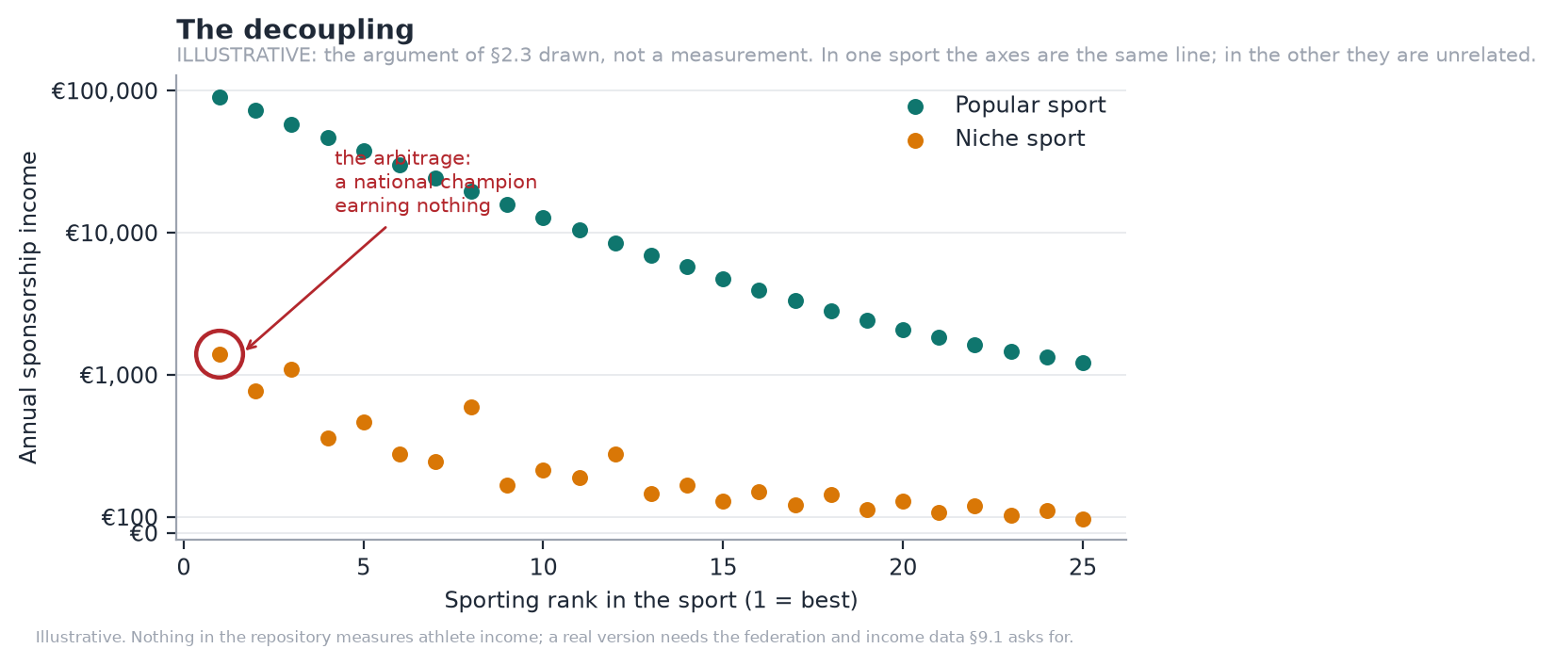
Figure 4: The decoupling. Illustrative, not a measurement.
In a popular sport, sporting rank and sponsorship income are close to the same line. In a niche sport they are unrelated: a national champion can earn nothing. That gap is the opportunity, and it exists because the intermediation layer that converts audience into income was never built for these sports.
The general environment works in the plan's favour on three fronts and against it on one. Creator-economy infrastructure is mature and fans are habituated to paying for access. EU regulation (DSA, DAC7, GDPR) raises the compliance floor, which favours a platform built for it over an incumbent retrofitting. Spain's Ley de Startups cuts corporate tax to 15% for the first four taxable years. Against: consumer discretionary spending is under pressure, and a subscription is discretionary.

3.2.2 The sector, and the competition
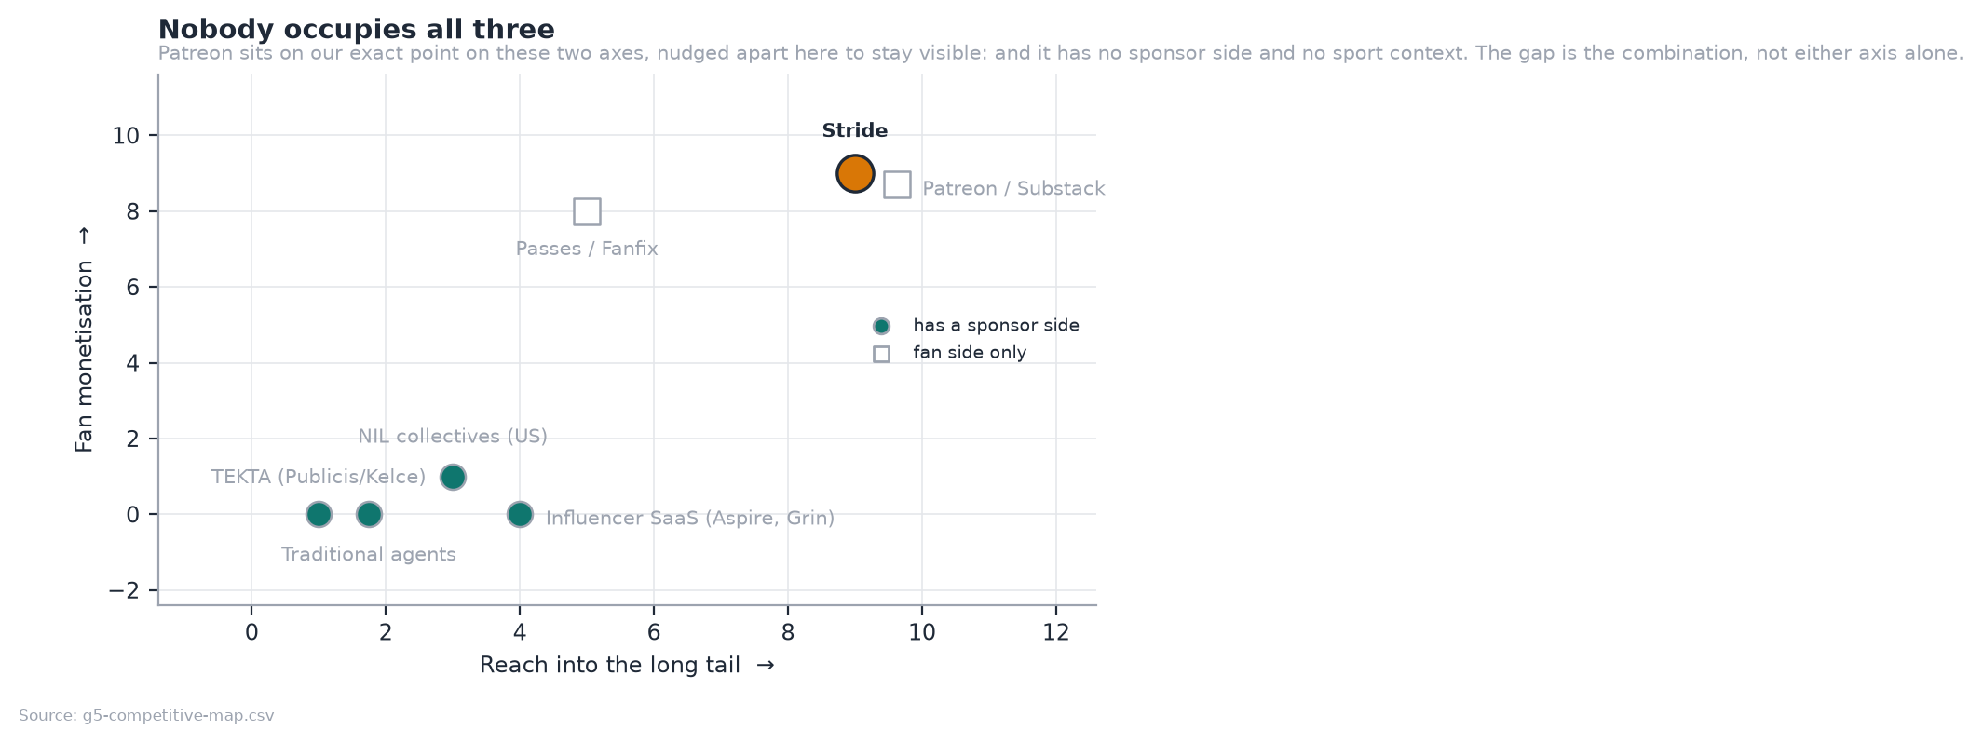
Figure 5: Nobody occupies all three. Patreon matches us on both axes and has neither a sponsor side nor sport context.
Player | Fan monetisation | Long tail | Why they are not us
TEKTA (Publicis / Kelce) | None | Minimal | Human-mediated consultancy, gated to selected Publicis clients, US college NIL. Excludes the tail by design
Traditional agents | None | Minimal | 10–20% for introductions, only for athletes already worth representing
Patreon / Substack | Strong | Broad | No sponsorship side, no sport-specific measurement, no second payer
Sports data platforms | None | Broad | Sell data to clubs and media, not income to athletes

Suppliers are few and consequential: Stripe for payments, AWS for compute, a zero-egress CDN for media. Switching cost is low for all but Stripe, whose pricing sets our unit economics (§5.10).
Substitutes and new entrants. The realistic substitute is the athlete doing it themselves on Instagram and a bank transfer. A funded entrant is the real risk (R4), and the defence is not the code; it is the accumulated scoring history and the athlete relationships, which take time nobody can buy.

3.2.3 The offering
Athletes connect their platform accounts and apply. The engine scores marketability on eight weighted components with the arithmetic visible. Admitted athletes get a fan-facing page with paid tiers, and appear in the sponsor-facing matching engine. Sponsors brief a campaign, receive a ranked and explained shortlist, make offers, and get delivery measured automatically.
Three properties are worth a technical diligence call:
- Every match score decomposes. A ranked athlete shows all eight components, weighted, with the arithmetic visible: audience fit 72 × 32% = 23.1.
- Missing data is `null`, never `0`. An unmeasured campaign reads as unmeasured, not as free.
- Nothing self-verifies. A club above the verification bar still waits for a human. A rejected proof cannot be cleared by re-submitting the form.

3.3 Key success factors
Positioning. The platform for athletes the industry ignores. Not a cheaper agent, not a sports Patreon: the first commercial infrastructure for sports that never had any.
Competitive advantage, in the order it becomes durable:
- The data position. Every admission decision and every campaign outcome improves the scoring model. This compounds and cannot be bought.
- Explainability as a sales asset. Sponsors buy against evidence; a decomposable score shortens the sales cycle in a market that runs on assertion.
- The club channel. One conversation brings a roster of 20–40 athletes with the verification problem already solved.
- Regulatory posture. Consent, audit trail and aggregate-only audience data are built in, not retrofitted.

3.4 Costs and investment required
The product exists, which is what makes the launch cost small. Total capital required is €649k: a €464k cash trough in Y4 plus a 40% buffer. Against that, €80k of founder time and direct cost is already spent. The gap between today and first revenue is one entity and one processor: there is no payment, tier-price or payout entity of any kind, and the €9.99 on the membership card is a label rendered by the client, not a price.

3.5 Revenue sources
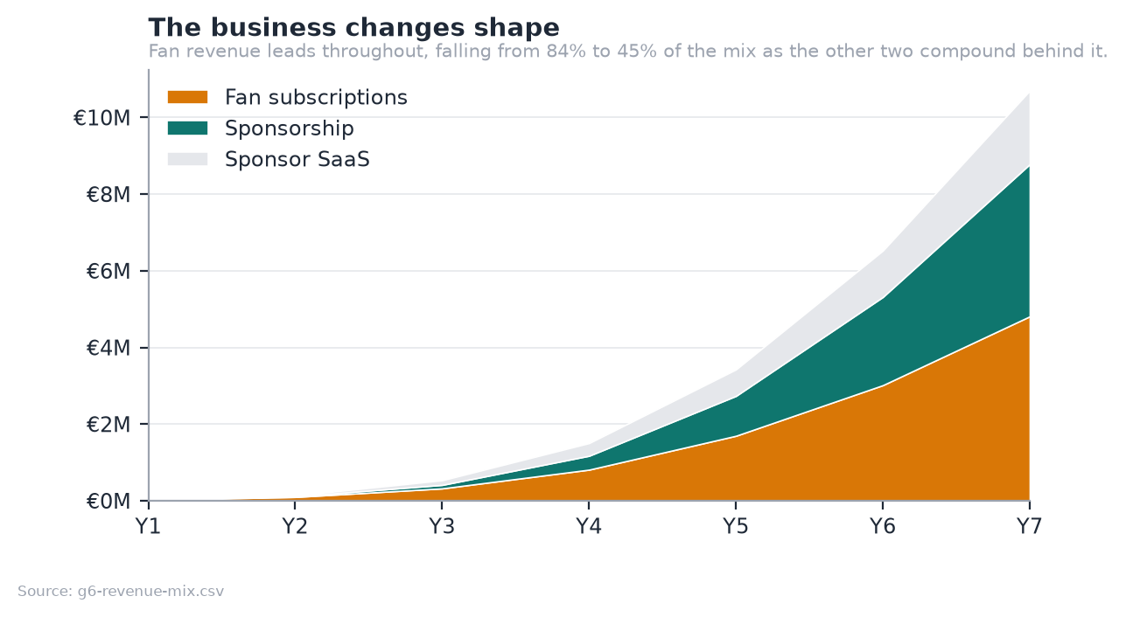
Figure 6: The business changes shape. Fan revenue leads throughout; the other two compound behind it.
Stream | Basis | Y7
Fan subscriptions | 15% of fan GMV | €4.81M
Sponsorship | 10% of deal value | €3.97M
Sponsor SaaS | Monthly subscription, tiered | €1.92M

The two sponsor streams add, they do not substitute. Commission is the marketplace take and every sponsor pays it on every deal, including those on the free plan. The subscription buys tooling rather than a commission waiver: the free tier runs one campaign and sees the top five matches, Scout Starter at €99 a month adds full matching, Scout Pro at €249 adds evidence views and pipeline, and Scout Agency at €999 adds multi-seat and API access. Only 10% of sponsors subscribe in Y1, rising to 20%. Subscription is briefly the larger of the two in Y2 and Y3, while deal volume is still small and the tool is being sold ahead of the marketplace; from Y4 commission leads, and by Y7 it is roughly double the subscription line.
Full derivation, tier design and the take-rate argument in Appendix A.

4. Marketing plan

4.1 Product strategy
Two products on one platform: the athlete's fan-facing page with paid tiers, and the sponsor's matching and measurement console. The sequencing is deliberate and matches the expert advice in §3.1.4: fan monetisation ships first, because it is the revenue leader and the assumption that needs testing; the sponsorship engine, already built, compounds behind it.

4.2 Pricing strategy
15% of fan revenue, 10% of sponsorship, no monthly athlete fee.
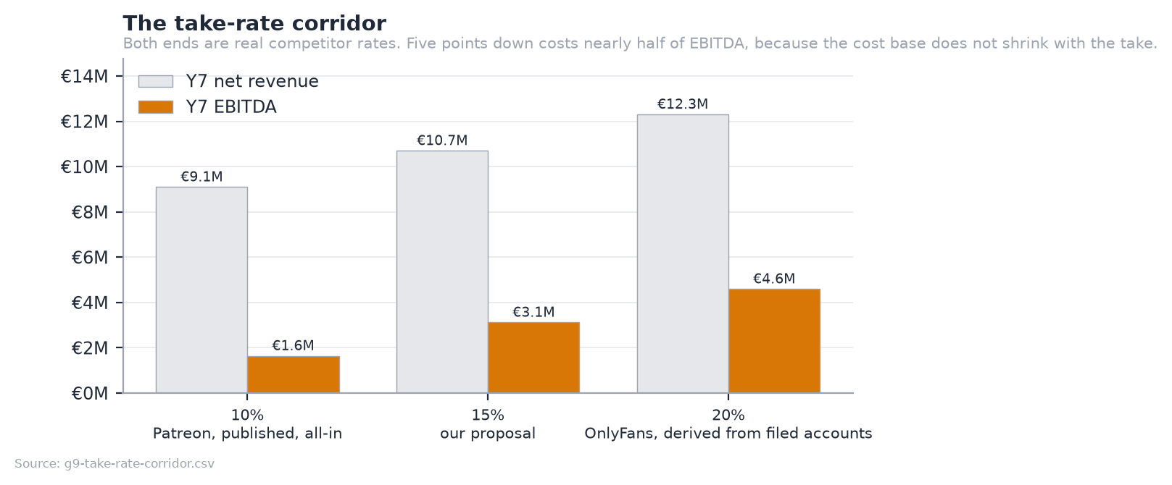
Figure 7: The take-rate corridor. Both ends are real competitor rates.
The corridor is bounded by published competitor economics: Patreon's all-in 10% and OnlyFans' 20%, derived from filed accounts. At 15% we sit between them and undercut the nearest comparable for any athlete earning under €1,380 a month, which is the whole long tail.
What the pricing decision costs, stated rather than hidden
15% flat with no athlete fee forfeits €1.6M of Y7 revenue against a 20% take. It buys a pricing argument that survives contact with the exact athlete we target, and a flat rate means the athlete earning €200 a month pays the same rate as the one earning €5,000. A subscription fee would have been regressive.
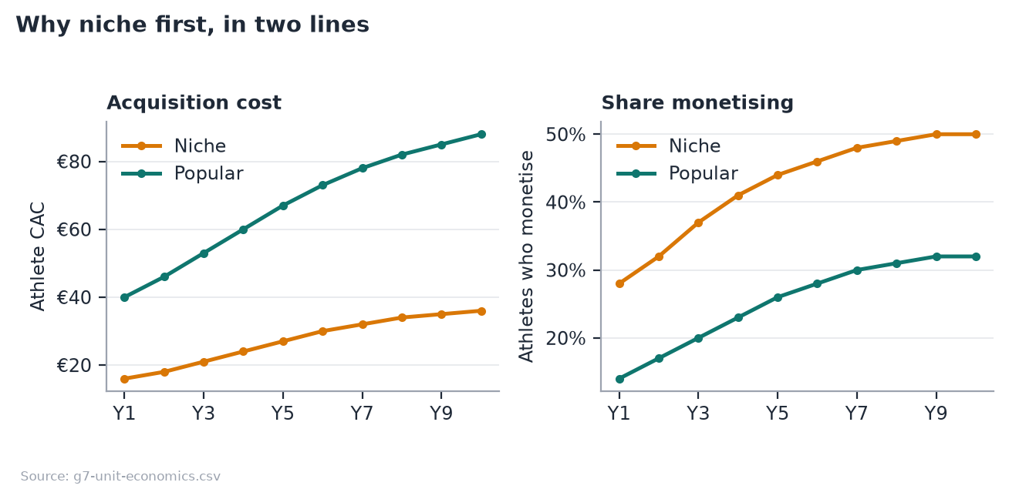
Figure 8: Why niche first, in two lines: acquisition cost and the share of athletes who monetise, niche against popular.
Niche athletes cost less to acquire and a larger share of them monetise. That is the whole reason the plan starts there rather than in football, and it is why the blended acquisition cost rises over the plan rather than falling: the mix shifts toward popular sports as the company earns the right to compete for them.

4.3 Communication strategy
Athlete-side. Community-led and sport by sport, not broadcast. The unit of acquisition is a sport in a country, entered through people already in it. Cost per athlete is modelled at €16–36 in niche sports and €40–88 in popular ones.
Fan-side. We do not acquire fans. Athletes bring their own audiences, which is why the model carries no fan acquisition cost, disclosed in Appendix G as understating the risk rather than presented as efficiency.
Sponsor-side. Outbound and evidence-led: the pitch is a shortlist with the arithmetic shown, not a media pack.

4.4 Channel strategy
Channel | Role | From
Direct athlete acquisition | The base, community-led | Y1
Club partnerships | The compounding one: a roster, not an athlete | Y2
Federation relationships | Credibility and licence data at national scale | Y3
Sponsor self-serve | Lowers the cost of the long-tail sponsor | Y4
Managed services | Higher take, higher touch, largest campaigns | Y6

4.5 Sales forecast
 | Y1 | Y3 | Y5 | Y7 | Y10
Active athletes (year end) | 400 | 3,000 | 10,500 | 22,000 | 40,000
Paying fans (year end) | 2k | 25k | 120k | 321k | 666k
Sponsors on the platform | 25 | 230 | 900 | 2,000 | 3,600
of which paying SaaS | 1 | 39 | 180 | 400 | 720
Net revenue | €0.02M | €0.53M | €3.43M | €10.70M | €25.38M

4.6 Sales plan
The forecast above is the commitment. This is the activity that reaches it.
A two sided marketplace sells twice, and the two motions have different economics, different owners and different failure modes. Supply is acquired in volume at low unit cost and gated on quality. Demand is acquired one account at a time at a cost that rises as the addressable pool of large sponsors thins.

Supply: the funnel replaces churn before it adds growth
The number that matters is not net growth. Athletes leave, and by Y7 the plan loses 3,200 a year, so showing 6,000 net additions requires 9,200 gross. Sizing the funnel from net growth would under-book it by a third. Every figure below is gross.
Athletes arrive either directly or through a club, and the two convert very differently. 20% of direct applicants are admitted against 45% of those a club nominates, because a club has already done the part of verification that is hardest to automate: it knows whether the person actually plays. The blended rate in the table is the mix of those two moving as the club channel grows, weighted by share of applications rather than of admissions.
 | Athletes lost | Gross adds needed | Applications | of which club-nominated | Blended admit rate | Headcount
Y1 | 0 | 400 | 2,000 | 0 | 20.0% | 1.5
Y3 | 294 | 2,094 | 8,375 | 1,675 | 25.0% | 3.5
Y5 | 1,296 | 5,796 | 20,337 | 6,915 | 28.5% | 10
Y7 | 3,200 | 9,200 | 30,164 | 12,669 | 30.5% | 22
Y10 | 6,229 | 12,229 | 38,516 | 18,102 | 31.8% | 38

That application column is the same series the operations plan sizes review capacity against in §5, read from the same model rather than derived twice.
Year 1 is the hardest year in the plan, and the table shows why
2,000 applications must be sourced, reviewed and admitted with 1.5 full time people and no club channel yet. Every later year has leverage Y1 does not: a partially built club pipeline, a product with athletes already visible in it, and staff. The pre-seed is sized to buy exactly this year, and if the plan fails it most likely fails here rather than at any of the larger numbers further right.

Demand: sponsors, sold one at a time
Sponsor acquisition is outbound and account based from the start. There is no self serve motion, because a brief that produces a good match needs a conversation about what the campaign is actually for.
The plan carries 25 sponsors in Y1 rising to 2,000 by Y7, of which the share paying for SaaS rather than transacting only moves from 10% to 20%. Acquisition cost rises from €900 to €1,900 per sponsor across the same period, which is the ordinary pattern: the most reachable brands are acquired first.

Who sells
Founder led in Y1, at 1.5 FTE. The BD and partnerships hire arrives in Y2 (§6), which is also when the club channel opens, and those two facts are the same decision: the hire exists to open club and sponsor accounts, and the club channel is what makes one conversation worth a roster. By Y3 the channel carries 20% of supply.

5. Operations plan
ESADE outline §7. Every figure here is generated by [`model.py`](model.py) or traceable to the codebase; the doc guard fails the build if any of them drift.
Stride is a two-sided marketplace delivered as software. That changes what an operations plan is about: there is no warehouse, no bill of materials and no delivery fleet, but it does not make the section thin. The operational questions simply move: how fast does an athlete get admitted, how reliably does a sponsor get measured delivery, and how much human judgement does each transaction need? Those three answers set the cost base and the ceiling on growth.
The section below follows the standard structure and says plainly where a heading is immaterial to a digital marketplace rather than skipping it.

5.1 Process identification and the process map
Four core processes create value. Three support processes keep them running.
┌──────────────────────── CORE ────────────────────────┐
ATHLETE application ──▶ automated proof check ──▶ human review
ADMISSION │ │
(P1) └────────── marketability scoring ◀──────┘
│
▼
admitted, listed
│
┌─────────────────────────────────────┼─────────────────────────────┐
▼ ▼
SPONSORSHIP FAN MONETISATION
(P2) (P4)
campaign brief fan subscribes
│ │
▼ ▼
explainable match ──▶ offer ──▶ deal ──▶ delivery ──▶ measurement paywalled content
│ │ │
└──────────────────────┬──────────────────────────────┘ │
▼ ▼
TAKE RATE 10% TAKE RATE 15%
└────────────────┬───────────────────────────┘
▼
PAYOUT (S2)
TRUST & SAFETY (P3): content moderation queue · report/block · admin review
runs continuously across P1, P2 and P4
└──────────────────── SUPPORT ─────────────────────────┘
S1 Platform data ingestion: connected social accounts, engagement refresh
S2 Payments and payouts: collection, float, athlete settlement, reconciliation
S3 Support and dispute handling: athlete, sponsor and fan queues
Classification. P1 and P3 are the only processes that consume meaningful human time. P2 and P4 are automated end to end once the entities exist. S1 and S2 are subcontracted (§5.2). This is the whole operational thesis: the marketplace scales without linear headcount because the only human step is admission review, and admission review is bounded by applications, not by transactions.
The bottleneck is admission, and it is deliberately human
A club scoring above the verification bar still waits for a person to open its roster page. A rejected proof cannot be cleared by re-submitting the form. That costs latency, and latency is the real price: an athlete sitting in the queue is not listed, not matchable and not earning. We accept the cost because a marketplace whose supply side can be faked has no sponsor-side value at all.

Volume and human load
 | Y1 | Y3 | Y5 | Y7
Applications | 2,000 | 8,375 | 20,337 | 30,164
Sent to human review | 500 | 1,977 | 4,600 | 6,654
Admission rate | 20.0% | 25.0% | 28.5% | 30.5%
Review FTE required | 0.02 | 0.08 | 0.18 | 0.26

At four minutes per review, the entire manual burden of the business peaks at roughly a quarter of one full-time person at Y7, against 22 FTE total. The admission gate is cheap. It is the design of the gate, not its cost, that carries the risk.

5.2 Structural and permanent subcontracting
Everything below is a permanent make-or-buy decision, not a temporary outsourcing arrangement. Each was chosen because owning it would consume engineering capacity without creating defensibility.
Function | Provider | Why bought, not built | Switching risk
Payment processing & payouts | Stripe Connect (Express) | Regulated money transmission, KYC, and payout rails in 30+ countries. Building this is a licence application, not a sprint | High. Take-rate economics are hostage to Stripe pricing. See §5.10
Compute & database | AWS | Managed Postgres and autoscaling genuinely earn their premium at our size | Low. Containerised; the stack runs on any Kubernetes
Media delivery | Zero-egress CDN (Cloudflare R2 / Backblaze B2 + Bunny) | Egress is the cost that decides viability. See 02 | Low, and deliberately separable from AWS
Authentication | Supabase | Email verification, session handling and password reset are solved problems with real security consequences | Low. Abstracted behind our own auth layer
Data protection officer | Fractional DPO (Y3) → hired (Y5) | GDPR Art. 37 exposure without a full-time salary until scale justifies it | Low
Legal counsel | External, Spanish firm | Corporate, IP and sponsorship contract templates. See 8 | Low

Nothing about the analytics engine is subcontracted. Marketability scoring, the admission gate and explainable matching are the source of advantage and stay in house, permanently.

5.3 Location, infrastructure and layout
Barcelona, Spain. Remote-first, with no customer-facing premises.
There is no layout to design: the company has no shop floor, no production line and no stockroom. The physical footprint is laptops and a co-working desk allocation until Y4.
The location decision is nonetheless a real one, taken for four reasons:
- Ley de Startups grants a 15% corporate tax rate for the first four taxable years against the standard 25%, worth €1.57M across Y6–Y9 in the model.
- Loaded engineering cost. A senior engineer at €72k loaded is roughly half the London or Amsterdam equivalent and a third of the Bay Area.
- Beckham Law offers a 24% flat IRPF rate for relocated hires, which materially widens the senior hiring pool from Y4.
- Market adjacency. Spain is the launch market. Being in it matters for the club channel and the anchor athlete relationship, both of which are relationship businesses before they are product ones.
Phase | Arrangement | Annual cost
Y1–Y3 | Fully remote, co-working desks as needed | Immaterial
Y4–Y5 | Small Barcelona office, 8–12 desks | ~€24k
Y6+ | Office to ~25 desks; second market opens remote-first | ~€60k

5.4 Permanent material resources
Resource | Basis | Note
Laptops and peripherals | ~€2,000 per head, 3-year cycle | The only meaningful capex
Cloud infrastructure | AWS base €180/mo (Y1) → €24,000/mo (Y7) | Scales with usage, not headcount
Software licences | ~€1,200 per head per year | Development, design, analytics, comms
Development capitalisation | 30% of people cost | Capitalised and amortised over 3 years

The model treats development as the principal capital asset, which is economically honest for a software business: the balance sheet's productive asset is the codebase, not equipment.

5.5 Transitory resources (consumables)
Not applicable in the physical sense. No raw materials, packaging or consumables of any kind.
The nearest economic analogue is the set of inputs consumed per unit of activity, and those are worth naming because they behave exactly like consumables in the cost model:
"Consumable" | Consumed per | Y7 volume | Y7 cost
Media egress | Paying fan per month (1.8 GB) | ~6.0 PB | €48k
Moderation review | Athlete per month (12 items) | 3.2M items | €70k
Verification check | Admitted athlete | 6,654 reviews | €18k
Payment processing | Transaction | See §5.10 | €2.55M

5.6 Stocks and inventory
Not applicable. Digital goods; nothing is held, warehoused or written off.
One analogue deserves the heading anyway, because it behaves like work-in-progress inventory and carries a real cost:
The admission queue is the only inventory in the business
An application awaiting human review is unsold supply. It occupies no shelf, but it ages, and an athlete who waits too long leaves. The queue is therefore managed to a service level rather than a cost target (§5.7), and automated proof-checking exists specifically to keep the human queue short rather than to make it cheap.

5.7 Delivery times and service levels
These are commitments, not observations: the product is deployed but pre-revenue, so each is a target the operating plan is built to hold.
Process | Target | Why this number
Automated proof check | < 5 seconds | Runs synchronously on submission
Human admission review | < 48 hours | Beyond two days, application abandonment rises sharply in comparable marketplaces
Campaign match generation | < 1 second | Deterministic scoring, no model inference
Offer → deal acceptance | Sponsor-controlled | Not ours to promise
Deliverable measurement | < 24 hours after post | Connected-platform refresh cycle
Athlete payout | 15 days from collection | The float assumption in the model; funds are held, not lent
Sponsor invoice settlement | 45 days | B2B norm; drives the receivables line
Trade payables | 30 days | Standard supplier terms

The 15-day payout float is worth stating explicitly because it is both a working-capital benefit and a trust obligation: it is athlete money held briefly, not company money. It is modelled as a cash benefit and disclosed as one.

5.8 Investment and launch costs
Item | Amount | Timing
Product build to date | €80k (founder time + direct cost) | Pre-seed, already spent
Payments integration (P0) | ~€25k | First 3 months post-raise
Tier entity and billing (P1) | ~€40k | Months 3–6
Media pipeline (P2) | ~€60k | Months 6–12
Spain go-to-market | ~€90k | Y1–Y2
Working capital and buffer | Balance of the raise | Continuous

The product already exists, which is what makes the launch cost small. The gap between today and first revenue is one entity and one processor: there is no payment, tier-price, payout or wallet entity of any kind, and the €9.99 on the membership card is a label rendered by the client, not a price.

5.9 Operating costs
Full detail sits in 02; the operational summary is that cost of sales is dominated by a single line that no amount of engineering removes.
Y7 cost of sales | Amount | % of revenue
Payment processing | €2.55M | 23.8%
Payouts to athletes | €237k | 2.2%
Infrastructure | €336k | 3.1%
Moderation | €70k | 0.7%
Athlete verification | €18k | 0.2%

Infrastructure is 3.1% of revenue. Payments are nearly eight times larger. Any optimisation effort belongs there: tier pricing, annual billing and processor negotiation, not the AWS bill.

5.10 Unit costs
The single most important operational mechanic in the business is that Stripe's fixed fee lands on our commission, not on the ticket.
Fan pays | Ex-VAT | Our take (15%) | Processing cost | We retain
€4.99 | €4.12 | €0.62 | €0.25 + 1.9% | 44%
€9.99 | €8.26 | €1.24 | €0.25 + 1.9% | 64%
€24.99 | €20.65 | €3.10 | €0.25 + 1.9% | 77%

The take is charged on the VAT-exclusive price, because that is the base the model uses. At €4.99 we keep well under half of our own commission; at €9.99, about two thirds. This single mechanic should set the minimum tier price and push hard toward annual billing. Patreon reports annual patrons churn at roughly one third the rate of monthly ones, so the retention gain compounds the fee saving.
Other unit costs, for completeness:
Unit | Cost
One human admission review | €1.49 in Y1, €2.75 by Y7 (4 min at a loaded hourly rising from €22.35 to €41.18)
One athlete's monthly moderation | ~€0.26 (12 items at €22/1,000)
One paying fan's monthly egress | ~€0.014 (1.8 GB at €0.008)

5.11 Launch plan
Sequenced by what unlocks revenue, not by what is easiest to build.
Stage | What ships | Gate it opens
P0 | Payments: Stripe Connect, wallet, payout rail | A euro can move
P1 | Tier entity with a price, recurring billing, entitlement expiry, dunning | Fan revenue starts. This is the pre-seed gate.
P1.5 | One-off unlocks, courses, sponsored labels | ARPU without new infrastructure
P2 | Transcode, object storage, CDN, automated classification | Video, and the thesis test at scale
P2.5 | Ballots, events with capacity, club publishing and revenue split | The club channel monetises

Market sequence: Spain through the pre-seed gate, second market at the seed, third and EU-wide from Series A. The reasoning is in 06: we start where there is no incumbent, and what we learn there generalises upward.
The launch is gated on evidence, not on a date
The pre-seed gate requires three months of real subscription data from one anchor athlete. Nothing in the product proves fans will pay, and no amount of further engineering will. That measurement, not a feature, is what unlocks the next stage.

6. Organization and human resources
ESADE outline §8. Headcount, loaded costs and the hiring sequence are generated by [`model.py`](model.py); the doc guard fails the build if the prose drifts from it.
The plan reaches €10.7M of revenue at Y7 with 22 people. That ratio is the central organisational claim, and it is only credible if the org design explains why it holds. It holds because the only human step in the value chain is admission review (see 5), and admission review scales with applications rather than with transactions.
This section sets out the structure, the roles, the policies that fill them, and who decides what.

6.1 Organizational structure

Headcount trajectory
 | Y1 | Y2 | Y3 | Y4 | Y5 | Y6 | Y7
Headcount (FTE) | 1.5 | 2.0 | 3.5 | 6.0 | 10.0 | 15.0 | 22.0
People cost | €57k | €104k | €210k | €384k | €660k | €1.02M | €1.54M

Growth to 38 FTE by Y10. The shape is deliberate: the team stays below five people until fan revenue is proven, because the pre-seed gate tests an assumption, and testing an assumption does not need an organisation.

Functional structure by stage
Y1–Y2 ── FOUNDER / CEO ──┬── Full-stack engineer
(2 FTE) └── Community / athlete lead
Y3–Y5 ── FOUNDER / CEO ──┬── ENGINEERING ── senior eng · full-stack
(3.5→10) ├── GROWTH ────── BD/partnerships · athlete success
├── OPERATIONS ── moderation lead · review
└── FINANCE & COMPLIANCE ── finance/ops · DPO (frac.)
Y6+ ── FOUNDER / CEO ──┬── VP ENGINEERING ── platform · data · mobile
(15→38) ├── VP GROWTH ────── sales · partnerships · marketing
├── HEAD OF OPS ──── trust & safety · support · review
└── HEAD OF FINANCE ─ finance · legal · DPO (hired)
Three functions, not five. Engineering, Growth and Operations carry the business; Finance & Compliance is fractional until Y4 and a function only from Y5. There is no separate marketing team before Y6, acquisition runs through the Growth function, because at this stage marketing is partnerships.
Why the org chart is flat for longer than is comfortable
The temptation in a marketplace is to hire sales ahead of supply. We deliberately do not: until the admission gate is producing athletes a sponsor actually wants, a salesperson has nothing differentiated to sell. Supply first, demand second, and the hiring sequence encodes that.

6.2 Job descriptions
Roles are listed in hiring order. Gross and loaded costs reflect Spanish employer social security at ~30–32% on top of gross.

Founder / CEO: Y1
Gross €0 → €45k · Loaded €0 → €59k Unpaid in Y1; the opportunity cost is modelled explicitly rather than hidden. Owns strategy, fundraising, the anchor-athlete relationship and the sponsor pipeline until a BD hire exists. Writes code in Y1–Y2. Requires: the venture's core insight, and enough technical depth to ship.

Senior engineer: Y2
Gross €55k · Loaded €72k Owns the platform end to end: API, data model, the analytics engine, deployment. Second pair of hands on a codebase that already exists and already has a test suite running on two databases. Requires: Python/TypeScript, Postgres, cloud deployment. Payments integration experience is the single most valuable specialism at this stage.

BD / partnerships: Y2
Gross €38k + commission · Loaded €50k+ Opens the club channel and the first sponsor accounts. Commission-weighted because the role is measurable and the early pipeline is the company's riskiest unknown after fan churn. Requires: Spanish sports ecosystem relationships. Federation or club-side experience preferred over agency experience.

Athlete success: Y3
Gross €30k · Loaded €39k Onboards admitted athletes, coaches content strategy, holds retention. The counterpart to BD on the supply side, and the role closest to the churn assumption the whole plan rests on. Requires: credibility with athletes. Competitive background strongly preferred.

Content moderation lead: Y3
Gross €34k · Loaded €45k Owns the review queue, the trust and safety policy, the age-gate enforcement and the escalation path. Also owns the admission-review service level (< 48 hours). Requires: trust and safety experience on a UGC platform; judgement under ambiguity.

Finance / operations: Y4
Gross €42k · Loaded €55k Payouts, reconciliation, VAT across markets, investor reporting, the working capital cycle. The first hire whose absence would become a control weakness rather than a workload problem. Requires: multi-jurisdiction VAT, marketplace payment flows.

Data protection officer: Y3 fractional → Y5 hired
Fractional €18k → Hired gross €60k / loaded €79k GDPR Article 37 exposure arrives with scale, not with launch. Fractional until the athlete base and the media pipeline justify a full-time appointment. Requires: GDPR practice, ideally with platform or minors experience given the 16–18 age model.

6.3 HR policies

Selection
Hire for the constraint, not for the org chart. Every role above exists because a specific bottleneck arrives at a specific time; none is a "nice-to-have at this stage" hire.
- Structured, evidence-based process. A work sample for every technical role: a real pull request against a scoped issue, paid at market rate. Consistent with a product whose own admission gate refuses to accept self-verification.
- Two-stage reference check for the athlete-facing roles, because those relationships are the asset.
- Non-discrimination. Selection criteria are written before candidates are seen and applied identically. This is both a legal requirement in Spain and a stated commitment (§6.5).

Management
- Remote-first, asynchronous by default. The company is distributed from Y1 and hires from a wider pool than Barcelona from Y4.
- Quarterly objectives tied to the gates, not to the calendar. The pre-seed, seed and Series A gates in 04 are evidence thresholds; team objectives are the components of those thresholds.
- One-to-ones fortnightly, written. Small teams lose context faster than they lose alignment.

Compensation
Element | Policy
Base | Benchmarked to Barcelona market, at or slightly below median, with equity making up the difference
Employer cost | Spanish social security at ~30–32%; every figure in the plan is loaded, not gross
Equity | ESOP topped to 10% by the Series A. All employees participate; four-year vesting, one-year cliff
Commission | BD only, and only on closed sponsorship revenue
Relocation | Beckham Law (24% flat IRPF) actively used for senior hires from Y4
Founder salary | €0 in Y1, rising to €45k. Deliberately below market; the return is equity, and the opportunity cost is disclosed in 04

Why below-median base with real equity
The plan's whole argument is that a small team can reach €10.7M of revenue. If that is true, equity is worth more than the salary gap, and if a candidate does not believe it, they are the wrong hire for a company whose central claim is exactly that.

6.4 Governance structure

Legal form
Sociedad Limitada (S.L.), incorporated in Spain. Rationale and the alternatives considered are in 8.

Board composition by stage
Stage | Board | Founder control
Pre-incorporation | Founder only | 100%
Pre-seed (€600k) | Founder + 1 investor observer | 79% held after the 2% advisory grant
Seed (€2.0M, optional) | Founder + 1 investor director + 1 independent | 66%
Series A (€8.0M) | Founder + 2 investor directors + 1 independent | 55%
Post-ESOP | As above | ~49%

Reserved matters
From the pre-seed onward, the following require investor consent: new share issuance, sale of the company, changes to the take rate, incurring debt above a threshold, and any change to the athlete age policy. The last one is on the list deliberately; it is the decision most likely to be pressured commercially and least reversible reputationally.

Advisory
A 2% advisory pool is opened at the pre-seed, vesting over two years. It covers two grants: the anchor-athlete advisor, which 04 sizes at 1% within a 0.5–1.5% range and against a performance trigger, and a sports-industry board advisor of similar size. The dilution table above models the full 2%, which is deliberately the expensive assumption, if only one grant is ever made the founder retains more than the table shows, not less. The intended profile is sports-industry rather than technology: the plan's weakest external dependency is the anchor athlete and the club channel, not the code.

6.5 Sustainability and responsible business
Addressing the programme learning objective on the UN Sustainable Development Goals. These are not decorative, each maps to a decision already taken in the plan and visible in the product.
SDG | How the business model addresses it | Where it is decided
8: Decent Work and Economic Growth | The core purpose: creating an income stream for semi-professional athletes who currently have none. A trail runner's alternative to Stride is nothing | 06
5: Gender Equality | Women's sport is systematically under-monetised by agent-mediated models, precisely because agents chase the largest audiences. An evidence-based matching engine that scores on engagement rather than on name recognition is structurally fairer to it | 11
10: Reduced Inequalities | The 15% flat take with no monthly athlete fee means the athlete earning €200 a month pays the same rate as the one earning €5,000. A subscription fee would have been regressive | 01
16: Peace, Justice and Strong Institutions | Nothing self-verifies. A club above the verification bar still waits for a human; a rejected proof cannot be cleared by re-submitting. Consent is versioned and audited | 11
12: Responsible Consumption | The zero-egress architecture is chosen on cost, and the same decision cuts billed cross-network transfer by an order of magnitude. We do not claim a measured energy saving: the €0.075 against €0.008 per GB in 02 is a price ratio, and no energy measurement sits behind it | 02

Two commitments that cost us money, stated because they are the test of whether the above is real:
- 18+ for fan subscriptions. This forfeits the 16–17 cohort's fan revenue for a year or two. Adults paying for private access to a minor is a categorically different risk from a sponsor paying for a post, and we treat it that way.
- 15% flat, no athlete fee. This forfeits €1.6M of Y7 revenue against a 20% take. It buys a pricing argument that survives contact with the exact athlete we target.
Each of these is a decision we would rather explain than have found.

7. Financial plan
Condensed. The seven-year model, scenarios and full statements are in Appendix C; capital and valuation in Appendix D.

7.1 Assumptions
Every figure in this plan is generated by a Python model and cross-checked against an Excel workbook that reproduces it independently. A consistency guard checks 302 prose claims across 15 documents against the model and fails the build if any figure drifts; a second guard evaluates all 2,520 workbook formulas and requires every variance against the Python model to be zero.
The assumptions that matter most:
Assumption | Value | Confidence
Fan monthly churn, niche | 9% (45% slower than Patreon benchmark) | Low: this is R1
Fans per monetising athlete | 20 → 41 over ten years | Low
Athletes who monetise | 28% → 55% (niche) | Medium
Fan ARPU | €8.00 → €9.50/month, VAT inclusive | Medium
Take rate, fan / sponsorship | 15% / 10% | Set by us
Payment processing | 1.9% + €0.25 | High: published
VAT on fan subscriptions | 21% blended | Medium
WACC | 25% | Medium: a stage premium over Damodaran's 6.0% for European listed software

7.2 Profit and loss
€k | Y1 | Y2 | Y3 | Y4 | Y5 | Y6 | Y7
Net revenue | 25 | 134 | 535 | 1,504 | 3,426 | 6,527 | 10,702
Cost of sales | 13 | 57 | 191 | 503 | 1,098 | 2,008 | 3,213
Gross profit | 11 | 77 | 344 | 1,001 | 2,328 | 4,519 | 7,489
Operating costs | 106 | 247 | 572 | 1,174 | 2,049 | 3,080 | 4,370
EBITDA | −95 | −169 | −228 | −173 | 278 | 1,439 | 3,119

Growth decelerates from +442% in Y2 to +64% in Y7, which is the shape a marketplace should have. Gross margin climbs from 64% in Y3 to 71% by Y10.
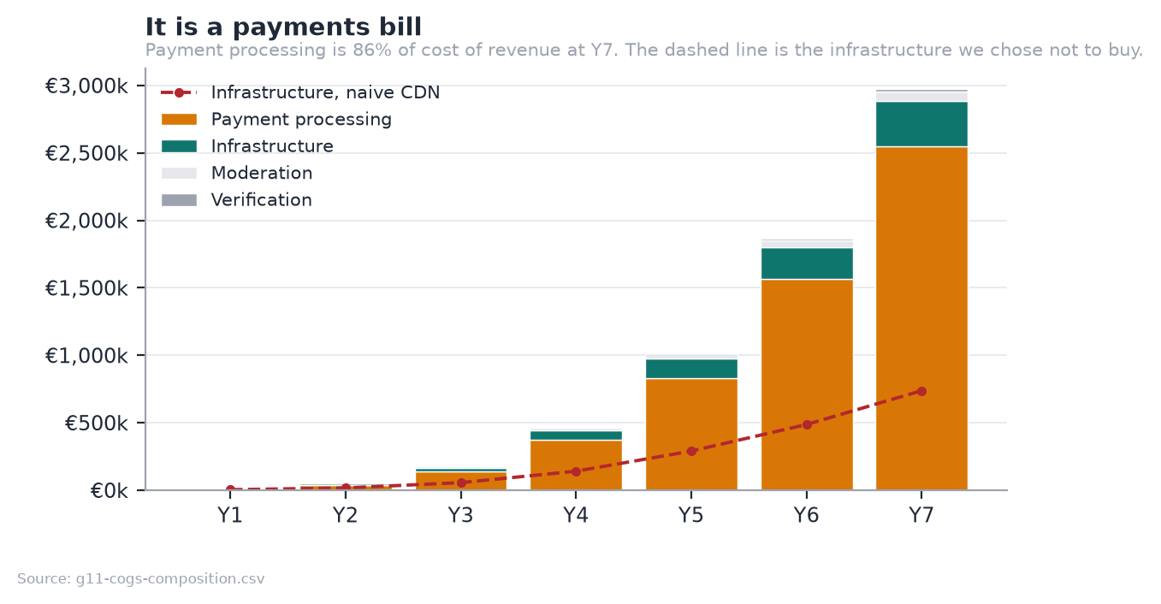
Figure 9: What cost of revenue is made of. The dashed line is the infrastructure we chose not to buy.
Payment processing is 24% of Y7 revenue and nearly eight times infrastructure. Any optimisation effort belongs in tier pricing, annual billing and processor negotiation, not in the AWS bill.

7.3 Pro forma balance sheet
€, year end | Y1 | Y3 | Y5 | Y7
Cash | €504k | €161k | €2.73M | €15.93M
Sponsor receivables | €0k | €26k | €213k | €726k
Net intangible assets | €11k | €52k | €170k | €410k
Total Assets | €516k | €239k | €3.12M | €17.06M
Athlete payout float | €8k | €144k | €989k | €3.23M
Trade payables | €9k | €47k | €168k | €359k
Total Liabilities | €17k | €191k | €1.16M | €3.59M
Paid-in capital | €600k | €600k | €2.60M | €10.60M
Retained earnings | €-101k | €-552k | €-642k | €2.88M
Total Equity | €499k | €48k | €1.96M | €13.48M
BALANCE CHECK | 0 | 0 | 0 | 0

The balance sheet is generated by the workbook and carries its own arithmetic check: the balance check row is zero in every year, which the verification script re-computes from the formulas rather than reading a cached value.
Two lines are worth a comment. Net intangible assets are capitalised development, 30% of people cost, amortised over three years, which is the honest treatment for a software business whose productive asset is its codebase rather than equipment. The athlete payout float is money collected from fans and not yet settled to athletes; it is a working-capital benefit and a trust obligation at the same time, and it is disclosed as both rather than quietly counted as cash.

7.4 Pro forma cash flow
€, indirect method | Y1 | Y3 | Y5 | Y7
Net profit | −€101k | −€265k | €153k | €2.38M
Add back amortisation | €6k | €37k | €125k | €322k
Change in working capital | €16k | €110k | €516k | €1.09M
Operating Cash Flow | −€79k | −€118k | €794k | €3.79M
Capital expenditure | −€17k | −€63k | −€198k | −€462k
Free Cash Flow | −€96k | −€181k | €596k | €3.33M
Equity raised | €600k | 0 | 0 | 0
Closing Cash | €504k | €161k | €2.73M | €15.93M

Free cash flow turns positive in Y5, one year after the trough. The working capital line is a source of cash rather than a use of it, which is unusual and worth explaining: sponsors settle at 45 days while fans pay upfront, and the 15-day athlete payout float means money is collected before it is disbursed. That float is a trust obligation as well as a funding benefit, and section 5.7 treats it as both.

7.5 Cash position and financing
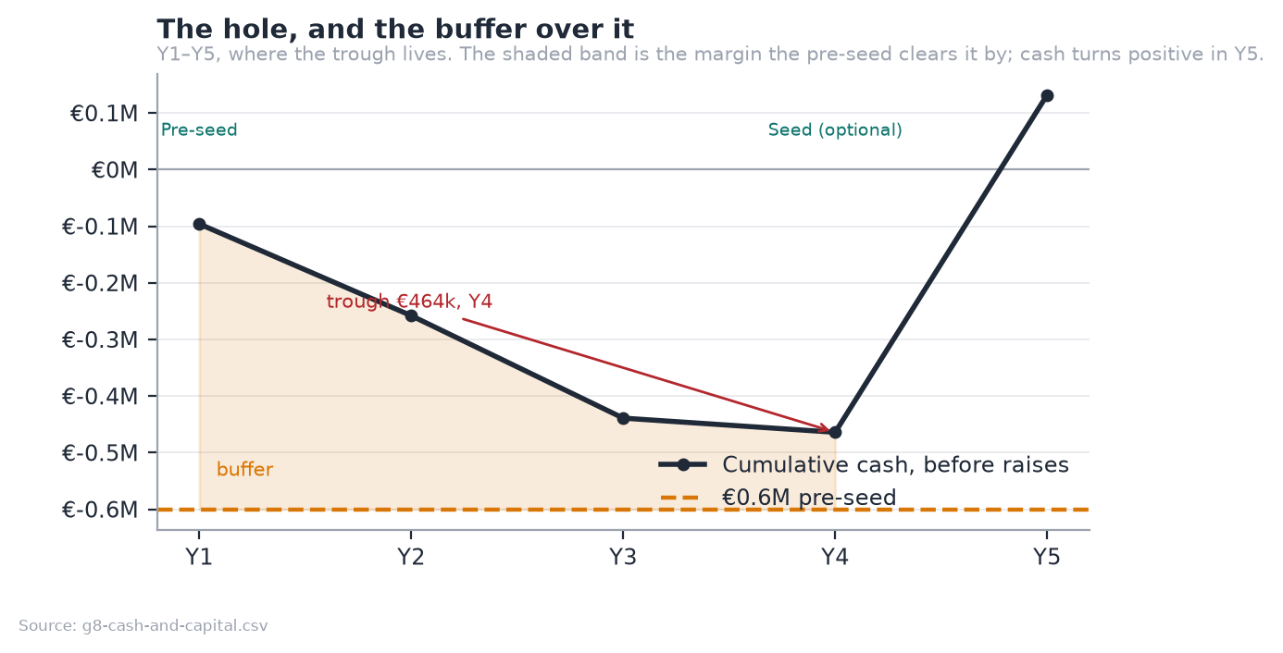
Figure 10: The hole, and the buffer over it. Y1 to Y5, where the trough lives.
The deepest the cash ever goes is €464k, in Y4. A €600k pre-seed covers that with €136k to spare, and free cash flow turns positive in Y5.
Stage | Amount | Pre-money | Gate
Internal | €80k + time |  | Product exists ✓
Pre-seed | €600k | €2.5M | 400 athletes · €10k MRR · anchor athlete public · payments live · 3 months fan churn
Seed (optional) | €2.0M | €10M | €80k MRR · churn <8%/mo · CAC payback <9mo · 2nd market
Series A | €8.0M | €40M | €300k MRR · NRR >110% · sponsorship >25% of revenue

The seed is a growth option, not a survival requirement
Because the pre-seed clears the trough, the honest answer to "what happens if the next round does not come?" is "we grow more slowly", not "we die". That is a materially stronger position to raise from.
Non-dilutive capital first. A realistic ENISA and CDTI Neotec stack of €300–500k covers most of the €464k trough on its own. The Ley de Startups 15% rate is already in the model and is worth €1.57M across Y6–Y9.
Dilution. The founder holds 79% after the pre-seed and 2% advisory grant, 66% after the seed, 55% after the Series A, and ~49% after the 10% ESOP.

7.6 Break-even and sensitivity
Break-even is Y5 on EBITDA and Y5 on free cash flow. The single most sensitive input is fan churn.
Each scenario below is the whole model re-run against changed drivers, not an adjustment applied to the base result. The three levers are the plan's own stated uncertainties: how many fans an athlete converts, what share of athletes monetise at all, and whether niche-sport churn really beats benchmark. Capital need is the cash trough plus the same 40% buffer used in §3.4, so the base column reproduces the headline ask rather than a second number meaning something subtly different.
Scenario | Change vs base | Y7 revenue | Y7 EBITDA | Cash trough | Capital need
Pessimistic | Fans/athlete −30%, monetise −25%, niche churn at benchmark | €8.45M | €1.97M | €865k | €1.21M
Base | As modelled | €10.70M | €3.12M | €464k | €649k
Optimistic | Fans/athlete +25%, monetise +20% | €12.59M | €4.08M | €347k | €485k

The downside is survivable and the upside is unspectacular, which is the honest shape of this business. Losing a third of the fan thesis costs 21% of Y7 revenue and roughly doubles the capital requirement, to €1.21M against a €600k raise. That is a bridge round, not an extinction event. The optimistic case adds 18% to revenue, because the constraint is athlete supply rather than fan yield, and no fan assumption relieves it.
All three hold market count constant. Opening a second market earlier is a real upside the model does not price, and it is deliberately excluded here: it needs capital the plan has not raised, and a sensitivity table is the wrong place to argue for it. That case is §10.
The pessimistic case now carries the risk the model used to hide
The plan assumes niche fans churn 45% slower than benchmark, and that assumption is the single largest source of value in it. At benchmark churn, holding the same Y10 fan base needs 0.79M gross adds a year instead of 0.64M, a quarter more acquisition every year, forever. Because the model charges nothing for fan acquisition, that burden still does not appear as a cost anywhere in the P&L. The pessimistic column above removes the churn advantage entirely, which is why it is the column to read first.

7.7 Valuation
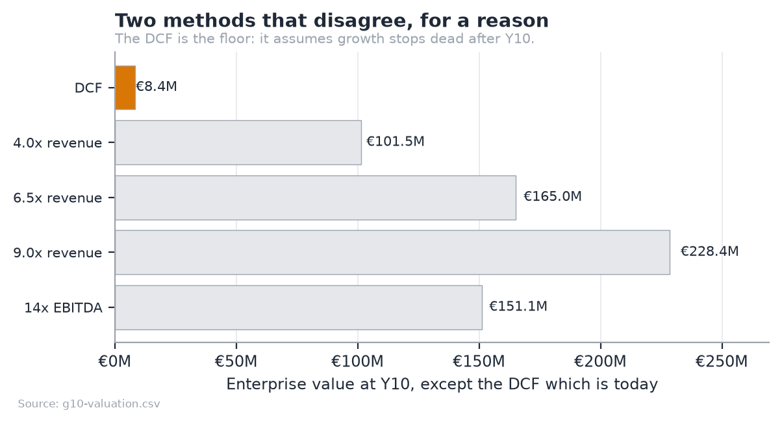
Figure 11: Two methods that disagree, for a reason.
The DCF says €8.37M today; the blended exit multiple says €165.0M at Y10. This is not an error in either; it is the standard failure of a perpetuity-growth DCF applied to a company that has not finished growing. The terminal value assumes growth collapses to 3% the day after Y10, from a year that still grew 27%.
Defensible headline: €11–25M enterprise value, the Y10 exit multiples discounted back at the same 25% WACC, with an €8.37M floor under a no-growth-after-Y10 assumption.

8. Legal aspects and intellectual property
ESADE outline §10. The growth strategy that used to sit here is now its own section: see [10](16-growth-strategy.md), which the outline separates and which an examiner grades separately. The regulatory analysis (VAT, GDPR, the age model and sponsorship rules) is in [§8 of the full plan](stride-business-plan-draft.md) and is not repeated here. This section covers the corporate and intellectual property questions the full plan does not.

8.1 Legal form and structure

The choice: Sociedad Limitada (S.L.)
Form | Minimum capital | Fit
Sociedad Limitada (S.L.) | €1 since Ley 18/2022, Crea y Crece | Chosen. Standard for Spanish venture-backed startups; investors expect it
Sociedad Anónima (S.A.) | €60,000, 25% paid up | Rejected. Capital requirement and formality serve no purpose pre-Series A
Autónomo (sole trader) |  | Rejected. No limited liability; cannot issue shares, so cannot raise
Foreign holding (Delaware, Estonia) |  | Rejected for now. See below

Why S.L. Limited liability, share issuance for the pre-seed, and eligibility for the Ley 28/2022, Ley de Startups regime, which is a separate statute from the one that cut the capital floor (15% corporate tax for the first four taxable years, worth €1.57M across Y6–Y9 in the model), and eligibility for ENISA participative loans and CDTI Neotec grants, which are the non-dilutive stack in 04.
Why not a foreign holding company yet. A Delaware or Dutch holding above a Spanish operating company is the standard structure if US venture capital leads a round. Doing it now would forfeit the Ley de Startups rate and the Spanish grant eligibility, for an outcome that may never happen. The decision point is the Series A, and the structure is designed to be flippable: a clean cap table with one share class and no convertible instruments makes a later reorganisation mechanical rather than fraught.

Capital structure
- One class of ordinary shares through the pre-seed. No preference stacking, no convertible notes, no SAFEs, an S.L. handles them badly under Spanish law and they complicate the very reorganisation above.
- Founder vesting: four years, one-year cliff, applied to the founder's own shares. Unusual to self-impose, and exactly what a pre-seed investor will ask for.
- ESOP to 10% by the Series A, via a Spanish plan de incentivos. Note the friction honestly: Spain has no equivalent of a US-style option pool held at the company, so the pool is contractual and its tax treatment for employees is less favourable than in the UK or US. The Ley de Startups improved this (deferred taxation and a €50,000 annual exemption) but did not eliminate it.

Registration and compliance calendar
Item | When
Name reservation (denominación social), notarial deed, Registro Mercantil | Pre-raise
NIF, IAE registration, social security as employer | At incorporation
Startup certification with ENISA (for the Ley de Startups regime) | Immediately after incorporation
Quarterly VAT (Modelo 303), OSS registration for cross-border B2C | From first fan revenue
DPO appointment (fractional) | Y3

8.2 Intellectual and industrial property
The honest position first: the defensibility of this business is not its patents. There are none, and there will not be. It is the data position, the athlete relationships, and the accumulated scoring history. The IP work below protects the surface, not the substance.

What we own and how it is protected
Asset | Protection | Status
Marketability scoring engine, admission gate, matching algorithm | Trade secret + copyright in the source | Held. The repository is currently public for academic assessment; it goes private before commercial launch
"Stride" word mark | EU trade mark (EUIPO), Nice classes 9, 35, 41, 42 | To file. €850 for the first class, €50 for the second, €150 for each beyond it, €1,200 for four
Domain and handles | Registration | To secure alongside the mark
Athlete engagement database | Sui generis database right (Directive 96/9/EC) | Arises automatically from substantial investment in obtaining and verifying the data. This is the most valuable and least discussed protection we have
Platform content (athlete posts, media) | Licensed from athletes, not owned | Terms grant a limited licence to host, display and promote; the athlete retains ownership
Sponsor campaign data | Contractual confidentiality | Per-deal terms

The name needs clearing before it needs filing
"Stride" is a common English word in an active sector; there are existing marks in apparel and in fitness software. A clearance search across classes 9, 35, 41 and 42 in the EUIPO register comes before any brand spend, and a rebrand is far cheaper now than after the anchor athlete launch. This is flagged as an open item, not a solved one.

IP ownership hygiene
- Assignment clauses in every employment and contractor agreement. Under Spanish law, employee-created works generally vest in the employer, but contractor-created works do not by default. Every contractor agreement assigns explicitly.
- Open-source compliance. The stack is permissively licensed (MIT/Apache/BSD). No copyleft dependency ships in the served product. This is checked, not assumed.
- No third-party data scraped. All platform analytics arrive through authenticated, athlete-consented API connections. That is a product decision with a legal dividend: there is no scraping exposure and no terms-of-service breach in the data position.

9. Critical risks and contingency plans
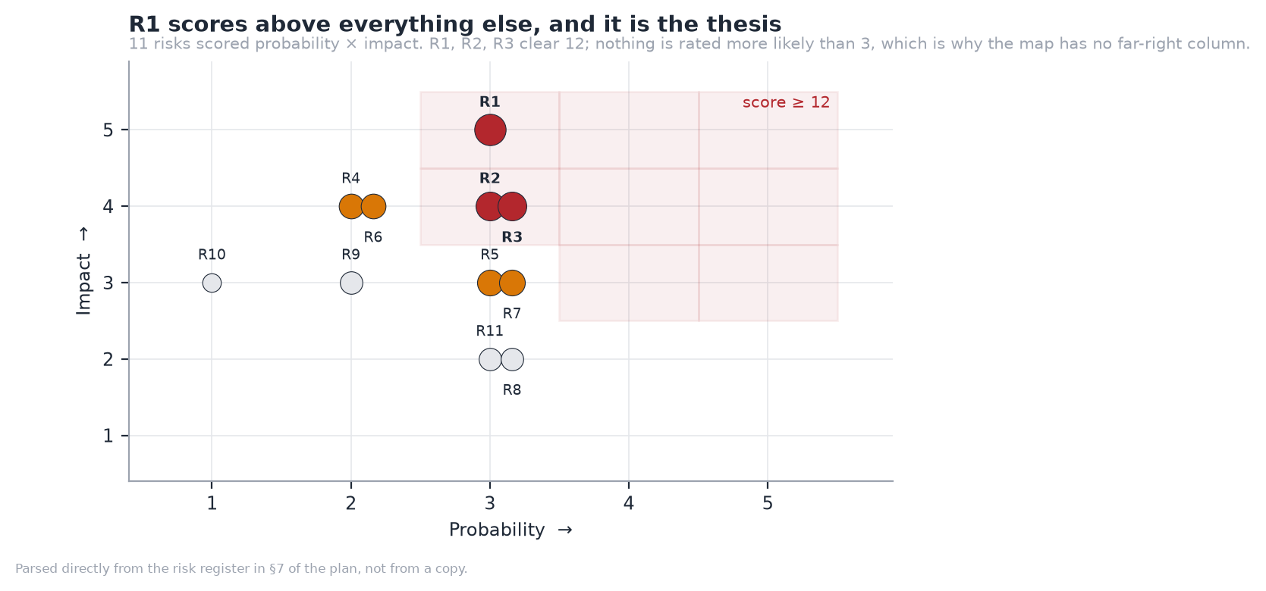
Figure 12: The risk map, parsed from the register itself.
Eleven risks scored probability × impact, both 1–5. Three clear a score of 12, and nothing is rated more likely than 3.
# | Risk | Score | Contingency
R1 | Fans do not pay for niche athletes, the thesis fails | 15 | P1 is built specifically to test this for €80k, not €2.6M. If false, the sponsorship marketplace remains a smaller, viable business
R2 | Churn is at benchmark, not 45% better | 12 | Measure early, on one athlete, before the seed. The model understates this
R3 | Athlete acquisition slower than modelled | 12 | Club and federation channels are multiplicative: one conversation is 20–40 athletes
R5 | Regulatory: DAC7, age assurance, startup law changes | 9 | Compliance built in; DAC7 reporting is a data export, not a rebuild
R7 | Moderation and content liability | 9 | Human review queue exists; prohibit adult content in the terms from day one
R4 | A funded competitor enters the niche | 8 | Data and liquidity are the moat, not the code
R6 | Payment costs rise or Stripe terms change | 8 | Multi-PSP architecture from P0; the take rate has corridor headroom

One risk sits above all the others and it is the thesis itself. A risk map that is evenly scattered has not identified which risk is the real one. Full register, with mitigations, in Appendix G.

10. Growth and business development strategy
ESADE outline §12. Sequenced from the same model that produces the financial plan: each trigger below is a figure the plan already commits to, not a milestone invented for this section.

Growth is sequenced along four axes. Market and segment are the two that are gated: the market axis moves one step at a time and only through a funding round, and the segment mix moves only as fast as the evidence that earns it. Product and channel develop continuously alongside both. Y2 opens the club channel and the seed opens Portugal, and those are deliberately different kinds of move.

10.1 Axis 1: Market
Stage | Markets | Trigger to move
Pre-seed | Spain only
Seed | +1 market (Portugal) | 3 months of fan churn data; €80k recurring MRR
Series A | +3–4 markets (Italy first), EU-wide | Unit economics stable across 3 markets
Y8+ | Selective non-EU | Regulatory review per market

The second market is chosen for sport-mix similarity, not size: the sport index in 08 scores 714 country × sport pairs, and the right second market is the one whose niche-sport profile most resembles Spain's, so the admission model and the scoring weights transfer without recalibration.

10.2 Axis 2: Segment
The plan starts in niche sports and does not stay there. The athlete mix moves from 95% niche in Y1 to 41% by Y10, crossing half in Y6.
 | Y1 | Y3 | Y5 | Y7 | Y10
Niche share of athletes | 95% | 80% | 58% | 45% | 41%
Weighted athlete CAC | €17 | €27 | €44 | €57 | €67

Why it starts there. Niche sports have no agent layer, so there is no incumbent relationship to displace and the athlete's alternative is nothing rather than someone taking 10 to 20%. That shows up in the numbers as a lower acquisition cost (€16 against €40 in Y1) and a higher share of athletes who monetise at all (28% against 14%). Entering a popular sport first would mean paying more to acquire athletes who convert worse, in order to compete with agents who already know them.
Why it moves. A popular-sport athlete has an agent and does not need market creation; what would persuade them is evidence that the matching engine prices them better than a relationship does. That evidence does not exist on day one. It is produced by the niche side: completed deals, measured delivery, and a scoring model trained on real outcomes. The mix shifts because the company earns the right to compete for athletes it could not have won earlier, which is the same compounding argument the channel axis rests on below.
What it costs. Weighted athlete acquisition cost rises from €17 to €67, almost four times, and none of that is inflation or inefficiency. It is the mix. The plan's blended CAC therefore rises over time where a normal software plan would show it falling, and 02 reports it that way rather than presenting an average that hides which segment the money went to.
This is a decision, not a drift. niche_share is an input to the model, not an output of it, so the trajectory above is chosen and can be argued with. Holding the mix at Y1 levels is a different plan: smaller, cheaper to acquire into, and capped by how many niche athletes exist.

10.3 Axis 3: Product
Fan monetisation deepens before sponsorship widens. The sequence is in 5.11: tiers and billing, then one-off unlocks, then video, then events and the club revenue split.

10.4 Axis 4: Channel
Channel | Role | When
Direct athlete acquisition | The base. Community-led, sport by sport | Y1
Club partnerships | The compounding one. A club brings a roster, not an athlete, and clubs have a reason to care about their athletes' income | Y2
Federation relationships | Credibility and licence data at national scale | Y3
Sponsor self-serve | Lowers the cost of the long-tail sponsor | Y4
Managed services / agency | Higher take, higher touch, for the largest campaigns | Y6

The club channel is the growth strategy, not a channel within it
A single club with 40 athletes replaces 40 individual acquisitions, and it arrives with the verification problem already solved, the club vouches for its own roster. That is why club nomination exists in the admission model, and why the B2B2C motion is where the plan expects operating leverage to come from after Y3.

10.5 What we will not do
Stated because growth plans are judged as much by their exclusions:
- No expansion into popular-sport representation. That is the agents' business, and competing there means competing on relationships we do not have.
- No paid social acquisition of fans. Fans are acquired by athletes, not by us. The model does not spend on fan acquisition, which is disclosed as understating the risk rather than presented as efficiency.
- No white-label of the analytics engine. It is the moat; licensing it to a federation or an agency would rent out the one thing that is hard to copy.

10.6 Long-term options
The plan is built to reach profitability without an exit, which is what makes the options real rather than hopeful:
- Independent operation. EBITDA-positive in Y5, €10.8M EBITDA by Y10.
- Strategic acquisition. The natural acquirers are creator platforms buying a vertical, sports-data companies buying a consumer surface, or a sponsorship agency buying disintermediation before it happens to them.
- Financial exit. The valuation range and the reasoning behind it are in 04.
No exit assumption is baked into the financial model. The valuation section presents the DCF as the conservative floor precisely so that the plan does not depend on one.

11. Conclusions
The opportunity is real and it is structural. In sports without an agent layer, there is no route from having an audience to earning from it. That is not a pricing failure to be competed away; it is missing infrastructure, confirmed by athletes who earn nothing from audiences they already have and by an expert with a decade inside Olympic broadcasting.
The plan is modest by design, and that is its strength. €600k of pre-seed capital funds a company to profitability in Year 5. The pre-seed clears the worst point in the cash curve on its own, which makes every subsequent round a growth option rather than a rescue. A plan whose survival does not depend on the next round arriving on schedule is a materially stronger one to raise against.
The product is not the risk. It is built, deployed and demonstrable, and every figure in this document is generated by a model that is checked against an independent implementation. The risk is a single assumption, that fans of semi-professional athletes will pay, and the plan is deliberately arranged so that assumption is tested for €80k and one year rather than €2.6M and four.
What would change my mind. If three months of subscription data from an anchor athlete shows fans do not pay, the fan thesis is dead and what remains is a smaller sponsorship marketplace: viable, but a different and less interesting company. That test is the pre-seed gate, and it is a gate precisely because no amount of further engineering, market sizing or interviewing can substitute for it.
The honest summary is that this is a plan with one large uncertainty, arranged so that the uncertainty is cheap to resolve and everything else is already done.

12. Bibliography
Market and industry
- Patreon. Creator retention and annual billing benchmarks. Published creator documentation and blog.
- OnlyFans / Fenix International Ltd. Annual accounts filed at Companies House, used to derive an all-in effective take rate.
- Publicis Groupe. TEKTA launch announcement, 19 August 2026.
- International Olympic Committee. Athlete365 Business Accelerator programme. olympics.com/ioc.
- Eurostat. EU-27 population and sport participation statistics.
Regulatory and tax
- Regulation (EU) 2016/679 (GDPR), Articles 13 and 37.
- Council Directive (EU) 2021/514 (DAC7), platform operator reporting.
- Council Implementing Regulation (EU) 282/2011, Article 9a, deemed supplier.
- Directive 96/9/EC, sui generis database right.
- Ley 28/2022 de fomento del ecosistema de las empresas emergentes (Ley de Startups).
- Regulation (EU) 2022/2065 (Digital Services Act).
Financial method
- Damodaran, A. Investment Valuation, WACC and terminal value method.
- Stripe. Connect and payment processing pricing, published rates.
Primary research
- Cristóbal Losada, Í. AI Lead, olympics.com. Interview.
- Athlete interviews: five athletes, rugby league (Spain and Lebanon) and CrossFit (Lebanon, Asian level).
Project artefacts
- Financial model: Stride_Financial_Model.xlsx, 2,520 formulas.
- Source and model: github.com/jadzoghaib/stride
- Deployed demo: stride-demo.onrender.com

Appendices
The detailed working behind the plan. Every figure in these documents is generated by the financial model and checked by the consistency guard described in Appendix C.

Appendix A: Revenue Model

Why OnlyFans is the right reference, and where the analogy stops
OnlyFans' insight was not adult content. It was that a creator with 1,000 real fans earns more from 1,000 subscriptions than from 10 million ad impressions. Ad-share pays for attention; subscription pays for relationship.
Platform | Creator keeps | Model | Median creator outcome
YouTube | ~55% | Ad share on views | Needs ~1M views/mo to matter
Instagram | ~0% direct | Brand deals only | Nothing without a brand deal
Twitch | ~50% | Subs + ads | Needs live-hours scale
Patreon | ~88–92% | Subscription | Works at small scale
OnlyFans | 80% | Subs + PPV + tips | Works at very small scale
Stride (proposed) | 85% | Subs + unlocks + tips + sponsorship | Works at small scale, plus a second payer

Where the analogy holds: recurring subscription, creator-set pricing, direct relationship, power-law outcomes, one-off unlocks and tips on top of the base.
Where it stops, in ways that matter:
Difference | Consequence for Stride
Athlete content is brand-safe | Better card-scheme terms, no high-risk processor premium, sponsors will co-exist with it
Athletes have a second payer (sponsors) | Two revenue engines from one audience, OnlyFans has one
Performance is objectively measured | The analytics engine is a real moat; "audience quality" is provable, not asserted
Athletes are often minors | A safeguarding obligation OnlyFans solved by banning under-18s outright
Careers are seasonal | Subscription revenue smooths what sponsorship spikes
Clubs exist | A B2B2C distribution channel: sign a club, acquire a roster

The eight revenue streams
# | Stream | Payer | Mechanism | Take | Built?
1 | Fan subscriptions | Fan | Recurring monthly tier, athlete sets price | 15% | ✗
2 | Content unlocks (PPV) | Fan | One-off purchase of a post or video | 15% | ✗
3 | Tips | Fan | Voluntary, often around results | 15% | ✗
4 | Sponsorship deals | Sponsor | Take on deal value | 10% | ◐ records only
5 | Club packages | Sponsor | Take on package value | 10% | ◐ records only
6 | Scout SaaS | Sponsor | Monthly seat/plan for matching + evidence | 100% | ◐ features exist, no billing
7 | Managed matchmaking | Sponsor | Done-for-you campaign, fee or higher take | 100% | ✗
8 | Market intelligence | Brand / agency | Aggregate reports on athlete audience economics | 100% | ✗

Streams 1–3 are the OnlyFans core. 4–6 are the reason this is not just OnlyFans for sport. 7–8 are later-stage margin, deliberately excluded from the base model so the plan does not depend on them.

Fan tiers
Athletes set their own price; Stride supplies defaults that steer away from the uneconomic bottom end (see 02).
Tier | Suggested | What the fan gets | Why an athlete offers it
Supporter | €4.99 | Training log, results before the feed, supporter badge | Volume tier, low effort
Insider | €9.99 | Behind-the-scenes video, session breakdowns, monthly Q&A | The default: best margin per effort
Inner circle | €24.99 | Direct messaging, personalised video, early merch | Small cohort, high ARPU
Season pass | €89/yr | Insider for a competitive season | One payment fee instead of twelve

Recommendation: suggest €9.99 as the anchor and make €4.99 opt-in rather than default. The €4.99 tier retains 44% of our take after payment costs; €9.99 retains 64%. The same content at double the price is not twice as hard to sell when the buyer is a fan of a specific athlete.
Annual billing is worth more than a take-rate increase. A €89 season pass carries one €0.25 fixed fee instead of twelve, worth ~€2.75/fan/year, against €13.35 of total take. Pushing 30% of subscribers annual is roughly equivalent to raising the take rate by a point, without asking athletes for anything.

Sponsor plans
Plan | Price | Includes | Target
Scout Free | €0 | Public directory, 1 campaign, top-5 matches | Trial, inbound
Scout Starter | €99/mo | Full matching, 2 campaigns, no evidence views | First paid step, single-brand sponsors
Scout Pro | €249/mo | Full matching, evidence views, 5 campaigns, pipeline | Regional brands, small agencies
Scout Agency | €999/mo | Unlimited campaigns, multi-seat, API, saved searches | Agencies, national brands

Why an entry tier exists, and why it is €99. In Y1 the average sponsor runs about €1,073 of deals through the platform, so the 10% commission on them is roughly €107. Scout Pro at €2,988 a year is twenty-eight times that. A sponsor is being asked to multiply their total spend with us by a large factor to buy software, at exactly the point when the directory is thinnest and the software is worth least. €99 a month is credible against that; €249 is not. The ratio only reaches parity around Y7, when the average sponsor runs €19,848 of deals and the commission alone is €1,985.
This is what the ARPU path has always assumed. Blended revenue per paying sponsor runs €199 in Y1 to €475 by Y10, and the early figures sit below the old cheapest plan, which no mix of €249 and €999 can produce. With Starter in the list the series resolves, and it describes a ladder rather than a mystery:
 | Y1 | Y2 | Y3 | Y7 | Y10
Blended ARPU per month | €199 | €229 | €260 | €400 | €475
Implied mix | 33% Starter, 67% Pro | 13% Starter, 87% Pro | 1% Agency, rest Pro | 20% Agency, rest Pro | 30% Agency, rest Pro

Sponsors enter on Starter, graduate to Pro as they run more campaigns, and the Agency share grows to roughly a third by Y10 as agencies rather than single brands become the larger buyer.
SaaS matters disproportionately: it is 100% margin (no GMV, no payment rail), and it converts the analytics engine into revenue that does not depend on a deal closing. By Y7 it is €1.92M of the €10.70M: 18% of revenue at close to 100% gross margin, which is roughly 26% of gross profit.

Take rate: benchmarked
Headline rates across the platforms an athlete could plausibly choose instead:
Platform | Headline take | Other creator fees | Effective take, small creator | Evidence
Passes | 10% | $0.30/txn + $29/mo creator fee | ~16–25% | Sacra; rebrand release
OnlyFans | 20% |  | 19.5% measured | filed accounts: see below
Fansly | 20% |  | 20% | not published; consistently reported
Fanfix | 20% |  | 20% | not published; consistently reported
Patreon | 10% | none: processing included | 10% | Patreon publishes it
Stride (proposed) | 15% | none: we absorb payment costs | 15% | our decision

OnlyFans' 20% is not a reported figure; it is arithmetic on filed accounts. OnlyFans' parent, Fenix International Limited, company no. 10354575, files publicly at Companies House. FY2024 (to 30 November 2024): $7.22bn of gross fan payments, of which $1.41bn was retained as OnlyFans' own revenue and $5.8bn paid out to creators. The take is 1.41 / 7.22 = 19.5%, measured, not asserted, in a document that will still be there in five years.
The two sides do not tie to exactly 100% (19.5% + 80.3% = 99.8%), and that is worth saying rather than rounding away: net revenue and creator payouts are separate lines in a set of accounts, not two halves of one split. The headline "80/20" is the company's description of its own pricing; 19.5% is what the money actually did. We use 20%, because that is the rate a creator is quoted.
Patreon's row was wrong and is now corrected. It read 8–12% by plan tier with payment fees passed to the creator, for an effective 12–15%. Patreon has since moved to a single published rate: 10% of what you earn, which it states includes "payment processing, currency conversion, and payout fees". So Patreon is materially cheaper than this document previously claimed. It ties Passes on the headline: both say 10%, but Passes adds $0.30 a transaction and $29 a month, so on all-in cost Patreon is the cheapest option in this table, cheaper than what we are proposing. That is worth stating plainly rather than leaving it to be discovered. It does not undo the Passes argument below, because Patreon is a membership tool rather than an athlete product and its 10% buys none of the sponsorship-side machinery, but the table should not have been flattering us, and it was.
Fansly and Fanfix do not publish a rate at all. Checked 2026-09-05: Fanfix's Creator Terms of Use and its public FAQ state no percentage, and Fansly's terms render client-side with nothing in the document. Both are private companies with no filings to derive it from. 20% is what every secondary source reports and what they charge in-app, but it is an estimate, and it is marked as one.
And the middlemen the athlete is paying on top of the platform:
Intermediary | Takes | Where the number comes from
Sports agent, endorsement deal | 10–20% | unregulated: no governing body caps it
Sports agent, playing contract | 2–5% | capped, and the caps are published
OnlyFans management agency | 20–50% of net, on top of the platform's 20% | agency rate guides

The playing-contract row used to read 4–10% on the authority of a blog that has since been deleted. The bodies that actually set these caps publish them: the NBPA regulations (amended September 2025) allow 2% where the player earns the CBA minimum and 4% above it, and FIFA's Football Agent Regulations, article 15 allow 5% at or below USD 200,000 of annual remuneration and 3% above, for representing the player. (FIFA's cap was suspended during litigation; the CJEU [upheld it on 16 July 2026](https://inside.fifa.com/news/welcomes-court-of-justice-european-union-decision-football-agent-regulations) and it takes effect with the new transfer system on 1 January 2027.)
The gap between those two rows is the point, and it is structural. The NBPA regulations do not contain the word "endorsement" once: unions cap what an agent may charge for negotiating a playing contract, and leave marketing work uncapped. That is why endorsement representation costs an athlete several times what a union permits on their salary, and endorsement is exactly the work Stride's 15% replaces.

Why 15% beats Passes' 10% for the athletes we serve
Passes is the closest competitor and looks cheaper. It is not, for the long tail, because its $29/month creator fee is regressive, a fixed cost is brutal on a small creator and trivial on a large one.
An athlete earning R per month across N transactions keeps:
Stride 0.85 × R (nothing else deducted)
Passes 0.90 × R − €0.28×N − €27 (per-transaction + monthly fee)
At an average ticket of €9.20 those cross at €1,380/month of fan revenue (27 / (0.05 − 0.28/9.20)).
Athlete's monthly fan revenue | Keeps with Stride (15%) | Keeps with Passes (10% + fees) | Better off with
€100 | €85 | €60 | Stride, by 42%
€313 (modelled niche athlete, Y7) | €266 | €245 | Stride, by 9%
€500 | €425 | €408 | Stride
€1,000 | €850 | €843 | Stride, barely
€1,380 | €1,173 | €1,173 | crossover
€2,000 | €1,700 | €1,712 | Passes
€5,000 | €4,250 | €4,321 | Passes

Below €1,380/month, Stride's 15% pays the athlete more than Passes' 10%. Our modelled niche athlete at maturity earns ~€313/month, comfortably on the left of that line, and the entire long tail with them. The athletes on the right are the ones who already have an agent.
Note what the crossover means for our own economics: the athletes for whom Stride is the better deal are also the ones whose revenue Passes' pricing is not designed to capture. We are not undercutting a competitor on the same customer; we are pricing for a customer they have chosen not to serve.
This is not a pricing trick; it is the opposite bet from Passes. Their pricing is optimised for creators who are already big. Ours is optimised for creators who are not. That is the same bet as serving niche sports, and the two decisions have to agree with each other.

The lever, quantified
At Y7 each point of take on fan GMV is worth €0.32M of revenue. It is the single biggest lever in the model, and it now has a real number at both ends rather than one:
Take | Y7 revenue | Y7 EBITDA | Against
20% | €12.31M | €4.59M | OnlyFans' rate, derived from filed accounts
15% | €10.70M | €3.11M | our proposal
10% | €9.10M | €1.64M | Patreon's published, all-in rate

Read the bottom row before the top one. Matching Patreon costs €1.60M of Y7 revenue and €1.48M of EBITDA: EBITDA falls 47%, from €3.11M to €1.64M. The same five points that look like upside going up are what a price war costs going down, and the downside lands harder because the cost base does not shrink with the take.
📊 GRAPH G9: the corridor, not the sensitivity
Chart · Three grouped columns, revenue and EBITDA at 10%, 15%, 20%, with the 15% pair highlighted and the other two labelled by the competitor they represent, not by the percentage alone. A sensitivity table nobody reads becomes a picture of where we sit between two real companies. Data · attachments/chart-data/g9-take-rate-corridor.csv Must say · The downside is steeper than the upside. Five points up adds €1.6M of revenue; five points down costs €1.6M of revenue and 47% of EBITDA, because the cost base does not shrink with the take. Draw the EBITDA series so that asymmetry is the thing the eye lands on.
Recommendation: hold 15%, and never add a monthly creator fee. But hold it for the right reason. The Passes argument below: that 10% plus $0.30 a transaction plus $29 a month is worse than a flat 15% for any athlete earning under €1,380 a month: is arithmetic, and it survives. It does not cover Patreon, whose 10% carries no fee at all and is genuinely cheaper for everyone. Against Patreon the argument has to be that the 15% buys something Patreon does not sell: the sponsorship side, the score a brand will price against, the admission gate that makes the roster mean something. If an athlete only wants a paywall, Patreon is cheaper and we should expect to lose that athlete. Revisit the percentage at Series A, when the network, not the price: is the reason to stay.
Sources: [Passes fee structure (Sacra)](https://sacra.com/c/passes/) · [Passes 10% confirmed at 2026 rebrand](https://www.prnewswire.com/news-releases/passes-rebrands-as-the-creator-accelerator-platform-302749690.html) · [NBPA agent fee cap, amended Sept 2025](https://imgix.cosmicjs.com/cd844850-97c7-11f0-91fa-d9e1671c2776-NBPA-REGULATIONS-GOVERNING-PLAYER-AGENTS-09-2025.pdf) · [FIFA Football Agent Regulations, art. 15](https://digitalhub.fifa.com/m/1e7b741fa0fae779/original/FIFA-Football-Agent-Regulations.pdf) · [CJEU upholds the FIFA cap, 16 Jul 2026](https://inside.fifa.com/news/welcomes-court-of-justice-european-union-decision-football-agent-regulations) · [OnlyFans agency commissions 20–50%](https://arunatalent.com/blog/onlyfans-agency-commission-rates/) · [Fanfix Creator Terms of Use](https://auth.fanfix.io/creator-terms-of-use), cited for what it does not* say
On the platform rates in the first table. They split three ways once actually chased down, and this note used to say flatly that none of them could be sourced. That was true of half of them. Patreon publishes its rate outright. OnlyFans does not, but its parent files accounts, so the 20% is recoverable as arithmetic rather than taken on trust. Fansly and Fanfix publish nothing and file nothing: checked 2026-09-05, Fanfix's Creator Terms and public FAQ state no percentage and Fansly's terms render client-side with nothing in the document, so those two stay at the reported 20% and stay marked as estimates.
What does not depend on any of this: the recommendation to hold 15%. It rests on the Passes comparison: Sacra plus the rebrand release, both live and both primary, and on the crossover arithmetic, which is computed from the model rather than cited.*

Revenue mix over time
 | Y1 | Y3 | Y5 | Y7
Fan take | €21k (84%) | €322k (60%) | €1.69M (49%) | €4.81M (45%)
Sponsorship take | €3k (11%) | €91k (17%) | €1.04M (30%) | €3.97M (37%)
Sponsor SaaS | €1k (5%) | €122k (23%) | €0.69M (20%) | €1.92M (18%)
Total | €25k | €0.53M | €3.43M | €10.70M

The mix shifts deliberately. Fans fund the early years because they can be acquired at near-zero cost: athletes bring their own audience. Sponsorship grows into it as the athlete pool becomes large enough that matching is genuinely useful, which is when the analytics moat starts to pay.

The cold-start problem, and the answer
A two-sided marketplace with a third side is three cold starts. The sequence that avoids all three at once:
- One anchor athlete brings fans on day one. Fan revenue needs no sponsors.
- Their club brings a roster: ten to thirty athletes without ten to thirty sales conversations.
- Sponsors arrive when the pool is measurable, not when it is large. Fifty athletes with real analytics beat five hundred unmeasured ones.
This is why the athlete partnership in 04 is a structural decision, not a marketing one.

Appendix B: Cost Model
Two costs decide whether this business works. Neither is engineering salary.

The fixed-fee problem
Stripe charges a Spanish entity 1.5% + €0.25 on EEA cards, 2.5% on UK cards and 3.25% on non-EEA: blended to 1.9% + €0.25 here. On small subscriptions the fixed component is most of the cost, and it lands on our commission, not on the athlete's share.
Fan pays (monthly) | Our take (15%) | Payment cost | We keep | % of take retained
€4.99 | €0.62 | €0.34 | €0.27 | 44%
€9.99 | €1.24 | €0.44 | €0.80 | 64%
€24.99 | €3.10 | €0.72 | €2.37 | 77%
€89.00 (annual) | €11.03 | €1.94 | €9.09 | 82%

Read that first row again. At a €4.99 tier, nearly half our commission goes to the payment processor: almost all of it the fixed €0.25, not the percentage. The tier floor matters more than any rate negotiation.
Three responses, in order of impact:
- Anchor the default tier at €9.99. Costs nothing, worth 20 points of retained take: 44% survives the fee at €4.99 against 64% at €9.99.
- Push annual billing. One fixed fee instead of twelve, worth ~€2.75 per subscriber per year. Patreon reports annual patrons churn at one third the rate of monthly ones, so the retention gain is larger than the fee saving.
- Renegotiate at volume. Above ~€5M/yr processed, interchange-plus pricing is available. Not modelled: upside.
At Y7 the payment rail costs €2.55M against €10.70M of revenue, 24% of revenue, our largest single cost line, larger than all salaries combined (€1.54M). The share rose when VAT entered the model: the processor charges on the price a fan pays, while the revenue it is measured against is net of the VAT that price includes.

The egress trap
docs/costs.md states, correctly, that the current architecture has near-zero marginal compute cost: marketability scoring is deterministic formulas, not model inference. That property does not survive the pivot to paid content.
Video served to paying fans is bandwidth, and bandwidth is where cloud providers price aggressively.
 | Y1 | Y3 | Y5 | Y7
AWS + zero-egress CDN | €2k | €28k | €149k | €336k
AWS + CloudFront list price | €4k | €56k | €290k | €738k
Annual difference | €2k | €27k | €142k | €402k

At 1.8 GB per paying fan per month and an average of 278k paying fans through the year, Y7 moves ~6.0 PB. At CloudFront list (~€0.075/GB after volume tiers) the bandwidth alone is €450k; behind an object store with free egress (Cloudflare R2, Backblaze B2 + Bunny) the same bytes cost €48k. The table rows above are larger than both because they add the €288k of AWS compute and storage that neither choice avoids: it is the difference between the rows, not the rows themselves, that the egress decision moves.
Average fans, not December's
Bandwidth is billed for the months a fan is actually subscribed, so the driver is the average count through the year, not the year-end one. The model charged twelve months at the December figure until this was corrected, which overstated infrastructure in every year of the plan, the same error its own cohort model documents on the revenue side and had already fixed there.
€402k a year is most of this plan's entire €464k cash trough, spent annually and decided by one architectural choice, €3.1M across the ten years.
The recommendation is AWS for compute and database, where its managed services genuinely earn their premium, and a zero-egress provider for media delivery. Hybrid, deliberately.

AWS build-up
Compute and data stay on AWS. The plan below is what the current architecture maps onto (infra/k8s/stride.yaml already describes this shape).

Stage 1: Y1–Y2 (validation → launch, ≤ 10k MAU)
Service | Configuration | Monthly
ECS Fargate (API) | 2 tasks × 0.5 vCPU / 1 GB | €35
RDS Postgres | db.t4g.small, Multi-AZ off, 20 GB gp3 | €45
ElastiCache Redis | cache.t4g.micro (rate limits, sessions) | €13
S3 | 200 GB media + snapshots | €5
CloudFront / R2 | low volume | €10
Route 53, ACM, Secrets Manager |  | €8
CloudWatch | logs + metrics, 30-day retention | €25
SES | transactional email | €5
Total |  | ≈ €146–650/mo

Stage 2: Y3–Y5 (growth, ≤ 250k MAU)
Service | Configuration | Monthly
ECS Fargate | 4–10 tasks, autoscaled | €280
RDS Postgres | db.r6g.large Multi-AZ + read replica | €520
ElastiCache | cache.r6g.large | €160
S3 | 20–80 TB media, lifecycle to IA | €420
Media delivery | zero-egress CDN | €650
MediaConvert | transcoding on upload | €180
CloudWatch + X-Ray |  | €140
WAF + Shield Standard |  | €60
Total |  | €2,100–11,000/mo

Stage 3: Y6–Y7 (scale)
Service | Monthly
EKS (control plane + nodes), API + workers | €4,200
Aurora Postgres, writer + 2 readers | €3,100
ElastiCache cluster | €700
S3 (300+ TB, tiered) | €4,800
Media delivery (zero-egress) | €5,600
MediaConvert | €2,400
Observability | €1,900
WAF, Shield Advanced, backup, DR | €1,300
Total | ≈ €24,000/mo

Reserved capacity and Savings Plans are not modelled. Committing to 1-year compute typically saves 25–40% on the Fargate/EKS/RDS lines, worth roughly €60–90k/yr by Y7. Treated as upside, not as plan.

People (Spain)
Spanish employer social security adds ~30–32% on top of gross salary. Every figure below is loaded cost.
Role | Gross | Loaded | First hired
Founder / CEO | €0 → €45k | €0 → €59k | Y1 (unpaid: see opportunity cost)
Senior engineer | €55k | €72k | Y2
BD / partnerships | €38k + commission | €50k+ | Y2
Athlete success | €30k | €39k | Y3
Content moderation lead | €34k | €45k | Y3
Finance / ops | €42k | €55k | Y4
DPO (fractional → hired) | €18k → €60k | €18k → €79k | Y3 fractional, Y5 hired

 | Y1 | Y2 | Y3 | Y4 | Y5 | Y6 | Y7
Headcount (FTE) | 1.5 | 2.0 | 3.5 | 6.0 | 10.0 | 15.0 | 22.0
People cost | €57k | €104k | €210k | €384k | €660k | €1.02M | €1.54M

Spain is a structural cost advantage. A senior engineer at €72k loaded costs roughly half the equivalent in London or Amsterdam and a third of the Bay Area, against a talent pool that is deep in Barcelona and Madrid. On a €23M-revenue plan that is worth several million euros cumulatively, and it is a legitimate argument to an investor for why the company is in Spain rather than an accident of where the founder studied.

Compliance and moderation
This is the line most creator-platform plans underestimate.
Item | Y1 | Y3 | Y5 | Y7
Legal & compliance | €18k | €90k | €200k | €270k
Moderation (variable) | €1k | €17k | €79k | €165k
Athlete verification (variable) | €0.7k | €9k | €30k | €43k

Legal covers entity formation, policies reviewed by counsel (docs/costs.md budgets €1–5k for the first pass), the DPO function, DAC7 reporting, platform app-review lead time, and an annual security review.
Moderation is modelled at €22 per 1,000 items at 12 items per athlete per month. It is a hybrid: automated classification first, human review on flags. The cost is not the issue: the liability is. Paid content plus a population that includes minors is the combination that has ended platforms, usually via card schemes rather than regulators.
Verification is the same obligation on the supply side: vetting who is on the platform rather than what they post, which is why it sits beside moderation in cost of sales rather than in overhead. It is priced off the funnel the admission gate creates: an athlete is the survivor of several applications, and a share of those applications need a human to open a link (11).
 | Y1 | Y3 | Y5 | Y7 | Y10
Applications behind the athlete plan | 2,000 | 16,563 | 51,958 | 70,820 | 72,199
Manual reviews | 500 | 3,909 | 11,753 | 15,623 | 15,674
Blended admission rate | 20% | 25% | 29% | 31% | 32%
Reviewer FTE implied | 0.02 | 0.15 | 0.46 | 0.61 | 0.61

The euros are not the point and the model says so. Verification peaks at €25k a year and 0.33 of one person, and the whole discounted stream is worth €63k against a €22.5M enterprise value, 0.28%. Two things follow, and they matter more than the line item:
- The admission rate is a real driver of marketing efficiency. It climbs from 20% to 32% purely because club nominations grow as a share of applicants, and a nominated applicant arrives with a verified club's credibility floor behind them. Club partnerships are not just a cheaper channel; they are a higher-yielding one, and the model now shows the difference.
- The reason to automate the check is latency, not labour. An athlete sitting in the queue is not listed, not matchable and not earning. At 0.6 FTE nobody automates to save the salary; you automate so supply goes live the day it applies.

Customer acquisition
 | Athlete | Fan | Sponsor
Y1 CAC | €17 | ~€0 | €900
Y7 CAC | €61 | ~€0 | €1,900
Applications behind one athlete | 5.0x in Y1, 3.3x in Y7
Channel | Clubs, federations, ambassador referral | Brought by the athlete | Outbound, events, agency partnerships

Fan CAC is approximately zero, and that is the whole economic argument for this model. We do not buy the audience, the athlete already has it on Instagram and TikTok. Stride converts an existing following into a paying one. That is why fan revenue can lead in Y1 while sponsorship is still cold.
The corollary: athlete CAC is the only acquisition cost that matters, and club partnerships are the cheapest route to it, one conversation, a whole roster.

Cost structure at maturity (Y7)
Line | Y7 amount | % of revenue
Payment processing | €2.55M | 23.8%
Marketing / CAC | €1.70M | 15.9%
People | €1.54M | 14.4%
Other opex | €856k | 8.0%
Infrastructure | €336k | 3.1%
Legal & compliance | €270k | 2.5%
Payouts | €237k | 2.2%
Moderation | €70k | 0.7%
Athlete verification | €18k | 0.2%
EBITDA | €3.12M | 29.1%

Infrastructure is 3.1% of revenue. Payments are nearly eight times larger. Any optimisation effort belongs there: tier pricing, annual billing, processor negotiation, not in the AWS bill.

Appendix C: Seven-Year Financial Model
Every table here is emitted by `model.py`. Y1 = 2027, EUR.
python business-plan/model.py

Drivers
Driver | Y1 | Y2 | Y3 | Y4 | Y5 | Y6 | Y7 | Y8 | Y9 | Y10
Active athletes | 400 | 1,200 | 3,000 | 6,000 | 10,500 | 16,000 | 22,000 | 28,000 | 34,000 | 40,000
Paying fans | 2,058 | 8,148 | 25,288 | 60,197 | 120,076 | 206,658 | 321,288 | 434,076 | 553,629 | 665,896
Sponsorship deals | 25 | 117 | 485 | 1,549 | 3,767 | 7,376 | 11,563 | 16,258 | 19,895 | 25,539
Paying sponsors (SaaS) | 0 | 8 | 39 | 95 | 180 | 280 | 400 | 520 | 620 | 720
Headcount (FTE) | 1.5 | 2.0 | 3.5 | 6.0 | 10.0 | 15.0 | 22.0 | 28.0 | 33.0 | 38.0

Retention and acquisition
Fans and athletes both churn, and the model runs the decay month by month rather than asserting a year-end stock. Two consequences that a net-stock model cannot show:
Retention & acquisition | Y1 | Y2 | Y3 | Y4 | Y5 | Y6 | Y7 | Y8 | Y9 | Y10
Paying fans, year end | 2,058 | 8,148 | 25,288 | 60,197 | 120,076 | 206,658 | 321,288 | 434,076 | 553,629 | 665,896
Paying fans, average | 1,306 | 5,897 | 18,939 | 47,228 | 97,837 | 174,458 | 277,911 | 391,108 | 507,748 | 622,731
Fans acquired (gross) | 3,298 | 11,704 | 34,885 | 78,554 | 149,732 | 245,280 | 353,875 | 449,346 | 549,558 | 636,796
Fans lost to churn | 1,241 | 5,614 | 17,746 | 43,645 | 89,854 | 158,698 | 239,245 | 336,558 | 430,005 | 524,528
Athletes acquired (gross) | 400 | 909 | 2,094 | 3,690 | 5,796 | 7,671 | 9,200 | 10,224 | 11,278 | 12,229
Athletes lost to churn | 0 | 109 | 294 | 690 | 1,296 | 2,171 | 3,200 | 4,224 | 5,278 | 6,229

Revenue accrues on the average fan count, not the year-end count. Charging twelve months at the December number overstates revenue by roughly a third during fast growth: the previous version of this model did exactly that.
Gross adds dwarf net adds. At 9%/month a cohort retains 32% over a year, so most of next year's fans are replacements for this year's. In Y7 we acquire 354k fans to finish with 321k, having lost 239k. That is the real acquisition machine, and it was invisible until churn was modelled explicitly.

The two segments
The model runs niche and popular as separate cohorts, because they differ in kind rather than in size. Sports are assigned by `sport_index.py`; the strategy is in 06.
Assumption at Y7 | Niche | Popular | Why
Share who monetise fans | 48% | 30% | Niche athletes have no other channel; the need is acute
Paying fans per monetising athlete | 34 | 44 | Popular athletes have far larger followings but convert worse
Fan ARPU / month | €9.20 | €8.00 | Niche fans are participants buying knowledge, not spectators
Share landing a sponsorship deal | 16% | 30% | Sponsors are already active in popular sports
Average deal | €1,700 | €4,000 | The whole reason to enter popular sports
Athlete CAC | €32 | €78 | Displacing an agent costs more than reaching someone with none

Segment | Y1 | Y2 | Y3 | Y4 | Y5 | Y6 | Y7
Niche: athletes | 380 | 1,656 | 4,400 | 8,840 | 14,500 | 19,000 | 23,400
Niche: paying fans | 2,128 | 11,658 | 40,700 | 101,483 | 191,400 | 279,680 | 381,888
Niche: net revenue | €43k | €250k | €912k | €2.37M | €4.64M | €6.96M | €9.68M
Popular: athletes | 20 | 144 | 1,100 | 4,160 | 10,500 | 19,000 | 28,600
Popular: paying fans | 73 | 710 | 7,040 | 33,488 | 103,740 | 218,120 | 377,520
Popular: net revenue | €2k | €22k | €231k | €1.21M | €3.99M | €8.88M | €15.58M
Niche share of athletes | 95% | 92% | 80% | 68% | 58% | 50% | 45%
Niche share of revenue | 95% | 92% | 80% | 66% | 54% | 44% | 38%

Niche funds the company; popular scales it. Niche sports carry 95% of revenue through Y2: the entire period before the first external raise, and fall to 38% by Y7 despite still being 45% of athletes, because popular-sport deals are 2.4× larger. Neither segment alone produces this plan: without niche there is no Y1, and without popular the Y7 number is a third smaller.

How the fan number is built
Paying fans are not a top-down market share. Per segment:
athletes × share who monetise × paying fans per monetising athlete
The defensible input is the last term: 34 paying fans per niche athlete at maturity. A trail runner with 20,000 followers converting 0.17% of them is not heroic: OnlyFans creators routinely convert 1–3% of smaller followings and Patreon's benchmark is ~2%. The model sits an order of magnitude below both, because sport fandom is less parasocial than the categories those platforms serve. In the popular segment it is lower still as a share of following, which is the point of splitting them.

Marketplace volume (GMV)
Marketplace volume | Y1 | Y2 | Y3 | Y4 | Y5 | Y6 | Y7 | Y8 | Y9 | Y10
Fan GMV (subs + unlocks) | €139k | €651k | €2.15M | €5.41M | €11.30M | €20.11M | €32.08M | €45.44M | €59.55M | €73.77M
Sponsorship GMV | €27k | €159k | €908k | €3.62M | €10.40M | €23.01M | €39.70M | €58.95M | €76.01M | €102.13M
Total GMV | €166k | €810k | €3.05M | €9.03M | €21.70M | €43.12M | €71.78M | €104.39M | €135.56M | €175.90M

GMV is the number a marketplace is judged on by investors; net revenue is the number that pays salaries. Both are shown throughout so neither can flatter the other.

Net revenue
Net revenue | Y1 | Y2 | Y3 | Y4 | Y5 | Y6 | Y7 | Y8 | Y9 | Y10
Fan take (15%) | €21k | €98k | €322k | €811k | €1.69M | €3.02M | €4.81M | €6.82M | €8.93M | €11.07M
Sponsorship take (10%) | €3k | €16k | €91k | €362k | €1.04M | €2.30M | €3.97M | €5.89M | €7.60M | €10.21M
Sponsor SaaS | €1k | €21k | €122k | €331k | €691k | €1.21M | €1.92M | €2.68M | €3.39M | €4.10M
Total net revenue | €25k | €134k | €535k | €1.50M | €3.43M | €6.53M | €10.70M | €15.39M | €19.92M | €25.38M

Growth: Y2 +442%, Y3 +298%, Y4 +181%, Y5 +128%, Y6 +90%, Y7 +64%. A decelerating curve that stays above 50% through Y7 is what a Series B buyer wants to see.

Profit and loss
P&L | Y1 | Y2 | Y3 | Y4 | Y5 | Y6 | Y7 | Y8 | Y9 | Y10
Net revenue | €25k | €134k | €535k | €1.50M | €3.43M | €6.53M | €10.70M | €15.39M | €19.92M | €25.38M
Payment processing | €8k | €39k | €137k | €371k | €830k | €1.56M | €2.55M | €3.67M | €4.78M | €6.08M
Payouts | €645 | €3k | €11k | €32k | €74k | €144k | €237k | €343k | €446k | €574k
Infrastructure (AWS) | €2k | €9k | €28k | €73k | €149k | €234k | €336k | €428k | €508k | €576k
Moderation | €1k | €4k | €10k | €19k | €33k | €51k | €70k | €89k | €108k | €127k
Athlete verification | €745 | €2k | €5k | €8k | €12k | €15k | €18k | €20k | €23k | €25k
Gross profit | €11k | €77k | €344k | €1.00M | €2.33M | €4.52M | €7.49M | €10.85M | €14.05M | €18.01M
Gross margin | 46% | 57% | 64% | 67% | 68% | 69% | 70% | 70% | 71% | 71%
People | €57k | €104k | €210k | €384k | €660k | €1.02M | €1.54M | €2.02M | €2.44M | €2.89M
Marketing / CAC | €29k | €87k | €229k | €520k | €915k | €1.30M | €1.70M | €1.85M | €1.80M | €1.95M
Legal & compliance | €18k | €45k | €90k | €150k | €200k | €235k | €270k | €300k | €325k | €345k
Other opex | €2k | €11k | €43k | €120k | €274k | €522k | €856k | €1.23M | €1.59M | €2.03M
EBITDA | €-95k | €-169k | €-228k | €-173k | €278k | €1.44M | €3.12M | €5.45M | €7.89M | €10.80M
Tax | €0 | €0 | €0 | €0 | €0 | €89k | €419k | €748k | €1.09M | €2.52M
Working capital movement | €-16k | €-38k | €-110k | €-264k | €-516k | €-821k | €-1.09M | €-1.21M | €-1.17M | €-1.46M
Capex (capitalised development) | €17k | €31k | €63k | €115k | €198k | €306k | €462k | €605k | €733k | €866k
Free cash flow | €-96k | €-162k | €-181k | €-25k | €596k | €1.87M | €3.33M | €5.30M | €7.23M | €8.87M

Free cash flow is EBITDA less tax, working capital movement and capex, not EBITDA less tax, which is what the table implied while those two rows were missing. Working capital is negative in every year, meaning it releases cash rather than consuming it: fan GMV is held about fifteen days before athletes are paid, and that float is larger than sponsor receivables net of payables. It is a real cash benefit and it is also a liability to the athletes, so it funds growth but is not available to lose.
Gross margin of 58–66% is the honest number for a payments-heavy marketplace. Pure SaaS would be 80%+; the difference is the payment rail, and no amount of engineering removes it. Investors who benchmark this against SaaS comparables should be pointed at Etsy (~70%), Fiverr (~80% but higher take), and OnlyFans' parent (~85% at a 20% take on far larger tickets).

Cash
Year | Free cash flow | Cumulative

Year | Free cash flow | Cumulative
Y1 | €-96k | €-96k
Y2 | €-162k | €-258k
Y3 | €-181k | €-439k
Y4 | €-25k | €-464k
Y5 | €596k | €132k
Y6 | €1.87M | €2.00M
Y7 | €3.33M | €5.33M
Y8 | €5.30M | €10.63M
Y9 | €7.23M | €17.86M
Y10 | €8.87M | €26.73M

Capital requirement | Value

Capital requirement | Value
Deepest cumulative cash position | €-464k
Year it occurs | Y4
Buffer at 40% (hiring slips, churn worse) | €186k
Total capital to fund the plan | €649k
First EBITDA-positive year | Y5

€649k is a small number for a plan that reaches €10.7M of revenue by Y7, and that should be interrogated rather than celebrated. It is small because the model hires behind revenue rather than ahead of it, and because fan acquisition is free. A growth-optimised version: hiring 12 months earlier, buying athlete acquisition harder, entering three markets simultaneously, would burn €3–5M and reach Y7 revenue a year or two sooner. That is a strategy choice, not a modelling error. See scenarios.

Scenarios
The base case above assumes conversion holds. The two assumptions most likely to be wrong are fans per athlete and share of athletes who monetise.
Scenario | Change vs base | Y7 revenue | Y7 EBITDA | Capital need
Conservative | Fans/athlete −30%, monetise rate −25% | ~€8.4M | ~€1.9M | ~€1.26M
Base | As modelled | €10.70M | €3.12M | €649k
Growth-optimised | Hire 12mo ahead, 3 markets from Y2 | ~€39M | ~€9M | €3–5M

To run these, edit Assumptions in model.py and rerun. The conservative case still reaches profitability in Y5, the same year as the base case, the robustness test that matters, and a stronger result than the old "later, at Y5 rather than Y4". Carrying VAT moved the base case back a year; it did not move the conservative one, because that case is already thin enough in Y4 that the VAT haircut changes nothing about when it crosses.

What the model deliberately excludes
Named so nobody thinks they were forgotten:
Excluded | Why
Managed matchmaking and market-intelligence revenue | Real, but later-stage; the plan should not depend on them
Reserved-instance / Savings Plan discounts | 25–40% on compute: upside, not plan
Processor renegotiation below 2.9% | Available at volume, treated as upside
Grant income (Neotec, ENISA) | Non-dilutive but uncertain; see 04
Working capital timing | Payout float is favourable (we hold fan money before paying athletes), a real cash benefit, unmodelled
FX | EUR-only until the UK or US entry
Cohort quality drift | Later cohorts may convert worse than early ones; not modelled

Athlete and fan churn are now modelled explicitly. The remaining weakness is that all cohorts are assumed to behave alike, in practice the athletes who join in Y6 are unlikely to convert as well as the hand-picked ones in Y1.

Appendix D: Capital & Valuation

Internal capital, priced honestly
You asked for the starting cash to be treated on an opportunity-cost basis. It should be, and the answer is larger than the cash figure, because the scarce input is not the money.

What is actually committed
Input | Amount | Opportunity cost basis | Annual cost
Founder cash | €80,000 | Alternative return 7% (diversified equity; Spanish 10Y is 3.2%, ECB deposit ~2%) | €5,600
Founder time, Y1 | Unpaid | Forgone salary for this skill set in Barcelona/Madrid | €50,000
Founder time, Y2 | €45k salary vs €70k market | Forgone differential | €25,000
Co-founder / CTO time, Y1–Y2 | Equity only | Forgone salary, 50% weight | €35,000

Cumulative economic commitment | Amount
Cash at risk | €80,000
Forgone earnings, Y1–Y2 | €110,000
Opportunity cost on cash, Y1–Y2 | €11,600
Total before any external euro | €201,600

The founder's time is 55% of the real investment. A plan that treats founder labour as free understates the capital committed by more than double, and it produces a hurdle rate that is far too low.

The hurdle this sets
To beat the alternative of taking the job and investing the €80k, the venture must return more than €201,600 compounded at 7%, plus a premium for the risk of total loss. At a 70% failure probability, the surviving case must return roughly €1.5–2M to the founder for the decision to have been rational ex ante.
The model delivers that: a founder retaining ~49% through the Series A holds that share of the enterprise value: €4.11M against the DCF floor of €8.37M, and €5.4–12.1M against the exit multiples discounted back. Even the floor clears the hurdle twice over, which is the honest justification for doing it at all.

Funding stages, gated on evidence
You were right to want raises gated on something concrete. Each gate below is a fact you can demonstrate, not a milestone you can assert.
Stage | Amount | Pre-money | Gate: what must be true before raising | Use of funds
Internal | €80k cash + time |  | Product exists (it does) | Payments, subscriptions, one anchor athlete live
Pre-seed | €600k | €2.5M | 400 athletes · €10k MRR · anchor athlete public · payments processing real money · fan churn measured for 3 months | 2 hires, Spain go-to-market, club channel
Seed (optional) | €2.0M | €10M | €80k MRR · fan churn < 8%/mo · CAC payback < 9mo · 2nd market opened · 30+ paying sponsors | Team to 15, second and third market, moderation infrastructure
Series A | €8.0M | €40M | €300k MRR · net revenue retention > 110% · sponsorship take > 25% of revenue · unit economics stable across 3 markets | EU-wide, sales org, managed services

The plan needs €649k. The rounds above raise €2.6M before Series A. The difference is deliberate: raising only what the model needs leaves no room for the assumption that turns out wrong, and a company that runs out of cash at the trough dies with a working product. Raise the buffer; do not spend it unless the conservative case materialises.
The pre-seed alone covers the €464k trough in Y4 with €136k to spare, which is why the seed is marked optional above. It is growth capital: a second market sooner, not rescue capital. A plan whose survival does not depend on the next round arriving on schedule is a materially stronger one to raise against.
Be precise about what that claims. €600k clears the trough the model produces; €649k is that trough plus the 40% buffer. The seed is optional against the plan as modelled, not against the conservative case the buffer exists for. If the buffer is needed, the €49k gap is what the non-dilutive stack above is for.

Why the pre-seed gate is the one that matters
Every gate after it is a scaling question. The pre-seed gate is the only one that tests the thesis: will fans of a semi-professional athlete actually pay?
Nothing in the product proves that today. Three months of real subscription data from one anchor athlete answers it definitively, and if the answer is no, you have spent €80k and a year, not €2.6M and four.
That is the single most important sequencing decision in this plan.

Spanish instruments: non-dilutive capital first
Spain has unusually good public financing for early-stage technology companies. Taking dilution before exhausting these is leaving money on the table.
Instrument | Amount | Cost | Fit
ENISA Jóvenes Emprendedores | €25k–€75k | Participative loan, ~Euribor + spread, no equity | Y1: designed exactly for this
ENISA Crecimiento | up to €300k | Participative loan, no equity | Y2–Y3
CDTI Neotec | up to €250k (70% of budget) | Grant, no equity | Y2: requires R&D framing; the analytics engine qualifies
Startup Capital (regional, Catalunya) | €25k–€100k | Grant / soft loan | Y1–Y2
Ley de Startups tax regime |  | 15% corporate tax for the first four taxable years vs 25% | Modelled: worth €1.57M across Y6–Y9
Beckham Law |  | 24% flat IRPF for relocated hires | Recruiting senior talent from abroad

A realistic non-dilutive stack is €300–500k, which covers most of the €464k trough on its own. Combined with a smaller pre-seed, the founder could reach the Seed gate holding materially more equity.
The 15% startup tax rate is already in the model. The others are excluded: they are upside, and grant timelines are unreliable enough that no plan should depend on them.

Valuation
Two methods, because they answer different questions and disagree for a reason.

Discounted cash flow
Valuation (DCF) | Value
PV of explicit FCF, Y1–Y10 | €3.91M
Terminal value (g=3%) | €41.53M
PV of terminal value | €4.46M
Enterprise value (WACC 25%) | €8.37M

Exit multiple
Exit method (Y10) | Multiple | Value at Y10 | Discounted to today
Marketplace comparables | 4.0x revenue | €101.53M | €10.90M
Blended marketplace + SaaS | 6.5x revenue | €164.99M | €17.72M
High-growth SaaS mix | 9.0x revenue | €228.45M | €24.53M
EBITDA multiple | 14x EBITDA | €151.13M | €16.23M

Why they disagree, and which to believe
The DCF says €8.4M; the blended exit multiple says €165.0M. This is not an error in either: it is the standard failure of perpetuity-growth DCF applied to a company that has not finished growing.
The DCF's terminal value assumes growth collapses to 3% the day after Y10, from a year that still grew 27%. For a marketplace that has just reached €25M revenue at a 71% gross margin with a network effect, that is not a neutral assumption; it is a pessimistic one. The terminal value is 53% of the DCF's total, so that single assumption carries half the answer.
For a venture-stage company, the exit-multiple method discounted back is the more informative number. The DCF is worth presenting precisely because it is the conservative floor: even if growth stops dead after Y10, the business is worth €8.4M today.
Enterprise value | WACC 20% | WACC 25% | WACC 30%
Terminal growth 2% | €13.67M | €8.14M | €5.14M
Terminal growth 3% | €14.23M | €8.37M | €5.25M
Terminal growth 4% | €14.86M | €8.63M | €5.37M

Defensible headline: €11–25M enterprise value, the Y10 exit multiples discounted to today at the same 25% WACC, with an €8.4M floor under a no-growth-after-Y10 assumption.

The anchor athlete
You want to start with one partner and one key athlete. That partnership is the pre-seed gate, so its structure matters more than its cost.
Structure | What they get | What you get | Verdict
Ambassador fee | €15–30k/yr cash | Name, no alignment | ✗ Burns scarce cash on the least aligned option
Revenue share on their vertical | 2–5% of their sport's GMV | Aligned, but complicates the cap table of every future deal | ◐ Workable, messy at scale
Advisory equity | 0.5–1.5%, 2-year vest, 6-month cliff | Aligned to exit, costs no cash | ✓ Recommended
Co-founder equity | 5–15% | Total alignment | ✗ Only if they are genuinely operational

Recommended: 1% advisory equity, two-year vest, six-month cliff, with a performance trigger: an extra 0.5% if they bring three clubs or 25 athletes. The cliff protects you if they lose interest after the launch photos.

What the anchor athlete must actually be
Not the most famous available. The right profile:
Criterion | Why
20k–150k engaged followers | Large enough to prove conversion, small enough that the result generalises to the long tail
Semi-professional or nationally competitive | The segment you are actually serving; a global star proves nothing about your market
A sport with a defined season | Recurring content and natural subscription renewal moments
Attached to a club | Brings the second-order channel with them
Over 18 | Removes the safeguarding blocker from the launch path entirely

That last row is a hard filter, not a preference. See 05.

Dilution path
Round | Raised | Pre-money | Post-money | New investor % | Founder(s) after
Internal |  |  |  |  | 100%
Pre-seed | €600k | €2.5M | €3.1M | 19.4% | 79% (after 2% advisory)
Seed (optional) | €2.0M | €10M | €12M | 16.7% | 66%
Series A | €8.0M | €40M | €48M | 16.7% | 55%
ESOP (cumulative) |  |  |  | 10% | ~49%

Retaining ~49% through Series A is a good outcome, and it depends on the non-dilutive stack being used before equity rather than after it.
This table used to be typed by hand, and did not add up
The previous version raised €400k and still ended at ~45%, because each row was written independently rather than carried forward from the one above it. Every cell here is now generated by model.dilution() and pinned by the doc guard: the pre-seed grew by €200k and retention went up, because the arithmetic was wrong before, not because the round got cheaper.

Appendix E: Product Gaps
What the application must gain before this plan can earn a euro. Assessed against the codebase as it stands, not against a description of it.

The headline
$ grep -ric "stripe|payout|subscription|tier|invoice|wallet" apps/api packages/
stripe: 0 payout: 0 subscription: 0 tier: 0 invoice: 0 wallet: 0
A fan's set of available actions today:
Endpoint | What it does
GET /api/discover | Ranked athlete discovery
POST / DELETE /api/follows/{id} | Follow / unfollow: the free relationship
POST / DELETE /api/subscriptions/{kind}/{id} | Subscribe / unsubscribe: the paid relationship, free in this build
GET /api/feed, /feed/content, /feed/news | Following feed: posts, products, polls, platform news
GET /api/athletes/{slug}/content | An athlete's wall; locked items return a title and no body
POST /api/content/{id}/vote/{option} | Vote in a poll
POST /api/athletes/{slug}/wall-posts | Write on a fan wall
POST /api/messages | Message an athlete you subscribe to

So the relationship and content halves of the creator platform exist, posts, image upload, locked items, polls, products, follow versus subscribe, a fan feed, fan DMs, and are demonstrable end to end. What does not exist is the part that makes it a business: there is no way for anyone to pay anything. The entire fan-monetisation model, 60% of Y7 revenue, has no product surface at all. Deals and packages record an amount and a status, but no money moves; they are contracts of record, not transactions.
This is not a defect. The product was built as an analytics-led sponsorship marketplace and it is genuinely good at that. But the honest starting position for the plan is that the marketplace rail is half-built and the creator platform is unbuilt.

Gap register
Ordered by what blocks revenue soonest.
# | Gap | Blocks | Effort | Notes
1 | Payments + payouts | All 8 streams | L | Stripe Connect (Express), KYC onboarding, webhooks, reconciliation
2 | **Currency: EUR** | Everything |  | Shipped: columns are amount_eur, base_rate_eur, price_eur, budget_eur_*, the interface renders €, and existing databases are renamed in place on start-up
3 | Subscriptions + tiers | Streams 1–3 | M | The subscribe relationship and the min_tier lock exist and gate content today. Missing: a tier entity with prices, recurring billing, entitlement expiry, grace/dunning
4 | Content + media | Streams 1–2 | L | Posts, image upload (magic-byte checked, server-named), locked delivery, polls and products are shipped. Missing: video transcode, object storage, CDN
5 | Age assurance | Legal launch | M | Partly delivered: admission collects a full date of birth, computes age exactly from it (a year alone reads as a lower bound), refuses under-16s outright, and cannot auto-admit without one. Nothing verifies the date, and the 16/18 tiering below is designed but unbuilt
6 | Moderation | Legal launch | L | Automated classification + human review queue + appeals
7 | Sponsor billing | Stream 6 | M | Plan entity, entitlements, seat management
8 | DAC7 reporting | EU legal | M | Platforms must report seller income to tax authorities
9 | Notifications | Conversion | S | Email exists as a cost line, not as code
10 | Refunds & disputes | Operations | M | Chargeback handling, partial refunds, deal disputes
11 | Athlete churn tracking | The model itself | S | The weakest assumption in model.py is unmeasurable today
12 | **Campaign measurement** | Sponsor renewal; learned matching |  | Shipped: see below

Effort: S ≈ days · M ≈ 2–4 weeks · L ≈ 1–2 months · XL ≈ 3+ months, at the Y2 team size of three.
On the currency: the seeded demo figures were relabelled, not converted. They are illustrative fixtures chosen to be readable, not amounts anyone quoted, so putting them through an exchange rate would have manufactured precision that was never there. The migration itself carries real data, the rename happens in place on start-up and is covered by a regression test that rewinds a seeded database to the old schema and checks every value back out.

What already exists and shortens the path
The architecture makes several of these cheaper than they would be on a greenfield codebase:
Existing | Why it helps
deals with a status lifecycle | The take-rate rail needs a payment attached, not a new model
package_commitments | Same: club revenue is a payment away
Consent recorded per platform with policy version | The pattern extends directly to payment and content consent
Audit log (events) taking arbitrary object types | Payment and payout events need no new infrastructure
RLS policies written for Supabase | Multi-tenant money data has a security model already drafted
require_role on every route | Entitlement checks have somewhere obvious to live
Aggregate-only demographics | Removes a whole category of privacy exposure from the content pivot

The riskiest gap is #4, content. Everything else is a well-understood integration. Media is where the cost model, the moderation obligation and the egress decision all converge, and it is the one that turns a data product into a content platform, with the operational weight that implies.

Campaign measurement: shipped
Until this shipped, a deal could reach status = 'completed' with nothing anywhere recording what the sponsor got. That mattered more once TEKTA launched selling "identify, activate and measure" (10): Stride did the first and half the second.
It was cheaper than it sounded, because the measurement layer already existed. posts and post_metrics already held reach, likes, comments, shares and watch time per post per capture, and engagement_rate() already computed from them. What was missing was the link.

What was built
ALTER TABLE deals ADD COLUMN completed_at TEXT;
ALTER TABLE deals ADD COLUMN projected_reach INTEGER; -- stored at offer time
CREATE TABLE deal_deliverables (
id INTEGER PRIMARY KEY,
deal_id INTEGER NOT NULL REFERENCES deals(id),
post_id INTEGER NOT NULL REFERENCES posts(id),
added_at TEXT NOT NULL,
UNIQUE (deal_id, post_id)
);
Endpoint | Who | Does
GET /api/athlete/posts | athlete | Their own recent posts, to pick a deliverable from
POST /api/athlete/deals/{id}/deliverables | athlete | Attaches the post that fulfilled the deal
POST /api/athlete/deals/{id}/complete | athlete | Sets completed_at; requires ≥1 deliverable
GET /api/deals/{id}/performance | sponsor | Delivered reach and engagement, cost per 1k reach, cost per engagement, actual vs projected, and the posts behind each

Two guards carry the weight. Attribution: an athlete can only attach a post from one of their own accounts, checked against platform_accounts.creator_id, without it an athlete could claim someone else's reach, which would poison the one dataset sponsors are asked to trust. The same query also excludes accounts they have disconnected, because consent is not a one-time grant: the rows are kept so past scores stay reproducible, but a platform you have taken back should not be offered up for new work. Two limits on that are deliberate, and the first is why the sentence says new. Disconnecting blocks further attachments; it does not retract deliverables already attached, which remain in the sponsor's report because that report records what was delivered rather than what is currently connected. And an account in error state: a failed token refresh: stays attachable, because a broken sync is an operational problem and not a decision the athlete made. Completeness: complete refuses with no_deliverables when nothing is attached, so no deal can reach completed through the API without something a sponsor can open. Rows written before that guard existed are not retrofitted, the seeded Rio event deal is deliberately one of them, because the honest demonstration of an unmeasured deal is an unmeasured deal. A sponsor opening it sees : rather than a zero, which is the rule the whole measurement view follows: unmeasured, not free.
That rule was written here before the endpoint kept it. Delivered reach and engagements came back as 0, and where a projection existed the variance read -100%, not "unmeasured" but "delivered a hundred per cent below plan", about an athlete who had not posted yet. The line runs between counts and measurements: posts is 0 because none are attached and that is a fact, while reach, engagements and variance are null because nothing was measured.
The discriminator is measurement, not attachment. A post can be attached before its metrics are captured, and treating "has deliverables" as "has numbers" reproduces the same zero through a different door.
projected_reach is captured when the offer is sent, from the athlete's median reach across platforms. Without it there is nothing to measure against, and it cannot be reconstructed later once the athlete's following has moved. Deals that predate the column read as , rather than as a zero variance: unmeasured, not free, the same rule the cost figures follow.
Interface. The athlete's Deals page gains a Delivering lane between open offers and history; the sponsor's pipeline gains an inline performance panel on any accepted or completed deal, where every headline figure decomposes to the posts underneath it: the discipline already applied to marketability scores.

Why this was the highest-value product change in the plan
- Sponsors renew on evidence. A sponsor's second campaign used to be a leap of faith. Renewal rate is the difference between the base and conservative cases.
- It is the Phase-2 analytics dataset. Learned matching weights need deal outcomes (09); there were none to learn from, so the weights could never stop being a guess. They now accumulate per deal.
- It is the decomposable version of what an agency asserts. TEKTA's "fan intelligence" is a claim. This one opens.

The two companions from the same reading, also shipped
Time to first offer. TEKTA advertises 50–70% faster than a traditional agency. Both timestamps already existed (campaigns.created_at, deals.created_at), so this is a query and a stat tile. It now reports the median wait on the sponsor's campaign board, and the number of campaigns that have produced no offer at all, because a median taken only over the campaigns that worked is a survivorship figure. Measured before it is claimed.
Disclosure text per deal. Paid posts must be disclosed and the duty is the athlete's: the Terms already said Stride surfaces it in the deal flow, and now it does. The Delivering lane and the deliverable dialog both carry the wording for the athlete's market (#ad, #publicidad, #werbung, #publicité…), falling back to #ad with an explicit note when the country is unmapped. It costs nothing, removes a real legal risk from the athlete, and is the kind of thing that makes a platform feel like it is on their side.

What this deliberately does not do yet
- Reach is captured at the latest metric, not at a fixed window. A post that keeps accruing views keeps improving the deal's number. Honest, but not the same as a 30-day campaign measurement, and the difference should be named before it is sold to a sponsor.
- Nothing verifies the attached post is actually the sponsored one. The attribution guard proves the post is the athlete's, not that it mentions the brand. Verifying that needs the disclosure tag or a campaign hashtag matched against post text: cheap, and the obvious next increment.
- No aggregate view. Performance is per deal. A sponsor with forty deals wants a campaign roll-up, which is a query over the same table.

The age model
Decision: 16 is the minimum age for an account. That is defensible, and it is forward-compatible with where Spanish law is going. But three constraints do not move with it, so the age model has to be tiered rather than a single number.

What the law actually says
Point | Position | Source
Digital consent age in Spain today | 14: below that, guardian consent required | LOPDGDD Art. 7
GDPR default | 16, member states may lower to 13 | GDPR Art. 8
Spain's direction of travel | A draft Organic Law on the Protection of Minors in Digital Environments (Council of Ministers, March 2025) would raise digital consent back to 16 and impose mandatory age verification on platforms | Draft bill, in Parliament
Stripe Express / Custom Connect | 18 minimum. Sign-up is refused below it | Stripe Connect docs
Stripe Standard Connect | 13+, but a legal guardian must own the account, and payouts need a verified bank account in the owner's name | Stripe support
Commercial use of a minor's image | Guardian consent required in Spain | LO 1/1982: confirm scope with counsel

Choosing 16 is well-aligned with the draft law, and if that bill passes, age verification becomes a legal obligation rather than a design choice. Building age assurance is therefore not optional under either outcome, only the deadline is uncertain.

The distinction that actually matters
Not age, but who is paying and for what:
 | A sponsor pays for a post | An adult pays for private access
Precedent for minors | Universal: minors sign endorsement deals in every sport | Essentially none on reputable platforms
Counterparty | A company, contractually identified | An individual, pseudonymous
Relationship | Mediated by a contract and a guardian | Direct, recurring, and private
Risk if it goes wrong | Contractual dispute | Safeguarding failure

A 16-year-old gymnast with a kit sponsor is normal. A 16-year-old selling monthly subscriptions with direct messaging to adult subscribers is the pattern that has produced litigation against creator platforms. The content being entirely innocent does not change the shape of the risk, and card schemes act on the shape.

Proposed tiers
Age | Profile & analytics | Club roster | Sponsorship deals | Fan subscriptions | Direct messaging | Payouts
Under 16 | ✗ | ✗ | ✗ | ✗ | ✗ | ✗
16–17 | ✓ | ✓ | ✓ guardian co-signs | ✗ (v1) | ✗ | Guardian-owned Standard Connect
18+ | ✓ | ✓ | ✓ | ✓ | ✓ | Express Connect, own account

The one place I would push back on 16 is fan subscriptions, and only there. Everything else the platform does is safe at 16 and industry-normal.
If you want 16–17 fan monetisation in v1 anyway, the minimum safeguards are: no direct-messaging tier at any price, no pay-per-view unlocks, guardian-owned payout account, identity-verified subscribers, and human review of every post before it goes behind a paywall. That is a materially heavier moderation operation than the model budgets, and it is the version I would revisit after the platform has a moderation team rather than before.

Consequences for the plan
- Age assurance is a P2 build, not optional, see the sequencing below.
- The anchor athlete filter in 04 stays: the first partner should be over 18, because the pre-seed gate tests fan subscriptions and that surface is 18+ in v1.
- Under-18 athletes are still worth onboarding from day one. They build the analytics pool, they attract sponsors, and they convert to fan monetisation automatically on their eighteenth birthday. The cohort is an asset that matures on a known date.

Sequenced build
The content halves of P1 and P2 have shipped since this table was first written. What has not shipped is every part of them that charges, which is the useful way to read the table now, so the Ships column below carries only what is genuinely outstanding:
Phase | Still to ship | Already shipped | Gate it serves
P0: pre-revenue | Stripe Connect, athlete KYC | EUR migration
P1: first revenue | A tier entity with a price, recurring billing, entitlement expiry, dunning | Posts, courses, events, products, polls, free-vs-locked, subscribe as its own relationship, fan feed, fan DMs | Pre-seed gate
P2: the thesis test | Transcode, object storage, CDN, automated classification ahead of the human queue | Image and video upload, locked delivery, age gate at 16, block, report, admin review queue | Pre-seed → Seed
P3: second engine | Deal payments, escrow, sponsor billing plans | Deals, deliverables, measurement against the offer-time projection | Seed gate
P4: scale | Refunds/disputes, multi-currency, notifications |  | Series A gate

DAC7 has moved out of P4
Sponsorship deliverables are "personal services" under the reporting directive, and personal services carry no de minimis, one paid deal is reportable. Seller due diligence therefore belongs with P3, not P4. Subscription content is a different matter and probably outside scope. See §8.1 L3 of the plan.
P1 is still the whole ballgame, and it is now a smaller bet. The question has not changed: will fans of a semi-professional athlete pay €9.99 a month? What has changed is the cost of asking it. This table used to put a content layer, a paywall and a billing system between here and the answer. Two of the three exist; the paywall works and has nothing behind it to charge.
Ship a tier with a price, get three months of churn data from one anchor athlete, and only then commit to P2's remaining cost structure.
If the answer is no, the sponsorship marketplace still works and the plan becomes a different, smaller, entirely viable business, one the product already supports today.

Appendix F: Market Strategy
Picking a single sport is the wrong frame. The segmentation that matters is not which sport but whether an intermediary already exists, because that determines what Stride is selling, who it displaces, and what it has to prove.
 | Popular sports | Niche sports
Examples | Football (lower divisions), basketball, tennis | Trail, triathlon, climbing, padel, rowing, handball, para-sport
Does an agent exist? | Yes, for the top; the tail is ignored | No
What Stride sells | Disintermediation: keep more, matched on evidence | Market creation: monetise at all
Athlete's alternative | An agent taking 10–20%, if one will take them | Nothing
Value proposition | "Your agent takes 20% to make introductions. We take 10% and match you on measured audience fit." | "There is no agent for your sport. There is now a platform."
Sales motion | Competitive displacement | Category education
CAC | Higher: must beat an incumbent relationship | Lower: no incumbent to beat
Willingness to pay | Anchored to agent rates (10–20%) | Anchored to zero, but the alternative is also zero
Sponsor demand | Already exists, already served | Must be created, but no one else is competing for it

Why niche sports come first
Every structural advantage points the same way, and it is the opposite of where instinct sends you.
1. No incumbent to displace. An agented footballer has a relationship, a contract, and someone whose income depends on Stride failing. A trail runner with 25,000 Instagram followers has an inbox of unanswered brand DMs and no idea what a fair rate is.
2. The pain is acute, not marginal. Disintermediation saves a popular-sport athlete 5–10 percentage points. Market creation takes a niche athlete from zero to something. One is an optimisation; the other is the difference between a hobby and an income.
3. The audience is more parasocial, not less. Endurance and adventure athletes already publish training logs, race reports and gear reviews, for free, on platforms that pay them nothing. The content habit exists; only the paywall is missing. That is the cheapest possible product-market fit test.
4. Sponsors in niche sports are underserved too. A running-shoe brand wanting fifty authentic trail athletes has no efficient way to find them. This is exactly what the matching engine already does, and it faces no agency competing for the same brief.
5. It proves the harder claim. If fans pay for a niche athlete with 25k followers, they will certainly pay for a footballer with 500k. The reverse does not follow: success with a famous athlete proves only that fame monetises, which nobody doubted and which does not generalise to the long tail the model is built on.

Why popular sports come second, not never
They are where the volume is, and the disintermediation argument is genuinely strong: it is simply a second argument, made from a position of proof.
 | Niche-first sequencing | Popular-first sequencing
First proof point | Fans pay for a long-tail athlete | Fans pay for a famous athlete
Does it generalise? | Yes, upward | No, not downward
Competitive response | None: nobody is there | Agencies defend immediately
Cost of being wrong | Small: one segment, cheap CAC | Large: burned the relationships you needed

The popular-sport pitch also becomes materially stronger with niche proof behind it: "Here is what athletes in our network earn from fans, and here is what your agent is charging you for introductions we make on evidence." That is a quantified argument, and it needs the niche cohort to exist first.

Sequenced go-to-market
Phase | Segment | Target | Motion | Proves
Y1 | 2–3 niche sports, Spain | 400 athletes | Anchor athlete → their club → their federation | Fans pay. The only assumption the business cannot survive being wrong about
Y2 | Broaden niche, add Portugal | 1,800 | Federation partnerships, ambassador referral | The model travels across sports and borders
Y3 | First popular-sport entry (lower-division football / basketball) | 5,500 | Disintermediation pitch, backed by Y1–Y2 earnings data | Agents are displaceable
Y4–Y5 | Both segments, EU-wide | 13k → 25k | Sales org + self-serve | Sponsorship engine compounds
Y6–Y7 | Both, plus agency channel | 38k → 52k | Agencies as customers, not competitors | Category leadership

Which niche sports, concretely
There is no launch sport. The platform is open to all of them, and early athletes are judged on everything: audience, consistency, professionalism, willingness to publish: with their sport as one input among those. The index in 08 scores 714 country x sport pairs so that judgement has a basis; it is context, not a gate.
Not a decision to make from a spreadsheet, but the filter is:
Criterion | Why it matters
Athletes already publish for free | The content habit is the hardest thing to create; find it, don't build it
Defined competitive season | Natural renewal moments for subscriptions
Strong club or federation structure | One conversation, a whole roster
Geographically concentrated in Spain | Federation access, events, word of mouth
Sponsors exist but buy inefficiently | The second revenue engine has somewhere to plug in
Audience skews adult | Keeps the 16–17 monetisation question off the critical path

On those filters, trail/endurance and padel score highest for a Spanish launch: endurance because the publishing habit is already universal and unmonetised, padel because it is Spanish-centred, commercially hungry and growing fast. Climbing and triathlon are close behind.
But this is the one part of the plan where your judgement should override the analysis: you know which federations will take a meeting.

What this means for the rest of the plan
Document | Consequence
01 Revenue | The 15%-flat, no-monthly-fee pricing is aimed at the long tail, same bet as niche-first. Passes' regressive pricing actively repels this segment
03 Financial model | Athlete counts are blended. A segmented version would show lower CAC and lower ARPU in Y1–Y2, converging later
04 Capital | The anchor athlete should come from a niche sport, a famous name would prove the wrong thing
05 Product gaps | Niche athletes skew adult, which keeps the 16–17 monetisation decision off the launch path

The pricing decision and the market decision are the same decision. Both say: serve the athletes nobody else wants, price so that they specifically win, and let the volume segment come to a platform that already has proof.

Appendix G: Decisions & Open Questions

Settled
# | Question | Decision | Consequence
E | Creator platform, or sponsorship marketplace? | Creator platform with a sponsorship feature | Fan revenue leads and funds the early years; sponsorship compounds behind it. Build order in 05 follows from this
A1 | Take rate on fan revenue | 15% flat, no monthly creator fee | Benchmarked in 01. Beats Passes for any athlete under €1,380/month, i.e. the whole long tail
B2 | Minimum age | 16 for accounts, tiered above that | Aligned with Spain's draft law. Fan subscriptions stay 18+ in v1: see 05 for the one place I would push back
C2 | Which sport first? | Wrong question. Segment by whether an intermediary exists | Niche sports first (market creation), popular sports second (disintermediation). Full reasoning in 06

What those decisions cost
Each was the right call, and each closed off something worth naming:
- 15% flat forfeits €1.6M of Y7 revenue versus 20%. Bought: a pricing argument that survives contact with the exact athlete we target.
- 18+ for fan subscriptions forfeits the 16–17 cohort's fan revenue for the first year or two. Bought: distance from the risk that has produced litigation against creator platforms. The cohort still builds the analytics pool and converts automatically at 18.
- Niche-first forfeits early volume. Bought: a proof point that generalises upward, and no incumbent fighting back while the model is still fragile.

Still open

A2: Free for athletes forever?
Free for the core is right for acquisition. The question is whether paid athlete tools ever appear (deeper analytics, competitor benchmarking, media-kit export).
My recommendation: free forever for the core, paid tools only if athletes ask unprompted. Charging the supply side before the marketplace is dense is how marketplaces die, and a monthly athlete fee is precisely the Passes mistake we are pricing against. This is close to settled; flag it if you disagree.

A3: Minimum tier price and annual billing
€4.99 retains 44% of our take after payment costs; €9.99 retains 64%; a €89 season pass retains 82%.
Recommendation: €9.99 default, €4.99 available but unsuggested, and push the season pass hard. Worth more than a take-rate change and costs nothing. Needs a decision before P1 ships because it shapes the tier UI.

B1: Video, or text and photo first?
Recommendation: text and photo in P1. It answers the only question that matters, will fans pay?, without a transcoding pipeline, a CDN decision, or video's moderation exposure. Commit to video only once P1 has three months of churn data. See 05.

B3: Sponsorship payments through Stride, or record-only?
Today the product records deals but moves no money. Recommendation: through Stride, with invoicing above ~€5k. Record-only take rates leak to zero.
Open sub-question: in the disintermediation pitch we claim 10% against an agent's 10–20%. If sponsors pay outside the platform, that claim is unenforceable, which makes this decision load-bearing for 06, not just for revenue.

C1: Spain only through the pre-seed gate?
Recommendation: yes. One market, one language, one tax regime. Portugal in Y2 as the cheapest test of whether the model travels.

C3: Anchor athlete: equity or cash?
Recommendation: 1% advisory equity, 2-year vest, 6-month cliff, +0.5% performance trigger. Now with an added filter from 06: they should come from a niche sport, and be over 18. A famous name would prove the wrong thing and cost more.

C4: Agencies: compete or partner?
Recommendation: partner. They serve the top 1% and ignore our segment. Scout Agency at €999/mo turns them into a channel.
Tension worth resolving: this sits slightly against the disintermediation pitch in popular sports. The honest reconciliation is that we disintermediate the deal-finding, not the representation, an agent still negotiates, we just make the introduction on evidence instead of on their contact list.

D1: Raise €649k, or the €2.6M the rounds imply?
Recommendation: non-dilutive stack first (ENISA + Neotec, €300–500k), then a smaller pre-seed. Every grant euro is equity retained.

D2: Founder salary in Y1?
The model assumes unpaid Y1: €50k of forgone earnings. Given the plan's modest capital need, €24k of Y1 salary changes little in the model and quite a lot in sustainability. Worth deciding deliberately rather than by default.

D3: Which valuation do we present?
Recommendation: lead with the exit multiple discounted back (€11–25M), present the DCF (€8.4M) as the conservative floor, and explain why they differ. An examiner who spots a perpetuity-growth DCF applied to a company still growing 27% in the terminal year will discount everything else.

New questions raised by the decisions just made

F1: Does the 16–17 cohort get fan monetisation in Y2, or later?
They convert automatically at 18, so the question is whether to build the heavy safeguards (identity-verified subscribers, pre-publication review, no DMs) to unlock them sooner. My instinct: not before there is a moderation team, so Y3 at the earliest. But it is a real cohort with real revenue.

F2: Which two or three niche sports, specifically?
The filter is in 06; endurance and padel score highest. This is the one call where your knowledge of which federations will take a meeting beats any analysis I can do.

F3: Should the sport index ship inside the product?
model.py is now segmented and sport_index.py classifies sports, so the business question is answered. The product question is not: today audience_scale is logband(followers, 2, 7) with no sport input at all, so a trail runner with 25k followers scores identically to a footballer with 25k. The engine currently under-rates exactly the athletes the strategy targets. Fixing it means a sport-relative percentile alongside the absolute score, see 05. My view: yes, and it is the highest-leverage product change in the plan, because it makes the algorithm agree with the strategy.

F4: What happens to the sponsorship marketplace if fans don't pay?
The fallback is good and should be stated: the product already works as a sponsorship marketplace today. If P1 shows fans won't pay, the company becomes a smaller, viable, analytics-led B2B business rather than a failure. Worth naming explicitly in any investor conversation; it is a genuine floor under the downside, and few pre-seed companies have one.

Appendix H: Sport Opportunity Index
714 country × sport pairs: 34 countries (EU-27 + UK, US, Canada, Mexico, Brazil, Australia, India) × 21 sports. Built by `sport_index.py` on data in `sport_data.py`.
python business-plan/sport_index.py # top opportunities
python business-plan/sport_index.py --country Spain # one country ranked
python business-plan/sport_index.py --sport padel # one sport across countries
python business-plan/sport_index.py --athlete Spain football # content guidance
python business-plan/sport_index.py --sponsor Spain padel # tier visibility
python business-plan/sport_index.py --coverage # data confidence audit
There is no launch sport. The index is context, not a gate. Early athletes are judged on everything: audience, consistency, professionalism, willingness to publish, and their sport is one input among those. What the index does is tell us, and them, how to read their numbers.

Method
Authoring 714 numbers by hand would be unmaintainable and indefensible, so the matrix is decomposed:
participation(country, sport) = activity_index(country) × base_participation(sport) × region_multiplier
fandom(country, sport) = media_index(country) × base_fandom(sport) × region_multiplier
34 country rows + 21 sport rows + multipliers only where a region genuinely departs from the world. Add a country, and every sport is scored for it.

The five signals
Signal | Weight | What it asks
supply | 0.25 | How many athletes exist to sign
demand | 0.20 | How many people might pay
gap | 0.25 | How much value is unclaimed (1 − agent density)
appetite | 0.15 | Do the fans do the sport?
concentration | 0.15 | Is this sport disproportionately strong here?

`appetite` does the conceptual work. participation / (participation + fandom) asks whether a sport's followers are practitioners or spectators. A trail runner's audience is other trail runners who want training knowledge and will pay for it. A football fan watches and does not want a training plan. Participatory sports already have the content habit, athletes publish training logs for free on platforms that pay them nothing, so the paywall is the only missing piece.
`concentration` is what a global average erases. Padel in Spain and padel in Poland are not the same proposition. Without this signal, running dominated every country and padel never surfaced; with it, padel/Spain is the 5th best pair in the world.
Supply and demand are log-normalised against the matrix's own range, learned at runtime. Change the data and the scale follows, no hand-tuned ceilings.

Results

Spain
Sport | Score | Segment | Audience
padel | 78.2 | niche | practitioner
running / trail | 74.9 | niche | practitioner
fitness / gym | 71.1 | niche | practitioner
cycling | 66.3 | niche | practitioner
swimming | 65.7 | niche | practitioner
climbing | 57.6 | niche | practitioner
athletics | 53.1 | popular | mixed
football | 53.1 | popular | spectator
triathlon | 52.6 | niche | mixed

Padel first, endurance second, which is where intuition put them, now derived rather than asserted.

Top pairs globally
# | Sport | Country | Score
1 | running / trail | Finland | 80.6
2 | running / trail | Sweden | 80.5
3 | running / trail | Denmark | 80.0
4 | running / trail | Australia | 78.9
5 | padel | Spain | 78.2
6 | running / trail | United Kingdom | 77.7
12 | padel | Finland | 75.7

Niche is 57% of all pairs and 100% of the top 50, and every one of the top 50 is a practitioner audience. That is the strategy falling out of the data rather than being imposed on it.
The Nordics outrank Spain on endurance because Eurobarometer puts them far ahead on participation (Finland 8% never exercise, vs an EU average of 45%). Worth knowing for market two.

Three product uses

1. Athletes: content guidance
The athlete sees their audience type and what converts for it. Not "your sport is niche": that is a positioning risk and tells them nothing useful, but what to publish.
$ python sport_index.py --athlete Spain football
Your followers watch your sport; they do not play it. (spectator, appetite 0.16)
They pay for proximity and personality, not for instruction.
Publish Matchday and travel access · Personality and off-season life ·
Reactions and commentary · Club and teammate content
Monetise Access-led. Tips and unlocks around fixtures outperform subscriptions.
Avoid Training plans: this audience does not want them, and low conversion
will read as low demand when it is a content mismatch.
That last line is the valuable one. Without it, a footballer publishes training content, converts badly, and concludes the platform does not work.

2. Sponsors: tiered visibility
Tier | Normalised | Raw | Components
Scout Free | yes | – | –
Scout Starter | yes | – | –
Scout Pro | yes | yes | –
Scout Agency | yes | yes | yes + API

Lower tiers see the sport-relative percentile only; higher tiers also see the raw absolute and the index components. This is an upsell ladder, but the constraint matters more than the ladder: normalisation must never hide its basis. A percentile is shown as "92nd percentile among padel athletes in Spain, n=340", never as a bare number. The product's entire claim is that a score decomposes, and a normalisation that cannot be opened would break it.

3. The scoring engine: the change that matters most
audience_scale is currently logband(followers, 2, 7), and sport is not an input to any dimension. A trail runner with 25k followers scores identically to a footballer with 25k, though 25k is elite in one and irrelevant in the other.
The engine under-rates exactly the athletes the strategy targets. The fix is a sport-relative percentile presented alongside the absolute figure, both visible, because both are true and they answer different questions. This is the highest-leverage product change in the plan: it makes the algorithm agree with the go-to-market.

Data provenance and refresh
Layer | Source | Confidence | Refresh
Country activity index | Special Eurobarometer 525 (2022) | 6 countries measured, 28 estimated | Every ~4 years, free
Sport licences | National federations (CSD Spain, DOSB Germany…) | Not yet ingested | Annual, free
Padel | FIP World Padel Report 2025 | measured | Annual
Fandom index | Reasoned estimates | estimate | Replaced by Stride's own data
Agent density | Reasoned estimates | estimate | Revised from observed deal flow

--coverage audits this at any time: today 6 of 34 countries are measured and 28 are estimates. That ratio is the honest state of the dataset, and it improves in a specific way.
The index becomes self-improving. Fandom and agent density are the weakest inputs today and are exactly what Stride will measure directly: once connectors are live, the platform observes real engagement per sport per country, and once deals flow it observes how many athletes arrive already represented. The estimates are placeholders for data the product generates as a by-product of operating, which is also why the index is defensible as a moat rather than a spreadsheet anyone could copy.

Honest limitations
- 28 of 34 country activity indices are estimates. They sit inside the Eurobarometer distribution and are the right shape, but they are not measured.
- Fandom is the weakest layer throughout, and it drives demand and appetite: the signal the whole content-guidance feature rests on. First candidate for replacement with real data.
- Regional multipliers are coarse. Sweden and Denmark share "nordics" despite different padel adoption.
- Agent density is a judgement, not a measurement, and it carries the heaviest single weight (0.25) alongside supply.

Appendix I: Analytics Strategy
Yes, phase it, and the phasing is not optional, because the data you need does not exist yet. Most of what an analytics team would want to know about Stride can only be learned by operating Stride.
The one thing that is urgent costs no headcount at all.

The rule
Capture early. Measure when there is something to measure. Explain before you predict. Hire last.
The expensive mistake is not lacking analysts. It is failing to record an event you cannot reconstruct later. Analysts hired before there is data build dashboards nobody opens; instrumentation skipped in year one is unrecoverable because the past does not come back.

Four phases
Phase | When | Data you have | Headcount | What it answers
0: Borrowed | Now → pre-seed | Public datasets, your own schema | 0 | Which sports and countries look promising, and what content to advise
1: Observed | Pre-seed → seed | Real engagement from connected platforms | 0 (engineering) | What actually converts, per sport and market
2: Outcome | Seed → Series A | Deal outcomes, churn cohorts, campaign results | 1 analyst-engineer | Which matches convert, and what a match is really worth
3: Intelligence | Series A+ | Everything above, at scale | 3–5 | Prediction, and data as a product

Phase 0: Borrowed data (now)
Everything in 08 is this phase: Eurobarometer for participation, FIP for padel, reasoned estimates elsewhere, each carrying a confidence flag. Cost: zero. Enough to rank 714 country × sport pairs and drive the athlete content guidance.
The only urgent work is instrumentation, and the product is already unusually well set up for it:
Already built | Why it matters later
score_snapshots store inputs and coverage per computation | Every score is reproducible after the fact, you can re-derive history when the formula changes
Versioned formula_version on every snapshot | Cohorts stay comparable across scoring changes
events audit log with arbitrary object types | New event types need no migration
Consent recorded with policy version | The lawful basis for analysing behaviour is already documented

What to add now, while it is cheap: an event for every fan subscribe, cancel, unlock, tip and paywall view, with the athlete, sport, country and tier attached. Those five events are the entire Phase-2 dataset, and adding them costs an afternoon during P1. Adding them in Y3 means a year of blind cohorts.

Phase 1: Observed data (pre-seed → seed)
Once connectors are live, Stride measures what it currently estimates. The fandom layer of the sport index: its weakest input, gets replaced by real engagement per sport per country, drawn from the athletes already on the platform.
This is the phase where the index stops being a spreadsheet and starts being a moat. Anyone can copy the method in sport_index.py. Nobody can copy a measured dataset of what athlete audiences actually do.
Still no analytics hire. This is instrumentation and queries, done by whoever built the pipeline.

Phase 2: Outcome data (seed → Series A)
Now the interesting questions become answerable, because you have outcomes:
- Which matches converted into deals, at what price, against what score?
- Do the eight matching weights in matching.py predict conversion, or are they a plausible guess that happens to be stable?
- Which fan cohorts retain, by sport, tier, price and content type?
- Does the content guidance in 08 actually raise conversion?
First analytics hire, and it should be one person who both models and ships, an analyst-engineer, not a data scientist and not a BI contractor. The job is to turn matching.py's hand-set constants into learned weights and to build the cohort reporting the board will ask for.
The matching engine was deliberately built as a transparent weighted sum. That was the right call for launch and it stays the explainable baseline: any learned model has to beat it, and if it cannot be decomposed for a sponsor it does not ship.

Phase 3: Intelligence as product (Series A+)
Three to five people. Predicted campaign lift, dynamic pricing guidance for rate cards, and market intelligence sold to brands, revenue stream 8 in 01, deliberately excluded from the base model so the plan never depended on it.

The trap nobody warns you about
Your platform data is not a sample of the market. It is a sample of who joined.
If padel athletes convert well on Stride, that may be because padel audiences pay, or because the padel athletes who joined early were unusually good at content, or because you recruited them personally and they tried harder. Concluding "padel converts" from platform data alone is selection bias, and it is the specific way this company would fool itself.
Three defences, none expensive:
Defence | Cost
Record acquisition channel and recruiter on every athlete | One column
Hold out a small unmanaged cohort: onboarded, then left alone | Discipline only
Compare against public benchmarks before believing an internal number | An afternoon per claim

This matters more than any modelling sophistication. A biased dataset analysed brilliantly produces a confident wrong answer, which is worse than an honest "we don't know yet."

Build versus buy
Data | Recommendation
Sport participation | Public: Eurobarometer, federation licences. Free, periodic, sufficient
Sports fandom / media panels | Do not buy before Series A. Nielsen/YouGov-class panels cost more than the whole Y1–Y2 analytics budget and are replaced by your own data in Phase 1
Social platform metrics | Already yours via connectors: the reason the engine was built first
BI tooling | Postgres and a notebook until Phase 2. The warehouse can wait for the data to justify it

What this costs
Phase | Headcount | Tooling | Annual
0 | 0 | Existing stack | €0
1 | 0 | Existing stack | €0
2 | 1 analyst-engineer | Warehouse + BI | ~€75k loaded + €6k
3 | 3–5 | Warehouse, orchestration, experimentation | ~€260k + €25k

Phase 2 lands in Y4 and Phase 3 around Y6 on the plan's headcount curve, so this is already inside the model's people line rather than an addition to it.

The honest summary
Analytics is not a phase-one investment for this company, but instrumentation is. The five events listed in Phase 0 are the whole difference between a Phase-2 team that can answer questions and one that spends its first six months backfilling.
And the reason to care beyond operations: the index in 08 is copyable as a method and not as a dataset. Every month of operating makes it less copyable, which is the most durable competitive argument in this plan, and it accrues automatically as long as the events are being written.

Appendix J: Competitive read: TEKTA
Launched 19 August 2026. Publicis Sports + 3 Arts Sports + Travis Kelce. The most consequential thing about it is what it is not.
 | TEKTA | Stride
What it is | A consultancy and activation offering, human-mediated | A product: self-serve
Who brings demand | Publicis, from its existing advertiser book | Sponsors sign up themselves
Who brings supply | 3 Arts, via universities and conferences | Athletes and clubs sign up themselves
Network | 45,000 Division I athletes, 68 Power Four universities | Long tail, any sport, EU-first
Access | "A select group of Publicis Sports clients" | Open, tiered self-serve
Geography | US college NIL | EU, all levels
Fan monetisation | None | The primary revenue engine
Athlete tooling | Education: financial literacy, career development | Analytics, rate card, deal flow
Fee | Bespoke, undisclosed | Published: 10% sponsorship, 15% fan

TEKTA is the intermediary Stride's thesis exists to remove. Agency plus talent management, taking a cut to make introductions, gated to selected clients. That is not a criticism: it is a good business, but it makes them the incumbent in the disintermediation pitch rather than a competitor in the marketplace one.
Sources: [Publicis Groupe press release](https://www.publicisgroupe.com/en/news/press-releases/publicis-sports-and-travis-kelce-s-tekta-join-forces-to-reimagine-the-future-of-nil-marketing) · [Variety](https://variety.com/2026/tv/news/publicis-groupe-3-arts-travis-kelce-ads-college-athletes-1236836867/) · [MediaPost](https://www.mediapost.com/publications/article/417313/publicis-sports-travis-kelce-3-arts-sports-form.html) · [On3](https://www.on3.com/nil/news/travis-kelce-partners-publicis-sports-launch-nil-activation-tekta/)

What it validates
- Brands want measured athlete partnerships, not just reach. TEKTA leads with "identify, activate and measure" and "one unified measurement framework". That is Stride's entire sponsor-side thesis, now being sold by a global holding company.
- The long tail is a real market. They are aggregating 45,000 athletes because no single one is large enough. Same insight, different geography.
- Athlete-side services drive retention. Financial literacy, brand development, transparent deal terms. They are buying trust, not just supply.
- Institutional relationships are the cheapest supply channel. 3 Arts brings universities and conferences, not individual athletes.

Where they structurally cannot reach
Agency economics have a price floor. Marketplace economics do not.
Human-mediated activation needs a campaign large enough to pay for the humans, realistically €15–25k+ per deal. Stride's modelled niche deal is €1,700, and the popular-sport deal is €4,000. TEKTA cannot profitably touch either, and would not want to.
They also cannot reach: non-US athletes, non-collegiate athletes, any sport outside the Power Four's orbit, brands too small for a Publicis retainer, and fan revenue entirely. The overlap with Stride's actual market is close to zero today, which is exactly why they are useful as validation rather than threatening as competition.

What Stride should take from this

1. Build measurement. This was the real gap. DONE
TEKTA's headline to brands is identify → activate → measure. Stride did identify (matching) and half of activate (offers). It did not measure: deals recorded an amount and a status, and nothing about what the sponsor actually got.
Now shipped: a campaign outcome record, reach delivered, engagement, cost per 1k reach, cost per engagement, actual versus projected, pulled from the same connectors that already produce the analytics. The athlete attaches the post that fulfilled the deal (guarded so it must be their own), completion is refused until they do, and the sponsor's pipeline opens every figure to the posts behind it. Build detail in 05.
Three things follow from it, which is why it was first:
- It closes the loop. A sponsor renews on evidence, not on hope.
- It is the Phase-2 analytics dataset. Learned matching weights need deal outcomes, and before this there were none. They now accumulate per deal, and the candidate slate behind every offer is logged alongside them, which is what makes a later ranker trainable at all (09).
- It is the honest version of what TEKTA asserts. Their "fan intelligence" is an agency claim. Stride's would decompose to the posts behind it, the same discipline already applied to marketability scores.

2. Make speed the quantified claim: DONE
TEKTA advertises "50–70% faster speed to market" against a traditional agency process. Stride's self-serve path is minutes, not weeks. That is a sharper claim than theirs and it was measurable already: time from brief created to first offer sent.
Now instrumented, on the sponsor's campaign board, reported with the count of campaigns that have produced no offer at all, so the median cannot quietly become a survivorship number. Measured before it is claimed, which is the whole difference between this and an agency's brochure.

3. Use clubs the way they use universities, HIGH
3 Arts' contribution is relationships with institutions. Stride already has the structural equivalent built: clubs, rosters, and packages, and the plan underuses it. One federation conversation onboards a roster; one athlete conversation onboards one athlete.
The EU analogue of "68 Power Four universities" is federations, clubs and academies, and Spain's federation structure is unusually accessible.

4. Athlete education as retention, not charity, MEDIUM
TEKTA offers financial literacy and brand development. Stride's weakest assumption is churn (Research tab); education is cheap retention. The sport index already generates content guidance per athlete, extending it into what to charge, how to read your own analytics, tax basics for a Spanish athlete, what a fair deal looks like.

5. Target the brands an agency will not serve, MEDIUM
TEKTA is gated to "a select group of Publicis Sports clients". Stride's Scout Free/Pro/Agency tiers are open. The regional brand with a €5k budget has no agency option at all. Say so explicitly in the positioning.

6. Sell to agencies rather than fight them, MEDIUM
TEKTA's existence proves agencies need athlete supply and measurement infrastructure. That is Scout Agency (€999/mo) validated as a channel, not just a customer tier. An agency using Stride as its supply and measurement layer is a better outcome than competing with one.

Integrations this suggests
Integration | Why | Effort
**Post-campaign measurement** via existing IG/YouTube/TikTok connectors | Closes the loop; feeds learned matching | Shipped
**Automatic disclosure tagging** (#ad / #publicidad) on sponsored deliverables | FTC/ASA/Spanish rules are the athlete's duty; surfacing it is trust and a compliance moat | Shipped: surfaced per market in the deal flow; auto-insertion into the post itself still needs write access
Federation / club membership import | Bulk onboarding, the cheapest supply channel | M
Agency workspace (multi-client, saved searches, API) | Turns competitors into distribution | M
Ad-platform read (Meta / TikTok) for paid amplification of sponsored posts | Measures the full campaign, not just organic | L
Contract e-signature on offer acceptance | "Transparent deal terms" is a stated TEKTA benefit; make it structural | S

Business-model implications
Publish the take rate as a weapon. TEKTA's fee is bespoke and undisclosed, as agency fees always are. Stride's 10% on sponsorship: against an agent's 10–20% and an undisclosed agency retainer, is a claim no incumbent can match without repricing their whole book.
Do not chase NIL. US college NIL is a different regulatory regime, a different geography, and now has a very well-capitalised entrant with the demand side already locked. Stride's advantage is the segment TEKTA's cost structure excludes. Chasing them would trade a defensible position for a fight against Publicis's client list.
Watch for the platformisation move. The risk is not TEKTA as it launched. It is TEKTA productising: if Publicis builds self-serve tooling on top of that 45,000-athlete network and takes it to Europe, the overlap becomes real. Signals to watch: a self-serve product announcement, non-US expansion, or opening the network beyond "select clients".

The one-line read
TEKTA validates the sponsor thesis at the top of the market and cannot serve the bottom of it. The correct response is not to compete, but to build the measurement layer they have made table stakes, and to keep the long tail they cannot reach.

Appendix K: Admission, Club Eligibility and Matching
Who is allowed onto the platform, whose word carries whom, and how a campaign ranks the people who got in. Cold start is the problem all three solve: before there are outcomes to learn from, the only evidence is what an applicant submits and what their public accounts show.
Implemented in apps/api/stride_api/admission.py and matching.py. Swept adversarially by scripts/admission_stress.py.

The decision everything else follows from
Credibility and commercial value are two different scores, and only one of them is a gate.
 | Credibility | Social score
Asks | is this entity what it claims to be? | how valuable is it to a sponsor?
Source | evidence the applicant supplies | measurement the platform takes
Setting | adversarial: applicants lie | non-adversarial: data is what it is
Shape | a gate | a ranking
Failure mode | fraud gets in | ordering is wrong
Role | admission | listing and matching

The tempting move is to blend them: A = 0.6·C + 0.4·S, admit above 60. Work it through and the gate does the opposite of what the product promises.
Applicant | C | S | Blended A | Blended verdict | Ours
Fitness influencer: local club claim, 5 years, no proof | 40 | 95 | 62 | admitted | rejected
Regional athlete, federation roster verified, no socials yet | 56 | 0 | 34 | rejected | admitted

A compensatory gate lets reach buy legitimacy, which admits exactly the person Stride exists not to be, and rejects exactly the person it exists to serve. Worse, it does the second by treating unmeasured analytics as a zero: the error matching.py already refuses to make.
So: credibility decides admission. The social score can only route a case to human review, never raise it. What the social score actually governs is listing: an admitted athlete with nothing to show starts as draft until they connect a platform. Gate on legitimacy, tier on value.

Three rules the arithmetic enforces
1. Evidence multiplies; it does not add. In the original rubric proof links were a required field worth zero points, so a self-declared international claim with a dead link outscored a verified regional one. As a multiplier it cannot: the strongest possible unevidenced application scores 24.0 and is rejected: just under the 25 review floor, by construction.
2. Missing is zero here: the opposite of `matching.py`, on purpose. That module renormalises weights over the analytics it could measure, because the athlete does not control whether Instagram returned data. Everything on an application form is the reverse: the applicant chooses what to supply. Renormalising over self-reported fields makes withholding raise the score, a blank competition level handed its whole weight to tenure and scored 100 in the first draft. Renormalise over what the system could not measure; never over what the applicant chose not to write down.
3. Competition level is read against its own sport. "Regional" in football sits under several professional tiers; in padel it is near the competitive ceiling. The tilt uses the agent-density column from 08.

Formulas

Athlete credibility
level = LEVEL_BASE[l] × (1 + 0.12 × (0.45 − agent_density(sport)))
LEVEL_BASE = { local .35, regional .58, national .78, international .92 }
tenure = min(1, max( years / 8 , years / (age − 10) ))
E = 1.15 verified | 0.70 pending | 0.55 unverified | 0.10 rejected
0.25 when no proof was supplied at all
(a rejected check dominates the absence of one, see stress test #2)
C = min(100, 100 × (0.85·level + 0.15·tenure) × E)
tenure takes the kinder of two readings because the failure modes point opposite ways: raw years is an age proxy that penalises the 16- and 17-year-olds the platform deliberately onboards (05), while pure share penalises the adult who started late. Eight seasons is full marks either way. The start age of 10 has to sit above MIN_AGE − 8 or the share reading never binds for anyone old enough to hold an account.

Decision
Order matters: disqualifications cannot be outscored, and the social score runs last and only ever moves a case towards a human.
checked = own proof verified OR nominated by a verified club
proof rejected → rejected ┐ hard disqualifications,
age < 16 → rejected ┘ and they run first
competition level missing → pending (not a decision at all)
max(C, club_floor) ≥ 55, age known:
and checked → admitted
and not checked → review (evidence_not_checked)
≥ 25 → review
S ≥ 70 and C ≥ 25 → review (never higher)
otherwise → rejected
The order of the first three lines is load-bearing. pending used to sit above the age gate, so a known 15-year-old who left one box blank was held on file rather than refused (stress finding 6).
Nothing auto-admits on evidence nobody has opened. pending means a link was supplied, not that it says what the applicant says it says, and at 0.70 a large enough claim clears the line unaided (see stress finding 3).

Club legitimacy
Scored on what makes a club real, not on what makes it marketable. A club with a large Instagram is more valuable, not more legitimate; reach belongs in package pricing.
w = { registration .30, federation .30, longevity .15, structure .15, roster_proof .10 }
L = min(100, 100 × Σ wᵢ·vᵢ × E)
verified ≥ 65 AND own proof checked · review ≥ 35 · else rejected
nomination_floor = 0.75 × L, and only when verified
The AND is load-bearing. Every field on a club application is a self-reported string; filled in perfectly they reach claim 100, which at the pending multiplier is 70: over the bar. Without it a fabricated club verifies itself and starts nominating (stress finding 4).

Nomination: a floor, not a bypass
"Verified club nominates → athlete auto-accepted" makes the club a fraud multiplier: verify one club, mint five hundred athletes. Three properties stop that:
- A nomination raises credibility; it cannot supply identity. No club can state someone else's date of birth, so the 16+ gate still cannot be cleared by a third party and a nominated athlete who submitted nothing stays pending. Minting a thousand athletes costs a thousand completed forms.
- Bounded by the roster the club declared. registered_athletes is also the nomination budget, which makes inflating it a checkable claim rather than free headroom.
- Revocable, because `admitted_via` is recorded. De-verifying a club returns to review exactly those athletes whose own credibility was below the admit line. Anyone who stood on their own evidence is untouched. Review, not rejection: losing your supporting evidence is not being caught lying.
At a 0.75 transfer only clubs scoring ~73+ can carry an athlete over the line unaided, so club strength propagates proportionally rather than as a switch.
A nomination is also a ratchet: it can raise a listing, never lower one. Without that, a club vouching for a healthy listed athlete would knock them to draft on a pending verdict: a third party's action costing someone their standing.

The second ratchet: listings that predate the gate
The directory existed before this gate did. Athletes listed under the old rules are not retroactively re-audited, but the first version of that promise only held while they ignored the gate. Submitting the eligibility form scored them, found the claim insufficient, and dropped a healthy listed profile to draft for the act of filling in a form. Found by an outside walkthrough of the demo, not by the test suite, which had encoded the behaviour rather than questioned it.
So the promise is now a rule with a stated end. A listing granted before the gate survives a shortage of evidence and ends only on a finding. Two things count as a finding, and they are named in DISQUALIFYING_RULES next to the decisions that produce them:
proof_rejected | somebody opened the link and it did not support the claim | ends it
under_minimum_age | an age the platform may not serve at all | ends it
credibility_below_review | the claim is weak | does not end it
incomplete_application | the form is unfinished | does not end it

The distinction is the whole point: "we have not been shown enough" is not the same statement as "we looked, and you are fifteen". Only the second is about the applicant. Keying this to any rejection delists people for filling a form in badly; keying it to the proof status alone let a declared age below the minimum keep a listing, which is the one rule here nothing may buy its way past.
The protection also ends when the gate itself grants a listing, recorded as admitted_via. From that point the listing was earned here rather than inherited, so weakening the claim behind it can take it away. Otherwise editing your application downwards would be a free way to keep a listing it no longer supports.

Matching
The existing eight-component model in matching.py is unchanged. What changed is the shape around it.
Hard constraints moved into retrieval. A weighted blend is compensatory by construction, so a strong audience fit would outscore a failed brand-safety or verification check: the one trade no brand wants made on its behalf. Anything a sponsor states as a must is now a filter in candidates(), where it cannot be outscored. require_verified_athletes is the first instance and it is what ties admission to matching: a risk-averse brand can require athletes whose participation was actually checked.
Congestion is surfaced, not silently corrected. The problem "stable matching" reaches for is real: the top few athletes absorb most offers, but Gale–Shapley solves two-sided preference with quotas and exclusivity, and sponsorship has none of those properties: a sponsor offers to many, an athlete accepts many, the binding constraint is budget rather than exclusivity, and the market clears asynchronously. Imposing it would mean batching offers and forbidding an athlete a second deal. Instead a match now carries open_offers, and at three or more says so in its caveats. Telling the sponsor lets them diversify; quietly reordering their results decides for them.
The slate is logged. This is the highest-value recommender work available today, and it is not a model.
Offers on their own are a biased sample: they record what a sponsor chose without recording what they chose from. Nothing recovers, later, the candidates that were never written down.
matching.ran now records every candidate shown, its rank, its score, its component vector, and the weights in force. One row per matching run, and unrecoverable if skipped: the classic selection-bias trap, and the reason most in-house rankers cannot be evaluated off-policy after the fact.

Why there is no learned ranker yet
Learning-to-rank needs labels. Until the measurement work in 05 shipped there were literally zero recorded campaign outcomes; there are now non-zero and they will stay small for a while. Proposing an LTR model today is proposing a model with an empty training set, and 09 already sequences this correctly: Phase 2, seed → Series A, one analyst-engineer.
What is being accumulated in the meantime, and what it becomes:
Logged now | Event | Becomes
Candidate slate: who was shown, rank, score, components, weights | matching.ran | Features + exposure, for off-policy evaluation
Offer sent | deal.created | Positive label (sponsor chose)
Accept / decline / no answer | deal.responded | Response-likelihood label
Delivered reach, engagement, variance vs projection | deal.completed | The outcome label that actually matters
Admission inputs and verdict, with policy_version | admission.decided | Back-test set for retuning the gate

The trigger to move from rules to a model is roughly 500 completed (campaign, athlete, outcome) triples with at least 50 distinct sponsors, below that a learned ranker fits one buyer's taste and calls it a market. The first version should be a gradient-boosted ranker on the components already logged, shipped behind an A/B against the current weights, judged on realised delivered reach per euro rather than on offer rate.
Until then the hand-set weights have one property a model would not: every score decomposes, in the UI, to the inputs behind it. That is worth keeping for as long as sponsors are being asked to trust a marketplace they have no history with.

Stress test
scripts/admission_stress.py sweeps the discrete input space exhaustively rather than spot-checking: 8,960 applications × the questions below. It found two failures that the hand-written test cases did not, two more turned up only by driving the running API, and a sixth appeared the moment the harness itself was widened to cover what those escapees had exposed. The honest reading is that sweeps, live runs and hand-written cases each catch a different class, and none of the three substitutes for the others.
Sweep | Checks | Result
Monotonicity | 21,120 ordered pairs | more evidence, a higher level or a longer career never lowers a score
Withholding | 89,600 blanked variants | no field, alone or in pairs, is better left blank
Clubs | 35,840 applications and variants | monotonic, withholding-proof, and no club verifies itself
Decision surface | 7,200 joint points | every invariant holds across credibility × proof × age × social × floor
Bounds | 8,960 scores | in range, and stable across repeated evaluation
Forgery cost | 8,960 applications | 0 admitted on anything short of a checked proof
Nomination | floors, laundering, compounding | a club's word never compounds and never admits alone
Social score | 8,960 applications | never turns a non-admission into an admission

The middle three rows were added after findings 3 and 4, because a harness that misses the class of bug it exists to find is itself the defect. Clubs had six hand-picked cases where athletes had thousands, and the decision function was only ever swept one axis at a time, which is exactly where both escapees lived. Widening it immediately produced finding 6.

Finding 1: an incomplete form was a softer landing than an honest one
13,992 combinations where blanking a field improved the outcome. Routing an unanswerable form to review made it strictly better than an honest weak claim, because a queued case can still be admitted by a human and a rejected one cannot. That hands every applicant heading for rejection a strategy: leave a box empty.
Fix: an incomplete application returns pending, not a lenient decision but the absence of one. It occupies no reviewer and confers nothing, so stalling gains nothing.

Finding 2: deleting failed evidence scored better than leaving it
With a rejected check at 0.10 and no proof at all at 0.25, withdrawing a link that had been checked and failed raised credibility. Combined with the endpoint resetting proof_status on every re-submission, that made "get caught, then delete the evidence" a strictly better move than never having lied.
Fix, in two places: a rejected status now dominates the absence of proof inside the scoring function itself, and a failed check is sticky across re-submission. A failed verification is a finding about the applicant, not about the URL, so only a reviewer can clear it.

Findings 3 and 4: nothing required the evidence to have been looked at
These two came from driving the running API rather than from the sweep, which had missed them because its own definition of "unevidenced" wrongly counted a queued link as evidence.
- An unchecked international claim scored 62.4 at the pending multiplier and was admitted outright.
- A fully fabricated club: plausible registration number, federation id, founding year, team count, roster URL, none of them opened, scored 70, cleared the 65 bar, and could verify itself and begin nominating.
Fix: admission requires one checked source, either the applicant's own proof or a verified club whose paperwork was itself checked; and verified on the club side now requires that somebody verified something. The sweep's definition was corrected too, so it would now catch this class on its own.
A fifth defect, found the same way: there was no ops endpoint to record a check against a club's roster page, so the verified state was unreachable, a club re-submitting its own form resets the proof to pending by design, which is correct, and left no forward path at all.

Finding 6: an unfinished form outranked a legal disqualification
Found by the widened sweep, on its first run. incomplete_application was checked before the age gate, so a known 15-year-old who left the competition level blank landed in pending rather than being refused. The function's own docstring promised that disqualifications run first; the code did not. Holding a minor on file in a pending state, inviting them to finish a form they can never pass, is the opposite of what the age model exists for.
Fix: both hard disqualifications, a failed proof check and being under 16, now run above the incompleteness check. An adult with the same unfinished form is still simply unfinished, and an applicant whose age is unknown still cannot be disqualified on age.
A seventh report in that run was not a defect: 594 "credibility exceeds claim × max multiplier" failures were the harness comparing two independently rounded figures. The tolerance now accounts for the display precision, and the check is stated against the multiplier constant rather than a literal. Worth recording, because a stress harness that cries wolf gets switched off.

What the policy costs in humans
The rates below are consumed by business-plan/model.py, which prices reviewer time off them. The sweep asserts the two stay in step and fails if a retuned threshold leaves the workbook costing a funnel that no longer exists.
Under an assumed applicant mix: an assumption, not a measurement; replace it with real intake data the moment it exists:
Admit threshold | admitted | review | rejected | pending
45 | 20% | 25% | 40% | 15%
55 (current) | 20% | 25% | 40% | 15%
65 | 5% | 40% | 40% | 15%

250 manual reviews per 1,000 applicants, about 17 hours per 1,000 at four minutes each.
The composition matters more than the level. Every case in that queue is there waiting for a proof link to be looked at, not because anyone is unsure about the athlete. A pending link caps credibility at 0.70×, which structurally holds a genuine regional athlete below the admit line until a human opens a URL.
That points at one obvious automation: fetch the roster or results page and look for the applicant's name. It converts most of the queue directly into admissions and leaves humans only the ambiguous cases. It is the only part of this design that needs the public internet, which is why it is specified rather than built here: every connector in this codebase is mocked.
A correction to the earlier framing, now that the financial model carries the funnel. This was described as the highest-leverage ops investment, which implied cost. It is not: verification peaks at €25k a year and 0.33 of one reviewer, and the whole discounted stream is 0.28% of enterprise value (02). Nobody automates a 0.6-FTE task to save the salary. The leverage is latency: an athlete sitting in the queue is not listed, not matchable and not earning, so the automation buys time-to-supply rather than headcount.
The cheaper lever the model does show is the club channel: the blended admission rate climbs from 20% to 32% purely because nominated applicants arrive with a verified club's credibility floor behind them. Club partnerships are a higher-yielding channel, not merely a cheaper one.
The threshold is otherwise on a plateau between 45 and 60, which is a comfortable place to sit. The nearest edge is verified regional football at 60.2; raising DENSITY_SENSITIVITY much above 0.12 would push it under the line, so that constant should not be retuned without re-running the sweep.

Built, and not
 | State
Credibility, legitimacy, nomination, decisions | Built: admission.py
Applications, review queue, proof review, revocation | Built: routers/admission.py
Hard retrieval filters, congestion, slate logging | Built: matching.py
Adversarial sweep | Built: scripts/admission_stress.py
Athlete eligibility, club eligibility + nomination, ops review queue | Built: see below
Automated proof-link checking | Specified: needs live HTTP; see above
Learned ranker | Deliberately deferred: no labels yet
The funnel in the financial model | Built: model.py, Stride_Financial_Model.xlsx
Topic embeddings for narrative fit | Deferred: needs real post text and a model dependency

The interface
Three surfaces, and one rule holding them together: show the working. The scorer returns components, weights, the evidence multiplier and a machine-readable rule precisely so the interface can turn a verdict into something the applicant can act on. A gate that returns a number without the arithmetic behind it is a gate nobody can appeal, and refusing to ship that is the same discipline the marketability scores already follow.
Route | Who | Shows
/athlete/application | athlete | Credibility as the headline figure, the verdict in plain words, where it sits against the admit line, what counted for and against, and the component-by-component arithmetic
/club/eligibility | club | The same for legitimacy, plus nomination against the declared roster
/admin/review | ops | The queue, built around one action: open the link, say whether it names the applicant

Three things the interface is deliberate about:
- Rule codes become sentences. evidence_not_checked reads "Your claim clears the bar: we just have not opened your proof link yet." The wording lives in the client so it can change without touching policy.
- The nomination panel says what a nomination cannot do, before the club spends its budget: nominees sit at pending until they complete their own form, because no club can supply someone else's date of birth. Without that, a club nominates twenty people and wonders why none are listed.
- The threshold markers sit at their real positions on the 0–100 rule rather than flush left and right. Flushing them told an applicant at 15 that 55 was the end of the bar.
Body copy on the tinted verdict panels is ink-2, not the semantic colour: measured against its own 10% tint it reads 6.67–7.64:1 across both themes, where ink-3 would have been 4.00–4.59 and failed AA on all three tones.

Appendix L: Evidence Base: Where Every Assumption Comes From
Generated from `research_data.py`, which also produces the Research sheet of the financial model. Every driver the model runs on appears here with its method and the comparable behind it. A driver appears twice where two separate decisions rest on it.

17.1 What the model is built on
The model runs on 32 named assumptions. Classifying them honestly matters more than the count, because a plan that presents an estimate with the same confidence as a published figure is not being read carefully by its own author.
Method | Count | What it means
SOURCED | 10 | A published figure, cited
BENCHMARKED | 9 | Set against named comparables
DERIVED | 3 | Computed from other assumptions or from the codebase
ESTIMATE | 10 | Reasoned, with no published figure behind it

Confidence | Count
High | 11
Medium | 12
Low | 9

10 of 32 assumptions are estimates, and 9 carry low confidence
These are listed below rather than buried. The weakest two are the athlete count trajectory, which is a target rather than a forecast, and sports fandom by country, which is the softest layer of the sport index. Both are named as such in the rows that follow.

17.2 The assumptions, in full

: Pricing & Take Rate:
Assumption | Method | Confidence | Benchmark or comparable | Source
Take rate on fan revenue | BENCHMARKED | High | Passes charges 10% but adds $0.30/txn and a $29/month creator fee; OnlyFans, Fansly and Fanfix are all 20%; Patreon 8-12%. A flat 15% with no monthly fee pays an athlete more than Passes for anyone under EUR 1,380/month of fan revenue. | Sacra company profile (Passes); Passes rebrand release, Apr 2026; MEXC platform comparison 2026
Take rate on sponsorship | BENCHMARKED | High | Sports agents take 10-20% of an endorsement and 4-10% of a playing contract. On OnlyFans, management agencies take a further 20-50% on top of the platform's 20%. | Oreate and Sapling agent-commission surveys; Aruna Talent agency rate guide 2026
Suggested tiers 4.99 / 9.99 / 24.99 | BENCHMARKED | Medium | Patreon's typical patronage is quoted at $8-12/month, so the EUR 9.99 anchor sits inside the observed band. EUR 4.99 retains only 54% of our take after payment fees, against 71% at EUR 9.99: which is why the floor matters more than the take rate. | Patreon 2024 Transparency Report; independent audits of ~1,200 creators
Season pass / annual billing | SOURCED | High | Patreon reports that annual patrons churn at ONE THIRD the rate of monthly patrons. This is the single strongest piece of evidence in the plan for pushing annual billing. | Patreon 2024 Transparency Report

: Fan Economics:
Assumption | Method | Confidence | Benchmark or comparable | Source
Fan ARPU per month | BENCHMARKED | Medium | Patreon's average monthly support rose from $5.40 to $6.10 during 2024, with typical patronage quoted at $8-12. Our EUR 8.00-9.50 sits in the upper-middle of that range. | Patreon 2024 Transparency Report
Fan churn per month | ESTIMATE | Low | OPTIMISTIC AGAINST BENCHMARK. Patreon runs 10-15% monthly. We assume 6-9% (niche) and 9-13% (popular), arguing that training content is habitual and that competitive seasons create natural renewal moments. That argument is currently untested. | Patreon 2024 Transparency Report (10-15%/month)
Paying fans per monetising athlete | DERIVED | Medium | 20 rising to 48 over ten years. Cross-check: Patreon creators average $350/month and our modelled niche athlete at maturity earns about EUR 313/month, closely aligned, which is reassuring for an assumption built bottom-up rather than from a comparable. | Patreon 2024 Transparency Report (creator average $350/month)
Share of athletes who monetise | ESTIMATE | Low | 28% rising to 50% for niche sports. No direct comparable exists: neither Patreon nor OnlyFans publishes activation rates for creators who sign up but never charge. | None found
Fan acquisition capacity | ESTIMATE | Low | An athlete can recruit 30-69 new paying fans a year depending on segment. This ceiling is what makes churn bite in the model: without it, higher churn perversely RAISED revenue, because the year-end target was reachable at any churn rate. | None: introduced to fix a modelling flaw found by stress testing

: Payment Rails:
Assumption | Method | Confidence | Benchmark or comparable | Source
PSP percentage fee | SOURCED | High | Stripe for a Spanish entity: 1.5% + EUR 0.25 on EEA domestic cards, 2.5% on UK cards, 3.25% on non-EEA. 1.9% is the blend for a mostly-European fan base. CORRECTION: an earlier version of this model used the US headline of 2.9% and overstated the largest cost line in the business by about a third. | Stripe published EU/EEA pricing, 2026
PSP fixed fee per transaction | SOURCED | High | EUR 0.25 per transaction. On a EUR 4.99 tier that single fee is a third of our take, which is why the tier floor and annual billing move more margin than the take rate does. | Stripe published pricing, 2026
Payout fees | SOURCED | Medium | Stripe Connect Express: roughly 0.25% + EUR 0.25 per payout, plus a monthly active-account fee that is not modelled as a separate line. | Stripe Connect pricing, 2026

: Market Sizing:
Assumption | Method | Confidence | Benchmark or comparable | Source
Sport participation by country | ESTIMATE | Medium | Eurobarometer 525, share who NEVER exercise: Finland 8%, Sweden 12%, Denmark 20%, Poland 65%, Greece 68%, Portugal 73%, EU-27 average 45%. Six of the 34 countries in the index are measured; the other 28 are estimates placed inside that distribution. | Special Eurobarometer 525, Sport and Physical Activity, September 2022
Padel market size | SOURCED | High | Spain has ~6.0M active players (12.7% of the population), 109,040 federation licences and 17,300+ courts; globally 35M+ players and 77,000+ courts. This is the clearest case for weighting a sport regionally rather than globally, padel scores 77.7 in Spain and 45.1 worldwide. | FIP World Padel Report 2025
Sports fandom by country | ESTIMATE | Low | The weakest layer of the sport index, and it drives both the demand and appetite signals. Commercial audience panels (Nielsen Sports, YouGov) cost more than the entire Y1-Y2 analytics budget. | None: reasoned estimates only
Athlete count trajectory | ESTIMATE | Low | 400 rising to 40,000 over ten years. This is the PLAN, not a benchmark: marketing spend is derived from it at segment CAC, not the other way round. Everything in the model scales off this line. | None: it is a target

: Costs:
Assumption | Method | Confidence | Benchmark or comparable | Source
Athlete CAC | ESTIMATE | Low | EUR 16-36 for niche, EUR 40-88 for popular. The gap reflects displacing an existing agent relationship versus reaching someone with no representation at all. No published comparable exists for athlete acquisition in this segment. | None found
Admission rate, direct applicants | DERIVED | Medium | 20% of direct applicants are admitted, 25% go to a human, 40% are refused and 15% never finish the form. Not a judgement: it is the ops-load output of scripts/admission_stress.py run over the admission policy itself, so retuning a threshold moves this figure. The sweep asserts the model and the policy stay in step and fails if they drift. | scripts/admission_stress.py, section 7, over a modelled applicant mix
Admission rate, club-nominated | ESTIMATE | Low | 45% admitted against 20% direct. A verified club's nomination confers a credibility floor of 0.75 x its own legitimacy score, which carries a completed application over the admit line that would otherwise have gone to review. It cannot carry an empty one: no club can supply someone else's date of birth, so the uplift is real but bounded. | None: the mechanism is built and tested, the conversion is not yet measured
Athlete verification cost | DERIVED | Medium | Four minutes per manual review, priced at the same loaded salary the People line uses, over 1,700 productive hours. Peaks at EUR 47k and 0.64 reviewer-FTE in Y10, which is the finding rather than the cost: verification is not a money problem at this scale. The reason to automate it is latency: an athlete sitting in the queue is not listed, not matchable and not earning. | Derived from the sweep's review volume and the model's own salary line
Athlete CAC vs the funnel | ESTIMATE | Low | Deliberately NOT multiplied by the admission funnel. Segment CAC is defined as the cost of landing one athlete ON the platform, so scaling it by 1/admission-rate would charge the same money twice. The Costs sheet carries a memo line showing what that CAC works out to per application (EUR 3.40 in Y1 rising to EUR 22), the figure to hold against what a channel actually charges per name reached. | None: this is a definitional choice, made explicit so it is not silently reversed
Loaded salary, Spain | BENCHMARKED | Medium | EUR 38k-76k loaded. Spanish employer social security adds roughly 31% on top of gross, so a senior engineer at ~EUR 55k gross costs ~EUR 72k, around half the London equivalent, which is a real argument for being in Spain rather than an accident of geography. | Spanish Seguridad Social employer contribution rates
AWS infrastructure | BENCHMARKED | Medium | Built up per stage from list prices: Fargate, RDS then Aurora, ElastiCache, S3, MediaConvert, CloudWatch. Reserved capacity and Savings Plans (25-40%) are deliberately excluded and treated as upside. | AWS published list pricing, 2026
Media egress | SOURCED | High | EUR 0.008/GB behind a zero-egress object store versus EUR 0.075/GB at CloudFront list price. At Y10 volumes that single architectural choice is worth over EUR 1M a year, the largest cost decision in the plan that is settled by engineering rather than negotiation. | Cloudflare R2 and Backblaze B2 pricing; AWS CloudFront list price
Moderation cost | ESTIMATE | Low | EUR 22 per 1,000 items reviewed, on a hybrid of automated classification and human review. Vendor pricing varies widely with SLA and content type. | None cited

: Tax, Capital & Valuation:
Assumption | Method | Confidence | Benchmark or comparable | Source
Corporate tax rates | SOURCED | High | 15% for the first four profitable years under the Spanish Startup Law, then the 25% standard rate. Modelled with loss carryforward against the Y1-Y4 losses. | Ley de Startups (Spain); Impuesto sobre Sociedades
Risk-free rate | SOURCED | High | Spanish 10-year sovereign yield, ~3.2% in mid-2026. Used as the floor for the founder opportunity-cost calculation rather than as the discount rate. | Spanish 10Y government bond yield
WACC / discount rate | BENCHMARKED | Medium | 25%, against a published mature-company anchor of 6.01%. Damodaran's European cost of capital dataset puts Software (Internet) at 6.01% in euros across 23 listed firms, and the European market ex-financials at 6.59%. Those are costs of capital for mature listed companies; this is a pre-revenue venture, and the 19-point gap is the stage premium. It is stated rather than buried because it is the largest single judgement in the valuation. Damodaran publishes no dataset for venture-stage rates, so the premium itself is convention (20-35% is the usual range) and not a sourced figure. The sensitivity grid runs 18-30% because this is arguable rather than knowable. | Aswath Damodaran, NYU Stern, Cost of Capital by Industry (Europe), updated 5 January 2026
Exit revenue multiple | BENCHMARKED | Medium | 6.5x blended. Marketplace comparables trade around 4x revenue and high-growth SaaS around 9x; our Y10 mix is roughly 55% marketplace take and 12% SaaS. | Public marketplace and SaaS trading multiples
Terminal growth | BENCHMARKED | Medium | 3%, approximating long-run nominal GDP. Ten explicit forecast years were chosen partly so this assumption carries less of the valuation than it would at Y7. | Standard DCF convention

: Compliance:
Assumption | Method | Confidence | Benchmark or comparable | Source
Payout age floor | SOURCED | High | Stripe Express and Custom Connect require 18. Standard Connect allows 13+, but a legal guardian must own the account and hold the bank account the money lands in. | Stripe Connect documentation
Digital consent age, Spain | SOURCED | High | 14 today under LOPDGDD Art. 7. A draft Organic Law on the Protection of Minors in Digital Environments would raise it to 16 and make age verification mandatory, which is why 16 is the forward-compatible floor for an account. | LOPDGDD Art. 7; draft Organic Law, Council of Ministers, March 2025

17.3 How this table is kept true
This appendix is generated, not maintained. research_data.py is the single source for both this table and the workbook's Research sheet, so the document and the model cannot disagree about where a number came from. What it records is provenance, not value: the numbers themselves live in the Assumptions sheet, which the workbook references live, and the prose figures are pinned separately by scripts/doc_consistency.py. Changing a driver therefore updates the model and the pinned prose, and leaves this table's method and source columns standing, which is correct only for as long as the reasoning behind them still holds. That judgement is not automatable.

Appendix M: Product Walkthrough: The Deployed Demo
Screens captured from the running application at [stride-demo.onrender.com](https://stride-demo.onrender.com), not mockups. The plan claims a working product exists; this is the evidence for that claim.

18.1 What is actually built
The demo carries all four roles the marketplace needs, real authentication, and seeded data behind every figure on screen. The marketability score shown on the athlete dashboard is computed by the same scoring code described in Appendix K, not typed into a fixture.
Anyone may sign in with the accounts shown on the first screen. The container sleeps between visits, so the first page load takes about forty seconds.

18.2 Sign in

Sign in: /auth
Five seeded roles, one per side of the marketplace, open to anyone. Route /auth, viewed signed out.

18.3 Athlete dashboard
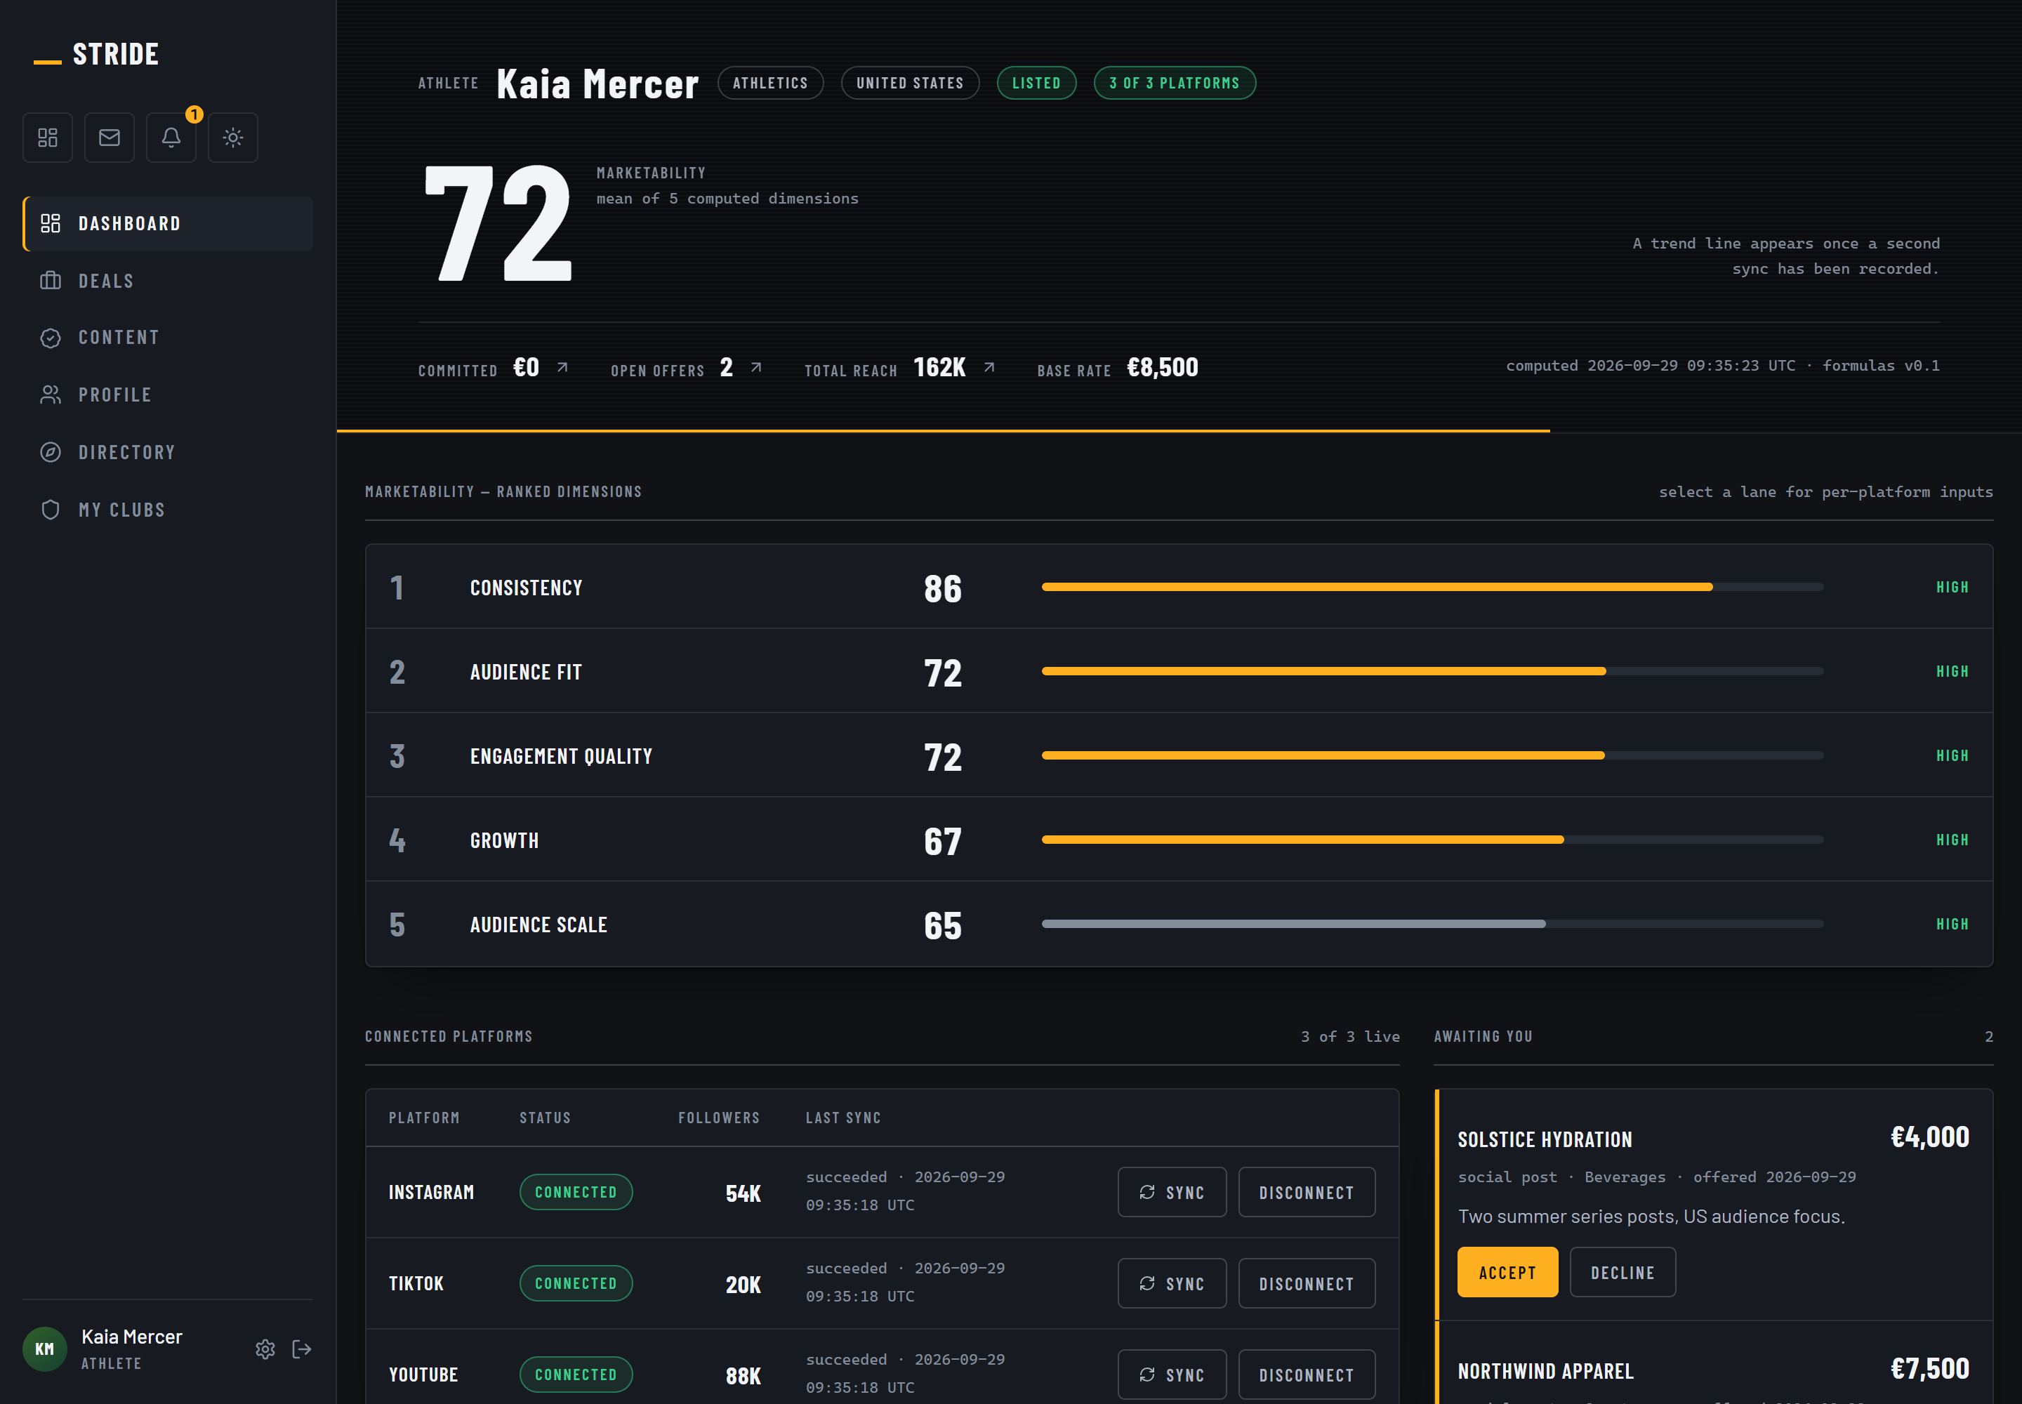
Athlete dashboard: /athlete
The marketability score and its ranked dimensions, computed from connected platform data rather than self-reported. Route /athlete, viewed athlete@demo.stride.

18.4 Public athlete profile
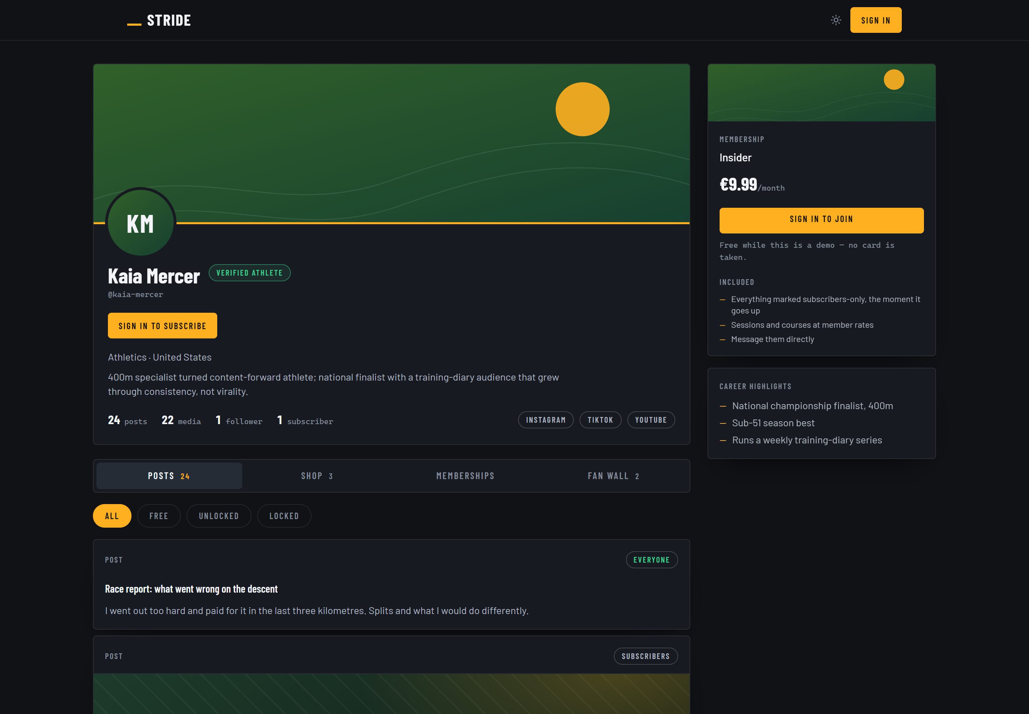
Public athlete profile: /athletes/kaia-mercer
The public profile, seen signed out. Identity, sport and club are open; the score and audience breakdown are withheld until a viewer is known. Route /athletes/kaia-mercer, viewed signed out.

18.5 Sponsor workspace
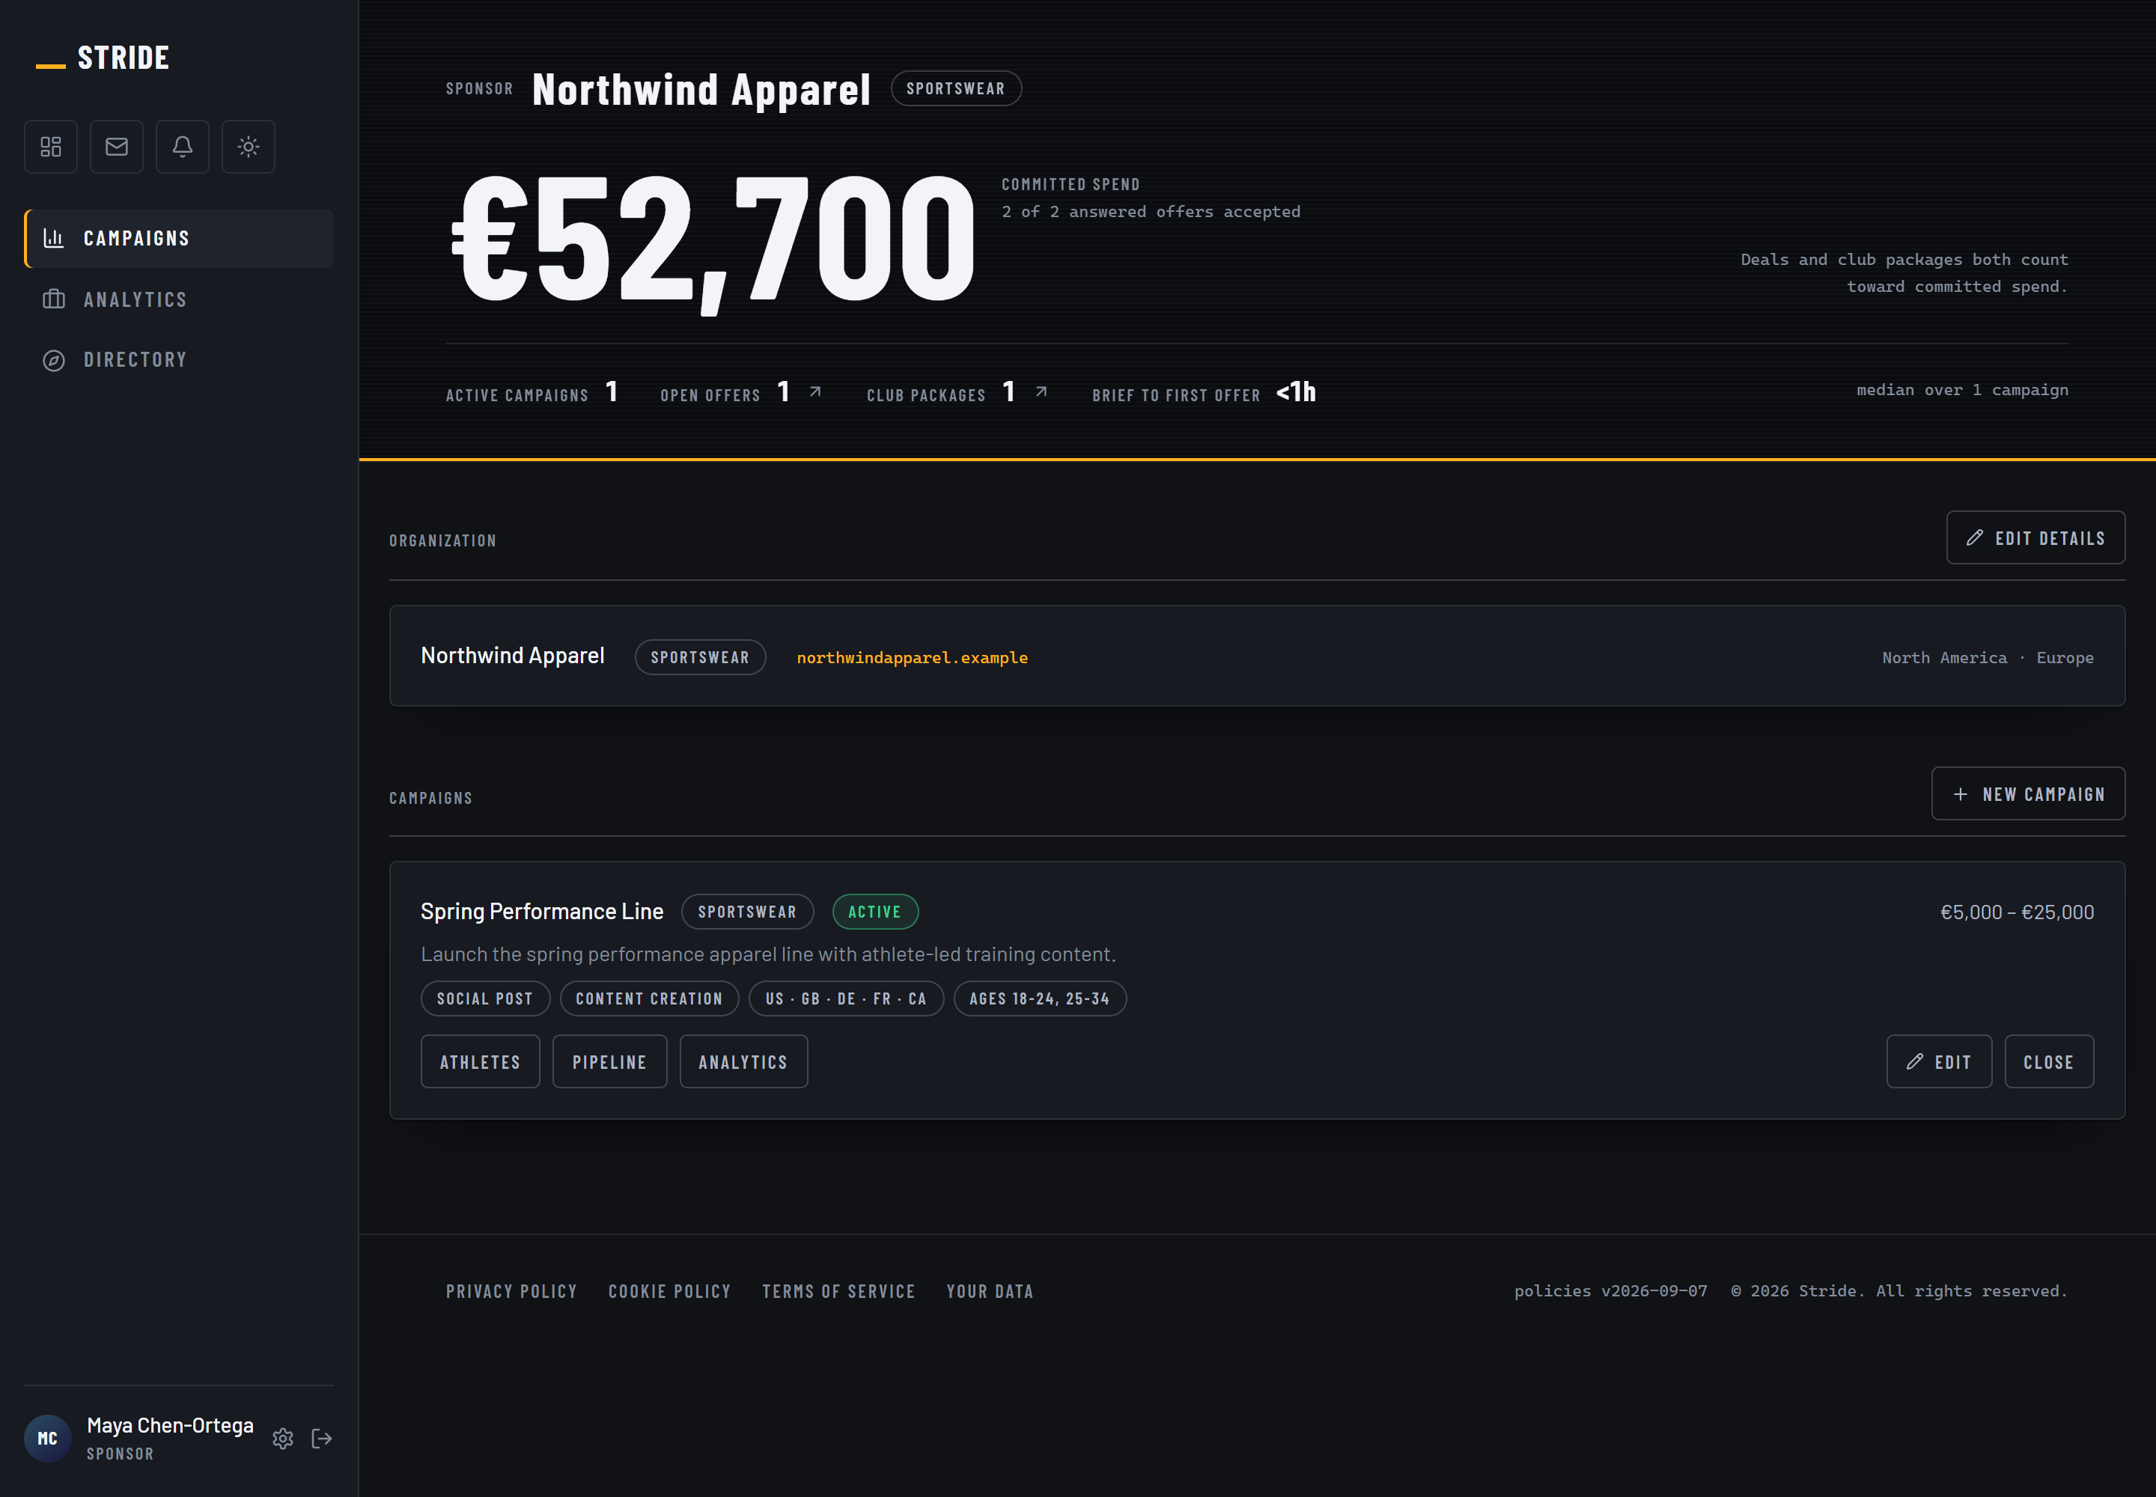
Sponsor workspace: /sponsor
Campaigns carry a brief, and the brief is what the matching engine scores against. Route /sponsor, viewed sponsor@demo.stride.

18.6 Club HQ
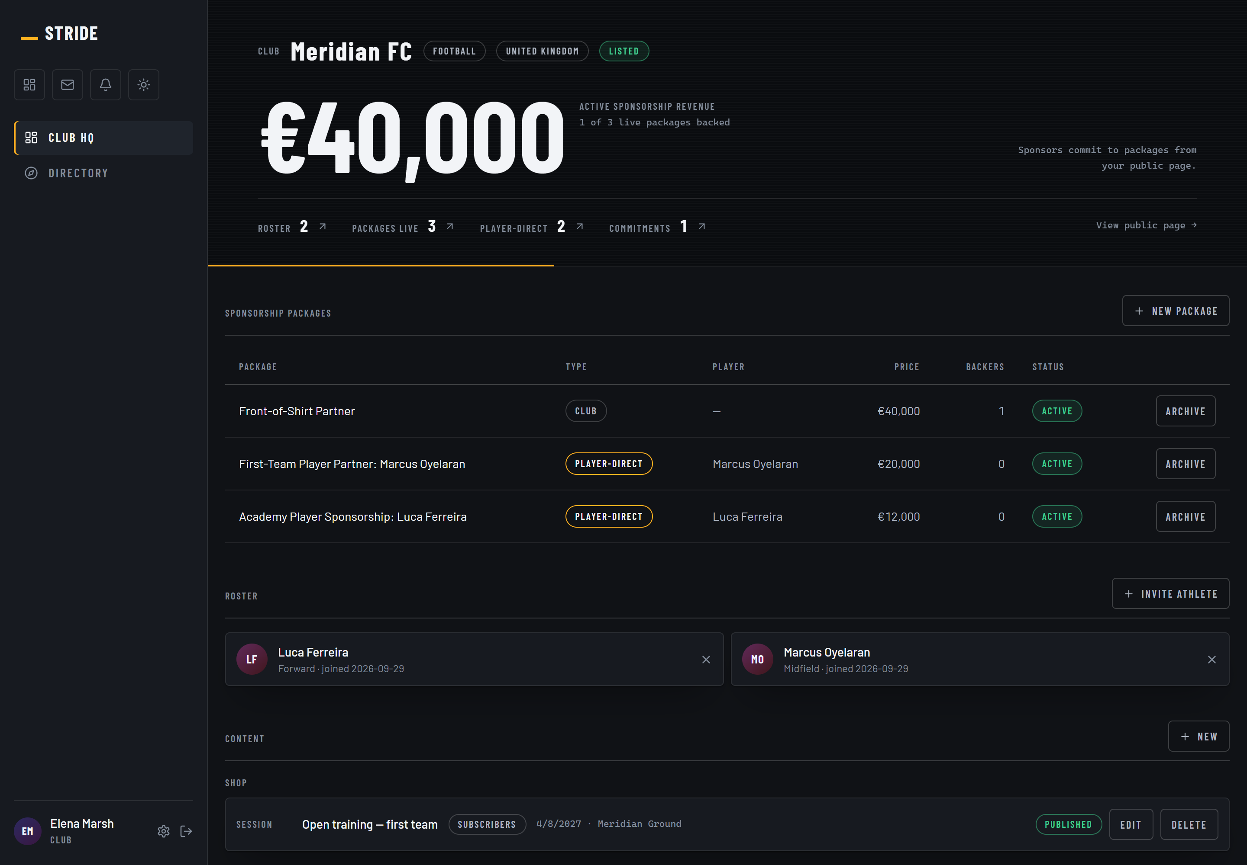
Club HQ: /club
The roster is the club channel of the sales plan: one relationship carries twenty to forty athletes. Route /club, viewed club@demo.stride.

18.7 Admission queue
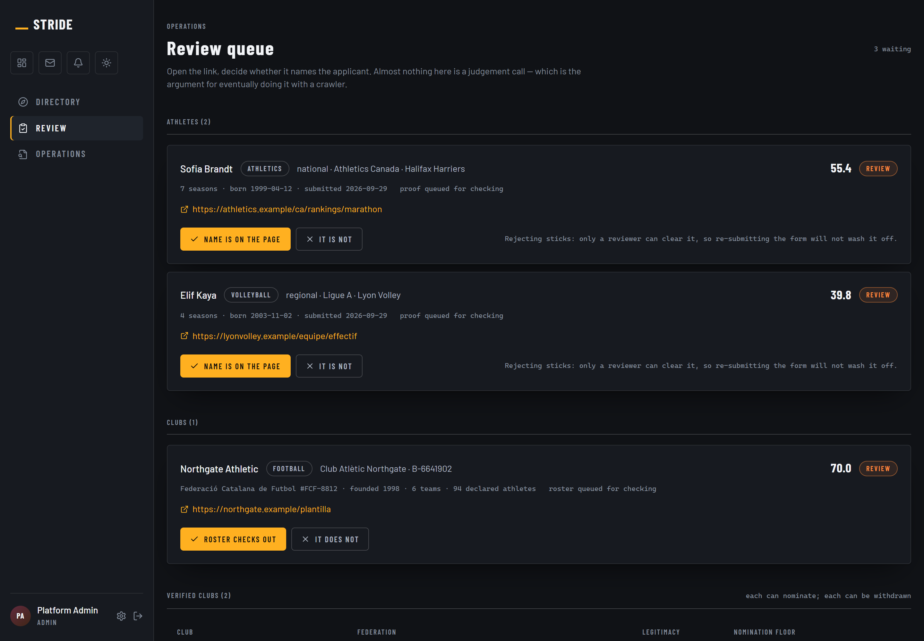
Admission queue: /admin/review
The operations plan treats admission review as the only step consuming meaningful human time. This is that step. Route /admin/review, viewed admin@demo.stride.

