Phase Two - Modeling

Hugo Lopez: HFL210000
Arpan Rathod: aar230000
James Nguyen: jxn200027
Nithin Samy: nss190006
Salahuddin Alshalabi: ssa230006

Hospital Database Outline

NOTE: We used (min, max) constraints to describe our data. We only specified the (min, max) constraint for that entity; the other constraint is specified with the other entity's description. We did specify who the constraint applies to, however.

Patients
- Cardinality (1, N) to record
  - Patients can only have up to many records
- Attributes
  - PID (primary key)
    - An integer that stores the patient's ID
    - Not Null constraint
  - Name
    - String containing the patient's first name and last name
    - CHECK constraint to make sure there is a space between inputs (accounts for first and last name)
  - Gender
    - A string that contains the patient's gender
    - Can be left empty, DEFAULT NULL
  - ContactInfo
    - Email
      - String containing patient email
      - Must be one per patient
      - Default is NULL
    - Phone
      - integer containing patient phone
      - There may be zero or more phones per patient

Records
- Cardinality (1:1) from the patient
  - Records can only be accessed by one patient
- Cardinality (1, 1) from the doctor
  - Records can be accessed by one doctor
- Attributes
  - RID (Primary key)
    - An integer storing the record ID
  - PID (foreign key to patients)
    - An integer referring to the patient ID
    - OnDelete cascade
    - OnUpdate Cascade
  - DocID (foreign key to employee)
    - An integer reference to all employees who worked with the patients' ID
      - OnDelete restricted
      - OnUpdate Cascade
  - Diagnosis
    - String containing patient results of tests
  - Treatment
    - String defining the treatment method (e.g., surgery, medication, etc.)
  - Hospital
    - A string containing the hospital name

Employee
- Cardinality (1, 1) to the department
  - Employees belong to one department
- Attributes
  - ID (primary key)
    - A BIG integer that must not be NULL
    - Must be unique
  - Name
    - A string storing the employee's full name
    - First and last name
    - CHECK constraint to make sure there is more than one character
  - StartDate
    - A string storing the employee's start date
    - Must not be null
    - Check constraint to make sure start date is less than the current date
  - ContactInfo
    - Email
      - A string storing employees' email contacts
    - Phone
      - An integer storing the employee's phone number
  - Shift
    - A string defining the night/day shift for the employee
    - CHECK condition since there can be two options, day and night
  - Role
    - A string defining if an employee is one of 3 roles
      - Immediate Responder, Administrative Staff, and/or Scheduled Staff

Doctors (Scheduled staff - child to employee)
- Cardinality (1, N) to records
  - Doctors have access to 1 or many records
- Attributes
  - DocID (foreign key to employee)
    - An integer referring to the doctor's ID from the employee
    - Must not be NULL, and this is a PK and FK to employee
    - On delete restricted
    - OnUpdate restricted
- Specialization
  - This has options such as Cardiology, Pediatrics, etc…

Head Doctor (scheduled Staff - child to doctor)
- Cardinality (1, 1) to the department
  - A doctor can manage only one department
- Requires that at least one doctor manages a department (participant constraint)
- No attributes besides the ones derived from doctor and employee

Nurses (Immediate responder - child to employee)
- Attributes
  - NID (foreign key to employee)
    - An integer referring to the nurse's ID from the employee
    - On delete restricted
    - On update restricted
  - Specialization
    - Nurse practitioner, nurse aid, lab nurse, etc

HR (Human Resources - Administrative Staff - child to employee)
- Attributes
  - EID (foreign key to employee)
    - An integer referring to the employees ID from employees
    - On update restricted
    - On delete restricted
  - ContactInfo
    - Email
      - A string containing the HRs email contact
    - Phone
      - An integer containing the HRs phone number
  - AccessLevels
    - A string defining the access level of the HR employee (Standard, manager, admin)

Department
- Cardinality (1, N) to employees
  - The department has at least one to many employees
- Attributes
  - DepID (primary key)
    - An integer storing the department ID
  - DepName
    - A string storing the department name
  - DepType
    - A string defining what the department manages (Clinical, Administrative, Non-Clinical (Customer Service))
  - Location
    - A string containing the department location
  - DepContact
    - Email
      - A string containing the department's email contact
    - Phone
      - An integer defining the department's phone number
  - OperatingHours
    - A string defining the departments' operating hours

Appointment
- Cardinality (1, N) to patient
  - An appointment can have at least one to many patients
- Cardinality (1, N) to a doctor
  - An appointment can have one to many doctors
- Attributes
  - AppID (primary key)
    - An integer storing the appointment ID
  - Date
    - Data type: Date, and its when the appointment is to take place
  - DocID(foreign key)
    - String of the doctor's name
    - On delete set null
    - On update cascade
  - PID(foreign key)
    - String of the patient's name
    - On delete cascade
    - On update cascade
  - Status
    - String containing a message confirming if the appointment was approved or not

ERD
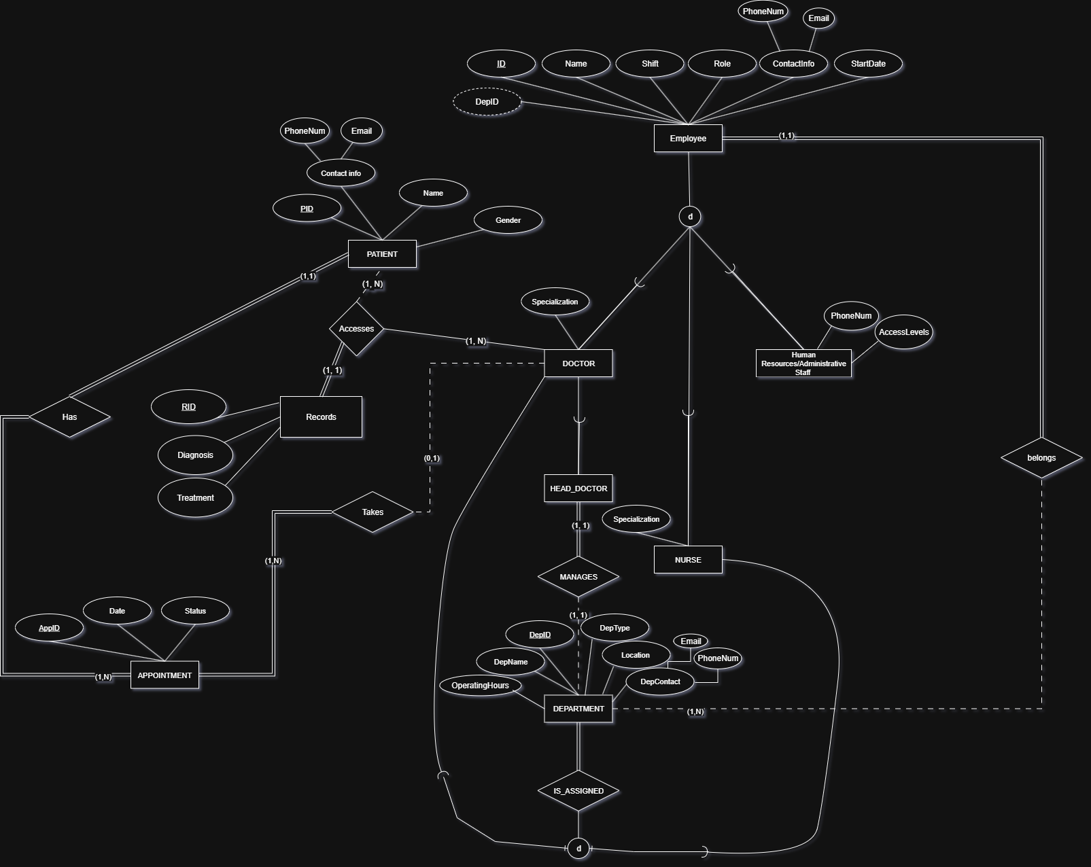

Relation DB Schema
