School of Electronic Engineering and Computer Science | Interim Report  Programme of study:  BSc Computer Science  Project Title:  Plat-Imee: A personalised anime tracking and recommendation platform.  Supervisor:  Dr Mustafa Bozkurt  Student Name:  Jaden Bellevue  Date: 06/05/2025
Final Year
Undergraduate Project 2024/25


Abstract
Titled Plat-Imee, this project explores the development of a platform for anime enthusiasts that integrates personalised recommendation capabilities into a web application. The platform allows users to create accounts, select and rate anime with the larger goal of forming personalised lists that will serve as input for the recommendation algorithm.
Anime has experienced a surge in global popularity driven by the rise of streaming platforms and an increasingly connected fanbase. However, with thousands of titles available, fans often face challenges in discovering new shows that match their tastes. There is a growing need for platforms that streamline the discovery process; Plat-Imee aims to address this problem, offering a personalised, simplified and user-friendly solution that centralises essential features, making it approachable for both newcomers and seasoned anime enthusiasts alike.

C
ontents

Chapter 1: Introduction 5
1.1 Background 5
1.2 Problem Statement 5
1.3 Aim 6
1.4 Objectives 6
1.5 Research Questions 6
1.6 Report Structure 7
Chapter 2: Literature Review 8
2.1 Background Research 8
Chapter 3: Requirements Analysis 16
3.1 Functional Requirements 16
3.2 Non-functional Requirements 16
Chapter 4: Design and Implementation 17
4.1 High-Level System Design 17
4.2 Low-Level System Implementation 24
Chapter 5: Recommendation Microservice Optimisation 46
Chapter 6: Testing 48
6.1 Test-Driven Development 48
6.2 Test Coverage Table 48
6.3 User Controller testing 49
6.4 Anime Controller Testing 49
6.5 UserAnime Controller Testing 49
6.6 Recommendation Endpoint Testing 49
6.7 Integration and Security Testing 50
6.8 Testing limitations 50
Chapter 7: Evaluation 51
7.1 Requirements Testing 51
7.2 Evaluation of Recommendation System Error! Bookmark not defined.
Chapter 8: Conclusion 56
8.1 Project Evaluation 56
8.2 Further Work 56
Chapter 9: References 57

Introduction

Background
Evident in the immense increase in revenue of Japan's animation industry—the home and leading exporter of anime—which it exceeded ¥2.93 trillion in 2022 (more than a 100 percent increase from 2013 [1]), alongside a daily eight-thousand-member increase in Reddit’s r/anime community [2, 3]. Anime to global audiences is a growing importance, yet current platforms lack cohesive tools to fully cater to this surge of new users and optimise how to keep as many of them as possible engaged.
Empirical evidence around the need for personalised engagement in member retention within hobby-based communities has arisen. The failure to personalise and centralise experiences is resulting in frustration, as users are forced to navigate between often cluttered or fragmented services. The clutter leads to information overloads and an overall lack of appeal. The fragmentation often leads to "platform fatigue" [4], a phenomenon observed in multiple online communities where users become disinterested due to inefficiencies in both discovery and engagement. ‘You need to divide your time and attention between different windows, screens, data sources, files, alerts, monitors, programs, etc. There are just too many places to go and too many windows to check’. “Figuring out which tools to use for which purpose is also a problem. There is overlapping functionality between many of these tools”.
Cohen’s et al. [4] additional words also support my argument as I allude to the platforms currently in place; MyAnimeList.net [5], Anilist.co [6] and AniBrain.ai [7] are all front runners in their roles each sharing attributes such as a recommendation system with each choosing a different route to its development.
For better insight, MyAnimeList.net provides a variety of features offering a lot to the user but to the extent that it adds clutter to its navigability and its overall impression. AniList.co simplifies it enabling it to emphasise the list making feature; where this platform falls short is where AniBrain.ai excels with its ability to provide personalised recommendations.

Problem Statement
The need for a more interactive and personalised experience for everyone's pastimes has become increasingly clear with the rise of numerous platforms and communities scattered across the web, each with its own angle into how it can engage users in a larger competition for their time.
Anime watchers are no exception to this problem. While their communities grow rapidly, existing platforms have failed to meet their evolving needs, often offering overengineered or even gimmicky excuses for what should be an all-in-one place for discovery, tracking and social interaction.
A common error that arises when someone takes an interest in a hobby is figuring out where to start. Opening the door to new users is the first step to their inclusion and that’s fostered by giving them a show tailored to their desire. An impersonal recommendation not only weakens the entry process, but it diminishes their initial experiences making it less likely that they will continue exploring the hobby. It would be appropriate to respond with “this is not for me” when what has been provided for them is not recommended for them properly.

Aim
The core aim of this project is to implement an all-in-one platform that streamlines the discovery of new shows through recommendations personalised to the user based on their preferences via viewing history and declared interests. This will be accompanied by key features such as customisable profiles to track and organise watchlists and provide users each with a unique and engaging interface.
While the mentioned features are present in various existing projects, their fragmentation across the web through different platforms has left no single place where they are united thus providing a scattered user experience. This project aims to fix this issue by providing an all-in-one platform mitigating the issue of platform fatigue by providing a service tailored to welcoming new users while remaining comprehensive enough to meet the needs of experienced users of similar services. By consolidating discovery, tracking and customisation under a single roof Plat-Imee will also address the current inefficiency users face when constantly switching between multiple services I would label as gimmicky - each with its own or unique but isolated features.

Objectives

Overall Aim
• To design, develop and deploy a web application that will aim at streamlining the recommendation process of new anime to users and allowing them to possess their own profiles and watch lists.

User profile objectives
• Design a database schema to hold user information on their preferences and watchlists.
• Implement an easy-to-use interface for customisation and adjustments to their watchlists.

Anime recommendation system
• Research the various existing recommendation systems to better understand what is most suitable for this project and how it can be implemented. This involves looking at existing similar applications as well as more conceptual models that support them.
• Design a recommendation system that tracks the preferences of users and uses that data to form new recommendations.

Research Questions
The success of Plat-Imee hinges on addressing key challenges in anime discovery. To guide its development, I have curated several research questions with a focus on how personalised recommendations can improve the discovery process and how a streamlined, user-friendly platform can balance simplicity and functionality catering to both new and experienced users.
- What recommendation techniques are the most effective for accurately predicting user preference?
- What recommendation techniques are feasible to implement and do not require excessive effort from the user.
- What design principles ensure that the platform remains approachable for newer users while catering to seasoned enthusiasts.

Report Structure
The rest of this report is organised to cover every aspect of this project.
Chapter 2 presents the background research including the literature review amongst a detailed analysis of similar applications and various recommendation systems candidate to Plat-Imee.
Chapter 3 outlines the systems functional and non-functional requirements, explaining what the solution needs to achieve and how it is expected to perform.
Chapter 4 details the project plan, including a timeline, chosen methodology and risk assessment. Together this guides the development and integration of frontend, backend and recommendation providing microservice.
Finally, Chapter 5 at this moment covers the references made throughout the other chapters.

Literature Review
In this chapter I investigate the principles behind recommendation systems and their implementation in content-focused platforms. Furthermore, here I evaluate existing competitors to determine their strengths and weaknesses to establish benchmarks for Plat-Imee's development.

Background Research

Importance of Recommendation Systems
Recommendation systems have emerged as a solution to the challenge of information overload online [8, 18], where users struggle to sift through vast amount of content to find what best suits them – a challenge daunting enough when you have a firm picture of what you are pursuing, but all the more troubling when you do not.
These systems are particularly valuable in contexts where the sheer volume of options can be overwhelming. Dominant platforms such as Netflix and Amazon exemplify their effectiveness with over 80 percent [9] of the formers watched content and 35 percent [10] of the latter's sales being attributed to recommendations. This demonstrates how such systems benefit all parties involved - the users, in how well received recommended content is and how now easily accessible it is; the content creators by connecting them with audiences who might otherwise remain unaware of their work; and the platform which through delivering content that resonates with the users, becomes a destination they are more likely to revisit.
In the field of recommendation systems for anime, their significance lies in addressing the vast diversity of titles, streamlining the process of discovering content. Such systems encourage exploration, helping fans uncover hidden gems that deepen their engagement with the medium. This, in turn contributes to the growth of the anime industry by broadening audience exposure to a wider range of content and creating a more inclusive and interconnected community of enthusiasts.
To conclude, without effective recommendations, fans, especially newcomers. may find it challenging to discover content that align with their interests or preferred style. Recommendation systems simplify this by analysing viewing habits and providing personalised suggestions, helping users find content that resonates with them while also encouraging them to explore beyond their usual preferences.

Recommendation System Models
This section examines different models that can be employed to design a recommendation algorithm. Each approach is assessed for its advantages, drawbacks and suitability in leveraging my chosen Kaggle anime dataset.

Content-Based Filtering
Content-based filtering is a recommendation approach that utilises the explicit attributes of items and assesses them against the preferences of users, to produce a recommendation. This approach focuses solely on the individual user, offering personalised recommendations based on each items characteristics rather than relying on the preferences of others. The system learns about the user based on their past interactions with the items, analysing the features of them to identify patterns in the users likes and dislikes [11, 12].
As mentioned, at the core of this method we have user preferences and item attributes; when putting this into the perspective of anime, this pertains to features such as genres (such as action, romance and comedy), episode count, or an average rating that predict whether a user will enjoy a particular title. If a user has a strong preference for action anime of around 25 episodes and with high ratings, then the system will prioritise recommending similar anime with these features [11, 17].
To put this concept into a better perspective we can demonstrate it through matrix factorisation. Note that while this technique can be applied to content-based filtering, it is relatively uncommon; it is far more commonly used in collaborative filtering where it learns latent user and item factors from interaction data without relying on explicit features. This requires us to represent data as matrices to model the relationship between users, items and their features. For example, given a matrix A that contains items anime (items) and their features (such as action and comedy for simplicity), and another matrix B that represents users and their preferences for these features; the recommendation process can be seen as the matrix multiplication of these two matrices which produces a third matrix C that captures the predicted ratings users will give [12, 17].
An advantage of content-based filtering is its ability to work independently of other users' data; this gives it an advantage in how effective it can handle users with unique or niche preferences. The independence from the user base also makes it effective in scenarios where there is insufficient data for other users such as when there is only one engaging with a particular type of content. Additionally, it is also very simple when proving reasoning for recommendations – the system can explain that you are being recommended anime x because it shares features with the ones you previously liked [11, 12].
Content-based filtering is not without its drawbacks. The cold start problem refers to the challenge of generating recommendations when there is insufficient data; in this context that means a lack of either user content when a new user joins the platform but has not declared any of their preferences, or item content when a new item is added but has no prior interactions [13]. When Netflix was first launched it circumvented this issue by having users fill out an extensive survey detailing their tastes. This solution was short lived as it only led to other problems – it was a burden to user and also prone to failure given that users are not always great at describing their own preferences – sometimes people enjoy things but are not capable of explaining why. Filter bubbles are another potential risk where recommendation systems repeatedly suggest content too similar to what the user already likes. This limits the scope of what the user is exposed to and occurs because there is no mathematical reason to providing the user with content that scores lower on calculated compatibility. These can be mitigated by incorporating collaborative filtering or other hybrid approaches to balance exploration with relevance.

Collaborative Filtering
Collaborative filtering is a recommendation approach that focuses on the implicit relationships among users or items derived from interaction patterns. It leverages collective preferences to provide recommendations unlike content-based filtering which relies on the features of items and individual user preferences. This approach is inherently social, operating on either the principle that items that received similar ratings or interactions from users in the past are likely to be similarly rated or interreacted with in the future (item-based), or the principle that users who have shared preferences in the past are likely to agree on future recommendations (user-based) [14, 17].
As alluded to, at its core, collaborative filtering can be divided into two main approaches: user-based which focuses on the comparison of users, and item-based which focuses on the comparison of items.

Item-based Collaborative Filtering
With this technique, we focus on the implicit relationships between items rather than users. It identifies items that are similar according to how users have rated them. For example, if many users who highly rated (sample anime’s) Naruto also liked Attack on Titan (AoT), then they would be considered as similar. A user who enjoyed Naruto but has not yet watched AoT then this method would likely recommend it to them.
A key advantage with item-based filtering comes from its stability over time. While user preferences are liable to frequent change, the relationships between items tend to remain consistent which makes the model less sensitive to changes in user behaviour. To add, due to the similarity computations being item-focused, this method is often more scalable in systems with a larger user base as computations are done without regard for the amount of them. It also works well in sparse datasets where user overlap is minimal, this is because the recommendation doesn't depend on finding similar users but instead on the target users' history and the item relationships – note that the similarity between items is stored as a relationship independent of which users contributed to it. It's also better for newer users as once they indicate interest in one thing, we are immediately able to recommend similar items to them [15, 22].
Item-based filtering comes with its own faults. It struggles with niche items due to its reliance on user interactions to computer similarities; if only a few users have interreacted with an item then there would be insufficient data to connect it to other items [15].

User-based Collaborative Filtering
In user-based collaborative filtering, the system identifies a target user’s “nearest neighbours” - users who have previously interreacted with similar items in similar ways. These like-minded users are the backbone of the predictions. To put this into better perspective, if user A and user B both rate Naruto and AoT highly then they would be considered as similar, and if user A also rates Steins;Gate (another sample anime) highly then this method is likely to recommend Steins;Gate (SG) to User B [16].
One of the notable advantages of this method is its ability to recommend content beyond a user’s apparent preferences. Referencing the example, the two shows viewed and rated highly by both users (Naruto and AoT) are predominantly action anime. If this was all the data, then we had collected then it would be most natural recommend user B with another action anime; content filtering would likely have promoted this. The system instead suggests SG - a drama or more specifically not an action anime. The ability to recommend new shows that do not directly correlate with their rating history allows us to expose the users to new content they may otherwise never have discovered.
A disadvantage of this method comes with data sparsity issues: in a system with many items, users may have little overlap in what they have rated, this makes it harder to identify nearest neighbours. Additionally, as the number of users increases, comparing each pair becomes more and more computationally expensive. Another limitation comes with the dynamic nature user preferences – what someone likes today may not be what they like tomorrow and as such a method that relies heavily on historical data may lose its foundation [16, 22].
The typical collaborative filtering algorithm works by calculating a score on similarity between two users based on the overlap in items that they have rated. A common method of calculating this score is with cosine similarity – this entails measuring the cosine of the angle between the two vectors where each vector measures the users' ratings e.g. (1, 5, 4) where each number represents their rating of an anime. You can imagine this as a row in a database where the rows represent users and the columns represent anime. Cosine similarity captures the direction (for a vector) of preferences showing how similar they are, but it neglects the magnitude of the preference [19].
Another approach would be dot product, this method not only considers the similarities mentioned but also the magnitude of preferences, making it more comprehensive. The magnitude of a preference represents the strength of a user's feelings towards an item. In a recommendation system, knowing not only whether preferences align with each other but now how strong they are helps prioritise recommendations that better reflect a user’s enthusiasm leading to a more accurate and personalised result. Considering two users with similar tastes in terms of direction – given they both like action anime, but one user rates consistently high (8–10 out of 10) while the other rates consistently in the upper middle range (6–8), then accounting for the magnitude would influence how much weight to give their input in recommendations [20].
While this explanation comes from the user-based side of collaborative filtering it also applies to the item-based side given that you are calculating similarity scores between items based on the overlap in user ratings, and both methods rely on identifying patterns in preferences to make recommendation.

Model-Based Approaches
Techniques in this category leverage the past ratings of users to construct a model with the goal of enhancing the performance of collaborative filtering. These models are typically built with various machine learning or data mining methods that analyse historical data to identify latent features - underlying factors that explain patterns in user-item interactions. By using a pre-built model, this approach allows us to generate recommendations more efficiently given that it doesn't require any real-time data analysis (Recalculating recommendations based on the entire dataset). The outcomes generally align with those generated by neighbourhood-based recommendation techniques such as user-based or item-based filtering, plus this approach can be integrated with traditional collaborative filtering methods to further refine the accuracy of the results [21].
One of the most prominent techniques in model-based collaborative filtering is matrix factorisation, which represents users and items as vectors in a shared low-dimensional space. The strength of a user’s preference for an item is commonly estimated through the dot product of these vectors, which communicates how closely aligned they are [14].
Extending on this, matrix factorisation can be solved using analytical methods such as Singular Value Decomposition (SVD) or via iterative approaches like Alternating Least Squares (ALS). Zhou et al. [28] demonstrates how ALS can be adapted to implicit feedback datasets by modelling preferences and confidence levels from observed user actions. In contrast, for explicit feedback data, stochastic gradient descent (SGD) remains a widely adopted optimisation technique well-suited for handling sparse user-item matrices [14].
More recently, deep learning methods have extended on traditional matrix factorisation through neural network architectures to capture non-linear relationships in user-item interactions. Often referred to as Neural Collaborative Filtering (NCF), these approach uses multi-layer neural networks, enabling richer representations and improved performance in tasks like cold-start recommendation and implicit feedback modelling [29].

Potential Drawback of Recommendation Systems
While recommendation systems have become essential for navigating large datasets and driving user engagement, their effectiveness comes with costs that call for careful consideration.
A prominent issue is the bias in the feedback loop. Given that recommendations are sources from user reviews they also naturally reflect subjective biases – items with a high number of positive reviews will tend to dominate recommendations while those with negative feedback may be unfairly suppressed. This has the potential to create a self-reinforcing cycle where popular items continue to gain attention while less popular items are marginalised. Similarly, items that are less often interacted with are prone to being disproportionately recommended despite potentially aligning with a user's interest – this further promotes the limitations to discovery [23].
An important consideration is the observation that ‘recommendations do more than just reflect consumer preferences – they actually shape them’ [23]. This shaping effect has far-reaching implications, both positive and negative, depending on how the system is implemented. To illustrate this, a platform may promote highly engaging content to increase user retention; while this can lead to more enjoyable experiences it also raises questions about whether the systems objectives align with users' best interests, particularly when it compromises on diversity or user satisfaction.
While it is less critical to this project due to the data gathered being limited to show ratings, privacy concerns are a growing issue as recommendation systems often require extensive access to user data, this could include details such as a user's age, location and browsing history above the expected data. Collecting, storing and processing this data raises concerns about consent, security and the potential for misuse [24].

Similar Applications
This section explores applications with features analogous to the goal of Plat-Imee. Here we focus on their angle to helping users discover content based on their preferences, by examining their functionalities ultimately with the goal of identifying effective design elements that contribute to their success. The analysis of their strengths offers valuable insights into approaches that enhance usability, personalisation and satisfaction. Equally the weaknesses of each application offer insights into features we should avoid and be conscious of during the planning phase of this project.

MyAnimeList.net
Standing as the pioneer among anime tracking and recommendation platforms having been established on November the 5th 2004 and having one of the most active platforms as proof [25]. It has established itself as one of the earliest platforms of its kind and from that base has cultivated a loyal user base that now benefit from a centralised hub to organise their anime and manga experiences that they know as ‘MAL’.
As the name implies the core feature of this platform is in how it allows users to create and maintain personal watchlists which aid in the organisation and tracking progress of the content that they consume. To add, it provides users with recommendations by suggesting similar titles based on user activities; being more specific it allows users to manually form relationships between two shows at a time and add descriptions on how they relate. A large part of MALs success comes from the accessibility to information around each title that it grants. With detailed entries for thousands of anime and manga, users can quickly find crucial information such as genres, synopses and production details – the ease of access it grants make MAL an invaluable resource for both newcomers and seasoned fans alike looking to explore the medium further.
Despite the success of MAL its downfall begins with its lack of commitment to its title. The platform has incorporated so many features – forums, blogs, seasonal charts and news – that it risks losing its identity as a recommendation and tracking platform used to create [my] anime list. As of writing this report I've captured the current appearance of the site in figure 1. The list feature is located in the navigation bar between “Hide Ads” text and the letter icon. The supposedly main feature as emphasised by the very name of the site, is reduced to a small icon competing with variety of other visual elements.
On the topic of visual elements, MyAnimeList.net allows for an extensive customisation of users lists through its ‘Add Custom CSS’ feature that enables users to tailor layouts, fonts, colours and even the functionality of lists to their liking. In comparison, competitors like AniList.co offer limited customisation, allowing only basic colour changes and banner additions. While AniList.co prioritises simplicity in this case, MAL’s approach caters to users that value creative freedom so long as they are willing to put the effort into their customisations.
As a pioneer, MyAnimeList.net has faced challenges in adapting to modem user expectations. The cluttered and outdated interface exacerbates this issue, with vibrant and often inconsistent colours dominating the layout, making navigation less intuitive with the forced sense of disorganisation. The sites busy design and overabundance of features leaves the user sifting through unnecessary elements just to access the tracking tools that were expected to be central. While the currently layout benefits those looking for the latest news through forums or seeking something new through the anime driven advertisements, it runs the risk of alienating its users, especially new users who seek and expect simplicity and clarity.
As previously discussed, MALs recommendations are based on manually created user recommendations that focus on comparisons between anime. The benefit of this is that it allows for greater control on what users get to recommend to others while also providing their reasoning. The negatives of this approach begin with how labour intensive manually creating recommendations are instead of passively creating them. This raises issues with scalability as recommendations are only as extensive and diverse as the contributors' efforts. The contributors themselves are liable to provide definitive declarations on subjective content such as when pushing the idea that two features are similar without any other input to regulate it. The main issue in this recommendation system is how MAL handles it. There are 20 non-searchable pages of recommendations, some with paragraphs, others with bullet points and each of random users comparing one unordered anime to another; it is unorganised, unnavigable and unappealing. Thankfully the site does offer recommendations for shows on their own dedicated pages and while this offers users a chance to find content similar to other specific content it is still a manual approach non-inclusive of their overall preferences.

AniList.co
AniList.co (AL) was founded in 2014, providing an alternative to MAL with a more modern design and enhanced analytics (in forms such as time spent watching anime and breakdowns of the genres and tags, they have interacted with most frequently), to name a few of its advantages. As an alternative, this platform offers all the same major features MAL with some key changes.
The platform employs a feature well in demand for modern platforms of all kinds – Dark mode. “Due to perceived advantages related to visual comfort and acuity, specifically when working in low-light environments” light-on-dark colour schemes are a must for many users and particularly with those who watch anime late at night or in dimly lit spaces. Research on viewing habits indicates that “linear TV viewing increases throughout the day, peaking between 8-9pm" which aligns with the common trend of watching anime during the evening dimly lit hours. This is further supported in how many anime watchers tend to consume content on their computers as opposed to TV where they have access to AniList.co [27]. Notably, the bias for computers largely comes from anime’s accessibility on the web verses the more limited releases on TV with Netflix included.
Another advantage AL holds is its flexibility with ratings. Unlike MAL which restricts users to integer ratings, AL allows users to assign decimal ratings such as 5.5, giving them more nuanced control over their expressions. Platforms based on users expressing their views should not limit their opinions especially given how common it is to feel that a show falls between two ratings. This level in precision in feedback also leads to more refined recommendations.
On the topic of recommendations, the immediate thing I noticed or rather did not notice was the placement of recommendations tab inconveniently located on the footer of the page. The recommendations page appears as a more structured version of MALs, offering pairs of anime with links to each other; an immediate issue is that there is no description of what the shows have in common nor a link to any creator of the pairing – by default it is simply listed as a default set of recommendations organised by their recentness. Fortunately, users can search for the highest and lowest rated recommendations possible by their ability to up or downvote ratings, enabling them to see the most frequently highlighted connections. More importantly, they are also able to see recommendations based on their personal lists, this feature compares items on their list with similar ones and is the closest AniList.co gets to personalised recommendations.
While AniList.co and previously mentioned MAL attach a list of similar items to each show on their dedicated page, it falls short of more personal recommendations that could have leveraged the available lists users create. How apparent this issue is can be seen in how other users have taken to third part apps to receive tailored recommendations. GitHub user ‘ameobea’ developed a platform ‘Sprout’, and reddit user ‘memingIsUnbreakable’ has created an unnamed tool to address this gap.


Figure 2.1 - The front page of MyAnimeList.net

Similar Application Summary
The table below provides a summary of the strengths and weaknesses of both websites discussed above.
Website name | Advantages | Disadvantages
MyAnimeList.net | • Offers user-curated comparisons with reasoning for similar titles  • Extensive forum integration  • Expressive list customisation options | • Cluttered and outdated interface with an inconsistent design  • Overloaded with features making navigation unintuitive. Main tracking features and de-emphasised  • Manual recommendation system that lacks scalability in one form and personalisation in another
AniList.co | • Modern design with user friendly features like dark mode  • Advanced analytics (e.g., time spent watching and genre breakdowns).  • Allows decimal ratings for better accuracy | • Recommendations lack detail/ explanation  • Inconveniently placed recommendations tab  • Limited (but simple) list customisation  • Lack of personalised recommendations

Table 2.1: The advantages and disadvantages of similar applications
A significant shortcoming of both platforms is the lack of personalised recommendations. MALs system is far too dependent on manually created user suggestions which, while detailed, lack organisation and scalability. AniList.co betters this approach but similarly does not adequately utilise user data to offer tailored recommendations. This gap highlights the need for a new recommendation system embedded into the main platform.
Both websites also face an issue with customisability. While MAL provides it to an extensive end directly through user created CSS, allowing users to create highly personalised list designs. AniList.co offers simpler options like changing base colours and adding banners – this may appeal to users wanting quick and minor changes. However, neither platform fully bridges the gap between simplicity and advanced personalisation - a similar issue to engaging more experienced users while providing ease of access to newer ones.

Requirements Analysis
This chapter outlines the functional and non-functional requirements for the project. Each requirement listed here is written with the aim of clarifying the project’s scope, timeline and complexity while minimising ambiguity and any unexpected changes during development.

Functional Requirements
Functional requirements define the systems essential operations and features – In the case of Plat-Imee, this includes:
- The project must utilise a dataset containing details on anime and user ratings for anime.
- The application should utilise an Api to receive details on anime.
- The recommendation system should implement a collaborative filtering algorithm for generating anime recommendations. This approach may be changed during comparisons to other methods during development.
- The recommendation system should utilise the users watch lists to form recommendations for them; this must be influenced by ratings.
- Users should be able to create accounts, requiring a username and password.
- Users should be able to delete their accounts.
- Users should be able to rate anime.
- The project should enable users to browse through anime optionally sorted by popularity and release date.
- The application should enable users to search for anime by name or genre.
- The project should enable users to select anime from the search results to add to their personal watchlist.
- The interface should enable users to remove anime from their watchlist.
- The interface should enable users to view details about anime such as genre, average rating and episode count.
- The project should enable users to view recommendations based on their watchlist.

Non-functional Requirements
Non-functional requirements focus on the systems behaviours and user experience – In the case of Plat-Imee, this includes:
- The project should run on the latest versions of major web browsers including Chrome, Firefox and Microsoft Edge.
- The application should load within 10 seconds of visiting any page within it under typical network conditions.
- The web interface should be developed using Kotlin for the backend, with HTML, CSS and JavaScript for the frontend.
- The recommendation algorithm will be implemented in Python, leveraging robust libraries for collaborative filtering. It must integrate seamlessly with the Kotlin backend.
- All pages should adhere to a shared format.
- The project should offer a user-friendly experience with intuitive navigation.
- Recommendations must reflect user preferences leveraging their anime list.
- User data, including passwords must be stored securely to prevent a data breach.
- Any data deleted by users should be removed from the system.

Design and Implementation
This chapter introduces the design and implementation of Plat-Imee, split into two parts: a higher-level architectural overview, and a lower-level set of implementation details. The higher-level design section outlines the system’s main components, their interactions and the flow of the user data through the platform while the lower-level section focuses on the technical construction of the backend, the recommendation microservice, the machine learning model and the front end; this is to highlight key challenges and design decisions throughout development.

High-Level System Design
This section outlines the high-level structure of Plat-Imee, including the client-server architecture, major components, and key supporting technologies.

Architecture
Plat-Imee's development incorporated Git and GitHub for version control, ensuring project stability throughout its changes and phases. Spring Boot and Kotlin were selected as the framework and programming language to build the backend – managed using the Gradle build system to streamline dependency management and project configuration. The recommendation microservice is implemented in Python using FastAPI and PyTorch, enabling efficient machine learning model serving, while the frontend utilises React combined with HTML, CSS, and JavaScript to provide a dynamic and responsive user interface.
The system follows a modular client-server architecture. The React frontend sends user interactions such as anime ratings or search requests to the backend via REST APIs. The backend stores user data, anime data, ratings, and watchlists in a relational database and interacts with the Jikan API to retrieve additional anime metadata not contained in the local database. When a recommendation is requested, the backend sends an internal HTTP POST request with the user’s rating data to the FastAPI microservice, which processes the request, queries a trained matrix factorisation model, and returns a ranked list of recommended anime IDs as a JSON response. These recommendations are then forwarded by the backend to the frontend, updating the user interface with the anime data of new suggestions.

Git and GitHub
Git is a free and open-source distributed version control system that facilitates tracking changes in source code during software development [30]. GitHub is a cloud-based hosting service for Git repositories that streamlines remote backup [31].
In this project, these systems provided the means of backing up stable versions of code, effectively safeguarding project progress and with that, enabling me to refactor solutions, optimising them while also experimenting with alternative methods. This was particularly important during feature development, early prototyping phases, and especially when designing an optimal recommendation system, given all the available routes in doing so for which many code branches were created to accommodate them.

Gradle
Gradle is the open-source build system of choice for Java, Android, and Kotlin developers [32]. In Plat-Imee, Gradle was used to manage the backends’ dependencies, automate the build process, and provide a structure for project testing; its use streamlined development by simplifying the setup process and ensuring the backend could be consistently built into a runnable application.

Spring Boot and Kotlin
Spring Boot is an open-source Java framework that simplifies the development of backend servers and RESTful APIs by providing ready-to-use defaults, automatic configuration, and an embedded server for running applications without the concern of external setup [33]. Kotlin is a statically typed programming language created by JetBrains and designed to run on the Java Virtual Machine (JVM) with concise syntax and strong null-safety features [34].
In Plat-Imee, the former was used to build the backend server, managing user accounts, anime information, user requests and forwarding recommendation requests. Kotlin was chosen for its reduced boilerplate code in comparison to Java, an older standard, making readability and maintainability more accessible and especially beneficial for a project developed over an extended period.

FastAPI and PyTorch
FastAPI is a modern, high-performance web framework for building APIs with Python - it is based on standard Python type hints for data validation and serialisation [35]. PyTorch is an open-source machine learning framework that accelerates the path from research and prototyping to production deployment [36].
In Plat-Imee, FastAPI was used to implement the recommendation microservice; it manages incoming POST requests from the backend server and routes them to the machine learning model. PyTorch was used to build and serve the matrix factorisation model responsible for generating personalised anime recommendations based on user rating data.

React, HTML, CSS, and JavaScript
React is an open-source JavaScript library developed by Facebook for building dynamic and responsive user interfaces [37]. HTML defines the structure of the web pages while CSS controls the styling and layout, and JavaScript enables interactive client-side functionality.
Together these components were used to forge the frontend, providing a dynamic and efficient interface for user interactions such as browsing anime, rating shows and managing watchlists.

Jikan
Jikan is an open-source REST API that provides programmatic access to MALs data without the need for manual web scraping, enabling the retrieval of anime, manga, and user profile information [38].
Integration with Jikan allowed the system to supplement the local anime database by retrieving additional metadata such as anime synopses, genres, and popularity statistics. This approach ensured more reliable and structured data access, avoiding the complexity and instability often associated with direct web scraping.

PostgreSQL
PostgreSQL is a powerful, open-source relational database management system known for its reliability, extensibility, and dedicated support for SQL standards [39].
To manage persistent data for Plat-Imee – PostgreSQL was used to store user profiles, anime metadata, user ratings and watchlists. The anime table in the database is initially populated by seeding information from the anime.csv dataset sourced from Kaggle [40], providing a base set of anime entries without relying on real-time API calls. Over time, as new anime titles exceeding the release data of this dataset are encountered, the database is updated to minimise repeated requests to the Jikan API to ensure both performance and data consistency across the system [41, 42].
While the official MyAnimeList.net API exists, Jikan was selected because it predates MAL’s public API release, and with that, benefits from a larger community of support. To add, using Jikan allowed the system to circumvent MAL’s authentication requirements thus simplifying integration and speeding up development.

Static System Model
The static model of Plat-Imee is illustrated in Figure 4.1. This diagram summarises the major system components and their relationships within the client-server architecture. As the system structure was described earlier in Section 4.1.1, this figure visually reinforces the modular design of the frontend, backend, microservice, database and external services at play.
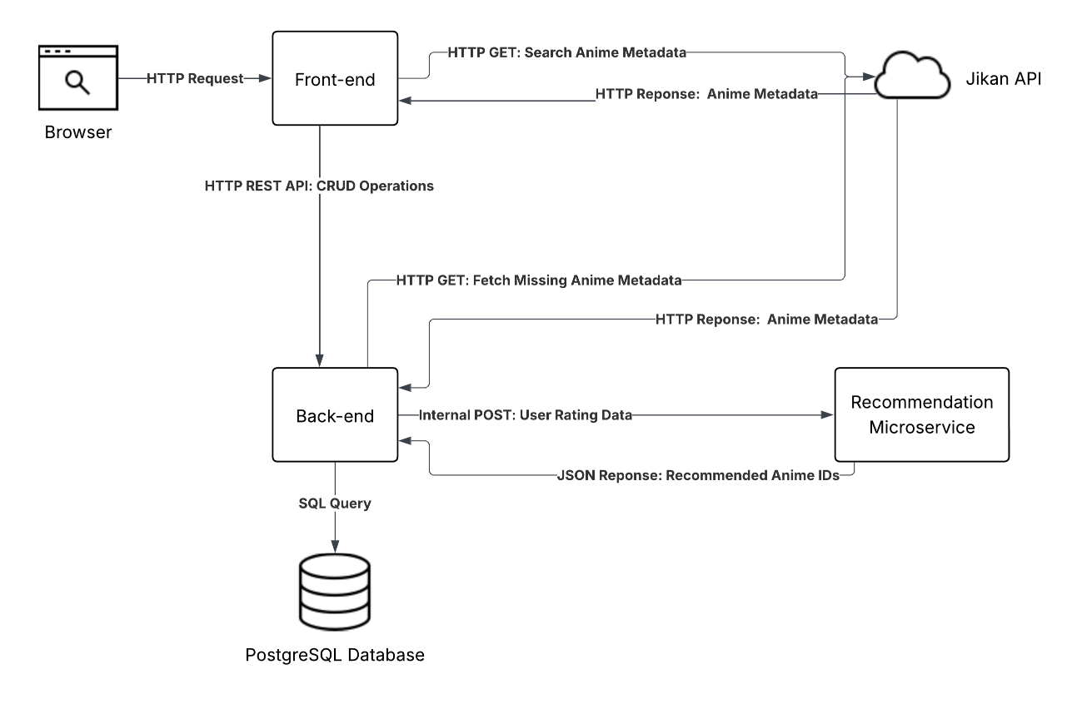
Figure 4.1: Static System Model of Plat-Imee
The primary components of the system are:
- Frontend (React, HTML, CSS, JavaScript): Manages user interactions and communicates with the backend.
- Backend Server (Spring Boot, Kotlin): Processes client requests, manages database interactions, and coordinates recommendation generation.
- Recommendation Microservice (FastAPI, PyTorch): Processes user rating data to generate personalised anime recommendations.
- Relational Database (PostgreSQL): Stores persistent user, anime, rating, and watchlist data.
- External Service (Jikan API): Provides supplementary anime metadata to the system.

Dynamic models
This section details the dynamic behaviour of Plat-Imee, showing how the system components interact in response to user actions. Here, sequence diagrams illustrate three key flows as a precursor to exploring the low-level design. They are as follows: forming a watchlist and requesting recommendations, anime search and viewing, and user login authentication.
These flows were chosen because they represent the core functional pathways that define the user experience withing the system – each flow highlights important dynamic interactions across the front-end, back-end server, database, microservices, and external APIs, capturing not just static architecture but real-time processes that enable personalised recommendations, efficient anime discovery and secure access control.

Watchlist Formation and Recommendation Request
Figure 4.2 details the interactions involved when a user adds an anime to their watchlist, submits a rating, and requests recommendations. When adding an anime, the front-end sends the user’s ID and the selected anime’s MyAnimeList.net ID (malId) to the back-end server. The backend checks whether the anime already exists in the local PostgreSQL database. If the anime is missing, the backend fetches the full metadata - including title, number of episodes, type, and genres - from the Jikan API before inserting it into the database. Upon submitting a rating, the backend updates the associated UserAnime record with the rating value. Finally, when a recommendation request is made, the backend compiles the user's user-anime entries that makes up their watchlist, sends it to the recommendation microservice, and returns a ranked list of anime IDs based on the personalised model output. To note, the anime ID used throughout the system is the malId - the standard from MyAnimeList.net. Additionally, user-anime entries without a given rating use 7/10 as a stand in for recommendation requests – this shows a basic positive preference.

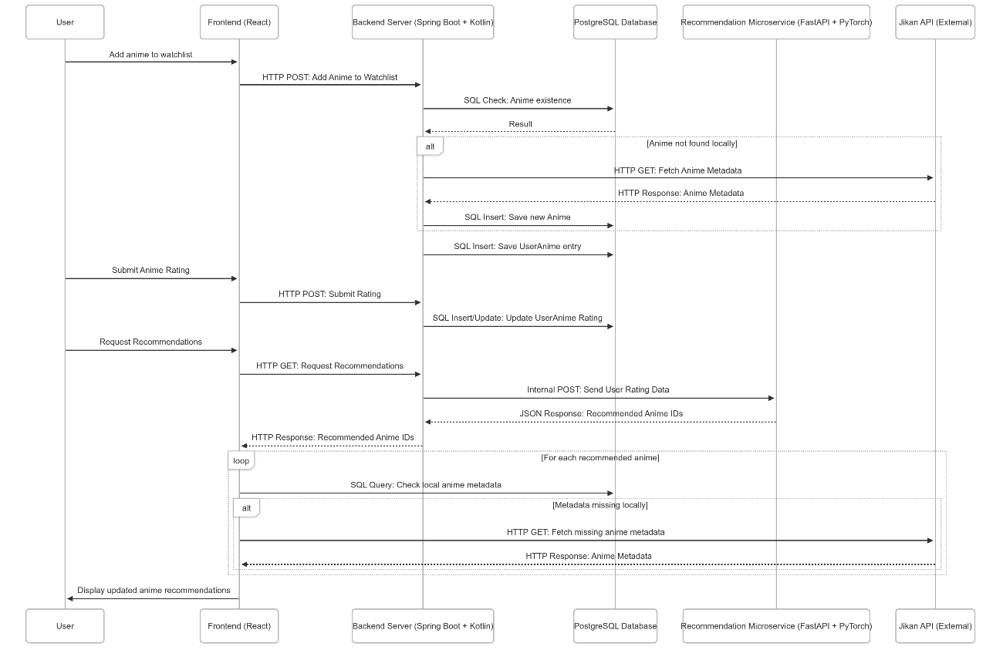
Figure 4.2: Sequence diagram showing the flow of anime addition to a user's watchlist, rating submission, and recommendation generation using the personalised matrix factorisation model in Plat-Imee.

Anime Search and Detail Retrieval
Figure 4.3 illustrates the process of searching for anime and then accessing detailed information on it. When a user accesses anime lists such as trending, upcoming, or seasonal categories—or performs a keyword-based search—the frontend communicates directly with the Jikan API to retrieve summary-level anime data. Should a user then click on a specific anime to view its full details, the frontend first checks a temporary in-session cache to avoid duplicate backend requests. If the anime is not cached, the frontend sends a request to the backend, which then checks if the anime exists in the local PostgreSQL database. If it does not, the backend fetches the complete metadata from the Jikan API, stores it locally, and returns the result to the frontend for display, while also storing a local copy of the data.
While the backend maintains a local copy of anime metadata to gradually build a persistent catalogue, the frontend still directly queries the Jikan API in pursuit of richer anime details such as images, trailers, and extended descriptions. Although this introduces some redundant external calls, maintaining a local database provides multiple advantages: it ensures data consistency for user watchlists, reduces the system's immediate dependency on the Jikan API, helps this project stay within Jikan’s usage limits, provides us with greater control over what data is exposed to its users, and opens the potential for greater filtering/ batch queries unavailable on Jikan such as, to provide an example, retrieving all anime released in Spring 2021 with a rating greater than 8.

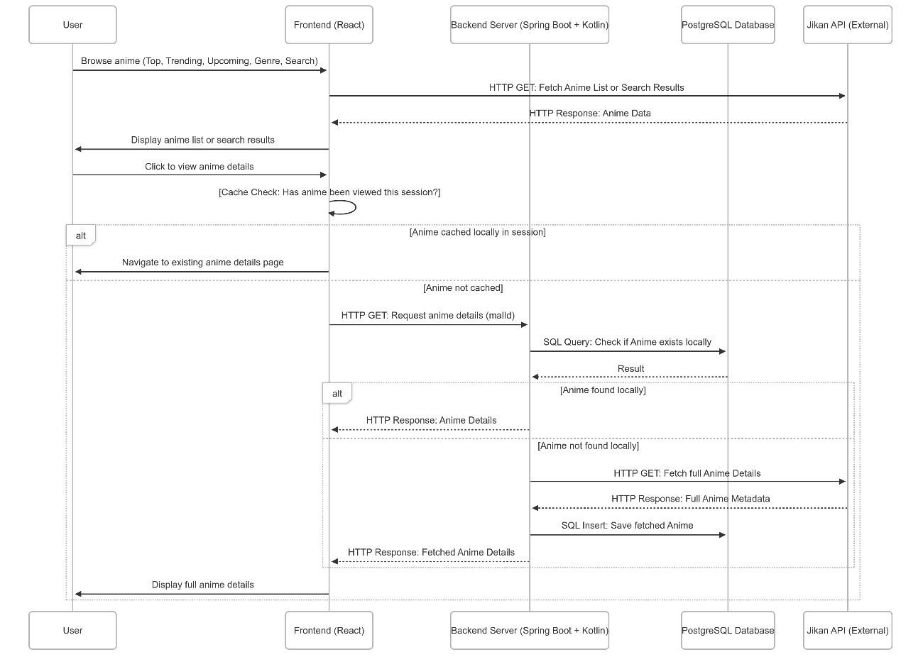
Figure 4.3: Sequence diagram showing how Plat-Imee handles browsing or searching for anime and retrieving full anime details, including fallback fetching, and caching behaviour.

User Login and JWT Authentication
Figure 4.4 illustrates the user authentication process in Plat-Imee. When a user submits their login credentials via the frontend, the backend server verifies them by querying the PostgreSQL database for the corresponding user record and validating the password using BCrypt hashing. Upon successful authentication, the backend generates a JWT (JSON Web Token) containing the user's identity and returns it to the frontend. The frontend then stores the JWT locally, enabling secure authenticated interactions for future API requests by attaching it to them. In the case of authentication failure, an error response is returned, and the user is notified accordingly.
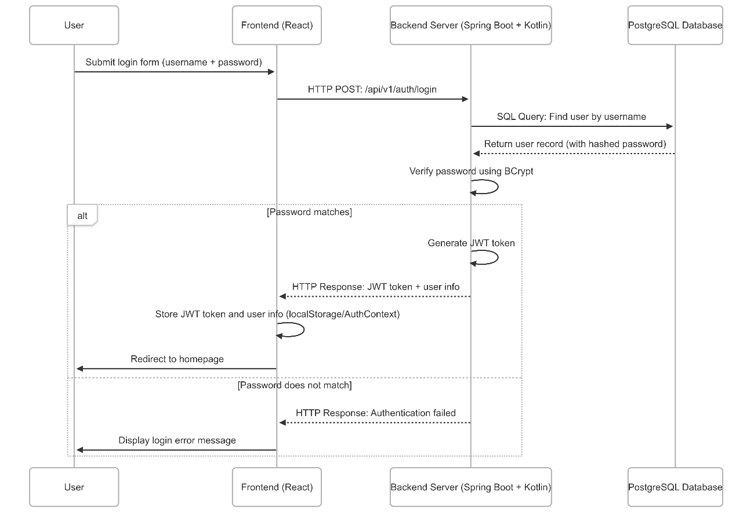
Figure 4.4: Sequence diagram showing the user login authentication flow in Plat-Imee, including credential validation, JWT token generation, and error handling.

GUI
Plat-Imee’s interface consists of a focused set of views designed to support user-friendly anime discovery and personalised recommendations. The homepage presents curated content such as trending anime in the current season, along with sections for top-rated and upcoming titles. Users can also browse by genre or use keyword searches to quickly locate specific anime.
Each anime card includes a 'View Details' button, leading to an individual anime page where users can read more, add the anime to their watchlist, and submit a rating. A dedicated recommendations page shows personalised suggestions based on the user's rating history. Navigation is consistent throughout the platform, with a persistent header offering quick access to search, recommendations, and account functions. Login and registration pages ensure secure access, with the JWT token stored client-side for maintaining sessions across reloads.

Design Focus and Comparison
The design of Plat-Imee intentionally prioritises clarity and task-focus over visual density. Compared to platforms like MAL which display a wide range of features, ads, and community content on their homepage, Plat-Imee achieves a minimalistic interface focused solely on anime discovery and recommendation.
This choice reduces visual clutter and cognitive load, helping users navigate directly to content relevant to their interests. By stripping away unrelated features such as forums, manga categories, and advertising, Plat-Imee maintains a clean layout that aligns more directly with its core purpose: helping users discover anime they are likely to enjoy. Figure 4.5 shows the home page of Plat-Imee to illustrate the difference between it and Figure 2.1.

Figure 4.5: The home page of Plat-Imee.
A comparison between Figure 4.6 and 4.7 exposes a key improvement between Plat-Imee's GUI over that of MAL. The actual anime list feature – a central part of Plat-Imee and as the name implies - that of ‘my [anime list]’ - has been centralised in the GUI instead of being overshadowed by other content and disguised as a vague icon.

Figure 4.6: The home page of Plat-Imee with the link to the anime-list highlighted.
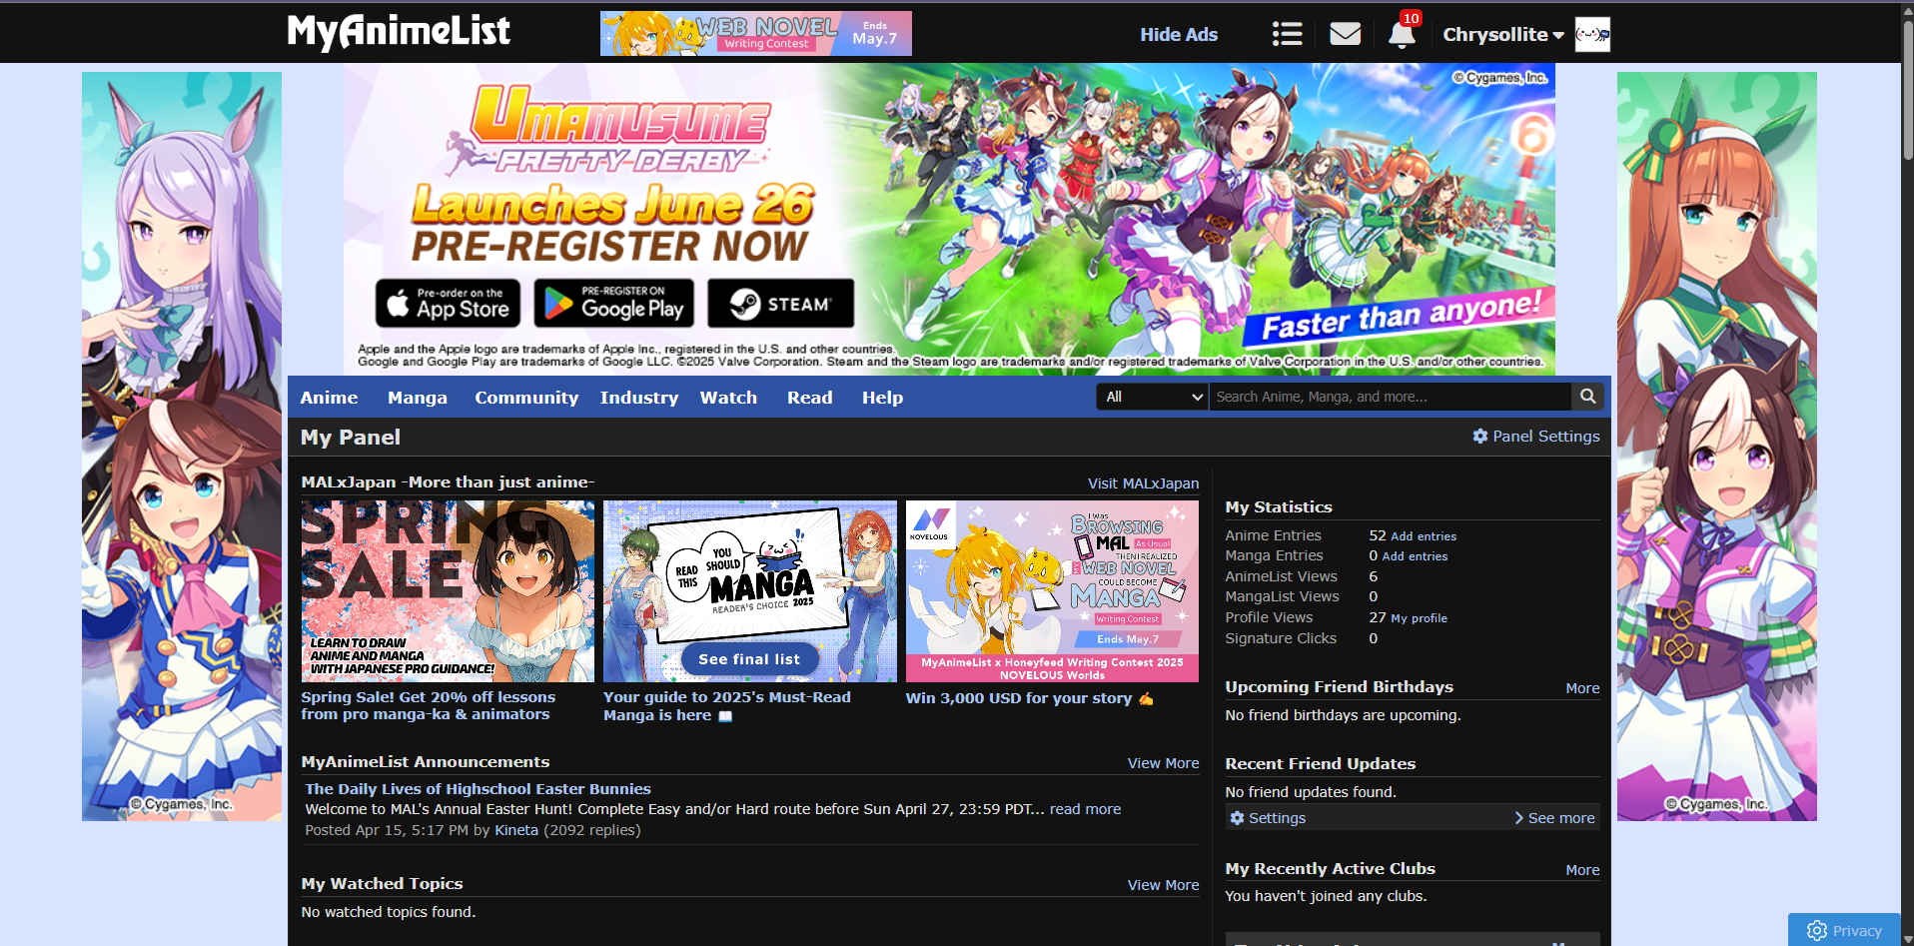
Figure 4.7: The home page of MyAnimeList.net with the to the anime-list highlighted.

Low-Level System Implementation
This section details Plat-Imee’s implementation at the code level; it expands on the systems backend architecture, data handing, machine learning integration and frontend interaction logic. The following subsections cover key components such as the Spring Boot backend and its layered structure, the FastAPI-based recommendation microservice, data transfer and authentication mechanisms, and the handling of anime metadata through both local storage and external API integration. Where relevant, diagrams are included to illustrate request flows, security processes, and system interactions between components.

Backend Server Architecture
Plat-Imee's backend is implemented using Spring Boot and Kotlin, structured around a modular architecture that separates the system into domain-specific packages: anime, user-anime, auth and recommendation. Each of these follows a consistent controller-service-repository pattern to promote clarity, testability, and separation of concerns.
Controllers, located in the entry point subpackages, handle HTTP requests from the frontend – these requests are delegated to services that contain the systems core business logic. Meanwhile, repositories abstract access to PostgreSQL database using Spring Data JPA, therefore allowing concise, declarative interaction with stored data. This structure is summarised in Figure 4.8 which demonstrates the typical flow of a request through the backend layers.

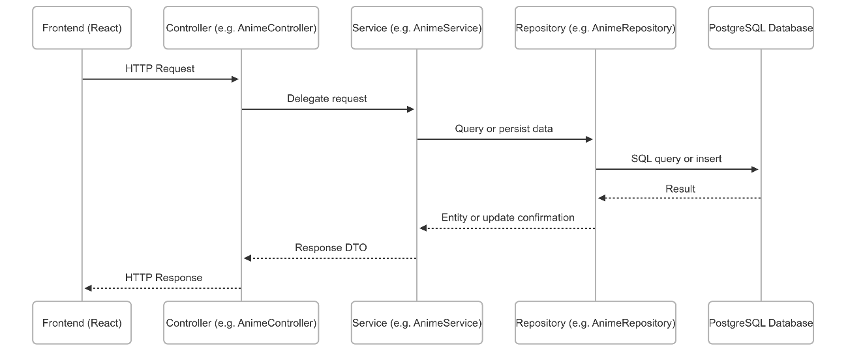
Figure 4.8: Illustrates the typical request flow within Plat-Imee’s backend. This layered structure is consistent across domain modules though some actions (later discussed in 4.2.1.2 and 4.2.1.3) may involve additional operations.

User Registration Flow
Figure 4.9 shows the request flow for user registration in Plat-Imee. When a user submits their registration details via the frontend, the ‘CreateUserController’ delegates the request to the ‘CreateUserService’, which performs the bulk of checks and operations. It first queries the database through the ‘UserRepository’ to ensure the provided username and email are not already in use. These checks are resolved via SQL queries through Spring Data JPA, with PostgreSQL managing the underlying persistence layer.
If the input passes validation, the password is encoded using ‘BCrypt’ before the user entity is saved to the database. The service then returns a ‘UserResponseDTO’ which the controller sends back to the client as JSON providing confirmation of successful registration. This flow reflects a typical example of Plat-Imee’s layered backend design, combining validation, security, and persistence logic in a clean modular structure.

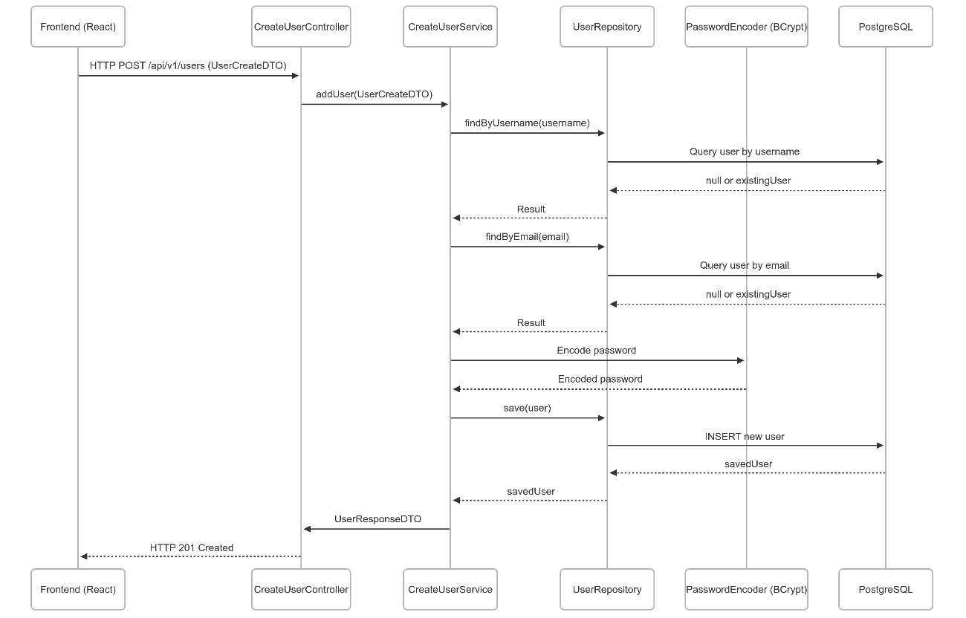
Figure 4.9: User registration flow including duplicate checks, password encoding, and database persistence using the standard layered backend structure.

UserAnime Creation
The UserAnime creation flow can be seen in the first half of Figure 4.3. This flow includes checking whether the selected anime exists in the local database, and if not, fetching its metadata from the Jikan API before saving both the anime and the UserAnime entry. This additional logic is specific to the user-anime domain and is not present in most other backend flows.

Login and Authentication
The implementation of Plat-Imee’s login flow and JWT authentication logic is detailed in Figure 4.4; it shows how the backend verifies credentials, issues tokens using the JJWT library, and enables stateless secure access for future requests.

DTO Usage and Validation
Plat-Imee uses Data Transfer Objects (DTOs) extensively across its backend to encapsulate and validate input data, and to shape consistent responses. DTOs such as ‘UserCreateDTO’, ‘UserUpdateDTO’, and ‘UserAnimeResponseDTO’, separate internal domain models from externally exposed API contracts, improving code clarity, maintainability, and security essentially providing an additional layer.
DTOs are annotated with validation rules using 'jakarta.validation’ annotations such as @NotBlank, @Size, @Email, and @Pattern. This ensures that inputs are validated at the controller level before ever reaching the service layer. For example, ‘UserCreateDTO’ enforces minimum and maximum field lengths, password complexity requirements, and email format validation. These constraints reduce boilerplate code in services and improve robustness by ensuring data correctness early in the request lifecycle.
Response DTOs are generated using dedicated mapper classes, such as ‘UserDtoMapper’, which converts domain entities into structured API responses. This approach decouples internal logic from external representation and ensures a clean separation of concerns throughout the backend.
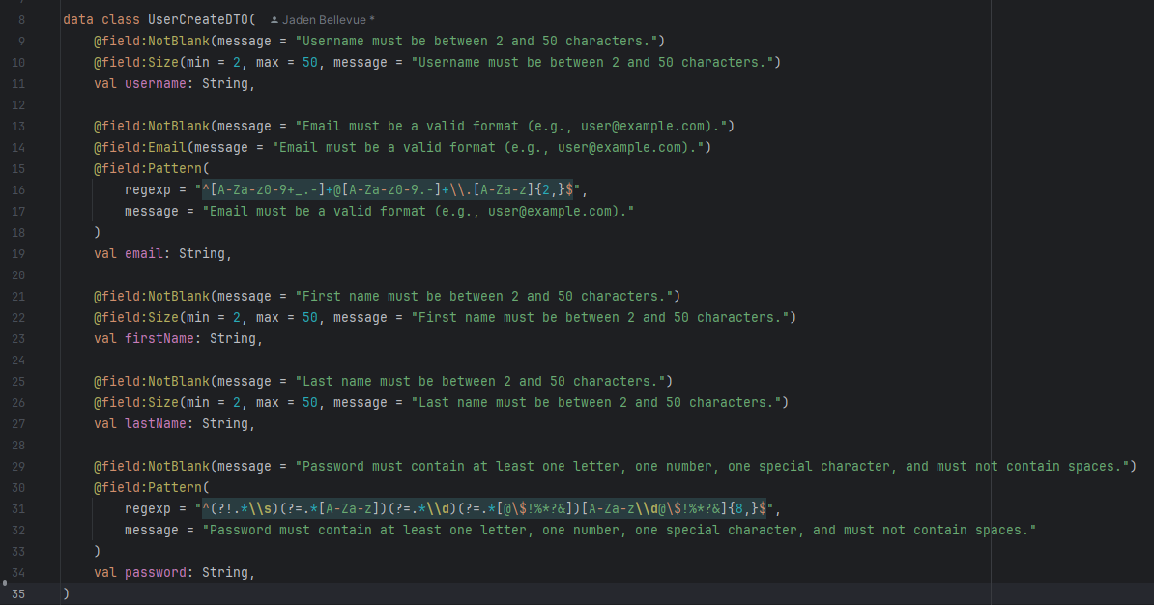
Figure 4.10: The ‘UserCreateDTO’ class which incoming requests to /api/v1/users are deserialised into.

Backend Endpoints
Table 4.1 summarises the key backend API endpoints exposed by Plat-Imee. Each route follows RESTful conventions and is organised by domain. These endpoints are accessed via the frontend and provide core functionality.
HTTP Method | Endpoint | Description
POST | /api/v1/anime | Adds anime to the local database
GET | /api/v1/anime | Retrieves all anime
GET | /api/v1/anime/{malId} | Retrieves a specific anime by its MAL ID (malId)
PATCH | /api/v1/anime/{malId} | Updates a specific anime by its MAL ID (malId)
POST | /api/v1/user-anime | Adds anime to user’s watchlist (with fallback to Jikan)
DELETE | /api/v1/user-anime/{id} | Removes anime from user’s list
GET | /api/v1/user-anime/{id} | Retrieves a specific user-anime record by its entry ID
GET | /api/v1/user-anime?userId={userId} | Retrieves all user-anime entries associated with a specific user
PATCH | /api/v1/user-anime/{id} | Updates user’s rating or watch status
POST | /api/v1/users | Registers a new user
DELETE | /api/v1/users/{userId} | Deletes a user's account
GET | /api/v1/users | Returns a list of all users
GET | /api/v1/users/{userId} | Returns a specific user by their ID
GET | /api/v1/users/me | Returns the currently authenticated user (JWT required)
PATCH | /api/v1/users/{userId} | Updates a user's details
POST | /api/v1/auth/login | Authenticates user and returns a JWT token for future requests
GET | /api/v1/recs/{userId:[0-9]+} | Returns personalised anime recommendations for a given user ID. An optional safe-search filter available.
GET | /api/v1/recs/me | Returns recommendations for the currently logged-in user based on JWT. An optional safe-search filter available.
Table 4.1: The backend server endpoints.
While all listed endpoints are implemented, some were originally designed for flexibility or future features and may not currently be invoked by the frontend. The inclusion of them reflects early planning decisions and can particularly be seen with the later inclusion on the /me endpoints when development switched to focusing on authenticated users.

Build Configuration and Dependencies
The backend is built using Gradle with the Kotlin DSL, set up for Java 21. Dependency management is managed with Spring Boot’s built-in tools so that everything stays consistent across builds. Here is a breakdown of those key libraries and tools:

Spring Boot Starters
These enable most of the core functionality:
- spring-boot-starter-web for APIs.
- spring-boot-starter-data-jpa for database access.
- spring-boot-starter-security for login and protected routes.
- spring-boot-starter-validation for handling input checks.

JSON Handling
- jackson-module-kotlin is used to manage JSON conversion - it deserialises incoming request bodies into Kotlin DTOs and serialises response data into JSON before sending it to the frontend.

Authentication and Security
- JWTs are created and validated using JJWT libraries. The backend signs a token on login and checks it on protected routes.

Database and Persistence
- PostgreSQL is used as the main database, and Spring Data JPA takes care of saving, updating, and querying data behind the scenes. H2 is used for running tests without needing the real database.

Validation
- DTOs use annotations like @NotBlank, @Size, and @Email from the Jakarta validation API to make sure the data coming in is clean.

Testing Stack
- Tests are written using Kotest and Mockk, along with Spring Boot’s test framework; It all runs on JUnit 5.

Database Structure
Figure 4.11 presents the relational structure of Plat-Imee's backend database. Given that the backend uses Spring Data JPA, this diagram closely reflects the system’s core domain model, which in turn makes it more suitable than a class diagram that would otherwise detail each controller, service and repository and DTO – just to name a few of the components – producing clutter when instead that further information can be derived from previous sequence diagrams.
Each table in the database corresponds directly to an entity class (e.g., User, Anime, UserAnime) and includes foreign key relationships that enforce data integrity and support the overall modular design of the backend.
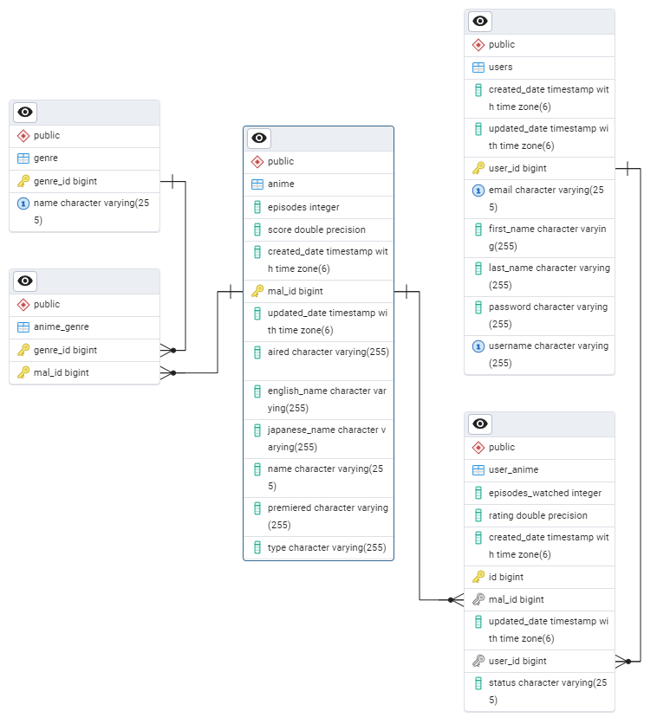
Figure 4.11: Entity Relationship Diagram of Plat-Imee's database structure.
The diagram presents a clean and well-normalised schema centred around five tables. The users and anime tables represent core entities, each identified by unique primary keys (user_id and mal_id, respectively). The user_anime table functions as a join table enriched with user-specific metadata such as rating, status, and episodes watched, enabling many-to-many relationships with meaningful context – anime lists. Genre information is stored independently in the genre table and linked to anime entries via the anime_genre join table, allowing each anime to be associated with multiple genres in a consistent manner. Foreign-key constraints maintain referential integrity, while consistent use of timestamp fields (created_date, updated_date) supports reliable tracking of data changes.

Database Seeding with Anime Dataset
To initialise the platform’s content, Plat-Imee includes a startup seeding process that populates the anime and genre tables using the dataset anime.csv. This is handled by a Spring CommandLineRunner bean (AnimeSeeder), which is executed automatically on application startup, unless the active profile is set to test.
The seeder reads each row from the CSV file, parsing fields such as mal_id, name, score, episode count, and types (e.g., TV, OVA, Movie). It also extracts genres from a comma-separated string ensuring each genre exists in the genre table—creating new ones if needed. These are then associated with the anime via a many-to-many relationship through anime_genre. To prevent unnecessary re-seeding, the system checks if any anime already exists in the database and skips the process if records are present.

Recommendation Microservice Architecture
The recommendation system in Plat-Imee is implemented as a standalone microservice using Python, FastAPI, and PyTorch. It is responsible for generating personalised anime recommendations based on user watchlist/ rating data. When a user requests recommendations via the frontend (more specifically from the /recommendations page), the request is routed through the /api/v1/recs/me endpoint in the backend where the user's identity is extracted from the JWT token. The backend retrieves the user's anime ratings and sends them, along with a safeSearch flag, in a POST request to the external microservice at /api/recommendations. The microservice uses a matrix factorisation model to infer a user embedding and compute a relevance score for each anime. For users already present in the model (warm users), their learned embedding is used directly; for new or cold-start users, a temporary embedding is constructed by averaging the embeddings of rated items, weighted by the rating values. If safe search is enabled, the system filters out anime tagged as ecchi or hentai. It then returns a ranked list of anime malIds, which the backend forwards to the frontend. This modular structure allows the recommendation logic to evolve independently of the web application stack.
As shown in Figure 4.2, the complete communication flow spans the frontend, backend, and recommendation microservice. The microservice is responsible for the core model inference and filtering, while the backend handles user validation, rating retrieval, and final response formatting.

Request Handling and Input Structure
The FastAPI endpoint /api/recommendations receives a POST request from the backend with a payload containing the users ID, a list of rated anime, and a safe search flag. The request is parsed and validated using Pydantic models which is essentially a DTO given that it's used for input/ output, enforces structure, handles defaults and validates data.
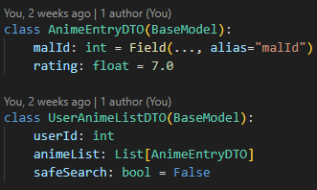
Listing 4.1: The format of input of the microservice.
This design ensures the recommendation service can function even if the user did not explicitly rate each anime. In such cases, a default score of 7.0 is assumed to represent mild preference.

Neural Network-Based Matrix Factorisation Model
At the core of the microservice lies a matrix factorisation model – a shallow neural network implemented using PyTorch. A neural network is a type of machine learning model that draws inspiration from the human brain, with the goal of learning patterns from data by making predictions and then adjusting its internal parameters based on error. This learning happens through a training loop that consists of two main phases: forward propagation, where the model makes a prediction from the input, and backward propagation, where it compares the prediction to the correct answer, calculates the error, and adjusts the weights to improve future predictions. This process is handled internally by PyTorch.
A shallow neural network refers to a model with only one or two layers of learnable parameters. In this case, the model consists solely of embedding layers, which are special layers that convert user and anime IDs into dense vectors of numbers (called embeddings). These embeddings capture traits like preferences or content similarity and are used directly to make predictions without any extra processing steps/ deeper layers in between. This simple structure keeps the model lightweight and fast to train, while still allowing it to learn useful patterns from rating data.
In Plat-Imee, the model learns:
- A vector (embedding) for each user where each entry is a latent factor.
- A vector for each anime.
- A bias term for each user to capture consistent tendencies (e.g., lenient or harsh raters).
- A bias for each anime (e.g., consistently highly or poorly rated content).
The final prediction for how much a user will like a given anime is computed using a dot produce between their respective embeddings plus the biases.
Listing 4.2: The calculation of the prediction.
The sum(dim=1) operation in PyTorch sums across the embedding dimensions, effectively computing the dot product between each user–anime embedding pair.
During training, the model minimises prediction error using the Mean Squared Error (MSE) loss function - a standard choice for regression tasks like rating prediction. Optimisation is performed using the Adam algorithm, which adaptively adjusts learning rates for each parameter and typically converges faster than basic gradient descent.
To promote stable learning at the start of training, embedding weights are initialised using a normal distribution with small variance (mean = 0, std = 0.01) - this means that numbers will be centred around 0 and stay small to discourage large/ erratic predictions. To add, bias terms are initialised to zero to avoid introducing skewed predictions in early iterations.
This structure is compact, fast to train, and expressive enough to capture meaningful patterns in sparse user–anime interactions.
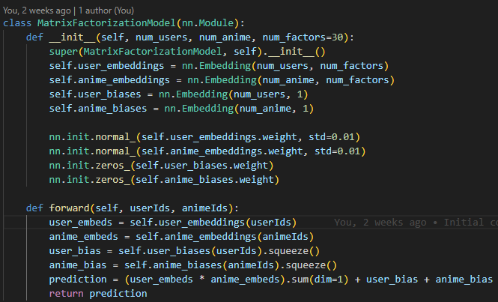
Listing 4:3: Implementation of the ‘MatrixFactorizationModel’ class. This shallow neural network learns user and anime embeddings along with bias terms and computes predicted relevance scores using a dot product.

Cold-Start Inference: User Embedding Construction at Runtime
Plat-Imee's recommendation system generates predictions for all users, using a cold–start strategy. This comes consequently to the matrix factorisation model not being retrained after deployment, meaning that no persistent user embeddings exist outside of the initial training set. Instead, the microservice constructs temporary user embeddings; it comes based on the user’s submitted watch list and ratings. This approach avoids the overhead of retraining every time a new user shows up and ensures the system can serve recommendations to any user without historical data on the service.
While the underlying model structure supports warm-start inference—as noted in the generation of user embeddings for warm start users—this feature is not currently in practice given that the recommendations are only ever requested by new, untrained users from Plat-Imee. The current design always builds embeddings on the fly leaving cold-start inference as the standard mode of operation.
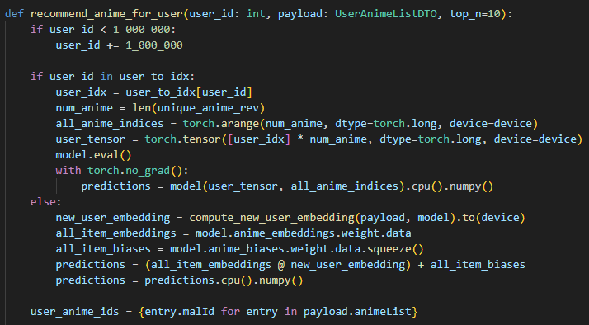
Listing 4.4: The separated logic for recommending anime for warm and cold start users. A buffer of 1,000,000 is applied to the user IDs to ensure that they are not present in the training data which only goes into the thousands, therefore it always triggers the ‘else’ portion of the code.

Constructing Cold-Start Embeddings
Given that recommendations are centred around the similarity between user and item embeddings, a user’s tastes can be approximated by averaging the embeddings of the content they’ve consumed, weighted by their rating for each item. In Plat-Imee, this is achieved by taking the learned anime embeddings, multiplying them by their corresponding user ratings, and averaging the result to form a temporary user vector.
This approach allows the system to simulate a user embedding even if the user was never seen during training. The resulting vector—built from known item embeddings and the user’s expressed preferences—can then be used directly to generate recommendation scores just like a regular embedding.
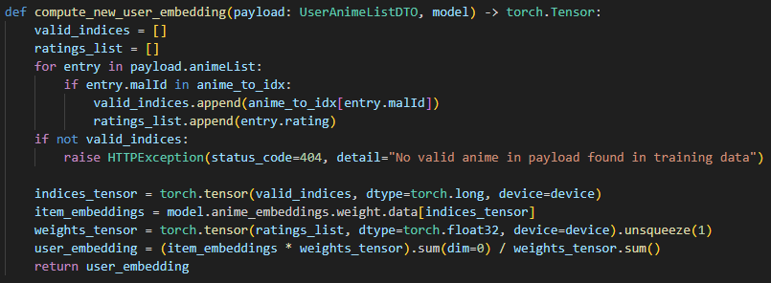
Listing 4.5: The code for computing a cold start users temporary embedding.
To make this more concrete, consider the example of Table 4.2:
Anime | Rating | Embedding
A | 8.0 | [0.1, 0.4, -0.3]
B | 9.0 | [0.0, -0.2, 0.7]
C | 7.0 | [0.2, 0.0, 0.5]
Table 4.2: Example data.
Step 1: Multiply each embedding by its rating:
- A × 8 = [0.8, 3.2, -2.4]
- B × 9 = [0.0, -1.8, 6.3]
- C × 7 = [1.4, 0.0, 3.5]
Step 2: Sum and average
- Sum = [0.8 + 0.0 + 1.4, 3.2 - 1.8 + 0.0, -2.4 + 6.3 + 3.5] = [2.2, 1.4, 7.4]
- Average = [2.2 / 24, 1.4 / 24, 7.4 / 24] ≈ [0.092, 0.058, 0.308]
This temporary vector becomes the cold-start user embedding.

Prediction Logic: Cold vs Warm
In both warm and cold-start scenarios, the system produces a relevance score for each anime. However, the way these scores are computed differs slightly in implementation.
For warm users, the model uses the learned embedding for that user along with the item embeddings and respective biases:
Listing 4.6: Prediction calculation for warm start users.
This operation multiplies the user and anime embedding vectors elementwise, sums the result across dimensions (i.e., performs a dot product), and adds the user and anime biases.
For cold-start users, there’s no learned user embedding or bias. Instead, the system computes a temporary embedding on the fly, and the prediction is made via:
Listing 4.7: Prediction calculation for cold start users.
Here, @ represents matrix multiplication between all anime embeddings and the new user embedding. This results in a single relevance score for each anime. To explain what’s happening mathematically:
$${\text{score}}_{i}=\sum_{k=1}^{d}{}\hat{u_{k}}⋅v_{i,k}+b_{i}$$
Where:
- $\hat{u_{k}} \text{is the }k\text{-th entry in the temporary user embedding}$
- $v_{i,k} \text{is the }k\text{-th entry in the embedding of anime }i$
- $b_{i} \text{is the bias term for anime }i$
- $d \text{is the embedding dimension}$
This formula computes the dot product between the user's vector and an anime's vector and then adds the anime bias. This is the same as in the warm-start approach, except that it does not include a user bias.
The reason there is no user bias for cold-start predictions is because the user does not have a persistent identity in the trained model. User biases are parameters that are specifically learned during training for each individual user ID. Since cold-start users are handled dynamically during inference, and were not part of the training process, the model has no stored bias term for them.
As a result, the predictions for cold users are based only on the temporary user embedding and the anime's learned characteristics. While this can lead to slightly less accurate predictions in some cases—especially for users who consistently rate things higher or lower than average—the weighted embedding still captures the user's overall preferences effectively.

Safe Search Filtering
To ensure user preference for content moderation are respected - this filtering occurs after the recommendation scores are computed. The system iterates through the ranked list of recommended anime and excludes any entry whose genre field includes a restricted tag. This allows the model to remain unchanged while enforcing a post-processing filter tailored to user preference.
In addition to safe search, the system also filters out anime that the user has already rated. These are removed by comparing the recommended malIds with the list of anime IDs received in the request body. This ensures that the recommendations surface novel content rather than repeating previously consumed titles.
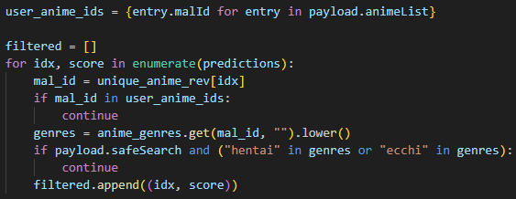
Listing 4.8: The filtering system.

Preprocessing for Model Training
To give some insight into the training data itself; Plat-Imee is trained using historical user–anime rating data sourced from the rating.csv dataset. This dataset consists of user IDs, anime IDs (malIds), and their corresponding ratings.
Before the matrix factorisation model can be trained, raw rating data must be formatted to fit the requirements of PyTorch’s neural network components - specifically, the embedding-based architecture. Note: An embedding layer maps discrete indices (like user or anime IDs) to continuous vectors. These vectors are trainable parameters that are updated through backpropagation. While the layer looks up an initial vector for a given index, it also learns those vectors over time, making it more than just a static lookup.
This involves transforming the original user and anime IDs into zero-based integers (a contiguous range of integers starting from 0). The embedding layers in PyTorch expect this format, as they are index-based where each index refers to a row in the trainable embedding matrix.
In Plat-Imee, this is handled through the following preprocessing steps:
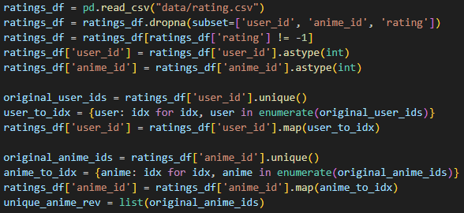
Listing 4.9: Preprocessing the data during the startup event.
This snippet reads in the ratings data, removes entries that are either missing or marked as unrated (-1), and casts IDs to integers for consistency. Then, each unique user and anime ID is remapped to a zero-based index. These new indices are the values that will be passed into the model’s embedding layers during training.
The user_to_idx and anime_to_idx dictionaries are saved and used during both training and inference to keep mappings consistent, while unique_anime_rev stores the reverse mapping to allow output predictions to be re-associated with their original malIds when presenting results.
Additionally, the anime.csv file is also loaded and cleaned to ensure the genre data needed for safe-search filtering is available later in the pipeline:
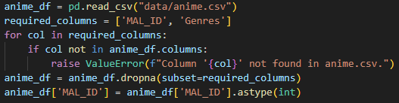
Listing 4.10: Loading the anime.csv file and checking if it’s properly formatted under the required columns.

Training Loop and Model Saving Process
With the data now formatted as zero-based integer indices, the system enters its training phase. The training process involves iterating over batches of user–anime–rating triples, using PyTorch’s data loader to manage shuffling and batching. In each epoch, the training loop performs the following:
Forward pass:
The model receives batches of (user, anime) pairs and predicts a rating for each using the matrix factorisation formula found in the forward() function:

Listing 4.11: Forward propagation.

Loss computation:
The prediction error is calculated using the Mean Squared Error (MSE) loss function:

Listing 4.12: Loss calculation.

Backward pass:
PyTorch computes the gradients of the loss with respect to each trainable parameter:

Listing 4.13: Backwards propagation.

Weight update:
The Adam optimiser updates the model’s parameters:

Listing 4.14: Weight updates.

The full training loop looks like this eventually returning the trained model:

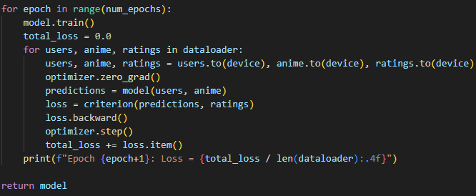
Listing 4.15: Full training loop.

Over time, the model learns to assign embeddings that represent a user’s preferences and an anime’s characteristics, minimising the gap between predicted and actual ratings.

Model Saving and Inference Preparation
After training, the model is ready to be used for generating recommendations. At this point, there’s no need to continue calculating gradients (numerical values that represent how much each parameter (like an embedding weight) influences the prediction error). During training, gradients are essential as they guide the adjustments to the model’s parameters through backpropagation. During inference however, where the model only makes predictions, they add unnecessary computation and memory usage.
To disable gradient tracking and enable faster, more efficient prediction, PyTorch provides torch.no_grad():
Listing 4.16: Disabling gradients.
The model’s learned parameters, including user and anime embeddings and biases, are then saved using:
Listing 4.17: Saving the model.
This stores only the weights, so during startup the model structure must be re-instantiated and loaded with those weights:
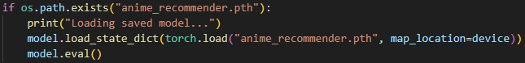
Listing 4.18: Loading the existing model.
Finally, during inference, the system switches between warm and cold-start logic based on whether the user ID exists in the training data. This logic for this is handled within the recommend_anime_for_user() function and avoids unnecessary recomputation for trained users, while still enabling recommendations for new users.

React frontend Structure
The React frontend for Plat-Imee is structured around a clear separation of concerns. Each major page is handled by its own component, and utility files handle shared tasks like API requests or navigation logic. The routing system defines how users move between pages, and the overall layout is tied together through App.js. Core behaviour like authentication and route protection is centralised in context and wrapper components, helping the app stay organised even as it grows.

Authentication and Routing
Plat-Imee manages user authentication and route protection through the pairing of JWT tokens, a React context, and a dedicated private route wrapper. This ensures that users can securely sign in, with protected pages only being accessible to authenticated users.
When a user logs in via the /login page, their credentials are sent to the backend at /api/v1/auth/login. If the login is successful, the backend returns a ‘LoginResponseDTO’ (In JSON as with all requests and responses) containing both a JWT token and basic user data. This token is stored in the browser’s local storage and used to authenticate future API requests.
The AuthContext.js file defines the global context for managing authentication state. Upon successful login, the frontend sets the user data directly using the response from the login endpoint. The token is stored locally, and the user data is made available across the application via the context, enabling authenticated components to reactively render based on login state.

Route Protection
To ensure that only authenticated users can access certain parts of Plat-Imee, such as a user's anime list page, the application defines a custom PrivateRoute component. This wrapper relies on the global authentication context to check whether a user is currently logged in.
Internally, PrivateRoute.js pulls the user and loading states from AuthContext. If the authentication status is still being determined (loading is true), a simple loading message is displayed. If no user is present, the route redirects to /login. Otherwise, it renders the target route as expected.
This approach centralises access control logic in one reusable component, keeping protected pages clean and focused on their specific responsibilities.

Centralised HTTP Requests with Axios
Plat-Imee uses a centralised Axios instance (axiosInstance) to handle all frontend communication with the backend API. This instance is configured once with a base URL (http://localhost:8000/api/v1) and includes logic for automatically attaching the JWT token to each request.
The token is retrieved from localStorage and injected into the Authorisation header of each outgoing request via an Axios request interceptor. This ensures that protected endpoints always receive the required credentials without duplicating logic in each request.
By wrapping Axios this way, Plat-Imee maintains consistency and reduces boilerplate across all API calls.

Adding Anime to the User’s List
The ‘handleAddToList.js’ file defines a reusable function that allows users to add anime to their personal list, typically triggered by selecting the ‘add to list’ buttons on anime entries.
When triggered, the function builds a request body containing:
- malId: the anime’s MAL ID.
- userId: the current user’s ID.
- status: set to “Watching” by default in the backend.
- rating: left as null to given that the user has not yet provided a rating.
- episodesWatched: initialised to 0.
A POST request is then sent to /api/v1/user-anime using the shared axiosInstance, which automatically attaches the user’s JWT token. If the backend confirms that the anime was successfully added, the callback is triggered allowing the component that initiated the request to respond accordingly, showing a success message.

Viewing Anime Details
The handleViewDetails.js utility provides a consistent and centralised way to navigate to the detailed view of a selected anime. It plays a supporting role in various parts of the front end that present the cover picture and title names of anime entries and allow further details to be discovered by clicking through to them.
When handleViewDetails() is triggered, it first checks whether the anime’s malId is already cached locally in memory via a simple Set. If not, it attempts to verify the anime’s existence by sending a GET request to /anime/:malId. If the anime does not yet exist in the local database (resulting in a 404 error), the utility constructs a payload using metadata from the original Jikan response and issues a POST request to /anime to create the anime locally. This includes fallback handling for missing or optional fields, such as defaulting to "TV" for unknown types or 0.0 for missing scores.
Once the anime’s existence is confirmed (either because it already existed or was just created), the user is redirected via React Router to the /anime/:malId route to view its full details. This approach, illustrated by figure 4.3, ensures that the frontend can safely display anime details from both user searches and recommendation result - even when the anime was not previously part of the local dataset.

My Anime List Page
The MyAnimeList component - not to be confused with MyAnimeList.net (Despite being inspired by it) - gives logged-in users a central place to view and manage the anime entries that make up their personal lists. It uses tab-based filtering, giving users the ability to switch between different lists distinguished by their watch statuses - ‘Watching’, ‘Completed’, ‘On Hold’, ‘Plan to Watch’ and ‘Dropped’. The lists themselves contain the index number of the anime in the list, its MALID, name, status, rating and episodes watched, where the ID serves as a link to further details of the show.
Each entry comes with the following options:
- Edit: Clicking on the row or the edit button enables inline editing of the user’s rating, status and episodes watched.
- Save: Clicking the checkmark or pressing ‘Enter’ sends a PATCH request to /user-anime/{recordId} to save updates.
- Delete: Clicking the delete icon triggers a confirmation dialog that if accepted, sends a DELETE request to /user-anime/{recordId}, removing the record

Recommendations Page
The Recommendations.js component is responsible for displaying personalised anime suggestions to the user. Recommendations are not generated automatically, the user must click on the ‘Generate Recommendations’ button to initiate the process; a design choice made to give users explicit control over when recommendations are fetched, preventing unnecessary API calls while allowing the user to toggle safe search before retrieving results.
When clicked, the fetchRecommendations() function is triggered. This sends a GET request to /api/v1/recs/me, including the user's JWT token and a safeSearch query parameter that reflects the state of a checkbox on the page. The backend returns a ranked list of anime mal_ids.
To display more information, the frontend then sends separate requests to the Jikan API to fetch detailed metadata for each recommended anime. This step is necessary because the backend response only includes minimal identifiers – the malIds, rather than full anime information (especially since the database and recommendations system dataset do not contain the necessary images).
The resulting list is rendered dynamically with cover images, titles, and type information. Clicking on an image invokes the handleViewDetails utility to navigate to the detailed view and ensure the anime exists in the local database.
This on-demand, client-driven generation flow keeps the interface responsive while letting users control when and how they want to fetch their recommendations.

Editing the User Profile
The edit profile functionality allows users to update their personal account details; their email, first name, last name and password. When the user navigates to the Edit Profile page, a form is rendered with input fields corresponding to the modifiable attributes. Upon submission, a PATCH request is sent to the backend at /api/v1/users/{userId}, with the updated fields included in the request body. This is done using the shared axiosInstance, which automatically attaches the user’s JWT for authentication.
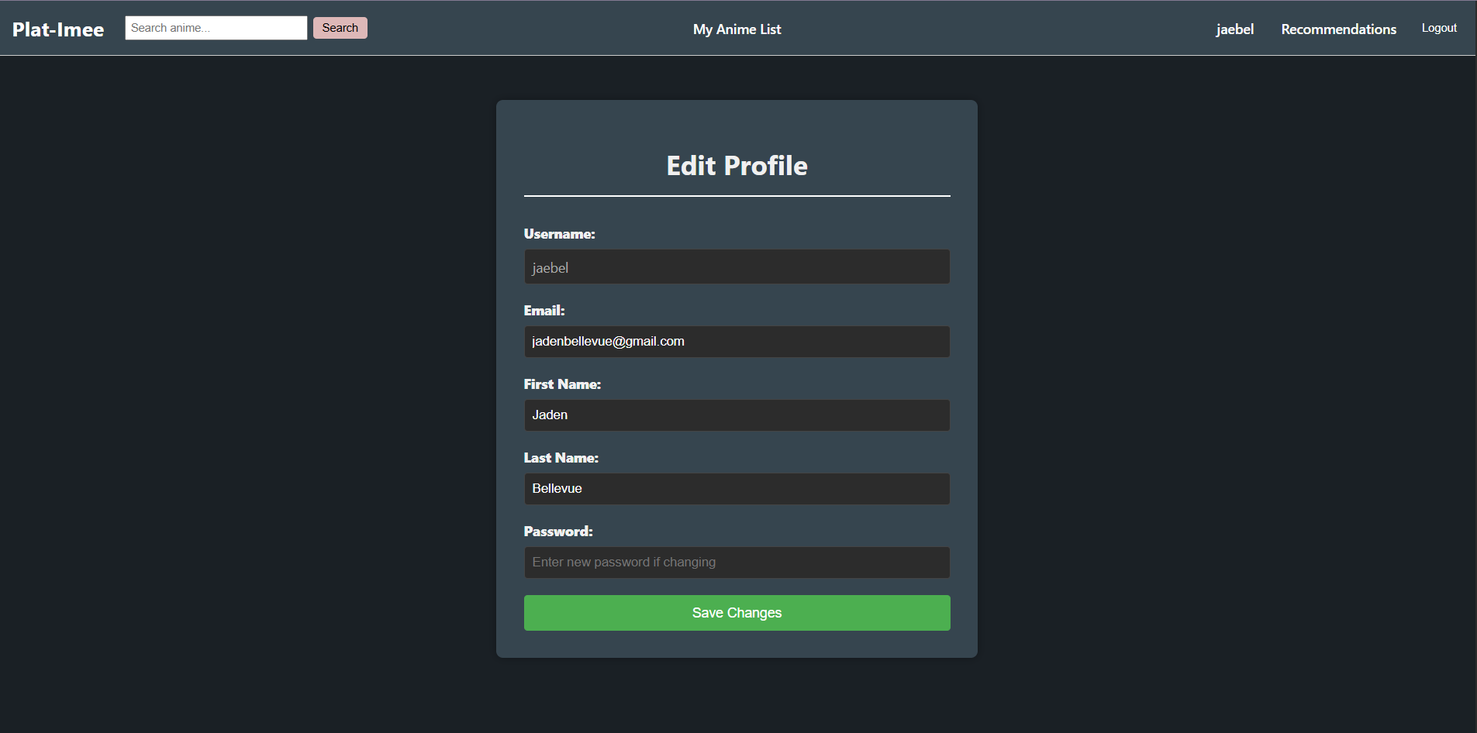
Figure 4.12: The edit profile page of Plat-Imee.
Noticeably in figure 4.12, the username is immutable, this comes as consequence to the earlier implementation where the username is set as the unique identifier used for authentication and token generation. If the username was the change:
- The token would still hold the old username as the subject.
- Any attempt to retrieve the user with the new username would fail unless the token is refreshed.
A work around would have involved further implementation. To add, this compromise was accepted given that many platforms do not offer name changes.

Frontend Structure Overview
The table above outlines the key frontend components and utility files in Plat-Imee. It highlights how responsibilities are separated across files, from user authentication to content navigation and external API interaction. While some files such as axiosInstance.js and ‘JikanService.js’ are structurally important, they follow conventional patterns and do not require further elaboration.
Page/ file | Purpose
App.js | Entry point for routing; wraps all components with context providers.
Login.js | Renders the login form and handles authentication.
SignUp.js | Handles new user registration.
Home.js | Displays a welcome page or overview.
MyAnimeList.js | Shows the logged-in user’s anime watchlist.
Recommendations.js | Let's users request and view personalised anime suggestions.
GenrePicker.js | Allows users to browse anime by selected genres.
EditProfile.js | Enables users to modify their account details.
Navbar.js | Provides navigation links across the app.
PrivateRoute.js | Restricts access to authenticated users only.
AuthContext.js | Maintains global user authentication state.
handleAddToList.js | Adds anime entries to the user's list; reuses server-side fallback logic.
handleViewDetails.js | Navigates to a detailed anime page, creating the record if needed.
JikanService.js | Contains helper methods for querying the Jikan API.
axiosInstance.js | Centralised Axios config; attaches JWT token to requests automatically.

Recommendation Optimisation
To improve recommendation accuracy while reducing prediction error, Plat-Imee’s model employs a dedicated optimisation script using Optuna – a python framework for hyperparameter tuning. The immediate goal is to minimise mean squared error (MSE) on the validation set, improving the model’s predictive accuracy across a range of user profiles.
The optimisation script mirrors the architecture of the deployed recommendation model. It begins by loading and cleaning the anime ratings dataset, mapping user and anime IDs to index space. The dataset is then split into a training and validation set (with an 80/ 20 split – a split within the recommended standard as heard from Encord.com [43]), allowing for independent evaluation of performance after each training cycle.
For each Optuna trial, a new instance of the model is created using a different combination of hyperparameters:
- num_factors: the number of latent dimensions in the user and item embeddings which controls the model’s capacity to learn complex relationships.
- learning_rate: a value that determines how aggressively the model updates its weights during training.
- weight_decay: a factor that penalises large weights to help reduce overfitting.
- num_epochs – the number of full passes over the training dataset during one trial.
As touched upon, this trail model is trained on the training split (80% of the data) where it learns to predict ratings by adjusting the weights and embeddings; it’s the same action the final model took but with less data. After each training epoch the model is evaluated on the validation split – the remining 20 percent – which it has never seen during training; it is an action that is exclusive to the optimising script. This allows the script to measure how well each model generalises to new data rather than memorising patterns from the training set (which is what overfitting is). Additionally, if the validation MSE stops improving for a few epochs then early stopping is employed to save time. Once training is complete, the validation MSE is recorded as the result of that trial.
So why is this split exclusive to the optimisation script? optuna_tuner.py is focused on evaluating alternative configurations and needs a validation set to avoid bias, while main.py is focused on deploying the final model and benefits from using the full dataset and best-known hyperparameters for training.
After 30 Optuna trials, the configuration that achieved the lowest validation MSE (1.4606) used:
- Latent factors: 30
- Learning rate: 0.00098238482170162
- Weight decay: 1.7546484188145045e-06
- Number of epochs: 19
These values were used to retrain a final model, which was saved as ‘anime_recommender.pth’ and integrated into the Plat-Imee system. In this report we highlight the results of such training in the evaluation section. At this stage there is confidence that the training configuration is now grounded in empirical evidence rather than guesswork.
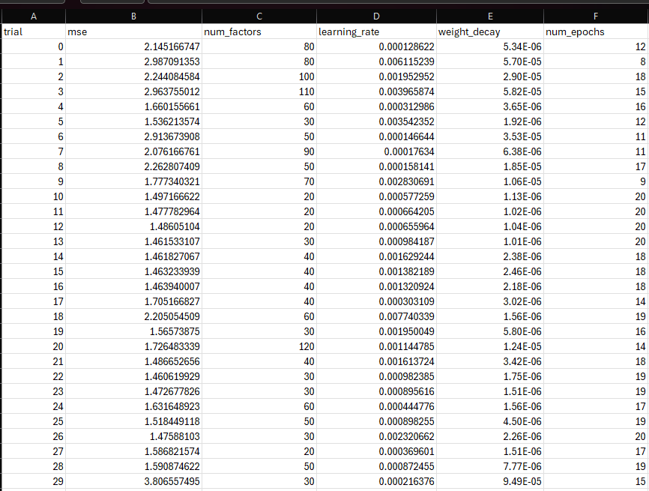
Figure 5.1: The optuna_trials.csv file showing the output of all its trials resulting MSE.

Testing
Bolstering the reliability, correctness and robustness of Plat-Imee, a comprehensive suite of automated tests was developed for the backend server implemented using Spring Boot and Kotlin. The testing strategy covers core functional areas including user management, anime records, user-anime interactions and the recommendation endpoint. These tests verify both the expected behaviours (happy paths) and edge cases (sad paths), ensuring that the system responds appropriately under a variety of conditions.
The backend tests were written using the Kotest framework alongside MockMvc, allowing full HTTP-level interaction with the controller endpoints without deploying the application. To isolate these tests and avoid dependencies on external systems, an in-memory H2 database was used with a dedicated test profile and test-specific configuration (application-test.yml). Spring Security was also accounted for in tests through a custom ‘TestSecurityConfig’, enabling secure endpoints to be tested by simulating authenticated users.
To add, the recommendation microservice’s integration with the backend was tested by mocking external HTTP calls to its /api/recommendations endpoint – this ensures that even if the Python-based microservice is unavailable, the backend can be reliably validated for correct request/response behaviours and payload handling.
Each section of the backend was tested independently with meaningful assertions that check not only status codes but also content structure and values. Where appropriate, repositories were queried directly to confirm persistence-layer outcomes.

Test-Driven Development
Throughout the development of the Plat-Imee backend, a test-driven development (TDD) approach was adopted where feasible. This involved writing tests for controller endpoints and service logic before fully implementing the corresponding features. By doing so, the structure of expected inputs, outputs and failure modes was clarified at an early point thus guiding the development of robust and modular code without having to return to would-be later spotted errors. TDD was particularly beneficial for features like user creation, input validation and recommendation endpoint integration, where defining clear acceptance criteria helped identify edge cases upfront. This practice improved test coverage, accelerated debugging and ensured confidence in my work through development.

Test Coverage Table

Tested Component | Functionality Tested | Testing Approach & Tools
User Controller | Create, Get (all/by ID), Update (partial/full), Delete; extensive input validation | MockMvc, Kotest, sad paths (e.g., invalid emails, duplicate usernames), security mocking used
Anime Controller | Create, Get (all/by ID), Update; Genre associations, field assertions | Uses ‘GenreRepository’ to pre-seed genres; validates genre mappings and update integrity
UserAnime Controller | Add to watchlist, retrieve, update status/rating/episodes, delete | Tests default status, handles non-existent records, uses repo directly for user/anime seeding
Recommendation Endpoint | Verifies integration with external microservice via mock server; tests GET and service layer | Uses ‘MockRestServiceServer’ to simulate /api/recommendations POST calls, asserts full flow
Integration & Security | Custom Spring test profile, in-memory H2, mock authenticated users, config isolation | ‘IntegrationTestSpec’, TestSecurityConfig, @ActiveProfiles("test"), uses user() in tests
Table 6.1: Test coverage table.

User Controller testing
Tests for the user controller covered creating, retrieving (all and by ID), updating, and deleting users. Validation cases included duplicate usernames and emails, missing fields, invalid name lengths, improperly formatted emails, and weak passwords lacking required characters. Update tests verified both full and partial modifications, ensuring unchanged fields remained intact and new passwords were securely hashed. Authentication was simulated using Spring Security’s test helpers to validate behaviour on protected routes.

Anime Controller Testing
Tests for the anime controller verified the creation, retrieval (all and by ID), and updating of anime entries. Validation focused on confirming that all required fields such as title, type, episode count, score, member count, and genres were properly processed. Genre data was seeded using the repository to ensure correct associations during both creation and updates. The tests also checked that updates reflected changes accurately and that invalid or non-existent anime IDs resulted in appropriate error responses.

UserAnime Controller Testing
Tests for the user-anime controller validated creating, retrieving, updating, and deleting records that link users to anime. Creation tests confirmed that a default status of ‘WATCHING’ was applied when none was provided. Updates were tested for modifying status, rating, and episodes watched, while retrieval and deletion tests ensured the correct handling of valid and invalid IDs. To support these tests, user and anime entities were seeded directly through their respective repositories.

Recommendation Endpoint Testing
Tests for the recommendation endpoint confirmed the backends' ability to communicate correctly with the recommendation microservice. The controller was tested using mocked responses from the /api/recommendations endpoint, while a ‘MockRestServiceServer’ was used to simulate the external service and verify that requests were correctly formed and responses properly parsed. Additional tests validated the service layer independently to ensure consistent behaviour and reliable integration.

Integration and Security Testing
Integration and security testing focused on verifying application behaviour across multiple layers using a dedicated test configuration. The forementioned H2 database was used to ensure test isolation and repeatability; Spring profiles and test-specific properties allowed for consistent environment setup. Authentication was simulated using Spring Security’s test utilities, enabling secure endpoints to be tested without requiring token generation. Together, these elements ensured the system was tested under realistic yet controlled conditions.

Testing limitations
No automated tests were written for the frontend; instead, its behaviour was verified manually during development. While the backend and recommendation endpoint were thoroughly tested for correctness and integration, the internal logic of the recommendation microservice was not directly unit tested (given it’s finnicky behaviour). Evaluation of its performance, including precision@10 metrics is discussed in the following section.

Evaluation
This section evaluates how well Plat-Imee devotes itself to the functional and non-functional requirements defined earlier in the report. It focuses on assessing whether the system delivers the intended features and user experience, amongst whether the recommendation microservice produces relevant and personalised output. The following analysis considers both the implemented functionality and the observable behaviour of the system during development, including how well it handles realistic use cases and user interactions.

Requirements Testing
This section assesses how well Plat-Imee fulfils the functional and non-functional requirements outlined in the early stages of the project. Each requirement is reviewed based on the current implementation and observed behaviour during testing and usage.
Table 7.1 reviews the functional requirements defined in the early stages of this project, alongside an assessment of whether each was satisfied based on the current implementation and testing outcomes.
Requirement | Findings
The project must utilise a dataset containing details on anime and user ratings. | Achieved. The system uses anime.csv and rating.csv as core input for recommendation generation.
The project should utilise an Api to receive details on anime. | Achieved. The backend exposes REST endpoints to serve anime data to the frontend.
The project should implement a collaborative filtering algorithm for generating anime recommendations. This approach may be changed during comparisons to other methods during development. | Achieved. This approach was changed but the outcome is in line with the project's requirements. A matrix factorisation-based approach was implemented using PyTorch.
The project should utilise the user's watchlist to form recommendations, influenced by ratings. | Achieved. The user-anime relationship model stores ratings and is passed to the recommendation microservice.
The project should enable users to create accounts, requiring a username and password. | Achieved. This feature is implemented with validation and security measures
The project should enable users to delete their accounts. | Partially achieved. The backend fully supports user deletion, and it is covered by tests; however, no frontend option currently exists to trigger this functionality.
The project should enable users to rate anime. | Achieved. The user can rate anime on their anime list
The project should enable users to browse through anime optionally sorted by popularity and release date. | Partially achieved. Anime can be sorted by popularity, but release date sorting is not currently implemented but instead replaced by alternative search/ filter options.
The project should enable users to search for anime by name or genre. | Achieved. Search features are implemented and functional.
The project should enable users to select anime from the search results to add to their personal watchlist. | Achieved. Watchlist entries are managed via the user-anime controller.
The project should enable users to remove anime from their watchlist. | Achieved. Deletion of user-anime records is fully supported.
The project should enable users to view details about anime such as genre, average rating and episode count. | Achieved. This information is returned via the backend and displayed on the frontend.
The project should enable users to view recommendations based on their watchlist. | Achieved. The recommendation microservice returns personalised results using user history.
Table 7.1: Functional requirements measured against Plat-Imee’s outcome.
In addition to meeting the majority of the original functional requirements, Plat-Imee includes several features that were not part of the initial specification. These include a safe search toggle to exclude ecchi and hentai anime from recommendations, pages for viewing all anime in the database, a dedicated view for upcoming anime releases, and a curated section showing anime trending this season. These features contribute to a richer user experience and demonstrate an effort to extend the platform beyond the minimum project goals.
Table 7.2 reviews the non-functional requirements defined earlier in the project and assesses whether they were met based on the system’s behaviour, architecture, and development process.
Requirement | Findings
The project should run on the latest versions of major web browsers including Chrome, Firefox and Microsoft Edge. | Achieved. The application was manually tested on Chrome and Firefox and displayed expected behaviour.
The application should load within 10 seconds of visiting any page within it under typical network conditions. | Achieved. All page’s load within acceptable times in local testing; recommendation requests return within 2 seconds.
The web interface should be developed using Kotlin for the backend, with HTML, CSS and JavaScript for the frontend. | Achieved. The backend is implemented in Kotlin (Spring Boot); the frontend uses React with plain CSS.
The recommendation algorithm will be implemented in Python, leveraging robust libraries for collaborative filtering. It must integrate seamlessly with the Kotlin backend. | Achieved. The recommendation microservice uses a matrix factorisation approach implemented in PyTorch, which is a form of collaborative filtering. It integrates cleanly with the Kotlin backend via a REST API.
All pages should adhere to a shared format. | Achieved. Page layout and styling are consistent across views
The project should offer a user-friendly experience with intuitive navigation. | Achieved. Navigation is structured logically with clear labels and responsive elements.
Recommendations must reflect user preferences leveraging their anime list. | Achieved. The recommendation microservice uses ratings and watchlist data to return personalised results.
User data, including passwords, must be stored securely to prevent a data breach. | Achieved. Passwords are hashed using BCrypt; all sensitive endpoints are secured.
Any data deleted by users should be removed from the system. | Partially achieved. Backend supports full deletion of users and watchlist entries; however, no frontend option currently exists for deleting users.
Table 7.2: Non-functional requirements measured against Plat-Imee’s outcome.

Evaluation of Recommendation System
When it came to evaluating the effectiveness of Plat-Imee’s recommendation system, a cold-start evaluation script was developed to test how well the system performs for users with only a few anime ratings; it’s situation likely to occur in practice, especially then a user is new to the platform.
The evaluation begins by loading and cleaning the ratings dataset (as with the main.py and optuna_tuner.py), followed by grouping users into buckets based on the number of anime they have rated – this lets us gauge performance across different user types. Groups or ‘buckets’ - the term "buckets" comes from data science and machine learning practice, used for categorising continuous or variable data into manageable groups, can be seen below:
- 1 to 2 ratings
- 3 to 5 ratings
- 6 to 10 ratings
- 11+ ratings
To simulate a cold start condition, the script withholds each user’s highest-rated anime (if the rating is 7 or above given that it then indicates a preference, while excluding users that do not meet this requirement) and uses the remaining entries as input to the model. The withheld anime is used as a ground truth to evaluate the relevance of the systems recommendations.
The script interacts directly with the deployed matrix factorisation model by importing and calling the ‘get_model_resources()’ function from main.py. This function returns the trained model and its associated resources: the anime ID mapping (anime_to_idx), the reverse mapping (unique_anime_rev), and the genre dictionary (anime_genres). This ensures that evaluation uses the exact same model and data representations that power the live recommendation system, keeping the testing process consistent and realistic.
Each user’s partial watch list is converted into an ‘UserAnimeListDTO’, which is passed to the recommend_anime_for_user() function to generate top ten recommendations. These are then compared against the withheld anime to compute:
- Precision@10: the fraction of the top 10 recommendations that include the withheld anime (with a max of 0.1 per user given that we only search for one relevant item (the withheld anime) per user, so the best base-scenario is that this 1 item appears in the top 10)
- HitRate@10 – the proportion of users for which the withheld anime appears in the top 10.

Resulting data
The results were recorded across all buckets and written to cold_Start_bucket_results.csv. Below are the results presented in table 7.3 for visibility.
Bucket | Users evaluated | Skipped | Precision@10 | HitRate@10
1-2 | 2069 | 184 | 0.0244 | 0.2441
3-5 | 4630 | 12 | 0.0316 | 0.3158
6-7 | 5407 | 3 | 0.0334 | 0.3344
11+ | 54203 | 1 | 0.0301 | 0.3009
Table 7.3: The evaluation results of the recommendation model.
The results show that Plat-Imee’s recommendations system performs reliably across all user buckets including those with minimal data. Users with only 1-2 rated anime achieved a HitRate@10 of 24.4% meaning that nearly one in four received a successful recommendation despite limited input.
As expected, performance improves with additional data: users in the 3-5 and 6-10 buckets achieved hit rates exceeding 31% and 33% respectively, with the 6-10 group attaining the highest Precicion@10 of 0.0334. Interestingly, users with more than 11 ratings saw a slight dip in precision – this may reflect the system’s difficulty in capturing more complex or diverse preferences. Nonetheless, a 30.1% hit rate in by far the largest bucket implies that the system scales well with experienced users. Overall, these results suggest that Plat-Imee’s model generalises effectively and remains robust under cold-start conditions while offering consistently and meaningful recommendations across user types.

Further insights
As forementioned, before developing optuna_tuner.py for optimising the models hyperparameters, I went by guesswork. The configuration used at that stage included:
- num_epochs = 10
- num_factors = 30
- learning rate = 0.003
- weight_decay = not applied
With this setup, the model achieved a final training loss (MSE) of 1.1438, which is notably lower than the optimised model’s loss of 1.1911. At a glance, this might suggest the initial model was more accurate. However, when evaluated using the evaluate_cold_start_precision.py – a more realistic test of recommendation quality – the opposite was true. Figure 7.4 displays the results of the pre optimised model:

Bucket | Users evaluated | Skipped | Precision@10 | HitRate@10
1-2 | 2069 | 184 | 0.0110 | 0.1097
3-5 | 4630 | 12 | 0.0105 | 0.1052
6-7 | 5407 | 3 | 0.0089 | 0.0891
11+ | 54203 | 1 | 0.0089 | 0.0887
Table 7.4: The evaluation results of the pre optimisation recommendation model.
The pre-optimised model produced considerably weaker recommendation capabilities as seen with a Precision@10 of just 0.0089 for the largest user group (11+ ratings), and HitRate@10 scores ranging from 0.089 to 0.11 across all buckets. In contrast, the optimised model - despite a slightly higher MSE - achieved much stronger cold-start results.
This highlights a crucial distinction: while the initial model was better at minimising error on training data, it lacked generalisation power. The optimised model was trained with better-suited hyperparameters and more careful control over training, which helped it more in this department for unseen users – the exact use case this system was built for.
Ultimately, this comparison underscores the value of proper hyperparameter tuning and evaluation on realistic conditions. It’s not enough to minimise loss alone; a recommender system must be measured by how well it serves its users - particularly when data is sparse.

Conclusion
This section summarises the outcomes of the Plat-Imee project in relation to the goals set at the outset. Here, I also propose improvement for the system in potential further work.

Project Evaluation
The primary aim of this project was to develop a personalised anime recommendation platform that supports both new and experienced users through accurate and dynamic suggestions – this was achieved through the development of a neural network-based matrix factorisation model, trained on user-anime-rating data; supported by a Kotlin backend and react front end to provide a seamless, full-stack experience.
To improve the performance of the model, a custom hyperparameter tuning script (optuna_tuner.py) was developed through the Optuna framework. This allowed the system to explore combinations of model configurations and select those which performed best on a validation set thus improving generalisation beyond what manual tuning could achieve.
To ensure practical relevance, the evaluation script (evaluate_cold_start_precision.py) simulated cold-start scenarios by withholding a user’s highest-rated anime and testing whether the system could recommend it back based on the remaining items in their watch list. This offered insight into how well the system serves users with spare data – a critical use case in real-world deployments.
Lastly, the frontend provided an engaging user interface adhering to the goal of solving MALs visual clutter while also making compromises on smaller details though settling for a muted colour palette in place of a dark mode.
What Plat-Imee was envisioned as; it achieved.

Further Work
While the system fulfils its core objectives, several areas for improvement and expansion were identified during development. The current recommendation engine is trained offline on a static dataset. A key area of future work would be to incorporate incremental or periodic retraining, allowing the model to adapt to newly submitted user ratings and emerging anime titles ideally without requiring a full retrain.
To add, While the backend and recommendation components were thoroughly tested, the frontend lacks automated test coverage. Introducing unit and integration tests on the frontend would significantly improve long-term stability, especially as more interactive features are introduced.
Finally, the management of sensitive configuration values could be done far better. Currently bother the JWT secret key (JwtUtil.kt) and the database credentials (application.properties) found in the Kotlin backend are hardcoded directly into the source code. While this simplifies development it introduces security risks particularly if the source code is shared. Further work should externalise all secrets using secure methods such as environmental variables.

Appendix
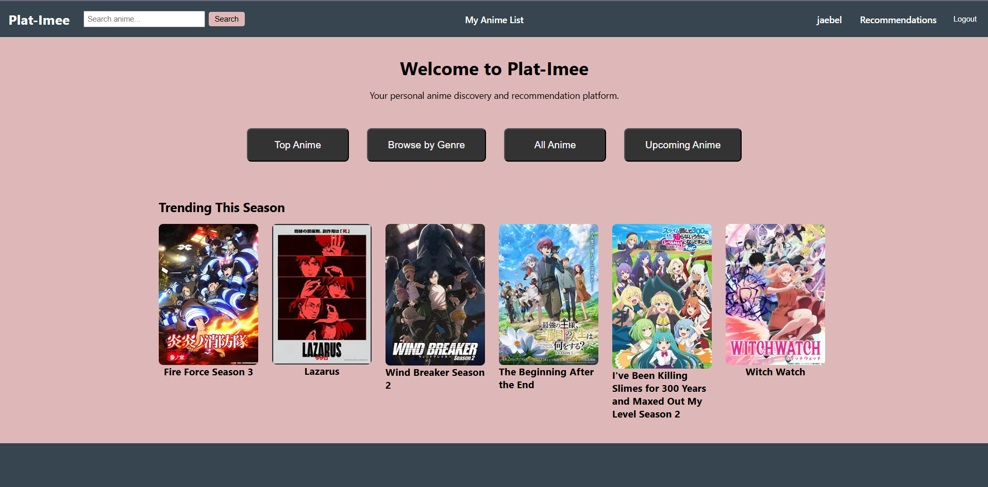Figure 9.1: Home page
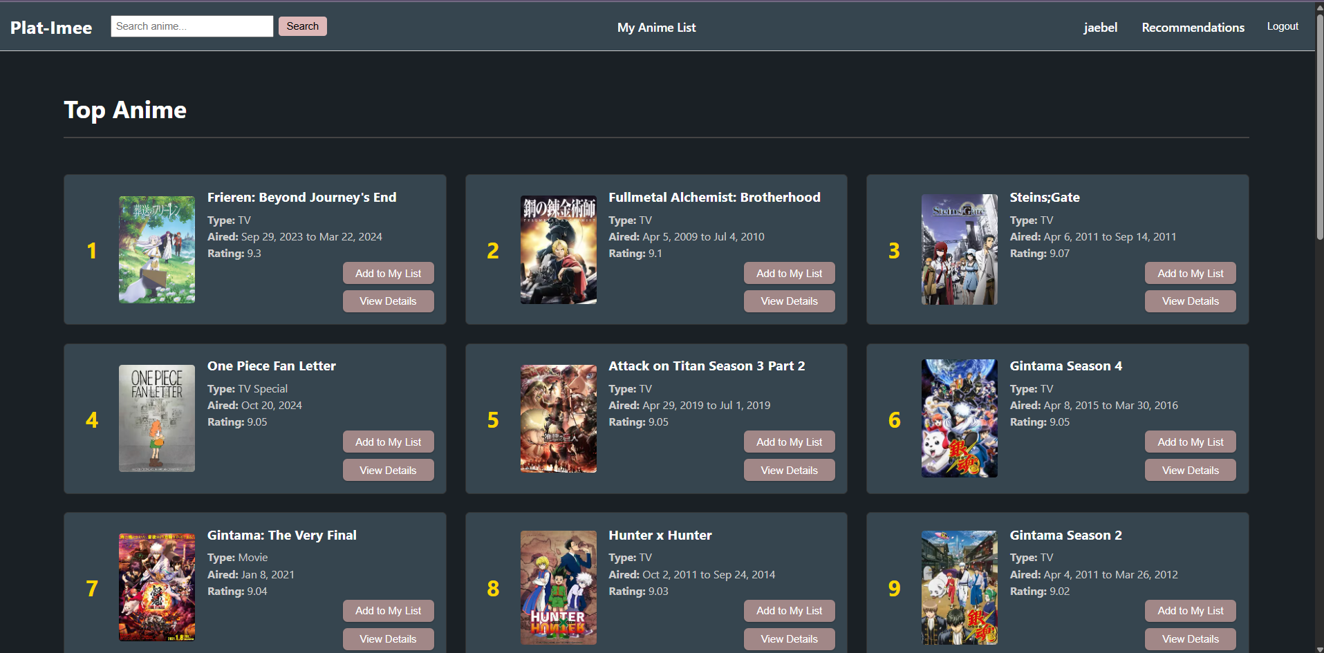Figure 9.2: Top Anime page
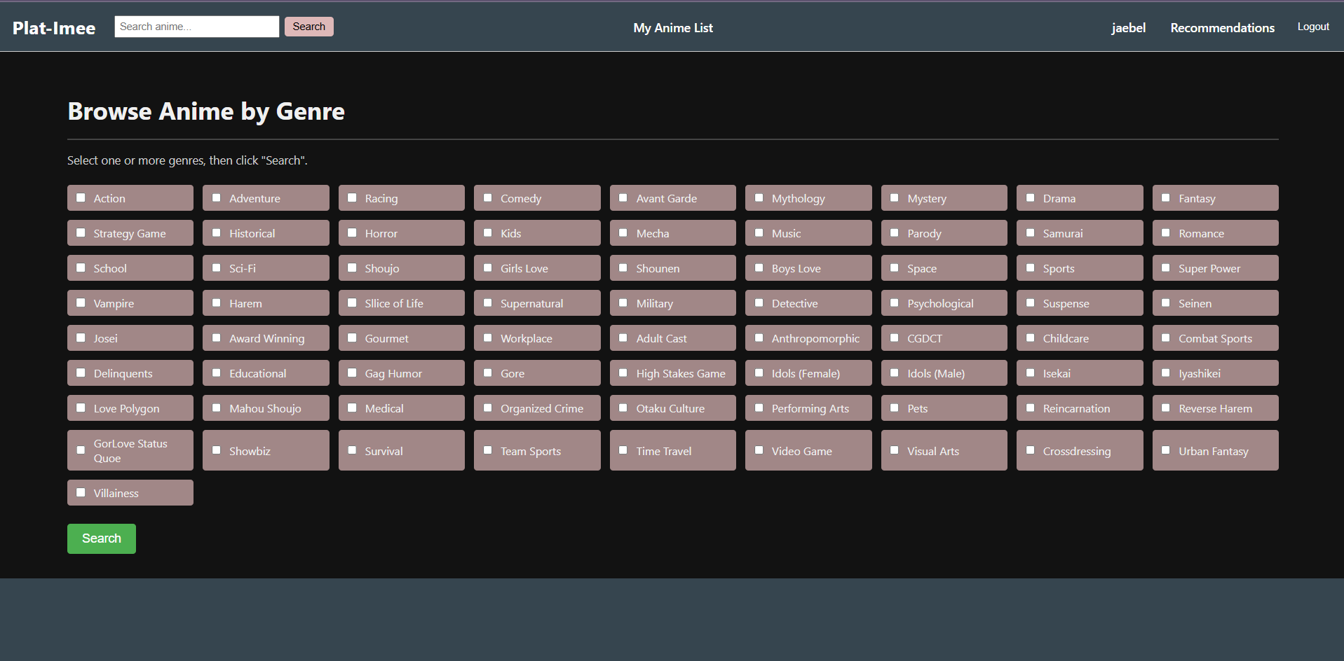Figure 9.3: Browse Anime by Genre page
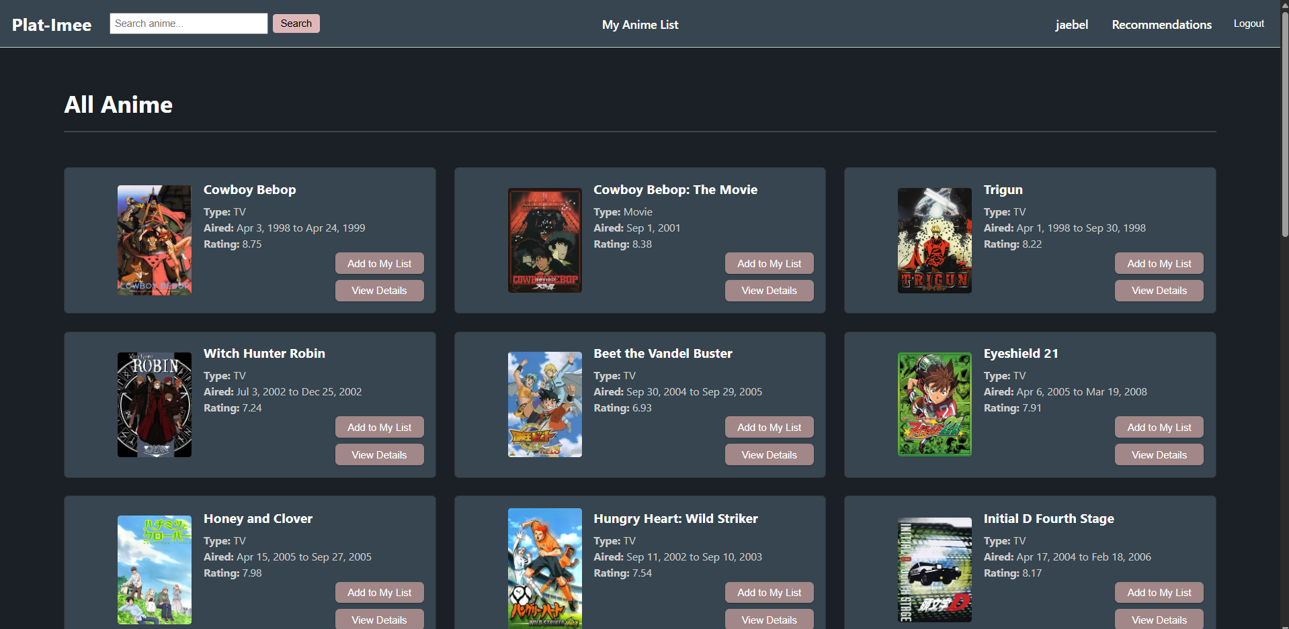Figure 9.4: All Anime page
Figure 9.5: Upcoming Anime page
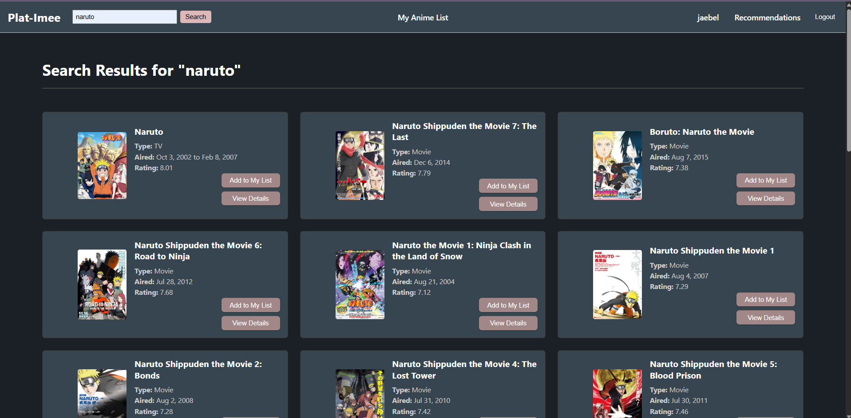Figure 9.6: Search results page where query=Naruto
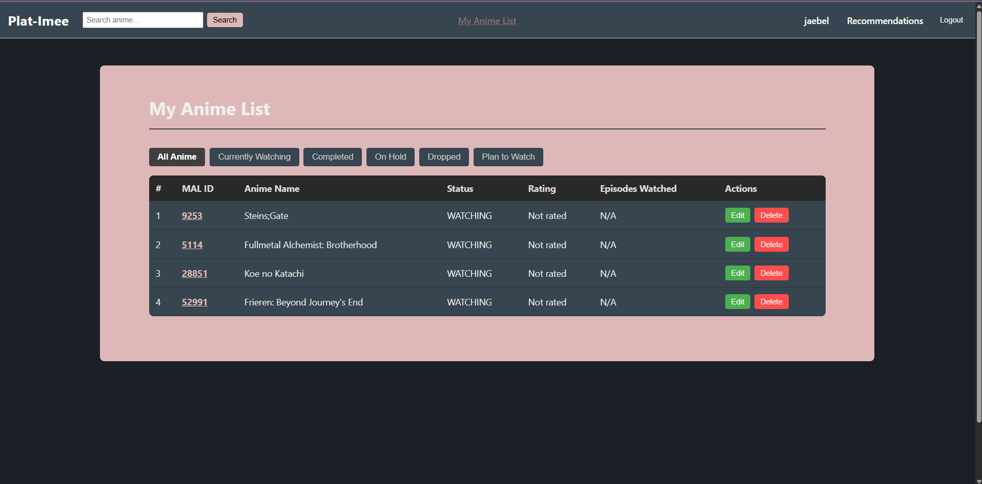Figure 9.7: My Anime List page
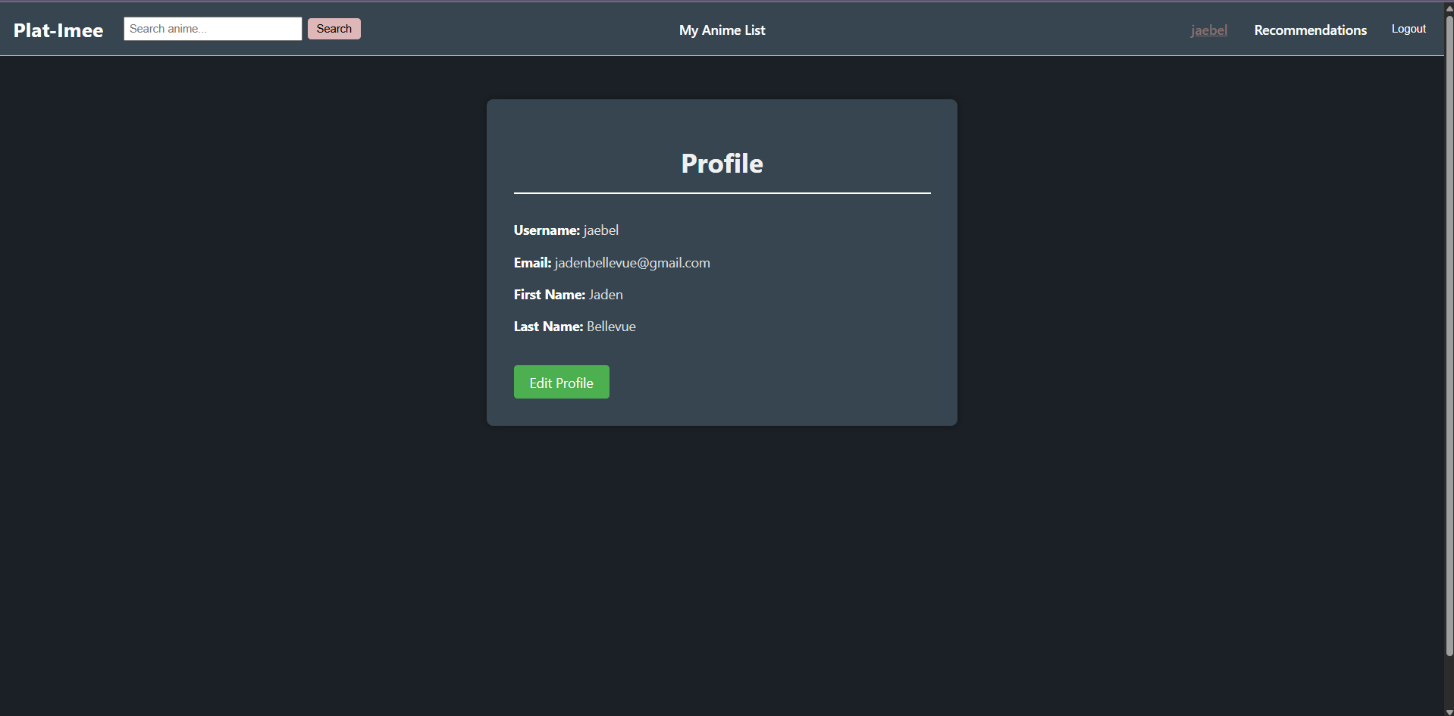Figure 9.8: Profile page
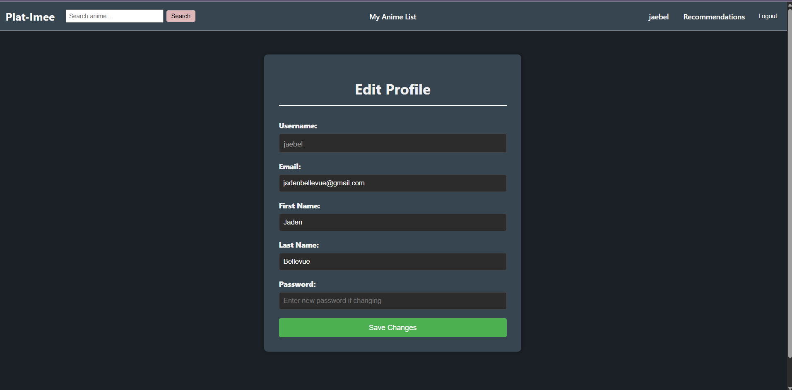Figure 9.9: Edit Profile page
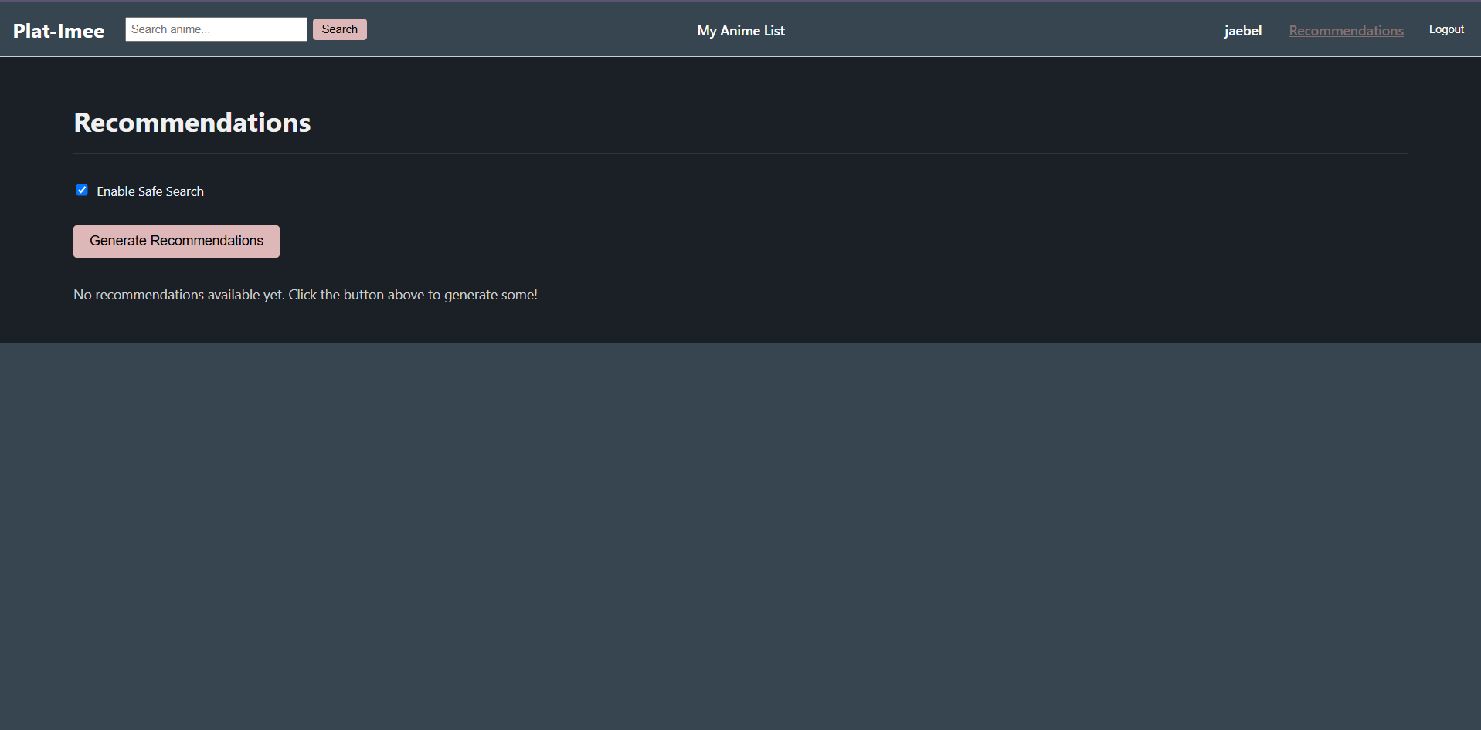Figure 9.10: Recommendations page (pre generation)
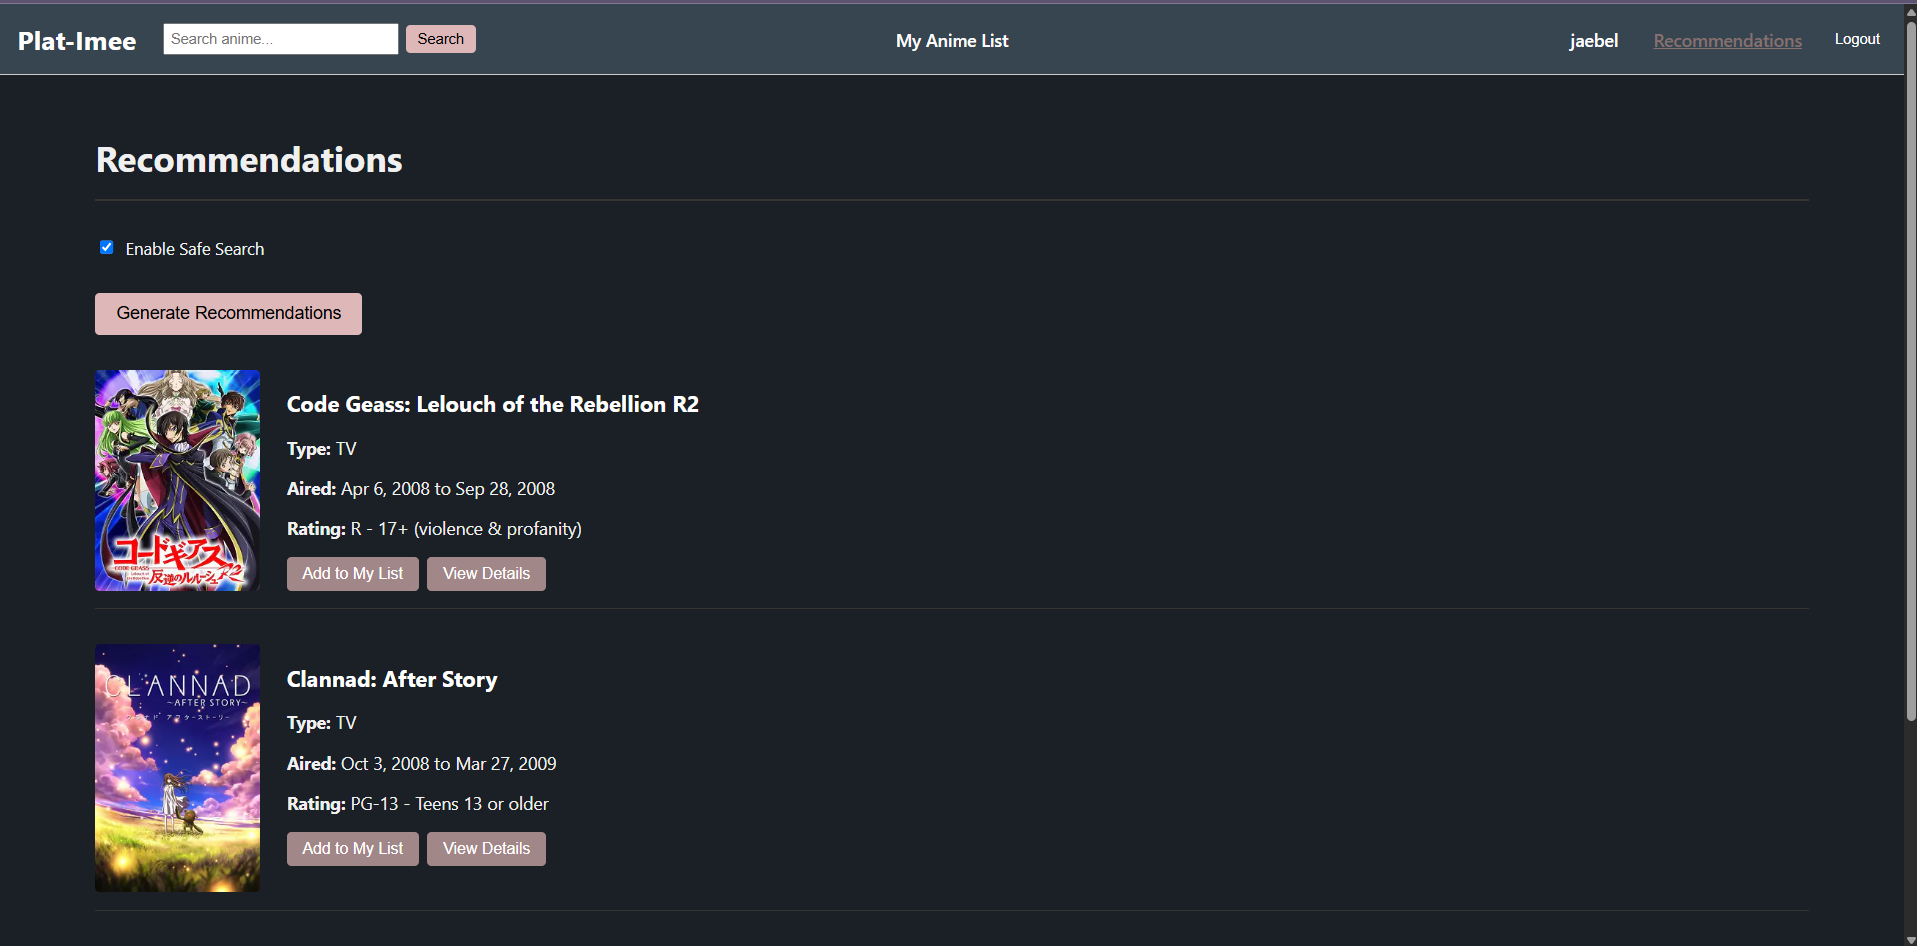Figure 9.11: Recommendations page (post generation)
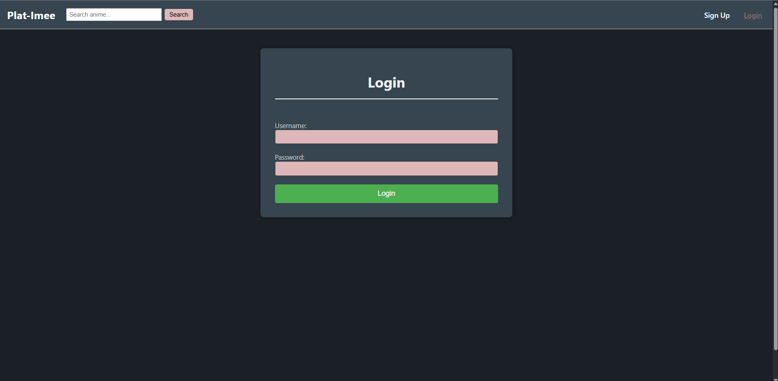Figure 9.12: Login page
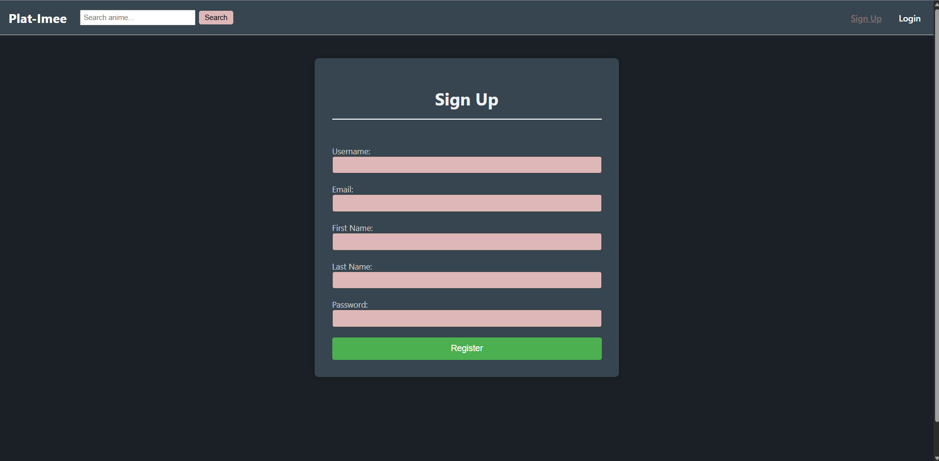Figure 9.13: Sign-Up page

References
[1]“Japan: anime market size,” Statista. https://www.statista.com/statistics/1297271/japan-animation-industry-total-sales/
[2] https://www.reddit.com/r/anime/
[3]“r/anime - Subreddit Stats & Analysis,” @gummy_search, 2025. https://gummysearch.com/r/anime/ (accessed Mar. 26, 2025).
‌[4]Y. Cohen, “How platform fatigue is ruining your company,” TechRadar, Jun. 03, 2019. https://www.techradar.com/news/how-platform-fatigue-is-ruining-your-company
[5] https://myanimelist.net/
[6] https://anilist.co/home
[7] https://anibrain.ai/
[8]F. O. Isinkaye, Y. O. Folajimi, and B. A. Ojokoh, “Recommendation systems: Principles, methods and evaluation,” Egyptian Informatics Journal, vol. 16, no. 3, pp. 261–273, Nov. 2015, doi: https://doi.org/10.1016/j.eij.2015.06.005.
[9]New America, “Why Am I Seeing This,” New America, 2020. https://www.newamerica.org/oti/reports/why-am-i-seeing-this/case-study-netflix/
[10]I. Altintas et al., “Amazon Recommender System,” 2020. Available: https://library.ucsd.edu/dc/object/bb8503744c/_2_1.pdf
[11]J. Son and S. B. Kim, “Content-based filtering for recommendation systems using multiattribute networks,” Expert Systems with Applications, vol. 89, pp. 404–412, Dec. 2017, doi: https://doi.org/10.1016/j.eswa.2017.08.008.
[12]“Building a Recommendation System in Python,” www.youtube.com. https://www.youtube.com/watch?v=G4MBc40rQ2k (accessed Sep. 18, 2023).
[13]B. Lika, K. Kolomvatsos, and S. Hadjiefthymiades, “Facing the cold start problem in recommender systems,” Expert Systems with Applications, vol. 41, no. 4, pp. 2065–2073, Mar. 2014, doi: https://doi.org/10.1016/j.eswa.2013.09.005.
[14]Y. Koren, R. Bell, and C. Volinsky, “Matrix Factorization Techniques for Recommender Systems,” Computer, vol. 42, no. 8, pp. 30–37, Aug. 2009.

[15]Sundog Education with Frank Kane, “Making Movie Recommendations with Item-Based Collaborative Filtering,” YouTube, Aug. 27, 2018. https://www.youtube.com/watch?v=Ty3Ui_mQtxY (accessed Nov. 28, 2024).
[16]Sundog Education with Frank Kane, “User-Based Collaborative Filtering,” YouTube, Aug. 24, 2017. https://www.youtube.com/watch?v=6mGMBipt7kU (accessed Mar. 26, 2025).
[17]Art of the problem, “How Recommender Systems Work (Netflix/Amazon),” www.youtube.com, Feb. 28, 2020. https://www.youtube.com/watch?v=n3RKsY2H-NE‌
[18]M. C. Urdaneta-Ponte, A. Mendez-Zorrilla, and I. Oleagordia-Ruiz, “Recommendation Systems for Education: Systematic Review,” Electronics, vol. 10, no. 14, p. 1611, Jul. 2021, doi: https://doi.org/10.3390/electronics10141611.
[19]ritvikmath, “Collaborative Filtering : Data Science Concepts,” YouTube, Dec. 02, 2020. https://www.youtube.com/watch?v=Fmtorg_dmM0 (accessed Aug. 24, 2024).
[20]Z. ul Abideen, “One-Stop Guide for Production Recommendation Systems,” Medium, Apr. 01, 2024. https://medium.com/@zaiinn440/one-stop-guide-for-production-recommendation-systems-9491f68d92e3
[21]N. Parashar, “Memory-Based vs. Model-Based Collaborative Filtering Techniques,” Medium, Sep. 08, 2023. https://medium.com/@niitwork0921/memory-based-vs-model-based-collaborative-filtering-techniques-c0a7f6ec4f5f
[22]“Data Science Repo - Machine Learning, AI, Stats,” datajobs.com. https://datajobs.com/data-science-repo/Recommender-Systems-%5BNetflix%5D.pdf
[23]J. Kim, I. Choi, and Q. Li, “Customer Satisfaction of Recommender System: Examining Accuracy and Diversity in Several Types of Recommendation Approaches,” Sustainability, vol. 13, no. 11, p. 6165, May 2021, doi: https://doi.org/10.3390/su13116165.
[24]J. Bockstedt, “The Hidden Side Effects of Recommendation Systems,” MIT Sloan Management Review, Nov. 13, 2018. https://sloanreview.mit.edu/article/the-hidden-side-effects-of-recommendation-systems/
[25]S. Chatterjee, “Recommendation Systems: Ethical Challenges and the Regulatory Landscape,” www.holisticai.com, Jul. 07, 2023. https://www.holisticai.com/blog/recommendation-systems
‌[26] https://www.similarweb.com/website/myanimelist.net/#overview
[27]Tvlicensing.co.uk, 2024. https://www.tvlicensing.co.uk/ss/Satellite?blobcol=urldata&blobheadername1=content-type&blobheadervalue1=application%2Fpdf&blobkey=id&blobtable=MungoBlobs&blobwhere=1370006457967&ssbinary=true (accessed Nov. 28, 2024).‌
[28]Y. Hu, Y. Koren, and C. Volinsky, “Collaborative Filtering for Implicit Feedback Datasets,” 2008 Eighth IEEE International Conference on Data Mining, Dec. 2008, doi: https://doi.org/10.1109/icdm.2008.22.
[29]S. Zhang, L. Yao, A. Sun, and Y. Tay, “Deep Learning Based Recommender System,” ACM Computing Surveys, vol. 52, no. 1, pp. 1–38, Feb. 2019, doi: https://doi.org/10.1145/3285029.
[30] git, “About.” https://git-scm.com/about
[31] github, “Features.” https://github.com/features
[32] Gradle, “Gradle,” Gradle, Oct. 18, 2019. https://gradle.org/
[33] Spring, “Spring Projects,” Spring.io, 2019. https://spring.io/projects/spring-boot
[34] “Kotlin & Modern Java: The 17 Differences,” Digma, Feb. 21, 2024. https://digma.ai/kotlin-modern-java-the-17-differences-experienced-developers-should-know/ (accessed Apr. 27, 2025).
[35] FastAPI, “FastAPI,” fastapi.tiangolo.com, 2023. https://fastapi.tiangolo.com/
[36]PyTorch, “PyTorch,” Pytorch.org, 2023. https://pytorch.org/
[37] React, “Quick Start,” react.dev. https://react.dev/learn
[38] @irfanDahir, “Jikan - Unofficial MyAnimeList API,” Jikan - Unofficial MyAnimeList API. https://jikan.moe/
[39] PostgreSQL, “PostgreSQL: About,” Postgresql.org. https://www.postgresql.org/about/
[41] hasibalmuzdadid, “⛩️Anime Ratings 〽️Analysis & 🤖Recommender System,” Kaggle.com, Nov. 30, 2022. https://www.kaggle.com/code/hasibalmuzdadid/anime-ratings-analysis-recommender-system/input
[42] chaitanya99, “Recommendation System (CF) | Anime,” Kaggle.com, May 17, 2023. https://www.kaggle.com/code/chaitanya99/recommendation-system-cf-anime/input
[43] A. Acharya, “Training, Validation, Test Split for Machine Learning Datasets,” encord.com, Jun. 13, 2023. https://encord.com/blog/train-val-test-split/
‌

‌
‌

‌

‌

‌

‌

‌
‌

‌
‌
‌
‌

