

Brutus Usage Guide

March 13, 2008
STB_Brutus-SWUM300-R

Broadcom Corporation • 5300 California Avenue • Irvine, CA, 92617 • Phone: 949-5300 • Fax: 949-926-5203

Revision History
Doc Number | Revision Date | Description/Author
STB_Brutus_Usage-SWUM300-R | 3/13/2008 | Initial version, from D. Erickson v 1.34

- Introduction

Brutus Overview
Brutus is a demonstration application that is delivered as part of the Broadcom Set-Top Reference Software release. It offers a wide variety of functionality in an integrated architecture and provides an example of how the Set-Top Reference Software can be used to create a final product. It also provides a means to test and use Broadcom reference boards, with actual functionality depending on the platform. Brutus is not intended to be a production-quality application, but its source code can be used as the basis for real applications.
To get going quickly, refer to the Brutus Installation Guide (document number STB_Brutus-SWUM200-R) for instructions on how to configure, build, and run Brutus.
Some of the features supported in Brutus are:
- Front-end Interfaces:
- QAM64, QAM256, QAM1024
- QPSK DVB and DIRECTV, 8PSK
- VSB
- Analog RF and A/V line input
- S-Video, Composite, Component, DVI/HDMI, RF modulator, L/R audio, S/PDIF outputs supported
- Single or dual decode
- Single or dual output
- Picture-in-picture (PIP)
- Channel change
- PSI scanning
- Programmable channel map
- PVR
- Single or dual record and playback
- Time-shifting (simultaneous record and playback)
- Single or dual channel encoder
- Wide range of host, decoder, and STC trick modes (including Broadcom proprietary trick modes like 1x rewind)
- DES/3DES PVR encryption and decryption
- GUI
- Broadcom embedded windowing system and widget set
- Anti-aliased TrueType fonts supported through FreeType
- Image rendering (including PNG, JPEG, and BMP support)
- Wide range of user input devices supported
- Single- or dual-instance GUI
- On-screen status
- Constellations
- Front-end and back-end Status
- Playback and decode FIFO monitors
Broadcom’s Reference Software team also develops numerous example applications, utilities, and test applications. They can be found in the source code tree in the following directories:
- BSEAV/api/examples
- BSEAV/api/utils

The Reference API Software Stack
Brutus is the topmost layer of the Reference Software Release, a complete top-to-bottom set-top box software stack. The Reference API, shown in Reference API Software Stack, consists of four main layers: Brutus and example/utility applications, the Settop API, the Porting Interface (PI), and the Operating System.
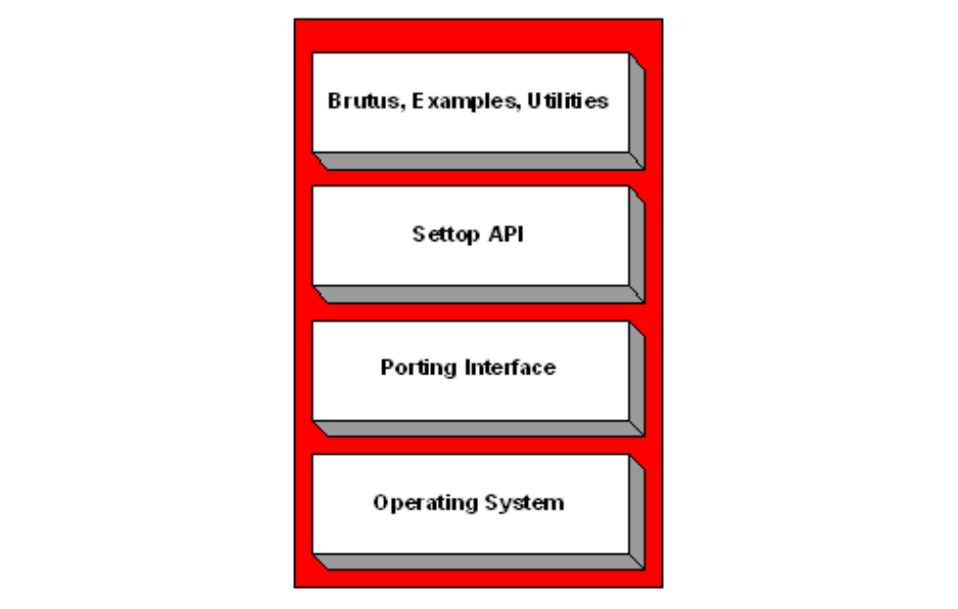
- Reference API Software Stack
The Settop API
The Settop API is an application-level C-language API that offers cross-platform, cross-OS portability. It implements a single usage model that is easily understood and extensible to support the features of Broadcom reference set-top boxes.
The Settop API handles a wide range of system programming tasks internally. These include:
- Interrupt handling
- Memory management
- Multi-threading and synchronization
- Optimal file I/O for PVR
- Multiple OS support

The Porting Interface
The porting interface is a low-level C-language API that offers full control of Broadcom set-top chips. This API:
- is modularized for each block on the chip.
- has a consistent API and design methodology.
- supports interrupt safety through clearly marked ISR code.
- is portable across multiple operating systems like Linux and VxWorks.
- supports single- and multi-threading systems.
- is fully ANSI C-compliant.
On BCM7038-based platforms, the porting interface is known as “Magnum.” For previous platforms, it was referred to simply as the “Porting Interface.” This layer also includes other elements like base modules and system libraries.

The Operating System
Broadcom supports a variety of operating systems, including Linux and VxWorks. While each layer in the architecture requires some operating-system-specific code, a large majority of the code is platform-independent. The operating system consists of the following components:
- The bootloader
- The BSP (Board Support Package)
- The kernel
- The root file system (Linux only)
- The tool chain
Source code for all Linux modules can be obtained upon request.
- Brutus Functional Description

High-Level Design Goals
Brutus is designed to:
- integrate the many features of the set-top reference platforms into a cohesive application.
- be configurable to support many of the usage modes of the set-top reference platforms.
- have a well-designed graphical user interface.
- provide intuitive use of input devices like IR remotes.
- support all Broadcom set-top reference platforms, including both satellite and cable systems.
- run on multiple operating systems, such as Linux and VxWorks.
- run on both disk-based and diskless systems.
Brutus Architecture
The Brutus application consists of several modules, shown in Brutus Component Modules. The only interface to any chip is through the Settop API. These modules are described below.
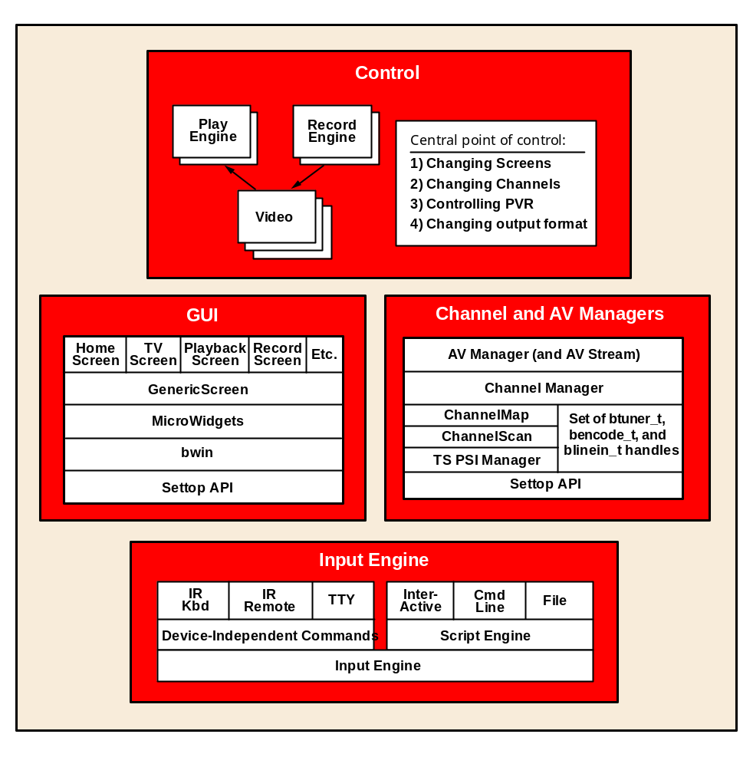
- Brutus Component Modules
The Control Module
The Control class coordinates the various components of Brutus. It keeps a list of screens and facilitates changing screens and resizing decode windows. It manages a set of Play and Record engines for doing PVR. It manages channel changes, including incremental channel digit entry, and deferral of the start of decode in order to speed up repeated channel changes. It also manages the change of display formats, which involves rescaling graphics and possibly restarting the decode.
Some of the engines have callbacks directly into the user interface. For instance, PlayEngine can notify the PvrTimeline widget that its state or position has changed. The Control module is responsible for setting up these connections.

The Graphical User Interface Module
Brutus’ user interface is built on top of a series of software layers. These layers include:
- Set-Top API Graphics, the part of the Settop API that provides frame buffer functionality
- bwin, a minimal windowing system with font and image rendering support
- bwin is written in C.
- The source code is found in BSEAV/lib/bwin.
- Microwidgets
- This is a TV-friendly widget library
- It is written in C++.
- It is modeled after Trolltech’s Qt library.
- The source code is found in BSEAV/lib/mlibs.
The UI follows a single-threaded, cooperative, multitasking model. This means that most application work is performed during “idle time,” when the UI is done painting. Idle-time processing must usually be done in short intervals (no blocking); otherwise the UI response time is slow.

Channel Manager and AV Manager Module
The Channel Manager takes a channel map as an input. The channel map is a file that lists frequencies, symbol rate and other information needed to obtain channels. By default, this file is channels.txt.
The Channel Manager scans the listed frequencies for PSI information. It uses the tspsimgr library to parse the PSI information and build a channel list. It makes this channel list available to Brutus. The Channel Manager also keeps the set of tuners which can be checked out for exclusive use.
The AV Manager wraps the Channel Manager and adds the concept of an AV Stream. The AV Stream encapsulates everything needed to decode or record a stream, including bstream_t (analog and/or digital), btuner_t, bencode_t, blinein_t, and the channel number currently on the stream.
The Input Engine Module
Brutus manages a variety of input devices. See Brutus Input Devices for details. The devices are plugged into bwin’s event loop so that Brutus can multiplex the I/O and need not create a thread per input device. Each input device’s commands must be translated to a set of device-independent commands.
The input engine also manages Brutus scripting. There are three scripting modes available:
- Interactive mode: Use the ./brutus --exec syntax, and type in scripting commands at a prompt. Type “help” to see the available commands.
- Script file: Load and execute script files stored on the file system. You can specify the files on the command line or select from an on-screen list through the Admin screen.
- Command line text: Specify script commands to run on the command line. This is helpful for testing or if you want to come up in a specific initial state.

Other Optional Features
The following features have special uses and do not appear in Brutus Component Modules:
- Cheops: a Broadcom-proprietary media protocol used for streaming media and Metadata over Ethernet and wireless connections
- XML and HTTP libraries: Small, efficient, Broadcom-proprietary libraries used by the Cheops protocol
- Startup Options
The Brutus application can be started with optional parameters that alter the way it runs. These should be supplied on the command line when starting the application. For example:
$ settop brutus --help
The following table lists the startup options.
- Brutus Start-up Options
Option | Description
--help | Print this help screen.
--help-cfg | Print the configuration file options.
-cfg FILE | Specify a configuration file (default is brutus.cfg).
-ch FILE | Specify a channel map file (default is channels.txt).
-pg FILE | Specify a program guide file (default is programguide.txt).
-pal | 576i (PAL) display mode.
-admin | Set admin sticky mode by default.
-tty | Use tty instead of Sejin IR keyboard.
-dbg {err|wrn|msg} | Set the debug level.
--exec | Start in interactive mode.
-scr SCRIPTFILE | Run a script file.
-scrtext SCRIPT | Run a script with semicolon delimited commands.
-hd | Use 1080i display mode.
-skin SKIN | Use graphical skin to display user interface (see Brutus Skinning for more details)

- These startup options depend on the options used to build the application. This means that not all the options are available for a particular build. Use the --help option for a list of the available options for a particular build.

- Brutus Application Modes
Brutus runs in four main modes. Application modes cannot be changed after starting Brutus, so the mode must be selected before starting.

Single Display

Mode
Single Display mode, shown in , consists of a single application running with a single user interface. It uses only one compositor, which means it supports only one output format at a time (such as 480i or 1080i, but not both). If an HD mode is selected, the SD video outputs are turned off.

For dual-decode platforms, picture-in-picture (PIP) is available.
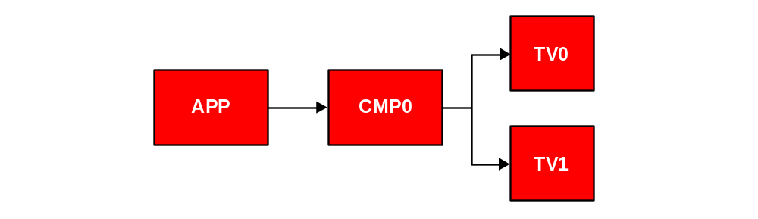

- Single Display Mode
In , the APP block is one instance of the Brutus application, CMP0 is the first compositor, TV0 is the first TV (also referred to as A), and TV1 is the second TV (also referred to as B).
HD/SD Single Display
Like the previous mode, HD/SD Single Display mode consists of single application running with a single user interface. Internally, however, both the video and graphics that make up the user interface are duplicated on two display pipelines. This means that when the first display is in an HD mode, the second display can still be driving the SD outputs. HD/SD Single Display mode is shown in HD/SD Single Display Mode.

To enable HD/SD Single Display mode, add “HDSD_SINGLE=1” to the brutus.cfg file.

This mode is supported on the BCM7038, BCM7401, BCM7400, BCM7405, BCM7325, and BCM7335 platforms.
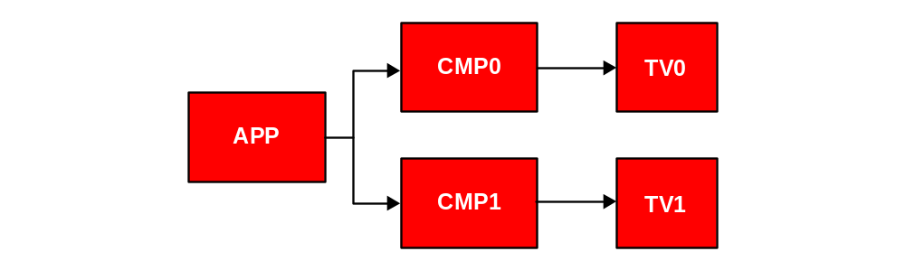
- HD/SD Single Display Mode

Dual Display Mode
In Dual Display Mode mode, shown in Dual Display Mode, a single set-top drives two displays as if it were two independent set-top boxes. They share the same front-end resources and hard drive, but have distinct user interfaces and application states.
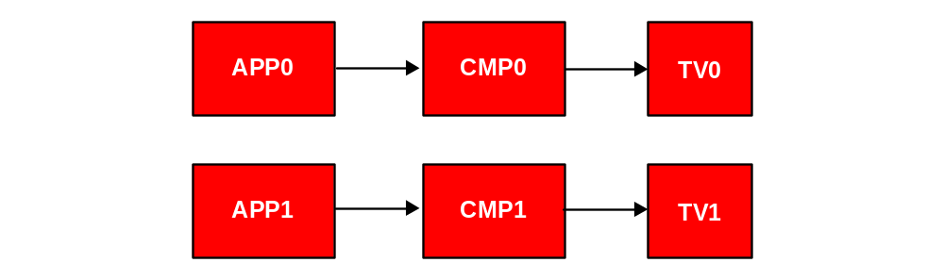
- Dual Display Mode
Brutus can accomplish dual display in two ways, depending on how many instances of the API are called. In this mode, there are two instances or Brutus and the Settop API. In Single Application, Dual Display mode, described below, there is only one.
Single Application, Dual Display
In Single Application, Dual Display mode, one copy of Brutus is started, which starts one instance of the Settop API. Then Brutus creates two instances of the main Control module and it runs two instances of the application logic. Minimal communication between instances is accomplished with synchronization between threads.

To enable Single Application, Dual Display mode, add “DUAL_OUTPUT=1” to the brutus.cfg file.
This is the only way to perform dual output with the user-mode driver architecture. This mode also supports the kernel-mode driver architecture. It is the only way to run dual output on a Magnum platform, such as the BCM7038 and BCM7400 platforms.
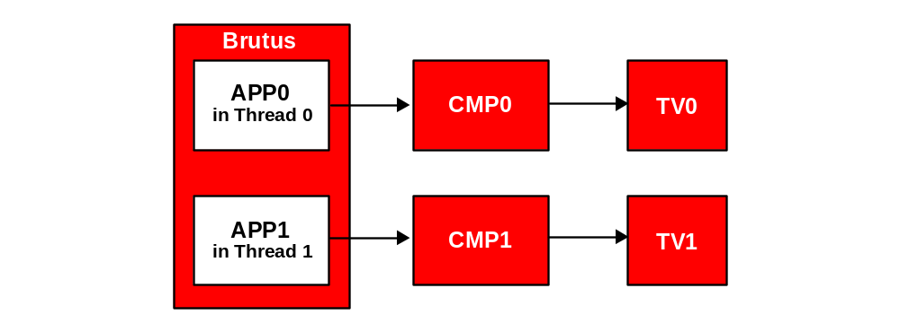
- Single Application, Dual Display Mode

Dual Display Input Devices

When running in dual display mode (either single or dual application), you have to assign the inputs to the application instances. By default, the following assignments are made:

- Inputs to the Two Single Application/Dual Display Mode Instances
APP0 | APP1
GI remote (CBL button on One-For-All remote) | SA remote (SAT button on One-For-All remote)
Front panel | No front panel
In single application, dual display mode, --exec defaults to app0. Use “app(#)” to switch between applications. | In dual application, dual display mode, both applications can have the --exec interface.
In single application, dual display mode, -tty defaults to app0. Use “a” to switch between applications. | In dual application, dual display mode, both applications can have the -tty interface.

Triple Display (HD/SD Single + Dual Output)
In Triple Display mode, a single set-top drives three displays as if it were two independent set-top boxes. They share the same front-end resources and hard drive, but have distinct user interfaces and application states. This mode is only supported on BCM7400 platforms.
To run this mode, add both “HDSD_SINGLE=1” and “DUAL_OUTPUT=1” to brutus.cfg.
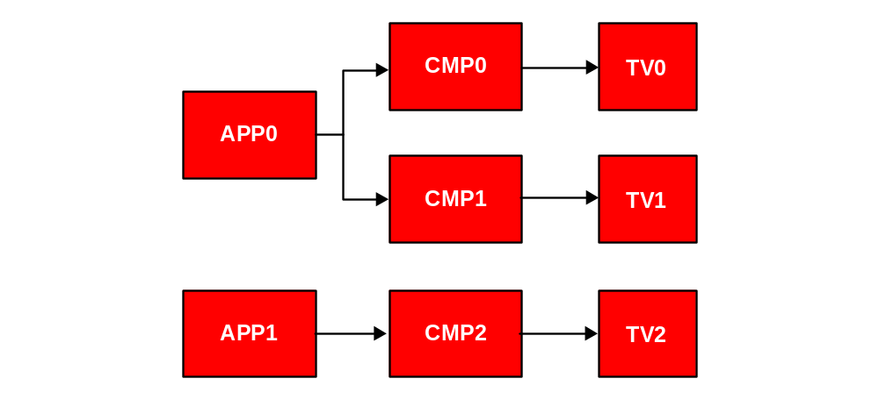
- Triple Display (HD/SD Single + Dual Output) Mode

Switching between PIP and Dual Output modes
For dual-output systems, you can toggle between single display and dual display modes using the Admin screen and an external script. The Brutus application does not actually switch modes. The application must exit and restart using the script.

On the Admin screen, there is a PIP Mode or Dual Mode button. The text indicates the mode you will enter if you click the button. Pressing this button causes Brutus to exit with a special return code. A special shell script must capture this return code and then restart Brutus in the other mode.

A sample bash script can be found in the BSEAV/app/brutus/samples/brutus_7320_wrapper directory. It uses brutus.cfg and creates a pip.cfg file. This is only sample code and may have to be modified for specific environments.
- Brutus Front-End Architecture

The Channel Map and Channel List
Brutus uses a text file called the channel map (channels.txt) to specify frequencies and symbol rates. Each entry in the channel map is a channel number. For digital channels, the PSI data is scanned and if programs are found, they are included in the channel list as subchannels (i.e., 10.1, 10.2, 10.3, etc.).
There is no initial scan. Channels are scanned when they are tuned.

Tuners
- From a hardware or porting interface point of view, the “tuner” is an RF tuning device and the demodulator is treated separately. From a Settop API or Brutus point of view, the “tuner” is both the RF tuner and its associated demodulator.

Brutus collects all tuners into a global Channel Manager. Tuners are checked out for exclusive use whenever a channel is decoded and/or recorded. When you are done decoding and recording, the tuner is checked back in. When you are in playback mode, there is no tuner needed because a live channel is not being decoded. When playback is stopped and live decoding is resumed again, Brutus tries to acquire another tuner.
This dynamic tuner assignment allows single-display and dual-display systems to make full use of the tuner resources without hard-coding which tuner must be used for a certain display.
If the platform has a non-orthogonal set of tuners, however (that is, dual display system with only one SDS tuner), you can scan SDS channels and have them in the channel list, but if you are decoding or recording an SDS channel on one display, the other display will have no tuner available. In this case, the GUI reports a “(no tuner)” message alongside the current channel number. If you stop record or decode on the first display, the tuner will become available. The other display can start decoding or recording the channel.

Background Recording
If there are available tuners and record devices, you can easily start multiple background record sessions. A “background” record session is a record session that is not currently being decoded.
Currently, you can only start recording a channel which you are currently decoding (because the GUI does not allow selecting a non-current channel to record). However, after you start recording, if you change the channel and if another tuner is available, the record session will not be stopped. It will simply be moved into the background. Another tuner will be checked out to start the live decode on the new channel.
You can move the record session back into the foreground by simply channel-changing back to the channel you are recording. This works because Brutus always prefers to decode something that is already being recorded, as opposed to using two tuners to record and decode the same content.
On platforms like the BCM97038 and BCM97400, this technique can be performed twice, which starts triple record. You can see the number of record sessions by looking at the red circles on the TV screen or on the Playback screen.
- Brutus On-Screen User Interface

Navigating the GUI
Please refer to Brutus Input Devices for options on controlling the graphical user interface (GUI). This manual assumes that you have a remote control.

Watching Live TV
Before starting Brutus, you must set your channel map to match what your head-end is broadcasting. See Display Formats for details. When Brutus is started, it performs a channel scan and builds a channel list. Analog channels are not scanned and will always appear in the channel list (whether they are there or not). Digital channels generally must be scanned.
Press the Exit button to go to full-screen TV. Use the channel +/– keys to change channels.
Press the Info button to see the front-end and back-end status. When viewing these status panels, you can also use the Right and Left arrow buttons to see addition status. Press the Info button again to toggle the panel off.

Press the Menu button to go to the Brutus home page. Press the arrow buttons to move to the TV window and press the Select button to go back to full-screen TV.

PVR Recording
Tune to the desired TV channel. Press the Record button once to go to a record screen. This allows you to set various options including:

- Recording name that will appear on the Playback screen
- Time-shifting checkbox
- DES/3DES/AES encryption
- Encoding quality for analog channels
Press the Record button again (or navigate to the Record button on the lower-right corner of the screen) to start recording.
On the TV screen, you'll see a red circle in the lower left corner for each active recording session.
For platforms that support dual- or triple-record, you see two or three red circles, depending on the number of record sessions that are active.
Note that pressing Stop on a full-screen TV does the following in this order:

- If currently in playback, it will stop the current playback. If in PIP mode, it will not stop the other playback.
- If not in playback but recording, it will stop one of the recordings.

You can also stop a specific record by pressing the Guide button, which will take you to the playback screen. The current recording should be at the top of the list with a red circle by it. You can press the Stop button here to stop that recording.

Time-Shifting and Continuous Record
Any playback of a file which is currently being recorded is called “time-shifting.” The user is delaying the viewing of live content. Brutus supports two modes of time-shifting: continuous record and linear.
Continuous record means that Brutus records the live channel into a circular buffer. This is enabled by adding the following option to brutus.cfg:
CONTINUOUS_RECORD_ENABLED=y
The duration of this file can be set in terms of time:
CONTINUOUS_RECORD_DURATION=<seconds>
If the continuous record option is not enabled, a Timeshifting checkbox is presented on the Record screen. This is the simplistic “linear” form of time-shifting. It simply starts a playback of whatever you are recording. The recorded file is not a circular, fixed-size buffer; it simply continues until the disk is filled.

PVR Playback
Press the Guide button on the remote to go to the Playback screen. You see a list of videos that have been recorded. If the list is empty, you will need to record something first.

Navigate to the video you want to play and press the Select button. Now you'll see detailed information about that video. Press the Play button to start playback. You then see the video being played full-screen with a timeline below.

As a shortcut, you can press the Play button while on the Playback screen to play the video without seeing the details screen.

On the TV Screen, press Stop to stop playback and return to live TV.
Timeline GUI
During playback, you see a PVR timeline when viewing full-screen TV. If you are playing a static file (that is, not time-shifting) the timeline will be green. If you are time-shifting, either continuous or linear, the timeline will be red.
For static playback, the width of the timeline represents the entire duration of the file.
For linear time-shifting, the width of the timeline can be set with RECORD_TIME_WINDOW=seconds.
For continuous time-shifting, the width of the timeline represents the CONTINUOUS_RECORD_DURATION and the live decode is always represented at the rightmost edge of the timeline. The distance between the cursor and the rightmost edge is the amount of time that playback is behind live decode.

Beginning/End of File Control
You can control what action Brutus takes when playback hits the end or beginning of a file with the following options:

PLAYBACK_AT_BOF={play|loop|pause}
PLAYBACK_AT_EOF={play|loop|pause}
PLAYBACK_AT_BOF_WITH_RECORD={play|loop|pause}
PLAYBACK_AT_EOF_WITH_RECORD={play|loop|pause}
The _WITH_RECORD variants apply when you are doing time-shifting, either with a liner or continuous record.

The options are:
- play: Switch to normal play in the current location (an exception is slow motion will remain slow motion).
- loop: Loop to the opposite end of the file and continue the current mode.
- pause: Pause playback wherever you are.

The loop option when recording is not naturally expected, but can be useful for testing.

PVR Trick Modes
After playback has been started, trick modes can be performed using the VCR buttons on your remote. The trick mode buttons will increment or decrement the speed. For instance, if you press the rewind button twice to see the second rewind speed, and then press the fast-forward button, you will return to the first rewind speed.

Other controls include:
- Play will resume normal playback from either pause or a trick mode.
- Pause will pause either normal playback or a trick mode.
- Pressing Pause again when in a paused state will resume normal play.
- Right arrow will jump forward 30 seconds
- Left arrow will jump backward 5 seconds
- When paused, Fast Forward functions as “frame advance” and Rewind functions as “frame reverse.”
Using Picture-in-Picture
For dual decode systems running in single display mode, Brutus supports picture-in-picture (PIP) mode. See Brutus Application Modes for more details.

Navigate to full-screen TV by pressing the Exit button. Then press the PIP button. If PIP is supported, you see a box appear in the upper right corner surrounded by a yellow outline. The yellow outline means that PIP has the control. All commands (like channel +/– or PVR) will apply to PIP and not to Main when the yellow box is visible.

Press the Move button and the yellow box will disappear. This means that Main has the control, but PIP is still visible.

Press the Swap button and the content of Main and PIP will be swapped. Press the Swap button again to restore the original Main and PIP.

Playing MP3s
If Brutus was compiled with AUDIO_SUPPORT=y and MP3_ENABLED=1 is in the configuration file, then you should see an MP3s button on the Brutus home page. This is the default for most platforms.

Press Menu to see the home page. Press the MP3s button, and you see a list of files in the “audio” subdirectory that can be played. You can refresh the list from the admin page if you copy more files after starting Brutus.

Click on a song title (or press the VCR Play button) to start playing. Press the VCR Stop button to stop playing.
- BCM7411 and BCM740x platforms support hardware MP3 decode. The Brutus MP3 screen still requires a software MP3 decoder, however. This is used to test PCM playback and to add CPU stress. You can do a hardware decode of an MP3 using the playback test application. It is included in the default installation binary tarball. Run it as follows:
settop playback -mpeg_type ES -audio 1 -audio_type 0x1 file.mp3

Viewing Pictures
If Brutus was compiled with PICTURES_SUPPORT=y, then you should see a My Pictures button on the Brutus home page.

Press the My Pictures button, and you see a list of JPEGs, PNGs and BMPs that can be viewed. If the view is empty, you'll need to copy some images into the pictures/ subdirectory and restart Brutus.

Some Broadcom chips support still-picture decode in hardware. This has not been integrated with this Brutus feature. You can use the feature with the Settop API test application BSEAV/api/tests/decode_still_picture.

Running a script
You can control all Brutus functions using a simple scripting language. The easiest way to learn about it is to start Brutus with the --exec command line option, type help to see your choices, and then enter script commands interactively. Please see Bru for more details.

Skinning the Graphical User Interface
You can modify the look and feel of the Brutus graphical user interface using “skins.” Start Brutus with the -skin blue command-line option to change its visual presentation based on the sample “blue” skin. Please see Brutus Skinning for more details.

Changing Video Outputs
You can control your display settings from the Info panel. Press the Info button on the remote, or press the Info button on the main menu. Navigate to the Display button, and then arrow over to the control panel.

The controls that you see reflect the options available for the current video format. Use the right and left arrows to change the arrow bars. Press the Select button on the remote to enable the change. You see an immediate change. Also notice that the list of available controls may change as the video formats are switched.

Editing the Channel Map Onscreen
The default channel map comes from the channels.txt file. You may find it easier to edit using a text editor. You can also edit the channel map onscreen using a remote and then overwrite that channel map.
From the main menu, click on Admin. If ADMIN=y has not been set in the configuration file, the password is 8822. Click on Edit Channels. You can then perform the following operations:

- To add a channel, click on Add, enter your settings, then click OK.
- To remove a channel, click on the channel in the list, then click Delete.
- To edit a channel, click on the channel in the list, make your changes, then click OK.
- To save your changes, click on Save.
- To abandon your changes, click Reset.
Renaming Video Streams
When a stream is recorded, Brutus will use the entry in programguide.txt. If there is no entry, Brutus will use a text string that describes the source (QAM, ANALOG, etc.)

After a stream has been recorded, it is often helpful to rename it. From the GUI, go to the Playback list, select the stream, and you will find a Rename button. Select the button. Here is a list of methods to change the name.

If you are using a Sejin IR keyboard, you can type in directly.
- If you are using --exec, you can use the entertext(XXXX) command.
- If you are using -tty, you can use the “;” command to enter text.
- You can exit Brutus and edit the *.info file and change the name field.
- If you are using a remote, your only option is to enter numbers; otherwise you need to use one of the above methods.
- Brutus Input Devices
There are several ways of controlling Brutus. Here is an overview:
- Using a front panel
- IR remote
- IR keyboard
- Keypad
- Text control from a console
- Script control
–scr (from file)
–scrtext (from command line)
- Interactive
--exec (interactive script commands)
-tty (single key command)
The easiest is to use is the remote control. But in case you do not have a front panel, the other methods provide full control, only not as intuitively.
This section presents is a detailed overview of each input device

One For All remote
The reference platform should include a “One For All” remote that has been programmed with GI and SA remote codes. If you need a remote, please request one from Broadcom’s System Operations department. These remotes are programmed using a computer application with a wired connection to each remote. It is very difficult to manually program every button correctly on these remotes.
Press the CBL button located at the top of the remote to use GI codes. These work for all platforms. On dual-output systems, this will control the first output.
Press the SAT button located at the top of the remote to use SA codes. For dual-output systems, this will control the second output.
If your remote does not work, do the following:
- Press the CBL button at the top of the remote (or SAT if using second output).
- Change the batteries.
- Make sure the front panel is connected; check whether the LEDs are lit up.
- Try the remote with another good set-top box, and/or try another good remote with this set-top box.
- If nothing works, contact Broadcom’s System Operations department for a new remote.
The remote control key map is given in Remote Control Key Map:
- Remote Control Key Map
Key | Function
PIP | Toggle pip on and off (lower left)
MOVE | Toggle pip control (lower)
SWAP | Toggle video between main and pip (lower)
INFO | Toggle the info panel on the full-screen TV screen (upper right)
MENU | Toggle the main menu (upper left)
GUIDE | Toggle the playback screen (upper left)
POWER | Enter Standby mode (if supported)
MUTE | Toggle volume mute
0…9 | Change the channel
REW | Fast rewind
FWD | Fast forward
F.REW | Slow rewind
F.FWD | Slow forward
REC | Press once to bring up record screen, press again to start recording.
PAUSE | Pause PVR. Only works on full-screen TV.
PLAY | Resume PVR play. Only works on full-screen TV.
STOP | Stop PVR. Only works on full-screen TV.
VOL +/- | Control volume (this will un-mute)
CH +/- | Change channel (this will stop PVR)

Sejin IR Keyboard
This wireless keyboard can be requested from Broadcom’s System Operations department. It is not included by default. The only reason a keyboard may be needed for Brutus is to enter PVR recording names (otherwise you must edit programguide.txt. See Display Formats for details.). The Sejin IR keyboard key mappings are given in Sejin IR Keyboard Mapping.
- Sejin IR Keyboard Mapping
Key | Function
F1 | Stop
F2 | Pause
F3 | Play
F4 | Slow motion
F5 | Rewind
F6 | Fast forward
F7 | Record
F9 | Show tv
F10 | Show menu
F11 | Show guide
F12 | Show info
PrtSc/SysRq | Toggle video
ScrollLock | Toggle PIP control
- | Channel down
+ | Channel up
[ | Volume down
] | Volume up
\ | Mute
Popup Menu | Toggle PIP

Front panel Keypad
In order to make the front panel as fully functional as possible, the meaning of some buttons on the keypad is context-sensitive.

Full-Screen TV Screen
When you are on full-screen TV, the buttons will behave differently if PVR playback or record is active, and if the Info panel is visible. The best way to learn these is to try them. Full-Screen TV Screen Key Mappings and All Other TV Screen Key Mappings provide some documentation of these key mappings.
- Full-Screen TV Screen Key Mappings
Key | Function
Power/Reset | Toggle SD/HD output (BCM937XX) or NTSC/PAL (all other platforms)
Left Arrow | If the info panel is visible, navigate left. If PVR playback is active, rewind.
Right Arrow | If the info panel is visible, navigate right. If PVR playback is active, fast forward.
Up Arrow | If PVR playback is active, pause; otherwise, channel up.
Down Arrow | If PVR playback or record is active, stop; otherwise, channel down.
Sel | If PVR playback is active and you are in a trick mode, then resume normal play. Otherwise toggle the info panel.
Guide | Toggle Playback screen and TV screen.
Menu | Toggle Home screen and TV screen. On the BCM97320, the Info button functions as the Menu button. To show the info panel, go to the TV screen and press Sel.
Ch + | Channel up
Ch – | Channel down
Vol + | Volume up
Vol – | Volume down

All Other Screens
- All Other TV Screen Key Mappings
Key | Function
Power | Toggle SD/HD output (937XX) or NTSC/PAL (97xxx)
Left Arrow | Navigate Left
Right Arrow | Navigate Right
Up Arrow | Navigate Up
Down Arrow | Navigate Down
Sel | Enter
Guide | Toggle Playback screen and TV screen
Menu | Toggle Home screen and TV screen
Ch + | Channel up
Ch – | Channel down
Vol + | Volume up
Vol – | Volume down

Text Control: Script Control
This uses the settop brutus--exec command and provides a Brutus> prompt from which commands can be entered. The commands are identical with the scripting language commands, which are documented in Bru.
Text Control: Single Key Command
This mode allows you to control Brutus with single key presses. You can only use this option if you start Brutus from a command line, using the serial console or telnet. Start Brutus with the settop brutus –tty option. Press ? to see the key mapping given in Text Control Key Mapping.
Brutus will open the console in raw mode, which allows it to process individual keystrokes. This can be hard to learn at first, but is very fast.
- Text Control Key Mapping
Key | Function
w | Go to TV Screen (Exit)
e | Go to Playback Screen
t | Go to Home screen
z | Stop PVR
x | Pause PVR
c | Play PVR
r | Go to Record Screen
n | Fast forward, frame adv when paused
b | Fast rewind, frame rev when paused
. | Slow forward
, | Slow rewind
- + | Channel down/up
p | Toggle pip
m | Catch up time-shifting PVR to record
o | Swap main and PIP
i | Toggle focus between main and PIP
[ ] | Volume down/up
\ | Mute audio
hjkl | Arrow left, down, up, right (some contexts)
tab | Tab to next control
` | Reverse tab to previous control
a | Switch between application instances in DUAL_OUTPUT modes.

- Brutus Channel Map
The channel map tells Brutus which frequencies and modulation types to include in its list of channels. It supports multiple line inputs, analog RF, QAM, QPSK, VSB, OFDM, and IP channels, depending on the platform.
For line-in and analog, each channel file entry corresponds to one channel in the user interface. For digital channels (either QAM or QPSK), the channel may have zero or more programs. These are displayed as a single channel with subchannels.
The default channel file is channels.txt. You can specify your own channel file using the -ch command line parameter.
There is also a primitive way to specify program guide information. Edit programguide.txt and add channel names. These will be used when displaying the current live channel and in the recorded stream name. Each entry in the program guide corresponds to one main channel. Subchannels all share the same name.

Channel Map Syntax
- Channel Map Syntax
Type | Parameter | Parameter | Parameter | Parameter
LINEINPUT | index | PAL or NTSC | – | –
ANALOG | Disabled? | Frequency | PAL or NTSC | –
QAM64 | Disabled? | Frequency | Symbol rate | annex
QAM256 | Disabled? | Frequency | Symbol rate | annex
QAM1024 | Disabled? | Frequency | Symbol rate | annex
QPSK_DVB | Disabled? | Frequency | Symbol rate | SDS Options
QPSK_DSS | Disabled? | Frequency | Symbol rate | SDS Options
QPSK_DSS_PES | Disabled? | Frequency | Symbol rate | SDS Options
QPSK_TURBO | Disabled? | Frequency | Symbol rate | SDS Options
QPSK_LDPC | Disabled? | Frequency | Symbol rate | SDS Options
8PSK | Disabled? | Frequency | Symbol rate | SDS Options
STREAMER | Disabled? | Streamer # | Transport type | –
VSB8 | Disabled? | Frequency | Symbol rate | –
OFDM | Disabled? | Frequency | Bandwidth | OFDM Options
VSB16 | Disabled? | Frequency | Symbol rate | –
IP_UDP | Disabled? | IP Address | UDP port | –
IP_RTP¹ | Disabled? | IP Address | UDP port | –
IP_RTP | Disabled? | URL² | – | –
1 See Support for RTP and RTCP Protocols on support for RTP protocol
2 See Support for RTP and RTCP Protocols on support for RTSP protocol

Be aware that for the BCM4500, 8PSK is always used as “Turbo 8PSK.” For the BCM4501, 8PSK is always used as “LDPC 8PSK.”
If a channel is marked as “Disabled” (set to 1), then channel up and down will skip over it. You can still select the channel using the digits on the remote.

SDS Options
For the SDS (satellite downstream) modulation types, there are a variety of options which can be listed after the symbol rate. They are not positional. These are given in Satellite Downstream Modulation Channel Map Options:
- Satellite Downstream Modulation Channel Map Options
SDS Option | Description
13v | Set DISEQC to 13 volts
18v | Set DISEQC to 18 volts
#/# | Select code rate #/#. Otherwise “scan” mode is used.
LDPC_PILOT | For LDPC modulation types, this enables LDPC_PILOT. Otherwise it defaults off.
LDPC_PILOT_PLL | If LDPC_PILOT is enabled, this also enables the LDPC PILOT PLL.
ToneOn | Enable DISEQC test tone. Otherwise it is off.

OFDM Options
For the OFDM (DVB-T/Terrestrial Handheld) modulation types, there are a variety of options which can be listed after the Bandwidth. They are given inOFDM Channel Map Options.
- OFDM Channel Map Options
SDS Option | Description
off | CCI Off (default)
auto | CCI Auto select
high | Tune to High Priority Streams (default)
low | Tune to Low Priority streams

The default options for OFDM are 8 MHz bandwidth, CCI off, and high priority streams.
Sample Channel Map Entries
# Line inputs
LINEINPUT 0 # 1st lineinput, e.g. composite
LINEINPUT 1 # 2nd lineinput, e.g. svideo
LINEINPUT 2
LINEINPUT 3

# Analog RF
ANALOG 0 63.25
ANALOG 0 409.25 PAL
ANALOG 0 411.25 NTSC

# Digital Cable
QAM64 0 765.0
QAM64 0 500.0 DEFAULT AnnexB
QAM64 0 500.0 DEFAULT AnnexA
QAM256 0 777.0 5.3069
QAM1024 0 789.0

# OFDM/Tererstarial Hendheld
OFDM 0 327.0 DEFAULT
OFDM 0 527.0 8 off high
OFDM 0 527.0 5 auto low

# Satellite
QPSK_DVB 0 1119.0 20.0 13V 3/4
QPSK_LDPC 0 1119.0 30.0 2/3 LDPC_PILOT

# Direct TV ES stream (must specify PROGRAM PIDS)
QPSK_DSS 0 1382.0 20.0 18V ToneOff
PROGRAM PIDS 0x64 0x64 0x65 0x3

# Direct TV PES stream (must specify PROGRAM PIDS)
QPSK_DSS_PES 0 1382.0 20.0 18V ToneOff
PROGRAM PIDS 0x64 0x64 0x65 0x3

# Streamer input (board muxes will be set appropriately)
STREAMER 0 0 TS # TS1_IN with MPEG2 Transport
STREAMER 0 1 TS # TS2_IN with MPEG2 Transport
STREAMER 0 0 DSS_ES # TS1_IN with Direct TV ES stream
STREAMER 0 1 DSS_PES # TS2_IN with Direct TV PES stream

# IP channels
IP_UDP 0 224.1.1.10 1234
IP_UDP 0 224.1.1.11 1234
# optionally specify PIDs
IP_UDP 0 224.1.1.12 1234
PROGRAM PIDS 0x1023 0x1023 0x1022 0x3 video_type=0x2
# an RTSP “channel”
IP_RTP 0 rtsp://192.168.0.38:554/Video/MyVTR/mystream.ts
# an RTP channel
IP_RTP 0 224.1.1.16 1234

Channel Numbers
Each line in the channel map corresponds to one channel in the Brutus UI. Comment lines and blank lines are not counted. The first Brutus channel is 0. LINEINPUTS are given channel numbers.

Bypassing Channel Scan by Specifying PIDs
If scanning PSI information is not desired, you can specify the PIDs immediately after each channel map entry. Here are a few examples:
QAM64 0 500.0
PROGRAM PIDS video=0x11 audio=0x14 audio_type=AC3
PROGRAM PIDS video=0x21 pcr=0x22

QAM64 0 765.0
PROGRAM PIDS video=0x11 audio=0x14 audio_type=MPEG2

STREAMER 0 0
PROGRAM PIDS video=0x11 video_type=AVC

The syntax of PROGRAM PIDS is:
PROGRAM PIDS pcr_pid video_pid audio_pid audio_type video_type
If only pcr_pid is specified, it is used for video_pid and pcr_pid.
You can list multiple audio and video pids as a comma delimited list:
PROGRAM PIDS pcr=0x11 video=0x11,0x12 video_type=MPEG,AVC audio=0x14,0x15 audio_type=AC3,MPEG
video_type values are: MPEG2, AVC, VC1, etc. (see Values for the vidtype field). The default is MPEG2. In addition, MPEG is accepted as MPEG2.
audio_type values are: MPEG, AC3, AAC, etc. (see Values for the audtype field). These values are the same as audtype in the *.info file.
You can also use the numeric Settop API values as well. If pcr is not specified, it defaults to video.
Using Streamers With Dual-Decode Platforms
Brutus does not allow two decodes from the same band, which was a design decision. It could be done if the application monitored PID usage, but Broadcom elected to enforce this at a band level.
For a single-decode system, it is relatively simple. STREAMER 0 in the channel map is TS1_IN, STREAMER 1 is TS2_IN. It all works with no problems.
For a dual decode system (either main/pip or dual output), it is more complicated and there are options.
- Connect a single streamer to TS1_IN and set export duplicate_streamer=yes before running Brutus. This causes the FPGA to duplicate the TS1_IN data to two bands, as if you have an identical streamer connected to TS2_IN. Only add STREAMER 0 into the channel map. App0 will use Settop API streamer id 0, App1 will use Settop API streamer id 1.
- This only works in Linux user mode because env variables are not supported in kernel mode. For VxWorks, you can call bsettop_set_config(name, value).

- Connect two streamers to TS1_IN and TS2_IN and do not set duplicate_streamer. Only add STREAMER 0 into the channel map. APP0 will use Settop API streamer id 0, APP1 will use Settop API streamer id 1. Be aware that if you use PROGRAM PIDS to specify PIDs in the channel map, you will need identical PIDs on both streamers.
- Under no circumstances should you specify STREAMER 1 in the channel map when running dual decode; otherwise problems will occur.

BT.656/I²S Input Support
On some platforms, BT.656 video and I²S audio external analog inputs are supported in both the Settop API and Brutus.
In the Settop API, it varies by platform.
- Settop API BT.656 input support is defaulted on for the BCM7038.
- Settop API BT.656 and I²S input support defaults to off for BCM7401 platforms. To enable it, uncomment the #define B_HAS_EXTERNAL_ANALOG line found in BSEAV/api/src/magnum/board/bsettop_bsp_7401.h.
- Settop API BT.656 and I²S input support defaults to off for BCM7400 platforms. To enable, uncomment the #define B_HAS_EXTERNAL_ANALOG line found in BSEAV/api/src/magnum/board/bsettop_bsp_7400.h.
In all cases, external analog input is available as btuner_open(B_ID(7)). See BSEAV/api/examples/tune656input.c for an example application.
This feature can be tested using the decode utility (from BSEAV/api/utils/decode) as follows:
settop decode –freq 0 –decode 0 –tuner 7
In Brutus, two changes are needed for external analog input support:
- Add B_HAS_EXTERNAL_ANALOG=yes to brutus.cfg
- Add an ANALOG line to your channel map. Frequency is ignored. PAL/NTSC is used.
For example:
ANALOG 0 0 NTSC # NTSC 656 input support
ANALOG 0 0 PAL # PAL 656 input support
- BCM7038 BT.656 input support has not been added to Brutus.

Support Of Various IP Network Protocols
Rudimentary IP STB functionality is part of the standard Brutus Reference Software build. The channel map tells Brutus which IP addresses (typically multicast IP addresses) and which UDP port numbers have programs that it can tune to. Edit the Brutus channels.txt file appropriately to match the IP head-end/video server configuration.
More advanced features require that the Reference Software be built with Live Media support. Building with Live Media support provides additional capabilities, including support for the RTP, RTCP, RTSP and SAP protocols.

Support for RTP and RTCP Protocols
This release may provide basic support for the Real-time Transport Protocol (check the release notes, both for current and previous versions). When configured correctly, the STB is capable of accepting and decoding MPEG-2 SPTS carried in RTP.
The application defaults to a Basic RTP support, which provides the minimum set of functionality required to receive an RTP stream and decode it. As such, Basic RTP support does not support RTCP, and is similar to ProMPEG Code of Practice #3 (Forward Error Correction), but omits the FEC element of that specification. Packet reordering is supported.
The more complete “Standard RTP” support provides processing of the RTP timestamp, along with the SSRC and CSRC (x CC), for use with RTCP. Standard RTP conforms fully to the IETF RFC 3550 and is implemented via the Live Media open-source library (under LGPL). In order to utilize this capability, users must build for Live Media support.
Support for RTSP Protocol
This release of Brutus may provide support for the Real-Time Streaming Protocol (check the release notes, current and previous). Also known as the “Internet VCR” protocol, RTSP is used for the retrieval of media from a Media Server (such as Video on Demand) and provides for setup, start, pause, trick-mode, and stop control of IP streams.
When configured correctly, the STB is capable of “tuning” to a URL via the Brutus channel map. Some restrictions apply:
- URL tuning is limited to RTSP URLs (for now)
- For RTSP, the server offers transport options via SDP, and the client then chooses between them (such as UDP or RTP). Your Media Server may only support RTP or UDP, or may support both.
- Choice of IP_UDP or IP_RTP must match the client/server capabilities (currently the STB only supports RTP when using RTSP)
- You must build with LIVEMEDIA_SUPPORT=y to use RTSP.
This means that to begin receiving and decoding an RTSP stream, the user places an entry in channels.txt, starts Brutus and then channel changes (if not the first entry) into the RTSP stream. The URL typically takes a form similar to:
rtsp://192.168.0.38:554/Video/MyVTR/mystream.ts
A more complete channel map example is contained in Display Formats.

Support for SAP/SDP Protocol
This release provides support for dynamic IP channel acquisition using Session Announcement Protocols (SAP) - RFC 2974 and Session Description Protocols (SDP) – RFC4566.
SAP and SDP protocols are implementing by extending the basic SDP parsing support provided by the Live Media Library. A new library called libblive_ext.a provides SAP/SDP support. Brutus has been modified to dynamically update the channel map as SAP requests are received to add or delete an IP session. Further details on the SAP/SDP design can be found in the SAP-SDP-Design document.
In addition, libblive_ext.a also provides thread-safe access to the Live Media library by implementing a scheduling thread.
- The Brutus Configuration File
The configuration file contains NAME=VALUE pairs that change the default operation of Brutus. The default configuration file is brutus.cfg. You can specify another configuration file using the -cfg command line option.
Basic types supported are:
- boolean (Strings beginning with “t,” “T,” “y,” “Y” or numeric non-zero are regarded as true.)
- int
- float
- string (with some special types defined, see below)

Learning the Options
To learn the standard options, run settop brutus --help-cfg, which will print each standard option, its default value (which can be platform-specific), its type, and a description. There are a large number of these options.
In this print-out, you will also see some special types, which are just variations on the string format:
- filename
- font (a bwin pre-rendered font file)
- color (ARGB8888 hex value, which must use 0x prefix)
Be aware that the configuration file can support custom options that are not documented, but these are not used often.

Custom Options
Some configuration options are not listed with settop brutus –help-cfg because they are custom and/or involve software parsing. These are described in this section.

Specifying Multiple Video Directories for PVR
By default, Brutus scans the videos subdir for *.info files. You can modify this behavior and specify a list of video directories to scan. The syntax is:
VIDEODIRx=subdir
VIDEODIRx_LABEL=Name
Some examples:
VIDEODIR0=avc_files
VIDEODIR0_LABEL=My AVC Files
VIDEODIR1=mpeg_files
VIDEODIR1_LABEL=My MPEG Files
If you want the labels visible in the Playback screen, add this option to brutus.cfg:
SHOW_VIDEODIR_LABELS=y
- Brutus PVR *.info files
The Playback screen shows a list of PVR files that can be played. This list is populated by scanning the videos/ subdirectory for *.info files. The standard installation comes with sample.info as an example.
The easiest way to generate *.info files is simply to record your own streams. Sometimes, however, you will want to import a stream you recorded elsewhere and make it available for Brutus. The minimum information needed is name, mediafile and the PIDs (vidpid, pcrpid, audpid, audtype). The mediafile and indexfile file names can be absolute; otherwise they are relative to the directory where the *.info file is (not where the Brutus binary is).

Minimal Example
name=The Mummy Returns
mediafile=brutus1.mpg
vidpid=0x11
pcrpid=0x11
audpid=0x14
audtype=AC3

Full Example
################################
#
# Sample .info file
#

# name shows up in the Playback list
name=The Mummy Returns
description=Recorded on the BCM93740.
mediafile=brutus1.mpg

# indexfile is optional. enables trick modes.
# .nav or .bcm extensions signify a Broadcom-proprietary index.
* Otherwise it is read as an SCT-format indx.
indexfile=brutus1.nav

vidpid=0x11
pcrpid=0x11
audpid=0x14
audtype=MPEG

# sortindex determines sort order on the screen.
# Highest number is on top.
sortindex=0

recordtime=1031651588
resumeindex=141
quality={Digital|HD|HITS|Best|High|Medium|Basic} #default is Digital
format=TS #default is TS. See table below
enc_type={NONE|DES|3DES} #default is none

PES Stream Example
name=PES Video Stream
mediafile=file.pes
# vidpid is the Stream ID for PES
vidpid=0xE0
format=PES

ES Stream Example
name=ES Video Stream
mediafile=file.es
# Setting the vidpid to non-zero means that this is a video stream
vidpid=1
format=ES

Values
- Values for the format Field
Value for the format field | Meaning
TS | MPEG-2 Transport with MPEG-2 Video
PES | MPEG-2 PES with MPEG-2 Video
ES | MPEG-2 Video Elementary Stream
AVC_TS, AVC_PES, AVC_ES | See above, but with AVC/H264/MPEG-4 Part 10 video
VC1_TS, VC1_PES, VC1_ES, VC1_ASF | See above, but with VC-1 video
DIVX_TS, DIVX_PES, DIVX_ES, DIVX_ASF | See above, but with DivX (MPEG-4 Part 2)
DIRECT_TV_ES | Direct TV Transport (DSS) with ES MPEG-2 Video Payload
DIRECT_TV_PES | Direct TV Transport (DSS) with PES Payload with MPEG-2 Video Payload

- Values for the audtype field
Values for the audtype field | Value | Meaning
MPEG, MPEG1, MPEG1L2 | 0x03 | MPEG1/2 layer 1/2
MP3, MPEG1L3 | 0x01 | MPEG1/2 layer 3
AC3 | 0x81 | AC3 (aka Dolby Digital, DD)
AC3+, DDP | 0x06 | AC3 Plus (aka Dolby Digital Plus, DDP)
AAC | 0x0F | AAC
AAC+ | 0x11 | AAC Plus (aka AAC-HE, AAC plus SBR) for ADTS streams.
AAC+_LOAS | 0x12 | AAC Plus for LOAS streams.
DTS | 0x82 | Digital Theater Systems, Surround sound
LPCM_HDDVD | 0x83 | LPCM for HD-DVD
LCPM_BLURAY | 0x84 | LPCM for Blu-ray™
DTSHD | 0x85 | Digital Theater Systems, Surround sound HD
WMA, WMASTD | 0x86 | Windows Media Audio, standard format
WMAPRO | 0x87 | Windows Media Pro Audio, standard format
LPCM_DVD | 0x88 | LPCM, DVD mode

- Values for the vidtype field
Values for the vidtype field | Value | Meaning
MPEG2, MPEG | 0x01 | MPEG-2 Video (ISO/IEC 13818-2)
MPEG1 | 0x02 | MPEG-1 Video (ISO/IEC 11172-2)
AVC, H264, H.264 | 0x1B | H.264 (ITU-T) or ISO/IEC 14496-10/MPEG-4 AVC
H263, H.263 | 0x1A | H.263 Video
VC1, VC-1 | 0xEA | VC-1 Advanced Profile
VC1SM, VC1-SM, VC-1SM,VC-1-SM | 0xEB | VC-1 Simple & Main Profile
Divx3, DivX-3 | 0x311 | DivX 3.11 coded video
MPEG4, MPEG4-2 | 0x10 | MPEG-4 Part 2 Video

- Brutus Scripting
Brutus has a very simple scripting interface. The easiest way to learn scripting is to use the interactive mode. Start Brutus with the --exec command line option. You see a Brutus> prompt. Type help and press Enter.
$ settop brutus --exec
Brutus>help
Type quit to exit Brutus cleanly. You can also press Ctrl-C to exit immediately, but it might leave the hardware in a bad state.

Brutus Scripting Overview
A script is a series of input commands and execution commands. Anything you can do with a remote, you can do with a script. There are also some general functions, like play(#), that perform multiple commands.
Multiple commands can be specified on a single input line when separated by semi-colons. A # on a command line indicates the start of a comment (the remaining text is discarded).
The script system does not support conditionals and error-checking. By creating multiple scripts that all end with the quit command, you can then create scripts (like bash or perl scripts) that can control Brutus in a variety of configurations.

Running a Script File
You can start a script when Brutus starts using a command line parameter. Here is an example:
$ settop brutus -scr scripts/changechannel.txt
This causes the scripts/changechannel.txt file to be executed after Brutus comes up. You can also start a script using the GUI. From the main menu, click Admin. You may need to know the admin password. Click the Run Scripts button. Select a script and click on it. It will start executing.

Stopping a Script File
Pressing any key from another input device, like a remote control or front panel, stops a script file. The key you press will only be used to stop the script and will not result in its normal action.

Command Line Script
You can also specify a short script on the command line. This is helpful for testing without having to pick up remote control all the time. Here's a sample:
$ settop brutus -scrtext "play(1);r;r;rew;sleep 2;pause"

Interactive and Scripting Commands
- Interactive and Scripting Commands 0000.doc
Command | Description
play(x) | Play the xth PVR file on the playback screen.  If x is negative, play the n-xth PVR file where n is the total files available on playback screen.
ch(x) | Do live decode of channel specified by x.
vol(x) | Set the volume level to the value x.
goto (<screen>) | Go to screen specified by <screen>, and set the focus to the upper left corner for consistent navigation. Screens: TV, playback, menu, record, admin, mp3s, pictures
pause | Pause playback.
stop | Stop playback and record.
play | Press the play button. Also, resume normal play mode
record | Show the Record screen.
ff | PVR Fast Forward.
rew | PVR Fast Rewind.
slow | PVR Slow forward.
slowrew | PVR Slow rewind.
chanup | Increment the current channel number by one.
chandown | Decrement the current channel number by one.
pip | Toggle Picture-In-Picture visible.
0-9 | Enter digits for channel change.
move | Move focus/control between main and PIP screens.
swap | Swap (audio/video) between main and PIP screens.
volup | Increase the volume level by one volume-scale unit (1-10).
voldown | Decrease the volume level by one volume-scale unit (1-10).
up | Move cursor (focus) up one control.
down | Move cursor (focus) down one control.
left | Move cursor (focus) left one control.
right | Move cursor (focus) right one control.
select | Select control/item with current focus. For buttons, this acts as a button press.
guide | Toggle between the Playback guide screen and TV screen.
menu | Toggle between the Brutus main menu screen and TV screen.
mute | Invoke the mute option (mute-audio) during live or recorded playback
exit | Display full-screen TV. This is the same as “goto(tv).”
info | Toggle the info panel. This option is only available in full-screen operation
pageup | Move focus up one page length.
pagedown | Move focus down one page length.
music | Go to the MP3's screen.
lock | Force playback to catch up to current record.
entertext('text') | Enter 'text' into the text box with current focus.
# (pound character) | Comment. All text following the “#” character is ignored by Brutus (up to next new line).
sleep <#> | Sleep “#” of seconds. Note there is a space between the command and the number.  The number can also be enclosed in parenthesis.
loop | Designates the start of a matching repeat/loop sequence.
repeat <#> | Repeat previous set of statements “#” more times. Repeat will start at matching “loop” command or beginning of file (if none). Note that there is a space between the command and the number. The number can also be enclosed in parenthesis.
quit | Graceful exit of the Brutus test application
app(#) | Switch between application instances on DUAL_OUTPUT=1 systems.

The Loop/Repeat Pair
Sets of script commands can be repeated by using a loop/repeat pair, comprised of a loop command followed by a set of other commands, followed by a repeat command. The loop/repeat pair can be nested (another loop, commands, and repeat inside a loop/repeat pair) to create complex scripts.
Each time a loop command is processed, it adds to a nested count. When a repeat command is processed, its repeat count is decremented and, if not zero, control skips back to the point where the last loop command was processed. Once the repeat count is exhausted, the command processing continues past the repeat. When another repeat command is processed, control skips back to the loop command that marked the matching loop/repeat pair.
If a repeat command is encountered without a matching loop command (dangling repeat), then control is transferred to the beginning of the script. If a repeat is encountered without a repeat count then that loop will repeat forever.

Sample Scripts
Here are a few samples to get started. Once again, use the --exec option, which puts you into interactive mode, to learn about scripting.
Channel change script:
# Channel change
1
sleep 5
chanup
sleep 5
chanup
sleep 5
chanup
sleep 5
repeat 10
quit
PVR script:
# PVR
play(1); sleep 4
ff; sleep 2
ff; sleep 2
play
rew; sleep 2
rew; sleep 2
quit
Fast forward/reverse script:
# loop example
loop
play(1); sleep 5
loop; ff; sleep 4; repeat 3
loop; play; sleep 5; pause; sleep 5; repeat 5
loop; rew; sleep 2; repeat 3
loop; play; sleep 5; pause; sleep 5; repeat 5
stop
repeat 10
- Brutus Skinning

Brutus Skinning Overview
A skin is a set of commands and media files that determine the overall look and feel of the Brutus user interface. This allows users to modify the user experience without having to recompile the application itself. Users have the freedom to use the predefined “blue” skin or can easily create new skins of their own.
Brutus skins are comprised of an XML-based command file (skin.xml) and associated image files. On startup, Brutus will use the instructions in the skin’s skin.xml file to generate Brutus’ graphical user interface.

Starting Brutus With Skin
Skin type can only be specified on startup and cannot be modified after Brutus has been started. The following example shows how to start Brutus with the “blue” sample skin.
$ settop brutus –skin blue
By default, Brutus will assume the “blue” skin directory resides in a directory named “skins” (alongside the brutus executable). It will also assume the skin command file (under “blue” directory) will be named: “skin.xml”.
Brutus configuration file options exist to modify these defaults:
- Brutus Configuration File Skin Options
Brutus Config File Options | Description
SKINS_PATH | Path where Brutus will attempt to load the specified skin.
SKIN | Default skin to use when running Brutus (“-skin” command line option will always override this if specified).
SKIN_FILE | Name of skin command file. (default: “skin.xml”)

XML Command File Syntax
Brutus’ XML-based grammar, like HTML, uses markup tags and plain text. A tag is a keyword enclosed by the angle bracket (< and >) characters. A tag may also have attributes inside the angle brackets which specify associated features and settings. Each attribute consists of a name and a value, separated by an equal ( = ) sign.
Tags occur in pairs consisting of the start tag <keyword> and the end tag </keyword>. Between the start and end tag, other tags and text may appear. Everything from the start tag to the end tag is called an element. If one element contains another, the containing element is called the parent element of the contained element. The contained element is called a child element of its containing element. The parent element may also be called a container.
<!-- and --> mark the start and end of an XML comment and can be placed almost anywhere within the command file.
Here is an example illustrating a “skin” topmost parent element and a “screen” child element, each with a corresponding name attribute:
<!—- My skin -->
<skin name=blue>
<screen name=menu>
</screen>
</skin>
Similar to how most web browsers work, malformed XML elements and attributes will be ignored by Brutus.

XML Tags
Unspecified element and attributes will default to that of the standard Brutus user interface look and feel.

The <skin> Tag
The <skin> element is the topmost element in the Brutus XML command file. Its attributes are given in <skin> Tag Attributes.

- <skin> Tag Attributes
Attribute | Description
name | Name of the skin. Must match the name specified after the -skin command line option when running Brutus. Must also match the directory name where the skin.xml file resides.
pixelformat | argb8888 | argb1555 | rgb565 | palette8
bordercolor | Color of the border around the entire user interface. (see Color Attribute Values)

The <screen> Tag
The <screen> element and its child elements describe all the widgets for the named screen. Each screen may contain a set of mandatory widgets that are not explicitly described as child elements but can still be modified using attributes of the <screen> tag. For example, the playback screen contains a list control that always exists, and will not be described as an independent XML element. Changing the look of this list control can be accomplished using attributes of the playback screen tag. Additional buttons and labels can be added to any of the screens using the <button> and <label> tags. The mandatory widgets provide a general framework for screen functionality, while the optional <button> and <label> tags allow skin designers the freedom to change the look and feel of the user interface.
Note that screens that do not have an associated named <screen> tag are displayed using the standard Brutus user interface style.

Common <Screen> Attributes
These attributes, given in Common <Screen> Attributes, are common to all <screen> tags:
- Common <Screen> Attributes
Attribute | Description
name | menu | playback | video | record | pictures | tv | audio  Indicates the name of the associated user interface screen.
color | Screen background color (see Color Attribute Values  )
image | Name of background image
pixmap | Name of background pixmap
height | Screen height
width | Screen width
x | X coordinate of upper left corner of screen
y | Y coordinate of upper left corner of screen
tvh | Height of decimated video window
tvw | Width of decimated video window
tvx | X coordinate of upper left corner of decimated video window
tvy | Y coordinate of upper left corner of decimated video window
dropshadow | 1 for drop shadowed text, 0 otherwise
bevelwidth | Width of the bevel around the decimated video window
bevelcolor | Color of the bevel around the decimated video window (seeColor Attribute Values)

Playback <Screen> Attributes
These attributes, given in Playback <Screen> Attributes, are only valid for the screen tag named “playback.”
- Playback <Screen> Attributes
Attribute | Description
listx | X coordinate of the upper left corner of the list of playback streams
listy | Y coordinate of the upper left corner of the list of playback streams
listw | Width of the list of playback streams
listh | Height of the list of playback streams
listbevelwidth | Width of the bevel around the list of playback streams
listbevelstyle | raised | sunken | updown  Style of bevel around the list of playback streams
listdropshadow | 1 for drop shadowed text, 0 otherwise
listrows | Number of visible rows in list of playback streams
listtextcolor | Color of unfocused text in list of playback streams (see Color Attribute Values)
listtextcolorfocus | Color of focused text in list of playback streams (see Color Attribute Values)
listfocusimage | Image used to display focus in list of playback streams. Image is scaled to required size.
listscrollbarimage | Image used to display the background of the scroll bar in list of playback streams
listscrollbarindimage | Image used to display the scroll bar thumb in list of playback streams

Video <Screen> Attribute
This attribute, given in Video <Screen> Attribute, is only valid for the screen tag named “video.”
- Video <Screen> Attribute
Attribute | Description
focus | Name of the control that is to receive initial focus.

Pictures <Screen> Attributes
These attributes, given in Pictures <Screen> Attributes, are only valid for the screen tag named “pictures.”
- Pictures <Screen> Attributes
Attribute | Description
listnothumbimage | Name of placeholder image used when a thumbnail does not exist and the original image is too large to downscale.
iconwidth | Width of each thumbnail image
iconborder | Empty space allotted around each thumbnail image

TV <Screen> Attributes
These attributes, given in TV <Screen> Attributes, are only valid for the screen tag named “tv”.
- TV <Screen> Attributes
Attribute | Description
infobevelwidth | Width of bevel on floating information windows
infobevelstyle | raised | sunken | updown  Style of bevel on floating information windows
infocolor | Information windows background color (see Color Attribute Values)
infobannercolor | Background color of embedded status banner (see Color Attribute Values)
infobannerbevelstyle | raised | sunken | updown  Style of bevel on embedded status banner
infobannerbevelwidth | Width of bevel on embedded status banner
halign | left | right | center  Horizontal alignment of the primary information window menu button text
infotextcolor | Color of the unfocused text in the information windows (see Color Attribute Valuess)
infotextcolorfocus | Color of the focused text in the information windows (see Color Attribute Values)
infoimagefocus | Image used to display a focused button in the primary information window
infobuttonimageOn | Image used to display a focused button in the secondary information windows
infobuttonimageOff | Image used to display an unfocused button in the secondary information windows
infobuttonimageDown | Image used to display a pressed button in the secondary information windows
pvrbarcolor | Color of the PVR progress bar. (see Color Attribute Values)
pipx | X coordinate of the upper left corner of the PIP window
pipy | Y coordinate of the upper left corner of the PIP window
pipw | Width of the PIP window
piph | Height of the PIP window

Audio <Screen> Attributes
These attributes, given in Audio <Screen> Attributes, are only valid for the screen tag named “audio.”
- Audio <Screen> Attributes
Attribute | Description
listx | X coordinate of the upper left corner of the list of audio files
listy | Y coordinate of the upper left corner of the list of audio files
listw | Width of the list of audio files
listh | Height of the list of audio files
listbevelwidth | Width of the bevel around the list of audio files
listbevelstyle | raised | sunken | updown  Style of bevel around the list of audio files
listdropshadow | 1 for drop shadowed text, 0 otherwise
listrows | Number of visible rows in list of audio files
listtextcolor | Color of unfocused text in list of audio files (see Color Attribute Values)
listtextcolorfocus | Color of focused text in list of audio files (see Color Attribute Values)
listfocusimage | Image used to display focus in list of audio files. Image is scaled to required size.
listscrollbarimage | Image used to display the background of the scroll bar in list of audio files
listscrollbarindimage | Image used to display the scroll bar thumb in list of audio files

The <img> Tag
The <img> element declares an image resource for use throughout the skin.xml file. All <img> elements are global, regardless of element nesting, and can be referenced from anywhere within the skin.xml file. <img> elements must include the filename of the associated image between the start and end tags as follows:
<img name=testimage>test.png</img>
All <img> tags must also contain a name attribute used to reference it by other elements in the skin.xml file. By themselves, <img> tags will not display anything on screen; they are only a means to declare shared image resources.
Common <label> and <button> Attributes
These attributes, given in Audio <Screen> Attributes, are common to all <label> and <button> tags.
- Common <label> and <button> Attributes
Attribute | Description
name | Name used to identify widget
color | Background color (see Color Attribute Values)
image | Name of background image
pixmap | Name of background pixmap
height | Widget height
width | Widget width
x | X coordinate of upper left corner of widget
y | Y coordinate of upper left corner of widget
textcolor | Color of unfocused text (see Color Attribute Values)
textcolorfocus | Color of focused text (see Color Attribute Values)
font | Format: name;size[;AA][;PK]  If pre-rendered font, size = –1  AA = anti-aliasing true  PK = kerning true
dropshadow | 1 for drop shadowed text, 0 otherwise
action | Assign an action to the widget. Actions may be generic (usable on any screen) or screen specific. (see Action Attributes)
halign | left | center | right  Horizontal text alignment
valign | top | center | bottom  Vertical text alignment
bevel | raised | sunken | updown  3D widget border type
bevelwidth | Width of widget border

The <label> Tag
The <label> element creates a widget that can be used to display text or an image. Action attributes, described in Action Attributes, can be assigned to dynamically set label text.
- <label> Tag Attributes
Attribute | Description
scale | single | stretch | max | down  Scaling mode to use for label image. Has no effect if image not assigned to label.  - single: no scaling  - stretch: scale to fit label dimensions (non-proportionally)  - max: scale to fit label dimensions (proportionally)  - down: scale down to max only (proportionally)
image | Image name to be displayed in label
wrap | word | newline | none  Text wrap mode.

The <button> Tag
The <button> element, whose attributes are given in <button> Tag Attributes, creates a widget that can be used to display images and/or text. When selected by user, it will perform some action (see Action Attributes).
- <button> Tag Attributes
Attribute | Description
imageOn | Image used for button in focused state.
imageOff | Image used for button in unfocused state.
imageDown | Image used for button in selected state.
imageIcon | Icon displayed to left of button text.

Action Attributes
Action attributes, given in Action Attributes 0000.doc, can be applied to both buttons and labels. An action can be applied to a button which will perform some function when pressed by the user. When applied to a label, an action will update its appearance dynamically. A particular widget can only have one associated action.
- Action Attributes 0000.doc
Attribute | Description | Screen
showAdminWin | Display the admin screen. | All
showAudioWin | Display the MP3 player screen. | All
showInfoWin | Go to full screen video and display the Info screen. | All
showMenuWin | Display the main menu screen. | All
showPhotoWin | Display the picture viewer screen. | All
showVideoWin | Display the video details screen. | All
showPlaybackWin | Display available playback streams screen. | All
showRecordWin | Display record options screen. | All
playVideo | Start video playback of selected stream. | Video
resumeVideo | Continue video playback of paused stream. | Video
renameVideo | Display video rename popup. | Video
deleteVideo | Display video delete confirmation popup. | Video
platformName | Sets widget text attribute to the platform name | All
platformNameLong | Sets widget text attribute to a detailed version of the platform name. | All
platformDesc | Sets widget text attribute to a short description of the platform’s capabilities. | All
record | Starts a recording. | Record
save | Saves program guide. | Record
videoTitle | Sets widget text attribute to the currently selected video’s title. | Video
videoDate | Sets widget text attribute to the currently selected video’s date. | Video
videoFilename | Sets widget text attribute to the currently selected video’s filename. | Video
videoSize | Sets widget text attribute to the currently selected video’s size. | Video
videoLength | Sets widget text attribute to the currently selected video’s length. | Video
videoIndex | Sets widget text attribute to the currently selected video’s index. | Video
videoVFormat | Sets widget text attribute to the currently selected video’s format. | Video
videoAFormat | Sets widget text attribute to the currently selected video’s audio format. | Video
videoVPid | Sets widget text attribute to the currently selected video’s video PID. | Video
videoAPid | Sets widget text attribute to the currently selected video’s audio PID. | Video
videoEncryption | Sets widget text attribute to the currently selected video’s encryption. | Video
playAudio | Plays selected audio file. | Audio
playAllAudio | Plays all audio files sequentially. | Audio
stopAudio | Stops audio playback. | Audio

Color Attribute Values
Color attribute values can be specified in two ways:
- ARGB value: #AARRGGBB where AA = Alpha value 00-FF, RR = Red value 00-FF, GG = Green value 00-FF, and BB = Blue value 00-FF
- Natural language color names. The following color names are supported: red, green, blue, magenta, cyan, yellow, black and white.

Example “blue” Skin
The example “blue” skin can be found at this location: BSEAV/app/brutus/samples/skins/blue.
- Brutus MP3 Playback

Compiling Audio UI Support
There are compile-time and run-time controls for MP3 decode. If you see the MP3s button on the Main Menu, then you have correctly enabled both.
The compile-time control is export AUDIO_SUPPORT=y, which is the default for IDE-enabled chips.
The run-time control is MP3_ENABLED=y in the brutus.cfg file. This is also set in the default brutus.cfg file.

Installing MP3 Decoders
Open source software decoders can be used to play MP3 files. Brutus has support to call two common decoders:
- mpg123: A floating-point decoder for FPU-enabled chips like the BCM7038 and BCM7400.
- madplay: A fixed-point decoder for no-FPU chips like the BCM7401 and BCM7118.
These programs are open source and GPL. The Settop API Reference Software is in no way a derivative work of these programs. It can call these programs through a shell interface and they are optional.
Broadcom does not include mpg123 or madplay in the reference release. They are available on the Internet and are easily cross-compiled for MIPS.
- Display Formats
By default, Brutus starts in NTSC output mode. There are three ways to change display formats in Brutus:
- Use Info panel GUI.
- Set OUTPUT_FORMAT in brutus.cfg.
- If an HDMI display is connected, allow Brutus to switch to the HDMI display’s preferred format.
The Info panel GUI is available by pressing the Info button on the remote or the Info button on the home screen.
The OUTPUT_FORMAT brutus.cfg option can be used to change the default format from NTSC to something else. The format you want must be spelled exactly, including spaces for the 50-Hz modes. The options are given in OUTPUT_FORMAT String Options.
- OUTPUT_FORMAT String Options
OUTPUT_FORMAT strings | Description
480i, NTSC | NTSC synonyms
576i, PAL | PAL synonyms
720p, 1080i, 1080p 24Hz, 1080p 30Hz | ATSC/60Hz HD modes
720p 50Hz, 1080i 50Hz, 1080p 25Hz | 50Hz HD modes
1366x768p, 1024x768p, 800x600p, 640x480p, vga, 1280x768p, 1280x720p | VESA modes
NTSC J, PAL M, PAL N, PAL NC, SECAM | Other NTSC, PAL and SECAM modes

When running the BCM7038, BCM7401 and BCM7400 in a dual-compositor mode, you can only change the format of the primary display. The secondary display is always NTSC, PAL or SECAM. It defaults to NTSC unless OUTPUT_FORMAT is set to a PAL/50Hz format.
When HDMI is connected (on platforms where HDMI output is supported), Brutus will read the EDID information and set the display to that preferred format. You can turn off this behavior by setting DVI_USE_PREFERRED_FORMAT=n in brutus.cfg. This does not take precedence over any OUTPUT_FORMAT setting.
1080p display formats are available with a Settop API compile-time configuration option. See BSEAV/api/src/magnum/board/bsettop_bsp_CHIP.h for B_HAS_1080P.
AUTO_OUTPUT_FORMAT=true instructs Brutus to set the display video format to match the video source format, as much as possible. If HDMI is connected, it will check with the supported HDMI formats. This auto-mode will not switch between 50 and 60 Hz modes.
- Settop API and Brutus Run-Time Options
To facilitate debugging, the Settop API and Brutus use environment variables to adjust internal state. The internal function is called bsettop_get_config. Magnum does not have any concept of environment variables.
The way the variables are set varies by system:
- In Linux usermode (include the proxy layer), these are environment variables.
- In Linux kernelmode, use the config variable to pass these in (see above).
- In VxWorks, there is a public function calls bsettop_set_config which you can call to set variables.
These run-time options are not part of the public API and are subject to change. Ultimately, you should grep the code for “bsettop_get_config” to find out what the options are and how to use them. The options can vary by platform.
The following is a partial list:
export msg_modules=XXXX,XXXX
Set the BDBG interface modules which should run at MSG level. Grep the api/src code for BDBG_MODULE() statements to find the module names.
export sync_disabled=yes
Disable the bsync module. TSM will still be enabled, but compositor sync and precision lipsync will not be active.
export force_vsync=yes
Do not enable TSM (time stamp managed) mode for audio or video decode. “No TSM” is also called vsync mode (even when applied to audio which has no vsync per se).
export not_realtime_isr=yes
By default, ISR processing thread in user mode runes at the highest priority. This option makes it run at normal priority which maximizes our chances of catching isr race conditions. This should be used for testing only.
export no_watchdog =yes
Disable audio and video decoder watchdog processing. The only reason to disable it is to catch decoder bugs during development. It’s also useful on the BCM74xx if you are using the ARC prompt, which halts the decoder and generates watchdogs.
export no_brcm_trick_modes=yes
If set, only use host trick modes.
export jail_avd=yes
Use memory controller’s address range checkers to see if any AVD (BCM740x video decoder) client is accessing memory outside of its allocations.
export jail_xpt=yes
Use memory controller’s address range checkers to see if any XPT client is accessing memory outside of its allocations.
export avoffset=OFFSET
Apply an AV offset (a.k.a. PTS offset) to both audio and video decode. OFFSET is a decimal value in PTS units (45 KHz for MPEG-2 TS, 27 MHz for DSS).
export sw_destripe=yes
For still-picture decode on BCM740x platforms, do not use the M2MC blitter. Use a software blitter instead.
export cont_count_ignore=yes
Do not enable transport continuity counter checking in XPT or RAVE. All packets will reach the decoders.
export bypass_7411=yes
On BCM97398 systems, do not use the BCM7411. Instead use the BCM7038’s MVD and AUD decoders.
export simple_bcmplayer=yes
Disable Broadcom trick mode performance optimizations
export BCM3520_TUNER=XXX
See bsettop_tuner_3520.c for different tuner types which are supported.
export hdmi_bypass_edid=yes
HDMI will not read or parse the EDID.
export use_rap_trick_modes =yes
BCM740x platforms now default to STC trick modes for audio and video pause and slow motion. You can switch back to decoder trick modes with this.
export indep_spdif_delay=XXX
On BCM740x platforms, set the independent S/PDIF delay feature to XXX milliseconds. By default, the feature is off.
export max_hd_display_format=1080p
export max_hd_display_format=1080p_30Hz
On BCM740x platforms, enable 1080p display formats. These do not default on because they require significantly more memory. The 1080p_30Hz setting allows for 24, 25, and 30. The 1080p setting also allows for 60 Hz, which is not supported by BCM740x HW.
See the Brutus Installation Guide (document number STB_Brutus-SWUM200-R) for compile-time options.

Recording name changes can be made with an IR keyboard or with the --exec interface.
It is also possible to import a file into Brutus. You must create a *.info file. See Section 10: “Brutus PVR *.info files” on page 34 for more information.

