Bcmplayer & bcmindexer
Design and Usage Documentation

Revision History

Revision Number | Date | By | Change Description
1.0 | 12/4/2003 | L Severin | First Created
2.0 | 8/1/2007 | D. Erickson | Revised

Table of contents
Architecture 2
Overview 2
System Integration 2
Bcmplayer Versioning and Codec Support 7
NAV Index for MPEG 8
NAV Index for AVC 9
Comparing BcmPlayer with TsPlayer 10
Usage Documentation 11
Bcmplayer Sample Code 11
Trick Modes 13
System Requirements for Broadcom Trick Modes 13
Handling Encrypted Streams 16
Producing Unique Timestamps 18
Searching a Broadcom index using PTS values 19
Bcmplayer Vchip Support 20
Utilities 21
Bcmplayer Utilities 21
Converting Broadcom Indexes 22

Architecture

Overview
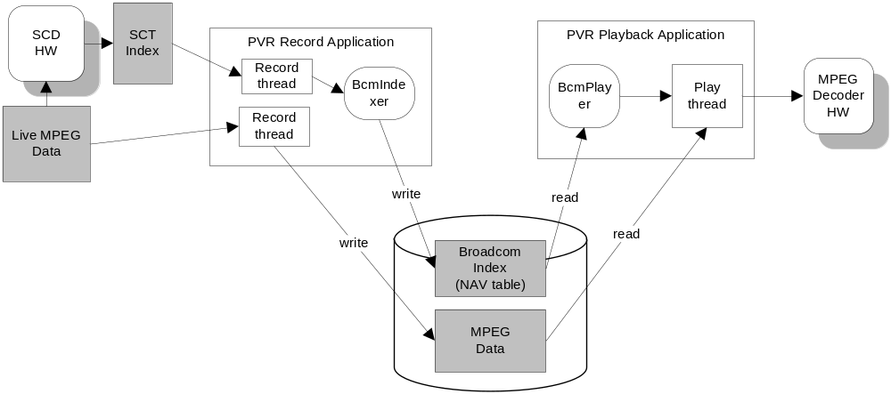

Stream Support
Bcmplayer supports:
- TS and PES streams
- MPEG and AVC video codecs
- Limited VC1 supported. We recommend the bmedia class (BSEAV/lib/media)
Bcmplayer does not support:
- ES streams
- Full VC1 support
- ASF, AVI, MP4 or other container classes

System Integration
Bcmindexer and Bcmplayer are software libraries which provide a playback and indexing service. The playback service provides an easy way to navigate through a file and perform host trick modes at decode time. The indexing service builds an index at record time which is used by the playback service.
The libraries have dependencies on Magnum’s DBG and KNI interfaces and some standard libc functions. There are no other calls to Magnum and no calls to file I/O or Settop API. The libraries do not read or write stream data, either transport or ES.
The application is responsible to connect bcmindexer and bcmplayer to the rest of the system.
For bcmindexer, the application receives index data from transport, then feeds to bcmindexer. Bcmindexer processes the data and fires a callback which contains the NAV index. The application writes the NAV data to disk.
For bcmplayer, the application gives bcmplayer access to the NAV index by means of read/seek callbacks. The application tells bcmplayer what mode to execute, then bcmplayer reports back to the application what data to read from disk and feed to transport.

Bcmindexer
The bcmindexer API is prefixed with "BNAV_Indexer". BNAV_Indexer_Open() initializes a handle which must be passed to all other bcmindexer functions. Before opening the indexer, you should get default settings and set your own settings.
After opening Bcmindexer, start code index data should be passed to the BNAV_Indexer_Feed() function. Bcmindexer will process this data and use the write callback to output the new index. The write callback is specified in the Settings passed into Open, and can simply be fwrite, as well as some other function which performs other tasks.
Be careful to only pass whole BSCT_Entry entries to BNAV_Indexer_Feed(), as partial entries will lead to corrupted data. You may need to verify that your start code index driver guarantees whole BSCT_Entry entries.
This diagram shows the bcmindexer state machine. Pictures are terminated by the start of the next SeqHdr or picture. There is not a one-for-one relationship between SCT entries push into Feed and NAV entries coming from the write callback.
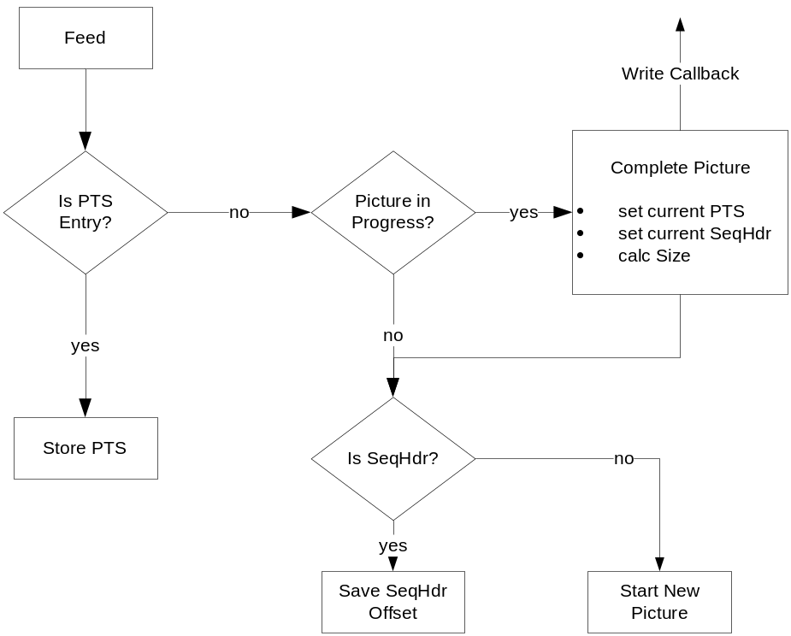

Bcmplayer
The bcmplayer API is prefixed with "BNAV_Player". BNAV_Player_Open() initializes a handle which must be passed to all other bcmplayer functions. Before opening the player, you should get default settings and set your own settings.
Bcmplayer only accesses the Broadcom index and does not read MPEG data. It tells an application what MPEG data to read and send to the decoder. During Broadcom Trick Modes, bcmplayer also generates 188 byte packets, which must be sent to the decoder along with the appropriate MPEG data.
The application is responsible to coordinate the data flow to the decoder. Certain operations, like jumping to a new point in the file, might need to be accompanied by seeking to an I-Frame and flushing the decoder (external to bcmplayer) otherwise abnormal delays or macro blocking might occur. Therefore using bcmplayer requires knowledge of the MPEG format and how your transport and decoder works.
Bcmplayer will sometimes be called from two threads, one thread which controls the player mode, and another which reads the next play entry. Bcmplayer is not re-entrant; therefore the application is responsible for protecting access.
Bcmplayer requires that your compiler support the uint64_t type. This is needed in order to handle large MPEG files. This does not mean that your system must support large files (>2GB). However, the callbacks used to access to the index file itself are only 32 bits.
Bcmplayer’s internal state machine uses a FIFO. Every time GetNextPlayEntry is called, one entry is returned from the FIFO. If the FIFO is empty, bcmplayer advances the player to the next index entry to be played.

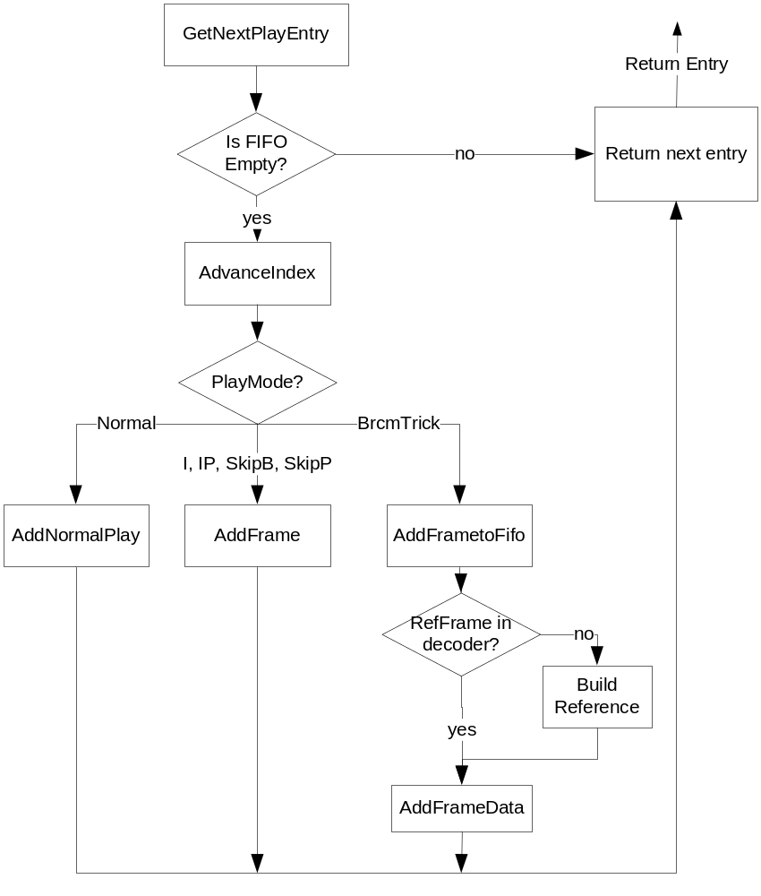

Bcmplayer Versioning and Codec Support
Bcmplayer and Bcmindexer each have separate version controls for their inputs and output.

Interface | Version Type | Usage
Bcmindexer Input | BSCT_Version | Supports 4 word and 6 word SCT’s.  RAVE platforms only support 6 word SCT’s.
Bcmindexer Output | BNAV_Version | Defaults to latest version.  AVC and VC1 codecs requires a special version.
Bcmplayer Input | BNAV_Version | Bcmplayer can read the version from the NAV table and is fully backward compatible
Bcmplayer Output | BNAV_DecoderFeatures | Application must specify. The structure contains booleans to turn on or off certain optimizations. The feature set can vary depending on the chip and firmware version.

Version Support

BNAV_VersionOriginal (value 0) are no longer supported. They used a reference frame offset which made open GOP B’s difficult. If you still need support for this index, you will need to use an older version of bcmplayer.
BNAV_VersionOpenGopBs (value 1) is still supported, but is very similar to BNAV_Version2.
BNAV_Version2 is the current version for MPEG streams.
BNAV_Version_AVC is the current version for AVC streams.
BNAV_Version_VC1_PES is the only version that supports VC1, but this was for internal develoment. VC1 is supported through the bmedia framework. If future VC1 transport support is required, we will revisit this version.

NAV Index for MPEG
The index produced by bcmindexer and used by bcmplayer is called a NAV table, NAV index or Broadcom Index. The common file extensions are either .bcm or .nav. You should definitely not use .idx or .sct because those suffixes are reserved for SCT (start code table) indexes.
This page discusses the BNAV_Version2 binary format of a Broadcom index used for MPEG codecs.
The BNAV_Entry structure is divided up into bitfields. Because space is limited, we don't want to waste a bit. Here is the current field mapping:

Field | Word | Bits | Definition
seqHdrStartOffset | 0 | 0..23 | Offset in bytes backward to the start of the sequence header needed for this frame.
frameType | 0 | 24..31 | I, B or P frame, including an RP (reference P) which is the first I slice P frame.
reserved | 1 | 0..3 | reserved
version | 1 | 4..7 | Version of the Broadcom index.
refFrameOffset | 1 | 8..15 | # of frames to go backwards to find the reference frame (either an I frame or first I slice P frame).
seqHdrSize | 1 | 16..32 | Size of the sequence header
frameOffsetHi | 2 | 0..31 | High 32 bits of a 64 bit offset into the MPEG file for the beginning of the frame (or picture).
frameOffsetLo | 3 | 0..31 | Low 32 bits of a 64 bit offset into the MPEG file for the beginning of the frame (or picture).
framePts | 4 | 0..31 | PTS value for this frame.
frameSize | 5 | 0..27 | Size in bytes of this frame.
reserved | 5 | 28..31 | reserved
timestamp | 6 | 0..31 | Bcmindexer generated timestamp to provide a continuous timebase.
packed_vchip | 7 | 0..11 | VCHIP information
reserved | 7 | 12..32 | reserved

NAV Index for AVC
This page discusses the BNAV_Version_AVC binary format of a Broadcom index used for AVC codecs.
The differnce between the AVC version and the MPEG version is that the AVC version needs to offsets and sizes for metadata. Instead of just the SeqHdr for MPEG, AVC requires an SPS and PPS per picture. This also required expanding the NAV entry to allow for more room.

Field | Word | Bits | Definition
seqHdrStartOffset | 0 | 0..23 | Offset in bytes backward to the start of the PPS (picture parameter set) needed for this frame.
frameType | 0 | 24..31 | I, B or P frame, including an RP (reference P) which is the first I slice P frame.
reserved | 1 | 0..3 | reserved
version | 1 | 4..7 | Version of the Broadcom index.
refFrameOffset | 1 | 8..15 | # of frames to go backwards to find the reference frame (either an I frame or first I slice P frame).
seqHdrSize | 1 | 16..32 | Size of the PPS
frameOffsetHi | 2 | 0..31 | High 32 bits of a 64 bit offset into the MPEG file for the beginning of the frame (or picture).
frameOffsetLo | 3 | 0..31 | Low 32 bits of a 64 bit offset into the MPEG file for the beginning of the frame (or picture).
framePts | 4 | 0..31 | PTS value for this frame.
frameSize | 5 | 0..27 | Size in bytes of this frame.
reserved | 5 | 28..31 | reserved
timestamp | 6 | 0..31 | Bcmindexer generated timestamp to provide a continuous timebase.
packed_vchip | 7 | 0..11 | VCHIP information
reserved | 7 | 12..32 | reserved
SPS Offset | 8 | 0..23 | Offset in bytes backward to the start of the SPS (sequence parameter set) needed for this frame.
reserved | 8 | 24..31 | reserved
SPS Size | 9 | 0..15 | Size of the SPS
reserved | 9 | 16..31 | reserved
Reserved | 10..15 | 0..31 | reserved

Comparing BcmPlayer with TsPlayer
The BSEAV team supports two PVR index formats and corresponding players.

BcmPlayer | TsPlayer
Used in Brutus demo app | Not used in Brutus demo app
Performs wide range of host trick modes | Performs slightly smaller set of host trick modes (no Skip B or Skip P)
Performs Broadcom trick modes (1x rewind, etc) | Does not perform Broadcom trick modes
Requires BcmIndexer to convert SCT data (produced by SCD hardware) into a NAV table | Works with SCT data directly. No conversion needed.
NAV table is one fixed sized entry per frame. This makes index-based jumps easier. | Has a variable number of SCT entires per frame
Embeds an index version number for backward compatibility. | No embedded version information.
Embeds a system-generated timestamp for time-relative jumps. | No embedded timestamp information.
Supports stream discontinuities produced by conditional access. | No support for this.
Embeds vchip information. | No embedded vchip information.

Common Features
Indexes pictures, sequence headers and captures PTS information.
Works with all set-top chips
Works with multiple OS'es

Usage Documentation

Bcmplayer Sample Code

Sample Bcmplayer User Code

#include "bcmplayer.h"
#include <stdio.h>

BNAV_Player_Handle player;
BNAV_Player_PlayMode playMode;
BNAV_Settings settings;

FILE *indexFile = fopen("myindex.nav", "r");
FILE *mpegFile = fopen("myvideo.mpg", "r");
int driverFd = open("/dev/pvr_playback", O_RDWR);

BNAV_Player_GetDefaultSettings(&settings);
settings.readCb = fread;
settings.tellCb = ftell;
settings.seekCb = fseek;
settings.filePointer = indexFile;
if (BNAV_Player_Open(&player, &settings))
FAILURE();

playMode.playMode = eBpPlayNormal;
playMode.playModeModifier = 0;
playMode.loopMode = eBpSinglePlay;
playMode. disableExtraBOptimization = 0;
if (BNAV_Player_SetPlayMode(player, &playMode))
FAILURE();

while (isPlaying) {
BNAV_Player_PlayEntry entry;
unsigned char packet[188];

if (BNAV_Player_GetNextPlayEntry(player, &entry, packet))
FAILURE();
if (entry.isInsertedPacket) {
// write contents of packet to the driver/decoder
// (of course, using write() might require a loop.)
if (write(packet, 188, driverFd) != 188)
FAILURE();
}
else {
// Position your mpeg file. Notice that we have to handle 64 bit
// offsets. If your platform only supports 31 bit file offsets,
// just ignore startOffsetHi and make sure you don't play files >2GB.

off_t offset = ((off_t)entry.startOffsetHi)<<32 | entry.startOffset;
if (fseeko(mpegFile, offset, SEEK_SET))
FAILURE();

// Read entry from the mpeg file. I'm assuming a buffer called buf
// which is guarunteed larger that the largest possible MPEG frame.
// Most likely you'll have to do N reads.
cnt = fread(buf, 1, entry.byteCount, mpegFile);
if (cnt <= 0)
FAILURE();

// write that data to the pvr playback driver
if (write(buf, cnt, driverFd) != cnt)
FAILURE();
}
}
BNAV_Player_Close (player);
close(driverFd);
fclose(mpegFile);
fclose(indexFile);

Sample Bcmindexer User Code
#include "bcmindexer.h"
#include <stdio.h>

#define BUFSIZE 1024*40
char buffer[BUFSIZE];
BNAV_Indexer_Handle indexer;
BNAV_Indexer_Settings settings;
FILE *outFile = fopen("newbcmindex.nav", "w");
// this assumes you have a hardware index on disk already.
FILE *inFile = fopen("hardwareindex.idx", "r");

BNAV_Indexer_GetDefaultSettings(&settings);
settings.writeCallback = fwrite;
settings.filePointer = outFile;
if (BNAV_Indexer_Open(&handle, &settings))
FAILURE();

while (!feof(inFile)) {
int cnt = fread(buffer, sizeof(sHwSctEntry),
BUFSIZE/sizeof(BSCT_Entry), inFile);
BNAV_Indexer_Feed(indexer, (BSCT_Entry *)buffer, cnt);
}
BNAV_Indexer_Close(indexer);
fclose(inFile);
fclose(outFile);

Trick Modes
PVR trick modes are accomplished by combining a variety of features to produce the desired end-user effect. There are three basic types of trick mode features:
-  Host-based trick modes
  - The application skips content.
-   Broadcom trick modes
  - The application instructs the decoder to how to decode and display individual pictures using embedded command packets.
- Decoder-based trick modes
  - The application instructs the decoder to drop or repeat pictures based on a variety of parameters.
- STC trick modes:
  - The application manipulates the STC used for audio/video TSM. The decoders remain in normal play and present pictures when the PTS matures (according to normal play TSM rules).
Bcmplayer accomplishes host and Broadcom trick modes by managing the algorithm and then instructing the application what data to send to the decoder.
Bcmplayer is not involved with Decoder of STC trick modes.

System Requirements for Broadcom Trick Modes

Overview
Broadcom trick modes require the highest system bandwidth because multiple frames must be decoded in order to display a single frame when moving in a reverse direction. The bandwidth requirements for the system can be considered in four categories:
- Chip Requirements - internal to the chip, for example transport and decoder bandwidth
- Disk Requirements - seeking and reading data from disk into memory
- CPU Requirements - processing data in memory before sending to the chip
- Source Requirements - what kinds of MPEG can be used
All bandwidth requirements in this document are based on 1x rewind with no decoder slow motion. By adding decoder slow motion or operating in frame reverse mode, all bandwidth requirements are greatly reduced.
All bandwidth requirements are given for a single channel. For systems capable of multiple simultaneous Broadcom trick modes (e.g. 7320 and Venom2), these requirements may not increase linearly.

Chip Requirements
1.a. Transport must be configured to allow at least 50 Mbps (megabits per second) of playback bandwidth to get the data to the decoder. All of Broadcom’s recent Settop chips allow this, but a specific XPT PI call may be required to enable the higher bandwidth.
1.b. The decoder must decode faster than 1.0x rate. For MPEG SD, this is usually not a problem. However, this is not possible for MPEG HD streams.

Disk Requirements
2.a. The system needs an equivalent 50 Mbps of disk throughput, however this total is made up of many frames which are read multiple times in close temporal proximity. Therefore we rely on disk caching to make this possible. See Source Requirements for more information.

CPU Requirements
3.a. The CPU must insert 188 byte BTP packets throughout the transport stream, and must perform multiple reads just to display one frame, therefore CPU utilization is higher than host-based trick modes.
3.b. On systems which read data from disk in user mode and transfer that data to a driver running in kernel mode, the data must be buffered and transferred in large blocks. Otherwise the many 188 byte transfers will consume too much system time. Ideally, the scatter/gather capabilities of the transport engine are used at the application level and no copy is required.
3.c. The index format is dependent on the endianness of the CPU. An index created on a little endian CPU must be byteswapped to be used on a big endian CPU.

Source Requirements
4.a. Broadcom trick modes work with SD content, both 480i (NTSC) and 576i (PAL). They also work with GOP-based (IBP) and HITS (progressive I slice) streams. They are the only way of doing trick modes with HITS streams.
4.b. HD content is not suitable for Broadcom trick modes because of the increased disk, CPU and decoder bandwidth required. With continuing optimizations, this may become possible in the future. It is certainly possible for frame reverse where bandwidth requirements are substantially less.
4.c. DSS (Direct TV) streams aren't compatible with Broadcom trick modes because they are not MPEG2 Transport streams. The Transport format is necessary for the inserted BTP packets.
4.d. Transport streams which contain multiple programs and PSI information (usually used on streamers) are usually not suitable for Broadcom trick modes. This is because the unneeded data causes a high number of cache misses which leads to underflow.

When not to use Broadcom trick modes
Because of the bandwidth requirements, there are times when comparable host-based trick modes are preferrable to Broadcom trick modes.
For GOP-based streams, you can do most forward trick modes with host-trick modes. One exception is a true 2x fast-forward. You can also do fast rewind with I frames.
For HITS streams, you can do some forward trick modes by dropping some or all B frames.
By choosing a host-trick mode over a Broadcom trick mode, you gain performance but lose the ability to specify an exact rate independent of GOP structure. However, the application may prefer to not guarantee a certain trick mode speed to the end-user.

Handling Encrypted Streams

How to record partially encrypted streams
SCD (start code detect) hardware produces SCT (start code table) entries as it finds start codes in unencrypted MPEG streams. The SCD hardware will not produce SCT entries for encrypted data, however, the MPEG will still be recorded. When the stream becomes unencrypted again, SCT entries will start to be generated again. However, bcmindexer is not informed when encryption starts or stops, so it must discern this.
Bcmindexer only knows frame sizes by taking the difference between adjacent frame starts in the SCT entries. Therefore the last clear frame before the encrypted data is going to be huge (with one exception noted later). If bcmindexer doesn't discard the huge frame, the application will try to feed all of the encrypted data as a single large frame. This will result in an application hang.
To discard huge frames, bcmindexer must define what "huge" is. "Huge" is defined as larger than any possible frame. Unfortunately, this cannot be deterministically specified, so we have to take a reasonable guess. We've seen HD I frames as large as 500K. If we assume that encryption will never be for just a few frames, we can pick a value quite a bit larger than 500K and still be safe. Therefore we chose a default "huge" size of 5M (0x500000) but we make this size configurable.
Also, when unencrypted data starts again, bcmindexer needs to discard all frames until the next I frame is encountered. It should also discard any open-GOP B's after the first I frame. This will avoid macro blocking video.
Unfortunately, size alone is not sufficient. If just the right amount of encrypted data comes through, the frame offset might wrap the 32 bits of SCT storage for the frame offset. This will result in the calculation of an incorrectly small frame size. One way to solve this is to add a time element. Fortunately, the time element can be quite large because a 32 bit wrap will always take time. For instance, 5 minutes would be appropriate. However, because of the next issue we do not prefer the time test.
Another unfortunate effect of wrapping 32 bits is that bcmindexer has no way to know deterministically how many times the index has wrapped. If an incoming frame offset is less than the last frame offset, it can assume it has wrapped. Using the time test mentioned above, you can detect a missed wrap, but it's hard to imagine a time test that can accurately distinguish between 1, 2 or more wraps across all MPEG streams of varying bit rates. A wrap only requires 4 GB of data and in an HD environment this is possible in a relatively short amount of time. An undetected double wrap is fatal for PVR and will cause the attempted playback of encrypted data.
The only way to solve this is for bcmindexer to be in communication with the MPEG record thread, and this cannot be done in a generic way. Therefore we provide an optional callback which the application developer can use to connect the index and MPEG record threads. Bcmindexer can call this callback at any time and retrieve a 64 bit MPEG file size. The synchronization of the MPEG and index threads is not an issue because Bcmindexer applies a 1 GB threshold to the test.
The new SCD hardware in the 73xx and 71xx chips allows 40 bit frame offsets in the SCT entries, and this effectively solves the problem. We can safely assume that we will never wrap 40 bits.
The maxFrameSize and mpegSizeCallback settings in bcmindexer's BNAV_Indexer_Settings implement this solution.

Producing Unique Timestamps
The purpose of the timestamp is to provide a guaranteed continuous timebase across a single pvr file for time-based navigation. The granularity and accuracy of the timestamp only needs to be enough to allow applications to navigate PVR files. Therefore 1/4 second or 1/2 second accuracy may be enough.
The SCD hardware does not support timestamping, and the SCD-produced data necessarily comes to bcmindexer in batches. Therefore if you need unique timestamp values for each frame, you'll need to interpolate between the system time when each batch arrives.
For instance:

Batch 1 arrives at 100, therefore: 100,101,102,103,104,105
Batch 2 arrives at 120, therefore: 120,121,122,123,124,125
There is no fixed time difference between frames, but this can't be guaranteed anyway because there is no fixed time between batches. However, because those batches are arriving at near-fixed time, it should be pretty closer to linear across the entire file, therefore BNAV_Player_FindIndexFromTimestamp() interpolates to a location, then does a linear search.
If you have to GUARANTEE unique timestamp values, then you've got to take into account the possibility that the next batch may arrive at a time before the last interpolated timestamp of the previous batch. If this happens, you could force the next batch's timestamp to start at the next available unique timestamp.
Another idea is to do a double-buffering scheme. You could timestamp the previous batch when the next batch arrives. That might allow you to end up with:
Batch 1 arrives at 100
Batch 2 arrives at 120, and Batch 1 is set to 100,103,109,112,115,118
Batch 3 arrives as 140, and Batch 2 is set to 120,123,129,122,125,128
The downside of this is that simultaneous play/record probably needs that index to be written to the disk ASAP.

Searching a Broadcom index using PTS values

Finding an index using a PTS.
Use BNAV_Player_FindIndexFromPts() to find an index using a PTS.
Because of normal PTS discontinuities, an index-wide binary search for a PTS is impossible; therefore a linear search starting from a particular location is required.
The starting point is either the current index or the last index returned by a successful PTS search. The latter case is an optimization, which results in much better search times if you are constantly calling IndexFromPts? when playing or performing trick-modes in the same direction. Average search loops can decrease from 100 loops to only 5. The actual decrease will depend on the size of your playback and decode buffers as well as the frequency of calls to get an index from a PTS.
Any linear search is limited by the searchWindow parameter. This specifies the number of index entries to search before giving up.
After the rough search is made using decode order, a frame-accurate search is performed using display-order. This search will always be very brief, using techniques like finding skipping previous B frames, etc. The length of this search depends on GOP format.

Finding an index using the current PTS of the decoder
A common operation is to find an index entry using the current PTS value of the decoder. Special care needs to be taken to avoid lengthy and uncertain linear searches.
If you are using bcmplayer for normal playback, the current index will be gapped from the current PTS of the decoder according to the size of your playback and decode buffers.
However, if you don’t use bcmplayer for normal playback, make sure you use IndexFromOffset to find what the current index should be then call SetCurrentIndex to set the current index. Only then should you search for the PTS because then you’ll be in the ballpark.
The value of the searchWindow parameter is related to the depth of your playback and decode buffers. For instance, a searchWindow of 400 frames, assuming a worst case of 60-frames/second content, would allow you to search through 6 seconds of buffered MPEG.

Other search techniques
Because of the limitations of PTS searches, they should be restricted to finding the index for the current PTS of the decoder. Any other search should be done with a different technique.
• An absolute position in the index can be stored and restored using the index number, mpeg offset or timestamp.
• Time-based jumps (e.g. jump forward 30 seconds) should be done with timestamp.

Bcmplayer Vchip Support
NOTE: Bcmplayer vchip support is incomplete and probably not useful in its current state.
Bcmindexer can store vchip data into the index file. This information is stored per frame because it can change over the span of a stream. The current level is set by calling BNAV_Indexer_SetVChipState.
Bcmplayer can return the vchipState for the current frame using BNAV_Player_GetPosition.
Neither Bcmindexer nor Bcmplayer has the ability to interpret the vchip data. It only stores and retrieves it. The interpretation of the data, which ultimately translates into a boolean (to play or not to play) is application-specific.

Current Usage
When recording a stream, the application can monitor the vchip information it's receiving. It can remember, outside of the index, what is the highest level (i.e. most restrictive) for the entire stream. It then controls the playback of the stream based on that single level. It's an all or nothing approach.
Obviously, there is no need to store vchip information in the index if this is the approach.

Possible Future Usage
To implement frame-level Bcmplayer support of vchip information, we would need to add the following:
• Add a callback function which took vchip state information as an input parameter and had a boolean return code if the data was playable. Bcmplayer would call this for each frame.
• For Broadcom trick modes, all necessary non-displayed frames would need to be playable in addition to a displayed frame.
• BNAV_Player_PlayEntry would need to be extended to return any vchip violation.
• When a violation occurs, the application would probably need to flush.
• Bcmplayer could continue in the same direction until it reached a playable frame.
• Bcmplayer would have to communicate back to the application how much time had been skipped so that the app could optionally put up a user notification and wait that amount of time before playing more. Other apps might just skip the content and resume playing immediately.
• Normal playback, which returns data in blocks and not frames, would have to scan each frame before it could return a block of data.

Utilities

Bcmplayer Utilities
The following utilities are found in the BSEAV/lib/bcmplayer/utils directory:

printindex
Print SCT (Start Code Table) and Broadcom indexes. It recognizes .nav and .bcm extensions as Broadcom indexes, otherwise it defaults to SCT indexes. There are command line options to control what fields are printed. Run "./printindex --help" for a full list of options.

createindex
Create Broadcom indexes from a MPEG2 Transport or SCT index. Also creates SCT indexes from a MPEG2 Transport source. Run "./createindex --help" for a full list of options. This replaces the old tsindexer utility.

Getting the utilities
The source is located in BSEAV/lib/bcmplayer/utils. Here are some examples of how to build:

# For Linux on mips
make

# For Linux on i386
export CC=gcc
make

# For Windows, see the win32 subdirectory for Visual Studio projects.

Converting Broadcom Indexes
Embedded in each Broadcom index file is a version number. We currently have version 0, 1 and 2 indexes. We've had to update the index format in order to support new optimizations and to handle conditions we weren't expecting before. bcmplayer is backward but not forward compatible.
If you try to play a new index using and old version of bcmplayer, you'll get an error.
Also, newer versions of bcmplayer no longer support version 0 indexes for two reasons:
• There was a time window when we created version 1 indexes but didn't mark them internally. We were planning on having external app-based versioning, until we realized this wasn't a good idea. So you can get false reads on the version number.
• Version 0 indexes cannot support most of the important performance optimizations. If you use them, you'll be sending megabytes of data unnecessarily and your decoder will underflow. This means your 1x rewind is more like 0.5x.

How to convert
- Build the createindex utility.
  - Go to BSEAV/lib/bcmplayer/utils and read the word doc there.
- Determine the filename of your stream.
  - If using Brutus, go to the brutus Playback screen. Select a video and press "Select". You should see the filename as XXXXX.mpg.
- Determine the video pid of the stream.
  - On the command line do the following, where XXXXX comes from XXXXX.mpg and look for the vidpid= line:
cat videos/XXXXX.info
-  Build the new index where PID is the vidpid you read from the previous operation. Be sure to include the 0x prefix in the PID:
cd /home/brutus/videos
createindex XXXXX.mpg XXXXX.nav PID

If that didn't work, try getting command line help:
createindex --help

