Broadcom IP STB
ASF/IP

Revision History

Revision Number | Date | By | Change Description
1.0 | 10/23/06 | P. Timariu | Initial draft
1.1 | 10/24/06 | J. Jordan | Editing and reformatting
1.2 | 12/08/06 | P. Timariu | Updating for new build
1.3 | 12/21/06 | P. Timariu | Updating new build parameters
Table of Contents
Revision History 2
Introduction 3
ASF over IP support in BRCM reference software 3
Integration 3
Dependencies 3
Howto: build & run 3

Introduction
ASF is a robust Windows Media format designed to function as a transport medium for all types of media. It typically hosts VC-1 Main/Simple/Advanced Profile or Windows Media Audio data. Encoding is done at the payload level and one can multiplex a number of A/V streams in one single ASF entity by using the Windows Media Encoder.

Windows Media Streaming Services allows content providers to publish ASF content over IP, in various forms. The transmitter entity is designated as a publishing point, which usually takes data from a playlist and delivers it over a transport “interface”. The transport descriptor can configure options such as type of transport: multicast or unicast, maximum number of allowed connections, carousel mode, buffering limits, etc.

ASF over IP support in BRCM reference software

Integration

Broadcom Reference Software includes support for unicast ASF playback over RTP, from a publishing point created in Windows Media Services versions 9.x. It makes use of the open source LiveMedia engine for RTP processing to some extent and uses the RTSP facilities in the library, to enable session setup. Note that Windows Media Services uses a proprietary announcement format for multicast streams (NSV) which is not handled by this module. Alternatively, Windows Media Encoder, another WM technology allows transport over MMS, an MS specific HTTP-like protocol.

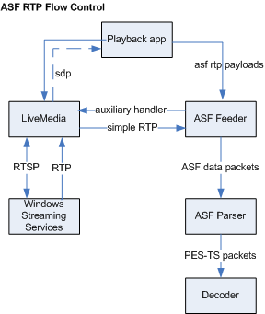

Fig.1) ASF/IP interaction

Dependencies

BRCM ASF IP support makes use of the LiveMedia engine to transport RTP, with plans to support the NETIF_DMA architecture in the near future. LiveMedia tends to have sub-optimal processor usage, when it comes to RTP processing, which is why NETIF_DMA is preferred for unicast/multicast. WMSS also supports RTP over TCP, which cannot be handled by NETIF_DMA at this point in time.

Windows Media uses a proprietary packetization scheme, signified by RTP packet type (96), to split the ASF data into RTP packets optimally.

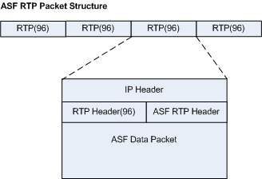

Fig. 2) ASF RTP packet

RTP Processing: As RTP packets are being received by the LiveMedia A/V session, they go immediately into the ASF feeder, whose main responsibility is to:
- verify RTP header information
- drop invalid packets
- prevent incomplete ASF data packets from reaching the parser/demux
- reorder out of order packets
- restore ASF data packets from the original stream
- feed the packets to the ASF parser/demux

The following rules apply to ASF when packetized over RTP:
- an ASF data packet can span over an indefinite number of RTP packets
- an RTP packet with a marker bit on, signifies the end of a data packet sequence
- Audio/Video ASF payloads can be part of the same RTP payload
- ASF data packets are NOT identical to the corresponding packets in the streamed file. ASF packet headers may contain different padding, error correction or fields.

The ASF RTP header is described in detail by the Windows Media Networking Kit. This header can contain among others, FEC information, other than the error correction information already existent in the ASF payloads.

ASF pre-RTP processing: Before any RTP processing can happen, the ASF headers must be received and parsed, to extract stream information, codec types, content description data and other parameters necessary for the playback. This is achieved by tapping into the SDP response of the RTSP DESCRIBE operation.

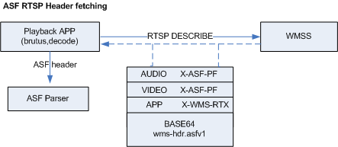

Fig. 3) ASF header in RTSP traffic

The ASF header is encoded in the wms-hdr.asfv1 section in the SDP. Recovery of the ASF header is critical, prior to starting any RTP processing. Server validation is performed before any playback command is sent to the server over RTSP, to make sure only Windows Media Servers are targeted.

ASF RTP packet recovery: Lost packets have a significant effect on the playback of the ASF stream as the access unit for the ASF, is a data object, containing a varying number of A/V payloads.

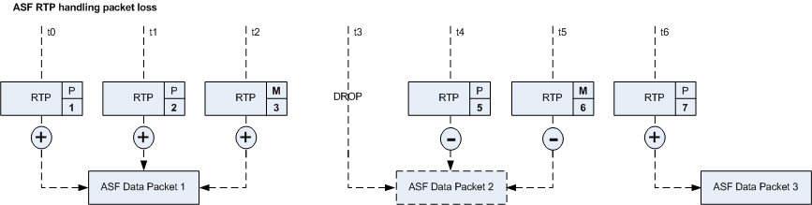

Fig. 4) ASF packet drop and recovery

As the data objects can be spanned over a varying number of RTP packets, any RTP drop will cause an invalidation of the data object it’s currently in, which in turn causes an invalidation of the data contained in RTP packets participating in the reconstruction of the broken ASF data packet, even if following RTP packets may have valid payloads in them.

Howto: build & run

- after downloading the IPSTB reference software version for your current platform, run the usual IPSTB make command with the additional ASF_SUPPORT=y:

make install ASF_SUPPORT=y

As of this release (3.5 Take 2), the PLAYBACK_IP_SUPPORT=y build parameter is not needed anymore, in order to build for ASFIP support.

from under $(BSEAV)/app/brutus/build. The asfip util will only build if ASF_SUPPORT is enabled in the reference build

- run a decode test with your target ASF content over the reference software decode application, both Simple/Main Profile and Advanced Profile. Try both WMA and VC-1 AP/SP content to make sure ASF support is built in and the stream plays well.

- once the build is done, run asfip from the target installation directory with the following parameters:

./settop asfip -video_type <vtype> -audio_type <atype> -mpeg_type <mtype> -audio <apid>
-video <vpid> -link <url>

vtype video type vc1, vc-1 VC1 advanced profile
vc1-sm VC1 simple/main profile

atype audio type wma Windows Media Audio

apid audio stream ID

vpid video stream ID

link windows media server exported RTSP stream url.
e.g. rtsp://10.15.3.192/PublishingPointAP

e.g.

./settop asfip -video_type vc1 -audio_type wma -mpeg_type asf -audio 0x1 -video 0x2 –link rtsp://10.15.3.192/PublishingPointAP

    - rtsp://10.15.3.192/PublishingPointAP is the link to the publishing point previously created on your Windows Media Streaming Server, extracted from the server console.
    - asfip is a spin-off derived from the refsw decode util, so many of the arguments supported in decode, such as decode window control parameters, are also supported in asfip.
    - audio pid and video pid are the corresponding stream ID numbers from the original ASF file.
    - Advanced Profile ASF must be signaled by -video_type vc-1, Simple/Main Profile must be signaled with -video_type vc1-sm.
    - Windows Media Audio has –audio_type wma

Notes: Trickmodes have not been implemented in this version although WM RTSP should allow trickmodes. Testing was done with video both SM and AP streams ranging from 100k to 2-3 Mbitps. Some video glitching may occur partially due to PR 24958, which is being investigated.
- SCR clock recovery from the ASF data packet is not implemented, and is also the subject of the aforementioned PR. This would allow the host STC to be in-sync with the server STC, thereby accounting for jitter occurring between the server and host clocks.
- Multicast playback is not yet allowed. MS uses an MMS/NSV protocol descriptor that is not fully documented and does not derive from existing RTSP-type protocols.

