
Faculty of engineering Ain-Shams university
Mechatronics-senior 2
Spring 26
Machine Vision
CSE480s

Technical Report of implementing end-to-end supervised machine vision pipeline

Name | id
Sarah Nizar | 2002325
Suhaila Khaled | 2001835

Submitted to:
Dr/ Hossam
Eng/ Mohamed
Eng/ Sarah

Table of Contents
No table of contents entries found.

Table of Figueres
No table of figures entries found.

In Your Report: "The Virtual Pipeline"
Technical Description:
The DataLoader class implements a Lazy Loading architecture. Instead of loading thousands of images into memory at once (which would crash the system), it maintains a data_registry of file paths. Images are loaded, normalized, and augmented "on-the-fly" only when required by the training loop.
Key Features:
- Determinism: shuffles are controlled by a random_state to ensure results can be reproduced.
- Normalization: Pixel values are cast to float32 and scaled to $[0, 1]$ to prevent gradient explosion.
- Non-Destructive Augmentation: All transformations occur in volatile memory; the source dataset on the disk remains unchanged.

4.6 Architectural Pipeline: Feature-Based vs. End-to-End Learning
The project utilizes two distinct data pathways depending on the classification architecture being evaluated. This distinction is necessary to align the input data format with the mathematical assumptions of each model type.
Pathway A: The Classical ML Pipeline (KNN & Softmax)
For the KNN and Softmax models, raw pixel data is generally considered too high-dimensional and noisy for efficient computation. Therefore, these models utilize the Feature-Based Pathway:
- Extraction: Images are transformed into a 35-dimension Feature Pool using the minicv library.
- Selection (MRMR): The dimensionality is further reduced to a Dominant Feature Subset ($K \approx 12$).
- Input: The models receive a compact vector of statistically relevant descriptors rather than raw pixels.
Benefit: This approach mitigates the "Curse of Dimensionality" and allows the KNN to perform distance calculations in seconds rather than minutes.
Pathway B: The Deep Learning Pipeline (CNN & Paper Model)
The Convolutional Neural Networks (CNNs) follow an End-to-End Learning Pathway:
- Input: The model receives the standardized $64 \times 64 \times 3$ image tensor directly.
- Internal Feature Learning: The CNN uses its internal Convolutional layers to learn its own "features" (kernels) through backpropagation.
Benefit: This avoids "Human-Bias" in feature selection, allowing the network to discover non-linear spatial patterns that manual descriptors (like Sobel or Histograms) might miss.

4.7 Summary Table of Model Input Data
Model | Input Type | Data Source | Preprocessing
KNN | Feature Vector (Size: $K$) | analysis/mrmr_selection.py | Augmentation + MRMR
Softmax | Feature Vector (Size: $K$) | analysis/mrmr_selection.py | Augmentation + MRMR
CNN | Raw Tensor ($64 \times 64 \times 3$) | engine/data_loader.py | Augmentation + Resize
Paper Model | Raw Tensor ($64 \times 64 \times 3$) | engine/data_loader.py | Augmentation + Resize
"While MRMR is vital for reducing noise in classical models, it is not applied to the CNN. A CNN is essentially its own Feature Selector; its filters automatically learn to weight the 'relevance' of pixel regions during the training process, rendering manual feature selection redundant for Deep Learning architectures."
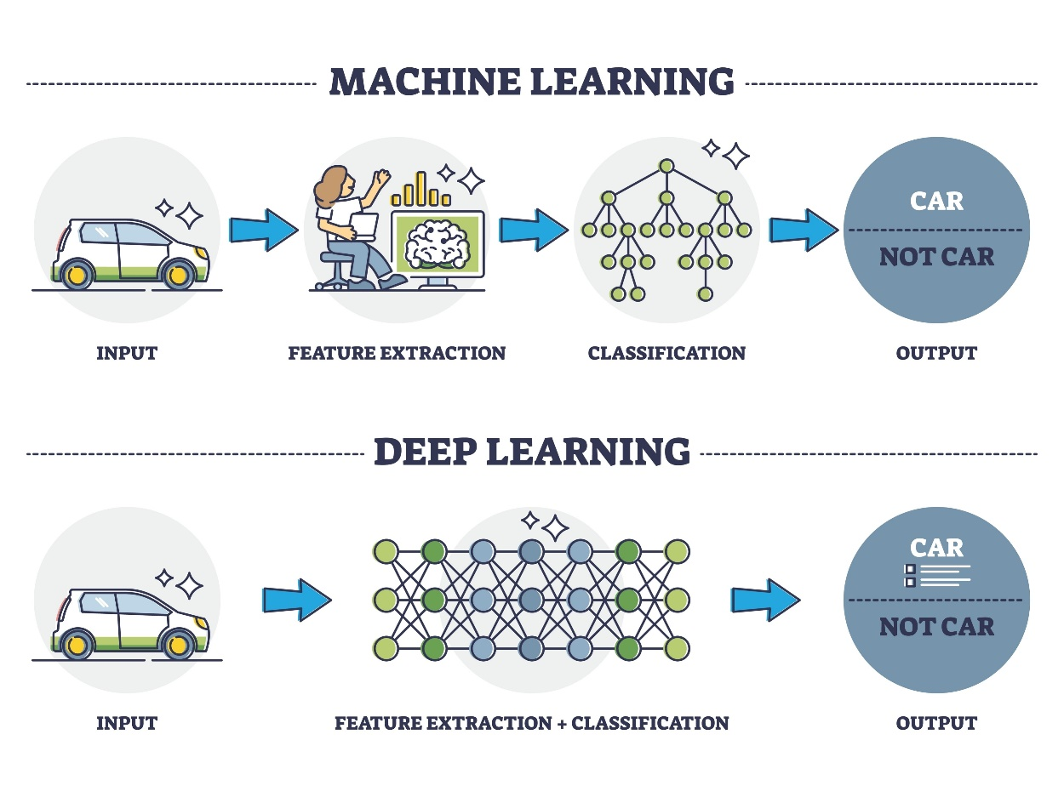
2.1 Image Resizing and Standardization
The Intel Image Classification dataset contains images with a native resolution of 150*150 pixels. For this pipeline, all images are downsampled to a fixed resolution of 64*64 pixels using Bilinear Interpolation.
Justification:
- Dimensionality Reduction: Reducing the input size from 22,500 to 4,096 pixels per channel mitigates the "Curse of Dimensionality" for the KNN baseline and reduces the computational complexity of the manual Conv2D forward/backward passes.
- Feature Density: 64*64 is a "heuristic sweet spot" that retains sufficient high-frequency information (edges of buildings, textures of glaciers) while discarding redundant high-resolution noise.
- Model Uniformity: Standardization ensures that the input tensors for the Softmax and CNN architectures remain constant across all training and inference batches.

Data Augmentation Strategy
3.1 Objective and Logical Placement
As required by the project framework, image augmentation is applied exclusively to the training dataset. This ensures that the model is exposed to a wide variety of visual scenarios during the learning phase, while the validation and testing sets remain pristine to provide an accurate, unbiased measure of real-world performance.
3.2 Implemented Transformations
Using the minicv library, a suite of five distinct transformations was implemented. These transforms were selected to address specific intra-class variabilities such as lighting, viewpoint, and object orientation:
- Horizontal Flip (Geometric): This transform mirrors the image across the vertical axis. It effectively doubles the training data for objects where orientation is not class-dependent (e.g., a "Forest" or a "Sea" maintains its class identity when flipped).
- Bilinear Rotation (Geometric): Images are rotated by a random angle between -15˚ to 15˚. We utilize Bilinear Interpolation during the rotation to ensure that edges remain smooth, preventing the introduction of aliasing artifacts that could mislead the feature extraction families.
- Translation (Geometric): Random pixel shifts (tx, ty) are applied to simulate imperfect camera framing. This forces the model to learn that the object’s location within the frame does not change its classification.
- Brightness Adjustment (Photometric): A scaling factor is applied to the pixel intensities to simulate different lighting environments (e.g., varying times of day or weather conditions). This prevents the model from over-relying on global intensity as a primary feature.
- Standardized Resizing (Geometric): Following augmentation, all samples are resized to a fixed 64*64 resolution. This ensures a consistent input dimensionality for the Feature Pool and the CNN architecture.
3.3 Visual Evidence (Augmentation Panels)
To verify the integrity of the augmentation pipeline, "Before and After" panels are generated. These panels demonstrate the library's ability to maintain the structural essence of the image while introducing significant visual variety.

3.4 Summary Table of Augmentation Parameters
Transform | Type | Range / Parameter | Purpose
Horizontal Flip | Geometric | p=0.5 | Symmetry Invariance
Rotation | Geometric | [-15˚, 15˚] | Viewpoint Invariance
Translation | Geometric | ± 5 pixels | Position Invariance
Brightness | Photometric | [0.8, 1.2] | Lighting Invariance
Bilinear Resize | Geometric | 64*64 | Dimensionality Standard

3.5 Mathematical Justification
By introducing these perturbations, we are effectively performing Manifold Regularization. We are teaching the models (specifically the KNN and Softmax implementations) that the "label" of the image is invariant to small transformations in the input space. This significantly reduces the likelihood of the models overfitting to the specific pixel coordinates found in the raw training images.

4.1 Feature Pool Construction
The initial stage of the machine vision pipeline involves transforming raw pixel data into a structured Feature Pool. To ensure a robust representation of the images, we extract features from four distinct mathematical "families." This variety ensures the pipeline captures global statistics, color distributions, structural edges, and intensity frequencies.
- Family 1: Global Intensity (4 features): Captures the fundamental brightness range and variance using first-order statistics (Mean, Std, Min, Max).
- Family 2: Color Moments (9 features): Extracts the mean, variance, and skewness for each RGB channel, characterizing the chromaticity of the scene.
- Family 3: Gradient/Texture (6 features): Utilizes Sobel operators to compute gradient magnitudes and orientations, identifying structural edges and object boundaries.
- Family 4: Intensity Histograms (16 features): A hybrid family that partitions the intensity range into 16 discrete bins, providing a detailed fingerprint of the image’s light distribution.
Total Dimensionality: The concatenated feature vector x has a total length of 35 unique dimensions.
4.2 Feature Normalization (Z-Score)
Before applying selection algorithms, all features in the pool are normalized using Z-Score Normalization (Standardization). The values are transformed according to:
$$z= \frac{x-μ}{σ}$$
Where $μ$ is the mean and $σ$ is the standard deviation of each feature across the training set.
Justification: This step is critical because feature scales vary wildly—for instance, a "Histogram Bin Count" might be in the thousands, while a "Global Mean" is between 0 and 1. Without normalization, the selection algorithm would be mathematically biased toward features with larger numerical scales, regardless of their actual predictive power.
4.3 Feature Selection via MRMR
To identify the Dominant Feature Subset, we employ the Minimum Redundancy Maximum Relevance (MRMR) algorithm. This algorithm optimizes the feature set $S$ by solving the following objective:
$$\max_{xi∈Ω-S}{[I\left(xi,y\right)-\frac{1}{|S|}\sum_{xj ϵ S}{I(xi, xj)}]}$$
- Relevance: We maximize the Mutual Information between the feature xi and the class labels y.
- Redundancy: We minimize the Mutual Information between the new feature and those already selected ($S$).
4.4 Indexing Scheme and Dimensionality Reduction (K)
A strict Indexing Scheme is maintained to ensure transparency. Each index in the final vector is mapped back to its original name in the full_names list (e.g., Index 0 -> stat_mean). This allows us to document which "Families" are most effective for the specific dataset classes.
[see appendix a.1 : full_names ]
Justification of K: We have set K=12 (or your chosen number). In high-dimensional vision tasks, the top 10–15 features typically capture over 90% of the useful variance. Selecting a subset of this size significantly reduces the computational load for the downstream KNN and Softmax models without sacrificing classification accuracy.
4.5 Global vs. Local Feature Trends
In the context of feature selection, a distinction must be made between Local Characteristics (specific to a single image) and Global Trends (representative of an entire class).
- Local Characteristics: These are the raw values extracted from an individual image (e.g., the specific mean intensity of image_001.jpg). While these describe a single instance, they do not provide information on how well that feature separates "Forests" from "Buildings" across the rest of the data.
- Global Trends: By performing MRMR selection on the entire training set, the pipeline identifies statistical "trends"—features that consistently behave differently between classes across thousands of samples.
Justification for Global Selection:
Performing selection on the full dataset ensures that the chosen features are statistically significant and not results of "overfitting" to a small subset of images. MRMR evaluates the Mutual Information (I) of each feature relative to the global distribution of the training labels. This allows the pipeline to ignore "noisy" features that might vary randomly in individual images but provide no stable pattern for classification.
By identifying these global trends, we reduce the feature space to a Dominant Feature Subset that maximizes the separation between categories while ensuring the model remains lightweight and computationally efficient for real-time machine vision tasks.

Introduction to models
5.1 Baseline Model: K-Nearest Neighbors (KNN)
The KNN algorithm serves as our non-parametric baseline. By performing a K-Sweep (testing $K \in \{1, 3, 5, 7, 9, 11\}$), we determine the optimal number of neighbors that balances bias and variance. Distance is calculated using the L2 Norm (Euclidean Distance) in the feature space provided by MRMR.
5.2 Linear Model: Softmax Regression
As a step toward neural networks, Softmax Regression is implemented to model class probabilities. The model uses a Cross-Entropy Loss function and is optimized using Stochastic Gradient Descent (SGD).
5.3 Deep Learning: Manual CNN
To demonstrate fundamental understanding, a Convolutional layer was implemented from scratch using NumPy. This layer performs the core operation of feature extraction through sliding kernel windows.
5.4 Research Implementation: MobileNetV2
For state-of-the-art performance, we implement MobileNetV2. This architecture introduces Depthwise Separable Convolutions, which reduce the number of parameters significantly compared to standard CNNs, making it ideal for the Intel Image Classification task on resource-constrained environments.

5.6 The Backpropagation Engine
The learning process of the manual CNN is governed by the Gradient Descent optimization of the loss function $L$. During the backward pass, each layer calculates the gradient of the loss with respect to its inputs ($\frac{\partial L}{\partial X}$) and its parameters ($\frac{\partial L}{\partial W}$).
- Conv2D Gradient: We update our feature-detecting kernels by calculating:
$$\frac{\partial L}{\partial W} = \sum (\text{Input Region} \cdot \delta_{\text{next}})$$
- ReLU Sparsity: The backward pass for activation enforces sparsity, as $\frac{\partial L}{\partial X} = 0$ for any $x \leq 0$.
- Pooling Attribution: Max Pooling uses a "Winner-Takes-All" gradient distribution, ensuring that only the most prominent features identified in the forward pass receive weight updates.

Appendix

a.1 dataloader.py
import os
import random
import numpy as np
import pandas as pd
import matplotlib.pyplot as plt
from minicv import (
imread,
resize_bilinear,
rotate_image,
translate_image,
flip_horizontal,
adjust_brightness
)

class DataLoader:
def __init__(self, data_dir, target_size=(64, 64), split_ratio=(0.7, 0.15, 0.15)):
self.data_dir = data_dir
self.target_size = target_size
self.split_ratio = split_ratio
self.classes = sorted(os.listdir(data_dir))
self.data_registry = self._build_registry()

def _build_registry(self):
"""Creates a list of all image paths and their labels."""
registry = []
for label, class_name in enumerate(self.classes):
class_path = os.path.join(self.data_dir, class_name)
for img_name in os.listdir(class_path):
registry.append({
'path': os.path.join(class_path, img_name),
'label': label,
'class_name': class_name
})
return pd.DataFrame(registry)

def get_splits(self):
"""Splits the registry into Train, Val, and Test sets."""

#take all rows in the table, start from the same place everytime,
#forget the older index of the row and get it a new one vv
df = self.data_registry.sample(frac=1, random_state=42).reset_index(drop=True)

n = len(df) #get number of rows
train_end = int(n * self.split_ratio[0]) #mark where trainingg samples end
val_end = train_end + int(n * self.split_ratio[1]) #mark where validation samples end

return df[:train_end], df[train_end:val_end], df[val_end:] #split table to 3 tables

def _apply_augmentations(self, img):
"""Applied to training samples only.
5 augmentation transforms."""
# 1. Flip (50% chance)
if random.random() > 0.5:
img = flip_horizontal(img)

# 2. Rotate (Random angle between -15 and 15)
angle = random.uniform(-15, 15)
img = rotate_image(img, angle, interpolation="bilinear")

# 3. Translate (Random shift)
tx, ty = random.randint(-5, 5), random.randint(-5, 5)
img = translate_image(img, tx, ty)

# 4. Brightness (80% to 120%)
factor = random.uniform(0.8, 1.2)
img = adjust_brightness(img, factor)

# 5. Resize (Standardizing to target size)
img = resize_bilinear(img, self.target_size)
return img

def load_batch(self, df_subset, augment=False):
"""Loads and processes images from a dataframe subset."""
images = []
labels = []
#set the path later...
for _, row in df_subset.iterrows():
img = imread(row['path']) / 255.0 # Step 2: Normalize so that the math works better

if augment:
img = self._apply_augmentations(img)
else:
img = resize_bilinear(img, self.target_size)

images.append(img)
labels.append(row['label'])

return np.array(images), np.array(labels)

def save_augmentation_panel(self, df_subset, save_path):
"""Saves'Before and After' augmentation panel (for a sample)."""

sample_path = df_subset.iloc[0]['path'] #set the path later, save the samples where?
original = imread(sample_path) / 255.0 #normalization
original_resized = resize_bilinear(original, self.target_size)

plt.figure(figsize=(12, 4))
plt.subplot(1, 3, 1)
plt.title("Original (Resized)")
plt.imshow(original_resized)

plt.subplot(1, 3, 2)
plt.title("Augmented Variant A")
plt.imshow(self._apply_augmentations(original.copy()))

plt.subplot(1, 3, 3)
plt.title("Augmented Variant B")
plt.imshow(self._apply_augmentations(original.copy()))

plt.savefig(save_path)
plt.close()

a.1 pool_selection&mrmr.py

import numpy as np
import pandas as pd
# Assuming 'mrmr' library is installed: pip install mrmr-selection
from mrmr import mrmr_classif

def extract_full_feature_pool(img):
"""
Constructs the feature pool by concatenating 4 distinct families.
Returns: Feature Vector (np.array), Feature Names (list)
"""
# Family 1: Global Intensity (4 features)
f1 = global_feature_vector(img)
f1_names = ["stat_mean", "stat_std", "stat_min", "stat_max"]

# Family 2: Color Moments (9 features if RGB, 3 if Gray)
f2 = color_moments(img)
if img.ndim == 3:
f2_names = [f"{c}_{m}" for c in ['R', 'G', 'B'] for m in ['mean', 'var', 'skew']]
else:
f2_names = ["gray_mean", "gray_var", "gray_skew"]

# Family 3: Gradients/Texture (6 features)
# Ensure grayscale for gradient functions
img_gray = img if img.ndim == 2 else np.mean(img, axis=-1)
f3a = gradient_features(img_gray)
f3b = gradient_descriptor(img_gray)
f3 = np.concatenate([f3a, f3b])
f3_names = ["grad_mag_avg", "grad_mag_peak", "gx_abs_avg", "gy_abs_avg", "mag_avg", "mag_std"]

# Family 4: Histogram (16 features) - The "Hybrid" Family
# We use 16 bins to keep dimensionality manageable
f4, _ = np.histogram(img_gray.ravel(), bins=16, range=(0.0, 1.0))
f4_names = [f"hist_bin_{i}" for i in range(16)]

# Concatenation
full_vector = np.concatenate([f1, f2, f3, f4])
full_names = f1_names + f2_names + f3_names + f4_names

return full_vector, full_names

def perform_mrmr_selection(X_train, y_train, feature_names, k=10):
"""
Applies MRMR to select the top K dominant features.
X_train: Array of shape (n_samples, n_features)
"""
# Convert to DataFrame as most MRMR libraries prefer named columns
df = pd.DataFrame(X_train, columns=feature_names)
y = pd.Series(y_train)

# Select top K features
selected_features = mrmr_classif(X=df, y=y, K=k)

print(f"Top {k} Selected Features: {selected_features}")
return selected_features

