Nanotechnology in the modern computer

## BSCS-NS-2AB

**Orain, Jieson R. Manalaysay, Bryan Aiman O.**

**Espinosa, Princess Nichole Olete, Maria Nesha**

* 1. **Objectives |**
* To explore the potential applications of nanotechnology in various fields, including medicine, energy, electronics, and materials science, and to evaluate the benefits of these applications.
* To investigate the role of nanotechnology in addressing global challenges such as climate change, food security, and public health, and to evaluate its potential impact in creating sustainable solutions.
* To assess the existing policies and regulations on nanotechnology, and to propose recommendations for enhancing their effectiveness in promoting the responsible development and use of the technology.
  1. **Technology observation |**

One of the most significant observations about nanotechnology is the vast potential it holds for creating new materials with unique properties. By manipulating the structure of materials at the nanoscale level, researchers can create materials with improved strength, durability, and conductivity, among other properties. This has already led to the development of new materials for use in a wide range of applications, from advanced electronics to aerospace engineering.

Another important observation is the potential for nanotechnology to revolutionize medicine. By enabling the targeted delivery of drugs and other therapies, nanotechnology has the potential to make treatments more effective and reduce side effects. It also holds promise for the development of new diagnostic tools and implantable devices that can monitor and regulate bodily functions.

* 1. **Surveys and technologies (Nanotechnology) |**

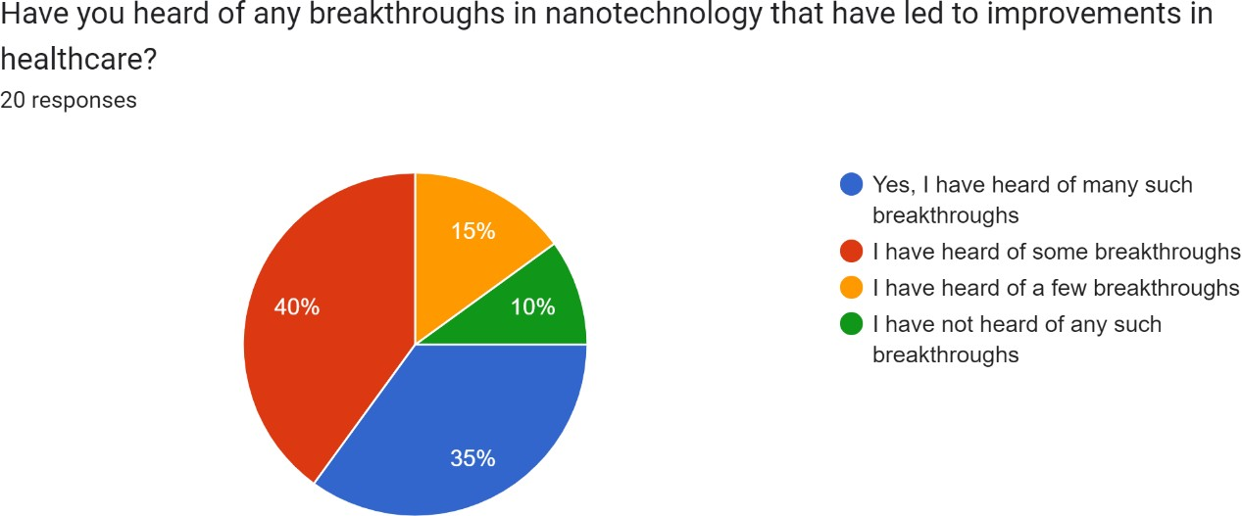

Based on the data provided, it appears that among the 20 respondents who answered the survey, 35% of them have heard of many breakthroughs in nanotechnology that have led to improvements in healthcare, 40% have heard of some breakthroughs, 15% have heard of few breakthroughs, and 10% have not heard of any such breakthroughs.

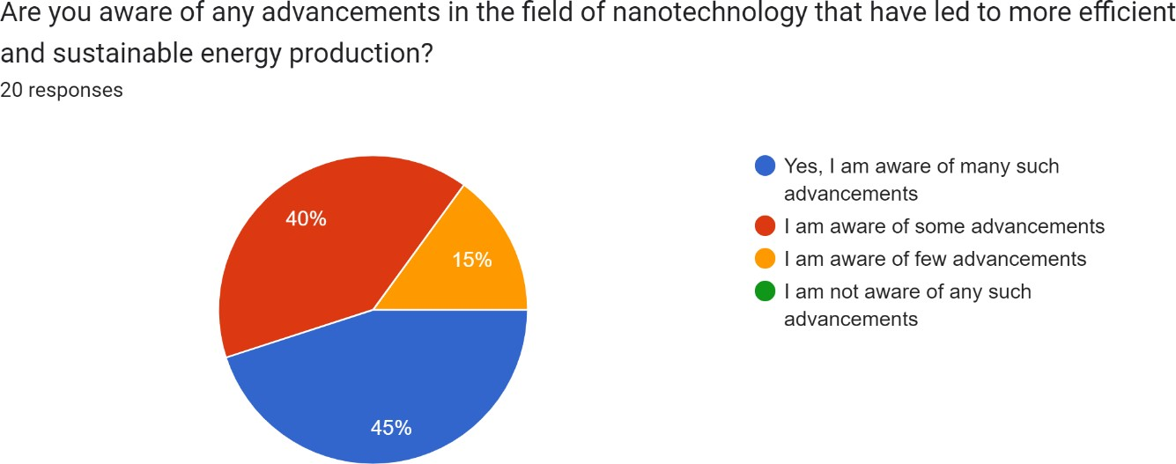

On this data provided, it appears that among the 20 respondents who answered the survey, 45% of them are aware of many advancements in the field of nanotechnology that have led to more efficient and sustainable energy

production, 40% are aware of some advancements, and 15% are aware of few advancements.

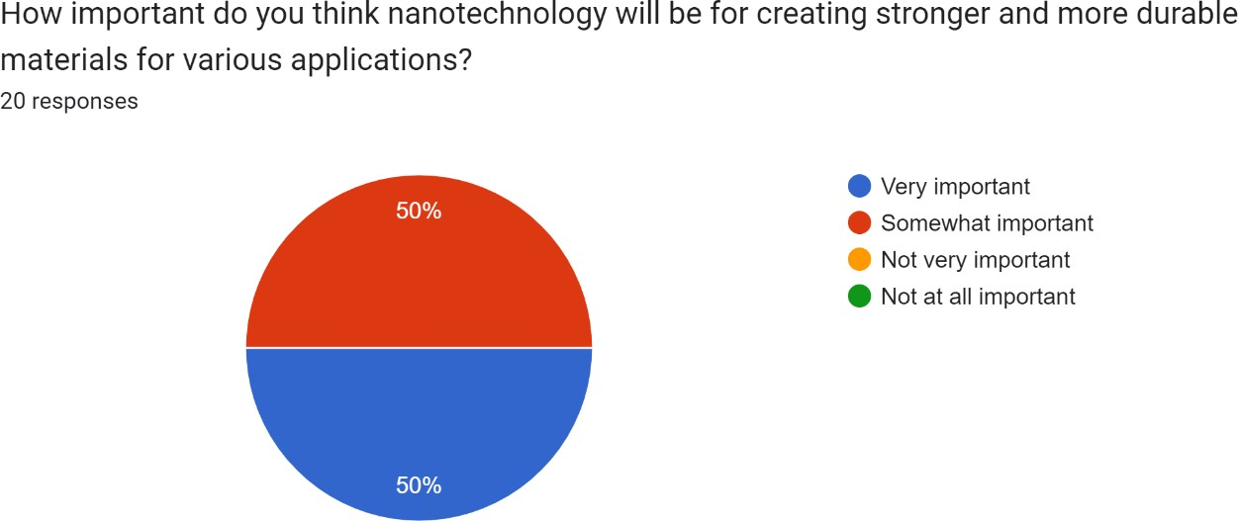

Based on the data provided, it appears that among the 20 respondents who answered the survey, 50% of them answered that nanotechnology will be very important for creating stronger and more durable materials for various applications, while the other 50% thought that it was somewhat important.

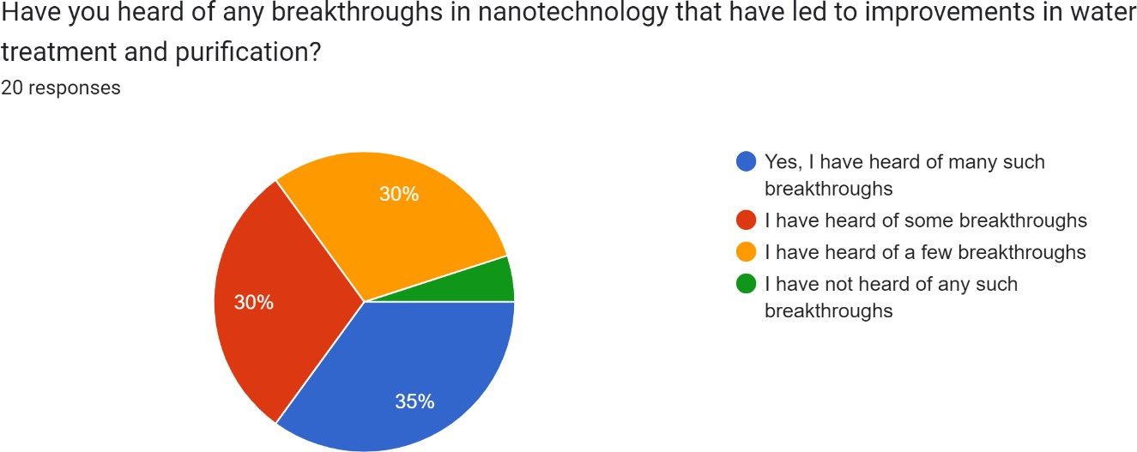

Based on the data provided, it appears that among the 20 respondents who answered the survey, 35% of them have heard of many breakthroughs in nanotechnology that have led to improvements in water treatment and

purification, 30% have heard of some breakthroughs, 30% have heard of a few breakthroughs, and 5% have not heard of any such breakthroughs.

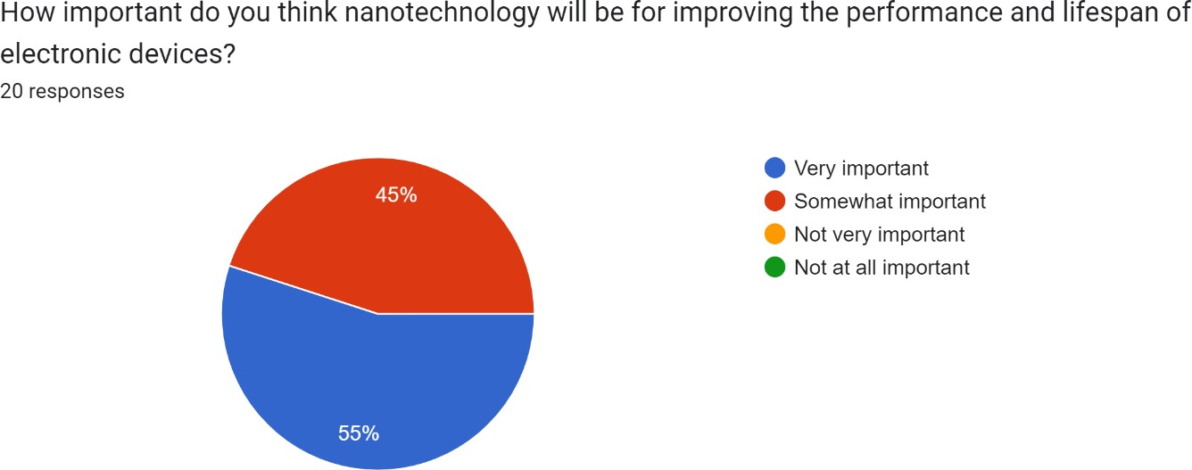

Based on the data provided, it appears that among the 20 respondents who answered the survey, 55% of them answered that nanotechnology will be very important for improving the performance and lifespan of electronic devices, while the other 45% thought that it was somewhat important.

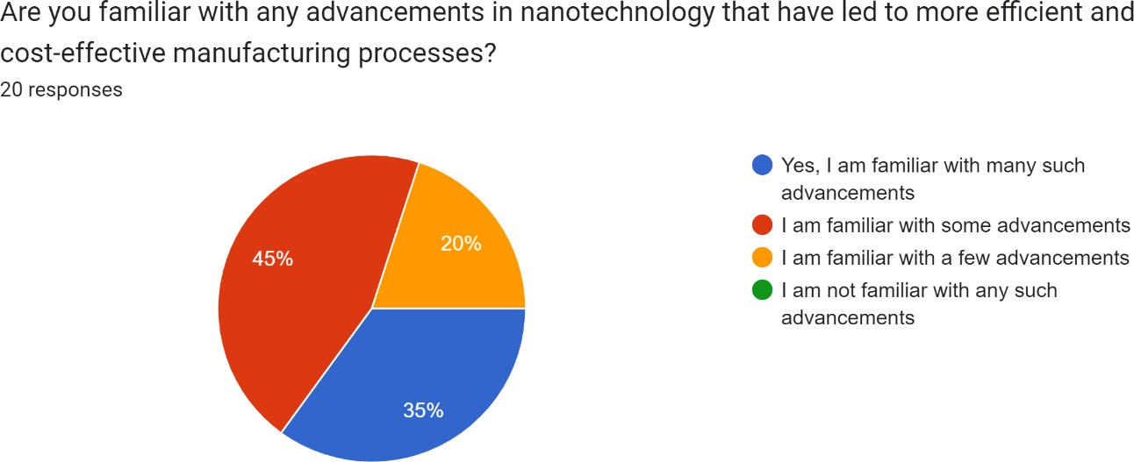

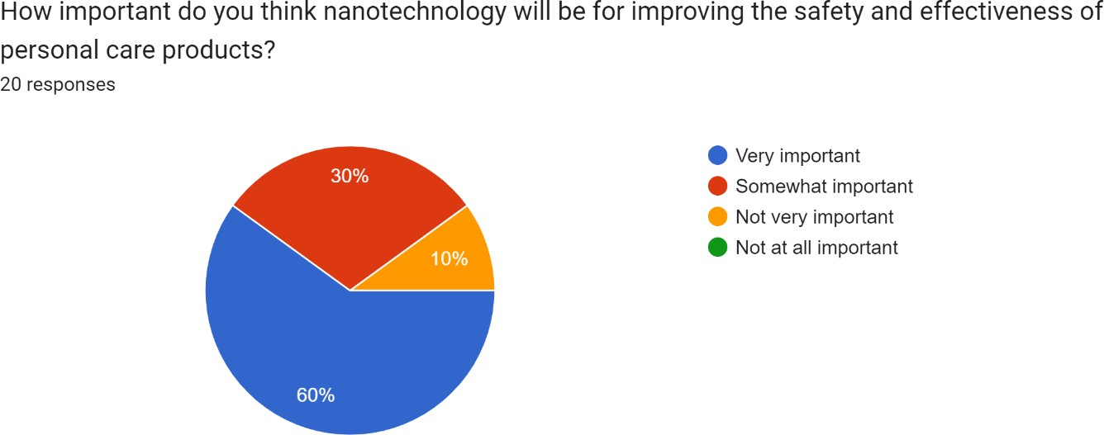Based on the data provided, it appears that among the 20 respondents who answered the survey, 35% of them are familiar with many advancements in nanotechnology that have led to more efficient and cost-effective manufacturing processes, while 45% are familiar with some advancements, and 20% are familiar with a few advancements.

Based on the data provided, it appears that among the 20 respondents who answered the survey, 60% of them answered that nanotechnology will be very important for improving the safety and effectiveness of personal care products, while 30% thought that it was somewhat important and 10% thought that it was not very important.

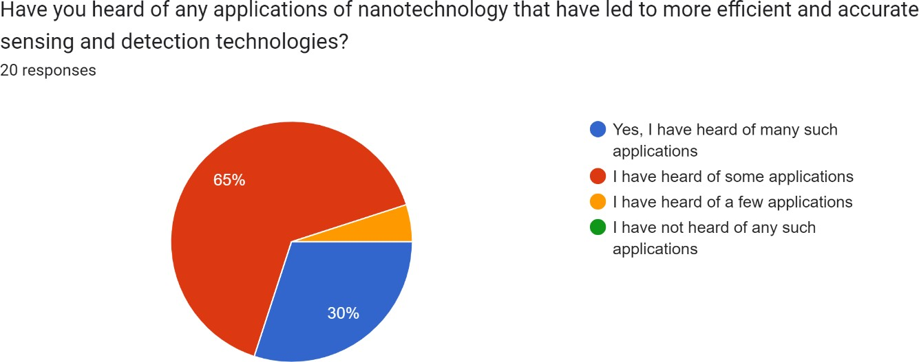

Based on the data provided, it appears that among the 20 respondents who answered the survey, 30% of them have heard of many applications of nanotechnology that have led to more efficient and accurate sensing and detection technologies. Additionally, 65% of the respondents have heard of some applications, while only 5% have heard of a few applications.

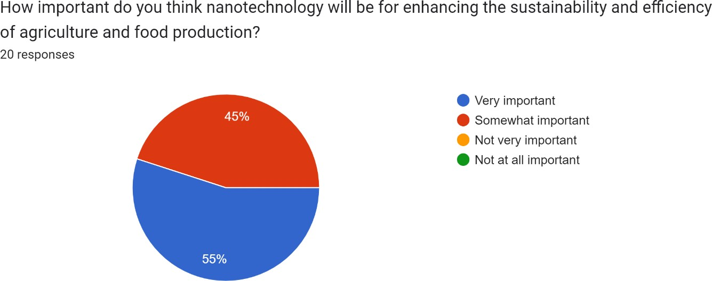

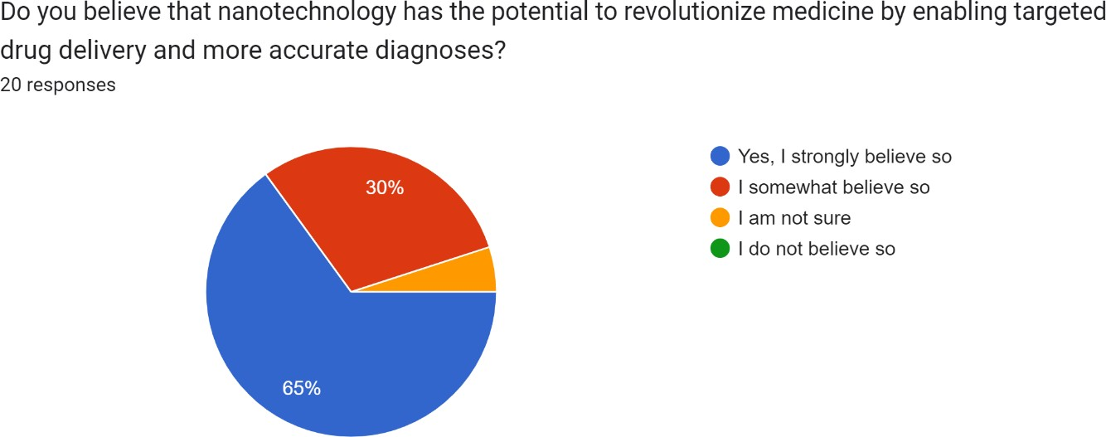Based on the data provided, it appears that among the 20 respondents who answered the survey, 55% of them answered that nanotechnology will be very important for enhancing the sustainability and efficiency of agriculture and food production. While 45% of the respondents believe that nanotechnology will be somewhat important for this purpose.

Based on the data provided, it appears that among the 20 respondents who answered the survey, a majority of 65% strongly believe that nanotechnology has the potential to revolutionize medicine by enabling targeted drug delivery and more accurate diagnoses. Additionally, 30% of the respondents somewhat believe that this is the case, while 5% are unsure.

* 1. **Summary |**

Nanotechnology is the field of science and technology that deals with the manipulation and control of materials at the nanoscale level. It has the potential to revolutionize many areas of science and technology, including medicine, energy production, electronics, and environmental remediation. One of the most significant benefits of nanotechnology is the creation of new materials with unique properties, such as improved strength, durability, and conductivity.

Additionally, nanotechnology has the potential to improve medicine by enabling targeted drug delivery and developing new diagnostic tools and implantable devices. Nanotechnology can also enhance energy efficiency by creating more efficient solar cells, batteries, and fuel cells, and reduce carbon emissions.

However, there are also concerns about the potential risks associated with nanotechnology, and it is essential to carefully evaluate its safety and develop appropriate regulations and guidelines to ensure responsible use.

# References:

(e.g., Asia Pacific Nanotechnology Forum 2005), https://ec.europa.eu/health/scientific_committees/opinions_layman/en/nanotechnologi es/l-3/1-introduction.htm#0p0

Allhoff, Fritz; Lin, Patrick; Moore, Daniel (2010). What is nanotechnology and why does it matter? from science to ethics. John Wiley and Sons. pp. 3–5. [ISBN](https://en.wikipedia.org/wiki/ISBN_(identifier)) 978-1-4051-7545-6.

Bates, D. W., Landman, A. B., Levine, D. M., & Department of Medicine, Brigham and Women's Hospital, Boston, MA 02115, USA. (2014). Health apps and health policy: What is needed? Journal of the American Medical Association, 312(12), 1293–1294. <https://doi.org/10.1001/jama.2014.13128>

Bennett, W. L., & Strange, N. (2011). The media and society: An introduction (2nd ed.). Routledge.

Cheon, J., Lee, S., Crooks, S. M., & Song, J. (2012). An investigation of mobile learning readiness in higher education based on the theory of planned behavior. Computers & Education, 59(3), 1054–1064. <https://doi.org/10.1016/j.compedu.2012.04.015>

Drexler, K. Eric (1986). [Engines of Creation: The Coming Era of Nanotechnology.](https://archive.org/details/enginesofcreatio00drex)

Doubleday. [ISBN](https://en.wikipedia.org/wiki/ISBN_(identifier)) 9780385199735. [OCLC](https://en.wikipedia.org/wiki/OCLC_(identifier)) [12752328.](https://www.worldcat.org/oclc/12752328)

Feldman, V. (2019). The positive and negative effects of technology on communication. Small Business - Chron.com. [https://smallbusiness.chron.com/positive-negative-effects-](https://smallbusiness.chron.com/positive-negative-effects-technology-communication-26363.html) [technology-communication-26363.html](https://smallbusiness.chron.com/positive-negative-effects-technology-communication-26363.html)

Gottschalk, F., Nowack, B., & Stintz, M. (2013). Engineered nanomaterials in waters and soils: A risk quantification based on probabilistic exposure and effect modeling. Environmental Toxicology and Chemistry, 32(6), 1278-1287.

https://doi.org/10.1002/etc.2163

Hampton, K. N., Goulet, L. S., Rainie, L., & Purcell, K. (2011). Social networking sites and our lives. Pew Research Center.

Kong, X., Zhang, Y., Liang, X., Li, X., Li, Y., & Li, S. (2021). Development and prospects of nanomaterials for MRI contrast agents. Frontiers in Chemistry, 9, 666903

(Margaret, Rouse, Technopedia, 2018). https://[www.techopedia.com/definition/3151/nanotechnology](http://www.techopedia.com/definition/3151/nanotechnology)

Maynard, A. D., Aitken, R. J., Butz, T., Colvin, V., Donaldson, K., Oberdörster, G.,

Philbert, M. A., Ryan, J., Seaton, A., Stone, V., Tinkle, S. S., & Tran, L. (2006).

Safe handling of nanotechnology. Nature, 444(7117), 267-269.

Park, Y. J., & Kim, H. (2021). Status and prospects of graphene-based nanoelectronics. Journal of Nanomaterials, 2021, 5568658.