**Nanotechnology and in the**

**modern computer**

**BSCS-NS-2AB**

**Orain, Jieson R.**

**Manalaysay, Bryan Aiman O.**

**Espinosa, Princess Nichole**

**Olete, Maria Nesha**

1. **Introduction |**

Drexler, K. Eric (1986) This topic is all about **Nanotechnology**, it refers to the study and application of extremely small structures, typically at the scale of atoms and molecules. In the computer world, nanotechnology can be used to create computer components and devices that are much smaller and more efficient than traditional components. **Nanotechnology**, often shortened to nanotech, is the use of matter on [atomic](https://en.wikipedia.org/wiki/Atom), [molecular](https://en.wikipedia.org/wiki/Molecular), and [supramolecular](https://en.wikipedia.org/wiki/Supramolecular) scales for industrial purposes.

The earliest, widespread description of nanotechnology referred to the particular technological goal of precisely manipulating atoms and molecules for fabrication of macroscale products, also now referred to as [molecular nanotechnology](https://en.wikipedia.org/wiki/Molecular_nanotechnology).

[Nanotechnology](https://ec.europa.eu/health/scientific_committees/opinions_layman/glossary/mno/nanotechnology.htm) is the term given to those areas of science and engineering where phenomena that take place at dimensions in the [nanometer scale](https://ec.europa.eu/health/scientific_committees/opinions_layman/glossary/mno/nanoscale.htm) are utilized in the design, characterization, production and application of materials, structures, devices and systems.

Although in the natural world there are many examples of structures that exist with nanometer dimensions (hereafter referred to as the [nanoscale](https://ec.europa.eu/health/scientific_committees/opinions_layman/glossary/mno/nanoscale.htm)), including essential [molecules](https://ec.europa.eu/health/scientific_committees/opinions_layman/glossary/mno/molecule.htm) within the human body and components of foods, and although many technologies have incidentally involved nanoscale structures for many years, it has only been in the last quarter of a century that it has been possible to actively and intentionally modify molecules and structures within this size range. It is this control at the nanometer scale that distinguishes nanotechnology from other areas of technology. (e.g., Asia Pacific Nanotechnology Forum 2005),

However, just as phenomena taking place at the [nanoscale](https://ec.europa.eu/health/scientific_committees/opinions_layman/glossary/mno/nanoscale.htm) may be quite different to those occurring at larger dimensions and may be exploitable for the benefit of mankind, so these newly identified processes and their products may expose the same humans, and the environment in general, to new health risks, possibly involving quite different mechanisms of interference with the physiology of human and environmental species.

1. **Background of the Study |**

The background of the study, Nanotechnology is process in the engineering of functional systems at the molecular scale. This covers both current work and concepts that are more advanced. In its original sense, nanotechnology refers to the projected ability to construct items from the bottom up, using techniques and tools being developed today to make complete, high-performance products. One [nanometer](https://en.wikipedia.org/wiki/Nanometer) (nm) is one billionth, or 10−9, of a meter.

Nanotechnology, in the context of computer science, is a type of engineering geared toward building electronic components and devices measured in nanometers, which are extremely tiny in size and structure. Nanotechnology facilitates the building of functional matter and systems at the scalar level of an atom or molecule. It incorporates concepts from physics, biology, engineering, and many other disciplines. (Margaret, Rouse, Technopedia, 2018).

Nanotechnology is a scientific field that uses system or component development techniques to build products on highly granular levels. Nanotechnology works through different approaches to build nano materials or products, including bottom-up, top-down, and functional system development. In a bottom-up approach, a product is designed as it evolves from its tiniest form factor to larger product. In a top-down approach, a large product may be reverse engineered to develop products scaled according to nanometer. A functional approach deals with a complete system and may incorporate bottom-up and top-down approaches. (Margaret, Rouse, Technopedia, 2018).

* 1. **Objectives |**
* To explore the potential applications of nanotechnology in various fields, including medicine, energy, electronics, and materials science, and to evaluate the benefits of these applications.
* To investigate the role of nanotechnology in addressing global challenges such as climate change, food security, and public health, and to evaluate its potential impact in creating sustainable solutions.
* To assess the existing policies and regulations on nanotechnology, and to propose recommendations for enhancing their effectiveness in promoting the responsible development and use of the technology.
  1. **Technology observation |**

One of the most significant observations about nanotechnology is the vast potential it holds for creating new materials with unique properties. By manipulating the structure of materials at the nanoscale level, researchers can create materials with improved strength, durability, and conductivity, among other properties. This has already led to the development of new materials for use in a wide range of applications, from advanced electronics to aerospace engineering.

Another important observation is the potential for nanotechnology to revolutionize medicine. By enabling the targeted delivery of drugs and other therapies, nanotechnology has the potential to make treatments more effective and reduce side effects. It also holds promise for the development of new diagnostic tools and implantable devices that can monitor and regulate bodily functions.

* 1. **Surveys and technologies (Nanotechnology) |**

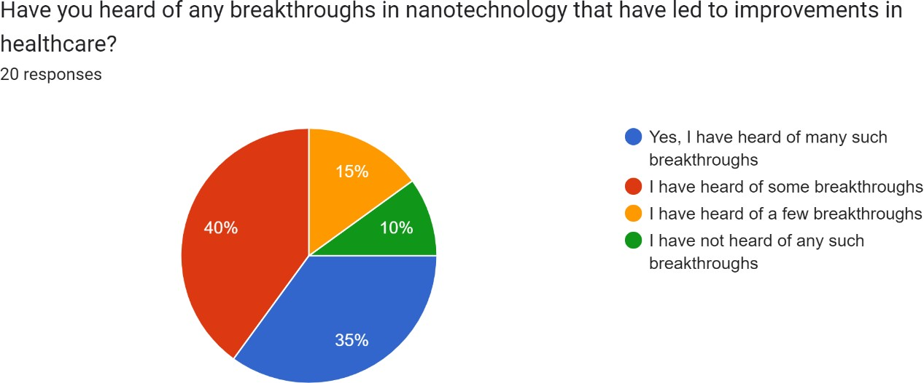

Based on the data provided, it appears that among the 20 respondents who answered the survey, 35% of them have heard of many breakthroughs in nanotechnology that have led to improvements in healthcare, 40% have heard of some breakthroughs, 15% have heard of few breakthroughs, and 10% have not heard of any such breakthroughs.

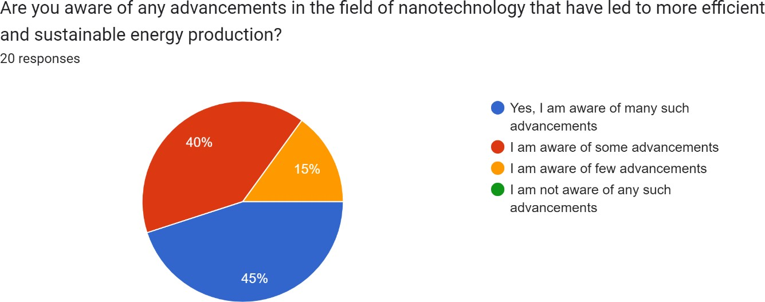

On this data provided, it appears that among the 20 respondents who answered the survey, 45% of them are aware of many advancements in the field of nanotechnology that have led to more efficient and sustainable energy

production, 40% are aware of some advancements, and 15% are aware of few advancements.

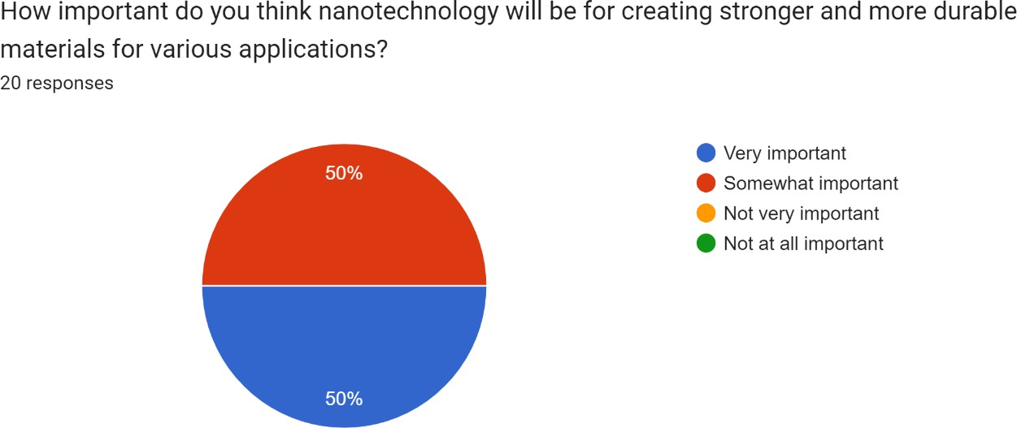

Based on the data provided, it appears that among the 20 respondents who answered the survey, 50% of them answered that nanotechnology will be very important for creating stronger and more durable materials for various applications, while the other 50% thought that it was somewhat important.

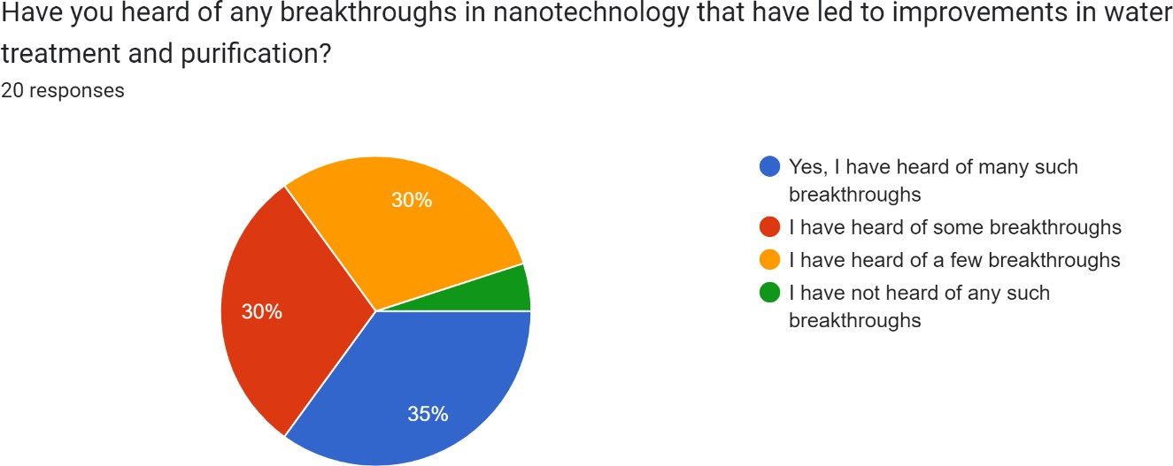

Based on the data provided, it appears that among the 20 respondents who answered the survey, 35% of them have heard of many breakthroughs in nanotechnology that have led to improvements in water treatment and

purification, 30% have heard of some breakthroughs, 30% have heard of a few breakthroughs, and 5% have not heard of any such breakthroughs.

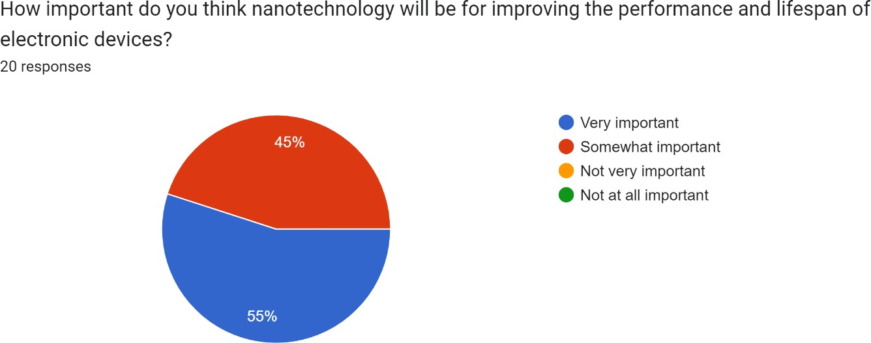

Based on the data provided, it appears that among the 20 respondents who answered the survey, 55% of them answered that nanotechnology will be very important for improving the performance and lifespan of electronic devices, while the other 45% thought that it was somewhat important.

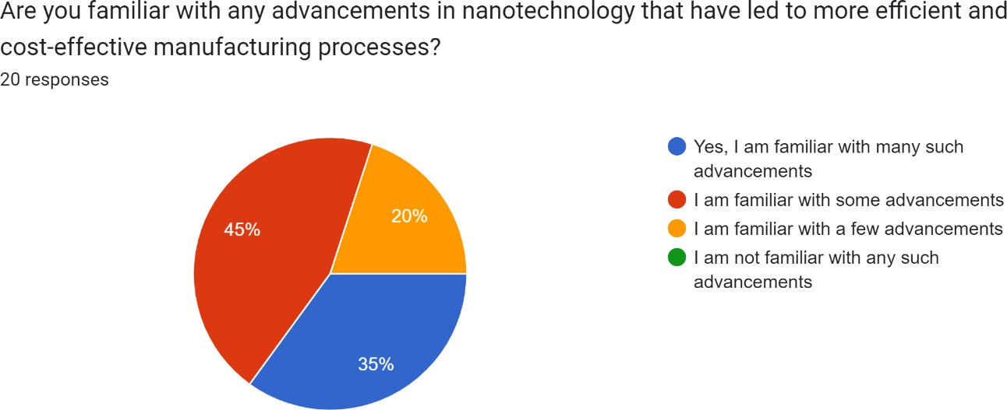

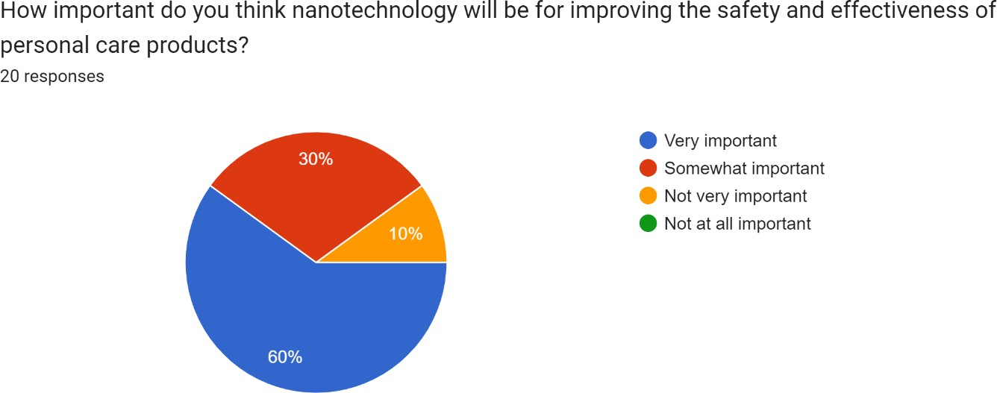Based on the data provided, it appears that among the 20 respondents who answered the survey, 35% of them are familiar with many advancements in nanotechnology that have led to more efficient and cost-effective manufacturing processes, while 45% are familiar with some advancements, and 20% are familiar with a few advancements.

Based on the data provided, it appears that among the 20 respondents who answered the survey, 60% of them answered that nanotechnology will be very important for improving the safety and effectiveness of personal care products, while 30% thought that it was somewhat important and 10% thought that it was not very important.

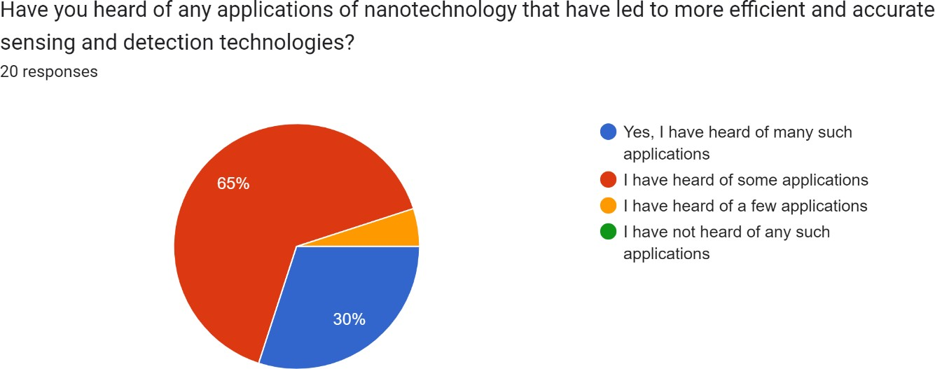

Based on the data provided, it appears that among the 20 respondents who answered the survey, 30% of them have heard of many applications of nanotechnology that have led to more efficient and accurate sensing and detection technologies. Additionally, 65% of the respondents have heard of some applications, while only 5% have heard of a few applications.

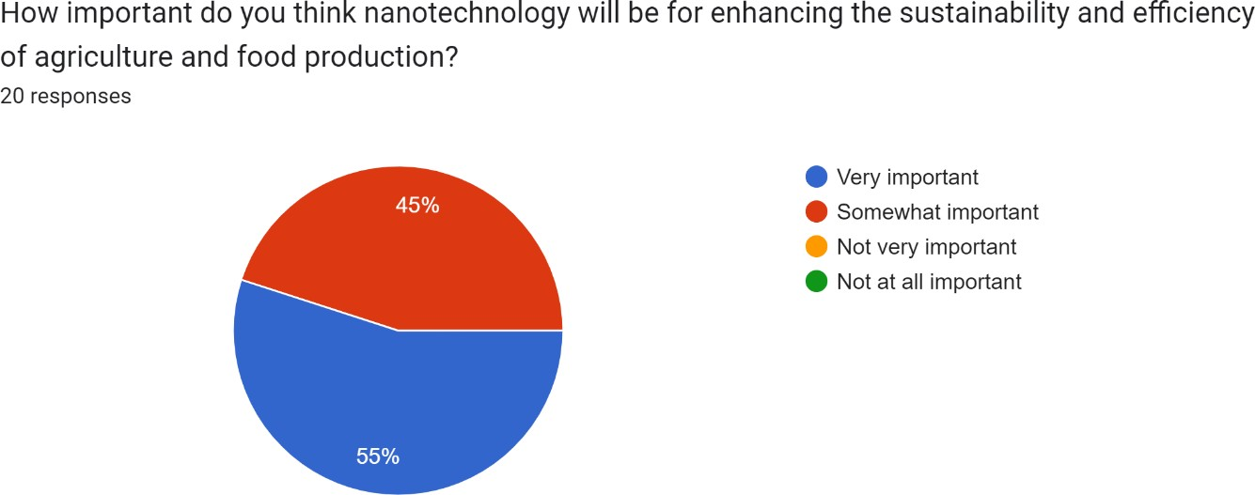

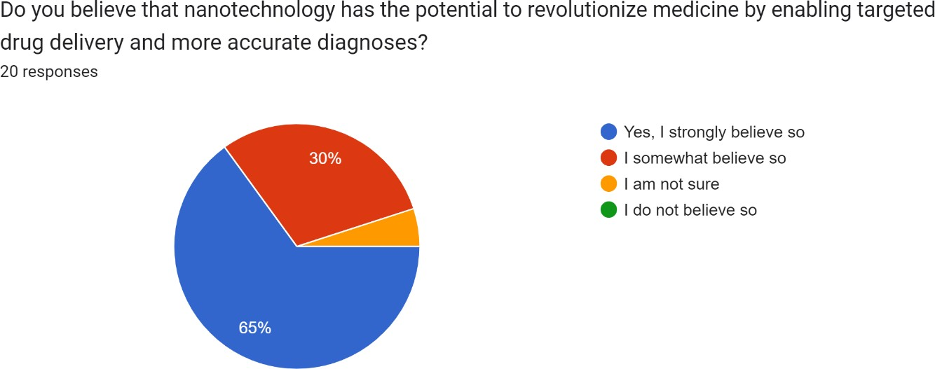Based on the data provided, it appears that among the 20 respondents who answered the survey, 55% of them answered that nanotechnology will be very important for enhancing the sustainability and efficiency of agriculture and food production. While 45% of the respondents believe that nanotechnology will be somewhat important for this purpose.

Based on the data provided, it appears that among the 20 respondents who answered the survey, a majority of 65% strongly believe that nanotechnology has the potential to revolutionize medicine by enabling targeted drug delivery and more accurate diagnoses. Additionally, 30% of the respondents somewhat believe that this is the case, while 5% are unsure.

* 1. **Summary |**

Nanotechnology is the field of science and technology that deals with the manipulation and control of materials at the nanoscale level. It has the potential to revolutionize many areas of science and technology, including medicine, energy production, electronics, and environmental remediation. One of the most significant benefits of nanotechnology is the creation of new materials with unique properties, such as improved strength, durability, and conductivity.

Additionally, nanotechnology has the potential to improve medicine by enabling targeted drug delivery and developing new diagnostic tools and implantable devices. Nanotechnology can also enhance energy efficiency by creating more efficient solar cells, batteries, and fuel cells, and reduce carbon emissions.

However, there are also concerns about the potential risks associated with nanotechnology, and it is essential to carefully evaluate its safety and develop appropriate regulations and guidelines to ensure responsible.

**Presentation of the chosen technology:**

The researchers have shown increasing interest in the field of nanotechnology owing to its potential for innovation and progress. Nanotechnology involves the manipulation, design, and utilization of materials and structures at the nanoscale level, ranging from 1-100 nanometers in size, offering distinct properties and functionalities that are not present at larger scales. This field has the potential to create revolutionary solutions in various sectors, including medicine, electronics, energy, and environmental science.

The primary reason why researchers are exploring nanotechnology is its potential to transform multiple industries. For example, in medicine, nanotechnology can provide precise and targeted drug delivery systems, leading to more effective and less invasive treatments. In electronics, nanotechnology has the potential to develop more efficient and powerful computing devices. Additionally, it can enhance energy storage and generation systems, such as solar cells, and provide sustainable and eco-friendly solutions to several issues, including waste reduction.

Furthermore, the interdisciplinary nature of nanotechnology is another factor that attracts researchers to this field. Nanotechnology combines knowledge and expertise from multiple fields, such as chemistry, physics, biology, engineering, and materials science, to create innovative solutions to complex problems. The collaborative efforts between these fields can lead to groundbreaking discoveries and ideas that would not have been possible otherwise.

In conclusion, the potential benefits of nanotechnology are significant, and the interdisciplinary nature of the field offers substantial potential for collaboration and innovation. It is no surprise that researchers are exploring this field to create solutions that can positively impact people's lives and shape the world for the better.

**Literature reviews and supporting information supporting the group position.**

The researchers conduct a comprehensive literature review and administer a survey for a small group of individuals to support the group's position on the positive effects of nanotechnology. This aims to strengthen the argument presented in the research paper.

* **Technology Literature Reviews**

Technology has become an essential element of modern civilization, influencing many parts of our life such as communication, healthcare, education, and entertainment. The purpose of this literature review is to look at current studies on technology and its influence on society, as well as to look at the potential advantages and disadvantages of using technology.

Communication has been significantly altered by technology, making it simpler and faster to interact with individuals all over the world (Hampton et al., 2011). However, the greater connection has raised worries about privacy and security, as well as cyberbullying and addiction difficulties (Feldman, 2019).

Technology can enhance patient outcomes and streamline operations in healthcare. Electronic health records, for example, can enhance the quality and accessibility of patient information, and telemedicine can improve access to healthcare in rural regions (Bates et al., 2014). Concerns have been expressed, however, concerning the potential for technology to lead to dehumanization and the loss of the human touch in healthcare (Montague, 2013).

Technology in education has created new learning possibilities and made education more accessible to individuals all around the world. Online courses and educational software can offer tailored learning experiences, and virtual and augmented reality can improve the learning environment (Cheon et al., 2012). However, there are worries that technology may contribute to social isolation and a lack of face-to-face engagement in schools (Manca & Ranieri, 2016).

Technology has transformed the way we consume media and created new avenues for innovation and expression in the entertainment industry. Streaming services and social media have spawned new types of entertainment and made it simpler for people to share their creative works (Bennett & Strange, 2011). Concerns have been expressed, however, concerning the potential for technology to lead to addiction and the loss of real-life experiences (Rosen et al., 2013).

Technology’s influence on society is complicated and multidimensional. While technology can provide several advantages, there are also concerns about its possible drawbacks. Additional study is necessary to fully comprehend the influence of technology on society and to establish ways for maximizing its advantages while reducing its negative consequences.

**III. Scope of the Topic**

Nanotechnology is a rapidly growing field with potential applications in various industries, and the scope of this topic involves understanding the fundamental properties and applications of nanoparticles in different fields. This includes the study of the unique properties of nanoparticles and their potential applications in drug delivery, biosensors, and imaging. Understanding the properties of nanoparticles can provide insight into developing new materials that could potentially revolutionize various fields.

The topic also covers the use of nanotechnology in healthcare, where it has the potential to improve drug delivery, diagnosis, and therapy for various diseases. This includes the study of nanoscale materials and their potential for use in personalized medicine, as well as the development of novel nano therapies and diagnostic tools.

Furthermore, the topic includes the applications of nanotechnology in electronics and energy. Nanotechnology has the potential to develop more efficient and environmentally friendly energy conversion and storage devices such as batteries and solar cells. The development of new materials at the nanoscale level can also lead to faster and more efficient electronic devices such as transistors and memory devices.

**V. Uses and Function:**

Nanotechnology has revolutionized the field of medicine and healthcare by providing novel solutions for drug delivery, imaging, biosensing, and tissue engineering. One of the most promising applications of nanotechnology in medicine is targeted drug delivery, which allows drugs to be delivered directly to the site of action, minimizing side effects, and improving drug efficacy. Nanoparticles such as liposomes, dendrimers, and polymeric nanoparticles have been used for targeted drug delivery, and their efficacy has been demonstrated in various preclinical and clinical studies.

Another important application of nanotechnology in medicine is imaging, where nanoparticles are used as contrast agents for various imaging techniques such as MRI, CT, and optical imaging. Nanoparticles such as quantum dots and gold nanoparticles have been used as imaging agents in preclinical and clinical studies, enabling earlier and more accurate diagnosis of diseases.

Additionally, nanotechnology has enabled the development of biosensors for detecting biomolecules and pathogens in biological samples, with nanoparticles such as carbon nanotubes and gold nanoparticles being used for biosensing applications. Finally, nanomaterials such as carbon nanotubes, graphene, and hydroxyapatite have been used as scaffolds for tissue engineering, providing a suitable microenvironment for cell growth and differentiation, with the potential to replace or regenerate damaged tissues and organs.

**VI. Importance and Benefits:**

Nanotechnology has the potential to revolutionize drug delivery by targeting specific cells and tissues while minimizing side effects, leading to more effective and personalized treatments for various diseases. Additionally, nanotechnology could enhance electronics by creating smaller, faster, and more efficient devices, opening possibilities for new technologies such as quantum computing and nanoelectronics. Furthermore, nanotechnology can improve energy storage and generation by creating more efficient batteries, solar cells, and other energy conversion devices, leading to more sustainable and environmentally friendly applications.

In addition, the use of nanoparticles as imaging agents for various diagnostic techniques such as MRI and CT can provide more accurate and earlier diagnoses of diseases. This could lead to improved healthcare outcomes and better patient care. Overall, the benefits and potential applications of nanotechnology are vast, and continued research and development are necessary to fully harness its potential for improving human health, energy efficiency, and environmental sustainability.

***XII. Conclusion:***

In addition, collaboration between researchers, industry, and policymakers is necessary to ensure the safe and responsible development and use of nanotechnology. Education and public awareness programs are also essential to inform the public about the benefits and risks of nanotechnology and its potential impact on society.

Funding for nanotechnology research should be increased to accelerate the development of new applications and technologies, while international regulations and standards should be developed to ensure the safe and responsible use of nanotechnology. By addressing these challenges, we can fully harness the potential of nanotechnology to benefit humanity while minimizing its potential risks.

***XIII.* Recommendations*:***

In order to achieve safe and responsible development and use of nanotechnology, it is crucial to conduct further research to understand potential risks and develop risk mitigation strategies, collaborate among researchers, industry, and policymakers, increase

**References:**

(e.g., Asia Pacific Nanotechnology Forum 2005), https://ec.europa.eu/health/scientific_committees/opinions_layman/en/nanotechnologies/l-3/1-introduction.htm#0p0

Allhoff, Fritz; Lin, Patrick; Moore, Daniel (2010). What is nanotechnology and why does it matter? from science to ethics. John Wiley and Sons. pp. 3–5. [ISBN](https://en.wikipedia.org/wiki/ISBN_(identifier)) [978-1-4051-7545-6](https://en.wikipedia.org/wiki/Special:BookSources/978-1-4051-7545-6).

Bates, D. W., Landman, A. B., Levine, D. M., & Department of Medicine, Brigham and Women's Hospital, Boston, MA 02115, USA. (2014). Health apps and health policy: What is needed? *Journal of the American Medical Association*, 312(12), 1293–1294. <https://doi.org/10.1001/jama.2014.13128>

Bennett, W. L., & Strange, N. (2011). *The media and society: An introduction* (2nd ed.). Routledge.

Cheon, J., Lee, S., Crooks, S. M., & Song, J. (2012). An investigation of mobile learning readiness in higher education based on the theory of planned behavior. *Computers & Education*, 59(3), 1054–1064. <https://doi.org/10.1016/j.compedu.2012.04.015>

Drexler, K. Eric (1986). [Engines of Creation: The Coming Era of Nanotechnology](https://archive.org/details/enginesofcreatio00drex). Doubleday. [ISBN](https://en.wikipedia.org/wiki/ISBN_(identifier)) [9780385199735](https://en.wikipedia.org/wiki/Special:BookSources/9780385199735). [OCLC](https://en.wikipedia.org/wiki/OCLC_(identifier)) [12752328](https://www.worldcat.org/oclc/12752328).

Feldman, V. (2019). The positive and negative effects of technology on communication. *Small Business - Chron.com.* <https://smallbusiness.chron.com/positive-negative-effects-technology-communication-26363.html>

Gottschalk, F., Nowack, B., & Stintz, M. (2013). Engineered nanomaterials in waters and soils: A risk quantification based on probabilistic exposure and effect modeling. Environmental Toxicology and Chemistry, 32(6), 1278-1287. https://doi.org/10.1002/etc.2163

Hampton, K. N., Goulet, L. S., Rainie, L., & Purcell, K. (2011). Social networking sites and our lives. *Pew Research Center.*

Kong, X., Zhang, Y., Liang, X., Li, X., Li, Y., & Li, S. (2021). Development and prospects of nanomaterials for MRI contrast agents. Frontiers in Chemistry, 9, 666903

(Margaret, Rouse, Technopedia, 2018). https://www.techopedia.com/definition/3151/nanotechnology

Maynard, A. D., Aitken, R. J., Butz, T., Colvin, V., Donaldson, K., Oberdörster, G., Philbert, M. A., Ryan, J., Seaton, A., Stone, V., Tinkle, S. S., & Tran, L. (2006). Safe handling of nanotechnology. Nature, 444(7117), 267-269.

Park, Y. J., & Kim, H. (2021). Status and prospects of graphene-based nanoelectronics. Journal of Nanomaterials, 2021, 5568658.

Tian, Y., Wang, S., & Cao, X. (2021). Recent progress in nanostructured electrodes for high-performance rechargeable lithium-ion batteries. Frontiers in Chemistry, 9, 726101.