|  |
| --- |
| D3DCOLOR colorA = D3DCOLOR_ARGB(150, 100, 0, 255);  D3DCOLOR colorB = D3DCOLOR_ARGB(150, 18, 255, 80);  g_pD3DDevice->SetRenderState(D3DRS_BLENDOP, D3DBLENDOP_ADD);  g_pD3DDevice->SetRenderState(D3DRS_SRCBLEND, D3DBLEND_SRCALPHA);  g_pD3DDevice->SetRenderState(D3DRS_DESTBLEND, D3DBLEND_INVSRCALPHA);  g_pD3DDevice->SetRenderState(D3DRS_ALPHABLENDENABLE, true); |

1. (100, 0, 255) * 150/255 + (0,0,0)*(1.0 – 150/255) = (59, 0, 150)
2. (18,255,80) * (150/255) + (59, 0, 150) * (1.0-150/255) = (35, 150, 109)
3. (18,255,80) * (150/255) + (0,0,0)*(1.0 – 150/255) = (11, 150, 47)

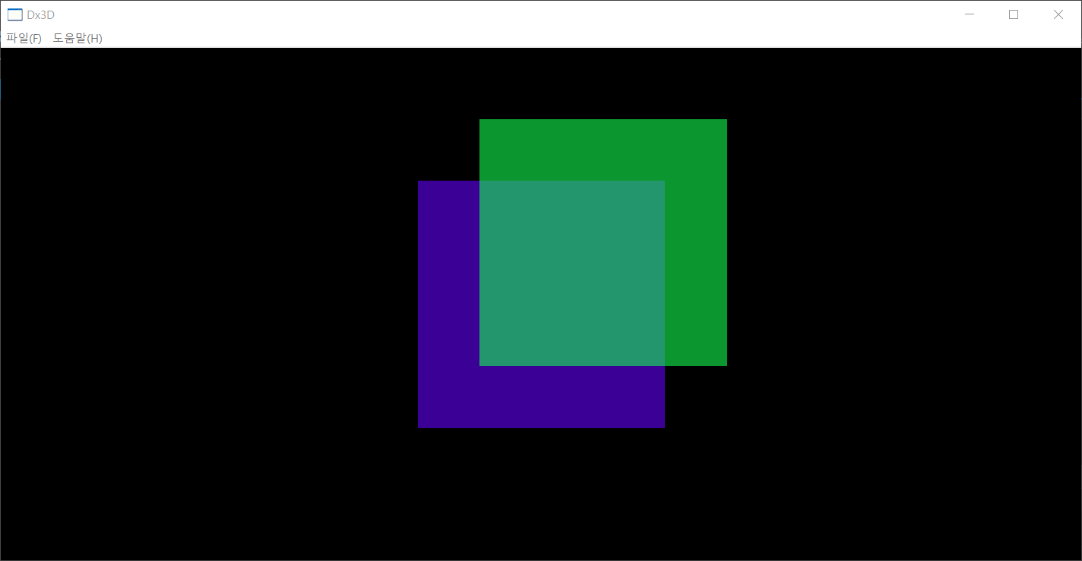

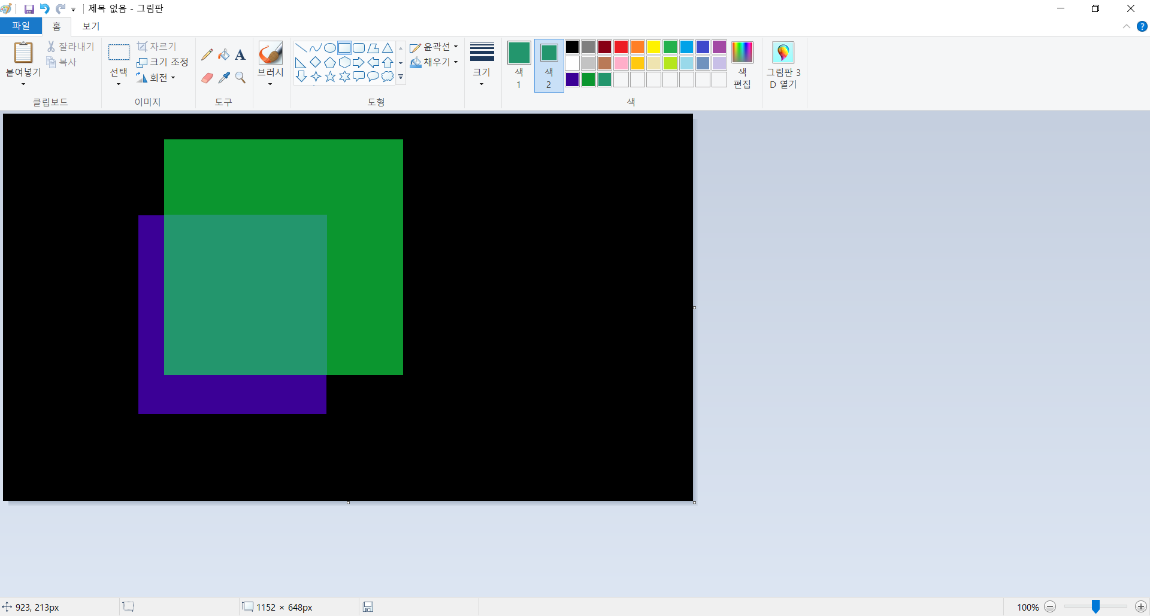

|  |
| --- |
| D3DCOLOR colorA = D3DCOLOR_ARGB(150, 100, 0, 255);  D3DCOLOR colorB = D3DCOLOR_ARGB(150, 18, 255, 80);  g_pD3DDevice->SetRenderState(D3DRS_BLENDOP, D3DBLENDOP_MAX);  g_pD3DDevice->SetRenderState(D3DRS_ALPHABLENDENABLE, true); |

1. [max(100,0), max(0, 0), max(255, 0)] = [100, 0, 255]
2. [max(18, 100), max(255,0), max(80, 255)] = [100, 255, 255]
3. [max(18, 0), max(255, 0), max(80, 0)] = [18, 255, 80]

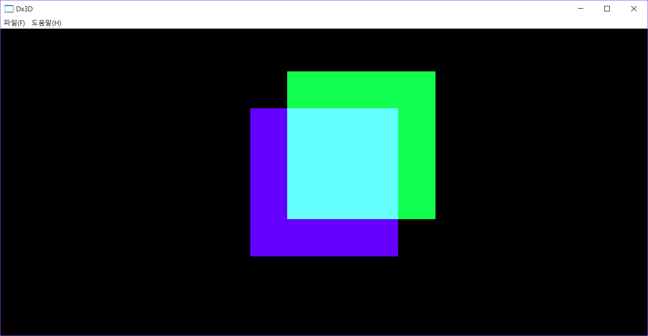

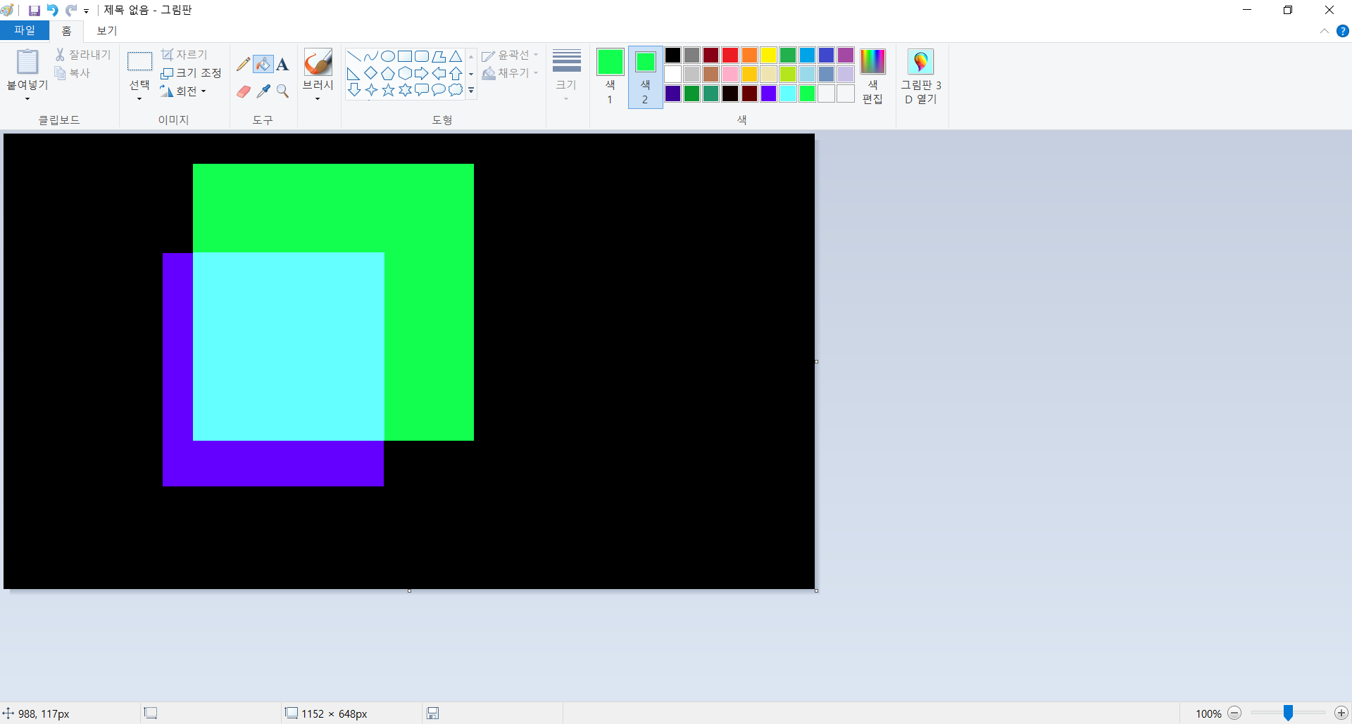

|  |
| --- |
| D3DCOLOR colorA = D3DCOLOR_ARGB(150, 100, 0, 255);  D3DCOLOR colorB = D3DCOLOR_ARGB(150, 18, 255, 80);  g_pD3DDevice->SetRenderState(D3DRS_BLENDOP, D3DBLENDOP_ADD);  g_pD3DDevice->SetRenderState(D3DRS_BLENDFACTOR, D3DCOLOR_ARGB(0,255,0,0));  g_pD3DDevice->SetRenderState(D3DRS_SRCBLEND, D3DBLEND_BLENDFACTOR);  g_pD3DDevice->SetRenderState(D3DRS_DESTBLEND, D3DBLEND_INVBLENDFACTOR);  g_pD3DDevice->SetRenderState(D3DRS_ALPHABLENDENABLE, true); |

1. (100,0,255) * (255,0,0)/255 + (0,0,0) * ((1.0,1.0,1.0) - (255,0,0)/255) = (100, 0, 0)
2. (18,255,80) * (255,0,0)/255 + (100, 0, 0) * ((1.0,1.0,1.0) - (255,0,0)/255) = (18, 0, 0)
3. (18,255,80) * (255,0,0)/255 + (0,0,0) * ((1.0,1.0,1.0) - (255,0,0)/255)= (18, 0, 0)



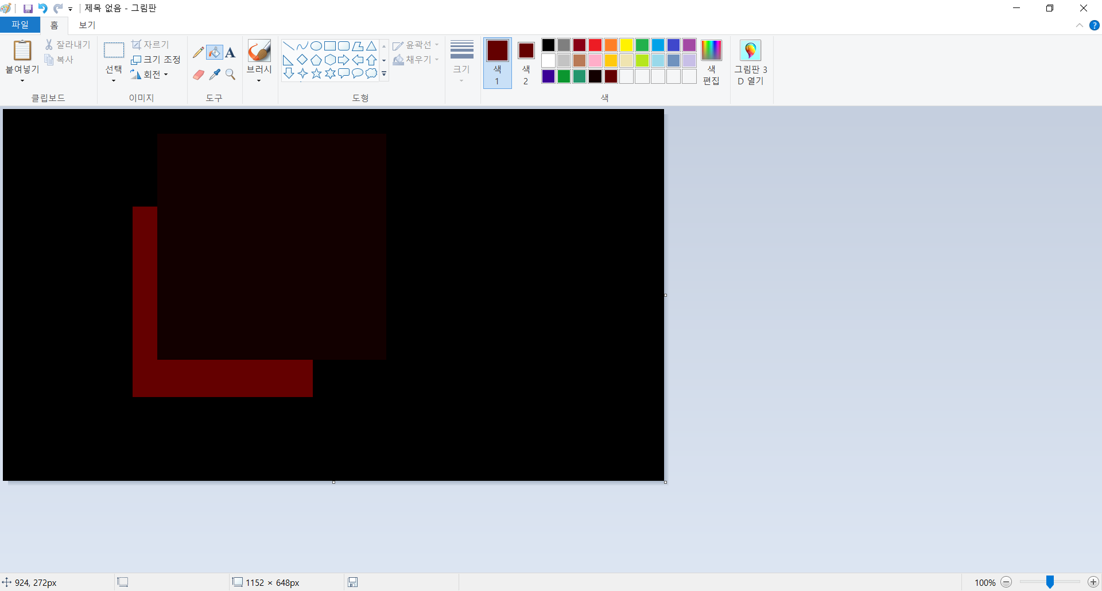

|  |
| --- |
| D3DCOLOR colorA = D3DCOLOR_ARGB(150, 100, 100, 255);  D3DCOLOR colorB = D3DCOLOR_ARGB(150, 255, 255, 100);  g_pD3DDevice->SetRenderState(D3DRS_BLENDOP, D3DBLENDOP_ADD);  g_pD3DDevice->SetRenderState(D3DRS_SRCBLEND, D3DBLEND_SRCALPHA);  g_pD3DDevice->SetRenderState(D3DRS_DESTBLEND, D3DBLEND_SRCALPHA);  g_pD3DDevice->SetRenderState(D3DRS_ALPHABLENDENABLE, true); |

1. [100, 100, 255] * 150/ 255 + [0,0,0] * 150/255 = [59,59,150]
2. [255,255,100] * 150/255 + [59,59,150] * 150/255 = [185,185,147]
3. [255,255,100] * 150/255 + [0,0,0] * 150/255 = [150,150,58]

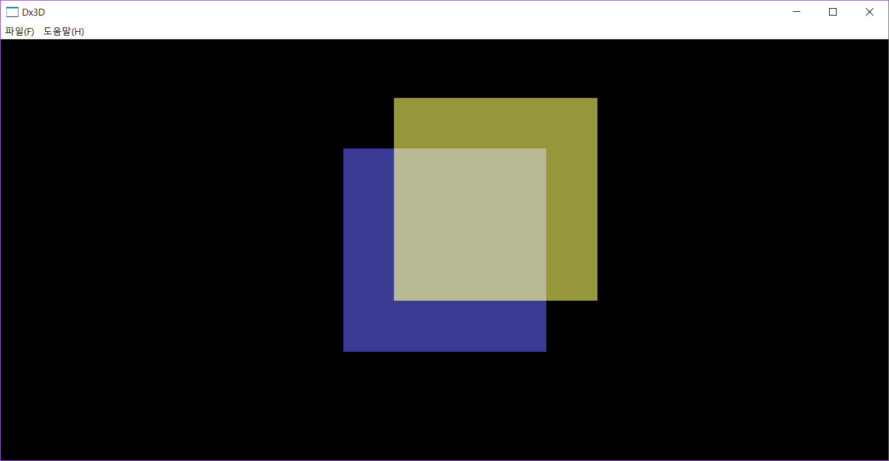

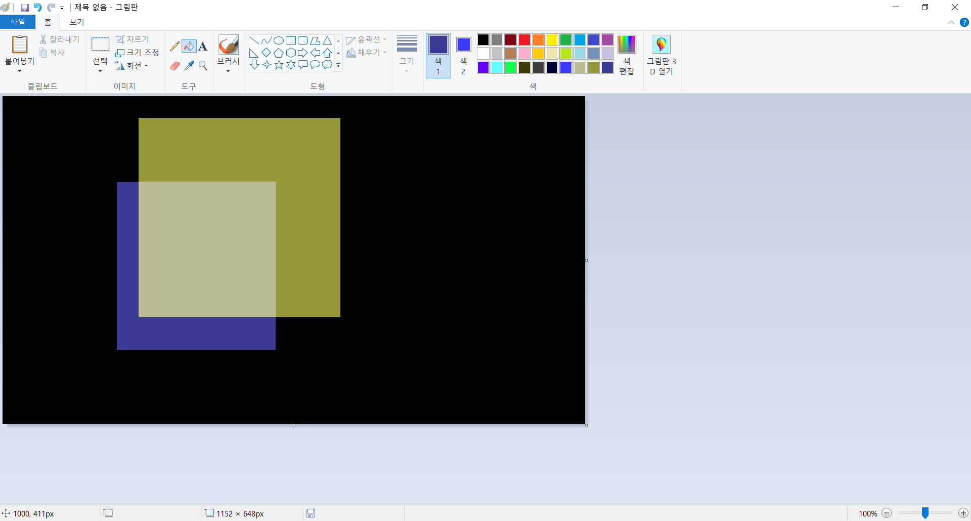

|  |
| --- |
| D3DCOLOR colorA = D3DCOLOR_ARGB(150, 100, 100, 255);  D3DCOLOR colorB = D3DCOLOR_ARGB(150, 255, 255, 100);  g_pD3DDevice->SetRenderState(D3DRS_BLENDOP, D3DBLENDOP_ADD);  g_pD3DDevice->SetRenderState(D3DRS_SRCBLEND, D3DBLEND_INVSRCCOLOR);  g_pD3DDevice->SetRenderState(D3DRS_DESTBLEND, D3DBLEND_ONE);  g_pD3DDevice->SetRenderState(D3DRS_ALPHABLENDENABLE, true); |

1. [100, 100, 255] *([255, 255, 255] - [100, 100, 255])/255 + 1.0*[0, 0, 0] = [60, 60, 0]
2. ([255, 255, 100]*([255,255,255] - [255, 255, 100])/255 + 1.0*[60, 60, 0] = [60, 60, 60]
3. ([255, 255, 100]*([255,255,255] - [255, 255, 100])/255 + 1.0*[0,0,0] = [0,0,60]

