**Act Report**

Monday, June 17, 2019

Jaekyung Lee

Question I : How Do People Rate Dogs?

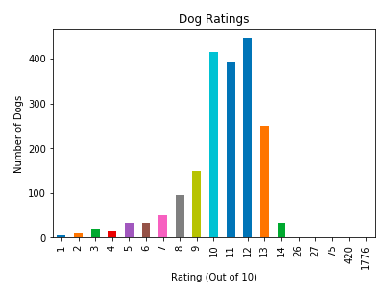

The mean of dog rating is 11.70 while more than 75 dogs have rate of 10, 11 and 12 (out of 10), which means that majority of users (voters) think that most dogs on WeRateDogs Twitter are **'good dogs**' and there are some **outstanding dogs** with rating of 420 and 1776.

I was curious of them, so I found their pictures (the top 2 dogs with highest rating!)

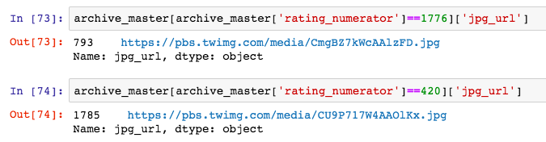



Our 2nd highest rating is the American dog!



Unbelievable… the photo with the highest rating is ‘Snoop **Doggs’**…

Question II : What is the relationship between 'Favorites' and 'Retweets'?

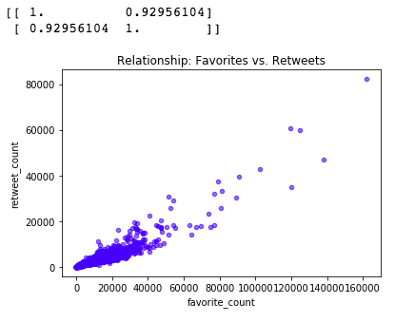

The correlation between favorite_count and retweet_count is **strong positive**. Using numpy corrcoef() function, the correlation coeffition is calculated for 0.92956. This means, there is strong positive relationship between high number of favorite counts and high retweets. With a quick glance at the graph, it seems about "3 counts = 1 retweet". A majority number of dogs are less than 60,000 favorite counts with 20,000 retweets.

Question III : What Sources Most Popular to Use Twitter?

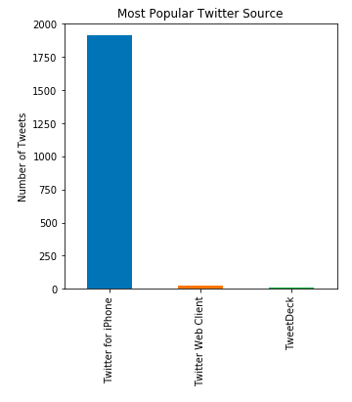

It's interesting to know that more than 98% users access tweets by using their iPhones. Twitter marketing department is recommended to update more functions or features on Twitter Web Clients and TweetDeck to attract more users.