# Meeting October 7, 2014

## Initial Design Discussion

* For the user, the output of camera could be useful
* Kinect SDK can recognize up to 6 people at a time on a first come first serve basic

## Kinect Device Set up and Testing

* Set up hardware and connect to a PC
* Examine data output from Kinect

## Zero-feature release

* Raw data from camera position near the instructor

## Next Step

* Document designs and diagrams

GUI Design

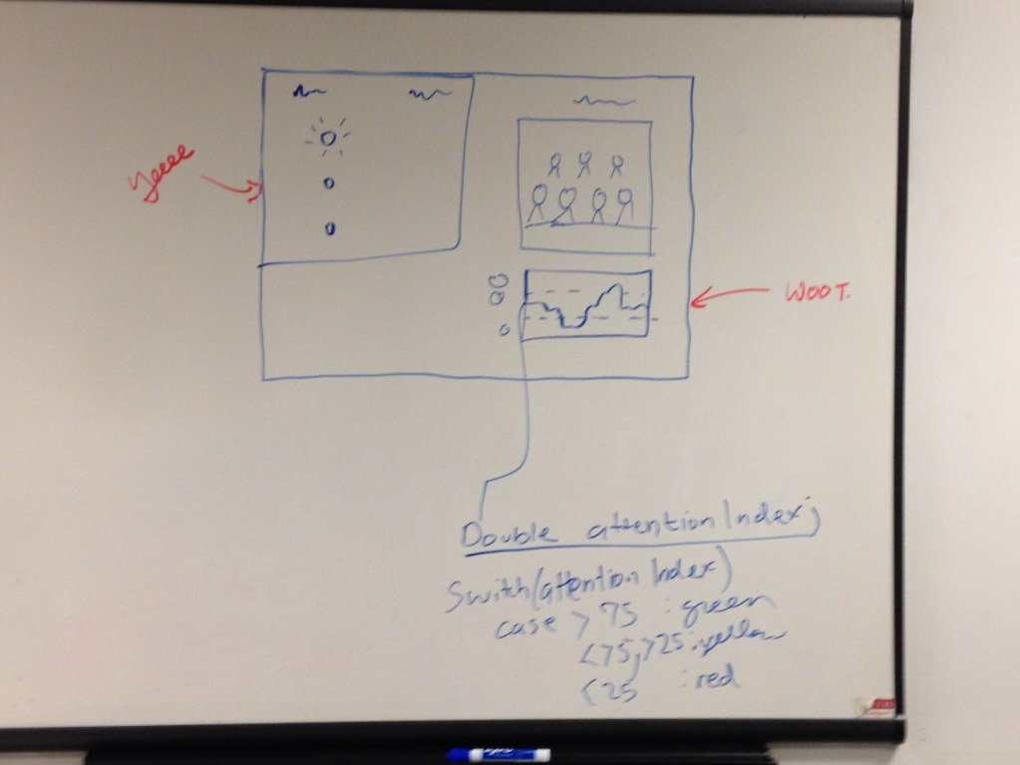

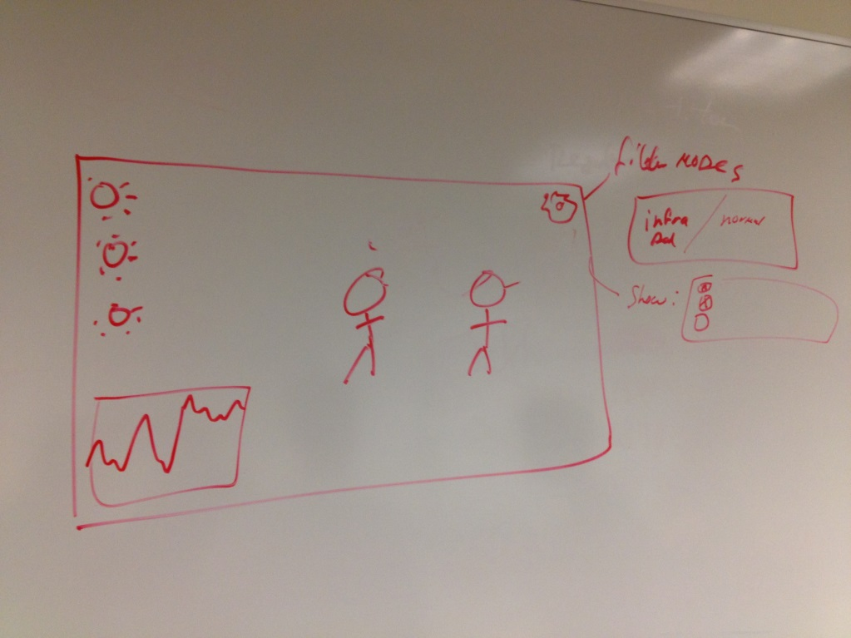

High Level Components View

