Dungeon Maker

*Team.Dungeon Maker*

Lee Jaemin

Kim Byeongjun

Lee Sangjin

**High Concept** **3**

**Game Flow** **3**

**Game Controls** **5**

**Game Mechanics** **5**

# High Concept

Game grows as users interact with objects in the game.

# Game Flow

When player starts the game, it starts in console page.

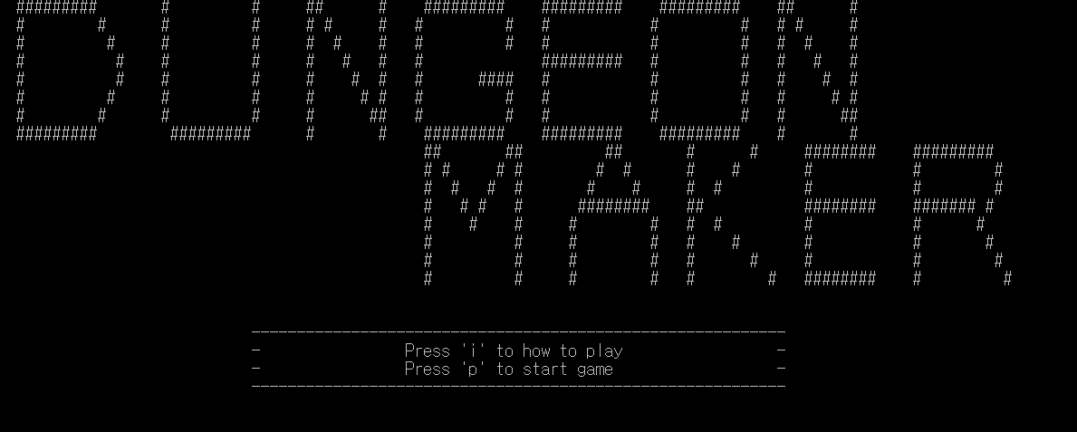

At console page, player gathers the characters so player have to make a string “doodle”

the gathered characters be displayed in the bottom of the screen

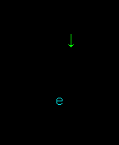



After you collect all characters(“doodle”), then you will go to doodle page.

In doodle page, player can only move left or right. The game window follows you as you move.

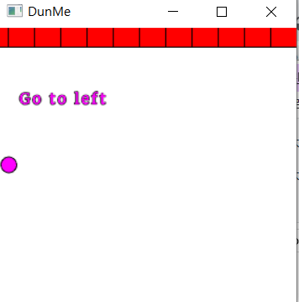

When player get items, player can move to four directions(up ,down, left, right) and also can extend the map. Player can push a pushable blocks and if the green blocks combined, new item will be generated. After player gets item, player can extend map.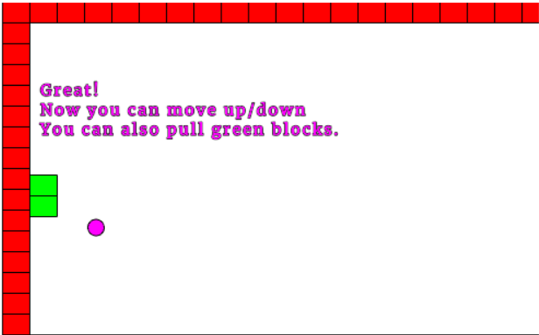

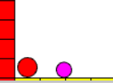

(pushable blocks and item)

Through this sequence, player can go to the item that can change the game’s genre to the platformer

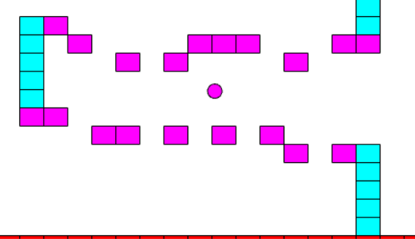

After clear the top viewed map, player move to another stage which has gravity. In that stage, player should go to the end using jump, ladder and blocks.

Lastly there is a maze and the window will be fixed small so that only can see near the player.

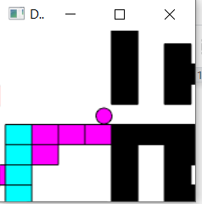

# 

If player clear the maze and reach the item, game will be cleared.

# Game Controls

In console page, player can move four directions using WASD. Using space bar player can collect the chars

In doodle page, player can move using ‘arrow keys’. At first player can only move left or right. However, later player can move up, down and jump after get item. Belong to the page, player get item using space bar, or jump using V.

# Game Mechanics

## Start with console:

The game started with console game. Now player did not create the doodle window so we can play in console at the start.

player can move in four direction (up, down ,left , right) and gather the char by pressing the spacebar.Through this method, player can gather the characters(d,o,o,d,l,,e).

## Doodle - Map following:

To implement map’s following, there is a big problem that have to be implemented.

(0, 0) is always center of the window. This means that even player moves left, the block that is located at (0, 0) will still there. To solve this problem, all blocks need to move against direction when the player is moving out of the window.

## Doodle - Map Extending:

To implement map’s extending, there is a big problem that have to be implemented. It’s similar to above problem.

(0, 0) is always center of the window. This means that even player moves left, the block that is located at (0, 0) will still there. To solve this problem, all blocks need to move against direction when the player is moving out of the window.

## Gravity:

2D vector is very useful to implement gravity so I used the 2D vector. Every frame the player’s position is added by velocity, and the velocity is added by gravity vector. gravity vector is increasing per frames when the player is not on the block.

Map Reading:

To make map easily, I made a map editor similar to mspaint. The map is created referring to “map.txt”. “map.txt” included the blocks’ position, size, color and type.

## Block Collision and Combine

Player can push the block by moving to the block. and blocks can pushed in succession. When a block is pushed towards the wall, it is not pushed. and in this time ,if blocks be pushed in succession, blocks can overlap

and if blocks be overlapped very closely, blocks combine

Through this way, player can make item

# Game Resource (Art, Audio)

* There is no Audio
* There are only some arts that is made by Doodle drawing functions.

# 

# Physics Design

* Block Pushing and collision:We made it possible for the block to be pushed back continuously, by continuously colliding objects.
* About gravity, we made a gravity so it seems like there are acceleration.
* About map following/extending, we moves all blocks to fit the blocks to player.