Summary

Augmenting Graph Inductive Learning Model With Topographical Features
Jae Muzzin
University Of Windsor
COMP4960B Fall 2021
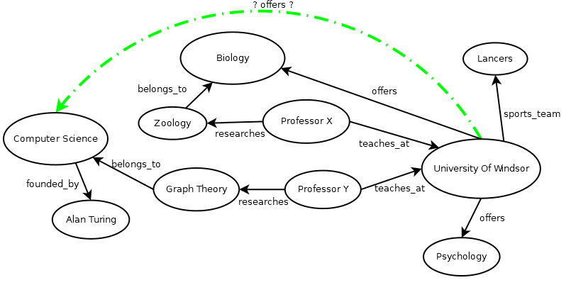Figure 1: Link Prediction
A knowledge graph can be represented as a set of (subject, relationship, object) triples, eg,
(Maroon, Shade_of, Red).
The task of knowledge graph completion aims to infer new triples based, on facts established from existing triples. A graph neural network (GNN) can be used to learn patterns in the knowledge graph which can be used to predict new triples. One such state of the art method, GraIL (Komal Teru et al), trains a GNN with subgraphs and assigns a probability score to a proposed triple. GraIL is able to learn the inductive rules of a knowledge graph, determining which mix of relationships may imply a new relationship. GraIL is applied to inductive settings, where the entities in the training set never occur in the training data, only the relationships. Since GraIL operates strictly on subgraphs, there is no extra information from the full, complete graph, available to the GNN during training. The improvement outlined here augments GraIL to provide the GNN with more information. Whereas GraIL trains strictly on subgraphs, this model provides summarized topological information of each entity, measured using the heuristics of PLACN (Ragunathan et al), from the complete knowledge graph. These topological statistics provide additional features on which the graph neural network can learn. Experiments on standard datasets demonstrate that our augmentation of GraIL delivers more accuracy in link prediction. The improvements that are achieved vary across the datasets.

Overview Of Inductive Knowledge Graph Completion

For the purpose of link prediction, the GNN acts as a subgraph classifier function. Given a proposed knowledge graph triple and its related subgraph, the GNN will determine the likelyhood score of the triple existing in the knowledge graph. By comparing the scores of a proposed triple with alternatives, a link can be predicted by ranking their scores.
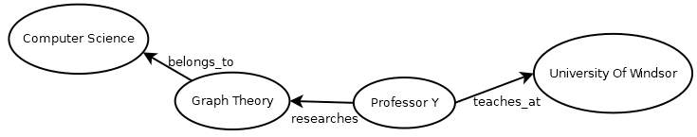Figure 2: Subgraph of target nodes. Only connecting nodes are included. In fixed sized subgraphs, the number of nodes is limited.
The model is suited for inductive problems, where the entities encountered during testing are not the same entities in the training set. Therefore, the model predicts solely based on relationship patterns in the graph. There is never any node identity information passed to the model in training or testing.

The model can be used to predict a relationship between two entities given a list of candidate relationships. It can also predict the object corresponding to a subject entity and a relationship, given a list of candidate entities. A knowledge triple is represented with a head, relation, and tail, or (h, r, t).

Predict Missing Object
To find the missing tail of a triple (h, r, t), where t is the missing missing tail, the GNN must evaluate every possible triple (h, r, y), where y belongs to the set of all nodes. If a triple (h,r,y) has the highest score, then y is the most likely missing tail t.

Predict Missing Relationship
To find the missing relation of a triple (h,r, t), where r is the missing missing relation, the GNN must evaluate every possible triple (h,q,t), where q belongs to the set of all relations. If a triple (h,q,t) has the highest score, then q is the most likely missing relation r.

The general steps of the process are

- Create negative samples from training data. These are corrupted triples which are generated from the real triples.
- Extract the subgraphs for all positive and negative triples. This is done by crawling the adjacency graph for all relationship types in the knowledge graph.
- Label nodes in all subgraphs. The nodes are given a unique label according to their distances from the target nodes.
- Calculate node features using the entire training graph. The features reflect qualities of the topology of the neighborhoods of nodes.
- Train GNN on positive and negative labeled subgraphs, their node features, and the relationship type of the test triple. The GNN can now score a subgraph's probability of implying a relationship between two nodes in the knowledge graph.
- Use GNN for link prediction by classifying subgraphs of proposed test triples and their enclosing subgraphs.

The transformation of input data can be described as

Knowledge graph triples →
Subgraphs →
Subgraphs with labeled nodes→
Subgraphs with labeled nodes with feature vectors →
Probability scores.

The improvement concerns the step of applying feature vectors to the subgraph nodes.

The authors of GraIL provide a theorem which asserts that the GNN can determine any logical rule, given certain conditions.
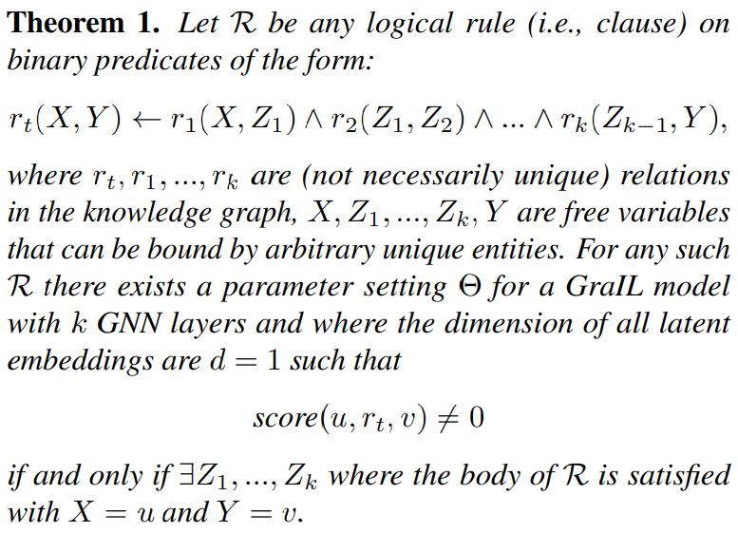Theorem 1: The GraIL Theorem, Komal K Teru et al

The theorem stipulates that the dimension of the latent embedding is 1. This paper refers to the latent embedding as the feature vector. For each node in the sugbraph, we provide a numeric list of values that represents the topology of the node in the complete graph, with respect to its subgraph neighbours.

Subgraph Extraction
For each triple in the knowledge graph, the subgraph is extracted with the goal of isolating the connecting nodes between the two target nodes. We wish to isolate only the nodes which are found along every possible path between the subject and object of the knowledge triple. These are referred to as the target nodes of the subgraph.

The subgraph is found by taking the intersection of the k-hop neighbourhoods of the target nodes.

Let Γ_{x}^{K} be the neighbors of x within k hops. The subgraph of (u,v) is given by the function S:V² → 2^{V}, the function that returns the set of nodes connecting u and v.
In these experiments, 3 was used for the maximum m.

Problems with PLACN's Fixed Sized Subgraphs
PLACN uses a constant value K, which is the absolute maximum size a subgraph may reach. K is derived in a way to be large enough for most node pairs. The value of K is a function of the number of edges and nodes in the complete graph.
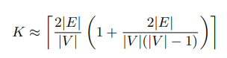
The theoretical analysis of GraIL determined that any logical rule R derived from the topology of a knowledge graph uniquely corresponds to a set of nodes connected through a sequence of relations, and that GraIL can learn this rule if the nodes and relations are present in the graph neural network.
I experimented with a variation of the model which used PLACN's fixed sized subgraphs. While the accuracy was higher on some of the smaller datasets, the shortcomings became clear on larger ones. For any knowledge graph of realistic size, fixed sized subgraphs are not suitable for Inductive Graph Neural Network models.
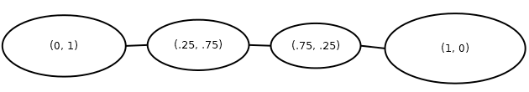Figure 3: Labeled Subgraph
It can be demonstrated using the GraIL theorem since there may not exist Z₁, ..., Z_{k} for a rule when fixed sized subgraphs are used. The GraIL theorem states that for any inductive rule R on nodes u,v ...
“there exists a parameter setting Θ for a GraIL model with k GNN layers and where the dimension of all latent embeddings are d = 1 such that score(u, r_{t}, v) is not 0 if and only if ∃ Z₁, ..., Z_{k}”

... In other words, if there is no path of nodes connecting u and v, the inductive rule can not be found by graph neural network.
Since the complete knowledge graph contains all edges, all inductive rules could be found. Due to complexity of training on a full knowledge graph, the models are trained on subgraphs which are meant to encapsulate the relevant local topographical of the target nodes. Every unique path that is excluded from the subgraph is an inductive rule which cannot be learned, thereby limiting the model.

If the PLACN K value is sufficiently large enough, it may include all connecting paths. The recommended PLACN calculation to derive K was shown to be too low for certain data sets, such as FB15k-237. If a knowledge graph has a high number of cycles, there may be many alternative paths between target nodes. Due to the truncation of the subgraph size to K, only a subset of possible paths will be analyzed by the neural network. Therefore, only a subset of the possible inductive rules will be learned by the GraIL. When those inductive rules are applied to link prediction, they fail to produce accurate results.
GraIL does provide a limiting factor to prevent excessively large subgraphs. It limits the number of hops from each node to a maximum, in all experiments, this maximum was 3 hops.

Node Labeling
In the GraIL model, nodes are labeled according to their distance from the target nodes. Each label is a 2-tuple, the first element being the distance from the first target node, the second element being the distance from the second. The target node labels are always (0,1) and (1,0).

Feature Extraction
The architecture introduced so far is identical to GraIL's inductive learning model. We now outline how we improved to the model by adding a feature vector to each node which contains topological information about the node and its subgraph neighbors.
In the GraIL graph neural network architecture, the features of a node are represented by a vector. While a knowledge graph does not provide any explicit feature information about a node, there exists an opportunity to use this feature vector to encode statistical information about the topology of a node in the complete graph, which would otherwise be lost during the subgraph extraction process.
We can extract the topological information about two nodes with scalar measurements derived from their neighbourhoods.

The formulas of these measurements are given by Placn authors as
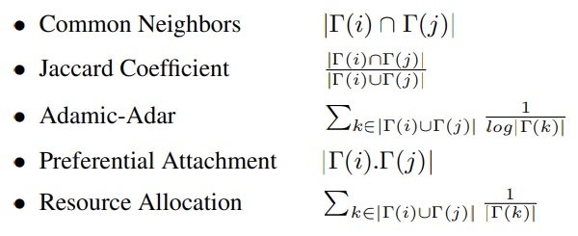Figure 4: PLACN features
The PLACN features above crawl the neighborhood of the nodes from the complete graph. This means they contain information about the nodes in context of the knowledge graph, which is not possible to include in the subgraphs. These measures can provide important training input to the graph neural network training model. Since they are derived directly from the knowledge graph, no extra input is needed from the user. To ensure the model is not hinted to the existence of the target link, the PLACN features between the target nodes is always left as 0.

Let f: V² → R⁵ be the function which returns the set of 5 PLACN features for the pair of vertices a, b. So f(a,b) returns a vector of 5 components, each holding the Common Nodes, Jaccard Coefficient, Adamic-Adair value, Preferential Attachment value, and Resource Allocation Value.

Let S be the set of nodes in the enclosing subgraph of target nodes (u,v), and u,v∈ S .

Then for every x∈ S, we can find the PLACN features of x and each of x's subgraph neighbors, y∈ S – {x}, using f(x,y). In the following discussion, x is the node whose features we are calculating.

Let Px be the matrix whose columns are PLACN feature vectors of x for each of its subgraph neighbours,

Px = [R0 .. R1 .. R|S|] where Ry = f(x, y) for all y∈ S.

The matrix Px contains all of the PLACN features of every possible pair of nodes in the subgraph. We call this the Topology Matrix. The number of rows is 5, and the number of columns is |S|.

For example, if {x,w,y,z} = S, and x,w are the target nodes of the subgraph, then
Px = ,
0 | 0 | CN_{y} | CN_{z}
0 | AA_{w} | AA_{y} | AA_{z}
0 | JC_{w} | JC_{y} | JC_{z}
0 | RA_{w} | RA_{y} | RA_{z}
0 | PA_{w} | PA_{y} | PA_{z}

The column for x is zero because it is pointless to compare x's topology to itself. The cell for x and w is always zero, because x and w are the target nodes. This way the neural network does not have any hint of connectivity of the targets from the complete knowledge graph of the training dataset. Recall that f(x, y) retrieves from the complete knowledge graph, where the link between the target nodes exists.

Since the size of Px will be dependent on the size of our subgraph, |S|, which is variable, this is not suitable for scaling in training on when the node degree of the graph is very high. A very large feature vector can cause critical performance issues in the model.

This is where the Fixed Sized Subgraph and Variable Sized Subgraph models diverge. Each take a different approach in deriving a feature vector Fx from the topology matrix Px.

Summarizing Topology Information in Variable Sized Subgraphs
In order to have a feature vector of constant size, we take a statistical analysis of each PLACN feature, across all of the nodes in the subgraph. For each PLACN feature R∈ R⁵, we can take the mean, median, standard deviation, minimum, maximum and variance across all of the nodes in the subgraph. In other words, we can apply the statistical functions to the rows of the topology matrix Px.
Let Fx = Stat(Px), where Stat(Px) replaces each row r of Px with
[Mean(r), Median(r), Variance(r),
Min(r), Max(r), StdDev(r)]

The resulting matrix always has 30 elements, that is, Fx =
where CN, AA, JC, RA and PA is list of measures across all nodes in the subgraph, the row of Px .
Mean(CN) | Med(CN) | Var(CN) | Min(CN) | Max(CN) | StdDev(CN)
Mean(AA) | Med(AA) | Var(AA) | Min(AA) | Max(AA) | StdDev(AA)
Mean(JC) | Med(JC) | Var(JC) | Min(JC) | Max(JC) | StdDev(JC)
Mean(RA) | Med(RA) | Var(RA) | Min(RA) | Max(RA) | StdDev(RA)
Mean(PA) | Med(PA) | Var(PA) | Min(PA) | Max(PA) | StdDev(PA)

Therefore, Fx sees the rows of Px replaced by the statistical results which are rows of fixed size 6, since there are 6 statistical functions. Fx will always have a total of 30 elements, suitable to be encoded into a node x's feature vector for training in the Graph Neural Network. We simply list all 30 elements as components of the final feature vector.

Normalizing Feature Vectors to Avoid Overfitting
During the experiments it was shown that use of feature vectors would cause the model to overfit the training data, and loose some generality when applied to the test triples. The model would reach near 100% accuracy on training data, but would achieve no low success rates in test runs. To resolve this, I utilized the NodeNorm function (Zhou et al) to normalize the feature vector. This gives the effect of making each feature vector have the save variance.

Zhou et all have observed that GNNs perform poorly when the variance of features of nodes is very high. The normalization replaces each component in the feature vector with the difference from the mean divided by the variance.

Where f is a component of feature vector F, the normalized component is

f ' = ( f -μ ) / σ
where μ and σ are the average and variance of all components of F.

Summarizing Topology Information in Fixed Sized Subgraphs
We experimented with fixed sized subgraphs, as PLACN uses in its architecture. This inherently limits the size of Px. The columns correspond to the fixed subgraph size and the rows correspond to each heuristic from PLACN, (CN, AA, etc). Therefore the size will always be
5|S|.

Thus for fixed sized subgraphs, we can directly encode Px
Fx = Px
In practice, this has led to very large vectors. In some experiments, the model would crash with errors before completing.

Experiments
The software implementation is built upon the Python code base provided by Komal Teru et al in their GraIL implementation. It uses the Deep Graph Learning library to implement a graph neural network. Experiments carried out were on 16 inductive datasets as well as a number of transductive datasets. These datasets where prepared by the GraIL authors and are identical to the data used in their experiments. WN18RR (Dettmers et al., 2018), FB15k-237 (Toutanova et al., 2015), and NELL-995 (Xiong et al., 2017). The inductive datasets were split so the test data contained entities distinct from the training set. The transductive datasets share nodes between training and test sets.
Based on the experiment results, we can see the additional feature vectors give better accuracy. In the Nell dataset, the improvement is most significant. The hypothesis of this paper is that the improvement is owed to the new information the GNN has to train on. That being the topology information calculated by the PLACN features.
Dataset | Nodes | Edges | Relations | Subgraph size, Calculated K Value | AUC_PR  GraIL  Published Results | AUC_PR  Augmented GraIL  Fixed Sized Subgraphs | AUC_PR  Augmented GraIL  “Our Model” | Improve-ment  Over GraIL
nell_v1_ind | 225 | 1024 | 14 |  | 86.05 | 90.56 | 91.21 | 5.16
nell_v2_ind | 4937 | 5521 | 79 | 3 | 92.62 | 93.7 | 96.84 | 4.22
nell_v3_ind | 4921 | 9668 | 122 | 4 | 93.34 | 94.18 | 97.04 | 3.70
nell_v4_ind | 3294 | 8520 | 61 | 6 | 87.5 | *crash | 95.42 | 7.92
fb237_v1_ind | 1500 | 2404 | 146 | 4 | 84.69 | 73.5 | 87.42 | 2.73
fb237_v2_ind | 2000 | 5092 | 176 | 6 | 90.57 | 84.56 | 91.20 | 0.63
fb237_v3_ind | 3000 | 9137 | 187 | 14 | 91.68 | 76.4 | 93.44 | 1.76
fb237_v4_ind | 3500 | 14554 | 204 | 16 | 94.46 | *crash | 93.52 | -0.94
WNRR18_v1_ind | 992 | 1991 | 9 | 5 | 94.32 | 96.38 | 94.76 | 0.44
WNRR18_v2_ind | 2923 | 4863 | 10 | 4 | 94.18 | 95.77 | 94.92 | 0.74
WNRR18_v3_ind | 5084 | 7470 | 11 | 3 | 85.8 | 89.28 | 86.46 | 0.66
WNRR18_v4_ind | 7208 | 15157 | 9 | 5 | 92.72 | 95.66 | 93.65 | 0.93
Bible | 2564 | 6683 | 15 | 6 | 85.05 | 86.98 | 84.91 | -0.14
Table 1: Inductive experiment results
Dataset | Nodes | Edges | Relations | AUC_PR  GraIL  Published Results | AUC_PR  Augmented GraIL  “Our Model” | Improve-ment  Over GraIL
nell_v1 | 3103 | 5540 | 14 | 83.95 | 92.44 | 8.49
nell_v2_ind
fb237_v1_ind | 2000 | 5226 | 183 | 88.97
fb237_v2_ind
WNRR18_v1 | 2746 | 6678 | 9 | 89.00 | 92.77 | 3.77
WNRR18_v2 | 6954 | 18968 | 10 | 90.66
Table 2: Transductive experiment results
One dataset which was prepared for these experiments, was generated from the Theographic online Bible knowledge graph. The loss of accuracy here may be due to the inconsistencies of the Bible, for example Jesus has two contradicting genealogies in the new testament. The model may have difficulties making predictions from the knowledge relationships.
To accelerate training performance, the mapping of (x,y) pairs to PLACN features is done by a two dimensional array which is prepared before training. When the PLACN features are needed by the model, they are looked up from from this array.
The Precision Recall Area Under Curve is metric is used to evaluate the model's accuracy. It is an evaluation of how accurate the model was with respect to predicting positive and negative samples. It is defined as the area under the Precision/Recall curve. Precision is the rate of true positives to guessed positives. Recall is the rate of true positives to total positives. The curve is constructed by finding the Precision (Y Axis) and Recall (X Axis) for different thresholds, given the results.
The source code can be found at
https://github.com/jaemuzzin/plagnn

References
Dettmers, T., Pasquale, M., Pontus, S., and Riedel, S. Convolutional 2d knowledge graph embeddings. In AAAI, 2018.
Kumaran Ragunathan, Kalyani Selvarajah and Ziad Kobti, Link Prediction by Analyzing Common Neighbors Based Subgraphs Using Convolutional Neural Network, ECAI 2020
Komal K. Teru, Etienne Denis, William L. Hamilton, Inductive Relation Prediction by Subgraph Reasoning, arXiv:1911.06962v2 [cs.LG] 12 Feb 2020
Toutanova, K., Chen, D., Pantel, P., Poon, H., Choudhury, P., and Gamon, M. Representing text for joint embedding of text and knowledge bases. In EMNLP, 2015.
Xiong, W., Hoang, T., and Wang, W. Y. Deeppath: A reinforcement learning method for knowledge graph reasoning. In EMNLP, 2017.
Kuangqi Zhou, Yanfei Dong, Wee Sun Lee, Bryan Hooi, Huan Xu, Jiashi Feng, Effective Training Strategies for Deep Graph Neural Networks, arXiv:2006.07107v1 [cs.LG] 12 Jun 2020
Theographic Online Bible Knowledge Graph
https://theographic.netlify.app/about/
The source code can be found at
https://github.com/jaemuzzin/plagnn

