Jae Park
Data Mining HW 8
Spectral Clustering

I chose the spread of 1000 after running the program 20 times each with different spread values using ratio cut.

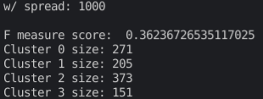

Asymmetric
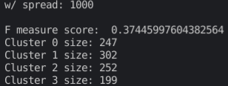

Symmetric
