Jae Park
Data Mining HW 5

Dual SVM

A good C value and a kernel parameter (spread) were found using sklearn.svm.SVC:
C = 10, σ² = 1

maxiter (max iteration permitted): 1000 was chosen for speed
-------------------------------------------------------< Linear >--------------------------------------------------------
C = 0.01
C = 0.1
C = 1
C = 10 <Best Validation set accuracy>
C = 11

-----------------------------------------------------< Gaussian >------------------------------------------------------
σ² = 0.1
σ² = 1
σ² = 2
σ² = 3
σ² = 10

Final output of the weight vector and bias with C = 10, σ² = 1
$ python3 Assign5.py energydata_complete.csv 10 0.001 1000 linear 1

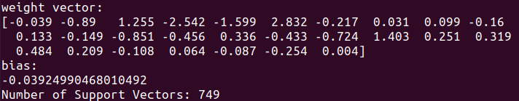
weight vector = (27 x 1)

