Jae Park
Data Mining HW 4
Linear Regression

η (step size): 0.00001 has been determined empirically.

When η >= 0.0001, the weight vector w does not converge.

ε (convergence threshold): 0.0001 has been determined empirically.

w from gradient descent is close to w given from the closed form formula when ε <= 0.0001.

α = 100

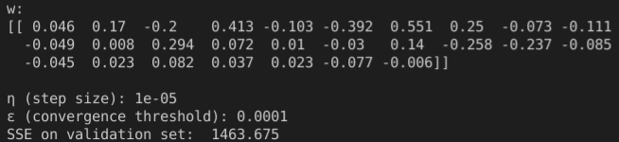
α = 200
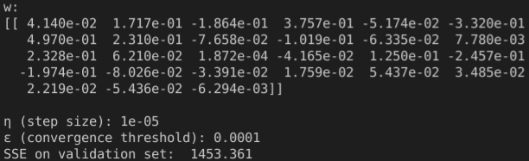
α = 300

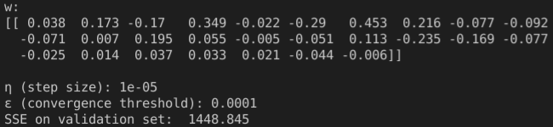
α = 400

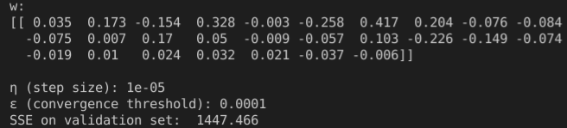
α = 500

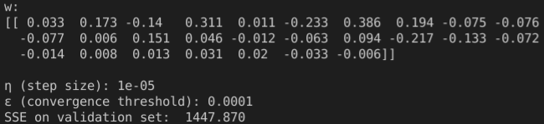
----------------------------------------------------------------------------------------------------------------------------
α = 350

α = 450
