mean vector
[ 97.695 3.802 21.687 40.26 20.341 40.42 22.268 39.243 20.855
39.027 19.592 50.949 7.911 54.609 20.267 35.388 22.029 42.936
19.486 41.552 7.412 755.523 79.75 4.04 38.331 3.761 24.988]
--------------------------------------------------------------------
total variance
12504.288
--------------------------------------------------------------------
inner product covariance
[[ 1.051e+04 1.605e+02 9.130e+00 3.510e+01 2.700e+01 -2.523e+01
1.749e+01 1.211e+01 8.436e+00 7.551e+00 3.737e+00 6.433e+00
7.345e+01 -2.656e+02 5.581e+00 -2.917e+01 7.936e+00 -5.037e+01
2.068e+00 -2.190e+01 5.405e+01 -2.646e+01 -2.326e+02 2.189e+01
2.790e-01 6.602e+00 -1.656e+01]
[ 1.605e+02 6.298e+01 -3.000e-01 3.378e+00 -9.800e-02 1.647e+00
-1.550e+00 3.387e+00 -1.440e-01 3.960e+00 -1.153e+00 1.011e+01
-3.819e+00 3.801e+01 -2.266e+00 1.423e+00 -1.109e+00 5.350e-01
-2.520e+00 -2.890e-01 -3.140e+00 -6.210e-01 8.105e+00 1.173e+00
1.875e+00 -1.209e+00 6.000e-02]
[ 9.130e+00 -3.000e-01 2.579e+00 1.048e+00 2.947e+00 -1.600e-02
2.875e+00 -1.490e-01 2.877e+00 6.820e-01 2.622e+00 -2.140e-01
6.404e+00 -3.077e+01 2.842e+00 1.110e+00 2.593e+00 -5.400e-02
2.733e+00 4.780e-01 5.831e+00 -1.789e+00 -8.268e+00 -3.450e-01
-1.444e+00 3.849e+00 -1.440e-01]
[ 3.510e+01 3.378e+00 1.048e+00 1.583e+01 2.355e+00 1.291e+01
2.021e+00 1.094e+01 8.630e-01 1.521e+01 1.511e+00 1.089e+01
7.661e+00 3.038e+01 1.800e-01 1.630e+01 -2.340e-01 1.530e+01
9.240e-01 1.262e+01 7.210e+00 -8.655e+00 1.625e+01 1.999e+00
-9.880e-01 1.067e+01 -4.000e-02]
[ 2.700e+01 -9.800e-02 2.947e+00 2.355e+00 4.809e+00 -1.478e+00
3.234e+00 8.670e-01 3.414e+00 2.204e+00 2.915e+00 5.860e-01
1.070e+01 -3.964e+01 3.071e+00 2.571e+00 2.480e+00 7.850e-01
2.985e+00 1.432e+00 9.238e+00 -2.159e+00 -1.651e+01 2.820e-01
-1.803e+00 5.359e+00 -3.520e-01]
[-2.523e+01 1.647e+00 -1.600e-02 1.291e+01 -1.478e+00 1.656e+01
1.121e+00 8.984e+00 -3.930e-01 1.275e+01 8.290e-01 9.189e+00
-2.400e-01 4.943e+01 -4.420e-01 1.437e+01 -3.270e-01 1.445e+01
4.470e-01 1.143e+01 7.290e-01 -7.698e+00 3.547e+01 6.900e-01
-2.580e-01 8.521e+00 3.700e-01]
[ 1.749e+01 -1.550e+00 2.875e+00 2.021e+00 3.234e+00 1.121e+00
4.024e+00 -7.300e-02 3.495e+00 1.069e+00 3.287e+00 -1.201e+00
8.392e+00 -4.047e+01 3.587e+00 1.771e+00 3.121e+00 4.660e-01
3.643e+00 1.121e+00 7.461e+00 -2.820e+00 -8.421e+00 -4.960e-01
-2.421e+00 5.435e+00 -1.510e-01]
[ 1.211e+01 3.387e+00 -1.490e-01 1.094e+01 8.670e-01 8.984e+00
-7.300e-02 1.059e+01 -9.340e-01 1.270e+01 -3.010e-01 1.102e+01
1.523e+00 5.220e+01 -1.717e+00 1.386e+01 -1.803e+00 1.409e+01
-1.280e+00 1.126e+01 2.046e+00 -5.617e+00 1.727e+01 2.100e+00
6.540e-01 5.657e+00 -2.300e-02]
[ 8.436e+00 -1.440e-01 2.877e+00 8.630e-01 3.414e+00 -3.930e-01
3.495e+00 -9.340e-01 4.173e+00 -4.310e-01 3.285e+00 -1.410e+00
8.116e+00 -4.474e+01 3.783e+00 4.550e-01 3.182e+00 -1.016e+00
3.661e+00 -2.170e-01 7.207e+00 -1.138e+00 -1.183e+01 -9.300e-01
-2.524e+00 4.451e+00 -5.400e-02]
[ 7.551e+00 3.960e+00 6.820e-01 1.521e+01 2.204e+00 1.275e+01
1.069e+00 1.270e+01 -4.310e-01 1.885e+01 7.350e-01 1.381e+01
6.849e+00 5.303e+01 -1.202e+00 1.986e+01 -1.419e+00 1.921e+01
-3.890e-01 1.544e+01 6.770e+00 -8.054e+00 2.179e+01 3.194e+00
1.350e-01 1.123e+01 -1.120e-01]
[ 3.737e+00 -1.153e+00 2.622e+00 1.511e+00 2.915e+00 8.290e-01
3.287e+00 -3.010e-01 3.285e+00 7.350e-01 3.402e+00 5.460e-01
7.068e+00 -3.634e+01 3.388e+00 1.405e+00 2.977e+00 1.580e-01
3.386e+00 5.540e-01 6.388e+00 -2.334e+00 -7.530e+00 -6.560e-01
-1.831e+00 4.552e+00 -1.470e-01]
[ 6.433e+00 1.011e+01 -2.140e-01 1.089e+01 5.860e-01 9.189e+00
-1.201e+00 1.102e+01 -1.410e+00 1.381e+01 5.460e-01 8.139e+01
-4.304e+00 7.413e+01 -2.719e+00 1.503e+01 -1.535e+00 1.696e+01
-2.518e+00 1.020e+01 -2.549e+00 -7.966e+00 2.500e+01 1.814e+00
-1.397e+00 2.958e+00 -1.446e+00]
[ 7.345e+01 -3.819e+00 6.404e+00 7.661e+00 1.070e+01 -2.400e-01
8.392e+00 1.523e+00 8.116e+00 6.849e+00 7.068e+00 -4.304e+00
3.709e+01 -1.275e+02 7.955e+00 7.976e+00 5.752e+00 2.346e+00
8.186e+00 4.663e+00 3.157e+01 -6.383e+00 -5.165e+01 2.526e+00
-5.841e+00 1.952e+01 -1.332e+00]
[-2.656e+02 3.801e+01 -3.077e+01 3.038e+01 -3.964e+01 4.943e+01
-4.047e+01 5.220e+01 -4.474e+01 5.303e+01 -3.634e+01 7.413e+01
-1.275e+02 9.703e+02 -4.955e+01 5.691e+01 -4.057e+01 7.967e+01
-4.637e+01 5.068e+01 -1.063e+02 -1.517e+01 3.335e+02 7.507e+00
3.994e+01 -3.402e+01 5.270e+00]
[ 5.581e+00 -2.266e+00 2.842e+00 1.800e-01 3.071e+00 -4.420e-01
3.587e+00 -1.717e+00 3.783e+00 -1.202e+00 3.388e+00 -2.719e+00
7.955e+00 -4.955e+01 4.452e+00 -3.660e-01 3.641e+00 -2.314e+00
4.016e+00 -6.800e-01 7.083e+00 -1.526e+00 -1.293e+01 -9.610e-01
-2.740e+00 4.130e+00 -1.190e-01]
[-2.917e+01 1.423e+00 1.110e+00 1.630e+01 2.571e+00 1.437e+01
1.771e+00 1.386e+01 4.550e-01 1.986e+01 1.405e+00 1.503e+01
7.976e+00 5.691e+01 -3.660e-01 2.615e+01 -1.241e+00 2.362e+01
2.890e-01 1.823e+01 8.000e+00 -1.006e+01 2.884e+01 2.670e+00
-4.330e-01 1.377e+01 1.350e-01]
[ 7.936e+00 -1.109e+00 2.593e+00 -2.340e-01 2.480e+00 -3.270e-01
3.121e+00 -1.803e+00 3.182e+00 -1.419e+00 2.977e+00 -1.535e+00
5.752e+00 -4.057e+01 3.641e+00 -1.241e+00 3.826e+00 -2.141e+00
3.426e+00 -1.273e+00 5.230e+00 -2.357e+00 -8.757e+00 -1.049e+00
-1.387e+00 3.215e+00 -9.100e-02]
[-5.037e+01 5.350e-01 -5.400e-02 1.530e+01 7.850e-01 1.445e+01
4.660e-01 1.409e+01 -1.016e+00 1.921e+01 1.580e-01 1.696e+01
2.346e+00 7.967e+01 -2.314e+00 2.362e+01 -2.141e+00 2.729e+01
-1.189e+00 1.856e+01 3.254e+00 -8.720e+00 3.794e+01 2.592e+00
2.845e+00 1.100e+01 3.390e-01]
[ 2.068e+00 -2.520e+00 2.733e+00 9.240e-01 2.985e+00 4.470e-01
3.643e+00 -1.280e+00 3.661e+00 -3.890e-01 3.386e+00 -2.518e+00
8.186e+00 -4.637e+01 4.016e+00 2.890e-01 3.426e+00 -1.189e+00
4.059e+00 -7.300e-02 7.158e+00 -2.338e+00 -9.572e+00 -8.780e-01
-2.469e+00 4.914e+00 -3.600e-02]
[-2.190e+01 -2.890e-01 4.780e-01 1.262e+01 1.432e+00 1.143e+01
1.121e+00 1.126e+01 -2.170e-01 1.544e+01 5.540e-01 1.020e+01
4.663e+00 5.068e+01 -6.800e-01 1.823e+01 -1.273e+00 1.856e+01
-7.300e-02 1.723e+01 4.928e+00 -5.644e+00 2.223e+01 2.428e+00
4.240e-01 9.409e+00 -1.780e-01]
[ 5.405e+01 -3.140e+00 5.831e+00 7.210e+00 9.238e+00 7.290e-01
7.461e+00 2.046e+00 7.207e+00 6.770e+00 6.388e+00 -2.549e+00
3.157e+01 -1.063e+02 7.083e+00 8.000e+00 5.230e+00 3.254e+00
7.158e+00 4.928e+00 2.827e+01 -5.636e+00 -4.549e+01 2.515e+00
-4.852e+00 1.764e+01 -1.173e+00]
[-2.646e+01 -6.210e-01 -1.789e+00 -8.655e+00 -2.159e+00 -7.698e+00
-2.820e+00 -5.617e+00 -1.138e+00 -8.054e+00 -2.334e+00 -7.966e+00
-6.383e+00 -1.517e+01 -1.526e+00 -1.006e+01 -2.357e+00 -8.720e+00
-2.338e+00 -5.644e+00 -5.636e+00 5.475e+01 -1.014e+01 -4.263e+00
3.518e+00 -7.576e+00 7.500e-02]
[-2.326e+02 8.105e+00 -8.268e+00 1.625e+01 -1.651e+01 3.547e+01
-8.421e+00 1.727e+01 -1.183e+01 2.179e+01 -7.530e+00 2.500e+01
-5.165e+01 3.335e+02 -1.293e+01 2.884e+01 -8.757e+00 3.794e+01
-9.572e+00 2.223e+01 -4.549e+01 -1.014e+01 2.220e+02 -6.445e+00
1.461e+01 2.282e+00 4.415e+00]
[ 2.189e+01 1.173e+00 -3.450e-01 1.999e+00 2.820e-01 6.900e-01
-4.960e-01 2.100e+00 -9.300e-01 3.194e+00 -6.560e-01 1.814e+00
2.526e+00 7.507e+00 -9.610e-01 2.670e+00 -1.049e+00 2.592e+00
-8.780e-01 2.428e+00 2.515e+00 -4.263e+00 -6.445e+00 6.008e+00
-2.170e-01 1.295e+00 -4.030e-01]
[ 2.790e-01 1.875e+00 -1.444e+00 -9.880e-01 -1.803e+00 -2.580e-01
-2.421e+00 6.540e-01 -2.524e+00 1.350e-01 -1.831e+00 -1.397e+00
-5.841e+00 3.994e+01 -2.740e+00 -4.330e-01 -1.387e+00 2.845e+00
-2.469e+00 4.240e-01 -4.852e+00 3.518e+00 1.461e+01 -2.170e-01
1.391e+02 -2.087e+00 -1.007e+00]
[ 6.602e+00 -1.209e+00 3.849e+00 1.067e+01 5.359e+00 8.521e+00
5.435e+00 5.657e+00 4.451e+00 1.123e+01 4.552e+00 2.958e+00
1.952e+01 -3.402e+01 4.130e+00 1.377e+01 3.215e+00 1.100e+01
4.914e+00 9.409e+00 1.764e+01 -7.576e+00 2.282e+00 1.295e+00
-2.087e+00 1.759e+01 -2.400e-01]
[-1.656e+01 6.000e-02 -1.440e-01 -4.000e-02 -3.520e-01 3.700e-01
-1.510e-01 -2.300e-02 -5.400e-02 -1.120e-01 -1.470e-01 -1.446e+00
-1.332e+00 5.270e+00 -1.190e-01 1.350e-01 -9.100e-02 3.390e-01
-3.600e-02 -1.780e-01 -1.173e+00 7.500e-02 4.415e+00 -4.030e-01
-1.007e+00 -2.400e-01 2.101e+02]]
--------------------------------------------------------------------
outer product covariance
[[ 1.051e+04 1.605e+02 9.130e+00 3.510e+01 2.700e+01 -2.523e+01
1.749e+01 1.211e+01 8.436e+00 7.551e+00 3.737e+00 6.433e+00
7.345e+01 -2.656e+02 5.581e+00 -2.917e+01 7.936e+00 -5.037e+01
2.068e+00 -2.190e+01 5.405e+01 -2.646e+01 -2.326e+02 2.189e+01
2.790e-01 6.602e+00 -1.656e+01]
[ 1.605e+02 6.298e+01 -3.000e-01 3.378e+00 -9.800e-02 1.647e+00
-1.550e+00 3.387e+00 -1.440e-01 3.960e+00 -1.153e+00 1.011e+01
-3.819e+00 3.801e+01 -2.266e+00 1.423e+00 -1.109e+00 5.350e-01
-2.520e+00 -2.890e-01 -3.140e+00 -6.210e-01 8.105e+00 1.173e+00
1.875e+00 -1.209e+00 6.000e-02]
[ 9.130e+00 -3.000e-01 2.579e+00 1.048e+00 2.947e+00 -1.600e-02
2.875e+00 -1.490e-01 2.877e+00 6.820e-01 2.622e+00 -2.140e-01
6.404e+00 -3.077e+01 2.842e+00 1.110e+00 2.593e+00 -5.400e-02
2.733e+00 4.780e-01 5.831e+00 -1.789e+00 -8.268e+00 -3.450e-01
-1.444e+00 3.849e+00 -1.440e-01]
[ 3.510e+01 3.378e+00 1.048e+00 1.583e+01 2.355e+00 1.291e+01
2.021e+00 1.094e+01 8.630e-01 1.521e+01 1.511e+00 1.089e+01
7.661e+00 3.038e+01 1.800e-01 1.630e+01 -2.340e-01 1.530e+01
9.240e-01 1.262e+01 7.210e+00 -8.655e+00 1.625e+01 1.999e+00
-9.880e-01 1.067e+01 -4.000e-02]
[ 2.700e+01 -9.800e-02 2.947e+00 2.355e+00 4.809e+00 -1.478e+00
3.234e+00 8.670e-01 3.414e+00 2.204e+00 2.915e+00 5.860e-01
1.070e+01 -3.964e+01 3.071e+00 2.571e+00 2.480e+00 7.850e-01
2.985e+00 1.432e+00 9.238e+00 -2.159e+00 -1.651e+01 2.820e-01
-1.803e+00 5.359e+00 -3.520e-01]
[-2.523e+01 1.647e+00 -1.600e-02 1.291e+01 -1.478e+00 1.656e+01
1.121e+00 8.984e+00 -3.930e-01 1.275e+01 8.290e-01 9.189e+00
-2.400e-01 4.943e+01 -4.420e-01 1.437e+01 -3.270e-01 1.445e+01
4.470e-01 1.143e+01 7.290e-01 -7.698e+00 3.547e+01 6.900e-01
-2.580e-01 8.521e+00 3.700e-01]
[ 1.749e+01 -1.550e+00 2.875e+00 2.021e+00 3.234e+00 1.121e+00
4.024e+00 -7.300e-02 3.495e+00 1.069e+00 3.287e+00 -1.201e+00
8.392e+00 -4.047e+01 3.587e+00 1.771e+00 3.121e+00 4.660e-01
3.643e+00 1.121e+00 7.461e+00 -2.820e+00 -8.421e+00 -4.960e-01
-2.421e+00 5.435e+00 -1.510e-01]
[ 1.211e+01 3.387e+00 -1.490e-01 1.094e+01 8.670e-01 8.984e+00
-7.300e-02 1.059e+01 -9.340e-01 1.270e+01 -3.010e-01 1.102e+01
1.523e+00 5.220e+01 -1.717e+00 1.386e+01 -1.803e+00 1.409e+01
-1.280e+00 1.126e+01 2.046e+00 -5.617e+00 1.727e+01 2.100e+00
6.540e-01 5.657e+00 -2.300e-02]
[ 8.436e+00 -1.440e-01 2.877e+00 8.630e-01 3.414e+00 -3.930e-01
3.495e+00 -9.340e-01 4.173e+00 -4.310e-01 3.285e+00 -1.410e+00
8.116e+00 -4.474e+01 3.783e+00 4.550e-01 3.182e+00 -1.016e+00
3.661e+00 -2.170e-01 7.207e+00 -1.138e+00 -1.183e+01 -9.300e-01
-2.524e+00 4.451e+00 -5.400e-02]
[ 7.551e+00 3.960e+00 6.820e-01 1.521e+01 2.204e+00 1.275e+01
1.069e+00 1.270e+01 -4.310e-01 1.885e+01 7.350e-01 1.381e+01
6.849e+00 5.303e+01 -1.202e+00 1.986e+01 -1.419e+00 1.921e+01
-3.890e-01 1.544e+01 6.770e+00 -8.054e+00 2.179e+01 3.194e+00
1.350e-01 1.123e+01 -1.120e-01]
[ 3.737e+00 -1.153e+00 2.622e+00 1.511e+00 2.915e+00 8.290e-01
3.287e+00 -3.010e-01 3.285e+00 7.350e-01 3.402e+00 5.460e-01
7.068e+00 -3.634e+01 3.388e+00 1.405e+00 2.977e+00 1.580e-01
3.386e+00 5.540e-01 6.388e+00 -2.334e+00 -7.530e+00 -6.560e-01
-1.831e+00 4.552e+00 -1.470e-01]
[ 6.433e+00 1.011e+01 -2.140e-01 1.089e+01 5.860e-01 9.189e+00
-1.201e+00 1.102e+01 -1.410e+00 1.381e+01 5.460e-01 8.139e+01
-4.304e+00 7.413e+01 -2.719e+00 1.503e+01 -1.535e+00 1.696e+01
-2.518e+00 1.020e+01 -2.549e+00 -7.966e+00 2.500e+01 1.814e+00
-1.397e+00 2.958e+00 -1.446e+00]
[ 7.345e+01 -3.819e+00 6.404e+00 7.661e+00 1.070e+01 -2.400e-01
8.392e+00 1.523e+00 8.116e+00 6.849e+00 7.068e+00 -4.304e+00
3.709e+01 -1.275e+02 7.955e+00 7.976e+00 5.752e+00 2.346e+00
8.186e+00 4.663e+00 3.157e+01 -6.383e+00 -5.165e+01 2.526e+00
-5.841e+00 1.952e+01 -1.332e+00]
[-2.656e+02 3.801e+01 -3.077e+01 3.038e+01 -3.964e+01 4.943e+01
-4.047e+01 5.220e+01 -4.474e+01 5.303e+01 -3.634e+01 7.413e+01
-1.275e+02 9.703e+02 -4.955e+01 5.691e+01 -4.057e+01 7.967e+01
-4.637e+01 5.068e+01 -1.063e+02 -1.517e+01 3.335e+02 7.507e+00
3.994e+01 -3.402e+01 5.270e+00]
[ 5.581e+00 -2.266e+00 2.842e+00 1.800e-01 3.071e+00 -4.420e-01
3.587e+00 -1.717e+00 3.783e+00 -1.202e+00 3.388e+00 -2.719e+00
7.955e+00 -4.955e+01 4.452e+00 -3.660e-01 3.641e+00 -2.314e+00
4.016e+00 -6.800e-01 7.083e+00 -1.526e+00 -1.293e+01 -9.610e-01
-2.740e+00 4.130e+00 -1.190e-01]
[-2.917e+01 1.423e+00 1.110e+00 1.630e+01 2.571e+00 1.437e+01
1.771e+00 1.386e+01 4.550e-01 1.986e+01 1.405e+00 1.503e+01
7.976e+00 5.691e+01 -3.660e-01 2.615e+01 -1.241e+00 2.362e+01
2.890e-01 1.823e+01 8.000e+00 -1.006e+01 2.884e+01 2.670e+00
-4.330e-01 1.377e+01 1.350e-01]
[ 7.936e+00 -1.109e+00 2.593e+00 -2.340e-01 2.480e+00 -3.270e-01
3.121e+00 -1.803e+00 3.182e+00 -1.419e+00 2.977e+00 -1.535e+00
5.752e+00 -4.057e+01 3.641e+00 -1.241e+00 3.826e+00 -2.141e+00
3.426e+00 -1.273e+00 5.230e+00 -2.357e+00 -8.757e+00 -1.049e+00
-1.387e+00 3.215e+00 -9.100e-02]
[-5.037e+01 5.350e-01 -5.400e-02 1.530e+01 7.850e-01 1.445e+01
4.660e-01 1.409e+01 -1.016e+00 1.921e+01 1.580e-01 1.696e+01
2.346e+00 7.967e+01 -2.314e+00 2.362e+01 -2.141e+00 2.729e+01
-1.189e+00 1.856e+01 3.254e+00 -8.720e+00 3.794e+01 2.592e+00
2.845e+00 1.100e+01 3.390e-01]
[ 2.068e+00 -2.520e+00 2.733e+00 9.240e-01 2.985e+00 4.470e-01
3.643e+00 -1.280e+00 3.661e+00 -3.890e-01 3.386e+00 -2.518e+00
8.186e+00 -4.637e+01 4.016e+00 2.890e-01 3.426e+00 -1.189e+00
4.059e+00 -7.300e-02 7.158e+00 -2.338e+00 -9.572e+00 -8.780e-01
-2.469e+00 4.914e+00 -3.600e-02]
[-2.190e+01 -2.890e-01 4.780e-01 1.262e+01 1.432e+00 1.143e+01
1.121e+00 1.126e+01 -2.170e-01 1.544e+01 5.540e-01 1.020e+01
4.663e+00 5.068e+01 -6.800e-01 1.823e+01 -1.273e+00 1.856e+01
-7.300e-02 1.723e+01 4.928e+00 -5.644e+00 2.223e+01 2.428e+00
4.240e-01 9.409e+00 -1.780e-01]
[ 5.405e+01 -3.140e+00 5.831e+00 7.210e+00 9.238e+00 7.290e-01
7.461e+00 2.046e+00 7.207e+00 6.770e+00 6.388e+00 -2.549e+00
3.157e+01 -1.063e+02 7.083e+00 8.000e+00 5.230e+00 3.254e+00
7.158e+00 4.928e+00 2.827e+01 -5.636e+00 -4.549e+01 2.515e+00
-4.852e+00 1.764e+01 -1.173e+00]
[-2.646e+01 -6.210e-01 -1.789e+00 -8.655e+00 -2.159e+00 -7.698e+00
-2.820e+00 -5.617e+00 -1.138e+00 -8.054e+00 -2.334e+00 -7.966e+00
-6.383e+00 -1.517e+01 -1.526e+00 -1.006e+01 -2.357e+00 -8.720e+00
-2.338e+00 -5.644e+00 -5.636e+00 5.475e+01 -1.014e+01 -4.263e+00
3.518e+00 -7.576e+00 7.500e-02]
[-2.326e+02 8.105e+00 -8.268e+00 1.625e+01 -1.651e+01 3.547e+01
-8.421e+00 1.727e+01 -1.183e+01 2.179e+01 -7.530e+00 2.500e+01
-5.165e+01 3.335e+02 -1.293e+01 2.884e+01 -8.757e+00 3.794e+01
-9.572e+00 2.223e+01 -4.549e+01 -1.014e+01 2.220e+02 -6.445e+00
1.461e+01 2.282e+00 4.415e+00]
[ 2.189e+01 1.173e+00 -3.450e-01 1.999e+00 2.820e-01 6.900e-01
-4.960e-01 2.100e+00 -9.300e-01 3.194e+00 -6.560e-01 1.814e+00
2.526e+00 7.507e+00 -9.610e-01 2.670e+00 -1.049e+00 2.592e+00
-8.780e-01 2.428e+00 2.515e+00 -4.263e+00 -6.445e+00 6.008e+00
-2.170e-01 1.295e+00 -4.030e-01]
[ 2.790e-01 1.875e+00 -1.444e+00 -9.880e-01 -1.803e+00 -2.580e-01
-2.421e+00 6.540e-01 -2.524e+00 1.350e-01 -1.831e+00 -1.397e+00
-5.841e+00 3.994e+01 -2.740e+00 -4.330e-01 -1.387e+00 2.845e+00
-2.469e+00 4.240e-01 -4.852e+00 3.518e+00 1.461e+01 -2.170e-01
1.391e+02 -2.087e+00 -1.007e+00]
[ 6.602e+00 -1.209e+00 3.849e+00 1.067e+01 5.359e+00 8.521e+00
5.435e+00 5.657e+00 4.451e+00 1.123e+01 4.552e+00 2.958e+00
1.952e+01 -3.402e+01 4.130e+00 1.377e+01 3.215e+00 1.100e+01
4.914e+00 9.409e+00 1.764e+01 -7.576e+00 2.282e+00 1.295e+00
-2.087e+00 1.759e+01 -2.400e-01]
[-1.656e+01 6.000e-02 -1.440e-01 -4.000e-02 -3.520e-01 3.700e-01
-1.510e-01 -2.300e-02 -5.400e-02 -1.120e-01 -1.470e-01 -1.446e+00
-1.332e+00 5.270e+00 -1.190e-01 1.350e-01 -9.100e-02 3.390e-01
-3.600e-02 -1.780e-01 -1.173e+00 7.500e-02 4.415e+00 -4.030e-01
-1.007e+00 -2.400e-01 2.101e+02]]
--------------------------------------------------------------------
correlation matrix
[[ 1. 0.197 0.055 0.086 0.12 -0.06 0.085 0.036 0.04 0.017
0.02 0.007 0.118 -0.083 0.026 -0.056 0.04 -0.094 0.01 -0.051
0.099 -0.035 -0.152 0.087 0. 0.015 -0.011]
[ 0.197 1. -0.024 0.107 -0.006 0.051 -0.097 0.131 -0.009 0.115
-0.079 0.141 -0.079 0.154 -0.135 0.035 -0.071 0.013 -0.158 -0.009
-0.074 -0.011 0.069 0.06 0.02 -0.036 0.001]
[ 0.055 -0.024 1. 0.164 0.837 -0.003 0.892 -0.029 0.877 0.098
0.885 -0.015 0.655 -0.615 0.839 0.135 0.825 -0.006 0.845 0.072
0.683 -0.151 -0.345 -0.088 -0.076 0.571 -0.006]
[ 0.086 0.107 0.164 1. 0.27 0.798 0.253 0.845 0.106 0.88
0.206 0.303 0.316 0.245 0.021 0.801 -0.03 0.736 0.115 0.764
0.341 -0.294 0.274 0.205 -0.021 0.639 -0.001]
[ 0.12 -0.006 0.837 0.27 1. -0.166 0.735 0.121 0.762 0.232
0.721 0.03 0.801 -0.58 0.664 0.229 0.578 0.069 0.676 0.157
0.792 -0.133 -0.505 0.052 -0.07 0.583 -0.011]
[-0.06 0.051 -0.003 0.798 -0.166 1. 0.137 0.678 -0.047 0.721
0.11 0.25 -0.01 0.39 -0.051 0.691 -0.041 0.68 0.055 0.676
0.034 -0.256 0.585 0.069 -0.005 0.499 0.006]
[ 0.085 -0.097 0.892 0.253 0.735 0.137 1. -0.011 0.853 0.123
0.888 -0.066 0.687 -0.648 0.847 0.173 0.795 0.044 0.901 0.135
0.699 -0.19 -0.282 -0.101 -0.102 0.646 -0.005]
[ 0.036 0.131 -0.029 0.845 0.121 0.678 -0.011 1. -0.14 0.899
-0.05 0.375 0.077 0.515 -0.25 0.833 -0.283 0.829 -0.195 0.834
0.118 -0.233 0.356 0.263 0.017 0.414 -0. ]
[ 0.04 -0.009 0.877 0.106 0.762 -0.047 0.853 -0.14 1. -0.049
0.872 -0.076 0.652 -0.703 0.878 0.044 0.796 -0.095 0.889 -0.026
0.663 -0.075 -0.389 -0.186 -0.105 0.519 -0.002]
[ 0.017 0.115 0.098 0.88 0.232 0.721 0.123 0.899 -0.049 1.
0.092 0.353 0.259 0.392 -0.131 0.894 -0.167 0.847 -0.045 0.857
0.293 -0.251 0.337 0.3 0.003 0.617 -0.002]
[ 0.02 -0.079 0.885 0.206 0.721 0.11 0.888 -0.05 0.872 0.092
1. 0.033 0.629 -0.632 0.871 0.149 0.825 0.016 0.911 0.072
0.651 -0.171 -0.274 -0.145 -0.084 0.588 -0.005]
[ 0.007 0.141 -0.015 0.303 0.03 0.25 -0.066 0.375 -0.076 0.353
0.033 1. -0.078 0.264 -0.143 0.326 -0.087 0.36 -0.139 0.272
-0.053 -0.119 0.186 0.082 -0.013 0.078 -0.011]
[ 0.118 -0.079 0.655 0.316 0.801 -0.01 0.687 0.077 0.652 0.259
0.629 -0.078 1. -0.672 0.619 0.256 0.483 0.074 0.667 0.184
0.975 -0.142 -0.569 0.169 -0.081 0.764 -0.015]
[-0.083 0.154 -0.615 0.245 -0.58 0.39 -0.648 0.515 -0.703 0.392
-0.632 0.264 -0.672 1. -0.754 0.357 -0.666 0.49 -0.739 0.392
-0.642 -0.066 0.719 0.098 0.109 -0.26 0.012]
[ 0.026 -0.135 0.839 0.021 0.664 -0.051 0.847 -0.25 0.878 -0.131
0.871 -0.143 0.619 -0.754 1. -0.034 0.882 -0.21 0.945 -0.078
0.631 -0.098 -0.411 -0.186 -0.11 0.467 -0.004]
[-0.056 0.035 0.135 0.801 0.229 0.691 0.173 0.833 0.044 0.894
0.149 0.326 0.256 0.357 -0.034 1. -0.124 0.884 0.028 0.859
0.294 -0.266 0.379 0.213 -0.007 0.642 0.002]
[ 0.04 -0.071 0.825 -0.03 0.578 -0.041 0.795 -0.283 0.796 -0.167
0.825 -0.087 0.483 -0.666 0.882 -0.124 1. -0.21 0.869 -0.157
0.503 -0.163 -0.3 -0.219 -0.06 0.392 -0.003]
[-0.094 0.013 -0.006 0.736 0.069 0.68 0.044 0.829 -0.095 0.847
0.016 0.36 0.074 0.49 -0.21 0.884 -0.21 1. -0.113 0.856
0.117 -0.226 0.487 0.202 0.046 0.502 0.004]
[ 0.01 -0.158 0.845 0.115 0.676 0.055 0.901 -0.195 0.889 -0.045
0.911 -0.139 0.667 -0.739 0.945 0.028 0.869 -0.113 1. -0.009
0.668 -0.157 -0.319 -0.178 -0.104 0.581 -0.001]
[-0.051 -0.009 0.072 0.764 0.157 0.676 0.135 0.834 -0.026 0.857
0.072 0.272 0.184 0.392 -0.078 0.859 -0.157 0.856 -0.009 1.
0.223 -0.184 0.359 0.239 0.009 0.54 -0.003]
[ 0.099 -0.074 0.683 0.341 0.792 0.034 0.699 0.118 0.663 0.293
0.651 -0.053 0.975 -0.642 0.631 0.294 0.503 0.117 0.668 0.223
1. -0.143 -0.574 0.193 -0.077 0.791 -0.015]
[-0.035 -0.011 -0.151 -0.294 -0.133 -0.256 -0.19 -0.233 -0.075 -0.251
-0.171 -0.119 -0.142 -0.066 -0.098 -0.266 -0.163 -0.226 -0.157 -0.184
-0.143 1. -0.092 -0.235 0.04 -0.244 0.001]
[-0.152 0.069 -0.345 0.274 -0.505 0.585 -0.282 0.356 -0.389 0.337
-0.274 0.186 -0.569 0.719 -0.411 0.379 -0.3 0.487 -0.319 0.359
-0.574 -0.092 1. -0.176 0.083 0.037 0.02 ]
[ 0.087 0.06 -0.088 0.205 0.052 0.069 -0.101 0.263 -0.186 0.3
-0.145 0.082 0.169 0.098 -0.186 0.213 -0.219 0.202 -0.178 0.239
0.193 -0.235 -0.176 1. -0.008 0.126 -0.011]
[ 0. 0.02 -0.076 -0.021 -0.07 -0.005 -0.102 0.017 -0.105 0.003
-0.084 -0.013 -0.081 0.109 -0.11 -0.007 -0.06 0.046 -0.104 0.009
-0.077 0.04 0.083 -0.008 1. -0.042 -0.006]
[ 0.015 -0.036 0.571 0.639 0.583 0.499 0.646 0.414 0.519 0.617
0.588 0.078 0.764 -0.26 0.467 0.642 0.392 0.502 0.581 0.54
0.791 -0.244 0.037 0.126 -0.042 1. -0.004]
[-0.011 0.001 -0.006 -0.001 -0.011 0.006 -0.005 -0. -0.002 -0.002
-0.005 -0.011 -0.015 0.012 -0.004 0.002 -0.003 0.004 -0.001 -0.003
-0.015 0.001 0.02 -0.011 -0.006 -0.004 1. ]]
--------------------------------------------------------------------
eigenvalue 10528.115
--------------------------------------------------------------------
eigenvector without normalization
[[ 1.000e+00]
[ 1.521e-02]
[ 9.800e-04]
[ 3.222e-03]
[ 2.726e-03]
[-2.618e-03]
[ 1.802e-03]
[ 9.676e-04]
[ 9.635e-04]
[ 5.273e-04]
[ 4.810e-04]
[ 3.554e-04]
[ 7.488e-03]
[-2.881e-02]
[ 7.053e-04]
[-2.993e-03]
[ 8.941e-04]
[-5.100e-03]
[ 3.546e-04]
[-2.275e-03]
[ 5.567e-03]
[-2.467e-03]
[-2.360e-02]
[ 2.079e-03]
[-1.252e-04]
[ 7.349e-04]
[-1.632e-03]]

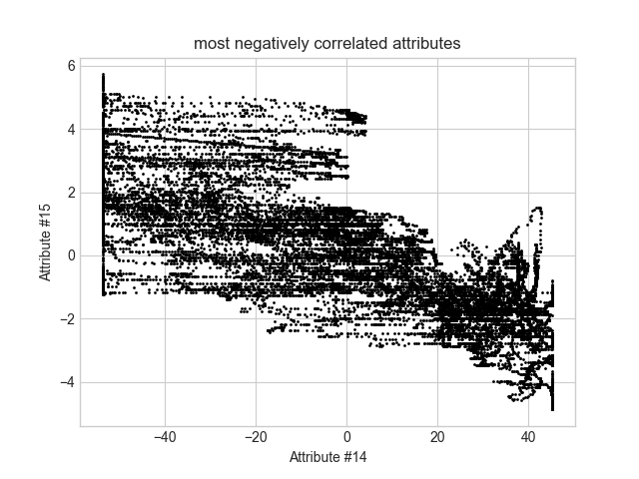
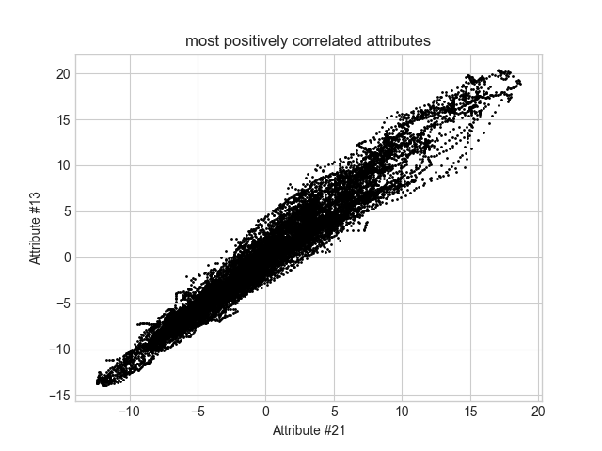

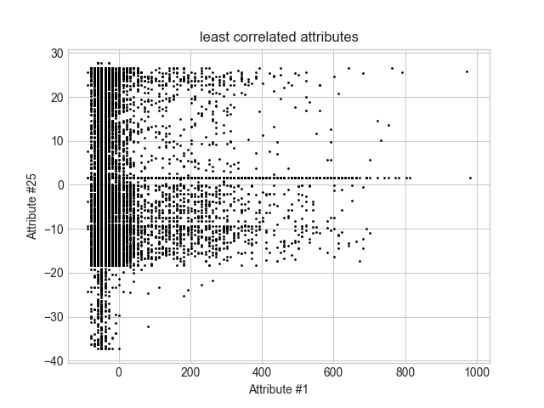

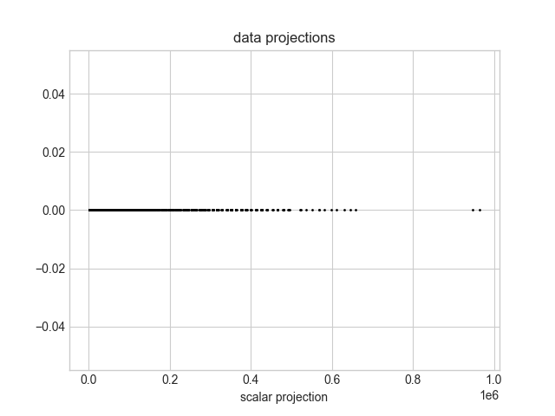
observations

One easily noticeable fact is that the covariance matrices from the inner product and the outer product are the same – which shows that one could compute a covariance matrix by either methods.
Furthermore, on the correlation matrix, all the diagonal entries are 1, because a correlation between the two identical data columns is always 1.

