BAF504: Assignment 1

20249433 MFE 최재필

1. **Selected Stocks**

I chose

1. KO (Coca-Cola Co)
2. XOM (Exxon Mobil Corp)
3. AAPL (Apple Inc)

The selection of the above stocks aims to evaluate the consistency and applicability of the constant growth Dividend Discount Model (DDM) is real-world scenarios.

Coca-cola and Exxon Mobil are recognized for their high dividend yields, unlike Apple. If the model holds, it should at least yield more accurate valuations for these dividend-rich stocks.

1. **Risk-free rate, risk premium and the data source**

* Risk-free rate ($r_{f}$): 4.0727%

I used the 1-year average of 10-year US Treasury market rate (DGS10) for the reference.

I believe 10-year US Treasury is more appropriate than 3-month T-bill because DDM valuation assumes perpetual dividends, which aligns more closely with long-term investment horizons.

Data source: [FRED](https://fred.stlouisfed.org/series/DGS10)

* Risk premium ($(E[r_{M}] -{ r}_{f})$: 33.2130% - 4.0727% = 29.1403%

I calculated the risk premium by subtracting risk-free rate from annualized 1-year average market return.

S&P500 TR (Total Return) index is utilized as a proxy for market return, as it accounts for dividend yields, unlike a vanilla standard S&P500 index.

You can see the significant difference between S&P500 TR and S&P500.

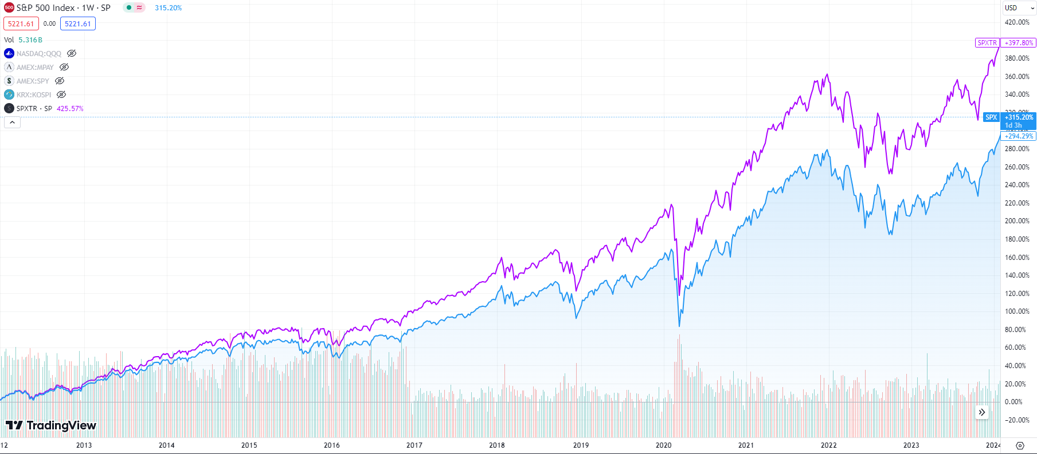

Figure 1) S&P500 TR vs S&P500, cummulative return

Also, I chose to annualize 1-year average return instead of using HPR(Holding Period Return) because HPR is highly sensitive to the selection of time frame, i.e., market timing.

Data source: [Yahoo Finance](https://finance.yahoo.com/quote/%5ESP500TR/)

1. **Required rate of return (using CAPM)**

Based on the above data, I can now calculate the required rate of return using CAPM.

$$k_{i}=r_{f}+β(E\left[r_{M}\right]-r_{f})$$

1. Coca-Cola
   1. Beta (5Y, monthly): 0.59
   2. k = 21.2655%
2. Exxon Mobil
   1. Beta (5Y, monthly): 0.95
   2. k = 31.7560%
3. Apple
   1. Beta (5Y, monthly): 1.29
   2. k = 41.6638%

I used 5-year, monthly calculated beta estimate because beta is known to be unstable if shorter time frame is used. (Also, it was the only available data from the source)

Data source for beta: Yahoo Finance

1. **PVGO**

$g$, the dividend growth rate can be calculated in either way:

1. The actual growth rate calculated from dividend history
2. The growth estimate using plowback ratio($b$) & ROE, assuming reinvestment.

Method 1: Actual dividend growth rate

1. Coca-Cola:
   1. Actual dividend growth rate (annualized): 3.9947%
2. Exxon Mobil:
   1. Actual dividend growth rate (annualized): 3.0444%
3. Apple:
   1. Actual dividend growth rate (annualized): 5.7569%

Using 5-year quarterly dividend history, annualized growth rate was calculated.

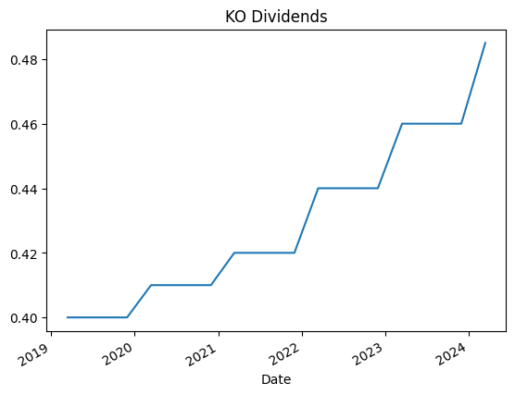

Figure 2) Coca-Cola quarterly dividend history for 5 years

Data Source: Yahoo Finance

Method 2: Growth estimate using plowback ratio & ROE

1. Coca-Cola:
   1. Dividend Yield: $1.94 / 3.20%
   2. ROE: 40.16%
   3. growth estimate: 38.8749%
2. Exxon Mobil: 3.34%
   1. Dividend Yield: $3.80 / 3.34%
   2. ROE: 18.00%
   3. growth estimate: 17.3988%
3. Apple:
   1. Dividend Yield: $0.96 / 0.57%
   2. ROE: 154.27%
   3. growth estimate: 153.3907%

The growth estimate was calculated as below:

$$g=\left(1-div yield\right)×ROE$$

Data Source: Yahoo Finance

Method 2’s dividend growth estimate is too extreme, probably due to the fact that it is a very simplified model assuming things like:

* ROE being constant throughout the history
* All plowback dividends are reinvested

Therefore, Method 1’s actual dividend growth rate will be used to calculate the PVGO. (But I’ll still use actual dividend $ amount from method 2’s data)

From the below formula:

$$V_{0}=\frac{E_{1}}{k}+PVGO$$

$V_{0}$ is constant growth model’s stock value.

$\frac{E_{1}}{k}$ is no-growth model’s stock value, since all the earnings are paid as dividend. Here, $E$ is EPS.

Calculating PVGO:

1. Coca-Cola
   1. EPS(ttm): $2.47
   2. $V_{0}$: $11.2328
   3. $\frac{E_{1}}{k}$: $11.6150
   4. PVGO: -$0.3822
2. Exxon Mobil
   1. EPS(ttm): $8.89
   2. $V_{0}$: $13.2351
   3. $\frac{E_{1}}{k}$: $27.9947
   4. PVGO: -$14.7596
3. Apple
   1. EPS(ttm): $6.43
   2. $V_{0}$: $2.6736
   3. $\frac{E_{1}}{k}$: $15.4331
   4. PVGO: -$12.7595

** ttm: trailing twelve month

Data source: Yahoo Finance

Unfortunately, calculated PVGOs were negative across the board.

The current values, regardless of using constant growth or no-growth method, were all far astray from actual current prices.

Actual current prices:

1. Coca-Cola
   1. Trading @: $61.05
2. Exxon Mobil
   1. Trading @: $115.05
3. Apple
   1. Trading @: $173.31
4. $V_{0}$**and $V_{1}$**

$V_{0}$ has already been determined, thus only the calculation of $V_{1}$ remains.

Under the constant growth DDM, the stock price is expected to grow at the same rate as dividends.

$$V_{1}=V_{0}(1+g)$$

1. Coca-Cola
   1. $V_{0}$: $11.2328
   2. $V_{1}$: $11.6816
2. Exxon Mobil
   1. $V_{0}$: $13.2351
   2. $V_{1}$: $13.6380
3. Apple
   1. $V_{0}$: $2.6736
   2. $V_{1}$: $2.8275
4. **Expected rate of return**

The expected rate of return is:

$$E\left(r_{1}\right)=\frac{V_{1}-P_{0}}{P_{0}}$$

However, the valuation of $V_{1}$ s are highly inaccurate so the expected rate of return will also be unreliable.

1. Coca-Cola
   1. $E\left(r_{1}\right)$: -80.8593%
2. Exxon Mobil
   1. $E\left(r_{1}\right)$: -88.1377%
3. Apple
   1. $E\left(r_{1}\right)$: -98.3685%

The result is highly unlikely.

1. **Final verdict**

If I have to choose which stock to buy/sell based on the analysis above, I would sell short all of them.

If I have to long one of them, I would choose Coca-Cola since the valuation is the least deviated from the actual stock price.

One silver lining is that stocks with higher dividends exhibited less deviation between their actual values and those estimated using the DDM method, just as initially anticipated.

1. Coca-Cola:
   1. $V_{0}$: $11.2328
   2. Trading @: $61.05
   3. Dividend Yield: $1.94 / 3.20%
   4. Error: x 5.43
2. Exxon Mobil
   1. $V_{0}$: $13.2351
   2. Trading @: $115.05
   3. Dividend Yield: $3.80 / 3.34%
   4. Error: x 8.68
3. Apple
   1. $V_{0}$: $2.6736
   2. Trading @: $173.31
   3. Dividend Yield: $0.96 / 0.57%
   4. Error: x 64.82