BAF504: Assignment 2

20249433 MFE 최재필

* **Constraints:**
  + Short-sale is not allowed

1. **Selected stocks**

I selected MSFT (Microsoft), GOOG (Alphabet, also known as Google), and KO (Coca-Cola) to analyze the impact of correlation on a portfolio, given that MSFT and GOOG are closely related, whereas KO is likely to have a lower correlation.

The data is from CRSP that is accessible with WRDS.

1. **Mean, variance and variance-covariance matrix of excess returns**

There were two choices for the return metric in WRDS CRSP

1. RET
   1. total return
2. RETX
   1. return without dividend

I will use RET, the total return, for more accurate analysis.



I found out that the covariance values are slightly different from the result obtained from Python’s pandas library. The reason for this is that while pandas library uses sample variance/covariance, Excel’s data analysis add-in uses population variance/covariance for the calculation.

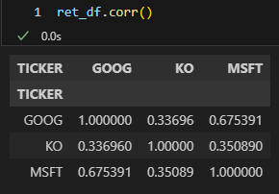

Like the initial conjecture, MSFT and GOOG have rather high correlation of 0.67 but the correlations with KO are rather low, around 0.35.

Even though I’m more comfortable using Python, I’ll use Excel’s result this time to get more familiar with the tool.

1. **(Long-only) opportunity set**





Given each stock’s excess return and variance-covariance matrix, we can iteratively change weight combinations to make portfolios. As illustrated above, the weight combinations were created with the step size of 0.1 .

The portfolio’s excess return is the weighted average of each stock’s excess return.

The portfolio’s variance is calculated by $wΣw'$ formula.

The portfolio’s E[R] is calculated by adding monthly average of risk-free rate to the excess return of the portfolio.

1. **Tangent portfolio and CAL**

The CAL(Capital Allocation Line) is illustrated above in green line.

Interestingly, the tangent portfolio is NOT diversifying at all and only holding MSFT stock.

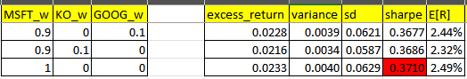

Long-only constraint shifts the efficient frontier to the lower-right direction, making it less efficient.

Excel solver verifies that the weight is optimal.

1. **Minimum 30% holding constraint**

Let’s assume that I have to hold at least 30% of KO (Coca-Cola) stock.

The maximum Sharpe ratio is now a little bit smaller, but it doesn’t change that fact that you should hold MSFT as much as possible.

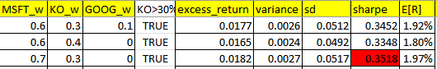

The optimal weights, expected return, standard deviation and the Sharpe ratio is as stated above.



The opportunity set also has slightly changed. Now there are only 35 portfolio combinations instead of 66 due to the 30% constraint.

The opportunity set has further shifted to the lower-right direction showing that the efficient frontier is even less efficient than before.

Excel solver verifies that the weight is optimal.

1. **(Monthly) 5% VaR & ES of the 30%-constraint portfolio**

If we assume that the return follows normal distribution (which is not in the real world), we can calculate the 5% VaR and ES using E[r] and standard deviation of the optimal tangent portfolio.

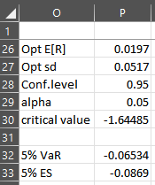

* Formula for VaR: =P26+P30*P27
* Formula for ES: =P26 - P27 * ( NORM.S.DIST(P30, FALSE) / P29)

In the above, both VaR and ES were calculating under the normality assumption.

If we want to calculate VaR and ES without normality assumption, we can apply the optimal portfolio’s weight to the actual historical data and see how it performs.

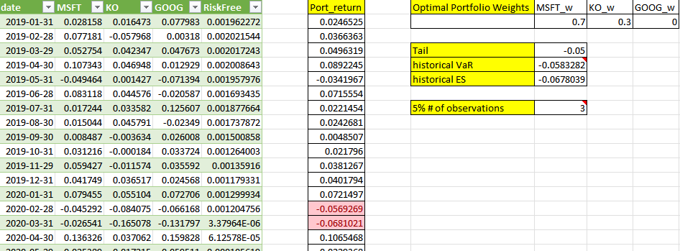

Like above, historical VaR and ES can be calculated with the actual data.

Here, no interpolation is needed since the 5% number of observations is an integer.

1. **Mixing risk-free assets**

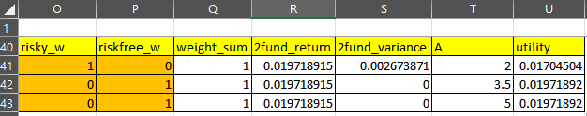

Mixing risk-free asset with optimal tangent portfolio (=market portfolio =risky asset) can sometimes optimize the investor’s utility given the risk-aversion coefficient, A.

Formulas:

* 2fund_return: =$O$41*$M$41+$P$41*pivot_RET!$P$2
  + pivot_RET!$P$2 is monthly average return of risk-free asset
* 2fund_variance: =O41^2 * $J$41 + P41^2 * 0
  + $J$41 is the variance of the risky asset (optimal portfolio)
* utility = =$R41 - 0.5*T41*S41

The result provides extreme suggestions where the utilities are optimized by either putting all the money in the risky asset or the risk-free asset.

The orange cell indicates that it was solved by Excel’s solver, by maximizing utility and giving constraint to keep the sum of the weight to 1.