BAF504: Assignment 3

20249433 MFE 최재필

1. **Selected stocks, report SIM alpha & beta**



* Choose 4 stocks:
  + Technology: AAPL (Apple Inc)
  + Financial: SPGI (S&P Global)
  + Consumer Cyclical: MCD (McDonald’s)
  + Consumer Defensive: KO (Coca Cola’s)
* Risk-free rate:
  + T-bill 3-month: IRX
* Market Index:
  + S&P500 Index ETF: SPY
* Data Source:
  + Yahoo Finance using `yfinance` library (python)

**Mean, variance and variance-covariance matrix of excess returns**

Regression results:

In the coefficient table, the value of const is alpha and the value of ticker is beta.

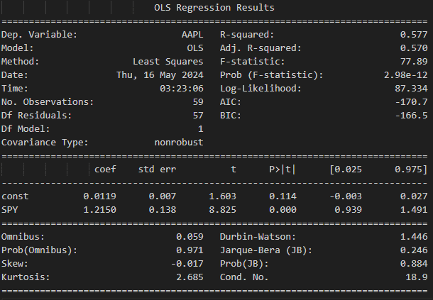

AAPL’s alpha=0.119, beta=1.2150

However, while beta is statistically significant, alpha is NOT significant at 5% level.

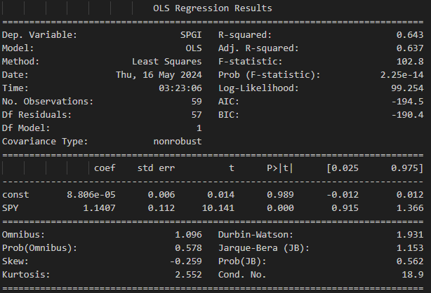

SPGI’s alpha=0.000, beta=1.1407

However, while beta is statistically significant, alpha is NOT significant at 5% level.

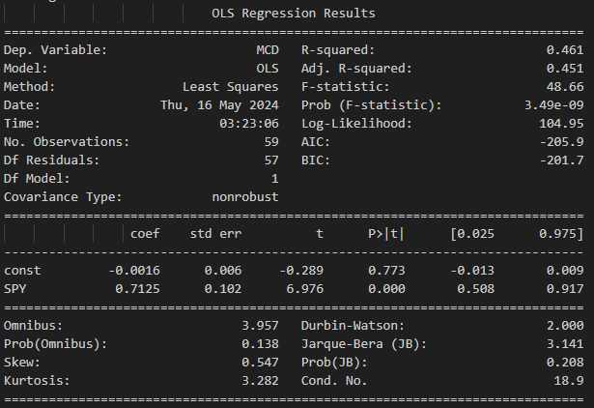

MCD’s alpha=-0.0016, beta=0.7125

However, while beta is statistically significant, alpha is NOT significant at 5% level.

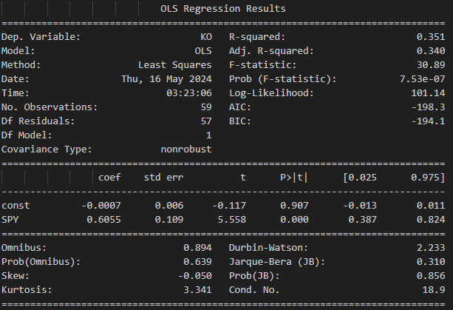

KO’s alpha=-0.0007, beta=0.6055

However, while beta is statistically significant, alpha is NOT significant at 5% level.

1. **Interpretation of the estimates**

Alpha is supposed to be the idiosyncratic return (unrelated to the market excess return) of the stock but as seen above, values of alpha are not statistically significant at 5%.

Beta on the other hand represents the sensitivity of the stock excess return to the market excess return and the values of beta are all statistically significant at 5%.

Sorted by beta values,

(In the order of ticker, alpha, beta)

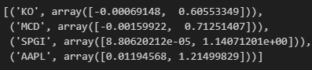

KO has the lowest beta of 0.605 and AAPL has the highest beta of 1.215

This result is consistent with economic rationale since KO belongs to the consumer defensive sector, which should be stable from the cyclic change of the market, and AAPL belongs to the tech sector which takes up a lot of portions in the market and more market-sensitive by nature.

1. Only using the first 30 months and running the regression

Using only the first 30 months, the estimates are:

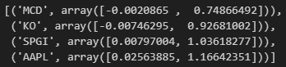

1. Only using the latter 30 months and running the regression

Using only the latter 30 months, the estimates are:

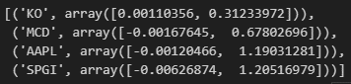

1. Discuss and compare the result of A), C) and D)

There are two findings:

* Using different time frames yield different results but the overall relative order and scale magnitude remain similar.
  + The order has changed between first 30 vs latter 30, but it is still in reasonable order as the lowest beta stock has been changed from MCD 🡪 KO and the highest has been changed from AAPL 🡪 SPGI. At least
  + The betas are also still in the reasonable range of 0~2. Negative or above 2 would be very rare, regardless of the selected time frame.
* Beta is unstable. It is very dependent on which time frame is used.
  + Betas are unstable in their absolute term as KO’s beta changed from 0.92 🡪 0.31 and SPGI’s beta changed from 1.03 🡪 1.20.