

Asset Pricing

Homework 7

Due at 24:00 pm (KST) on Thursday

Submit one file: written solutions with executable Python code in Jupyter Notebook(.ipynb)

**Subjects**

**[Session4. CAPM and APT]**

**[Session7. Consumption CAPM]**

1. Asset Pricing   
**Chapter 1.** Consumption-Based Model and Overview

**Chapter 2.** Applying the Basic Model

**Assignment 1.**

Summarize Chapter 1.

Summarize Chapter 2.

**Assignment 2.**

Solve the following problems

**Problem 1.**

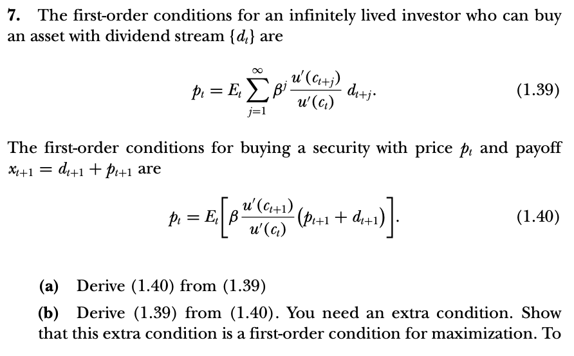

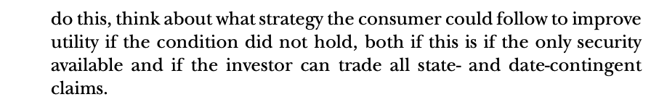

**Problem 2.**

