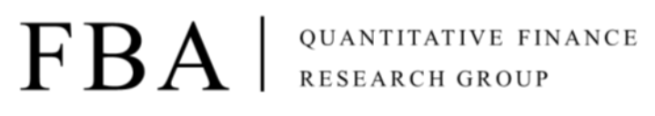

Asset Pricing

Homework 16

Due at 24:00 pm (KST) on Thursday

Submit one file: written solutions with executable Python code in Jupyter Notebook(.ipynb)

**Subjects**

**[Session12. Robust Portfolio with Factors 1.]**

1. Advanced Data Analysis

**Chapter 16.**Factor Analysis

2. Advanced Portfolio Construction and Analysis with Python (Coursera)

Week2 Robust estimates for the covariance matrix

**Assignment 1.**

Summarize this week's study

**Assignment 2.**

Solve the following problems

**Problem 1.**

With the Coursera lecture: Advanced Portfolio Construction and Analysis with Python, please replicate the code in the Module 2 Lab Session - Covariance Estimation.

**Problem 2.**

Check that following equations in the book Advanced Data Analysis are compatible

Equation 16.11

$$Cov\left[X_{i}, X_{j}\right]=\sum_{k=1}^{q}{w_{ki}w_{kj}}$$

Equation 16.25

$$v=ψ+w^{T}w$$

**Problem 3. (Optional)**

We intend to find a robust optimal portfolio consisting of the top 10 companies in market capitalization within the S&P500 using the Markowitz mean-variance method such that

(a) First, download the monthly price data of the top 10 companies in the market capitalization within the S&P500 from the fast five years and calculate the sample covariance matrix.

$$w_{opt}={\left(λΣ\right)}^{-1}μ_{e}$$

(b) Derive the covariance matrix (factor covariance matrix) using the Fama-French 3 factor model.

Hint: How to download FF3 Factor

|  |
| --- |
| import pandas_datareader.data as pdd  FF3 = pdd.DataReader('F-F_Research_Data_Factors', 'famafrench') |

(c) Using the paper’s method, “Honey I shrunk the sample covariance matrix” construct an improved portfolio for the above 10 shares the robust covariance matrix and then compare the performance (Sharpe ratio, Information ratio, Mean-return) of the portfolio obtained from the sample covariance matrix.

