

Asset Pricing

Homework 2

Due at 24:00 pm (Korea Standard Time) on Thursday, (Date)

Submit one file: written solutions with executable Python code in Jupyter Notebook(.ipynb)

**Subject**

**Chapter 5.** Risk, Return, and the Historical Record

**Chapter 6.** Capital Allocation to Risky Assets

**Assignment 1.**

Summarize this week study

**Assignment 2.**

Make a problem about the above subject

**Assignment 3.**

Solve the following problems

**Problem 1.**

**Problem 2.**

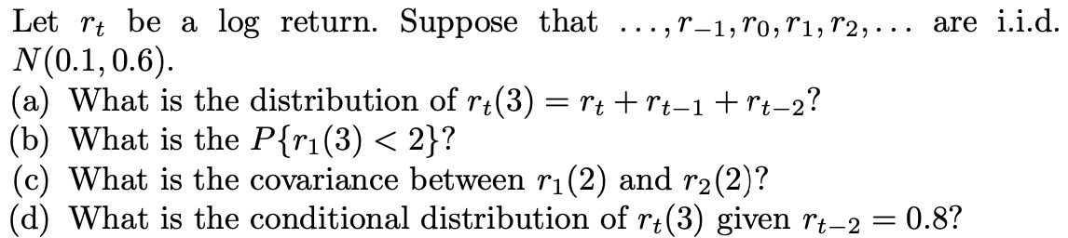

**Problem 3.**

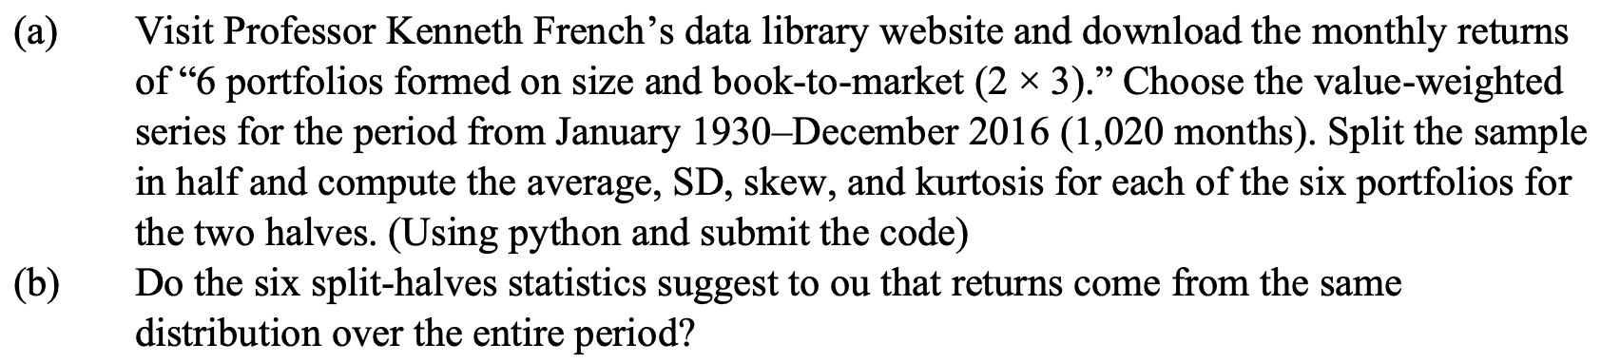

**Problem 4.**

