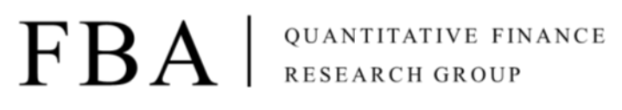

Asset Pricing

Homework 3

Due at 24:00 pm (KST) on Thursday

Submit one file: written solutions with executable Python code in Jupyter Notebook(.ipynb)

**Subject**

**1. Investments**

**Chapter 7. Optimal Risky Portfolios**

**Chapter 8. Index Models**

**2. Coursera**

**Week 1. Analyzing returns**

**Assignment 1.**

Summarize this week's study

**Assignment 2.**

Make a problem about the above subject

**Assignment 3.**

Solve the following problems

**Problem 1.**

With the Coursera lecture: Introduction to Portfolio Construction and Analysis with Python, please replicate the code in the lab session of Week 1, analyzing returns.

**Problem 2.**

**A pension fund manager analyzes the relationship between a specific asset and the market. First, he wants to show that the monthly returns of the biggest company are highly correlated with monthly market returns. (Let a risk-free rate be the interest rate of a Treasury bill with a 3-month maturity. You can download the data on FRED:** [**https://fred.stlouisfed.org/series/TB3MS**](https://fred.stlouisfed.org/series/TB3MS)**)**

1. **Download the monthly excess returns(monthly return – risk-free rate) of Apple Inc. and S&P 500 from Jan 01, 2013, to Jan 01, 2023, using the yfinance library in python. And then, draw the scatter plot with Apple's monthly returns as dependent variables (y-axis) and the S&P 500 monthly returns as independent variables(x-axis).**
2. **Calculate the simple linear regression coefficient (alpha, beta) using the above data**
$$r_{apple}-r_{f}=α+β\left(r_{snp500}-r_{f}\right)+ϵ$$

3. **Test hypothesis $H_{0}:β=0, H_{1}:β>0$ for gradient $β$ at a significance level of 5%.**

**Problem 3.**

**A Student majoring in finance wants to form an efficient frontier of a portfolio of the top five companies in market capitalization within the S&P 500.**

**a. Download the daily returns for the top five current market cap companies from Jan 1, 2018, to Jan 1, 2023.**

**b. Find the average annual return (average daily return * 252) and the annual covariance matrix (covariance matrix with daily return * 252)**

**c. Draw the following scatter plot of risk and returns using the Monte Carlo simulation. (trials: 20,000)**

**d. Find the point with the largest sharp ratio and draw the CAL. The risk-free rate is assumed to be 2%.**

**Hint:**

