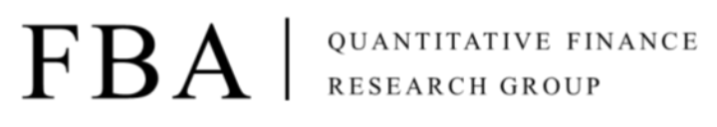

Asset Pricing

Homework 6

Due at 24:00 pm (KST) on Thursday

Submit one file: written solutions with executable Python code in Jupyter Notebook(.ipynb)

**Subjects**

**[Session5. Fama-French 3 Factor Model]**

1. Investments

**Chapter 10.** Arbitrage Pricing Theory and Multifactor Models of Risk and Return

2. Paper Review

**Paper** Fama-French 3 Factor Model 논문 해설과 한국시장 분석 전편, 후편

**Assignment 1.**

Summarize **the** **Chap 10 of the textbook, Investment**

**Assignment 2.**

Solve the following problems

**Problem 1. Buffet’s Alpha**

Source: BRK13F.csv (uploaded in Notion)

The analyst wants to evaluate the performance of Berkshire Hathaway from Jan/1999 to Dec/2013. Determine whether the fund has generated alpha (i.e., excess returns that cannot be explained by exposure to some factors) using returns of the market, the size factor (SMB), the value factor (HML), the quality factor (QMJ), the low volatility factor (BAB), and the momentum factor (UMD).

1) Analyze the performance of BRK and determine whether the fund has generated alpha with the Fama-French 3 Factor Model **(MKT, SMB, HML)**

2) Analyze the performance of BRK and determine whether the fund has generated alpha with the Carhart 4 Factor Model **(MKT, SMB, HML, UMD)**

3) Analyze the performance of BRK and determine whether the fund has generated alpha with the 6 Factor Model **(MKT, SMB, HML, QMJ, BAB, UMD)**

Hint:

When you try to solve (1)

1. Calculate the excess returns for the market, size, and value factors by subtracting the risk-free rate of return from their monthly returns.

2. Regress the BRK's excess returns against the excess returns of the market, size, and value factors using the Fama-French 3 Factor model:

3. Test the regression equation using various statistical methods.

, (,

4. Compare this model to other models using evaluation metrics such as AIC, BIC, and so on.