Flash Card – iPhone App

All your Flash Card decks should AUTOMATICALLY sync to your Scholar iPhone app. Below are screenshots from Aaron’s prototype, with desired tweaks below.
Who is Aaron? He’s the rock star developer who read our requirements and built us a prototype in his spare time. We Aaron.

1 2 3 4 5
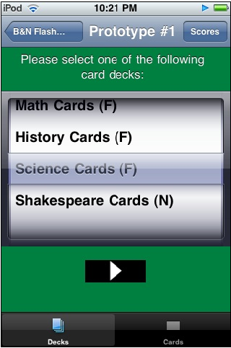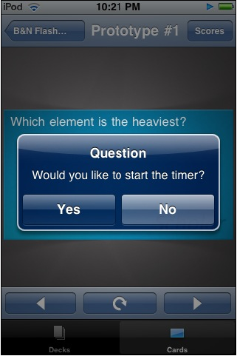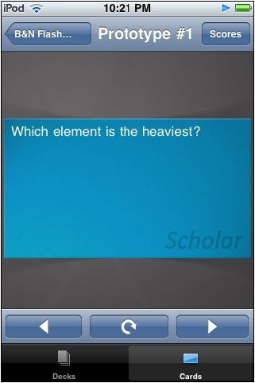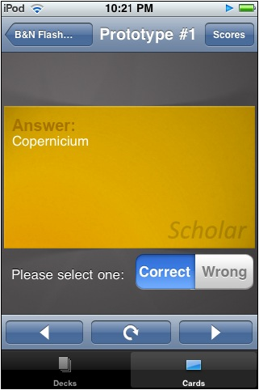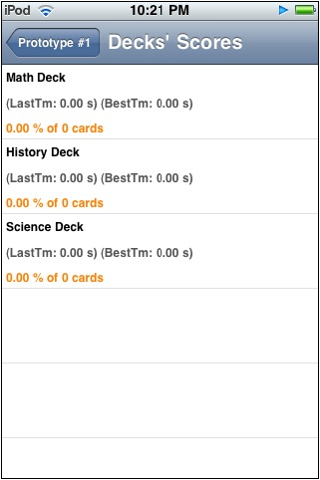
We should plan for a 2 tiered sorting system: Course, then Deck. (Same to song management on iPod)
Not sure we need the bottom two buttons if we have the same navigation on the top. Let’s see how the user testing goes.
We’ll have a couple of options here (see play modes in wireframes).

We’ll have a couple of options here (see play modes in wireframes).
We also want to modify the animation of the flip behavior vs. the next button. (make flip go top to bottom, next go side to side).
Also want ability to go full screen if user turns app sideways – where tap flips card over and swipe goes to next card.

Buttons currently default to ‘Correct’. Shouldn’t default to either – user must choose and then button highlights to confirm choice.

Mimic the History in the wireframes. Can either be for the current deck in use or a roll up across all decks.

