In my program, the evaluations functions were as follows:

* **custom_score_3**: this evaluation function evaluates the board based on the number of legal moves available for the computer player less moves available for the opponent.
* **custom_score_2**: this evaluation function is an enhanced version of the of the custom_score_3. #_my_moves - 2 * #_opponent_moves
* **custom_score**: This function evaluates based two factors: number of moves and distance from the center. The function evaluates the position more positively if the player’s distance is closer to the center of the board.

The result is shown below:

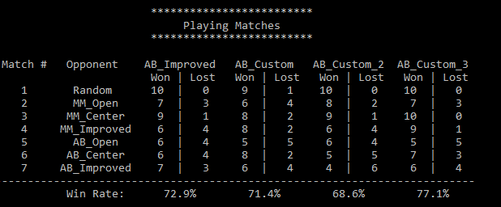

custom_score_3 The logic behind this function makes sense because the more moves available to a given player that should be positive.  This function performed the best among all other functions. custom_score_2’s logic is similar to custom_score3 but it gives more weight if a move creates less available moves eliminating. Overall this gave a good result but not the best. The reasoning may be that in trying to eliminate the opponent’s options, the agent may not be choosing the more optimal moves available. custom_score’s logic is that the closer to the center of the board, the more likely a player would have more options down the road.

Overall I had interesting and mixed results.  The computer player had overall good results but did not perform well against AB_Improved. For some games, a simple custom_3 function performed better than rest of the evaluation functions. Perhaps larger game plays may provide a better picture of the performance among the evaluation functions.

Based on the above data I would recommend the function custom_score3, which evaluates the position based on the difference between the number of agent’s moves and opponent’s moves. (1) It’s easy to understand and has an intuitive logic behind it; (2) it had the best performance compared with other functions winning against every opponent with one tie; (3) it is simple design in algorithm will allow better performance in timed games.