Oferhlýp

Overview
Oferhlýp is an abstract strategy game played between two players on a board made up of 35 hexes. On the surface, gameplay is similar to checkers (draughts.) However, players may move in any of six directions rather than just forwards diagonally. In addition, a player’s own pieces may be jumped to create a more dynamic game, and pieces must be jumped twice before they can be removed from the game.

Objective
Player try to eliminate their opponent’s pieces via jumping attacks while retaining their own pieces.

Components
- Game board
- 12 two-sided light pieces



- 12 two-sided dark pieces



Setup & starting the game
Tokens are placed on the game board using the following layout. All tokens start at full-strength status with the double bullseye side up.
Players choose which color (light or dark) to use with the dark color taking the first turn. Players then alternate taking turns.
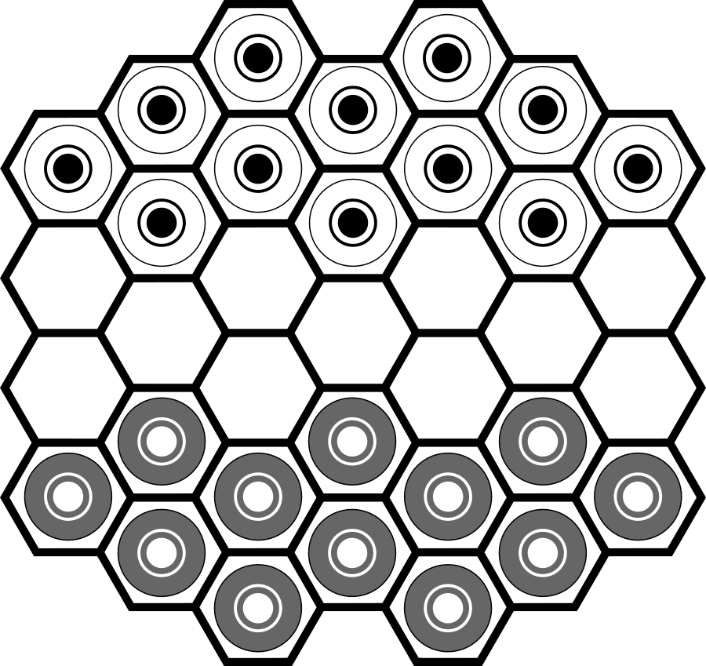

Playing the game
On a player’s turn, the player may move or attack with one piece.

Moving
Pieces may be moved one hex in any direction onto an open hex.
A piece belonging to the player may be jumped in a legal move called a friendly jump. Making more than one friendly jump per turn is not permitted.
A player may not follow a move or friendly jump by an attack. A player may not follow an attack and with a move or friendly jump.

Attacking
Players may attack an opponent’s piece by jumping directly over it to an open hex. Attacks are not compulsory.
Players may perform a chain attack by jumping more than one of their opponent’s pieces in a sequence (similar to checkers) following the normal attack rule.
After being attacked, pieces at full-strength status are flipped over to the open bullseye side to signify that they are now at half-strength.
After being attacked, pieces at half-strength status are removed from the board and are out of play.
Pieces may not be attacked more than once per turn. (You cannot simply jump over a piece then jump back over the same piece.)

Winning the game
Players continue to alternate turns until all of one player’s pieces have been removed or if a player only has one piece left.
Perpetual repetition is illegal. If a board position is repeated three times, the player in control of the situation must find another move.

Credits
Oferhlýp was created by John Beers. It was conceived in 2013 while working on another game. “Claim the Crown” incorporated the concept of tokens with two hitpoints but featured various types of Middle Ages themed units like spearmen and archers and replaced jump attacks with dice rolling combat. Oferhlýp is a purer abstract interpretation of that with a focus on strategy over luck.

Legal
Oferhlýp is available under a Creative Commons Attribution-ShareAlike 4.0 International license. (https://creativecommons.org/licenses/by-sa/4.0/)
You are free to:
- Share — copy and redistribute the material in any medium or format
- Adapt — remix, transform, and build upon the material for any purpose, even commercially.
The licensor cannot revoke these freedoms as long as you follow the license terms.
Under the following terms:
- Attribution — You must give appropriate credit, provide a link to the license, and indicate if changes were made. You may do so in any reasonable manner, but not in any way that suggests the licensor endorses you or your use.
- ShareAlike — If you remix, transform, or build upon the material, you must distribute your contributions under the same license as the original.
No additional restrictions — You may not apply legal terms or technological measures that legally restrict others from doing anything the license permits.

Find out more
More information on Oferhlýp can be found at:
http://github.com/jaerrib/oferhlyp

