

Q4OS User Manual
Version 0.3.3
Table of Contents
Q4OS setup and using 5
Introduction 5
Testing 5
Live CD 5
In Virtualbox 5
Installation 5
Live media 5
Installating from the Live Desktop 5
Postinstall steps 6
Wireless network setup 7
Print and Scan 7
Hewlett-Packard printers and scanners 7
Other printers 7
Scanners 7
Power management 8
Hardware sensors 8
Touchpad device 8
Proprietary multimedia codecs 9
Proprietary video drivers 9
Users and groups 9
Adding a regular user 9
Android interconnection 10
Security updates, software management 10
Update manager 10
External software repositories 10
Alternative desktop environments 11
Adding more languages 11
Add languages 11
User setup 12
Example 12
Miscellaneous tips 13
Kickoff start menu 13
Single click icons 13
Desktop effects 13
Autologin 13
Timezone selection 13
Screen resolution 14
Q4OS Frequently asked questions 15
Introduction 15
Installation 15
How can I create bootable Q4OS installation USB disk? 15
Is there a way to dual boot Q4OS alongside Windows? 15
I have no sound after installation, what should I do? 15
System 16
There are broken packages dependencies in my system. How can I fix it? 16
Some letters being mis-typed. Some letters show up correctly, but a few ('L' shows up as '3', 'J' as '1') show up incorrectly. 16
Fonts and icons are too small on my hiDPI screen, can I make them larger ? 16
How can I display current CPU temperature in the system panel? 16
I am behind a proxy, package manager based aplications don't work. 16
I want to use a more recent Linux kernel. Is it possible? 17
Desktop 17
How to set up multiple virtual desktops in Q4OS? 17
I am not able to rename or edit some icons on my Desktop. 18
How can I edit Start menu? 18
Can I customize view and shortcuts on the right panel of the default Q4OS 'Bourbon' Start menu? 18
I want a Welcome Screen entry to be shown in the Start menu. 18
How can I autostart an application? 19
I have messed my desktop. How can I revert default colors, fonts, theme and other desktop settings? 19
How can I set single-click icons instead of double-click? 19
Tell me the easiest way to get a screenshot. 19
Is it possible to change icon theme? 19
I have defined keyboard shortcuts in the Control Panel, but they don't work. 20
I have noticed the 'Programs' entry have vanished from the main menu. I did notice before that it had moved to above the separator line and now it has gone completely. 20
Keyboard shortcut doesn't work to switch between non-latin keyboard layouts. 20
Applications 20
How can I set up 'Conky' transparency? 20
How can I make Q4OS look like Windows? 20
Available Q4OS Applications 29
Introduction 29
Q4OS software resources 29
How to install software from repositories 29
Synaptic package manager 29
Commandline way 29
Recent applications versions 29
Adding external repositories 30
Windows applications 30
Native Q4OS applications 30
Set up a Q4OS remote Desktop server 31
Introduction 31
Installing Application Server 31
Local Server installation 31
Installation on a VPS, or any other remote computer 31
Set up Application Server 32
Set static IP address 32
Remove Network Manager service 32
Disable GUI 33
Create users 33
Advanced settings 33
Client side 33
Hardware ThinClients 33
Software Clients 33
X2Go Client for Q4OS 33
X2Go Client for Windows, OS X, Linux 34
Client for tablets and phones 34
A clean install of Q4OS Desktop on an ARM device 35
Introduction 35
Armbian installation 35
Q4OS setup 35
After install steps 35
Easy way to create custom application installer 36
Introduction 36
Create a simple application 36
Build installer 36
Step-by-step to create new Q4OS C++ Application 37
Introduction 37
Run development IDE 37
Create new C++, Q4OS project 37
Add your own dialog to the project 37
Design new dialogs, write C++ code 38
Let create application installer 38
Q4OS Application install how to, general recommendations 39
Introduction 39
Basic installation rules in short 39
Installer 40
Standard setup using Apt 40
Simple setup mode 41
User setup mode 41
Directory tree 41
Desktop icons 41
Menu entries 42
Configuration files 42
Registration 42
Internet repository 42
Update mechanism 43
Porting existing applications 43
Windows applications 43
How to remaster Q4OS Live CD 43
Appendix A: Q4OS (Scorpion) Full Installation Guide 45
How to create a Live-CD-ROM using Windows 45
How to create a Live-USB using Windows 55
Install Q4OS from the live desktop 63
Acknowledgements 81
Licensing 81

Q4OS setup and using
User Manual

Introduction
This section covers how to set up, configure and use Q4OS operating system. Q4OS is recommended to be used on production machines, as it has been built on top of the rock stable, secured and reliable Debian system tested by many people around the world. There is a huge stable software base sitting in the default repositories. You are free to use it and adjust the system to suit your needs.

Testing

Live CD
If you want to get a quick Q4OS experience or test it within a real hardware, you can safely boot a Q4OS live CD or USB. It will write nothing into your hard drive and will not affect your existing installation. It's possible to install Q4OS system directly from live media using the live installer.

In Virtualbox
We recommend to install Q4OS inside Virtualbox for testing purposes. Enter operating system: Linux, version: Debian (32/64-bit), when you create new virtual machine.
It's appropriate to setup "Virtualbox guest additions" within the guest system to achieve the best performance, there is a convenient auto-installer in the Q4OS 'Software centre' available. Installer contains optimized drivers and is preferred to install from original Oracle's or other sources.

Installation
In order to make a fresh Q4OS installation, you have to acquire installation or live media first. Download the ISO image from Q4OS web site and create bootable medium. You can burn the ISO image onto a CD/DVD or make bootable USB. The other way is to order prepared media in Q4OS e-shop.

Live media
If you are coming from using Windows and are unfamilar with the process of creating live media, Appendix A contains guides with comprehensive screenshots for both live CD and live USB media.

Installating from the Live Desktop
There are two basic options after booting from installation media: classic and fast installation. Classic install will ask you to set up partitioning, so you have the option to keep current data, resize existing partitions, or repartition your hard drive to your wishes. You will be able to free some hard drive space during installation and have Q4OS installed alongside other operating systems. The list of installed systems will be autodetected and offered on every boot.
Fast install will recreate all partitioning on the disk drive automatically and format it with no question. It will erase all the hard drive data and install Q4OS onto the primary device. A predefined user account will be created, and the system will ask the user to set up a password immediately after the first login.
Note, the installation CD doesn't require any network connection. It will install the basic Q4OS system on computers even with no network card.
For a detailed guide on installing from the live desktop, see Appendix A.

Postinstall steps
When you boot your Q4OS installation, you are greeted by the Welcome Screen. It contains some useful options and configurations.
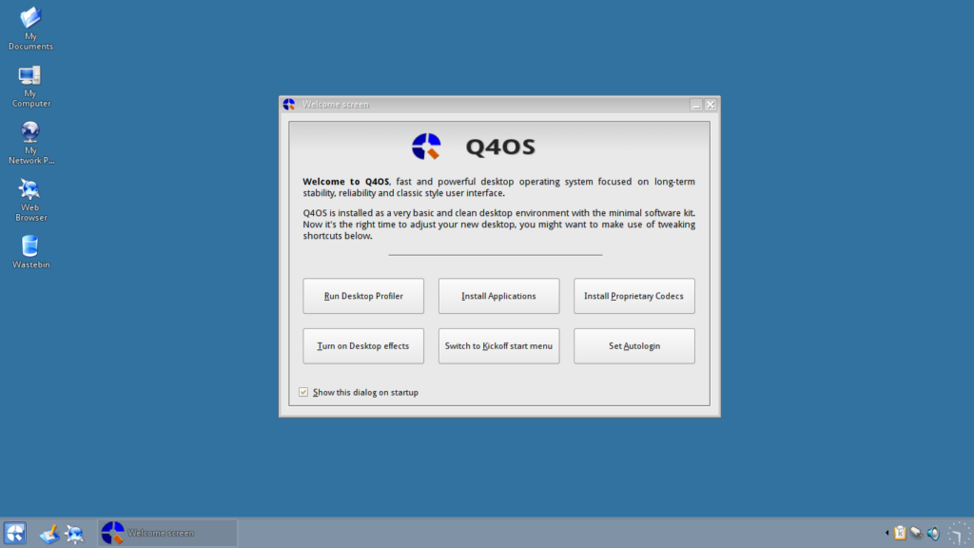
If you would like it NOT to show when you start your machine, just uncheck the box at the bottom left of the window and it will not show on your next boot. It will still be available through right clicking on the desktop, select run command, and type welcome-screen.exu in the dialog box.
The first option, and the first postinstall step a user should do, is to run the 'Desktop profiler' tool and apply the most applicable desktop profile according to the user's intention. There are a few basic profiles available at this time, however additional different profiles will continue to be created. After applying a profile, the user is free to install required applications. The best and recommended way is to use the 'Software Centre' from the system menu.
The second option, 'Install Applications', will run the Q4OS Software Centre to install other pre-packaged applications (like Google Chrome, Chromium, Firefox, LibreOffice, VLC Media Player, Skype, Wine, X2Go Server/Client, and more)
The third option will install Proprietary Codecs. These will allow the best experience of most modern codecs available.
The fourth option will turn on desktop effects. This will give you more “bells and whistles.” Just remember that everything you turn on uses resources, and if you are using a lower spec machine it may slow up a little.
The fifth option allows you to switch the start menu style to either KickOff, Bourbon, or Classic type, and also allows you to have the menu sorted by Categories or the standard Q4OS menu structure.
The sixth and final option allows you to set auto-login, this will toggle on / off the autologin feature for the current user.
Q4OS has many more configuration options and if you want to do something I haven’t yet made a guide for you could look in the Q4OS Forum, and if you still can’t find what you are looking for ask a question there, I’m sure somebody will soon answer your query.

Wireless network setup
Q4OS fully supports wireless networking, includes fitted 'knetworkmanager' tool to manage wireless connections. If you are looking for more comfortable WiFi manager, we advise you to install external 'Network Manager' from Software Centre.

Print and Scan

Hewlett-Packard printers and scanners
Install HP Linux printing and imaging system, fix dependencies and setup a printer in terminal:
$ sudo apt install hplip hplip-gui avahi-utils cups
$ sudo apt install libcupsimage2-dev libdbus-1-dev libssl-dev libusb-1.0.0-dev python-dev
$ sudo hp-setup
Some HP printers require a downloadable driver plug-in. The 'hp-setup' command will download and install the plug-in automatically.

Other printers
First list drivers and choose the proper one for your model:
$ apt-cache search printer-driver
Install a specific set of drivers, for example Samsung laser printers:
$ sudo apt install printer-driver-splix cups
or you can install all of available printer drivers:
$ sudo apt install foomatic-db printer-driver-all cups
Next add and configure printers, open Start menu -> Applications -> Settings -> Print system. You can find a valuable additional information at the Debian wiki.

Scanners
We recommend to use 'Kooka' application for scanning. Install required software and add any users who need access to the 'scanner' group:
$ sudo apt install libsane sane sane-utils xsane kooka-trinity
$ sudo adduser your_user_name scanner
A user will need to log out and log back in to take effect of the new group. Check the scanner is now recognized:
$ scanimage -L
$ sane-find-scanner
If you want to configure a network scanning, see Sane over network.

Power management
It is desirable to install power control application for laptops and mobile devices:
$ sudo apt update
$ sudo apt install rfkill tdepowersave-trinity
Log in again and a nice power control application will be present in system tray. You will be able to control CPU frequency, view battery status, configure sleep and hibernate actions for different events like lid close, power button push and more.

Hardware sensors
Most computers come with various sensors, which can be used to watch your hardware and prevent it from unexpected fault. This is where 'ksensors' application comes in. It allows you to access information from temperature, voltage, and fan speed sensors. So, let's install it:
$ sudo apt install ksensors-trinity
You will find 'ksensors' monitoring application in the Start menu or in the system tray. It provides a convenient graphical interface to view various sensors information from system panel or 'ksensors' main window, and to set alarms, thresholds and actions on limits exceeding. You can add sensors to view with right mouse click on a free space of the 'ksensors' main window.
Q4OS should recognize available sensors automatically out of the box, so you will not need to process further steps. If not so, you have to detect needed kernel modules using 'sensors-detect' terminal command:
$ sudo sensors-detect
You will be asked at the end of scan process if you want what it finds to be added to '/etc/modules' file, so that it will be loaded with the other kernel modules. Answer 'yes' for doing that and then reboot.

Touchpad device
Q4OS uses 'libinput' driver to control touchpad and related pointing devices by default. Check for the complete list of 'libinput' configuration options using terminal command:
$ man libinput
All the options could be applied in the '/etc/X11/xorg.conf.d/60-libinput.conf' file. You can also make an older 'synaptics' driver take precedence over 'libinput' by installing 'xserver-xorg-input-synaptics' package:
$ sudo apt install xserver-xorg-input-synaptics
Use default 'synclient' command-line tool to configure Synaptics touchpads. Run the command to see current touchpad settings:
$ synclient
If you will see no settings printout, but 'driver not loaded' message, your hardware is probably not supported. In this case, you cannot use 'synclient' tool.
The next command will tell you all the options that are available for the synaptics driver:
$ man synaptics
If you want, for example, to disable touchpad's 'tap to click' simply run:
$ synclient TapButton1=0 TapButton2=0
For more detailed info please read Debian documentation.

Proprietary multimedia codecs
Many codecs are already available in default repositories. These include codecs for MP3, H264, and AAC encoding and decoding. If you want to install extra collection of professional quality codecs, you can run the easy to use installer from Q4OS Software Centre. Media players such as VLC and Mplayer make use of these codecs in order to provide support for playback of files encoded through these many different codecs.

Proprietary video drivers
Install proprietary drivers to improve video performance and get full 3D acceleration, see graphics card Debian wiki page for detailed instructions. If you have a NVIDIA graphics card, you can run the installer from Q4OS Software Centre. It will probe the hardware for related available drivers and install them in a user friendly way.

Users and groups

Adding a regular user
Open "Users and groups" window:
Control Panel -> System Administration -> Users and groups
Click "Add" button, specify new username and fill user details. Assign users to specific system groups to specify user rights. For example, to enable playing a music add user to "audio" group; to install printers to "lpadmin"; or to provide administrator permissions, add user to "sudo" group. It is recommended to assign "cdrom, audio, video, plugdev, netdev, powerdev" groups for newly created users.

Android interconnection
Use 'gmtp' application, a fast and well arranged graphical file manager, that connects most of phones and other Android devices to PC via usb cable. It offers fast file transfer between a computer and Android device. Install it in terminal:
$ sudo apt install gmtp
Attach your device via USB cable, set it as MTP device and run 'gmtp' file manager. You will be able to browse internal directory structure and copy, delete and manage files from your Android device.

Security updates, software management
Q4OS uses the "Apt" package management system and related tools to maintain system health and clean, there is an automatic unattended upgrades mechanism to get security and software updates quietly. Apt keeps your computer up to date and safe.
If you need to update your system immediately manually, issue commands in terminal:
$ sudo apt update
$ sudo apt dist-upgrade
If you want to know how to install additional software, please see Available Q4OS Applications in this user manual.

Update manager
The Update Manager notifies users about available security and software updates and allows them to upgrade the system on request. You can easily install Update Manager from the Q4OS Software Centre.

External software repositories
This section is intended specifically for power users familiar with the Debian package management system. The default Q4OS configuration offers the basic and dependable set of software repositories. If you want to add more external repositories, you are free to follow standard Debian procedures. In addition, Q4OS offers one more easy way to add a set of predefined repositories. See the example below.
Suppose we want to install the Opera web browser from external repository.
List available predefined repositories:
$ sudo qrepoadd --gui
Select 'opera' repository from drop-down combobox and click 'Ok' button to add it to the system. Alternatively you can add the repository directly, using terminal command:
$ sudo qrepoadd opera
Install packages:
$ sudo apt update
$ sudo apt install opera-stable
If you decide to uninstall Opera web browser and disable repository again, run in terminal:
$ sudo apt autoremove opera
$ sudo qreporm opera
$ sudo apt update
Keep in mind, adding external third-party repositories is a low level system action, and it could deeply influence package database integrity and dependencies. Fortunately the Apt package management system contains strong tools for administrators to fix broken dependencies, so you are always able to revert to the initial clean state.

Alternative desktop environments
Integrating other desktop environments into the Q4OS system is supported. These can be installed alongside the default Trinity desktop. For example: KDE Plasma, LXQt, XFCE, and others. You can add a desktop environment using the Desktop Profiler tool. This can be launched from the Welcome Screen popup window or by running the following in a terminal:
$ swprofiler.exu
Once launched, click the ">" button on the top right of the window. Click the checkbox acknowledging that you want to install an additional desktop environment. Choose the desired desktop from the dropdown list, then click ok to install. Log out of your current session, and you will be able to select your newly installed desktop environment. Click the 'Menu' button on the TDM login screen to select the desired session type (desktop environment.)

Adding more languages
It's possible to add multiple languages into Q4OS and set different national environments for different users. The administrator installs separate localization packages, and users will be able to switch between different languages. Follow the next sections to prepare the system, install localization packages for applications and finaly set an user national environment.

Add languages
In order to prepare additional languages for regular users, the administrator should run new the language wizard from terminal. Repeat the command to get multiple languages:
$ addlanguage
If you have installed some applications having separate localization packages, install those as well. Follow Libre Office example:
$ apt-cache search libreoffice-l10n
$ sudo apt install libreoffice-l10n-xx
Users will be able to individually set installed languages in their user profiles now. (See the next section.)
Optionally, you can change a global system locale and timezone:
$ sudo dpkg-reconfigure locales
$ sudo dpkg-reconfigure tzdata

User setup
Pickup and set a locale using UTF8 locales:
$ chqloc --list
$ chqloc --setlocale xx_XX.utf8
Select a new user language. Open "Country/Region & Language" dialog from Control panel:
Control Panel -> Regional & Accessibility -> Country/Region & Language
Choose your country by clicking the country button. It will set up the user's language as well as various national conventions, for example date and time format, currency, etc.
Select a keyboard layout:
Control Panel -> Regional & Accessibility -> Keyboard Layout
Log in again, and you will see your profile translated into the chosen language. All installed applications will follow your locale settings too.

Example
Suppose a fresh installation of Q4OS with Libre Office suite installed. We would like to set-up German language. Open terminal, and run the new language wizard to select German language:
$ addlanguage
Libre Office lang pack:
$ apt-cache search libreoffice-l10n
$ sudo apt install libreoffice-l10n-de
Set user's German locale :
$ chqloc --list
$ chqloc --setlocale de_DE.utf8
Open "Country/Region & Language" dialog:
Control Panel -> Regional & Accessibility -> Country/Region & Language
Click first button with country flag and choose "Europe, Central -> Germany".
Select German keyboard layout:
Control Panel -> Regional & Accessibility -> Keyboard Layout
Log in again, and you will see your profile translated into the chosen language. All installed applications will follow your locale settings too.

Miscellaneous tips

Kickoff start menu
The Kickoff menu is a well-arranged, modern style start menu which offers search bar, favorites tab, history and more. If you want to switch to the Kickoff menu, right mouse click on system panel a context menu will pop up, then navigate:
Configure Panel -> Menus -> Start menu style -> Kickoff
You can restore default start menu the same way.

Single click icons
Icon activation by mouse doubleclicking is default in Q4OS. It's easy to set single click activation, hover effect and more in control panel:
Control Panel -> Peripherals -> Mouse -> General tab -> Single click to open files and folders

Desktop effects
You can turn desktop smoothing and beautifying effects on. (Note: desktop effects will work flawlessly on modern hardware only; it's not recommended to use it with legacy hardware.) Desktop effects can be turned on directly from the Welcome Screen popup. You can also enable desktop effects in the terminal:
$ ctrl-compmgr --enable
Disable desktop effects::
$ ctrl-compmgr --disable

Autologin
It is possible to bypass the login screen and log in as a specified user automatically after system boot. There is a simple commandline tool to set or unset autologin into the Q4OS desktop. Run the following in a terminal to see all possible options of the command:
$ sudo ctrl-autologin --help
Enable autologin:
$ sudo ctrl-autologin --enable username

Timezone selection
Run command in terminal to select system timezone:
$ sudo dpkg-reconfigure tzdata

Screen resolution
A fresh Q4OS installation should detect screen resolution automatically and possibly adapt the system scaling, however you can force system to use user defined DPI, dots per inch, using a terminal command, see an example to set 144 DPI:
$ sudo sh /usr/share/apps/q4os_system/bin/dpi_set.sh 144
Reboot and check the scaling. Increasing the DPI value will make fonts and icons bigger, a correct value for modern displays is ranging from 120 to 200 DPI depending on the screen type.

Q4OS Frequently asked questions
User Manual

Introduction
Notify us about any errors you find; suggestions are also appreciated. When possible, send us what you think would be a clearer solution. You can safely stick to the Trinity desktop environment FAQ.

Installation

How can I create bootable Q4OS installation USB disk?
The easiest way in Linux is to plug your usb in, do not mount it, and run in terminal:
$ sudo cp bootable.iso /dev/sdx
'sdx' is the target usb drive, for example 'sdb'
'bootable.iso' is bootable Q4OS installation CD image, you can download it from Q4OS website.
Alternatively, you can use multiplatform 'UNetbootin' or 'Rufus' software to create bootable USB disks, see how to create a live media external website.

Is there a way to dual boot Q4OS alongside Windows?
Sure. The preferred way is to proceed with installation from a 'Live' CD/USB as it gives you a bootloader install option. If you allow the installer to install the Grub bootloader, it will autodetect all available operating systems, including Windows, and offer them on every boot. If you want to keep Windows bootloader, do not forget to uncheck related checkbox during installation.
We strongly recommend backing up all your data before, please read installation instructions.

I have no sound after installation, what should I do?
We recommend you to install the PulseAudio sound server first:
$ sudo apt install pulseaudio pavucontrol-qt
Reboot your computer. Right-click to 'mixer' icon in system tray -> 'Select Master Channel...' -> set 'Current Mixer' to 'PulseAudio' in the top right listbox -> click 'Ok' to close the dialog. Run 'Volume Control' application from the Start menu and configure output mixer settings on the 'Output Devices' tab, check if output channels are not muted. The audio system should work now. If not so, continue following the steps below.
Left-click to 'mixer' icon in the system tray, and click to 'Mixer' button to check and update audio mixer levels. Make sure there is the 'PulseAudio' sound card selected in the top right corner of the 'kmix' mixer window. Then run command in terminal and check debug output:
$ artsplay /opt/trinity/share/sounds/KDE_Startup.wav
If there is still no sound, terminate temporarily Trinity sound server and try to play audio with independent alsa player:
$ artsshell terminate
$ aplay /opt/trinity/share/sounds/KDE_Startup.wav
Again, check debug output. If your audio system still doesn't work, continue Troubleshooting sound problems at Trinity FAQ.

System

There are broken packages dependencies in my system. How can I fix it?
We have a handy tool to autofix broken dependencies in Q4OS, just run in terminal:
$ sudo sh /usr/share/apps/q4os_system/bin/qapt_fix.sh
$ sudo apt update
$ sudo apt dist-upgrade
Keep in mind, we strongly recommend to install software from reliable and Debian compatible sources only to prevent package system from being corrupted.

Some letters being mis-typed. Some letters show up correctly, but a few ('L' shows up as '3', 'J' as '1') show up incorrectly.
A common glitch, that occurs on Netbooks with a small keyboard. Keyboard is blocked by NumLock, you could try to switch NumLock off. Launch Control Panel:
Control Panel -> Peripherals -> Keyboard -> NumLock on KDE startup -> set Off
Login again and try the keyboard.

Fonts and icons are too small on my hiDPI screen, can I make them larger ?
Yes, Q4OS can scale the screen resolution, please read the screen resolution section.

How can I display current CPU temperature in the system panel?
Run 'ksensors' application from Start menu -> Programs -> Accessories -> System -> KSensors. If 'ksensors' is not installed yet, follow the hardware sensors chapter to install it. Click with the right mouse button to 'ksensors' icon in system tray -> Configure -> select related HW sensors group -> select desired sensor from the list -> Dock tab -> check 'Visible' checkbox. You can optionally set colors, alarms, thresholds, actions on limits exceeding and other options. Click 'Apply' button and close the dialog.

I am behind a proxy, package manager based aplications don't work.
You need to set system wide environment variables. Open the /etc/environment file with your favorite editor. Add the following lines, modifying appropriately, you must duplicate in both upper-case and lower-case because some programs only look for one or the other:
http_proxy="http://myproxy.server.com:8080/"
https_proxy="http://myproxy.server.com:8080/"
ftp_proxy="http://myproxy.server.com:8080/"
no_proxy="localhost,127.0.0.1,localaddress,.localdomain.com"
HTTP_PROXY="http://myproxy.server.com:8080/"
HTTPS_PROXY="http://myproxy.server.com:8080/"
FTP_PROXY="http://myproxy.server.com:8080/"
NO_PROXY="localhost,127.0.0.1,localaddress,.localdomain.com"
APT package management system will not obey the environment variables when used normally with sudo. So separately configure them; create a file called 95proxies in /etc/apt/apt.conf.d/, and include the following:
Acquire::http::proxy "http://myproxy.server.com:8080/";
Acquire::ftp::proxy "ftp://myproxy.server.com:8080/";
Acquire::https::proxy "https://myproxy.server.com:8080/";
Finally, reboot to make sure the changes take effect.

I want to use a more recent Linux kernel. Is it possible?
We recommend to use the reliable and deeply proven default Q4OS/Debian kernel. There isn't much reason for ordinary users to use a newer kernel. Keep in mind, the latest kernels are not as secure as the rock stable and exhaustively tested default Debian kernel. However, a newer kernel could bring improvements, newer device drivers, and support. If you prefer the latest linux kernel, run the auto-installation script in a terminal to easily install it from backports repository:
$ qinst-kernel-bpo
The old good default kernel will not be uninstalled so you can anytime choose and boot it from the grub boot menu if you will fall into any issues.

Desktop

How to set up multiple virtual desktops in Q4OS?
1) Launch the Control Panel and go to Desktop -> Multiple Desktops and select how many virtual desktops you wish to have. You can then set up a couple ways of switching desktops:
2a) Add a desktop switch applet to your taskbar by right-mouse clicking on the taskbar and select Add Applet to Panel. If the taskbar is locked, un-lock it first, then choose the Add Applet to Panel option.
2b) In the pop-up window that appears, select the Desktop Pager / Switcher app, then click the Add To Panel button.
3a) Configure a keyboard shortcut by launching the Control Panel and go to Regional & Accessibility -> Keyboard Shotcuts.
3b) Under the Global Shortcuts tab, scroll down the list of commands and find Switch To Next Desktop under the Desktop Switching heading.
3c) Click the button next to the Custom option and assign the keyboard combination you wish to use to switch your desktops.
3d) Click the OK button to save.

I am not able to rename or edit some icons on my Desktop.
There could be three logical types of icons present on your desktop. System and global icons owned by root and User icons created and owned by user. Users are not allowed to directly edit or rename system and global icons, however, they can remove them from the desktop if needed.
The given set of System icons, 'My Computer', 'My Documents', 'My Network Places', 'Trash', 'Web Browser' and 'Printers', is not directly editable by a user. However, users are allowed to remove them from their own desktop.
Global icons are usually created by application installers. They are owned by root and shared by all users. Users can hide the global icons from the desktop, but they are not allowed to edit or rename such icon.
User icons and shortcuts are created by a single user and users have full control over them. You can freely delete and rename them, as well as edit icon properties.
If you would want to edit a global or system icon, we recommend to remove it from the desktop and create matching user's icon using Drag&drop -> Copy from the Start menu. It will be owned by user and fully editable as usual, use Right mouse click -> Properties.

How can I edit Start menu?
Open the Start menu, click with the right mouse button on any item under the 'Programs' entry, select 'Edit menu', menueditor window appears. You will be able to create new custom submenus/folders structure and fill it with desired menu items. You can create new shortcuts using right mouse click, or drag&drop icons from the Start menu or Desktop into the menueditor window. Newly created items will appear in the Start menu after closing the menueditor window.
In addition, you can switch Start menu items to be organized by Categories or by Applications:
$ sh /usr/share/apps/q4os_system/bin/kmenu_struct.sh --help

Can I customize view and shortcuts on the right panel of the default Q4OS 'Bourbon' Start menu?
Yes, edit file '$HOME/.trinity/share/config/kickerrc' in your home directory. There are several configuration options beginning 'Bourbon' commented out by default. You need to uncomment 'BourbonSysViewCustomItems' line and specify '.desktop' links you wish to be displayed on the right menu panel, use comma ',' as a delimiter. It's also possible to hide default shortcuts with the 'BourbonShowSysViewFolders=false' and 'BourbonShowSysViewApps=false' options.

I want a Welcome Screen entry to be shown in the Start menu.
Run command to update Welcome screen shortcut in terminal:
$ sudo kwriteconfig --file '/usr/share/applications/q4os-welcome-screen.desktop' --group 'Desktop Entry' --key 'NoDisplay' 'false'
Alternatively, you can edit '/usr/share/applications/q4os-welcome-screen.desktop' file manually. Welcome screen icon will appear under Start menu -> Programs -> Accessories -> System folder.

How can I autostart an application?
You need to add an application shortcut, i.e. the '.desktop' file, into the '$HOME/.trinity/Autostart' or '$HOME/.q4data/Programs/Startup' autostart folder. It will be launched immediately after the user login. Just drag any of application shortcuts from the start menu or from desktop and drop it into the autostart folder. It's also possible to place a shell script or executable into the autostart folder as well.

I have messed my desktop. How can I revert default colors, fonts, theme and other desktop settings?
Simply run in terminal:
$ sh /usr/share/apps/q4os_system/bin/default_desktop_settings.sh

How can I set single-click icons instead of double-click?
Icon activation by mouse doubleclicking is default in Q4OS. It's easy to set single click activation, hover effect and more in Control Panel:
Control Panel -> Peripherals -> Mouse -> General tab -> Single click to open files and folders

Tell me the easiest way to get a screenshot.
You can do this without any other packages, simply press 'PrtScr' key and then right click on the desktop and select Paste clipboard contents, this will display a dialog where you can enter the filename and image type and the file will be saved to the desktop. You could also open konqueror to browse to preferred folder, again right click and select Paste clipboard contents and file will be saved to preferred location.
In addition, there is a lightweight and powerful application 'ksnapshot-trinity', it's capable to grab full screen, region, a window or window part only. You can install it from terminal this way:
$ sudo apt install ksnapshot-trinity

Is it possible to change icon theme?
Yes, you have to unlock the advanced Control Panel options in a terminal:
$ sudo kcmodules --unlock
Go to Control Panel -> Appearance & Themes -> Icons, and set up theme you prefer.

I have defined keyboard shortcuts in the Control Panel, but they don't work.
You only need to enable khotkeys service to be ran on session login. Go to Control Panel:
Regional & Accessibility -> Input Actions -> General Settings tab -> uncheck Disable KHotKeys checkbox

I have noticed the 'Programs' entry have vanished from the main menu. I did notice before that it had moved to above the separator line and now it has gone completely.
It happens rarely on some specifically configured systems. The workaround that should fix it is to re-switch from classic - kicker - classic menu. You could report it as a new bug in our Bug tracker, and add some description if you find any connections.

Keyboard shortcut doesn't work to switch between non-latin keyboard layouts.
Keyboard switching shortcut defaults to 'Alt+Space' or 'Ctrl+Alt+K'. It works flawlessly if you have installed latin keyboard layouts only. To be able to switch non-latin keyboard freely, you need to add 'latin layout' to each keyboard layout you use. Run Control Panel:
Regional & Accessibility -> Keyboard shortcuts -> select a non-latin keyboard layout ->
-> check 'Include latin layout' checkbox

Applications

How can I set up 'Conky' transparency?
You have to have Q4OS/Trinity desktop effects enabled, it can be set up via Welcome screen or Control panel. Edit the '/etc/conky/conky.conf' file and add lines:
own_window yes
own_window_hints undecorated,below,sticky,skip_taskbar,skip_pager
own_window_argb_visual
own_window_argb_value 0
Comment out line:
#own_window_type desktop

How can I make Q4OS look like Windows?
From https://dai-trying.com/tutorials/make-your-desktop-look-like-windows/
Many users want their desktop to look and feel more like the classic Windows interface. This can be achieved quite simply by installing an application called XPQ4, which, as the name suggests will give your Q4OS a more Windows look, although it is not limited to the XP look. You can also use a Windows 10 theme and others in between.
To start using these themes, you should first visit the XPQ4 website (https://xpq4.sourceforge.io/) and download the Q4OS installer. There are two options, and you should choose the one for you. The differences are minimal. However, one of them will include some copyrighted icons for use. This will mean you must accept a user license agreement in order to use them.
The current version (at time of writing) is 2.1. I am using the Full version for this guide and would recommend this for the best user experience.
Once you have the file downloaded you can use the file manager to navigate to where this has been downloaded (/home/user/Documents/ by default).
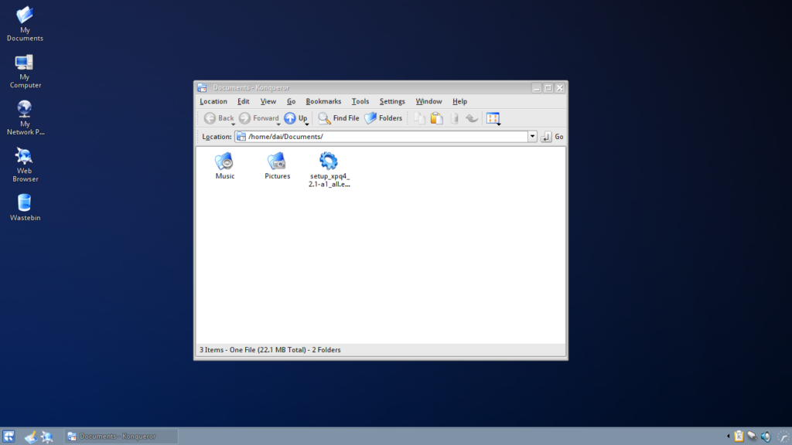
and simply double click the file setup_xpq4_2.1-a1_all.esh this will start the installation.
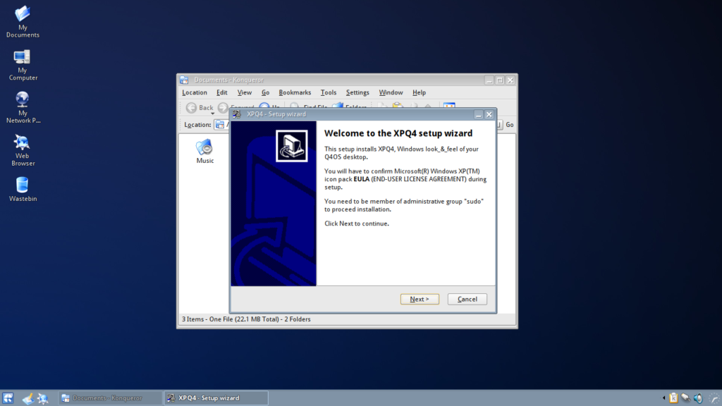
Click on Next to continue…
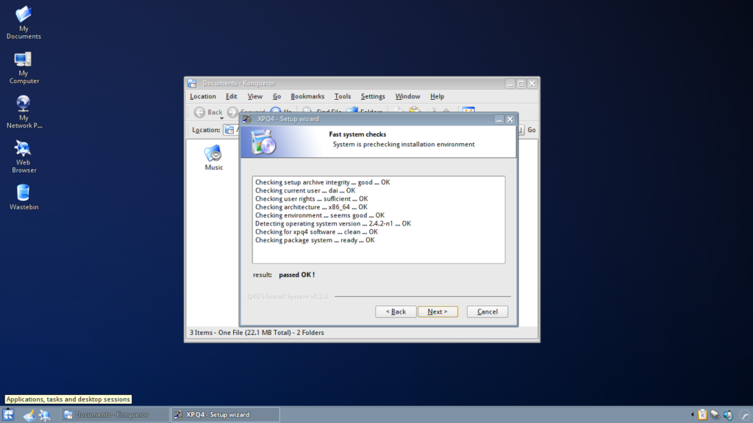
This checks that the system is Ok to install the package, click Next
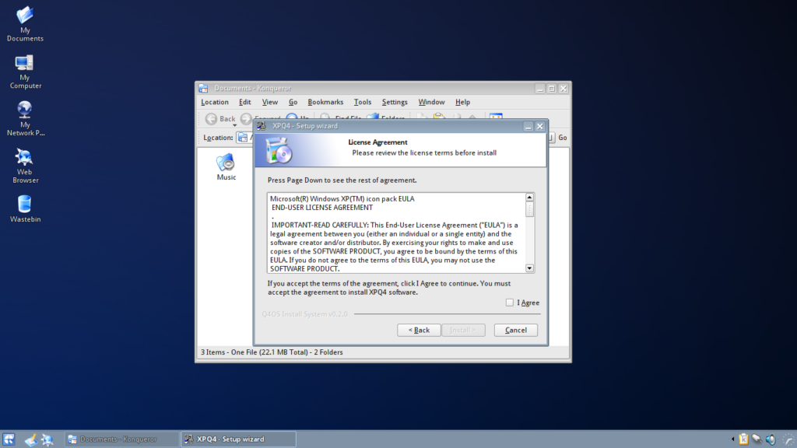
Here you will need to accept the License Agreement as mentioned earlier, check the box “I Agree”.
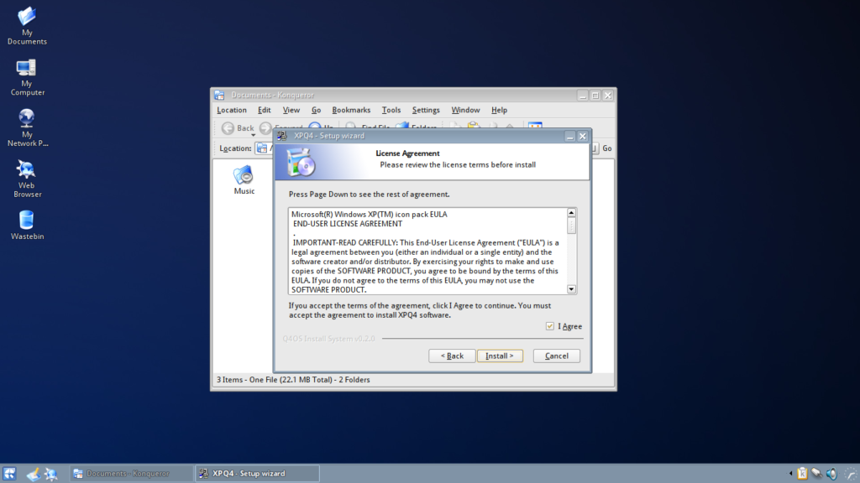
Now click “Install” to begin the installation.
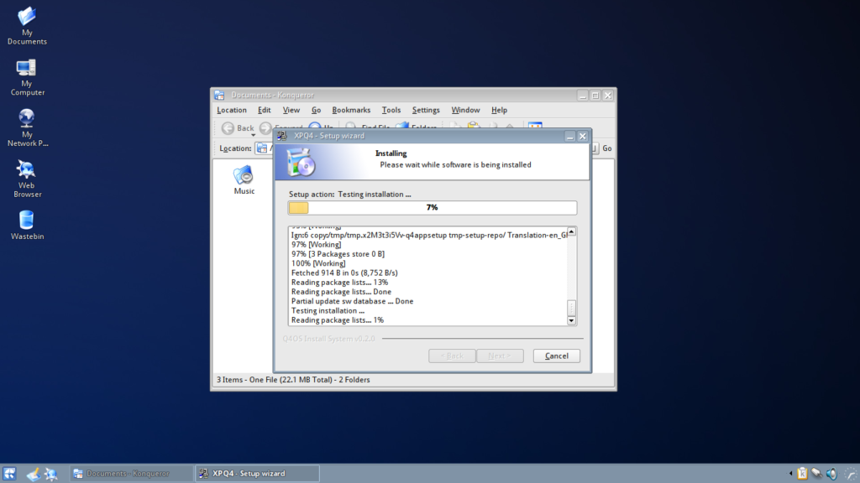
Installation take just a few minutes and it’s progress is reported in the progress bar.
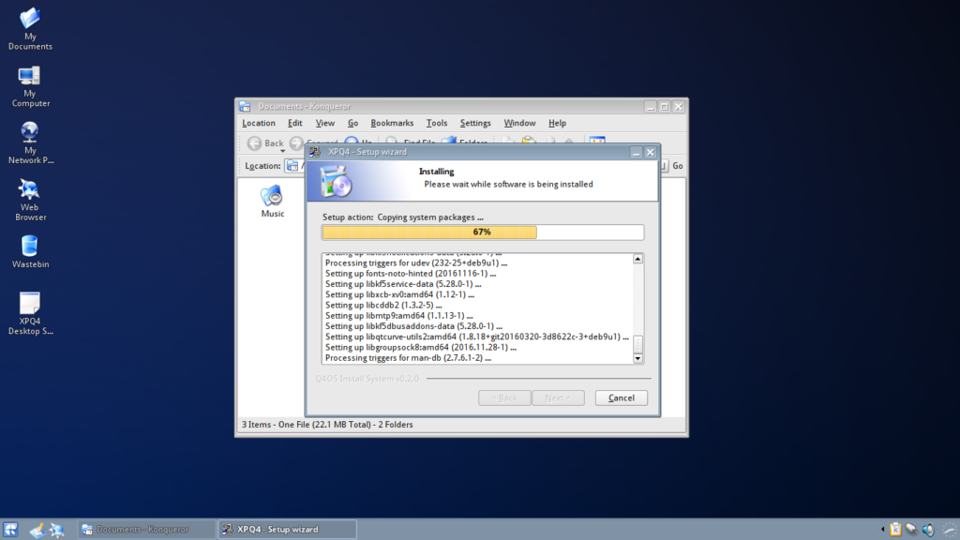
When the install process has completed it will tell you (above the progress bar).
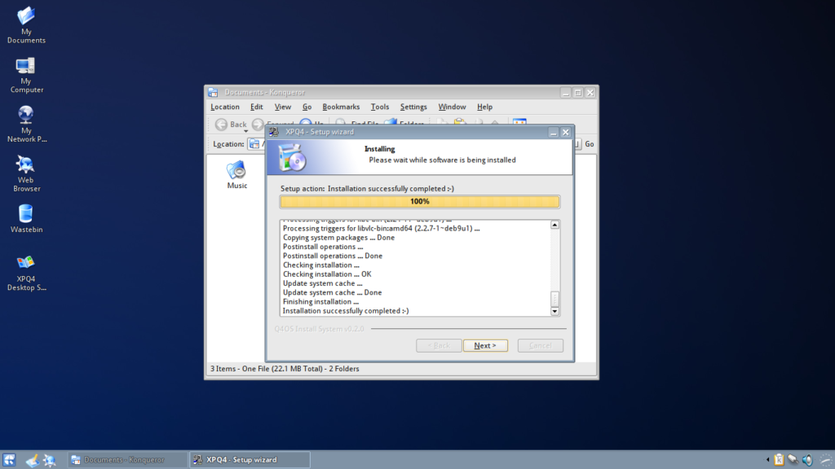
Click on Next to continue.
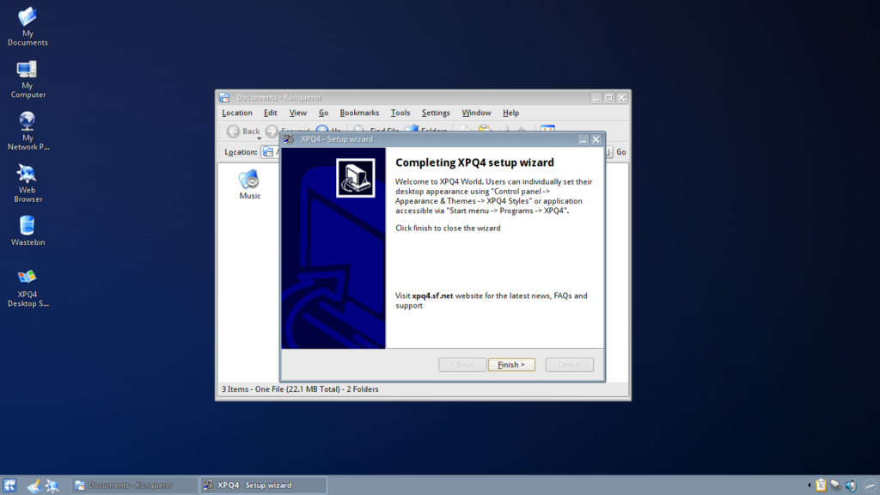
This dialog gives you some information about starting the application. You can also click on the desktop shortcut that has been created. Click on Next and the installer will close and XPQ4 will start.
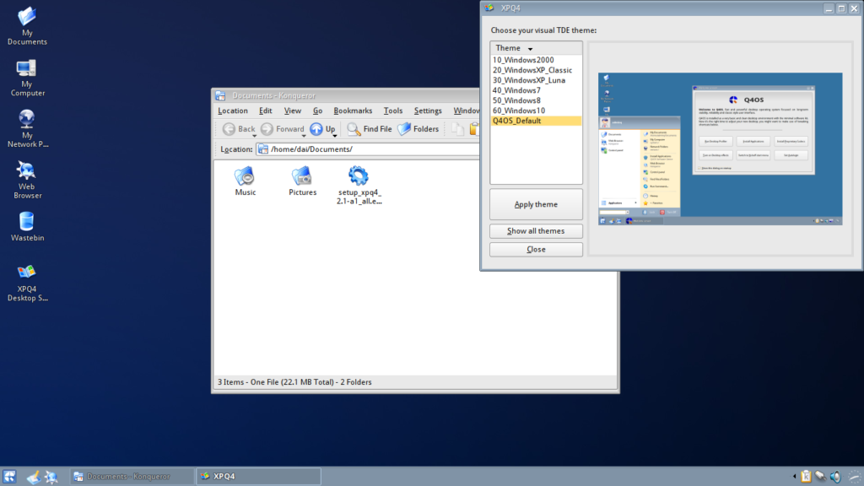
Here you can see a thumbnail of what the desktops look like to help you choose the best option for your display. You can select and try them all and each will replace the previous settings.
Here are screenshots of my desktop with each of the themes applied.
Windows 2000
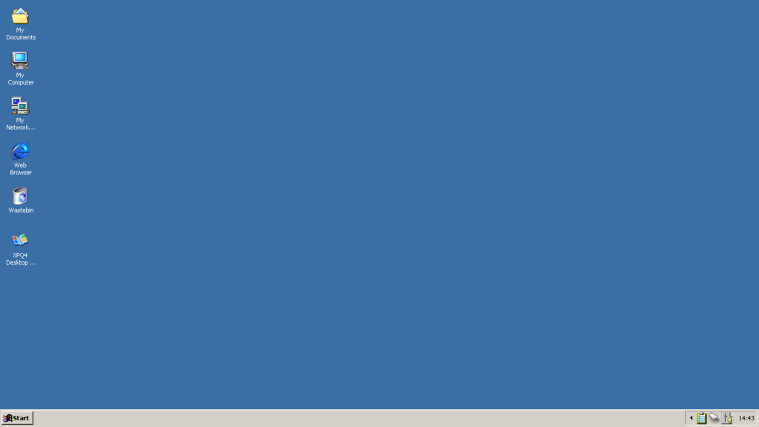
Windows Xp Classic
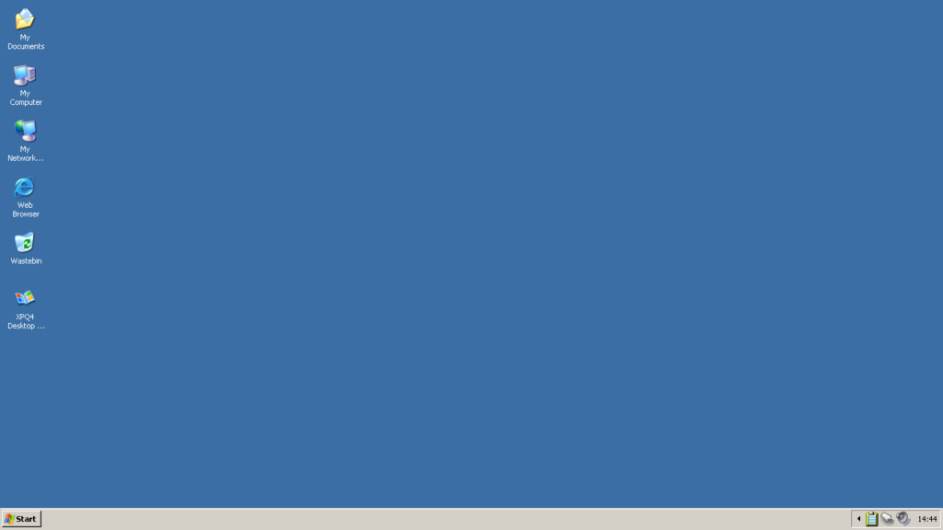
Windows Xp Luna
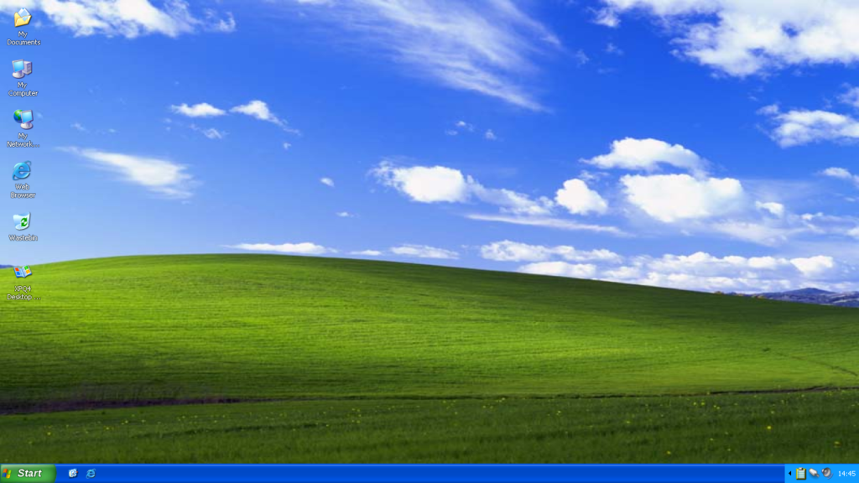
Windows 7
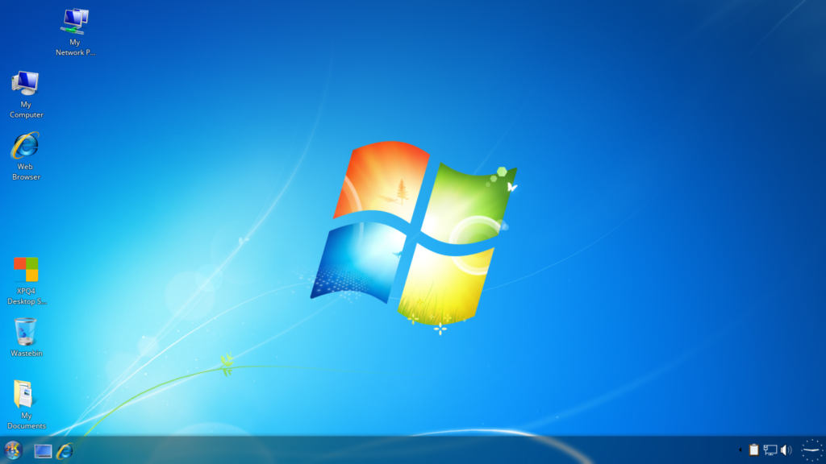
Windows 8
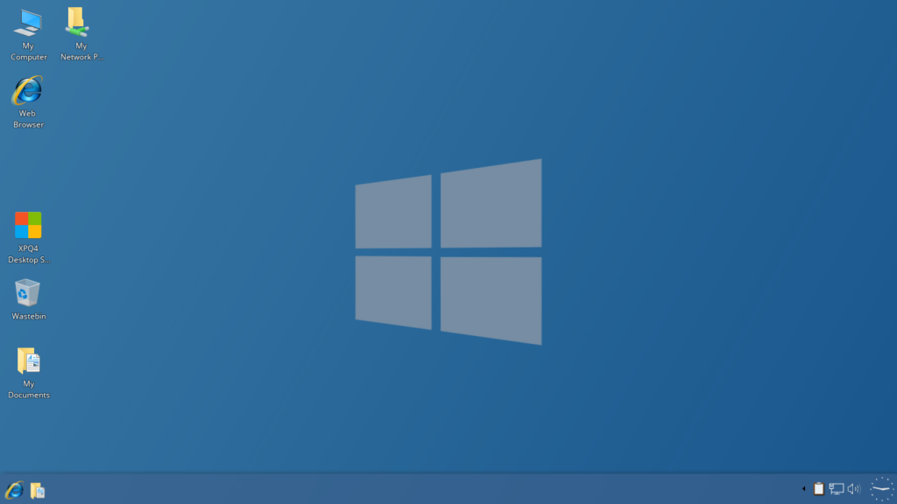
Windows 10
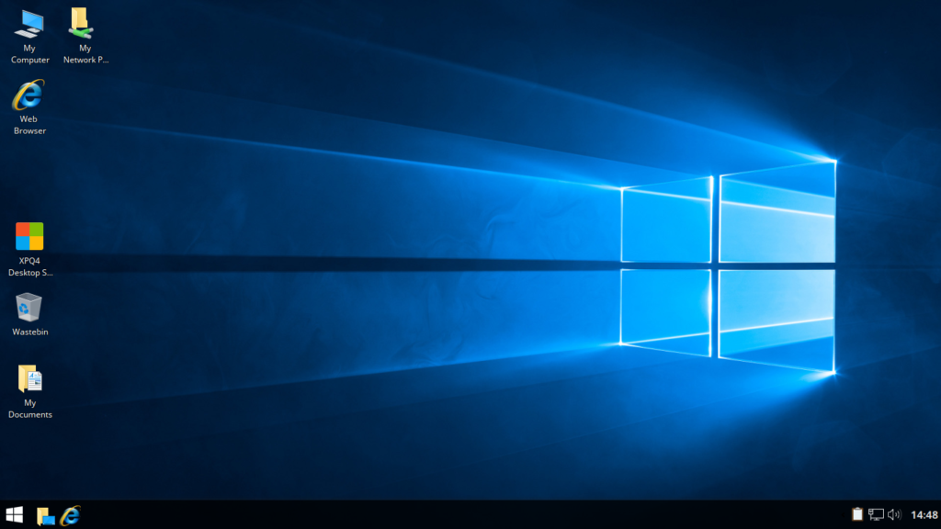
You are free to adjust the settings in the normal way and can change transparency, colours and icons if you prefer something different.
I hope you can find the desktop you prefer to use, and if you need some help with a specific setting you want to change visit the Q4OS forum where someone will try to help you.

Available Q4OS Applications

Introduction
This document is intended for Q4OS users, describes howto install available software. Q4OS is built ontop of rock stable, secured and reliable Debian system tested by lot of people around the World. There is huge stable software base sitting in default repositories, you are free to install from.

Q4OS software resources
The best and recommended way to easily setup several handy applications and system tools is to use native Q4OS 'Software Centre' available in the Start menu. An alternative method is to follow instructions from Software downloads section of the Q4OS website. Download and save installer, doubleclick it from Q4OS filemanager and follow setup instructions.

How to install software from repositories
It is possible to install thousands of verified applications, tools and libraries from Q4OS repostitories, see the next chapters.

Synaptic package manager
Using Synaptic package manager, you can search, install, uninstall and manage all software from repositories in well arranged graphical interface. You can install Synaptic from Q4OS Software Centre.

Commandline way
Software from repositories could be installed with 'Synaptic', convenient graphical package manager, see previous chapter, or manually using terminal commands, according to next instructions. You have to be member of administrative group 'sudo' for these operations, open terminal and type commands:
sudo apt update
sudo apt install desired_application
Software will be installed as a system wide accessories for all users, shortcuts are created under matching group in 'Start menu -> Programs -> Accessories -> [Program_group] -> [Desired_application]'. You can then manually link icon to Desktop or somewhere to Start menu.

Recent applications versions
There is a 'Debian Backports' repository with recent versions of many useful applications. For example, LibreOffice, VLC multimedia player, Virtualbox and more are available. Backports stay unused and passive until you directly ask to install specific software from. It is straightforward and clean action having no effect on system integrity.
If you would like to use recent version of some application instead of rock stable Debian version, you have to tell Q4OS to install the desired software from backports. See VLC multimedia player example:
$ sudo apt -t jessie-backports install vlc

Adding external repositories
Please follow External software repositories link.

Windows applications
Q4OS is ready to run Windows applications using Wine compatibility layer. Wine layer, a direct Windows API replacement, enables the ability to install and run Windows applications without loss of performance, so it is possible to make a free 'Windows box' from your computer. If you want to do so, install a specifically-tuned Wine package from Q4OS Software Centre.
Keep in mind that Wine API is under heavy development and not fully complete yet, so some Windows applications may work great, but others will have breaking issues. At the moment, we are working at Wine optimization and close integration into the Q4OS system.

Native Q4OS applications
Native, optimized Q4OS software is the absolute primary aim of the Q4OS system. It will be available if more developers start to develop applications for Q4OS to fulfil considerable Q4OS's potential. Such applications should be based on QT libraries as a native Q4OS API, thus can be really fast with very low hardware requirements, as well as integrated into the graphical user interface.

Set up a Q4OS remote Desktop server
Administrator Manual

Introduction
This paper describes how to build VDI, virtual desktop infrastructure, for business, small company, hospitals, schools, or another various ICT environments. Q4OS is designed to be optimal solution for cloud computing and virtualization due to its low hardware, low network bandwidth requirements. Q4OS Application Server uses NX protocol, which allows clients secure graphical access to a remote desktop over a low speed Internet connections as well as fast broadband LAN networks, communication is ssh tunneled, fully encrypted.
You can turn almost any PC into the Server or Client, see the chapters below. Application Server could be virtualized, if a host computer has force enough. Depending on the Server's hardware it is possible to operate up to hundreds of clients for one server. Minimum HW requirements for the Server meets minimum requirements for Q4OS system and applications being used.

Installing Application Server

Local Server installation
Launch X2Go Server installation from the Q4OS Software Centre and follow setup instructions. Computer is ready to act as a Q4OS Application Server using NX protocol immediately after installation.

Installation on a VPS, or any other remote computer
If you have no local access to the Server machine available, you can install Q4OS Desktop using ssh connection. This is mainly useful for public VPS (virtual private server) hosting services or headless virtualized servers. Since many of providers offer a Debian based VPS service, it's possible to use it as a fast, multi-user, remote desktop. The performance is excellent, very close to a local computer, the only thing needed is a Debian based remote machine with ssh enabled.
At first, login to your VPS, or another Debian based remote computer, over ssh and launch root shell:
$ ssh [remote-adminuser]@[remote-ip-address]
$ su
or alternatively login directly as root:
$ ssh root@[remote-ip-address]
If there is no ordinary user account on the remote machine, you will have to create it using 'adduser' command. Download and run Q4OS setup script, the setup process will take a while. After installation close ssh connection:
# wget q4os.org/downloads/q4os-setup.sh
# sh q4os-setup.sh
# exit
$ exit
Log in as the first ordinary user again:
$ ssh -l [remote-adminuser] -X -C [remote-ip-address]
You will see a few warnings and the ssh gui performance could be a bit weak; you can safely ignore it for now.
Run the Q4OS desktop profiler and apply the 'Pure' profile:
$ swprofiler.exu
Run the Q4OS Software Centre and perform X2Go Server installation from it:
$ swcentre.exu
Once the job finishes, you can move on to setup the Server now, see the next chapter.

Set up Application Server
It is possible to use the Server without additional configuration as it is ready to operate immediately after installation. You can optionally proceed some additional steps to adapt Server to your production environment, see below.

Set static IP address
We advice you to set a fixed IP address for this machine, to be able make permanent settings for all clients, there is '/etc/network/interfaces.d/.fixed-ip-eth0.example' file as a basic example. Simply edit the file to configure Server's IP address and rename it for example to 'fixed-ip-eth0'. You can perform the procedure in terminal:
$ cd /etc/network/interfaces.d
$ sudo nano .fixed-ip-eth0.example
$ sudo mv .fixed-ip-eth0.example fixed-ip-eth0
New IP configuration will be set after reboot.
Alternatively clients may refer Server by a network name, using DHCP and dynamic DNS is a feasible way.

Remove Network Manager service
'Network Manager' service takes care about dynamic events like manual cable plug or wireless networks managing. You could safely remove it, if the Server uses network interfaces with fixed IP configuration only. Type in terminal:
$ sudo systemctl disable NetworkManager.service
$ sudo systemctl stop NetworkManager.service
If you want to disable network manager applet icon from system tray:
$ sudo kwriteconfig --file "/etc/trinity/tdenetworkmanagerrc" --group "General" --key "Autostart" "false"
$ sudo chmod a+r /etc/trinity/tdenetworkmanagerrc

Disable GUI
You should disable Server's graphical user interface, if you don't need it. Type in terminal:
$ sudo systemctl mask tdm-trinity.service
$ sudo systemctl mask tdm.service
$ sudo reboot
After reboot you will have remote NX, ssh and local console login to the Server available.

Create users
Create user profiles the standard way using control panel or command line tool 'adduser'. For help, see 'man adduser'. Default users are allowed to establish remote NX desktop sessions. If you want to finetune user's session settings see 'Advanced settings' below.

Advanced settings
Load balancing, file sharing, printing and other extending functionality is available, if you want to fine tune, monitor or control Server operation see X2Go detailed documentation at x2go.org wiki. Please keep Debian commands all the way. Additional packages are directly installable as the repository is already included in the system. Use 'apt' command to manage packages, example to install broker agent package:
$ sudo apt install x2gobroker

Client side
Workstations can be provided by a hardware minimized thin-clients, low cost computers, desktop client software as well as tablets, phones. Desktop session is adjustable accepting connections from low speed modem bandwith up to LAN wideband networks.
You can securely access Application Server anywhere in Internet or local network, you only need to know Server's IP address and login credentials.

Hardware ThinClients
It is possible to access a Server using any ThinClient workstation equipped with NX/X2Go protocol. While we have no compatibility list, we don't guarantee proper functionality for any third-party model yet.

Software Clients
The most applicable software client is X2Go client, available for all major operating systems. It is sufficient to fill Server IP, username and password to reach a Q4OS Application Server in a network, although there are plenty of other options to adjust a connection in addition.

X2Go Client for Q4OS
You can use any Q4OS computer as a client, please find convenient installer of the standard X2Go client in Q4OS Software Centre. First run wizard will help you to enter the basic Client settings.

X2Go Client for Windows, OS X, Linux
Find X2Go Client downloads and installation instructions here. In order to establish a connection with Q4OS Server, you have to enter the needed basic configuration in 'Session preferences' dialog, the 'Session' tab:
Host: [ Server's IP address ]
Login: [ User name ]
Session type: 'Custom desktop'
Command: 'start-q4os-x2go'
The 'start-q4os-x2go' command is essential. You are free to adjust additional advanced Client settings, for example network bandwidth limits and more, see documentation here.

Client for tablets and phones
Android/IOS/Windows based clients are not available now, they are planned to be released.

A clean install of Q4OS Desktop on an ARM device
Administrator Manual

Introduction
Q4OS on ARM architecture is a free operating system based on Debian ARM port. It runs on wide variety of hardware equipped with ARM processors, including Chromebooks, tablets, single board computers, embedded devices and more. Q4OS is now one of the few distributions offering the full desktop environment on the ARM architecture. If you want to install Q4OS on Raspberry Pi boards, please follow Q4OS on Raspberry Pi specific setup guide.
Q4OS setup process consists of a couple different steps. First, you will have to install either Armbian or Debian operating system onto your device, see chapter 2. below. Then, you will download and run Q4OS installation script, see chapter 3., it will setup and fully configure fresh Q4OS desktop within your device.

Armbian installation
Perform, or start from existing, 64bit/arm64 or 32bit/armhf Armbian or Debian setup. Installation method depends on the specific target device, we recommend to follow official Armbian documentation and guides, you could start here. The fastest and recommended way is to perform the basic Armbian setup with SSH server, however you can select any Armbian packages to install including alternative desktops too. Once the Armbian installation has finished, launch Q4OS setup script, see the next chapter.

Q4OS setup
There is an interactive installation script available, it supports both Armbian as well as Debian operating systems. Simply download and run this script in terminal as 'root', see below, it will add Q4OS repositories and guide you throughout Q4OS setup process, please follow on-screen instructions.
Login into the previously installed Armbian system via SSH, console or desktop and get ready to execute a few terminal commands. Download and run Q4OS setup script as 'root' superuser:
$ wget q4os.org/downloads/q4os-setup.sh
$ su
# sh q4os-setup.sh
Reboot and login into the fresh and clean Q4OS Desktop.

After install steps
Now it's the right time to install desired applications, the best and recommended way is to use Q4OS Software Centre, please read Q4OS documentation. Enjoy your new desktop and don't forget to involve yourself in the Q4OS community.

Easy way to create custom application installer
Developer manual

Introduction
This document describes, how to create Q4OS self-extracting convenient installer for your own applications, files and directory structure. This procedure will create both '*.deb' file for manual installation with 'dpkg' command, and '*.esh' fully automated, convenient installer. The installer will flawlessly install and deliver an application or set of files to Q4OS users.
First of all, you have to install Q4OS Development Pack. Download development pack installer from Software downloads section of the Q4OS website and double-click downloaded file from file manager to launch setup. Follow installer instructions to install development pack.

Create a simple application
We will create some custom files and directory structure first, it will represent an application. Run commands in terminal to create working directory and application files, you can use cut and 'shift-insert' paste into the terminal:
$ mkdir -p $HOME/my-appdir
$ cd $HOME/my-appdir
$ echo 'kdialog --msgbox "Hello World"' > my-app.sh
$ echo -e 'install:\n\tcp my-app.sh /usr/bin/application.exu' > Makefile
$ chmod a+x my-app.sh
Newly created directory structure represents our application. Let's go to build the installer now.

Build installer
Copy the predefined configuration file for the installer. The configuration file is well documented and can be adjusted later to customize installer:
$ cd $HOME/my-appdir
$ cp /program_files/q4os-devpack/appsetup/q4os_setup.cfg.sample installer.cfg
Finally generate installer:
$ export SHOWDEBDIALOG=1
$ dash /program_files/q4os-devpack/bin/create_q4app_setup.sh installer.cfg
A comfortable Q4OS installer will be generated automatically, answer 'Yes' to 'Open installer location ?' question, when process finishes. You can now proceed testing installation of your application double-clicking 'setup_*.esh' file. Upload and publish this file somewhere on the Internet, Q4OS users will be happy for easy setup of your application.

Step-by-step to create new Q4OS C++ Application

Introduction
This document describes in an easy manner, how to create new, shiny, simple, C++ application, step-by-step. Preferred way to write Q4OS applications is to use QT libraries, your code will not be Q4OS specific, but broadly multiplatform. Please read the Q4OS Application install how to, general recommendations section.

Run development IDE
At first, you have to install Q4OS Development Pack and start development IDE.
- Download and save "Q4OS Development Pack" installer from Software downloads section of the Q4OS website.
- Navigate file manager to downloaded file "setup_q4os-devpack_*.esh" and doubleclick it to launch setup. Follow installer instructions to install development pack.
- Start main development IDE after installation - doubleclick "KDevelop Q4OS" icon on your desktop.

Create new C++, Q4OS project
- From top toolbar choose second button "Generate a new project from a template". New project wizard appears.
- Expand the tree, select "C++ > Q4OS > 1. New Project (Q4OS/TDE)" and fill field "Application name" as "Project1".
- Click "Next" for all wizard questions, new project will be created.
- Press "F8" key and confirm "Run qmake" to build this new project.

Add your own dialog to the project
This chapter describes procedure to create new dialog the best way, using subclassing wizard. This procedure is related to the new classes, forms and source code files.
- Click "TQMake Manager" toolbar on the right side, TQMake Manager panel will open.
- Click to "FORMS" with right mouse button and choose "Create new file..." from context menu.
- Set "ui_form2" to "File name" field and select "TQT Dialog (.ui)" from drop-down list. It's important to keep 'ui_' prefix for form names to avoid conflicts during building. Confirm "OK", new "ui_form2.ui" file will be opened in TQT Designer.
- Modify new form to suite your wishes, save the form and close designer.
- Right mouse button click to "ui_form2.ui" on TQMake Manager panel, choose "Subclassing Wizard..." from context menu.
- Fill new class name as "Form2", let file name "form2" and other boxes unmodified. Click "Create" to create source and header files of the form.
- Press "F8" to build the project again. Simple two-form Q4OS Application is now created.

Design new dialogs, write C++ code
Now its time to write C++ code and do some programming, you will use objects, classes, signals, slots, events, actions, etc.. QT programming is not part of this document..
- optional: Connect "form2" to some action, for example button click, write C++ code.

Let create application installer
You need to be member of "sudo" group to process installer creation, as the installer needs root permissions definitely. "Installer Builder" tool will create both "*.deb" file for manual installation with "dpkg" command and "setup_*.esh" fully automated, convenient installer. You can choose which one to use.
"Installer Builder" is a part of Q4OS Development Pack, if you are planning to build your own custom Application installer, feel free to copy and use it as a skeleton or self-explainable example.
- optional: If you want to modify installer settings edit configuration file "installer.cfg" in project directory, else let this file untouched with default values.
- Click main menu "Tools -> Installer Builder" to start creating setup file.
- Self extracting, user comfortable application installer will be generated automatically. Answer "Yes" to "Open installer location ?" question, when process will finish.
- You can now proceed test installation of your new, shiny, simple, C++, Q4OS application. Doubleclick "setup_*.esh" file to run it and keep instructions on the screen to install "Project1". Start menu entry and desktop icon of "Project1" is now created.
- Upload and publish this setup file somewhere on the Internet, Q4OS users will be happy for easy setup of your application.

Q4OS Application install how to, general recommendations

Introduction
This developer manual generally describes important rules for installing Unix-like application to Q4OS operating system, alongside clarifies essential install steps and also help you to understand Q4OS basics and design.
Q4OS is desktop operating system designed to offer compact and clean user interface, simple accessories and to serve stable foundation for running complex third-party applications. Since Q4OS is a Debian/Linux based OS, it uses "Apt" package management system and related tools to maintain system health and clean.
We advise you to use QT libraries API to program your applications. If Application requires some library or other software, which is not part of base Q4OS installation, the easiest way is pick it and install as a system shared from official Q4OS repository. Another way is to add library directly into your setup package, decreasing dependency on third-party software. It is possible to run Linux executables without restriction or modification. If you are looking for specific examples, please the Step-by-step to create new Q4OS Application section.

Basic installation rules in short
- Any Application file may not affect other system files or directory structure !
- Install Applications using "Apt" package management system. Two exceptions are enabled, see "simple setup mode" and "user setup mode" bellow.
- All Application files are located in "/program_files/appname" directory, some rare exceptions are specified in this document.
- System menu entries in "/usr/share/apps/q4os_system/q4os_menus_applications_merged/".
- System menu links in "/usr/share/applications/".
- System desktop icons in "/opt/trinity/share/apps/kdesktop/Desktop/".
- System configuration files in "/program_files/appname/" or "/etc/appname/".
- Registration via "/usr/share/apps/q4os_system/q4_regs/appname.qrg" file is necessary.
- User menu entries and links in "$HOME/.q4data/applnk/Programs/".
- User desktop icons in "$HOME/Desktop/".
- User configuration files in "$HOME/.appname/".
- Placing some files somewhere in user's "$HOME/" directories structure is possible.
- Using "/tmp/" for temporary operations is recommended.
- Placing file to other than specified location is allowed only in absolutely necessary cases, such files must be controlled via "Apt" packaging system.
- Q4OS allows you to install application bypassing "Apt" system using "simple setup mode", installer in this mode must absolutely strictly pass criteria quoted here.
- It is possible to install user specific application in "user setup mode", installer in this mode must pass criteria quoted here.

Installer
Install job should be automated by user comfortable installer to let user to answer questions, take some more installation steps like environment checks, pre/post-install actions, another optional steps and finally install the software. Packages can be packed together and joined to installer creating single self-extracting executable.

Standard setup using Apt
The preferred way to distribute your application is to create Apt "*.deb" packages (or single package) installable using "apt" or "dpkg" commands, which are part of basic system installation. If Application requires some external library, which is included in official Q4OS repository, you can set it as dependency and installer automatically takes care about proper setup. Installer can install/remove packages from official repositories standard "Apt" way using command-line tools as "dpkg" or "apt", any administrative operations need to be executed via "sudo" command. Using "Apt" capabilities and advanced functions, significantly make easier developing and distributing your software. For detailed resource on "Apt" package management system look at http://www.debian.org/doc/debian-policy.
You can take and modify simple installer skeleton from "Q4OS Development Pack" software now, we plan to release official Q4OS installer in the future.
Advantages of using "Apt" package management system:
- control over any Application file
- take care about installation of dependent software
- close integration to system, keeping it clean
- watch dependencies, avoid package conflicts
- easy uninstall process
- easy update mechanism
- possibility to create your own Internet repository
- possibility to order your app into Q4OS software centre
Notes about installer actions:
Application installer has to process at minimum the following operations:
- Create "program_files/appname" directory.
- Copy application files and directory structure into "program_files/appname".
- Create menu and desktop entries.
- Register application to the system.
Optional operations:
- Create configuration files.
- Adding some system users and groups.
- Other operations.
Important restrictions !
- Application may not affect any Q4OS system files and structure.
- All files should be installed into permitted folders only.

Simple setup mode
Q4OS allows installer to only copy application files into "/program_files/appname" tree without packaging and installing with "Apt", but you loose some noted advantages in this case. However the basic rules must be kept:
- All files belonging to application must be located in "program_files/appname" and/or user's "$HOME/.program_files/appname" directory.
- Register application into the system using "/usr/share/apps/q4os_system/q4_regs/appname.qrg" file.
- Menu entries located in "$HOME/.q4data/applnk/Programs" directory.
- Desktop icons located in "$HOME/Desktop".
- Other application files can be stored somewhere in user's "$HOME/" directory structure.
- Any other file locations and other exceptions are strictly forbidden in "simple setup mode".

User setup mode
Non-privileged users will use this mode for installations, all Application files are located strictly in user's "$HOME/" directory structure. It is recommended to use "$HOME/.program_files/appname" folder as much as possible.

Directory tree
According to basic Q4OS rules, any file (executables, libraries, data, ...) belonging to an application has to be located in application specific folder "/program_files/appname" with rare exceptions (menu and desktop entries, configuration) all described in this document. "/program_files" folder is intended to be independent on operating system files and structure.
One necessary step for installer is to create folder "/program_files/appname" and copy all application data into it. Subtree structure is optional, for example properly ported Unix applications will contain standard subdirectories like "bin, share, var, etc, ..."

Desktop icons
- Desktop icons folder - global:
"/opt/trinity/share/apps/kdesktop/Desktop/"
Directory contains "*.desktop" files - links to desktop icons, for more info see http://standards.freedesktop.org/desktop-entry-spec/desktop-entry-spec-latest.html.
- Desktop icons folder - user:
"$HOME/Desktop/"
Directory contains "*.desktop" files - links to desktop icons.

Menu entries
Installer should create some "Start menu" shortcuts, any entry can be global (for all users) or user specific. Important system directories intended to write to:
- Menu entries - global:
"/usr/share/apps/q4os_system/q4os_menus_applications_merged/"
Directory contains xml file "appname.menu", for more info see http://standards.freedesktop.org/menu-spec/menu-spec-latest.html.
- Menu links - global:
"/usr/share/applications/"
Directory contains "*.desktop" files - links to menu items, for more info see http://standards.freedesktop.org/desktop-entry-spec/desktop-entry-spec-latest.html.
- Menu entries - user:
"$HOME/.q4data/applnk/Programs"
Directory contains user menu items, organized into real subdirectory structure. Any directory can contain subdirectory (submenu) or "*.desktop" file (menu item). Users are allowed to add, remove or change menu items modifying this directory structure and files contained.

Configuration files
Configuration should be stored somewhere in "/program_files/appname/", or in "/etc/appname/" directory structure. User specific configuration in "$HOME/.appname/".

Registration
Applications have to be registered by describing "appname.qrg" file in "/usr/share/apps/q4os_system/q4_regs/q4apps" directory. Installer create new file "/usr/share/apps/q4os_system/q4_regs/appname.qrg" copying skeleton file "app.qrg.template" and substitute all fields properly. This step is important to maintain proper information about your application, *.qrg file is a simple, but important interface between your application and Q4OS.

Internet repository
You can have your own Internet repository for easy application updates or to order your app in the Q4OS software centre. To learn how create your own GPG signed Internet software repository start here http://wiki.debian.org/HowToSetupADebianRepository.

Update mechanism
There is no recommended way how to solve this quite complicated task. You can use custom software repository and package management system to simplify developer's life. If you need some specific functions, you have to code custom updater. Doing any update action, it is important to ensure keeping Apt package system in clean consistent state.

Porting existing applications
Q4OS handles typical Unix filesystem structure, any native Linux executable can be run without modification, so porting Unix applications is fairly easy. The easiest, but not clean way would be simply run "make install", however you have to take care about Q4OS installation rules above.
At minimal, you should modify Makefile to add menu and desktop entries for Q4OS and take care of registration to the system. Locating installed files in "program_files/appname" folder is strongly recommended, although not necessary. Installing with user comfortable installer improve user's comfort and make distribution of your application easier.

Windows applications
It is possible to run Windows applications within Q4OS using Wine compatibility layer. There is Wine installer available at Q4OS website, development utilities are installable from basic Q4OS repositories. Developers can use great Wine debug tools and WineLib to adapt even to compile Windows applications for Q4OS. See Wine Developer's Guide, detailed resource for development with Wine. At the moment we are working at Wine optimization and close integration into the Q4OS system.

How to remaster Q4OS Live CD
Everyone could build own Q4OS based media and distribute it, feel free to follow instructions below. Note, this procedure is intended to be more common, so creating needed temporary working directory structure and copying files to the right places is not part of the instructions, please take care about it on your own.
In general, you will need to proceed following steps:
Extract iso file:
$ sudo bsdtar xfp input_file.iso
Extract squashed filesystem:
$ sudo unsquashfs -d /some_work_dir/ filesystem.squashfs
Add, remove files, modify live-cd directory structure in '/some_work_dir'
Chroot into filesystem and remove/install additional packages:
$ sudo mount --bind /dev/pts/ /some_work_dir/dev/pts/
$ sudo cp /etc/resolv.conf /some_work_dir/etc/
$ sudo chroot /some_work_dir
# mount -t proc /proc /proc
# mount -t sysfs /sys /sys
# apt update
# apt install some-required-packages
# exit
$ sudo umount /some_work_dir/sys/
$ sudo umount /some_work_dir/proc/
$ sudo umount /some_work_dir/dev/pts/
$ sudo rm /some_work_dir/etc/resolv.conf
Create new squashfs filesystem:
$ sudo mksquashfs /some_work_dir filesystem.squashfs
Replace old 'filesystem.squashfs' file with the created one
Create iso file:
$ XORRISO_OPTIONS="-R -r -J -joliet-long -l -cache-inodes -iso-level 3 -isohybrid-mbr /usr/lib/ISOLINUX/isohdpfx.bin -partition_offset 16 -b isolinux/isolinux.bin -c isolinux/boot.cat -no-emul-boot -boot-load-size 4 -boot-info-table --hardlinks -eltorito-alt-boot -e boot/grub/efi.img -no-emul-boot -isohybrid-gpt-basdat -isohybrid-apm-hfsplus -A "Q4OS Live" -p "Q4OS" -publisher "Q4OS" -V "Q4OS"
$ sudo xorriso -as mkisofs "$XORRISO_OPTIONS" -o output_file.iso dir_structure
modify XORRISO_OPTIONS to suite your needs

Appendix A: Q4OS (Scorpion) Full Installation Guide
From https://dai-trying.com/tutorials/linux/q4os-scorpion-full-installation-guide/
This is a full installation guide for Q4OS, a Debian-based Linux distribution which offers low resource usage combined with a highly configurable desktop based on TDE.
TDE (Trinity Desktop Environment) was born from KDE 3.5 which many consider to be one of the best KDE versions, although to use that now would feel somewhat outdated. TDE has evolved to become quite a stable and usable desktop that can be configured to look and behave in a manner that suits you and/or your working methods.
This guide will take you through the installation of the Stable version codenamed Scorpion, a stable platform for most hardware, old and new.
This guide has been split into three sections, each including helpful screenshots:
- How to create a Live-CD-ROM using Windows
- How to create a Live-USB using Windows
- How to install Q4OS from the live desktop session

How to create a Live-CD-ROM using Windows
First, you will need to download an ISO image to use for installation. You can find the latest Q4OS images at http://www.q4os.org/downloads1.html. Be sure to choose the live-cd version if you want to follow along with this guide.
The program I use in Windows for writing ISO images to a CD-ROM is ImgBurn, and can be found at http://imgburn.com/. It is quite straight-forward to use, and I will go through the process with you here.
When you open the program, it will display the following screen. You need to select the first option (Write image file to disc).
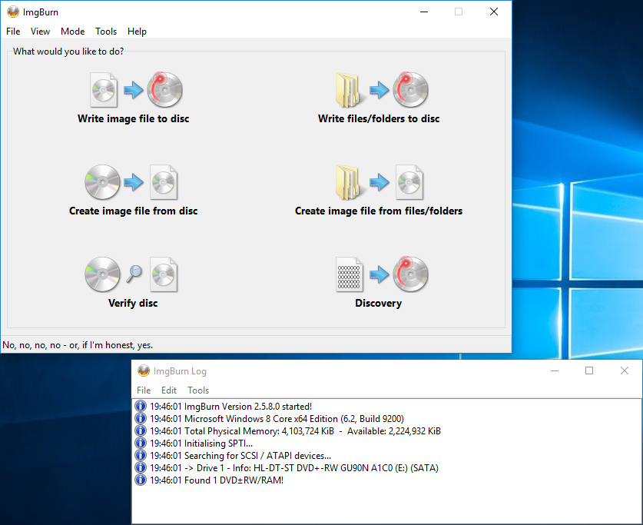
Now you will need to select a file to write to the CD-ROM, select this in the Source section. If you have already inserted your blank CD-ROM into the machine then the right hand panel will give you some information about it.
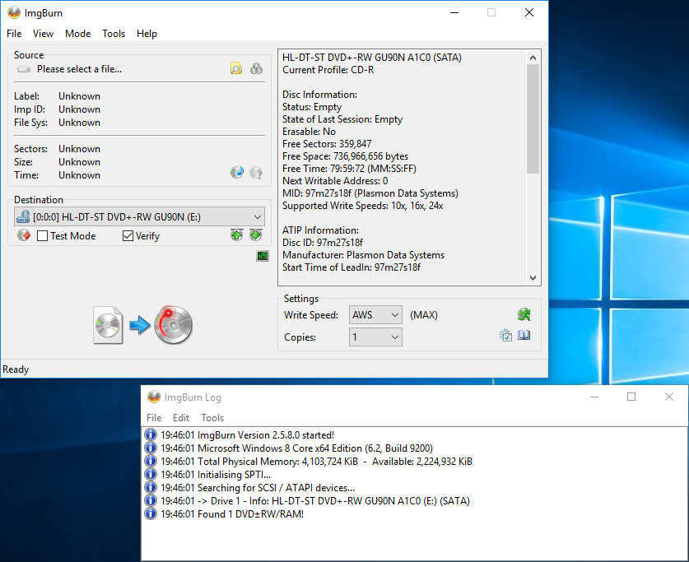
Now you have your Image selected, you can uncheck the verify checkbox in the destination section. I prefer to leave this option on just to make sure the image has been written correctly, but it does take just a few minutes longer.
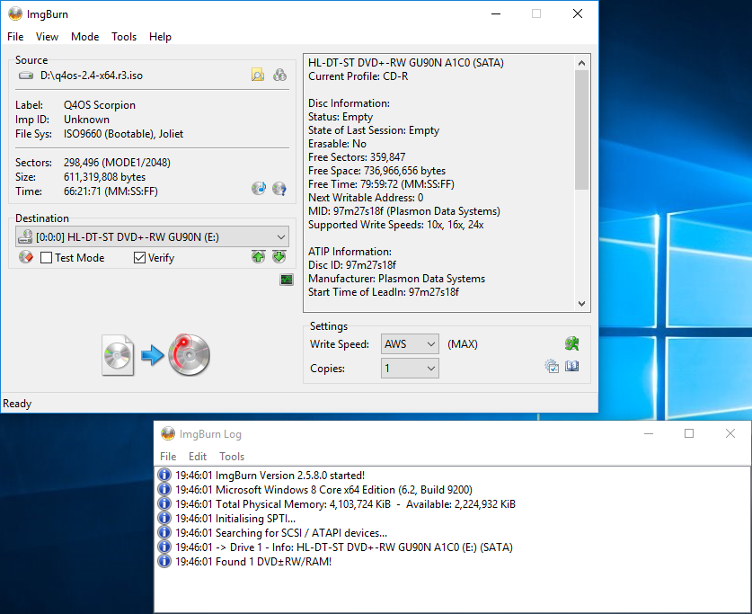
Once you are happy with the configuration, you can click the write button (the image at the bottom of the left hand panel) and it will begin the process.
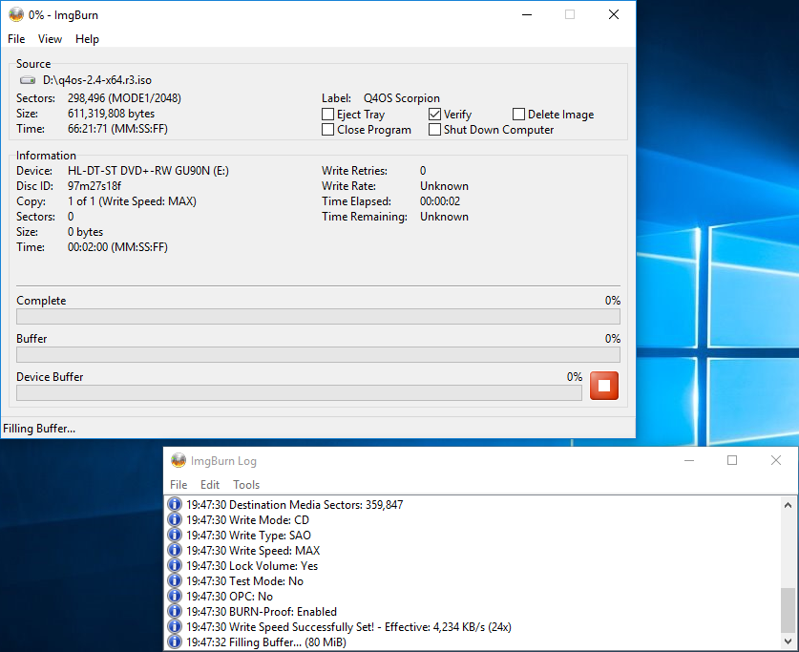
First it will fill the software buffer…
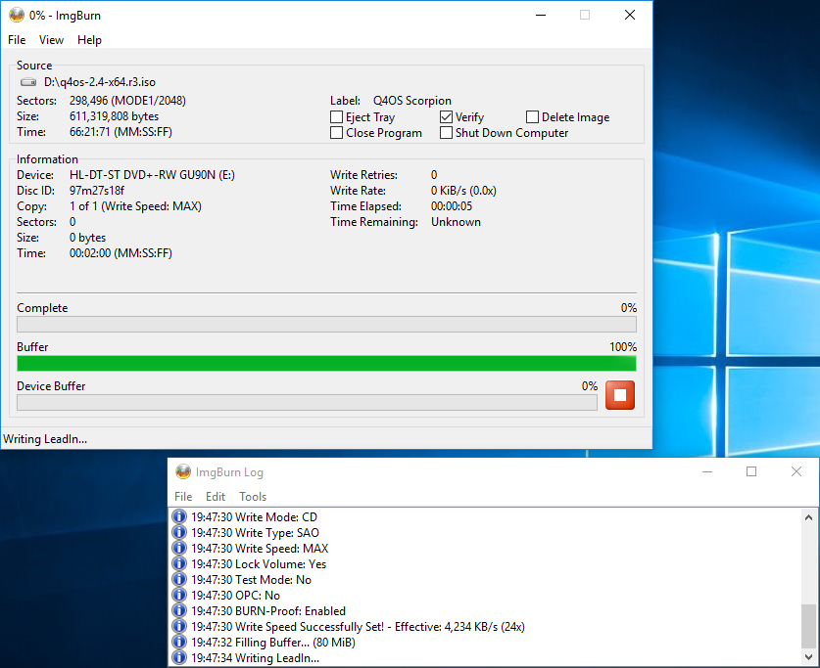
Then it will fill the Device buffer…
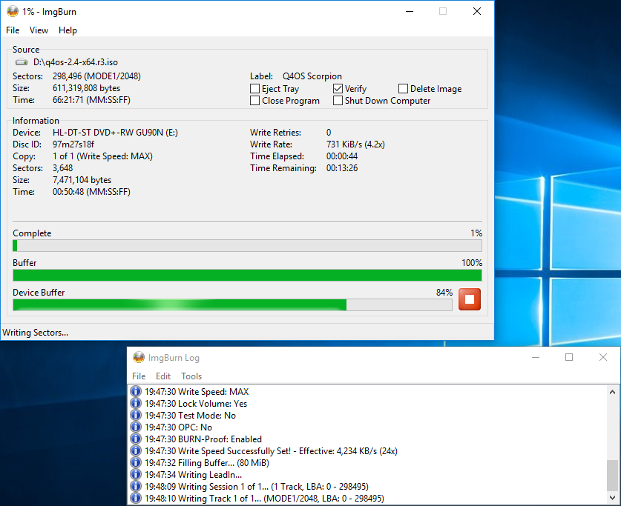
Then it will start writing the data to the disc…
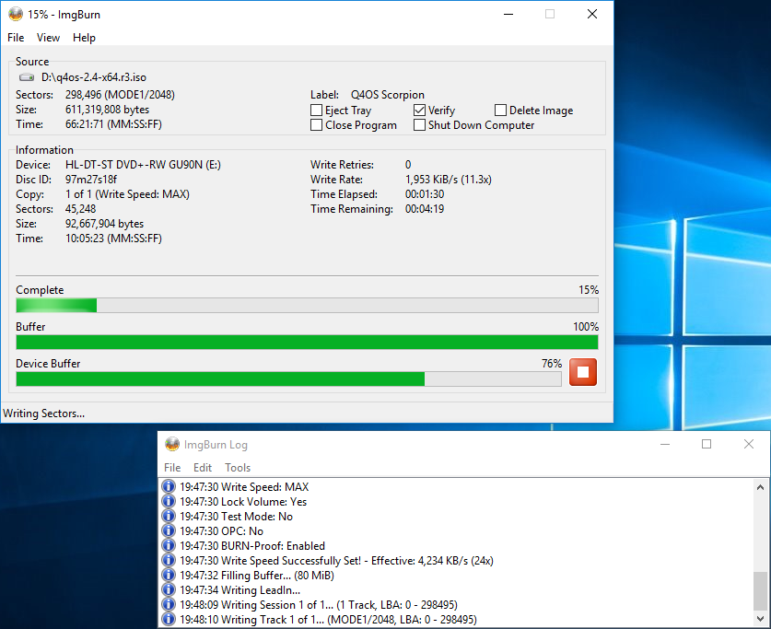
As it gets towards the end of writing, the buffers will empty…
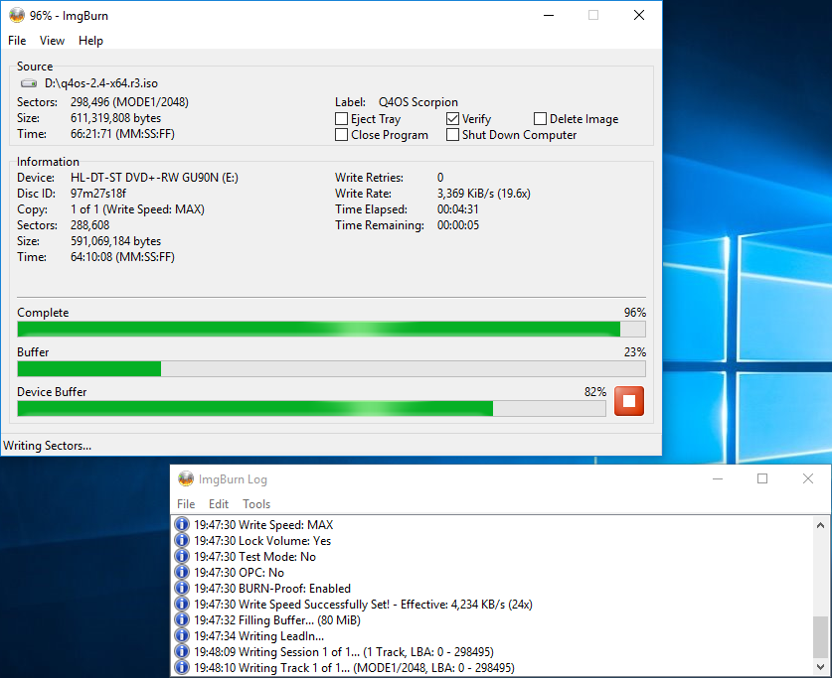
Once writing is complete, the drive will be ejected so that it can be re-inserted to verify the contents have been written correctly. If you are using a laptop (like I am for this guide) then the disk will probably not automatically be re-inserted and this dialog will pop-up. Simply close the drive and click OK to begin the verification process. Of course, if you unchecked this earlier you will not have to do it now.
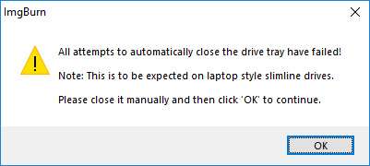
Once this is done the verification commences…
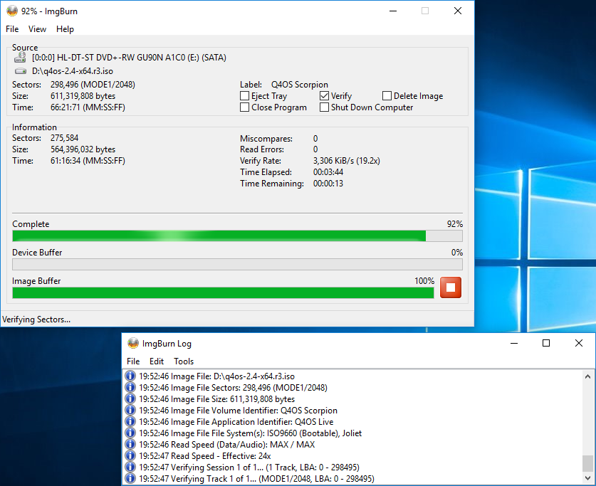
When near the end of this process, the buffer is emptied…
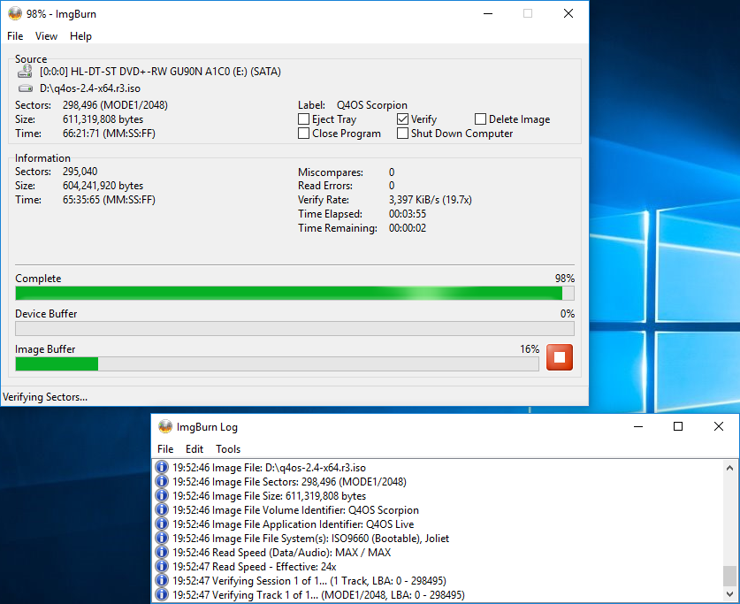
And when this process has finished, you will (hopefully) be presented with this dialog telling you so. At this point, if the image was not written (or verified) correctly you would receive a message telling you so.
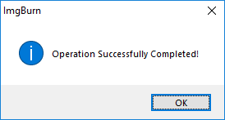
You can now reboot to begin your installation using this CD-ROM, I tested this on both UEFI and BIOS systems, and both work as expected.
On some machines, you will need to either change the BIOS/UEFI settings to allow you to boot from a CD-ROM and/or press F12 during the boot process and select the drive to boot from.

How to create a Live-USB using Windows
First things first, you will need to download an ISO image to use for installation, You can find the latest Q4OS images at http://www.q4os.org/downloads1.html. Be sure to choose the live-cd version if you want to follow along with my guides.
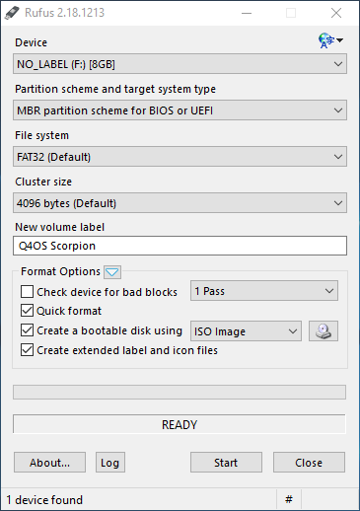
The Windows program I use to put the image onto usb is called “Rufus” and can be found at https://rufus.akeo.ie/. There are many software choices when it comes to creating a bootable USB/CD-ROM, and you can use whichever suits you best.
I usually select the MBR partition scheme which can be used for either BIOS systems or UEFI systems the same as I have both.
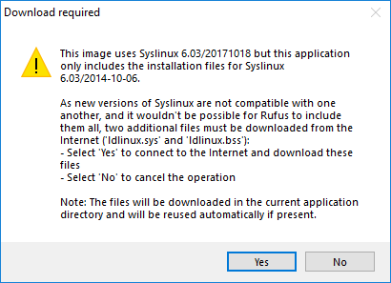
When you select your ISO image, you may be shown this dialog box. It is asking if you want to download the correct version of syslinux for you image. I answer Yes to allow it to fetch the correct version for me.
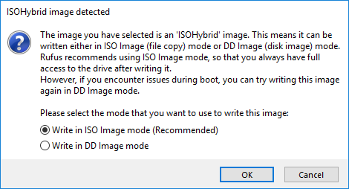
When this has downloaded, you will be shown this dialog. I usually write my images in ISO mode as I can then examine the contents of the disk without having to loop-mount it first. If this method does not work for you, it can be written in DD mode and should work the same.
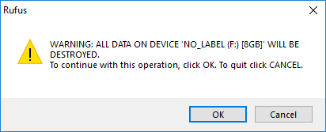
Next, you will be given a last warning that the selected device will be written to and all data or information on it will be lost. This is your last chance to ensure you have selected the correct device to write to! Check twice to be certain it is the right one!
Now Rufus will begin the writing process…
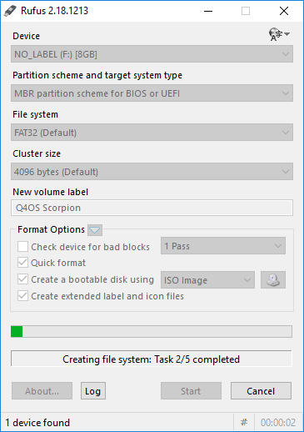
And then writes some more…
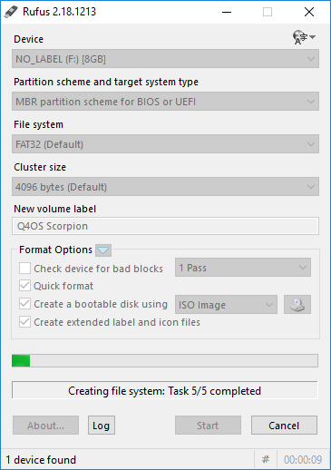
And then some more…
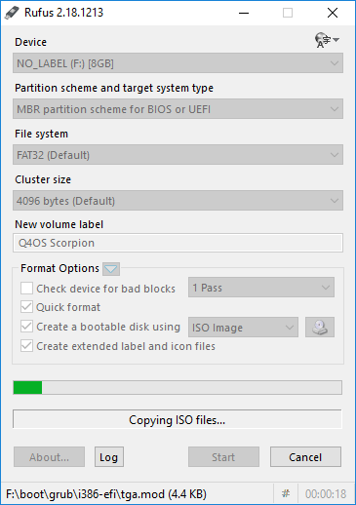
You can see the current file being copied at the bottom of Rufus’s window.
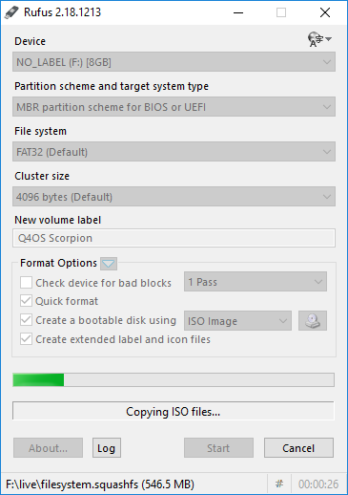
The main file is the filesystem…
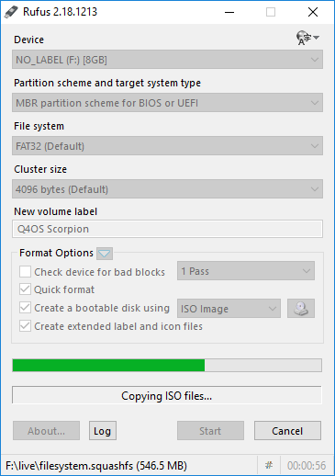
Nearly finished now…
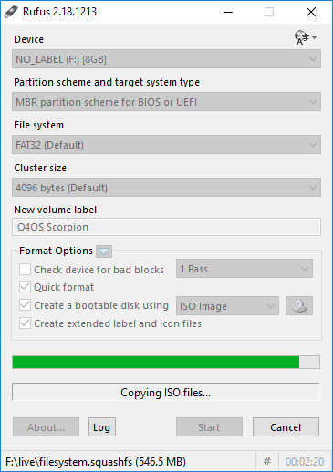
Once Rufus has finished, it will say it is “READY” in the information line (below the progress bar) you can now close Rufus and your boot stick is ready.
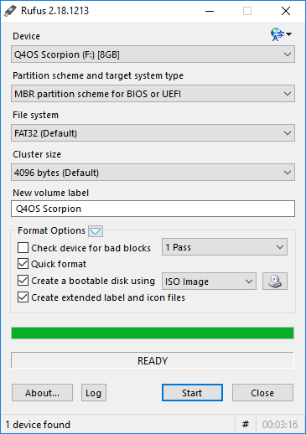
You can now restart your machine and boot into the live system.
On some machines, you will need to either change the BIOS/UEFI settings to allow you to boot from a USB device, and/or press F12 during the boot process and select the USB drive to boot from.

Install Q4OS from the live desktop
When you first boot your machine and select the Live Media to boot, you will be presented with the Grub boot menu.
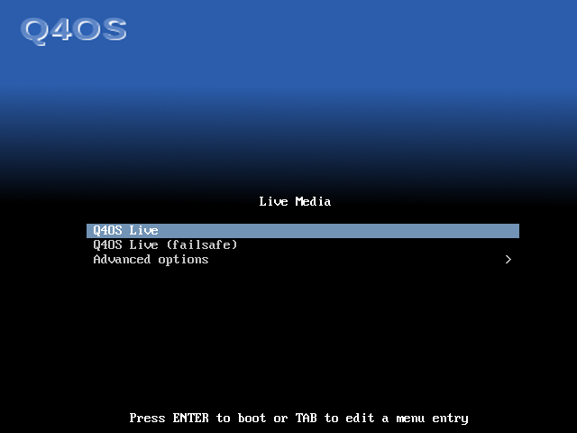
You can normally select the first option and everything will work as expected, but occasionally you might be running hardware that requires special firmware that is not directly available. If that is the case, you could try to boot in “failsafe” mode by selecting the second option and press <Enter>.
You will then see quite a lot of text scrolling up your screen as the system initializes and begins to configure itself to your hardware. This is normal.
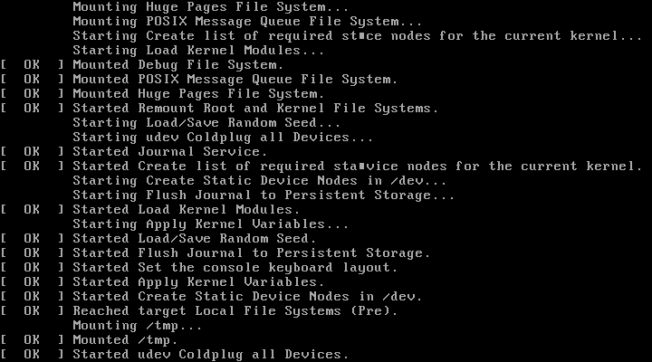
When this finishes, you will first see a blank screen. This is normal as the desktop is being created/configured. You will see a message in the top left corner saying this.

As the desktop is configured, all the required components will be loaded.
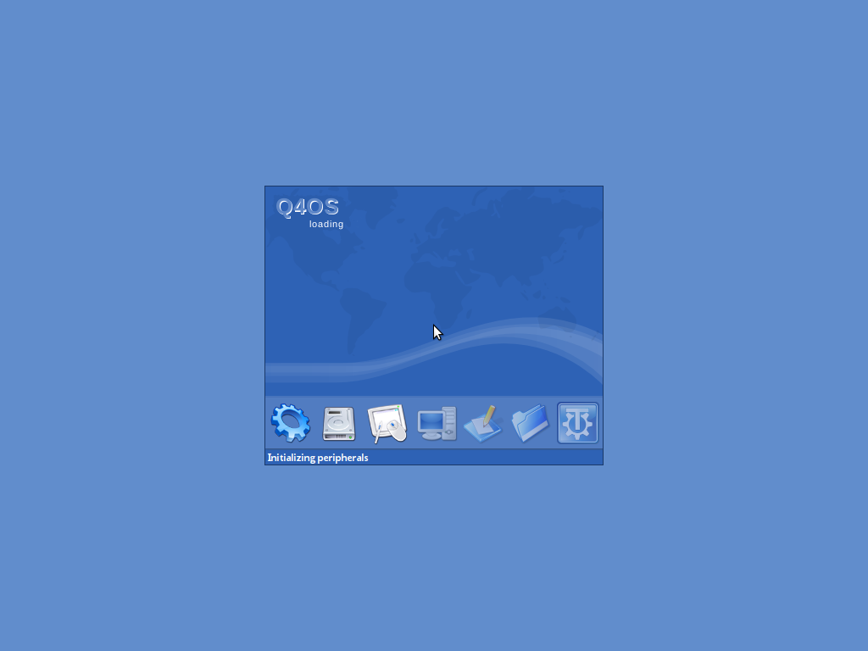
And finally, you will be looking at a desktop in the live session.
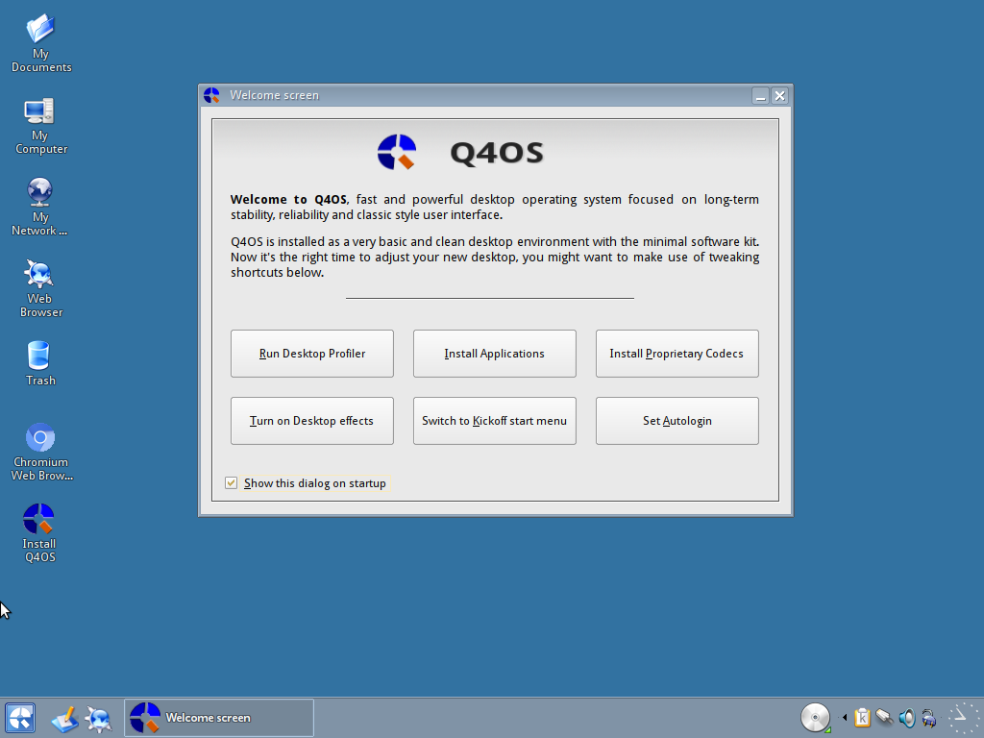
We will explore the Live desktop in another guide, but for now, we can just close the Welcome Screen and double-click the “Install Q4OS” icon to proceed with the installation.
The first page that appears is to select the language you want to use, I am in the UK and my first language is English, so I select that and click on “forward”.
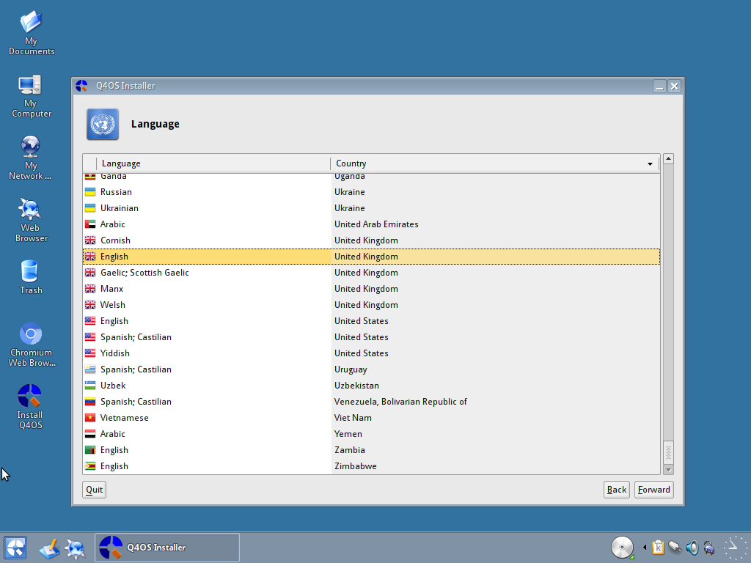
Next, you can select your own location and timezone. If you already have a network connection, this should be set correctly, but you can change it to your preference.
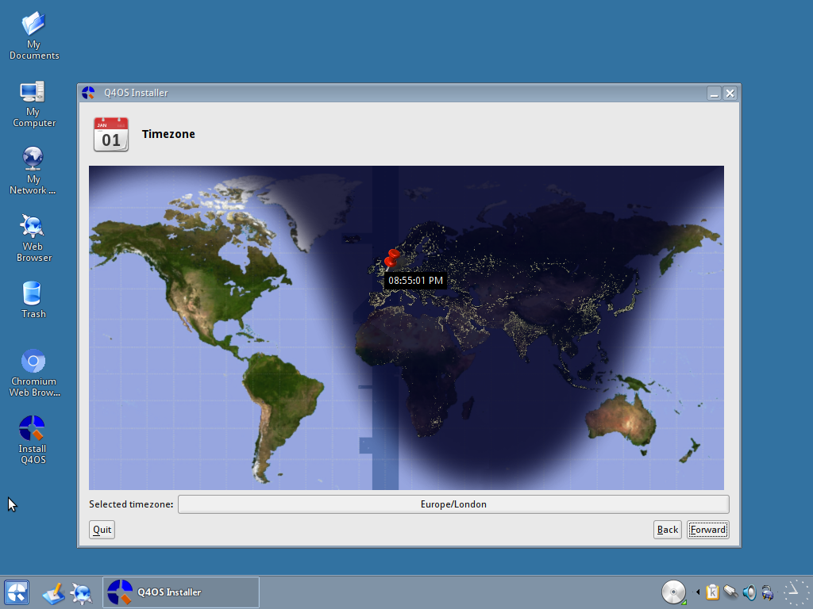
Next, we can choose our keyboard. There is an area to test the keys are working correctly. Use this and make sure you select the correct one as it could cause some issues if not set properly.
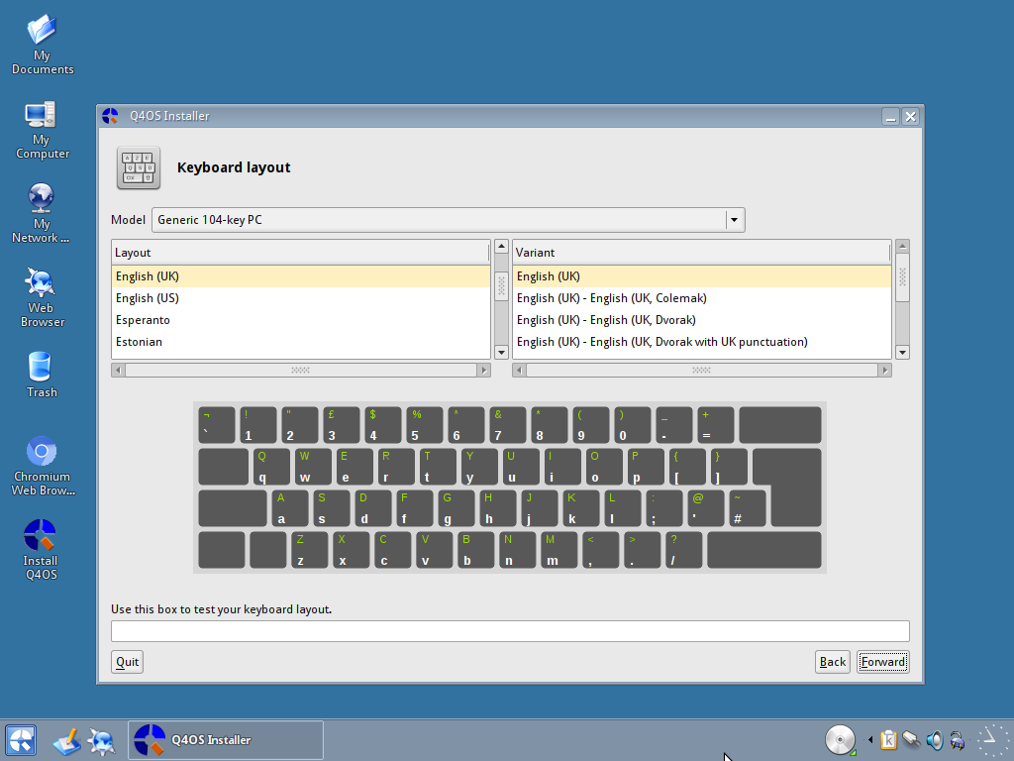
Next, we can choose our user information: your full name, the username you wish to use, and a password (set according to your own security preferences) which must be entered twice. You can set Q4OS to log-in automatically if you wish. Lastly, you can set the machines name for the local network. You can also select an image for your user if you have one available.
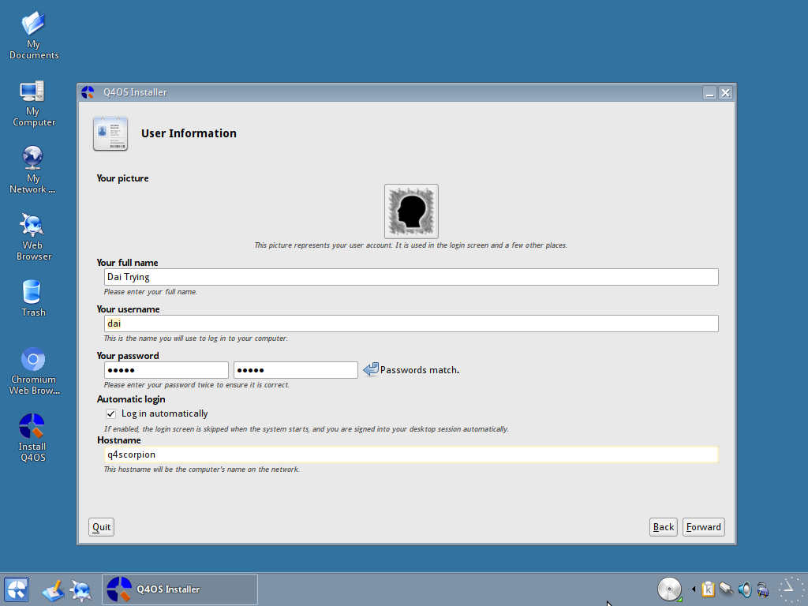
Now you can select the partition to install to. If you do not have any pre-made partitions, you can create them in this here.
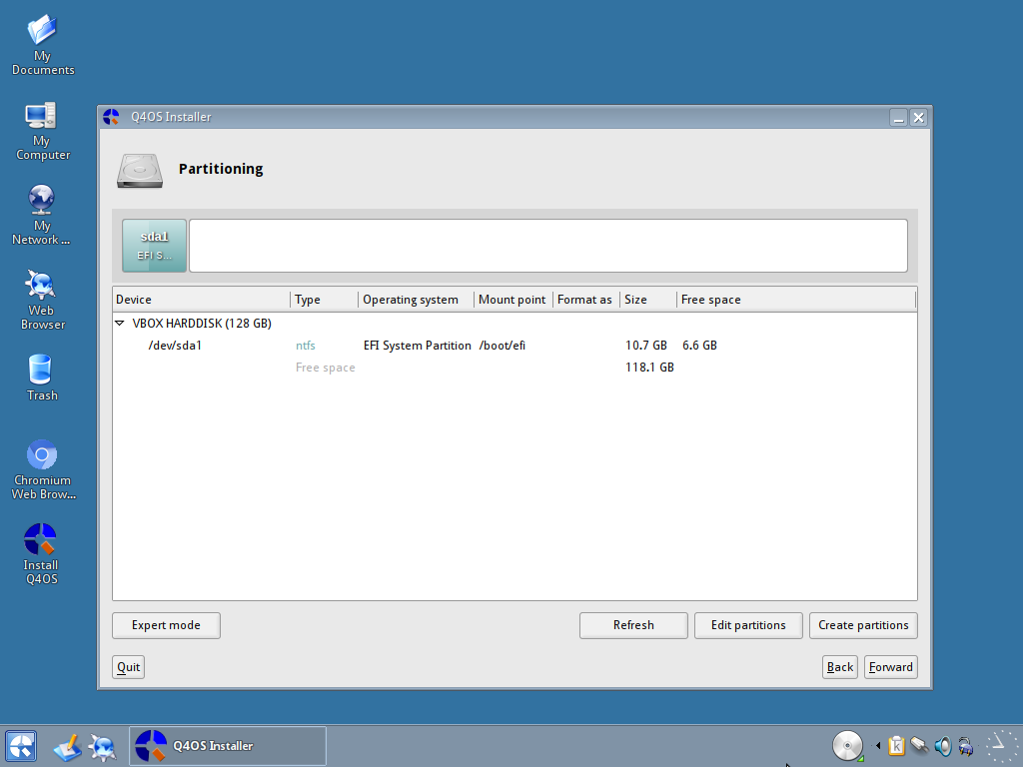
As you can see, I have a windows partition already on this HDD, and I want to leave that in place. I start by selecting “Edit Partitions” and the program GParted will open.
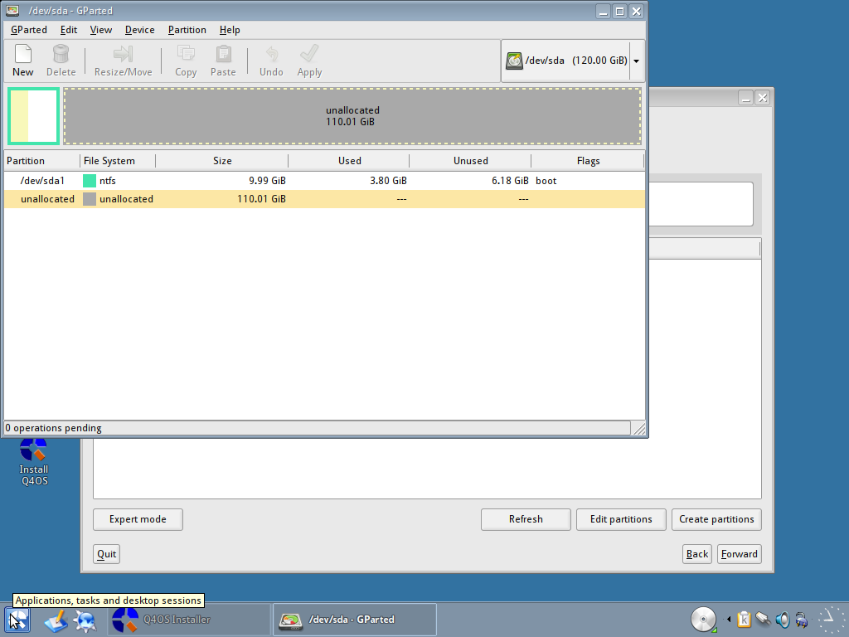
If you right-click on the unallocated space in GParted and select “New”, you will be presented with this dialog for creating a new partition.
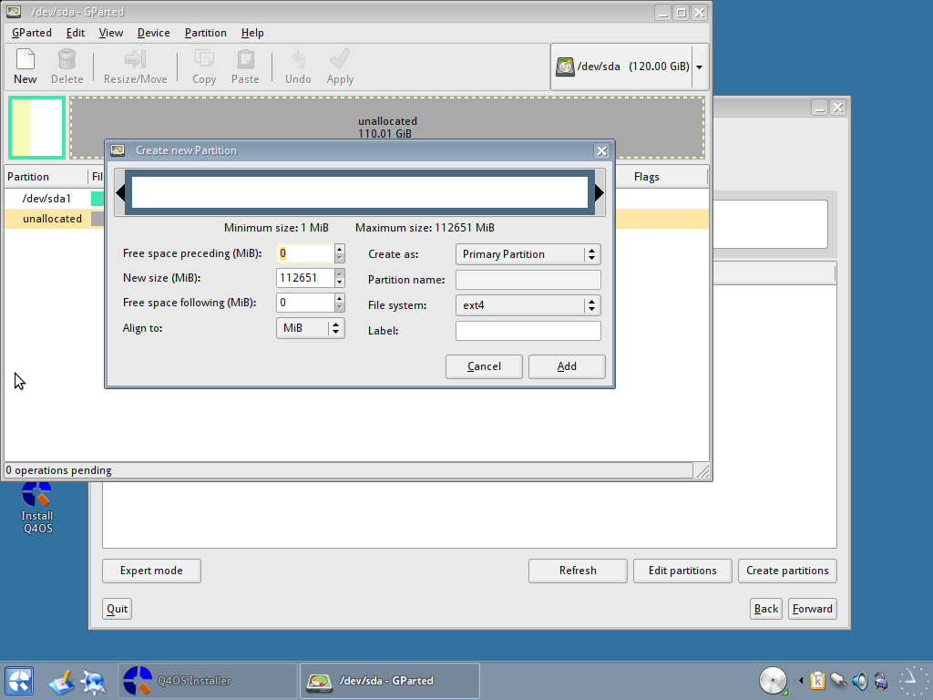
Change the “New size” to the size you want for your system (I have used 20Gb) and then select “ext4” as your “File system”.
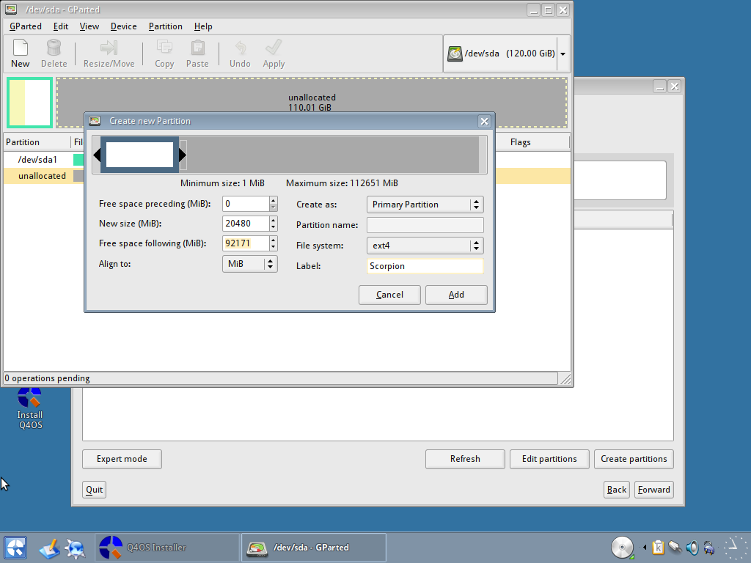
You can also label the partition for easy reference if you want to. When you are happy with the settings, click on “Add”. Now create another partition, but this time, change the size for your swap partition (between 2GB and 8GB depending on your needs) and select the “File system” as “linux-swap”. Again, you could label this if you wanted to. I label mine as swap, again for easy reference. When you are happy with the settings, click the “Add” button.
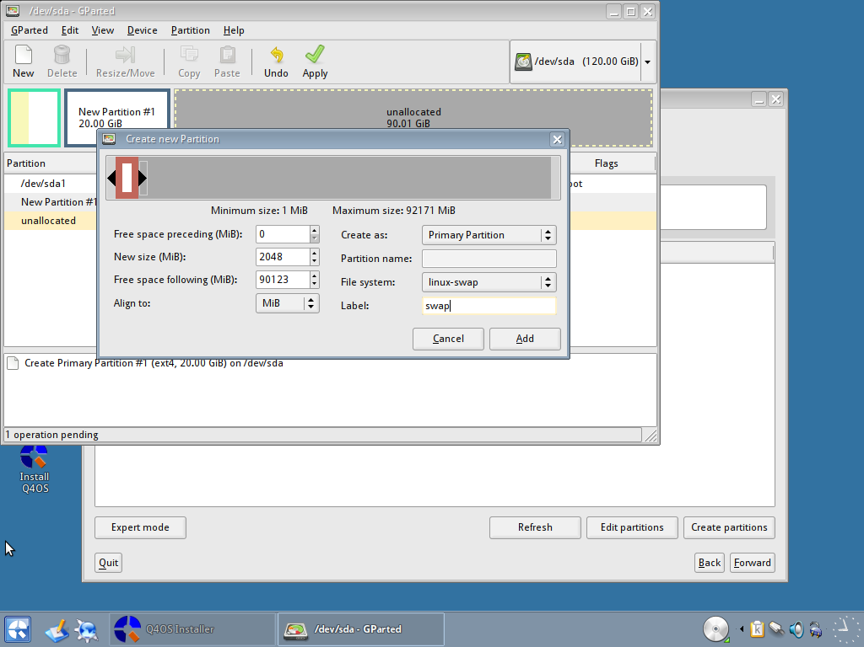
The partitions have not yet been written to the partition table and are waiting for confirmation. Click the “Apply” button (tick) and your changes will be applied and the partitions will be created.
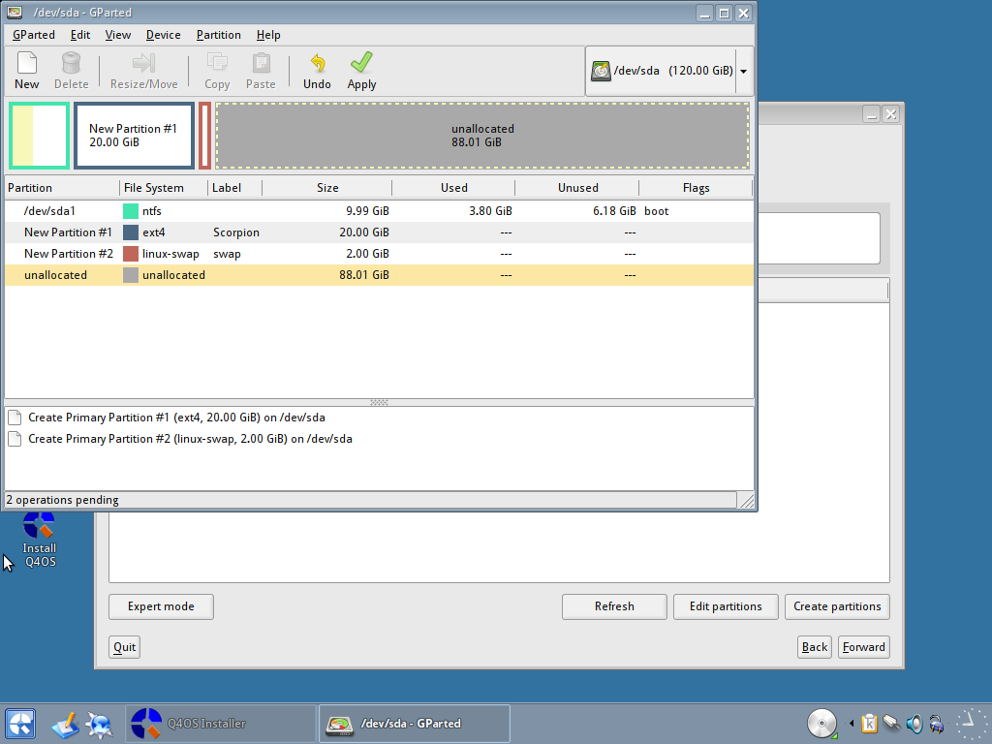
You will be asked to confirm you want to make the changes. Select “Apply”.
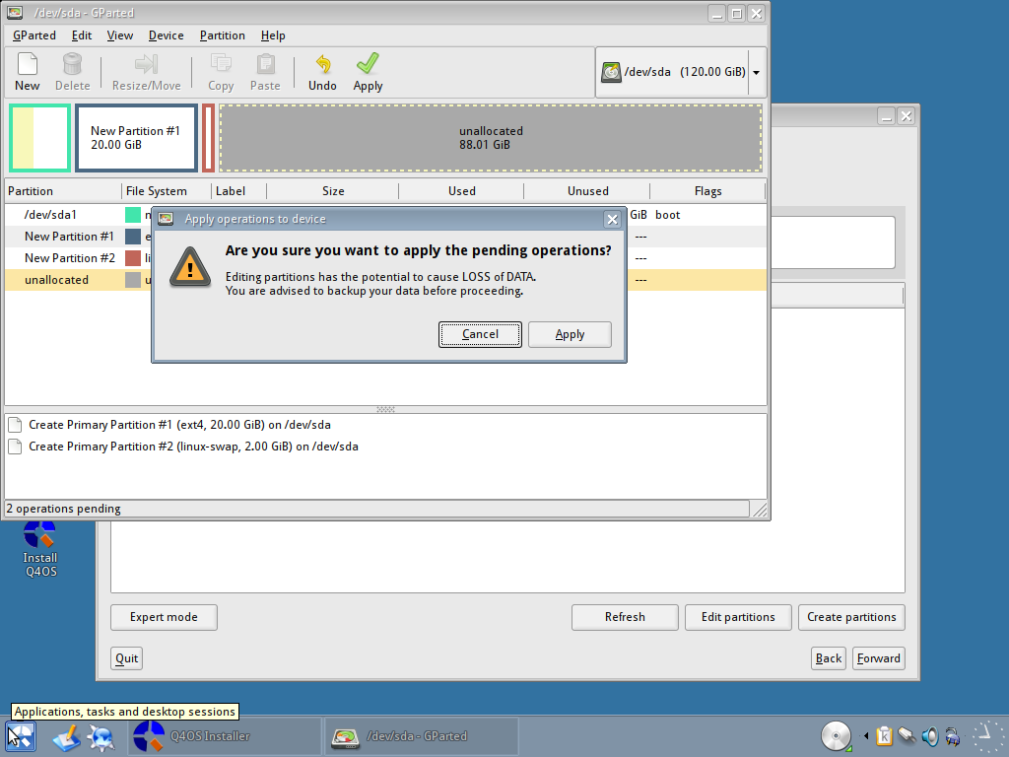
When this is complete, you will be presented with a confirmation dialog like this.
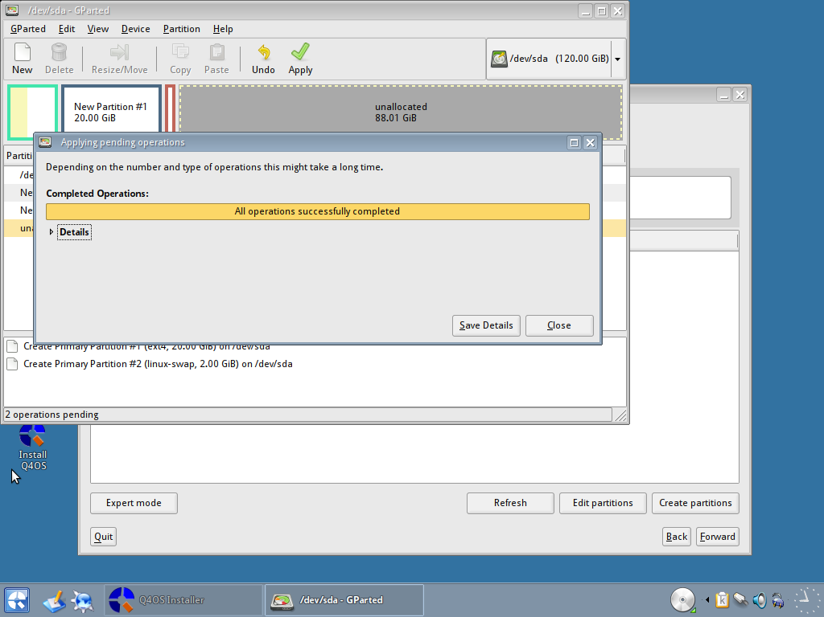
Select “Close” and you will be able to see the partitions in place.
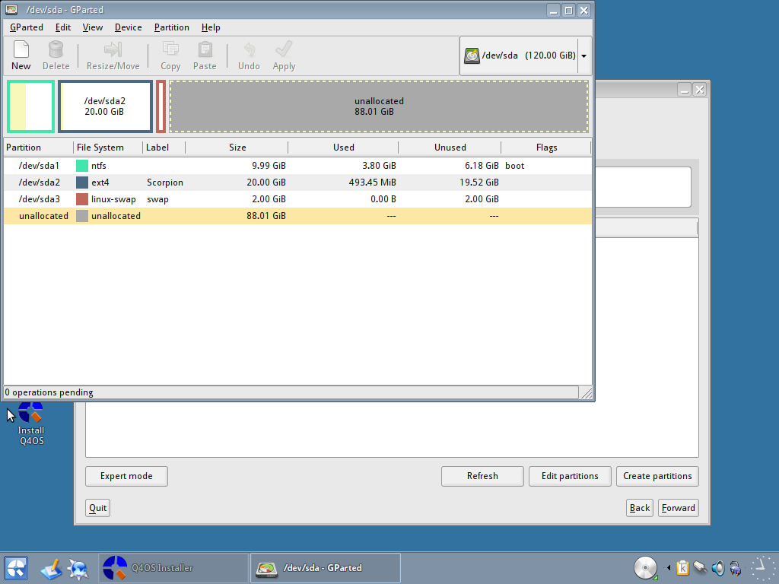
You can now close Gparted, and you will be back to the partition section of the installer. Click on refresh to see the new partitions you have created.
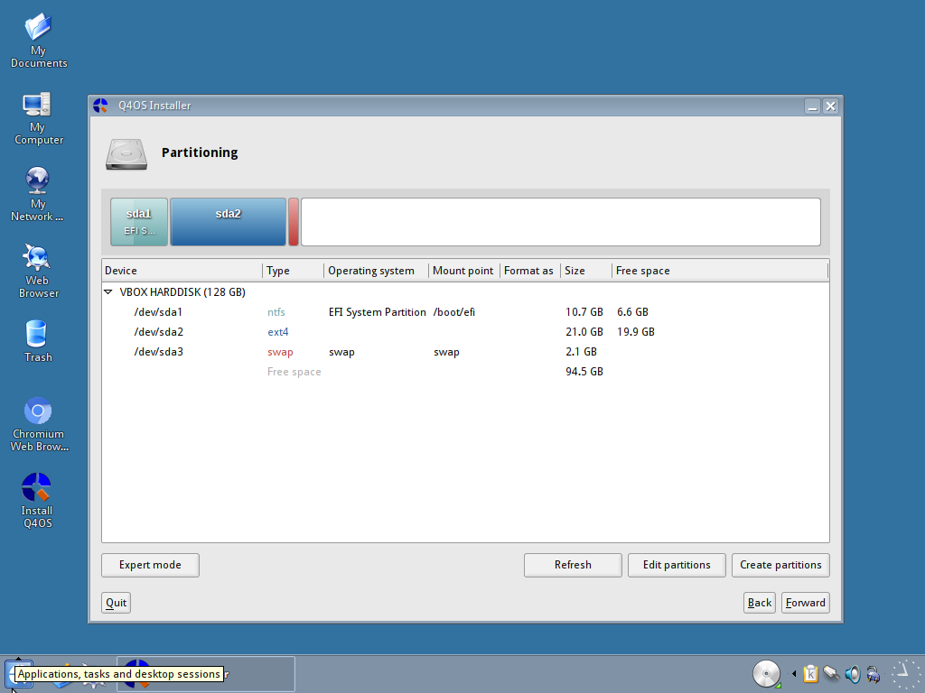
One important thing to note here: the Windows partition has been identified as a UEFI boot partition. It is, in fact, a Windows XP partition I use for testing so I need to correct the instruction for the installer to NOT use this partition. Double-click the partition, and you will see this “Edit partition” dialog.
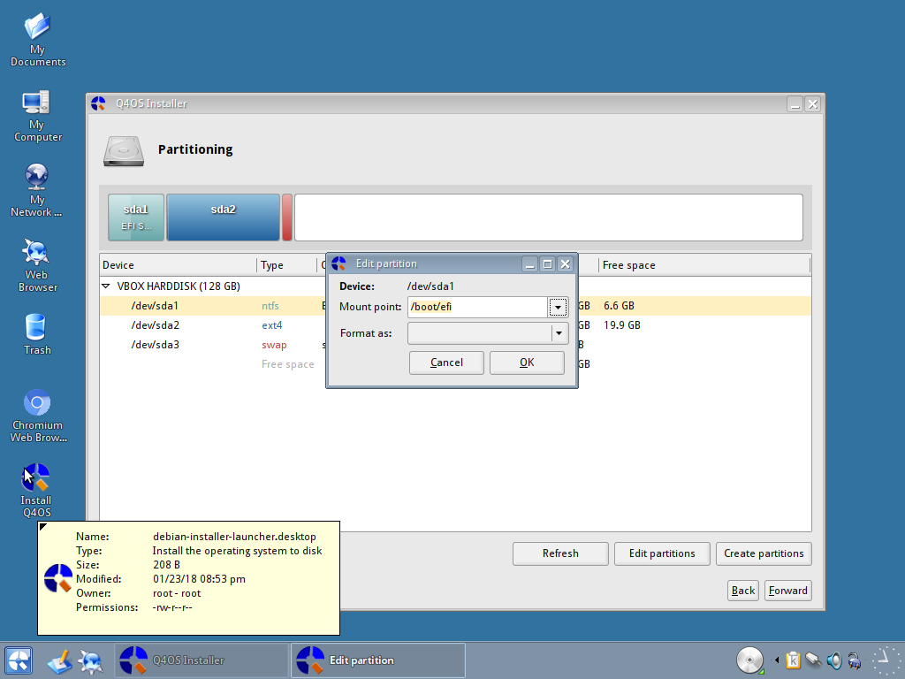
Change the Mount point to be blank, and make sure there is nothing entered in the Format as select box.
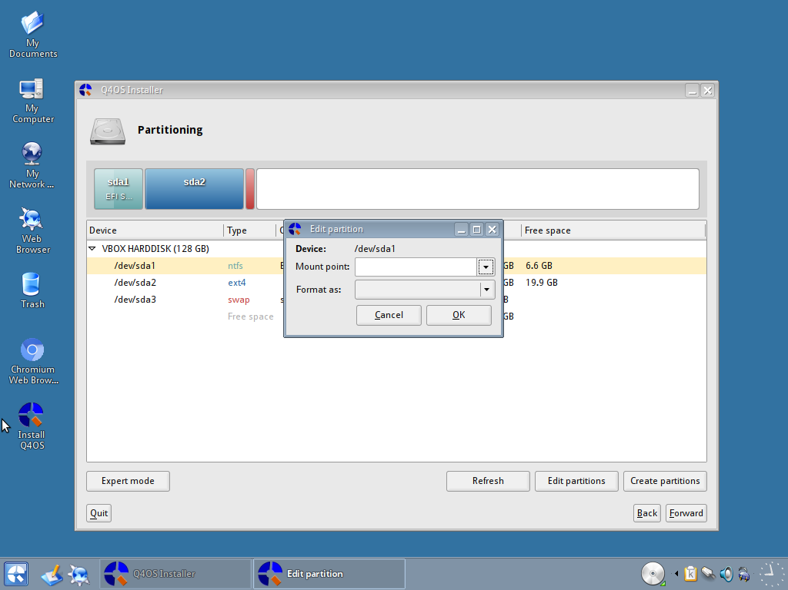
Select OK and this will prevent this partition from being used.
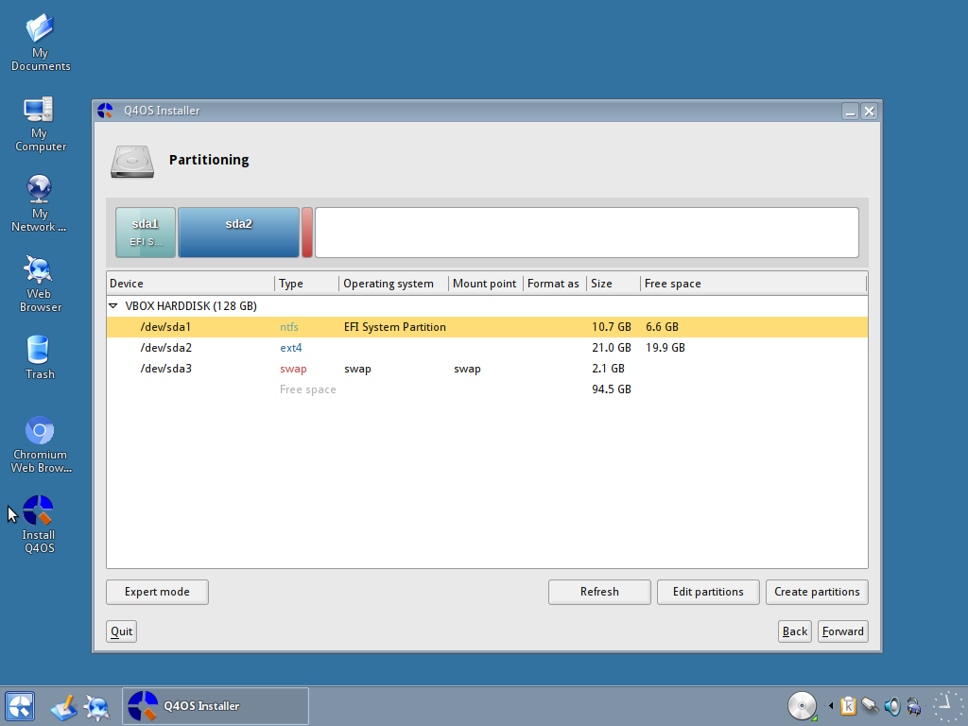
Now double-click on the ext4 partition we just created, and this time select “/” as the Mount point, and set “Format as” to ext4.
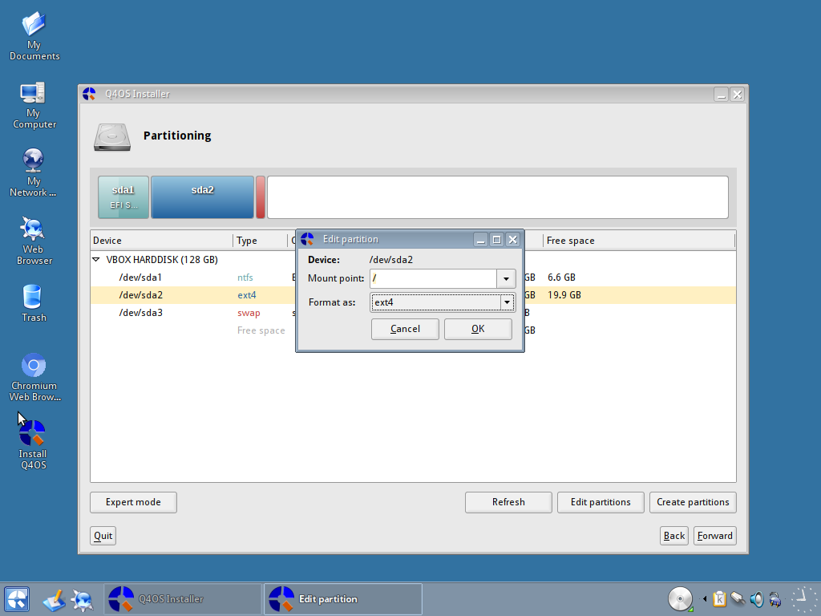
You can now click OK to set the options. Next we want to set the swap partition. Double-click on the swap partition, and select the mount point as swap and the Format as to swap too.
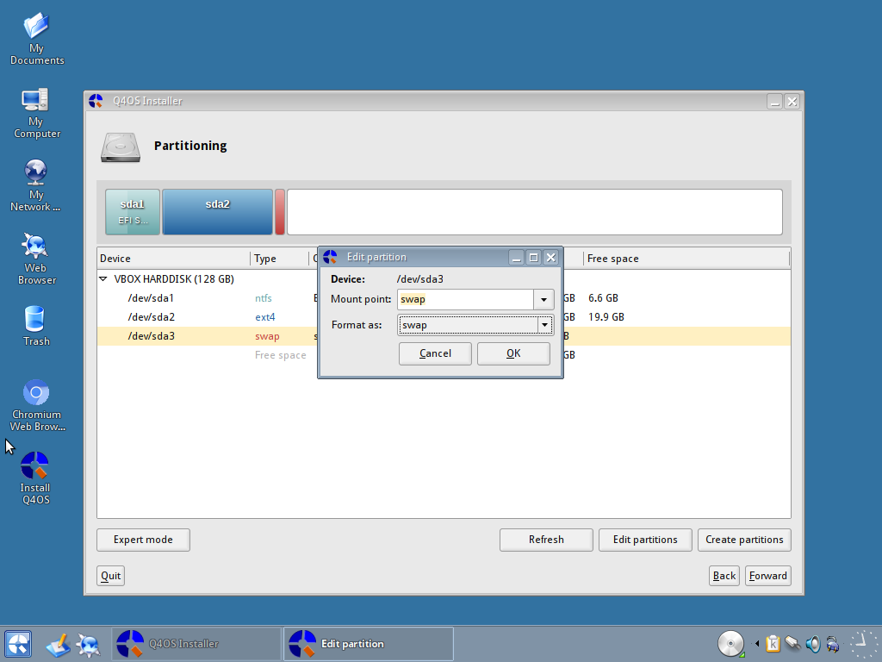
Click ok to set them, and check to make sure they are set correctly.
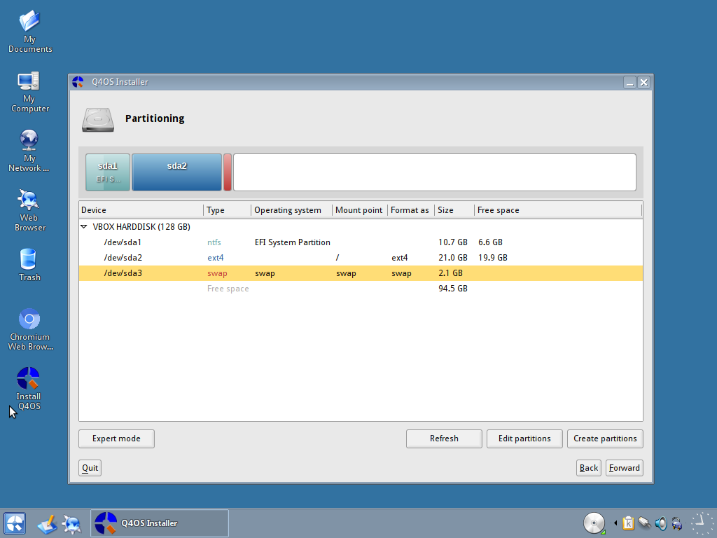
You can now click on the forward button.
You will now be asked if you want to install Grub. This is the package that will allow you to boot into your Linux Operating system and also give you the option to boot Windows instead. If you only have one HDD, it is probably labelled as /dev/sda, but you can check the options in the drop down box if you know it should be different from the default.
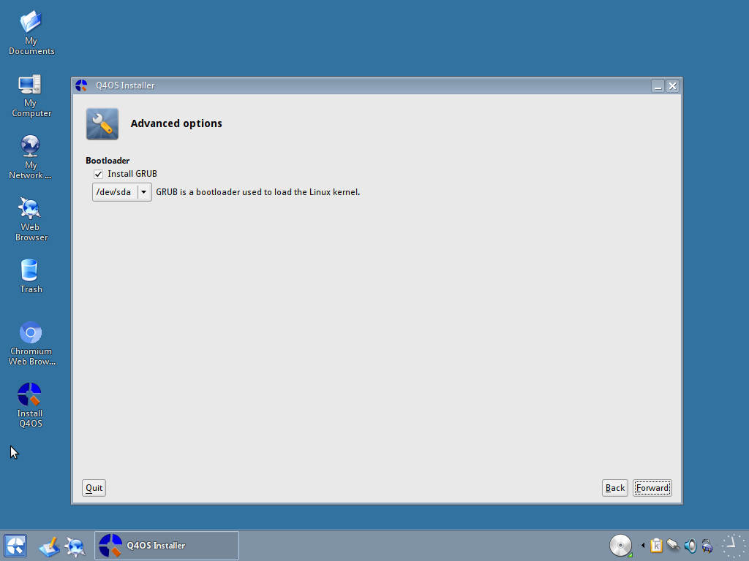
If you are happy with the selection, you can click the forward button.
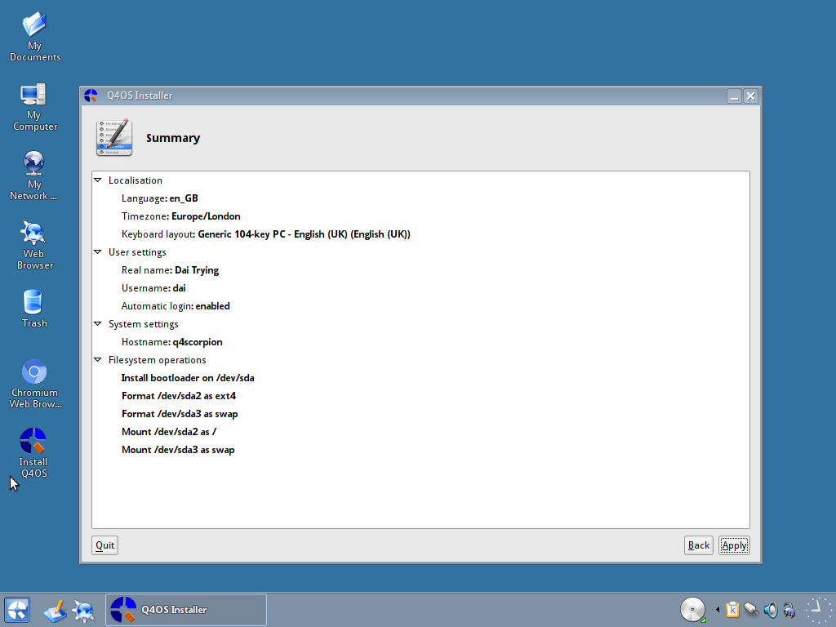
Here you will see the summary of your installation settings. It will tell you (among other things) which partitions will be formatted, where they will be mounted and also if grub is being installed and the location for it. Double check everything is where and how you want it. When you are happy, click the "Apply" button.
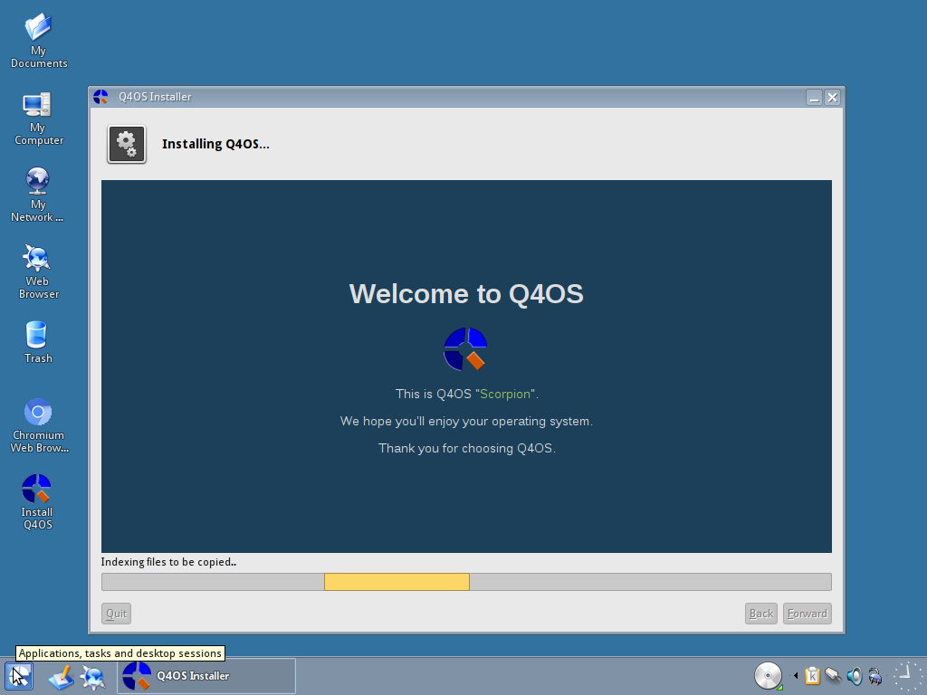
On the installation screen, you will be given information regarding the install progress and also some general information in the main window.
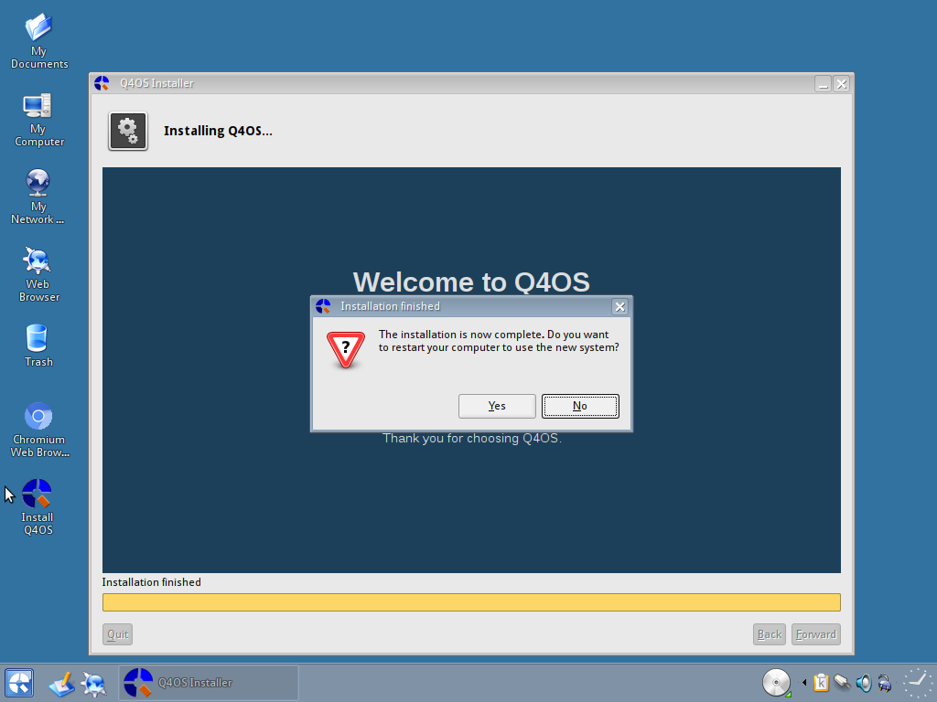
When the installation has completed, you will be shown this dialog box asking if you want to boot into your new system. Click on yes, remove the CD/USB from the drive, and you will be booted into the fresh system.
The first screen you will see is the Grub screen.
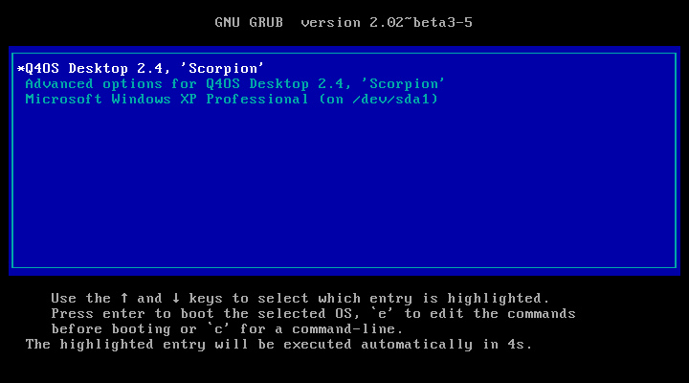
As you can see, I have the option to boot Windows instead of Linux. This is called multibooting, which allows you to have several Operating Systems installed and choose which one you want to use.
There is a timeout option. If you do not press any keys you will boot into the first item on the grub list. This is usually set between 5 and 10 seconds and can be changed later on.
You will now be presented with some scrolling text as the system loads. After a minute or so, you will be at your desktop.
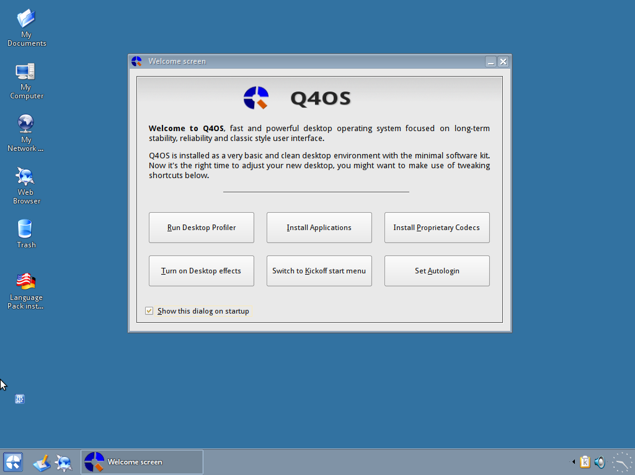
There are two quite important things to be done here. If your install went smoothly and without errors, you will be asked to install your language pack (internet connection required for this) and the desktop profiler will run asking for your software preferences.
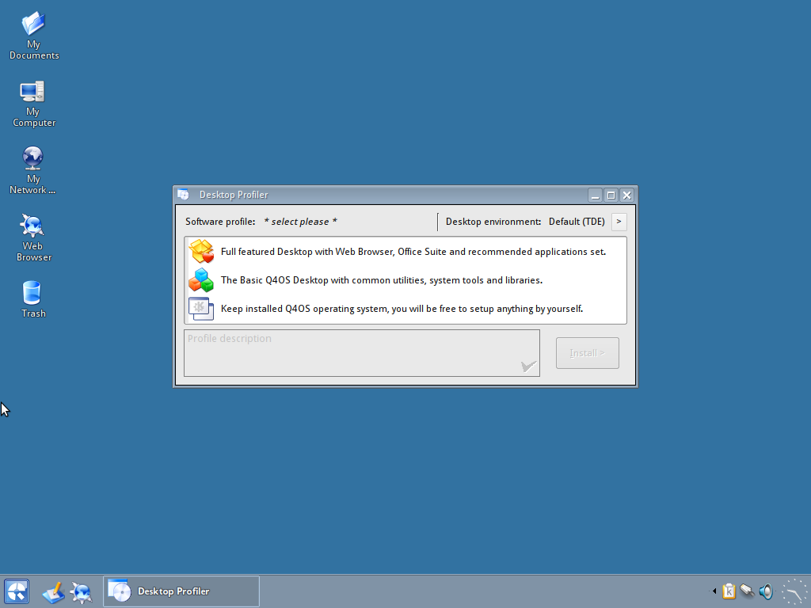
Because I have been using Linux for quite some time, I have a certain set of packages that I prefer to have on my system so I select the “Q4OS Pure” option, which does not install any more software leaving me to set up my system manually. For most users, especially new ones, you would be recommended to install the “Q4OS Desktop”, which will give you a Web browser, Office suite and some other recommended packages There is also the “Q4OS Basic” option which is somewhere between the other two.
Select the preferred option, and click the “install” button. The software will now be downloaded and installed for you. There is a progress bar to indicate the remaining time. When this has finished, simply click on “Finish”
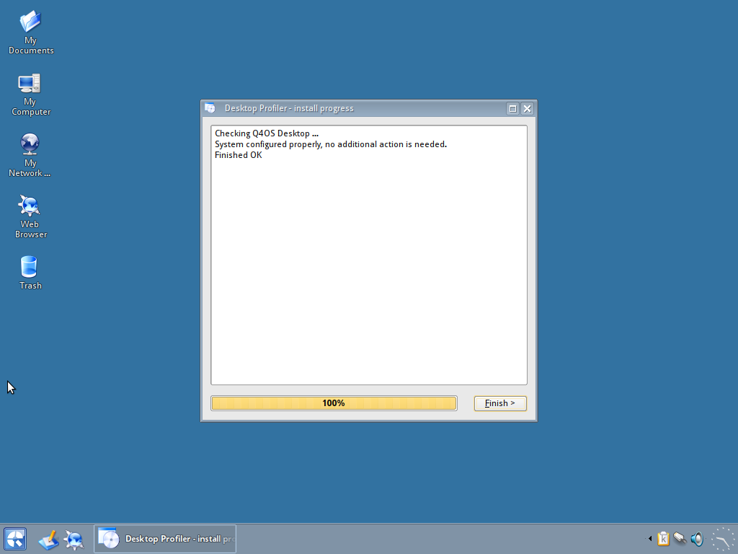
You have now completed all the installation steps and can use your new Operating System.
If you would like some hints and tips on what to do with your new Linux system, please look through my other guides. I’m sure there will be something for you.

Acknowledgements
The majority of this guide is comprised of documentation written by the Q4OS team (www.q4os.org) with additional tutorials courtesy of Dai Trying (dai-trying.com). Formatting, editing, and otherwise compiling things together has been done by John Beers (https://github.com/jaerrib).

Licensing
This guide is licensed under the GNU General Public License v2.0 (https://www.gnu.org/licenses/gpl-2.0.html)

