

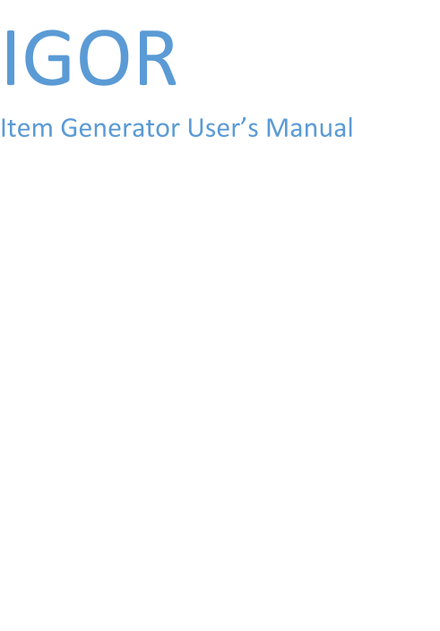

**Table of Contents**

Installation and Setup**2**

Java Installation 2

Running IGOR 2

Type chapter title (level 1)**4**

Type chapter title (level 2)5

**Installation and Setup 1**

**Checking your Java**

The IGOR software is a Java application, and requires an installed Java version 6 or higher.