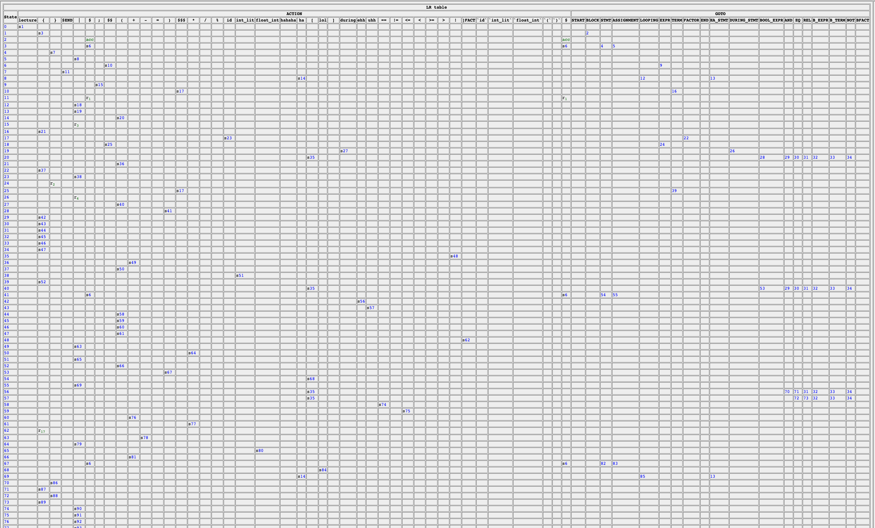

STRINGS THAT

DO PARSE

STRINGS THAT DO NOT PARSE

GRAMMAR RULES

