**COSC 419 – Summer II 2019**

**Assignment4: Decorator, Builder, and Composite_patterns (Maxi 100 points)**

Number of People: Individual. You are welcome to discuss the problem among your classmates but not sharing the solution.

Due: (Thursday) August 8, 2019 by 11:59pm or 7 days from the posted date.

Submission: Zip all your Java source files (*.java) plus your written/non-programing description (*.docx) into a single file and upload it to the proper course folder in Canvas. Please make sure you have successfully tested your program without crashing. Be sure to submit the .java (source codes) not the .class files.

Coding Style: Use consistent indentation (use the Format tool in Eclipse (Ctrl+Shift+ F) . Use standard Java naming conventions for **variableAndMethodNames**, **ClassNames**, **CONSTANT_NAMES**. Must have comments for all your codes. Comments should focus on what and why and NOT how.

**TA: Mariam Mayeesha ( mayeesha.mariam@alumni.ubc.ca)**

Please discuss with your TA/GA first regarding your marking discrepancy.

The purpose of this assignment is to exercise the design patterns (Decorator, Builder, and Composite) that we discussed last week in class.

**Question 1**: (30 points) Builder Design Pattern Question: In our lecture, we discussed about using the Builder Design Pattern to separate the construction of a complex object from its representation. Such that the same construction process can create different representation. In the class, we discussed about using multiple steps in building meals is a restaurant as a model to illustrate the Builder Design Pattern. For this question, add a Canadian Meal with your favorite drink, main course, and side to the program and update UML diagram accordingly. The source code is included in Canvas Assignment4.

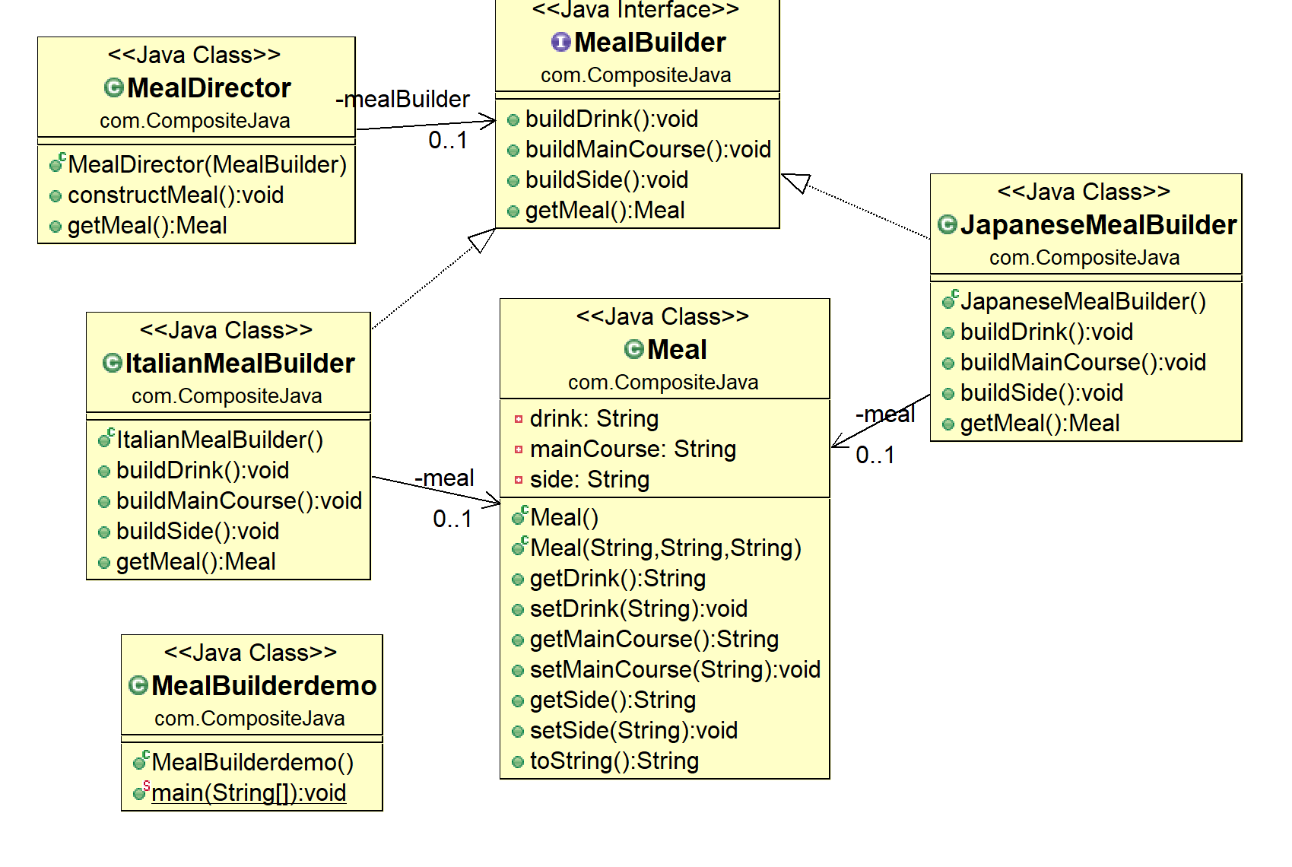

**Question 2** (30 marks) Composite Design Pattern Question. Use the Composite Design Pattern approach that we discussed in class to list the organization with name, salary, and the overall department salary:

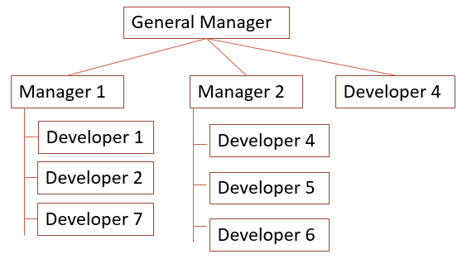

|  |  |  |  |
| --- | --- | --- | --- |
| Name | Report to | Position | Salary (Monthly) |
| Jordan | Self | GM | 500,000 |
| Jae | GM | Manager1 | 155,000 |
| Jennifer | GM | Manager2 | 160,000 |
| Farhan | Manager1 | Developer1 | 110,000 |
| Mansour | Manager1 | Developer2 | 150,000 |
| Tafthim | GM | Developer3 | 200,001 |
| Hayun | Manager2 | Developer4 | 120,000 |
| Carson | Manager2 | Developer5 | 130,000 |
| Prajeet | Manager2 | Developer6 | 125,005 |
| Nawaf | Manager1 | Developer7 | 123,456 |

A basic composite pattern codes are provided to get you started. (in Canvas Assignment 4)

**Question 3**(40 points) Decorator design pattern question. You bought a beautiful Christmas tree on sale for $35.50, and you want to add three items to decorate the tree:

- chain of colorful light --- cost 20.10

- Candy canes from CandyLand – cost 25.20

- sparking ribbons – cost 22.50.

Use the decorator design pattern method that we discussed in class to write a java program showing the progression of your Christmas tree decoration and the associated cost.

Your display result should look like to the following:

I am a beautiful Christmas Tree.

xTree cost 35.5

Total cost 35.5

I am a beautiful Christmas Tree.

I am a chain of colorful light.

You need to plug me in to light up

light cost: 20.1

xTree cost 35.5

Total cost 55.6

I am a beautiful Christmas Tree.

I am a chain of colorful light.

You need to plug me in to light up

added candy stick from the world famous CandyLand

Sweet !!

candy stick cost 25.2

light cost: 20.1

xTree cost 35.5

Total cost 80.8

I am a beautiful Christmas Tree.

I am a chain of colorful light.

You need to plug me in to light up

added candy stick from the world famous CandyLand

Sweet !!

I am a sparkling ribbon

I add colors to the tree

Ribbon cost 22.5

candy stick cost 25.2

light cost: 20.1

xTree cost 35.5

Total cost 103.3