Matrix
- Sparse matrix
- Dense matrix

Sparse Retrieval (Heuristic retrieval, syntactic retrieval) - BM25
* Retrieval for sparse representations (=contains many zeros)
- sparse vectors for documents
- corpus (a set of documents, document: a bag of terms) -> a sparse matrix = term-document matrix
- inverted index: {(term, posting list)}
- {(against, (4:1, 7:3, 8:2, 9:3, ..), …, (ago, (4:2, 9:3, ..), ..}
- {(against, (4:1/5, 7:3/4, 8:2/2, 9:3/10, ..), …, (ago, (4:2/6, 9:3/10, ..), ..}
- posting list: doc ID list
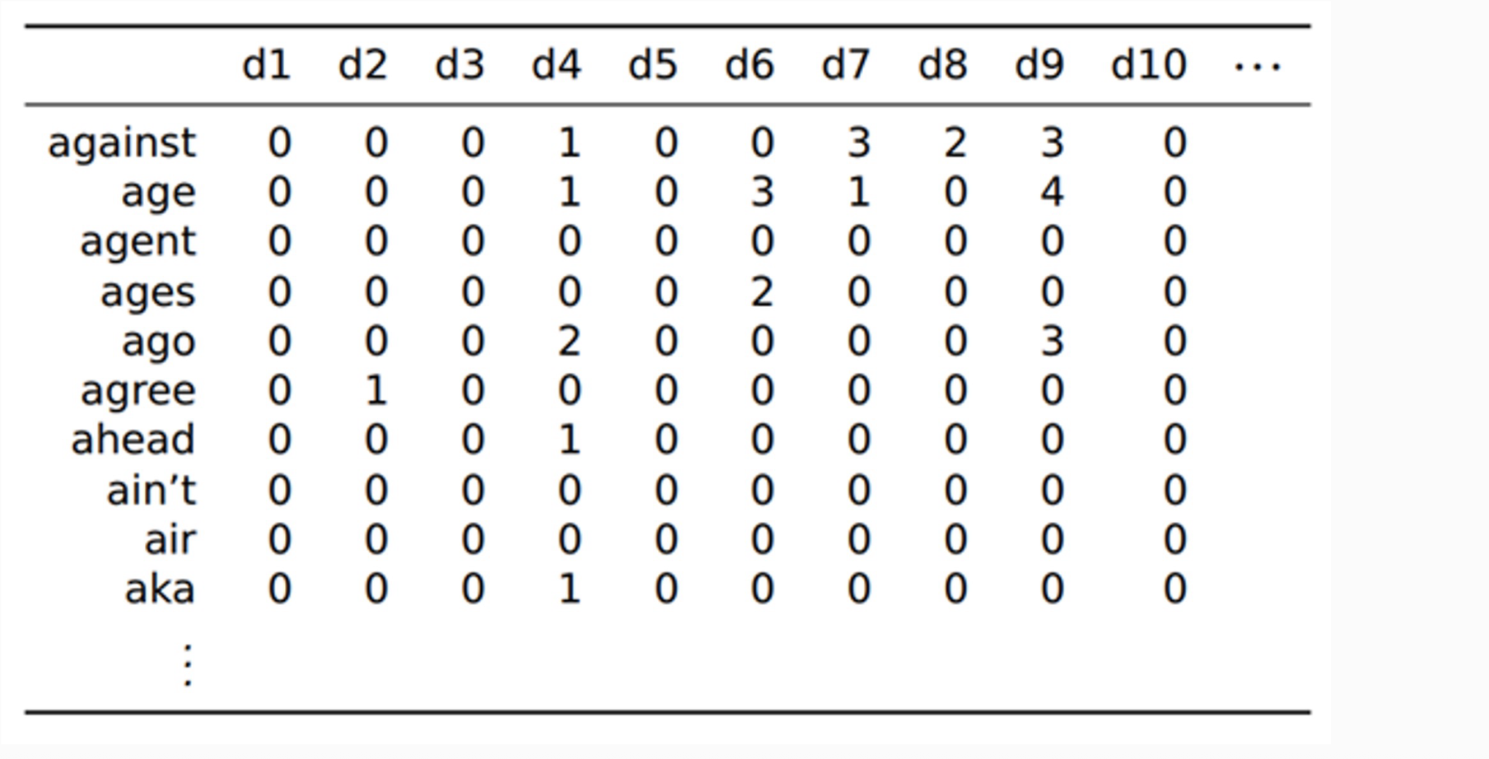
- document: a sequence of keywords
- term (keyword)

Boolean retrieval (no ranking)
q: a set of keywords (k1, k2, …, kn)=> column vectors
= getPostingList(k1) ∩ getPostingList(k2) … ∩ getPostingList(kn)

Ranking!!
{d1, d2, …, dm} m>>n
d3, d10, d25
Q: samsung electronics

TF-IDF (TF * IDF)
TF: term frequency
IDF: inverse document frequency
document frequency for a keyword ‘samsung’ : # of documents containing the keyword ‘samsung’

IDF - samsung, electronics

TF-IDF: representation, ranking (dot, cosine similarity)

BM25

Dense Retrieval (Learning-based retrieval, semantic retrieval) - Cross Encoder (one encoder), Bi-Encoder (dual encoders, two encoders)
* Retrieval for dense representations (= no zeros)
- dense vectors for documents
- term (token)

{(apple, (d3, d10, d20, …, )}

Document -> a dense vector
Query -> a dense vector
Ranking -> cosine similarity, dot product
- sim(q, d) => Enc(q, d): a similarity value
- sim(q, d) => EncQ(q) dot (or cosine similarity) EncD(d)
Finetuning of BERT
- Training data
- Loss function
Fusion of BM25 and Dense retrieval (Hybrid retrieval)

Information retrieval

D: corpus
rank(q, D) - ranking all documents in D: 1 ~ |D|

IR metrics
Benchmark
- BM25 > Cross Encoder ?

Vector database
Top-k search over high-dimensional vectors
d-dimensional vector
History
- d is small
B-tree, R-tree (d <= 8), space-partitioning tree: kd-tree, octree, …
- d is medium-sized

Curse of dimensionality (차원의 저주)
- d is high

=> solutions: 1) LSH, 2) clustering-based indexing (IVF:Inverted File Index), 3) graph-based indexing

Inverted index: { (term, posting list) }

