UCSC Extension – Digital Design with FPGA

**Homework #7**

Jae-Yang Park ([jaeyangp@gmail.com](mailto:jaeyangp@gmail.com))

Problem 5.13.8 Implement 4:1 mux

1. Implement using only ‘case’ statement

module mux41_case(in, out);

parameter S = 2; //

parameter N = 1 << S; // # of cases

input [N+S-1:0] in;

output out;

reg out;

wire [S-1:0] sel;

assign sel[1:0] = in[5:4];

always @(*) begin

case (sel)

2'b00: out = in[0];

2'b01: out = in[1];

2'b10: out = in[2];

2'b11: out = in[3];

default: out = 1'b0;

endcase

end

endmodule

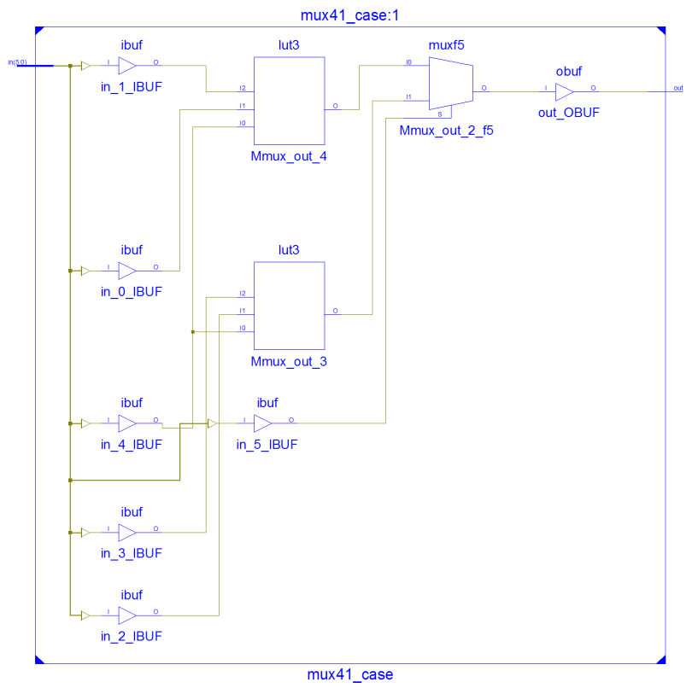

=========================================================================

* Final Report *

=========================================================================

Final Results

RTL Top Level Output File Name : mux41_case.ngr

Top Level Output File Name : mux41_case

Output Format : NGC

Optimization Goal : Speed

Keep Hierarchy : No

Design Statistics

# IOs : 7

Cell Usage :

# BELS : 3

# LUT3 : 2

# MUXF5 : 1

# IO Buffers : 7

# IBUF : 6

# OBUF : 1

=========================================================================

Device utilization summary:

---------------------------

Selected Device : 3s100ecp132-5

Number of Slices: 1 out of 960 0%

Number of 4 input LUTs: 2 out of 1920 0%

Number of IOs: 7

Number of bonded IOBs: 7 out of 83 8%

=========================================================================

Timing constraint: Default path analysis

Total number of paths / destination ports: 7 / 1

-------------------------------------------------------------------------

Delay: 6.054ns (Levels of Logic = 4)

Source: sel<0> (PAD)

Destination: out (PAD)

Data Path: sel<0> to out

Gate Net

Cell:in->out fanout Delay Delay Logical Name (Net Name)

---------------------------------------- ------------

IBUF:I->O 2 1.106 0.532 sel_0_IBUF (sel_0_IBUF)

LUT3:I0->O 1 0.612 0.000 Mmux_out_3 (Mmux_out_3)

MUXF5:I1->O 1 0.278 0.357 Mmux_out_2_f5 (out_OBUF)

OBUF:I->O 3.169 out_OBUF (out)

----------------------------------------

Total 6.054ns (5.165ns logic, 0.889ns route)

(85.3% logic, 14.7% route)

=========================================================================

1. Implement using only 3 LUTs (No MUXF5)

module mux41_3_luts(in, out);

parameter S = 2; //

parameter N = 1 << S; // # of cases

input [N+S-1:0] in;

output out;

wire [S-1:0] sel;

wire l1, l2;

assign sel[1:0] = in[5:4];

LUT4 #(16'h00ca) L1(l1, in[0], in[1], sel[0], 1'b0);

LUT4 #(16'h00ca) L2(l2, in[2], in[3], sel[0], 1'b0);

LUT4 #(16'h00ca) L3(out, l1, l2, sel[1], 1'b0);

endmodule

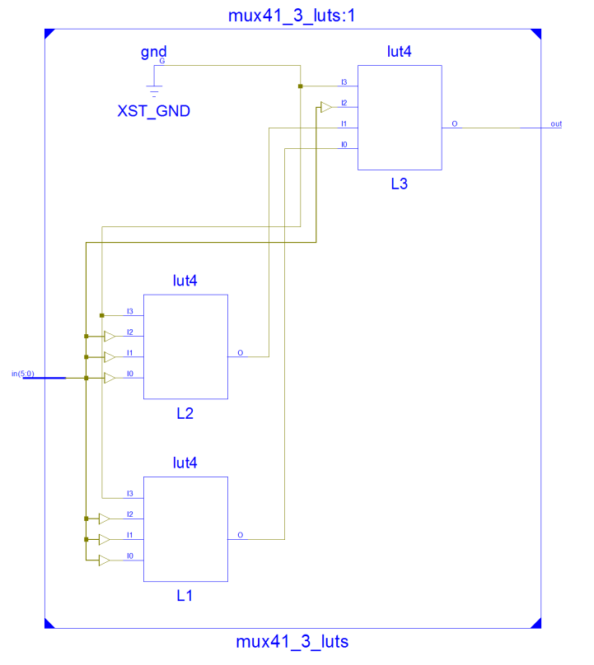

=========================================================================

* Final Report *

=========================================================================

Final Results

RTL Top Level Output File Name : mux41_3_luts.ngr

Top Level Output File Name : mux41_3_luts

Output Format : NGC

Optimization Goal : Speed

Keep Hierarchy : No

Design Statistics

# IOs : 7

Cell Usage :

# BELS : 4

# GND : 1

# LUT4 : 3

# IO Buffers : 7

# IBUF : 6

# OBUF : 1

=========================================================================

Device utilization summary:

---------------------------

Selected Device : 3s100ecp132-5

Number of Slices: 2 out of 960 0%

Number of 4 input LUTs: 3 out of 1920 0%

Number of IOs: 7

Number of bonded IOBs: 7 out of 83 8%

=========================================================================

Timing constraint: Default path analysis

Total number of paths / destination ports: 7 / 1

-------------------------------------------------------------------------

Delay: 6.874ns (Levels of Logic = 4)

Source: in<0> (PAD)

Destination: out (PAD)

Data Path: in<0> to out

Gate Net

Cell:in->out fanout Delay Delay Logical Name (Net Name)

---------------------------------------- ------------

IBUF:I->O 1 1.106 0.509 in_0_IBUF (in_0_IBUF)

LUT4:I0->O 1 0.612 0.509 L1 (l1)

LUT4:I0->O 1 0.612 0.357 L3 (out_OBUF)

OBUF:I->O 3.169 out_OBUF (out)

----------------------------------------

Total 6.874ns (5.499ns logic, 1.375ns route)

(80.0% logic, 20.0% route)

1. Implement using only 2 LUTs (No MUXF5)

module mux41_2_luts_no_muxf5(in, out);

parameter S = 2; //

parameter N = 1 << S; // # of cases

input [N+S-1:0] in;

output out;

wire [S-1:0] sel;

wire l1, l2, o1;

assign sel[1:0] = in[5:4];

LUT4 #(16'h00ca) L1(l1, in[0], in[1], sel[0], sel[1]);

LUT4 #(16'hca00) L2(l2, in[2], in[3], sel[0], sel[1]);

MUXCY CY1(o1, 1'b1, 1'b0, l1);

MUXCY CY2(out, 1'b1, o1, l2);

endmodule

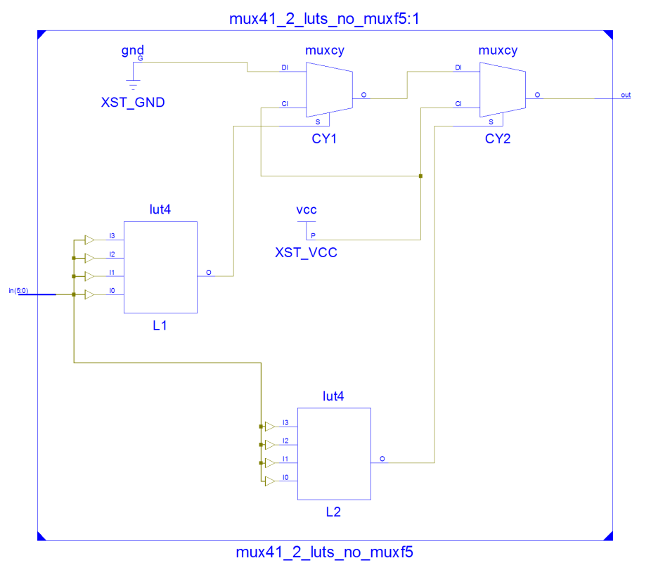

=========================================================================

* Final Report *

=========================================================================

Final Results

RTL Top Level Output File Name : mux41_2_luts_no_muxf5.ngr

Top Level Output File Name : mux41_2_luts_no_muxf5

Output Format : NGC

Optimization Goal : Speed

Keep Hierarchy : No

Design Statistics

# IOs : 7

Cell Usage :

# BELS : 6

# GND : 1

# LUT4 : 2

# MUXCY : 2

# VCC : 1

# IO Buffers : 7

# IBUF : 6

# OBUF : 1

=========================================================================

=========================================================================

Timing constraint: Default path analysis

Total number of paths / destination ports: 8 / 1

-------------------------------------------------------------------------

Delay: 7.626ns (Levels of Logic = 5)

Source: in<0> (PAD)

Destination: out (PAD)

Data Path: in<0> to out

Gate Net

Cell:in->out fanout Delay Delay Logical Name (Net Name)

---------------------------------------- ------------

IBUF:I->O 1 1.106 0.509 in_0_IBUF (in_0_IBUF)

LUT4:I0->O 1 0.612 0.000 L1 (l1)

MUXCY:S->O 0 0.752 0.000 CY1 (o1)

MUXCY:DI->O 1 1.121 0.357 CY2 (out_OBUF)

OBUF:I->O 3.169 out_OBUF (out)

----------------------------------------

Total 7.626ns (6.760ns logic, 0.866ns route)

(88.6% logic, 11.4% route)

1. Implement using only 2 LUTs and one MUXF5

|  |  |  |  |
| --- | --- | --- | --- |
| f = s1’s0’d0 + s1’s0d1 + s1s0’d2 + s1s0d3 | | | |
| S1 == 0 | | S1 == 1 | |
| S0’d0 + s0d1 | | S0’d2 + s0d3 | |
| S0 == 0 | S0 == 1 | S0 == 0 | S0 == 1 |
| D0 | D1 | D2 | D3 |

module mux41_2_luts_1_muxf5(in, out);

parameter S = 2; //

parameter N = 1 << S; // # of cases

input [N+S-1:0] in;

output out;

wire [S-1:0] sel;

wire l1, l2;

assign sel[1:0] = in[5:4];

LUT4 #(16'h00ca) L1(l1, in[0], in[1], sel[0], 1'b0);

LUT4 #(16'h00ca) L2(l2, in[2], in[3], sel[0], 1'b0);

MUXF5 F5(out, l1, l2, sel[1]);

endmodule

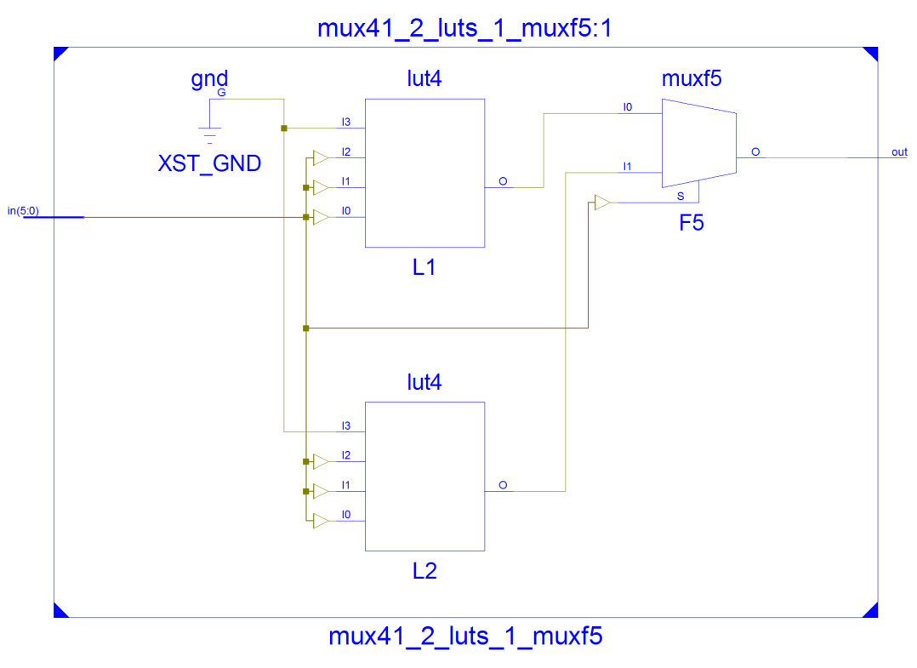

=========================================================================

* Final Report *

=========================================================================

Final Results

RTL Top Level Output File Name : mux41_2_luts_1_muxf5.ngr

Top Level Output File Name : mux41_2_luts_1_muxf5

Output Format : NGC

Optimization Goal : Speed

Keep Hierarchy : No

Design Statistics

# IOs : 7

Cell Usage :

# BELS : 4

# GND : 1

# LUT4 : 2

# MUXF5 : 1

# IO Buffers : 7

# IBUF : 6

# OBUF : 1

=========================================================================

Device utilization summary:

---------------------------

Selected Device : 3s100ecp132-5

Number of Slices: 1 out of 960 0%

Number of 4 input LUTs: 2 out of 1920 0%

Number of IOs: 7

Number of bonded IOBs: 7 out of 83 8%

=========================================================================

Timing constraint: Default path analysis

Total number of paths / destination ports: 7 / 1

-------------------------------------------------------------------------

Delay: 6.031ns (Levels of Logic = 4)

Source: in<0> (PAD)

Destination: out (PAD)

Data Path: in<0> to out

Gate Net

Cell:in->out fanout Delay Delay Logical Name (Net Name)

---------------------------------------- ------------

IBUF:I->O 1 1.106 0.509 in_0_IBUF (in_0_IBUF)

LUT4:I0->O 1 0.612 0.000 L1 (l1)

MUXF5:I0->O 1 0.278 0.357 F5 (out_OBUF)

OBUF:I->O 3.169 out_OBUF (out)

----------------------------------------

Total 6.031ns (5.165ns logic, 0.866ns route)

(85.6% logic, 14.4% route)

**TOP Module**

module mux_top(CLK1, arst, seg, an, Led);

parameter N = 7;

parameter W = 4;

parameter S = 8;

parameter H = 14; // binary size ..9999

parameter MS = 2; // mux sel

parameter MN = 1 << MS; // mux 4:1

input CLK1, arst;

output [0:N-1] seg;

output [W-1:0] an;

output [S-1:0] Led;

wire [15:0] text, disp_text;

wire one_sec;

wire [S-1:0] num_sel;

wire selected;

wire selected1, selected2, selected3, selected4;

assign Led = num_sel;

assign selected = (selected1 == selected2 == selected3 == selected4);

assign disp_text[3:0] = {3'b0, selected};

assign disp_text[7:4] = 4'b0;

assign disp_text[11:8] = text[3:0];

assign disp_text[15:12] = text[7:4];

one_second ONE (.CLK1(CLK1), .arst(arst), .one_sec_clock(one_sec));

counter #(N-1) CNT (.clk(CLK1), .arst(arst), .en(one_sec), .q(num_sel));

mux41_case #(.S(MS)) MUX4_1 (.in(num_sel), .out(selected1));

mux41_3_luts #(.S(MS)) MUX4_2 (.in(num_sel), .out(selected2));

mux41_2_luts_no_muxf5 #(.S(MS)) MUX4_3 (.in(num_sel), .out(selected3));

mux41_2_luts_1_muxf5 #(.S(MS)) MUX4_4 (.in(num_sel), .out(selected4));

bin2bcd #(H, W) BCD (.in(num_sel), .out(text));

display T (.text(disp_text), .clk(CLK1), .arst(arst), .seg(seg), .an(an));

endmodule

**4:1 MUX Design Comparison Table**

|  |  |  |  |  |  |  |
| --- | --- | --- | --- | --- | --- | --- |
| **Design** | **# SLICEs** | **# LUTs** | **# MUXF5** | **# MUXCY** | **# LEVELs** | **DELAY** |
| CASE | 1 | 2 | 1 | 0 | 4 | 6.054 ns |
| 3 LUT4 | 2 | 3 | 0 | 0 | 4 | 6.874 ns |
| 2 LUT4, NO MUXF5 | 1 | 2 | 0 | 2 | 5 | 7.626 ns |
| 2 LUT4, 1 MUXF5 | 1 | 2 | 1 | 0 | 4 | 6.031 ns |

|  |  |  |
| --- | --- | --- |
|  |  |  |

**Problem 5.13.9 Implement 5:1 MUX**

1. Implement using “case” statement

module mux51_case(in, out);

parameter S = 3; //

parameter N = 1 << S; // # of cases

input [N-1:0] in;

output out;

reg out;

wire [S-1:0] sel;

assign sel[2:0] = in[7:5];

always @(*) begin

case (sel)

3'b000: out = in[0];

3'b001: out = in[1];

3'b010: out = in[2];

3'b011: out = in[3];

3'b100: out = in[4];

default: out = 1'b0;

endcase

end

endmodule

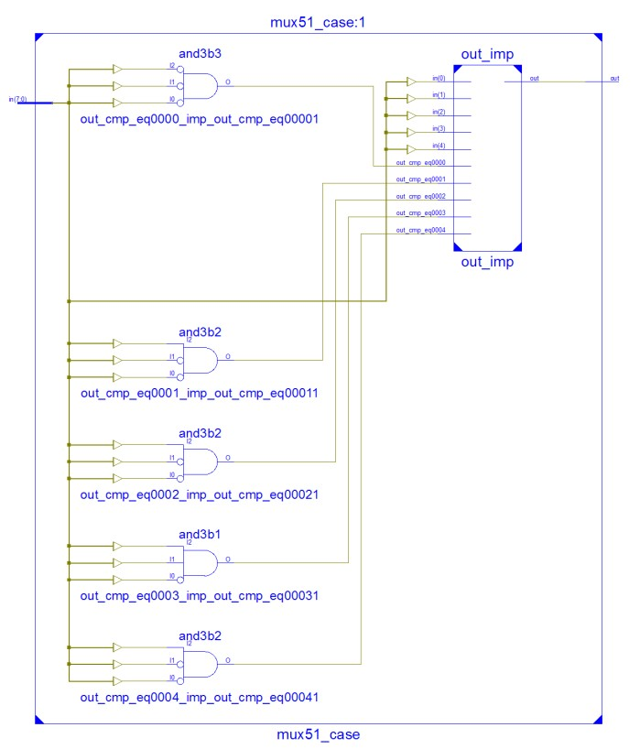

=========================================================================

* Final Report *

=========================================================================

Final Results

RTL Top Level Output File Name : mux51_case.ngr

Top Level Output File Name : mux51_case

Output Format : NGC

Optimization Goal : Speed

Keep Hierarchy : No

Design Statistics

# IOs : 9

Cell Usage :

# BELS : 4

# LUT4 : 4

# IO Buffers : 9

# IBUF : 8

# OBUF : 1

=========================================================================

Device utilization summary:

---------------------------

Selected Device : 3s100ecp132-5

Number of Slices: 2 out of 960 0%

Number of 4 input LUTs: 4 out of 1920 0%

Number of IOs: 9

Number of bonded IOBs: 9 out of 83 10%

=========================================================================

Timing constraint: Default path analysis

Total number of paths / destination ports: 13 / 1

-------------------------------------------------------------------------

Delay: 6.968ns (Levels of Logic = 4)

Source: in<6> (PAD)

Destination: out (PAD)

Data Path: in<6> to out

Gate Net

Cell:in->out fanout Delay Delay Logical Name (Net Name)

---------------------------------------- ------------

IBUF:I->O 3 1.106 0.603 in_6_IBUF (in_6_IBUF)

LUT4:I0->O 1 0.612 0.509 out27 (out27)

LUT4:I0->O 1 0.612 0.357 out69 (out_OBUF)

OBUF:I->O 3.169 out_OBUF (out)

----------------------------------------

Total 6.968ns (5.499ns logic, 1.469ns route)

(78.9% logic, 21.1% route)

1. Implement using “if” statement

module mux51_if(in, out);

parameter S = 3; //

parameter N = 1 << S; // # of cases

input [N-1:0] in;

output out;

reg out;

wire [S-1:0] sel;

assign sel[2:0] = in[7:5];

always @(*) begin

out = (sel == 3'b000) ? in[0] :

(sel == 3'b001) ? in[1] :

(sel == 3'b010) ? in[2] :

(sel == 3'b011) ? in[3] :

(sel == 3'b100) ? in[4] : 1'b0;

end

endmodule

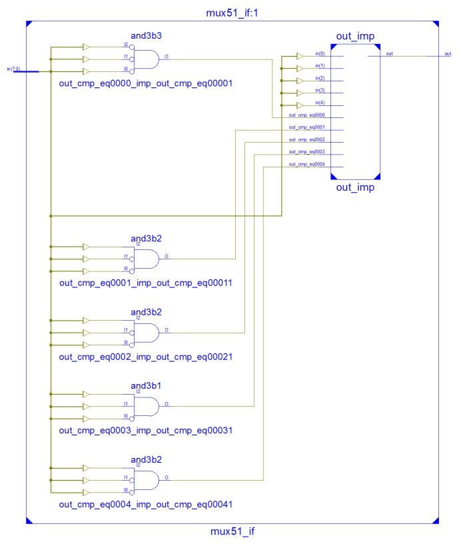

=========================================================================

* Final Report *

=========================================================================

Final Results

RTL Top Level Output File Name : mux51_if.ngr

Top Level Output File Name : mux51_if

Output Format : NGC

Optimization Goal : Speed

Keep Hierarchy : No

Design Statistics

# IOs : 9

Cell Usage :

# BELS : 4

# LUT4 : 4

# IO Buffers : 9

# IBUF : 8

# OBUF : 1

=========================================================================

Device utilization summary:

---------------------------

Selected Device : 3s100ecp132-5

Number of Slices: 2 out of 960 0%

Number of 4 input LUTs: 4 out of 1920 0%

Number of IOs: 9

Number of bonded IOBs: 9 out of 83 10%

=========================================================================

Timing constraint: Default path analysis

Total number of paths / destination ports: 13 / 1

-------------------------------------------------------------------------

Delay: 6.968ns (Levels of Logic = 4)

Source: in<6> (PAD)

Destination: out (PAD)

Data Path: in<6> to out

Gate Net

Cell:in->out fanout Delay Delay Logical Name (Net Name)

---------------------------------------- ------------

IBUF:I->O 3 1.106 0.603 in_6_IBUF (in_6_IBUF)

LUT4:I0->O 1 0.612 0.509 out27 (out27)

LUT4:I0->O 1 0.612 0.357 out69 (out_OBUF)

OBUF:I->O 3.169 out_OBUF (out)

----------------------------------------

Total 6.968ns (5.499ns logic, 1.469ns route)

(78.9% logic, 21.1% route)

1. Implement using only Spartan3E primitives that requires 2 levels of logic

// 2 levels of logic

module mux51_luts_1(in, out);

parameter S = 3; //

parameter N = 1 << S; // # of cases

input [N-1:0] in;

output out;

wire [S-1:0] sel;

wire l1, l2, l3, l4, l5;

assign sel[2:0] = in[7:5];

LUT4 #(16'h00ca) L1(l1, in[0], in[1], sel[0], 1'b0);

LUT4 #(16'h00ca) L2(l2, in[2], in[3], sel[0], 1'b0);

LUT4 #(16'h0002) L3(l3, in[4], sel[0], 1'b0, 1'b0);

LUT4 #(16'h00ca) L4(l4, l1, l2, sel[1], 1'b0);

LUT4 #(16'h0002) L5(l5, l3, sel[1], 1'b0, 1'b0);

**MUXF5 F5_1(out, l4, l5, sel[2]);**

endmodule

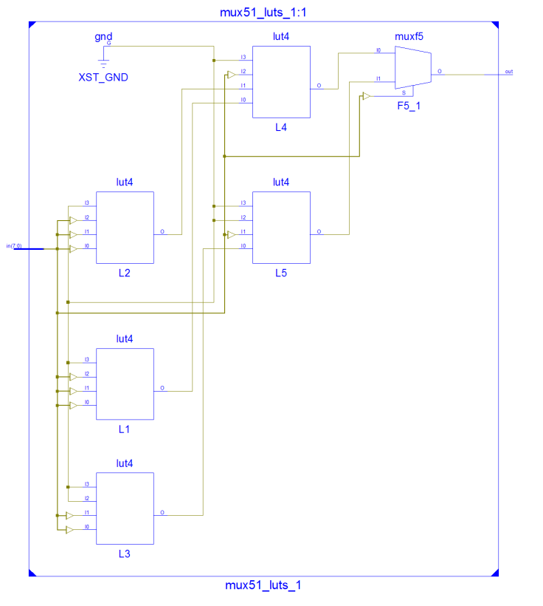

=========================================================================

* Final Report *

=========================================================================

Final Results

RTL Top Level Output File Name : mux51_luts_1.ngr

Top Level Output File Name : mux51_luts_1

Output Format : NGC

Optimization Goal : Speed

Keep Hierarchy : No

Design Statistics

# IOs : 12

Cell Usage :

# BELS : 7

# GND : 1

# LUT4 : 5

# MUXF5 : 1

# IO Buffers : 9

# IBUF : 8

# OBUF : 1

=========================================================================

Device utilization summary:

---------------------------

Selected Device : 3s100ecp132-5

Number of Slices: 3 out of 960 0%

Number of 4 input LUTs: 5 out of 1920 0%

Number of IOs: 9

Number of bonded IOBs: 9 out of 83 10%

=========================================================================

Timing constraint: Default path analysis

Total number of paths / destination ports: 11 / 1

-------------------------------------------------------------------------

Delay: 7.163ns (Levels of Logic = 5)

Source: sel<0> (PAD)

Destination: out (PAD)

Data Path: sel<0> to out

Gate Net

Cell:in->out fanout Delay Delay Logical Name (Net Name)

---------------------------------------- ------------

IBUF:I->O 3 1.106 0.520 sel_0_IBUF (sel_0_IBUF)

LUT4:I1->O 1 0.612 0.509 L3 (l3)

LUT4:I0->O 1 0.612 0.000 L5 (l5)

MUXF5:I1->O 1 0.278 0.357 F5_1 (out_OBUF)

OBUF:I->O 3.169 out_OBUF (out)

----------------------------------------

Total 7.163ns (5.777ns logic, 1.386ns route)

(80.6% logic, 19.4% route)

1. Implement using only Spartan3E primitives that requires 1 level of logic

// 1 level of logic

module mux51_luts_2(in, out);

parameter S = 3; //

parameter N = 1 << S; // # of cases

input [N-1:0] in;

output out;

wire [S-1:0] sel;

wire l1, l2, l3, l4, l5;

assign sel[2:0] = in[7:5];

LUT4 #(16'h00ca) L1(l1, in[0], in[1], sel[0], 1'b0);

LUT4 #(16'h00ca) L2(l2, in[2], in[3], sel[0], 1'b0);

LUT4 #(16'h0002) L3(l3, in[4], sel[0], 1'b0, 1'b0);

**MUXF5 F5_1(l4, l1, l2, sel[1]);**

**MUXF5 F5_2(l5, l3, 1'b0, sel[1]);**

**MUXF6 F6_1(out, l4, l5, sel[2]);**

endmodule

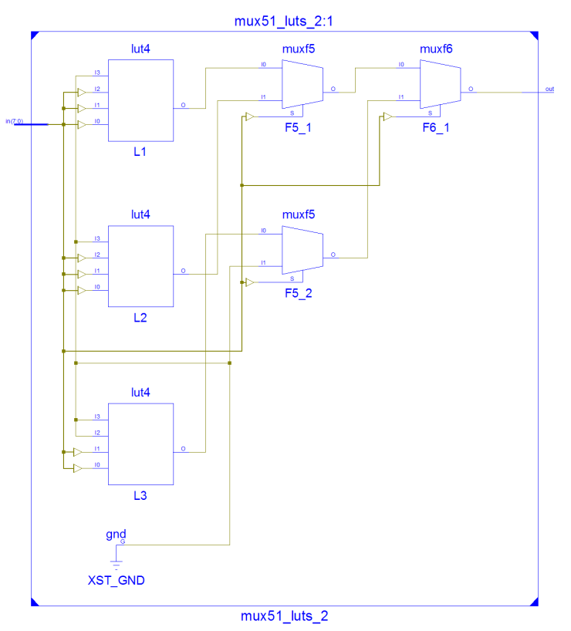

=========================================================================

* Final Report *

=========================================================================

Final Results

RTL Top Level Output File Name : mux51_luts_2.ngr

Top Level Output File Name : mux51_luts_2

Output Format : NGC

Optimization Goal : Speed

Keep Hierarchy : No

Design Statistics

# IOs : 12

Cell Usage :

# BELS : 7

# GND : 1

# LUT4 : 3

# MUXF5 : 2

# MUXF6 : 1

# IO Buffers : 9

# IBUF : 8

# OBUF : 1

=========================================================================

Device utilization summary:

---------------------------

Selected Device : 3s100ecp132-5

Number of Slices: 2 out of 960 0%

Number of 4 input LUTs: 3 out of 1920 0%

Number of IOs: 9

Number of bonded IOBs: 9 out of 83 10%

=========================================================================

Timing constraint: Default path analysis

Total number of paths / destination ports: 11 / 1

-------------------------------------------------------------------------

Delay: 6.493ns (Levels of Logic = 5)

Source: sel<0> (PAD)

Destination: out (PAD)

Data Path: sel<0> to out

Gate Net

Cell:in->out fanout Delay Delay Logical Name (Net Name)

---------------------------------------- ------------

IBUF:I->O 3 1.106 0.520 sel_0_IBUF (sel_0_IBUF)

LUT4:I1->O 1 0.612 0.000 L3 (l3)

MUXF5:I0->O 1 0.278 0.000 F5_2 (l5)

MUXF6:I1->O 1 0.451 0.357 F6_1 (out_OBUF)

OBUF:I->O 3.169 out_OBUF (out)

----------------------------------------

Total 6.493ns (5.616ns logic, 0.877ns route)

(86.5% logic, 13.5% route)

**Top Module**

module mux_top(CLK1, arst, seg, an, Led);

parameter N = 7;

parameter W = 4;

parameter S = 8;

parameter H = 14; // binary size ..9999

parameter MS = 3; // mux sel

parameter MN = 1 << MS; // mux 5:1

input CLK1, arst;

output [0:N-1] seg;

output [W-1:0] an;

output [S-1:0] Led;

wire [15:0] text, disp_text;

wire one_sec;

wire [S-1:0] num_sel;

wire selected;

wire selected1, selected2, selected3, selected4;

assign Led = num_sel;

assign selected = (selected1 == selected2 == selected3 == selected4);

assign disp_text[3:0] = {3'b0, selected};

assign disp_text[7:4] = text[3:0];

assign disp_text[11:8] = text[7:4];

assign disp_text[15:12] = text[11:8];

one_second ONE (.CLK1(CLK1), .arst(arst), .one_sec_clock(one_sec));

counter #(MN+MS) CNT (.clk(CLK1), .arst(arst), .en(one_sec), .q(num_sel));

mux51_case #(.S(MS)) MUX5_1 (.in(num_sel), .out(selected1));

mux51_if #(.S(MS)) MUX5_2 (.in(num_sel), .out(selected2));

mux51_luts_1 #(.S(MS)) MUX5_3 (.in(num_sel), .out(selected3));

mux51_luts_2 #(.S(MS)) MUX5_4 (.in(num_sel), .out(selected4));

bin2bcd #(H, W) BCD (.in(num_sel), .out(text));

display T (.text(disp_text), .clk(CLK1), .arst(arst), .seg(seg), .an(an));

endmodule

**5:1 MUX Design Comparison Table**

|  |  |  |  |  |  |  |
| --- | --- | --- | --- | --- | --- | --- |
| **Design** | **# SLICEs** | **# LUTs** | **# MUXF5** | **# MUXF6** | **# LEVELs** | **DELAY** |
| CASE | 2 | 4 | 0 | 0 | 4 | 6.968 ns |
| IF | 2 | 4 | 0 | 0 | 4 | 6.968 ns |
| 2 Levels of Logic | 3 | 5 | 1 | 0 | 5 | 7.163 ns |
| 1 Levels of Logic | 2 | 3 | 2 | 1 | 5 | 6.493 ns |

|  |  |  |
| --- | --- | --- |
|  |  |  |
|  |  |  |

**Other modules**

`timescale 1ns / 1ps

**module mod_counter(clk, arst, q, done);**

parameter N = 7;

parameter MAX = 127;

input clk, arst;

output [N-1:0] q;

output done;

reg [N-1:0] q;

reg done;

always @(posedge clk or posedge arst) begin

if (arst == 1'b1) begin

q <= 0;

done <= 0;

end

else if (q == MAX) begin

q <= 0;

done <= 1;

end

else begin

q <= q + 1;

done <= 0;

end

end

endmodule

**module one_second(CLK1, arst, one_sec_clock);**

parameter C = 26; // counter,

parameter CRYSTAL = 50; // 50MHz

parameter NUM_SEC = 1;

parameter [C-1:0] STOPAT = ((CRYSTAL * 1_000_000 * NUM_SEC) - 1) >> 1; // 0.5 sec

input CLK1, arst;

output one_sec_clock;

wire [C-1:0] clock;

mod_counter #(C, STOPAT) ONE_MC (.clk(CLK1), .arst(arst), .q(clock), .done(one_sec_clock));

endmodule

`timescale 1ns / 1ps

**module bin2bcd(in, out);**

parameter N = 14; // input size, decimal 9999 is hex 270f (14 bits)

parameter C = 4; // chunk size

input [N-1:0] in;

output [15:0] out; // bcd output

reg [N-1:0] bin;

reg [N+3:0] bcd;

reg [N+3:0] result;

assign out = bcd[15:0];

always @(*) begin

bin = in;

result = 0;

repeat (N - 1) begin

result[0] = bin[N-1];

if (result[3:0] > 4)

result[3:0] = result[3:0] + 4'd3;

if (result[7:4] > 4)

result[7:4] = result[7:4] + 4'd3;

if (result[11:8] > 4)

result[11:8] = result[11:8] + 4'd3;

if (result[15:12] > 4)

result[15:12] = result[15:12] + 4'd3;

result = result << 1;

bin = bin << 1;

end

result[0] = bin[N-1];

bcd <= result;

end

endmodule

`timescale 1ns / 1ps

**module counter(clk, arst, en, q);**

parameter N = 7;

input clk, arst, en;

output [N-1:0] q;

reg [N-1:0] q;

always @(posedge clk or posedge arst)

if (arst == 1'b1)

q <= 0;

else if (en)

q <= q + 1;

endmodule

**module hex2_7seg_lut(in, out);**

input [3:0] in;

output [6:0] out;

LUT4 #(16'h2812) CA (out[6], in[0], in[1], in[2], in[3]); // a

LUT4 #(16'hd860) CB (out[5], in[0], in[1], in[2], in[3]); // b

LUT4 #(16'hd004) CC (out[4], in[0], in[1], in[2], in[3]); // c

LUT4 #(16'h8492) CD (out[3], in[0], in[1], in[2], in[3]); // d

LUT4 #(16'h02ba) CE (out[2], in[0], in[1], in[2], in[3]); // e

LUT4 #(16'h208e) CF (out[1], in[0], in[1], in[2], in[3]); // f

LUT4 #(16'h1083) CG (out[0], in[0], in[1], in[2], in[3]); // g

endmodule

// for MUX4:1

**module decoder(text, s, y, val) ;**

input [15:0] text;

input [1:0] s ;

output reg [3:0] y ;

output reg [3:0] val ;

always @(*) begin

case (s)

0: begin

y <= 4'b1110 ;

val <= text[3:0] ;

end

1:begin

**y <= 4'b1111;**

val <= text[7:4] ;

end

2:begin

y <= 4'b1011 ;

val <= text[11:8] ;

end

3: begin

y <= 4'b0111 ;

val <= text[15:12] ;

end

default:begin

y <= 4'bx ;

val <= 4'bx ;

end

endcase

end

endmodule

// for MUX5:1

**module decoder(text, s, y, val) ;**

input [15:0] text;

input [1:0] s ;

output reg [3:0] y ;

output reg [3:0] val ;

always @(*) begin

case (s)

0: begin

y <= 4'b1110 ;

val <= text[3:0] ;

end

1:begin

y <= 4'b1101;

val <= text[7:4] ;

end

2:begin

y <= 4'b1011 ;

val <= text[11:8] ;

end

3: begin

y <= 4'b0111 ;

val <= text[15:12] ;

end

default:begin

y <= 4'bx ;

val <= 4'bx ;

end

endcase

end

endmodule

**module display(text, clk, arst, seg, an);**

parameter C = 26; // counter,

parameter N = 7; // seven segment

parameter W = 4;

parameter S = 2;

parameter ANODE_FREQ = 19;

input [15:0] text;

input clk, arst;

output [0:N-1] seg;

output [W-1:0] an;

wire [C-1:0] q;

wire [S-1:0] sel;

wire [W-1:0] zero_to_f_counter;

assign sel[1] = q[ANODE_FREQ];

assign sel[0] = q[ANODE_FREQ - 1];

counter #C DISP_C (.clk(clk), .arst(arst), .en(1), .q(q));

decoder DISP_D (.text(text), .s(sel), .y(an), .val(zero_to_f_counter));

hex2_7seg_lut DISP_H (.in(zero_to_f_counter), .out(seg));

endmodule