4357. Embedded Firmware Essentials

Homework #4

Jae Yang Park ([jaeyangp@gmail.com](mailto:jaeyangp@gmail.com))

**Debug with CMSIS-DAP using pyOCD**

Python and pyOCD installation

Python

$ sudo apt-get install python libusb-1.0.0-dev libncurses5:i386

Update USB setting to get non-root access to DAP

$ sudo sh –c ‘echo SUBSYTEM==\”usb\”, ATTR{idVendor}==\”0d28\”, ATTR{idProduct}==\”0204\”, MODE:=\”666\” > /etc/udev/rules.d/mbed.rules’

$ sudo /etc/init.d/udev restart

Download pyusb and pyOCD

$ git clone <https://github.com/walac/pyusb>

$ cd pyusb

$ sudo python setup.py install

$ cd ..

$ git clone <https://github.com/mbedmicro/pyOCD>

$ sudo python setup.py install

pyOCD test

$ python test/basic_test.py

**Debugging homework 4**

Target source code (from quiz 4)

/*

* Enter a hex number [0-9a-fA-F]; Decode it in 4-bit binary format and display them on 4 on board leds.

*/

#include "mbed.h"

Serial pc(USBTX, USBRX); // tx, rx

DigitalOut ledArr[4] = {DigitalOut(LED1), DigitalOut(LED2), DigitalOut(LED3), DigitalOut(LED4)};

void DisplayLed(int ch)

{

int i=0;

if (ch>='0' && ch<='9')

ch-='0';

else if (ch>='A' && ch<='F') {

ch-='A';

ch+=10;

} else if (ch>='a' && ch<='f') {

ch-='a';

ch+=10;

} else

ch=0;

for (i=0; i<4; i++) {

if(ch& (1<<i))

ledArr[i] = 1;

else

ledArr[i] = 0;

}

}

int main(void)

{

int ch;

pc.baud(9600);

pc.printf("\r\nHello World!");

while(1) {

pc.printf("\r\nEnter:");

ch = pc.getc();

pc.putc(ch);

DisplayLed(ch);

}

}

Terminal 1:

$ sudo python test/gdb_server.py

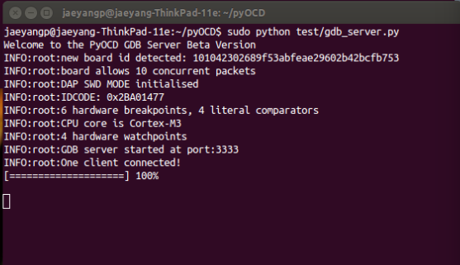

Terminal 2: (minicom, 9600, n, 8, 1, /dev/ttyACM0)

$ sudo minicom

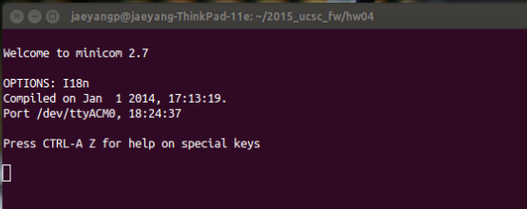

Terminal 3:

$ arm-none-eabi-gdb hw04.elf

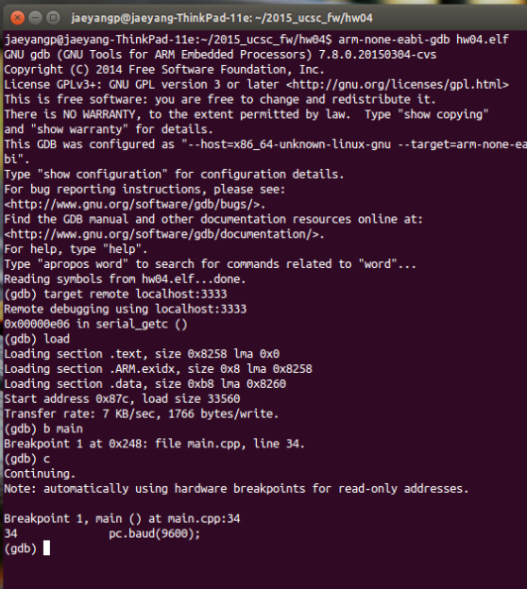

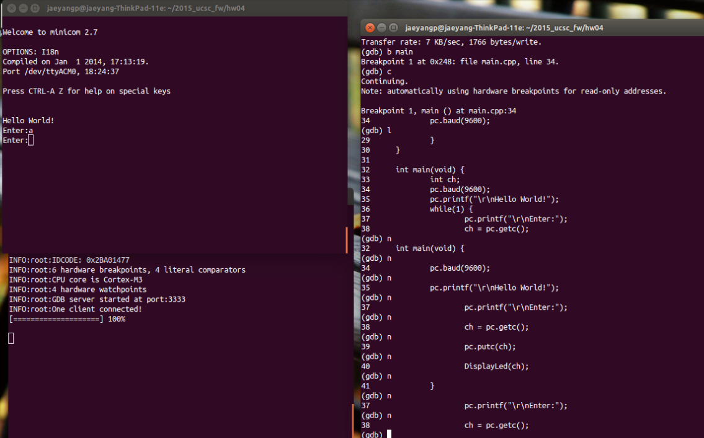

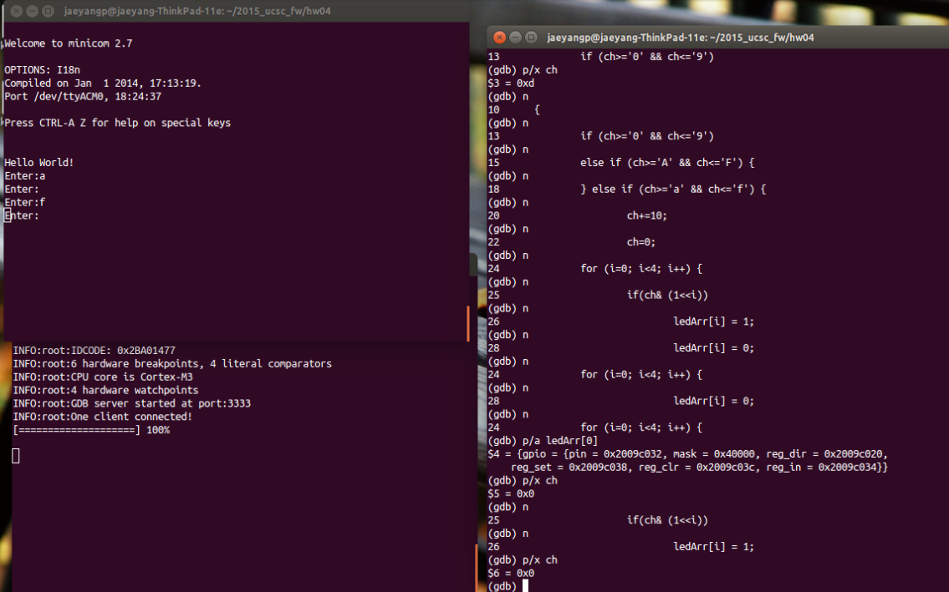

**What I learned from this:**

CMSIS-DAP, SWD, pyOCD, How to debugging Cortex-M



**Total spent hours: 3.5 hours**

* Python and pyOCD installation and test: 0.5
* Debugging code with pyOCD: 1
* CMSIS-DAP, pyOCD and GDB study: 1
* Report: 1