1. Try making the game run with all the correct indentations. Refactor the draw function to move
2. Try the 4 questions on pdf page 237
   1. DELAY THE GAME START
      1. Use the non blocking delay tkObject.after()
   2. A PROPER “GAME OVER”
   3. ACCELERATE THE BALL
   4. PREVENT PADDLE GOING OUT OF BOUNDS
   5. RECORD THE PLAYER’S SCORE
   6. GIVE THE PLAYER FINAL SCORE
   7. PADDLE GETS SMALLER
   8. PADDLE MOVE ONLY WHEN YOU HOLD
   9. WARNING FOR SPEEDING UP THE BALL
   10. POWER UPS
       1. BIGGER PADDLE
       2. plus 10 points
       3. SLOW MOTION BALL FOR 5 SEC. Didn’t do it. We thought 2 power ups are good enough
   11. background images
   12. reduce the time delay 0.01 in the loop to 0.005 seconds i think thats what’s making the bug happen

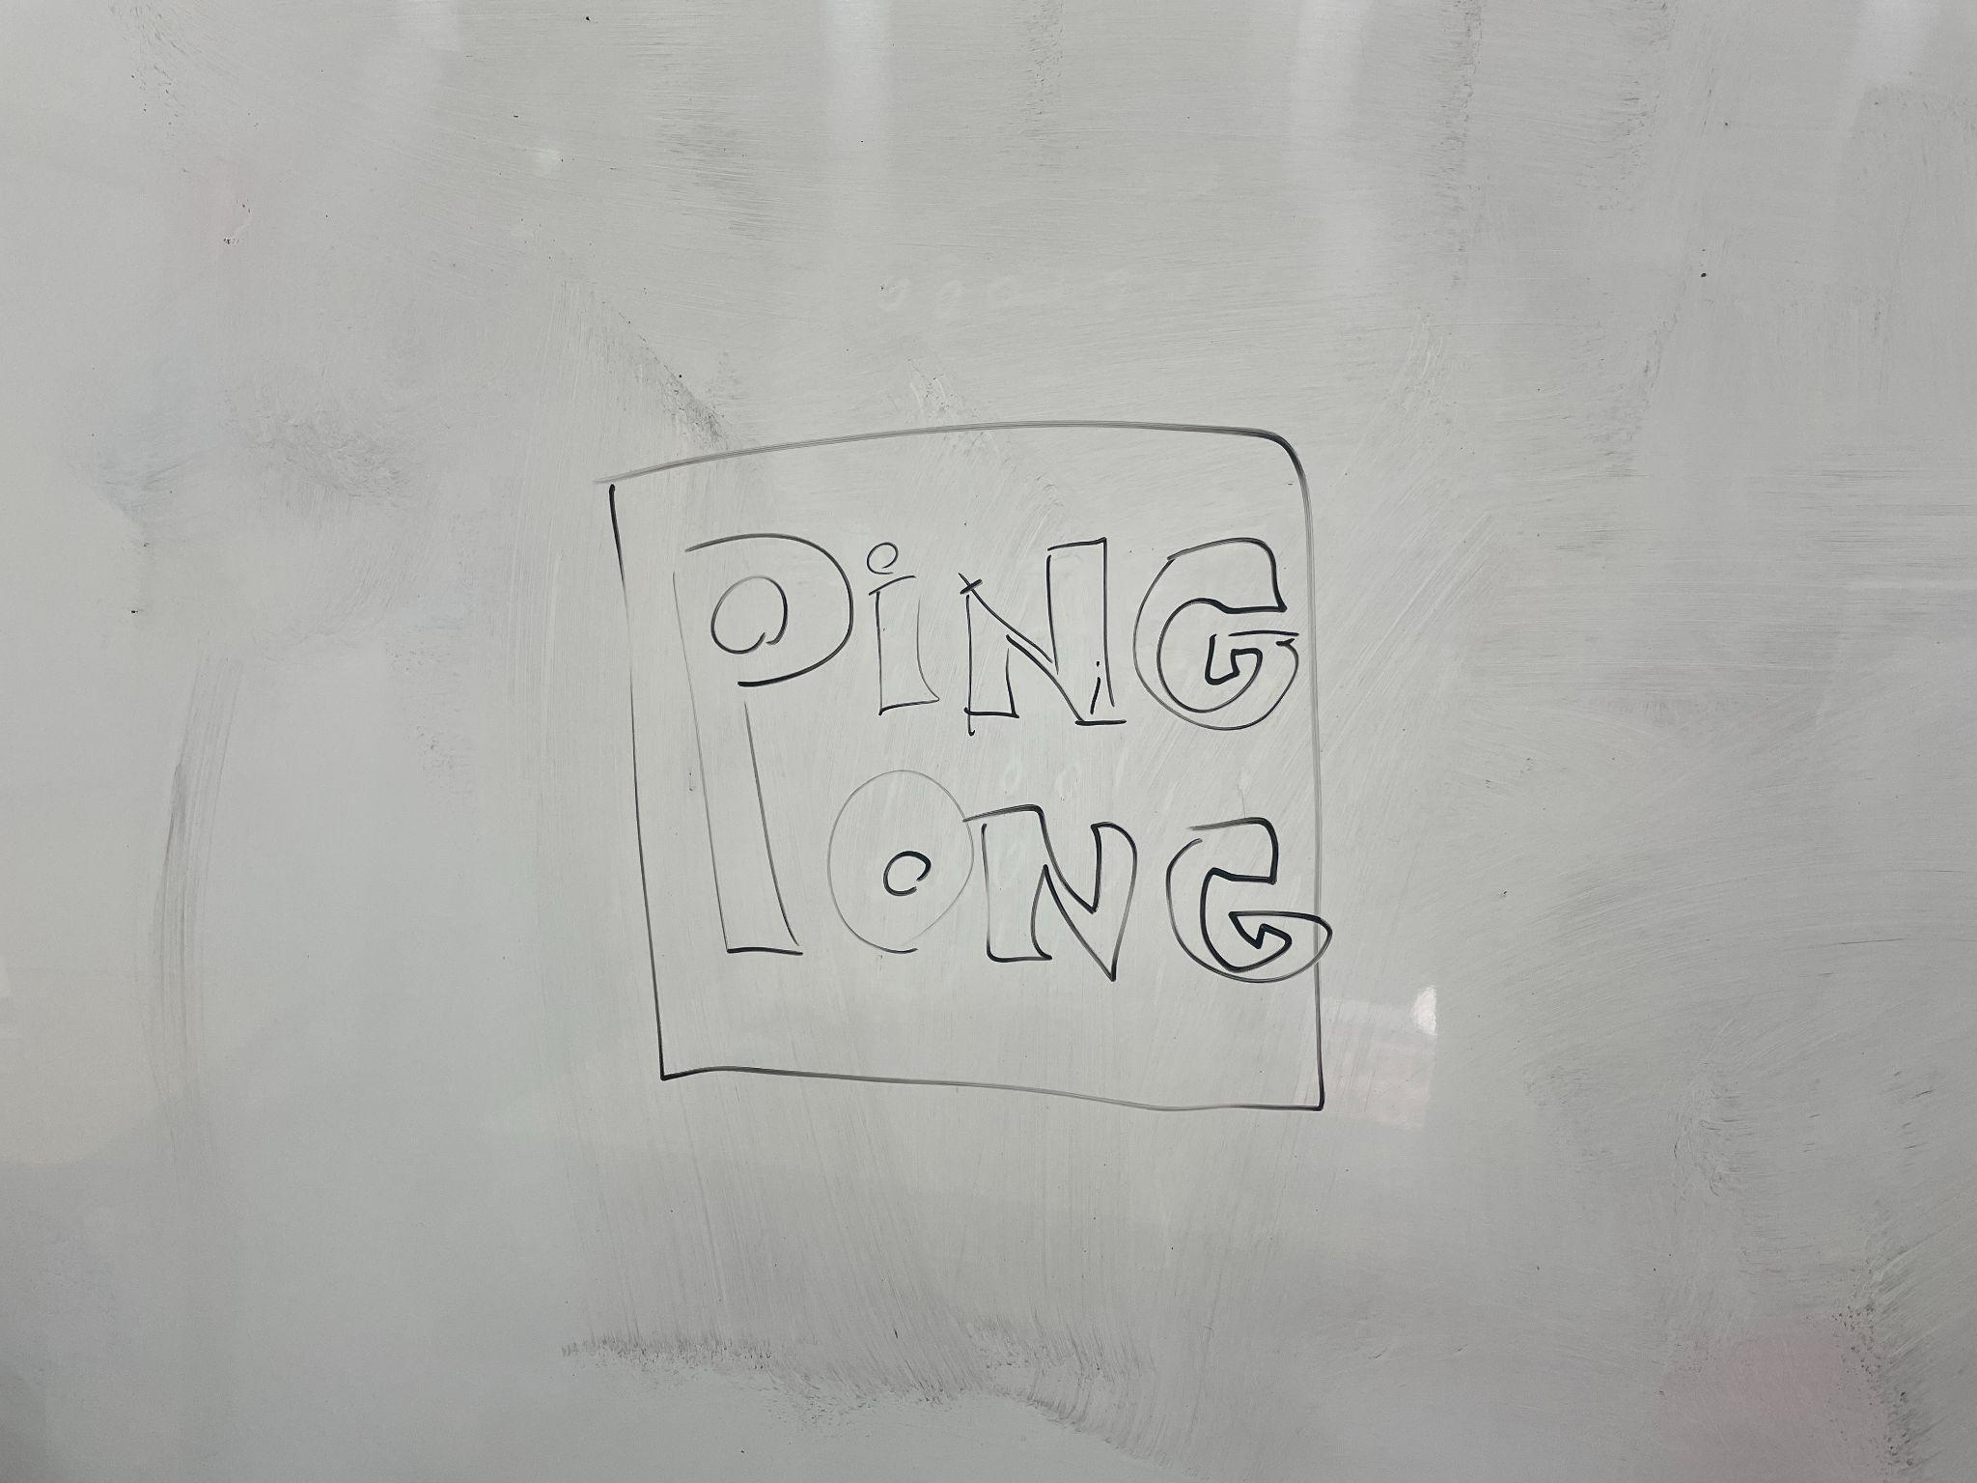

falling method for power up class