AHEAD AI Agent — MVP Architecture

1. The Problem
The current DQ pipeline is fully manual: R scripts run offline on UNICEF laptops, output flagged Excel files, which then kick off a long cascade up and down the hierarchy until corrections are made. Not only does this make it extremely difficult to pinpoint where the process is at a given moment or to track and follow up in a timely manner, it also doesn't scale and leaves the door open for errors to go unresolved for weeks. The goal of the AI agent is to automate this loop — catch errors close to the source, notify the right person immediately, and only escalate what genuinely can't be resolved at the facility level.

Current workflow (as-is)
The diagram below shows the existing manual process. The AI agent replaces steps 2–12 — the Excel production, email cascade, and manual phone outreach — with an automated, real-time notification and correction loop.
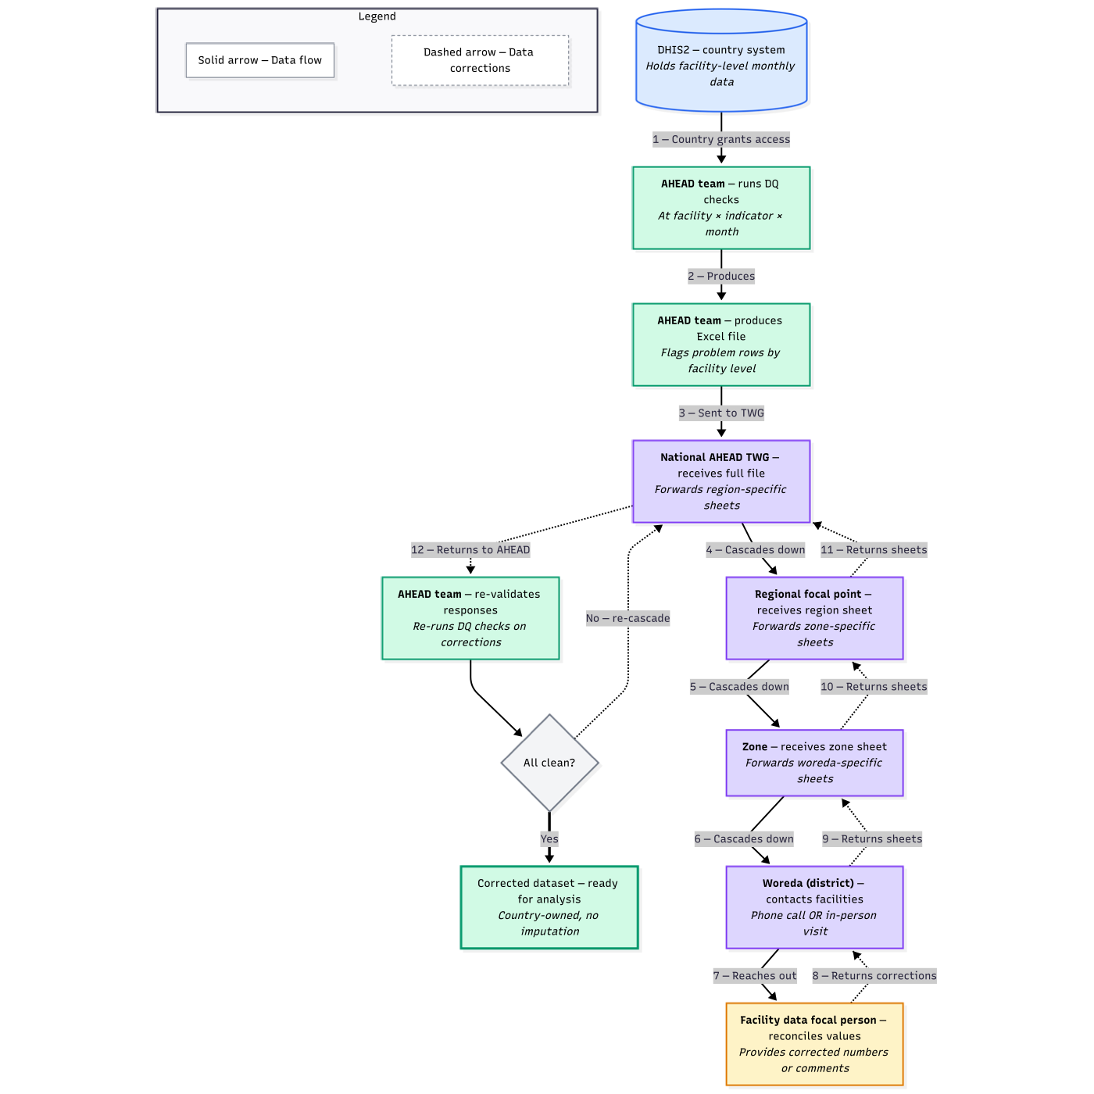

2. Where the AI Agent Fits
The agent runs post-commit — after data lands in DHIS2 — and works in two parallel modes: it checks new submissions as they come in, and separately runs a daily scan for facilities that never submitted at all.
Facility submits EPI form
│
▼
DHIS2 datavalue table ← data written immediately
│
▼ API poll every x minutes/hours
┌────────────────────┐ ┌─────────────────────────────┐
│ DQ ENGINE │ │ DAILY CRON │
│ (on new submit) │ │ (missing report check) │
└────────┬───────────┘ └──────────────┬──────────────┘
│ issues found? │ facility did not submit?
└──────────────┬──────────────────┘
▼
Assign reference ID (e.g. DQ-AX42)
Notify facility via SMS
│
▼
┌──────────────────────────────┐
│ CASCADE STATE MACHINE │
│ tracks each open issue │
└──────────────┬───────────────┘
│
resolved? ────┤──── 3 days unresolved?
↓ │ ↓
close │ escalate → woreda
│ │
│ 1 week unresolved?
│ ↓
│ escalate → region
│ │
│ end of month?
│ ↓
│ national summary
│
all events logged to Data Issue Log (standalone web page)
One important nuance on the cascade: catching errors at submission time would reduce escalation volume significantly, but it does not eliminate the cascade entirely — and for the MVP, attempting to intercept at submission time introduces more complexity than it's worth. Pre-submission checking requires a custom DHIS2 front-end app that intercepts the form before the API call, which is substantial development effort. The more practical approach is to run checks immediately post-commit, within minutes of data landing in DHIS2, which achieves the same outcome without needing to modify DHIS2 itself.
Three cases still require escalation even with near-real-time post-commit checks: (1) missing reports — if no one submits, there is nothing to check; (2) dismissed warnings — the submitter can acknowledge a flag and submit anyway; (3) systemic patterns — some anomalies only become visible when looking across multiple facilities at the woreda or zone level, not from a single submission.
It is also worth noting that in practice, the submission flow does not always follow the administrative hierarchy as drawn. Facilities often collect data on paper and pass it to the Woreda HMIS officer, who is the one actually entering it into DHIS2 on their behalf. In those cases the Woreda is both the submitter and the first escalation contact, and the cascade hierarchy may look different from what the diagram above suggests.

3. DQ Engine

Origin of the four checks
These four checks are not from the EPI metadata package — they come from AHEAD's existing DQ methodology, currently implemented as R scripts that run offline. The EPI package does have its own built-in validation rules (the 'Run Validation' button in DHIS2 Data Entry), but those are more basic plausibility checks within a single form. What we're automating here is the broader, cross-facility analysis the AHEAD team already runs manually.

Check | Method | Flag condition
Missing report | Daily cron queries DHIS2 completeness endpoint | Facility has no submission by day 5 of the following month
Statistical outlier | 5 methods in parallel: SD, MAD, Median AD, Lowess, Abs diff from mean | 4+ methods flag = strong (notify immediately); 1–3 = weak (batch to weekly review). Thresholds configurable.
DTP1/DTP3 consistency | Compare Penta1 vs Penta3 for same facility-period via DHIS2 API | Penta3 > Penta1 is implausible. Thresholds vary by level: facility >30%, woreda monthly >20%, woreda annual >15%.
Name consistency | Fuzzy match admin1/admin2 pairs against reference gazetteer | Record count below expected max for that admin pair

R code reuse strategy
Rather than rewriting the statistical logic in Python, the plan is to reuse the AHEAD team's existing R scripts directly. The Python agent pulls data from DHIS2, formats it as CSV, calls the R script as a subprocess, and reads the flagged output.
DHIS2 API → Python pulls data → formats as CSV
│
Rscript dq_checks.R --input data.csv
│
Python reads flags.json
│
Creates issue objects → cascade
The main prerequisite is getting access to the existing R scripts. A quick read-through to assess how modular they are is the most important de-risking step before starting the DQ engine build.

4. Two-Way SMS Conversation Loop

Communication channel decision
For MVP, we are starting with SMS only. WhatsApp is the more natural channel for most users but requires Meta Business API approval which can take 1–4 weeks and is a real timeline risk. Email reply parsing is also noisier in practice (quoted text, auto-signatures, threading). SMS works immediately with no approval process, works on basic phones without internet — which matters for rural facility workers — and the forced brevity is actually useful here. The conversation logic itself is channel-agnostic, so WhatsApp and email can be added in Phase 2 without changing any of the underlying state machine.

Reference IDs
Every issue gets a short reference ID when it is created (e.g. DQ-AX42). The ID only uses characters that are visually unambiguous — no 0/O, 1/I/L, 2/Z — so there is no confusion when reading it off a phone screen. It appears in every outbound message and is used to match inbound replies back to the right issue. This solves two problems cleanly:
- If a facility has multiple open issues, the reference ID makes clear which one is being addressed
- It acts as a lightweight token — random enough to be hard to guess, which prevents spoofed replies

Conversational confirmation flow
The agent does not apply corrections automatically. It proposes the change and asks for confirmation first. If the facility worker gives a different number than the agent expected, or corrects the agent mid-conversation, the agent adapts without requiring them to start over. The goal is for this to feel like a natural back-and-forth, not a rigid command interface.
Agent → "[ DQ-AX42 ] Limalimo HP, Apr 2026: BCG <1yr = 350
(normal range 30-45, ~10x high). Was this an error?
Reply with the correct value or KEEP to leave as-is."
Facility → "35"
Agent → "[ DQ-AX42 ] Confirm: change BCG <1yr at Limalimo HP
(Apr 2026) from 350 to 35.
Reply YES to apply or NO to cancel."
Facility → "no wait, should be 53"
Agent → "[ DQ-AX42 ] Got it — so the correct value is 53?
Reply YES to apply 53 or send the correct number."
Facility → "YES"
Agent → "[ DQ-AX42 ] Done — BCG <1yr updated to 53.
Issue resolved. ✓"
An LLM parses inbound replies to extract the intended corrected value from free text. This handles messages like "oh that was a typo, should be 53" without requiring the facility worker to follow a structured format. Hallucination risk is low here because the task is extracting a specific number from a very bounded context — it is not open-ended generation.
Conversation state | Trigger | Agent action
notified | Issue created | Send initial SMS with reference ID
awaiting_confirm | Facility replies with a value | Propose specific change, ask YES/NO
resolved | Facility replies YES | Apply fix to DHIS2 via API, close issue, log
dismissed | Facility replies KEEP | Leave value as-is, close issue, log
retry | No reply after 24h (×3) | Re-send notification
escalated | 72h no resolution | Hand off to woreda HMIS officer

5. Data Issue Log (Standalone Web Page)
All issues, SMS conversations, and resolution actions are logged and viewable on a standalone web page. It is separate from DHIS2 — it reads from the agent's own database — but would be the primary place for supervisors and the AHEAD team to monitor what the agent is doing and intervene if needed.
Column | Description
Ref ID | e.g. DQ-AX42
Issue type | outlier / missing report / DTP inconsistency
Facility | Facility name and woreda
Period | e.g. Apr 2026
Flagged value | The value that triggered the check
Resolved value | What it was corrected to (if resolved)
Status | notified / awaiting_confirm / resolved / escalated
Conversation | Full SMS thread (expandable)
Opened / Resolved | Timestamps

Embedding this as a proper DHIS2 app (React, DHIS2 App Framework) is a Phase 2 improvement.

6. Technical Stack
Layer | Technology | Rationale
DQ checks | AHEAD DQ R scripts (called via Python subprocess) | Reuses validated logic directly; no statistical reimplementation risk
Agent orchestration | Python | Glue layer: poll DHIS2, call R, manage state, send SMS, apply fixes
LLM | Claude API (claude-haiku-4-5 for parsing, sonnet for generation) | Parse free-text replies; generate context-aware notification messages
DHIS2 integration | DHIS2 REST API only (GET dataValueSets, POST dataValueSets) | No DHIS2 internals modified; agent reads and writes via the same API as any user
State + audit log | SQLite (MVP) → PostgreSQL (production) | Tracks issue lifecycle and full conversation history; survives restarts
SMS | Twilio | SMS only for MVP; WhatsApp and email are Phase 2 (same logic, different transport)
Inbound webhook | Flask (receives Twilio SMS webhook) | Routes inbound SMS to the correct open issue via reference ID
Issue log page | Flask (standalone web page) | Displays all issues, statuses, and conversation threads
Scheduler | APScheduler | Daily missing report cron; retry timers; monthly summary
Deployment | Docker Compose (same host as DHIS2) | No new infrastructure; agent container added to existing compose file

7. Feasibility Assessment
Component | Effort | Risk | Notes
DQ engine (R script reuse) | Low | Low | Subprocess wrapper only; core logic already exists in R
Missing report detection | Low | Low | Simple completeness query against DHIS2 API
Cascade state machine | Medium | Low | Standard pattern; main work is timer and retry logic
Outbound SMS (Twilio) | Low | Low | Twilio SMS is straightforward; live in minutes
Inbound SMS webhook + ref ID match | Low–Medium | Low | Flask webhook + reference ID routing is simple and reliable
LLM reply parsing | Low | Low | Bounded extraction task; low hallucination risk
Apply fix to DHIS2 | Low | Low | POST /api/dataValueSets with corrected value
Standalone issue log page | Low | Low | Simple Flask page over SQLite; no DHIS2 app framework needed
WhatsApp / email (Phase 2) | Medium | Medium | Meta approval takes weeks; email reply parsing is noisier
Pre-commit DHIS2 app (Phase 2) | High | Medium | Requires custom React app in DHIS2 App Framework

8. MVP Scope

In scope
- Post-commit DQ checks reusing the existing R scripts: all four checks — outlier detection, DTP1/DTP3 consistency, missing report, and name consistency
- Full cascade: facility → woreda → zone → region → national
- Two-way SMS with reference IDs and a conversational confirmation loop before applying any fix
- Structured response options per check type (matching the existing Excel dropdown options)
- LLM parsing of free-text replies and generation of notification messages
- Agent writes confirmed corrections back to DHIS2 via the standard API
- Re-validation: after corrections are applied, re-run all checks on the corrected data
- Standalone Data Issue Log page showing all issues, conversations, and resolution history
- Configurable thresholds via a config file — no hardcoding

Out of scope for MVP — Phase 2
- WhatsApp and email channels
- Pre-commit interception (requires a custom DHIS2 React app)
- Embedding the issue log as a native DHIS2 app
- Inbound phone call routing

9. Open Questions
- Access to the existing R scripts — reviewing them is the most important prerequisite before building the DQ engine
- Reporting deadline — what day of the following month triggers the missing report flag?
- Contact registry — do facility workers have registered mobile numbers, or is there a shared facility phone? Who owns and maintains that list?
- Dismissed warnings — if a facility acknowledges a flag but submits the original value anyway, should that automatically escalate to the woreda?
- Post-commit vs. pre-commit — is post-commit notification (within minutes of submission) acceptable for the MVP, or is blocking the form before submission a hard requirement?
- SMS language — should messages go out in Amharic, English, or both?

