https://www.freelancer.com/contest/article-fro-fund-raising-1179424.html

A Step out for the Future Tanzania

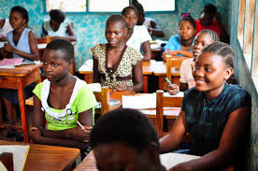

Tanzania is one of the developing countries in Africa. All walks of lives of Tanzania dreams to see our country developed. To ensure development of a country rural education is a must especially the women education is very much needed, women and children development is necessary.

How many of us know about the condition of young girls who study in Dar es Salam. They are the student of different universities. How they continue their studies. How do they continue their lives in the town when they must take care of the family members living the rural areas by sending money? How do they do that?

Let’s look at the real situation what happens internally.

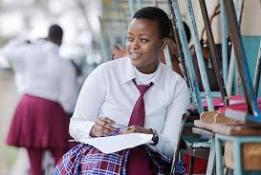

They must continue their studies because they know that without better study they don’t get good job. Their parents are poor and most of them live in the rural areas. For running their study they don’t have any alternative earnings while they must pay for the universities for their study. As a result getting no alternative they involved themselves in different sexual activities to earn not only for themselves but also for the university payment and family help.

Many girls go to the capital city for higher studies. At the beginning their family can support them and provide them with money. But for want economic insolvency the family can’t support them the money they need. In this situation they are at a loss. They can’t leave their study and they can’t have also earning source so what to do. They struggle to sustain themselves.

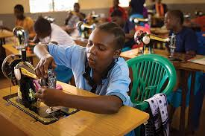

For the want of money they are obliged to do any type of work. But when work is not available, they tend to sexual work to keep themselves on the track of university study.

Many of the girls are connected with illegal brothels to earn. They become successful to earn but the after consequence become very dangerous. They become involved in it in different hotels and unknown brothels. There they are roughly used by the customers without considering their health risk. Most of them by continuing these activities they are injurious to health and suffer different types of sexually transmitted diseases. Most of them don’t have option to take treatment to the doctors because of secrecy. And gradually they become the worst sufferers and they suffer mentally and physically.

They become physically assaulted. Sometimes they are treated inhumanly by their customers. Often they are blackmailed and harassed by the police and miscreants. They don’t get legitimate help from administration.

If this situation continues a girl become emotionally depressed and she also physically suffer from various sexually transmitted diseases. At last she must leave the study and nothing to do to help herself.

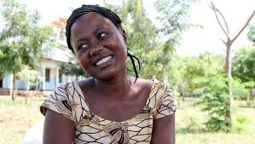

In the same way girls who go to household works in the town to get better salary they also in the household become vulnerable to sexual attack. Sometimes they become victim of unwilling pregnancy. They have to face abortion and also face health hazard and risk.

In brothels most of the times there is no protection in sexual mating. So most of the women easily victim of HIV. Ultimately they die an unnatural death.

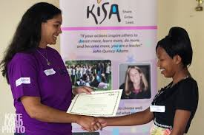

There are so many solvent people in Tanzania. They should step out to help those helpless who are may be the asset of the country. If all the humanitarian group, the solvent people and even the general people help in this matter, the situation may be different. If they get proper support from us they may be the asset of the country. The women of the country will be empowered that will be a good attempt for the future Tanzania

At first we should make lists of those types of helpless girls who come to the capital or any other big town to study and to build future, we should come forward to helping them. The future of the girls means the future of Tanzania.

I have a wish to create a social group. We hope to create a fund and raise the fund from all walks of lives to strengthen the women folk.

Top of Form

Bottom of Form

TANZANIA has a growing number of street children who are often harassed and sexually assaulted by security agents including the police. A research made by ILO/IPEC in 1998 shows that there were about 4,500 street children in Dar es Salaam at that time.  
  
Many young girls are moved from rural Tanzania to urban areas for domestic service or other exploitative undertaking. And there is the warped belief that the girls are free from HIV/AIDS. So, sexual abuse of child domestic workers is increasing. Indeed, Commercial Sexual Exploitation of Children (CSEC) is a growing problem in most urban areas in Tanzania due to acute poverty, another research commissioned by the International Labour Organization (ILO) and the International Programme on the Elimination of Child Labour (IPEC) has shown.  
The upper is article from paper   
  
I want you to create a perfect fundraising campaign for kickstater . indiegogo, fundly ,pateron and other website   
My name is Dr kartik charan and my friends few days back I meet a girl who is student and also sex worker . I asked her why are you doing this than she told me we have no other option and we have to study so we can get job in future. we have to send money to parents because we are from poor family .Than meet others they all came from different places of Tanzania to big city DAR es salaam for good job and studies so they can have good life after studies . initially they come here to have job in DAR es salaam from there villages and small towns but they didn't get job and turned in sex workers which they didn't like at all . They want to study but the fees is high here and they cant afford it. so by prostitution they deposit there fee . so from last few's days i cant sleep . I want to do something for them so first i given the money which i have but that is not enough for them ,so decided to emailed every big organization like human rights and other social worker to famous personality and stars , musician because they have lot of fans and they can do it easily. I dint got any reply from them . I cant wait so decided to create campaign i dont know it will be successful or not .i will do my best . some of them even cant complete there studies because they die from HIV and they are going from lot of pain mentally , emotionally .so any one who can help me to create a article ,poster , logo . video . website anything which he or she capable of doing i am thankful to them .I dint have money right now in my account there is 17 $ in freelancer so i will give that to you that all i have right now. i am not professional i cant create myself i need your help . you thing its non of my business someone have to take responsibility i am ready to take even its costs me my life or career . please try to help me professionals . so i can raise fund for there education and basic needs there are lot of them i alone cant do this please help me my sister and brother with your creative ideas .They are our sisters so please help to create fundraising article. i thought name should be STEP OUT you can also suggest me . i love to have you to be part of this team for change ,what ever we can do if we can save one that also counts. i will not stop .. i will do whatever i can do .please help me   
i want to write more but i dont know how to write professionally .. right now also this time they are suffering the physical abuse .so started searching for freelancer who can help . you can msg me on whats app or freelancer messenger waiting for your help my number is +255682139001 there are many mistakes in my description so sorry for that try to understand

**Supported Submission File Types**

MOV, MPEG, FLV, AVI

[**Post a Contest like this**](https://www.freelancer.com/contest/create.php?from=ContestRepost&contestId=1179424)