**DOCUMENTATION**

* **TASK:**

Break-through is a two-player game, played on a board consists of n x n fields. Each player has 2n dolls in two rows, placed on at the player’s side initially (similarly to the chess game, but now every dolls of a player look like the same). A player can move his doll one step forward or one step diagonally forward (can’t step backward). A player can beat a doll of his opponent by stepping diagonally forward onto it. A player wins when his doll reaches the opposite edge of the board. Implement this game, and let the board size be selectable (6x6, 8x8, 10x10). The game should recognize if it is ended, and it has to show in a message box which player won. After this, a new game should be started automatically.

* **UML CLASS DIAGRAMS:**

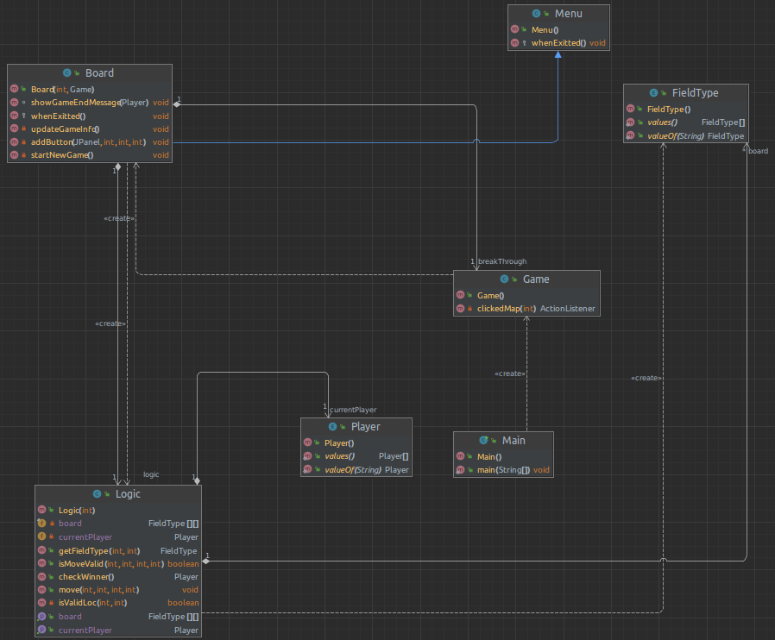

* **Testing:**

1. Player Black wins
2. Player White wins