User Stories

1. **Point a place**

User U1 want let U2 know where (s)he is. U1 can sent his current position to u2. The position can be get from two ways:

1. GPS
2. U1 generates it by point a place in Map.

Activity specification:

SA.1.A.1 UserA connected to Server.

SA.1.A.2 UserA find friends in the Server

SA.1.A.3 If UserA open dialog to UserB

SA.1.A.4 UserA send button (where am I).

SA.1.A.5 UserB get the message notification

SA.1.A.6 UserB accept the message and the his screen will jump to UserA’s position.

Web Server/ point comm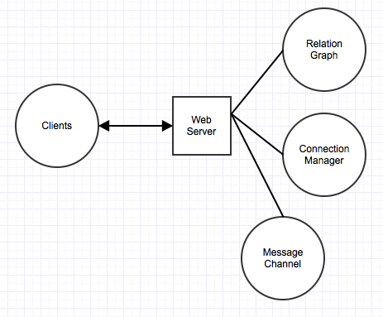unicator / friend-ship storage/ user status