SRUServer



Version 1.0 draft

Copyright Oxford University and the JISC

Version History

Version | Comments
1.0 Draft | Initial version for review

Changes since last version

Omissions

Document Details

Author | Andrew Foster
Owner | Matthew Dovey
Distribution | Adrian Cuthbertson

References

ID | Description | Reference
Table of Contents

1. Introduction 5
1.1. Purpose of Document 5
1.2. Scope 5
1.3. Overview 5
2. Research 6
2.1. Reload Editor 6
2.2. LionShare 6
2.3. LimeWire 7
2.4. ITunes 7
2.5. Research Conclusion 7
3. Desktop Client Overview 9
3.1. My Library tab 9
3.1.1. Screenshot 9
3.1.2. List Relationships 11
3.1.3. Manipulating resources in lists 11
3.2. Search tab 14
3.2.1. Screenshot 14
3.2.2. Search Criteria Panel 14
3.2.3. Results Panel 15
3.2.4. My List Panel 16
3.3. Desktop Client Main Menu 17
3.4. Add Resources Dialog 18
3.4.1. Screenshot 18
3.5. Create List Dialog 19
3.5.1. Screenshot 19
4. Design 22
4.1. Philosophy 22
4.2. Supporting technology 23
4.2.1. Glazed Lists 23
4.2.2. Apache Xerces 24
4.2.3. Apache FOP 24
4.3. Model Layer 25
4.3.1. MDCStyle 26
4.4. View Layer 27
4.4.1. Windows 27
4.4.2. Panels 28
4.4.3. MDCModelUpdateListener Interface 30
4.4.4. Utility Classes 31
4.4.5. GUI Models 32
4.4.6. Adding and Removing columns 33
4.5. Control Layer 35
4.5.1. Handling Resource Item Button Clicks 37
4.5.2. Event Lists in controllers 37
4.5.3. Maintaining Synchronisation 38
4.5.4. Utility Classes 40
4.6. Persistency Layer 41
4.6.1. Loading and saving the users library 41
4.6.2. Importing and exporting lists 43
4.6.3. Applying styles 45
4.6.4. Performing an on-line search 47
5. Appendix 48
5.1. Example Mods Transfer File 48

Introduction

Purpose of Document

The purpose of this document is to:

- Describe the basic design for the SRU server
- Configuration of SRU server
- Outline what has been tested
- List omissions and future work

SRU Overview

The goal of the SRUServer is to provide a simple way to provide SRU access to any SRW server and to return the resulting XML back to the caller. This is done through a configurable Servlet that can be instantiated against any SRW server.

The other major goal was to try and make the implementation as simple as possible to upgrade should the SRU or SRW specification change.

SRU Design

The SRU server’s main goals were:

- to provide a simple method of configuration as to the SRW server supported
- to make implementation simple to understand
- provide a mechanisms to support new versions of the SRU and SRW protocols with minimal change

When considering how to allow future versions two options were considered

- A fully customisable XML configuration file that describes all the parameters that an SRU operation supports for a particular version.
- An XML configuration file that specifies a class that supports the operation for a given version of the protocol

Given the timescales and complexity involved it was decided to opt for the second approach. This decision was made because:

- It’s simple to understand and configure. Any user can read and understand the XML, where option 1 would need a very complex schema, and an intelligent user to upgrade it for future versions. Option 2 involves adding one line and creating a new class that is a copy of the previous version but upgraded for the new parameters / changes.
- Processing the schema is kept very simple and straight forward. XPath expressions can be used to obtain the name of the class to instantiate.
- No need to use complex reflection based routines. Option 1 needed to use reflection everywhere to determine the class instantiated, whether it supported the method for the parameter being set. It’s complexity in both coding and testing can not be justified against the second approach.
- Although there is repetitive code in option 1 some of this could be moved into a super class for the version being supported and the code that is repeated across versions is so simple to follow that there was no real gain from trying to encapsulate it away.

Class diagram

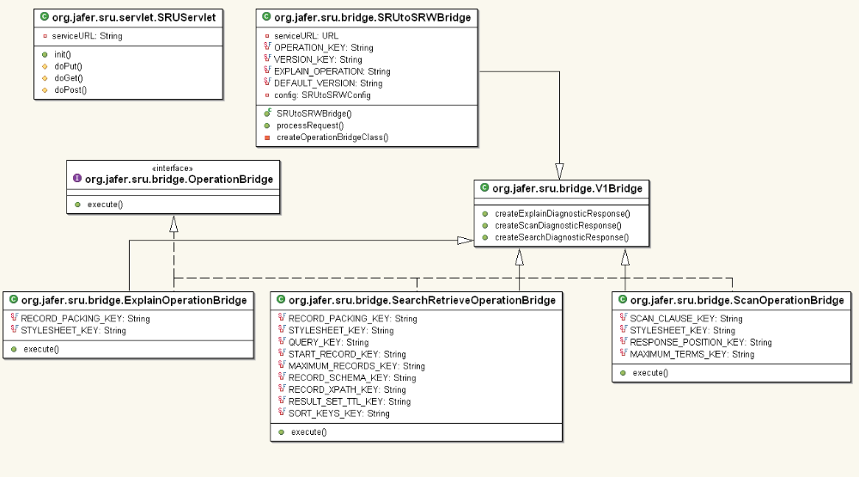

Invoking an operation

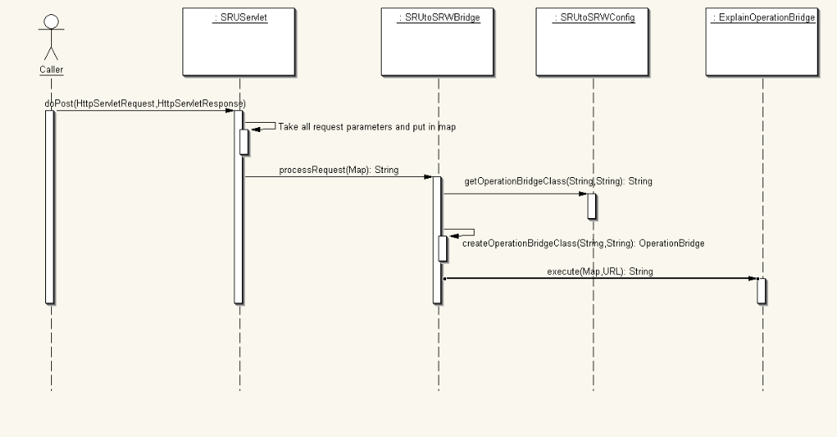

The execute method

The execute method is broken down into three sections that are almost identical in each bridge operation class. They all follow the same structure:

- Create operation request object
- Set version to this operation bridge predefined version
- Set record packing to default to XML
- Extract all operation request parameters from the supplied map
- Where the operation request parameter is not NULL or empty set it in request
- If any parameter is mandatory and has not been supplied return an error diagnostic block for the operation type
- Create SRW stub class and invoke operation
- Serialise the returned objects back to XML and return to SRUtoSRWBridge class so it can return it to the caller.

Any errors that occur during this process are returned as operation diagnostic blocks. The methods to create these responses sit in the common V1Bridge class.

Configuration

Servlet Configuration

The servlet is configured in the web.xml file. The important line is the init-param highlighted in blue in the example. This defines the full URL of the SRWServer that this instance of the SRUServer will point to.

The Servlet definition can be defined multiple times under different servlet-names to allow multiple instances of the SRU server to be created supporting different SRWServers.

Note: The example index.jsp page provided with the server is configured for the <servlet-name> SRUSever </servlet-name> instance and tries to call its execute URL (www.servname.com/SRUServer/execute). Multiple copies of this file must be created to point to the different SRU servers should you define more than one.

Current web.xml file:

<?xml version="1.0" encoding="ISO-8859-1"?>

<!DOCTYPE web-app
PUBLIC "-//Sun Microsystems, Inc.//DTD Web Application 2.2//EN"
"http://java.sun.com/j2ee/dtds/web-app_2_2.dtd">

<web-app>
<display-name>Jafer SRU Server</display-name>
<!-- Standard SRU Servlet Configuration (with debugging) -->
<servlet>
<servlet-name>SRUServer</servlet-name>
<description>this servlet processes SRU requests to SRWSevers</description>
<servlet-class>org.jafer.sru.servlet.SRUServlet</servlet-class>
<init-param>
<param-name>serviceURL</param-name>
<param-value>http://alcme.oclc.org/srw/search/GSAFD</param-value>
</init-param>
<load-on-startup>2</load-on-startup>
</servlet>
<!-- SRU Server Servlet Mapping -->
<servlet-mapping>
<servlet-name>SRUServer</servlet-name>
<url-pattern>/execute</url-pattern>
</servlet-mapping>

<session-config>
<!-- Session time out is 30 minutes -->
<session-timeout>30</session-timeout> - </session-config>

</web-app>

Bridge Configuration

The bridge configuration has a very simple schema.

<operations> - Groups all the operations supported by the SRUtoSRWBridge class
<operation> - Describes a supported operation. It has three mandatory attributes:

- Name: The name of the operation being defined. This much match the SRU operation name specified on SRU url.
  - ?operation=<defined operation name>

- Version: The version of the SRU protocol this supports. This much match the SRU version specified on SRU url.
  - ?version=<defined version>

- Bridge: The fully qualified class name of the bridge that supports the operation and version specified

Current configuration file:

<?xml version="1.0" encoding="UTF-8"?>
<operations>
<operation
name="explain"
version="1.1"
bridge="org.jafer.sru.bridge.ExplainOperationBridge"/>

<operation
name="searchRetrieve"
version="1.1"
bridge="org.jafer.sru.bridge.SearchRetrieveOperationBridge"/>

<operation
name="scan"
version="1.1"
bridge="org.jafer.sru.bridge.ScanOperationBridge"/>

</operations>

Testing

Due to time constraints not all the SRU parameters are supported currently. The following table shows the supported parameters and the ones that have currently been tested both visually and by using JUnit tests.

Request / Response Parameter  (* mandatory) | Supported in operation bridge class | Visually and JUnit Tested | Extra Details
EXPLAIN
Rq – Operation * | Yes | Yes
Rq – Version * | Yes | Yes
Rq - Record packaging | Yes | Yes
Rq - Stylesheet | Yes | Partially | Tested that it appears in correct place but not tested visually to see style sheet applied
Rq - Extra Request Data | No | No | Currently Outstanding
Rs - Echo response | Yes | Yes | SRU CLIENT Enforced
SEARCH RETRIEVE
Rq – Operation * | Yes | Yes
Rq - Version * | Yes | Yes
Rq - Query * | Yes | Yes
Rq - Start Record | Yes | Yes
Rq - Max Records | Yes | Yes
Rq - Record Packaging | Yes | Yes
Rq - Record Schema | Yes | No
Rq - Xpath | Yes | No
Rq - ResultSetTTL | Yes | No
Rq - Sort keys | Yes | No
Rq - Stylesheet | Yes | Partially | Tested that it appears in correct place but not tested visually to see style sheet applied
Rq - Extra Request Data | No | No
Rs - Echo response | Yes | Yes | SRW Server enforced
SCAN
Rq - Operation * | Yes | Yes
Rq - Version * | Yes | Yes
Rq - Scan Clause * | Yes | Yes
Rq - Response Position | Yes | Yes
Rq - Maximum Terms | Yes | Yes
Rq - Stylesheet | Yes | Partially | Tested that it appears in correct place but not tested visually to see style sheet applied
Rq - Extra Request Data | No | No
Rs - Echo response | Yes | Yes | SRW Server enforced

