JAFER UDDI
Requirements Document



Version 1.0 draft

Copyright Oxford University and the JISC

Version History

Version | Comments
1.0 Draft | Initial version for review

Changes since last version

- None

Omissions

- None

Document Details

Author | Andrew Foster
Owner | Matthew Dovey
Distribution

References

ID | Description | Reference
Table of Contents

1. Introduction 4
1.1. Purpose of Document 4
1.2. Scope 4
1.3. JAFER Overview 4
1.3.1. Registration / Maintenance 5
1.3.2. Discovery 5
1.3.3. Client 5
1.3.4. Server 6
1.4. Terminology 7
2. UDDI Overview 8
2.1. Core UDDI Data Models 9
2.1.1. Business entity 9
2.1.2. Business service 9
2.1.3. Binding template 10
2.1.4. Technical model 10
2.1.5. Publisher assertion 10
3. Requirements 11
3.1. Business Requirements 11
3.2. Technical Requirements 11
3.2.1. Registration / Maintenance 12
3.2.2. Discovery 13
3.2.3. Category Bags & TModels 14

Introduction

Purpose of Document

The purpose of this document is to:

- Provide an overview of UDDI
- Define the requirements for JAFER UDDI support

Scope

This document is intended to provide all the information required for analysts and designers to produce a working design for UDDI support.

JAFER Overview

The ANSI/NISO Z39.50 defines a standard protocol for communication and information retrieval between computers, typically over a network. It provides standard ways to search distributed databases, and to retrieve full-text documents, bibliographic data, images and multimedia, and can be implemented on any computer platform.

The JAFER Project (Java Access For Electronic Resources) aims to produce an easy to use, visual toolkit, which will allow users to build portals and information sources without having to deal with the technical intricacies of Z39.50.

JAFER is broken down into three main categories:

- Registration / Maintenance
- Discovery
- Client
- Server

Registration / Maintenance

This category is all about registering new JAFER and Z39.50 services on the internet and allowing information on already registered JAFER services to be updated. Registration is implemented in JAFER by utilising the UDDI standard.

Discovery

This category is all about discovering JAFER and Z39.50 services that have been registered. Discovery is implemented in JAFER by utilising the UDDI standard.

Client

The client is all about providing a mechanism to easily access a Z39.50 server and retrieve records. The JAFER client is designed to work using XML to allow it to integrate easily with web applications. It uses a JAFER XML based query to create Z39.50 request to search for records and then converts the retrieved binary records into the MARC XML format. The client can then be configured to apply transformations on the base MARC XML format to the integrating applications desired format.

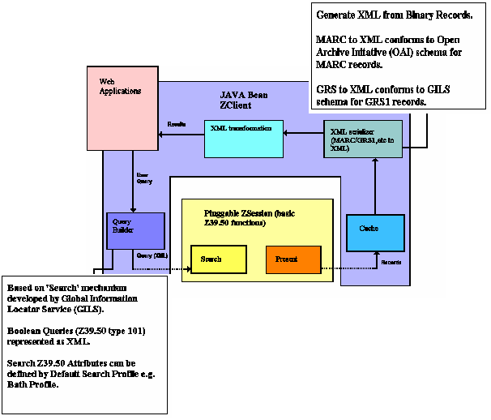

Server

The server is about providing a mechanism to service Z39.50 requests and map them onto an existing database. It provides an XML Query interface that must be implemented to obtain the desired records in the MARC format. The server then converts this to a Z39.50 binary reply to send back to the caller. This allows the interface to be implemented, for example:

- to interact with an XML database
- transform the XML query to JDBC to interact with a relational database
- to even interact with a JAFER client

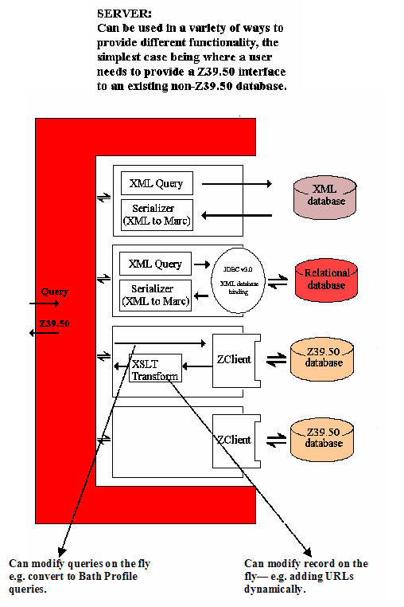

Terminology

The following acronyms are used in this document

API | Application Programming Interface
GUI or UI | Graphical User Interface
J2SE | Java 2 Standard Edition
JAFER | Java Access For Electronic Resources
JDBC | Java Database Connectivity
JVM | Java Virtual Machine
MARC | http://www.loc.gov/marc standard
MDC | Middleware for Distributed Cognition
UDDI | Universal Description, Discovery and Integration
WC | The web client
XML | Extensible Mark-up Language
XSLT | Extensible Stylesheet Language Transformation
Z39.50 | Refers to International Standard, ISO 23950

UDDI Overview

The Universal Description, Discovery and Integration (UDDI) project was originally an industry initiative. UDDI was the first cross-industry effort driven by all major platform and software providers, marketplace operators and e-business leaders. In July 2002, the UDDI Community was counting over 250 companies that have agreed to support the development of the UDDI standard.

The UDDI project creates a framework for describing services, discovering businesses, and integrating business services using the Internet. It has been developed as a platform-independent and open framework taking advantage of widely accepted standards such as HTTP, XML and SOAP.

As a part of the UDDI project, the UDDI Business Registry (UBR) has been established to allow businesses to publish and discover Web services on the Web. These UDDI Registries are run by Microsoft, IBM, SAP and NTT Communications and are replicated over each other. UDDI Registries have also gained ground on the intranet to support the various corporate or external services used by companies.

A business can register three types of information in a UDDI registry. These three types of information are commonly referred to as "white pages", "yellow pages" and "green pages" information in the literature:

- White pages provide basic contact information about a company, such as the business name, address and contact information. White pages allow customers and partners to discover business services based upon business identification.
- Yellow pages describe a business service using different categorizations ("taxonomies" in UDDI terminology). This information allows others to discover business services based upon its categorization (such as being in the manufacturing or software development business).
- Green pages provide technical information on the behaviours and supported functions of a business service hosted by a business. Green pages in UDDI are not limited to describing XML-based Web services, but any business service type offered by a business entity. This may cover phone-based services such as call centers, E-mail based services such as technical support for a product, fax-based services such as a fax to E-mail service, etc.

Core UDDI Data Models

The core UDDI data model is broken down into five main objects and specified in detail at the following link http://uddi.org/pubs/uddi_v3.htm :

- Business Entity
- Business Service
- Business Template
- Technical model
- Publisher Assertion

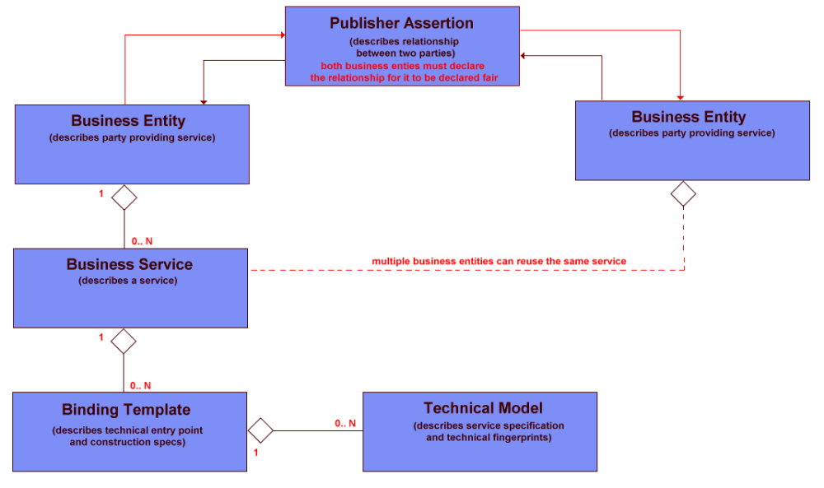

The Version 3 XML schema can be found at http://www.uddi.org/schema/uddi_v3.xsd

Business entity

The <businessEntity> structure holds the basic business information such as contact information, categorization, identifiers, descriptions, and relationships to other businesses.

Business service

The <businessService> structure represents a single service provided by the <businessEntity>. The business service details any type of service a company can provide, from a manual, fax, E-mail or phone service to a fully automated XML-based Web service. The <businessService> is a reusable structure that can potentially be referred to by several <businessEntity> structures.

Binding template

The <bindingTemplate> structure contains pointers to technical descriptions of services as well as their access points. An optional text description of the web service can be provided. The <bindingTemplate> does not contain the details of the service's specification. Rather, it refers to a technical model <tModel> structure that holds pointers to the actual location of the specifications.

Technical model

the <tModel> structure is an abstract description of a particular specification or behaviour to which the web service adheres. The <tModel> is a type of digital "fingerprint" for determining the specifics of how to interact with a particular web service. The <tModel> structure does not provide the web service's specification directly. Rather, it contains pointers to the locations of the actual specifications. Companies can use the information pointed to by a <tModel> to determine whether a web service is compatible with their business requirements.

Publisher assertion

The <publisherAssertion> structure establishes a relationship between two <businessEntity> structures. In order to prevent any unfair relationship claim, a relationship between two <businessEntity> structures is visible to the "public" only when a reciprocal assertion has been created by the two companies. To do so, the two businesses publish independently two separate <publisherAssertion> documents that each claim relationship with one another. The <publisherAssertion> structure defines a fromKey that identifies the <businessEntity> at the first "side" of the relationship and a toKey that identifies the <businessEntity> at the other "side".

Requirements

This section defines the UDDI discovery requirements for JAFER. It is broken down into two sections:

- Business Requirements
- Technical Requirements – Defines required UDDI technical solution

Business Requirements

The JAFER discovery category is only focused on registering and locating JAFER services on the internet. Therefore, the JAFER UDDI offering only needs to provide a set of services to meet this requirement. Full UDDI support for all non essential functions should hence be omitted. The user should be provided with:

- Java business service classes that can be used for integration purposes
- A web application that uses these classes to register and locate JAFER services.
- Documentation detailing class usage (JavaDoc and Design Document)

Technical Requirements

The technical requirements are broken down into the two distinct UDDI areas:

- Registering new JAFER services
- Maintaining JAFER services
- Discovering JAFER and Z39.50 services

These services will all operate on the UDDI Business Registry (UBR) that is shared and replicated between a number of key partners. The JAFER UDDI API should allow the user to select one of the following UBR hosts.

- IBM
- Microsoft
- SAP

As well as supporting the UBR the JAFER UDDI services should also be able to operate on a private registry. Therefore it is required to initialise the registry with any configuration data, such as <TModels> for searching, if it does not already exist.

Registration / Maintenance

The JAFER registration and maintenance API needs to allow the creation and maintenance of the following UDDI model data by the user. When registering the API should generate and return a new key to the caller so they can use it when relating Service and Binding elements to their parents or for use with the discovery API.

UDDI is very flexible with the information that can be stored against the various model entities. In order to simplify the interface for JAFER the following restrictions will be applied:

- Reduced cardinality
- Reduced Language Support

Reduced cardinality

UDDI allows certain elements to be repeated indefinitely to support multiple language support or multiple destination etc. To simplify the interface to the caller these have been reduced and hence restricted where sensible. The JAFER applied cardinalities that have been restricted are specified in the following table by (*).

Reduced Language Support

To support multiple languages a number of elements have a language attribute. The JAFER UDDI API will be restricted to English. Hence all names and descriptions will have the English tag automatically applied.

The following table shows the data that the API should allow the caller to create or update in the UDDI registry.

Model in Schema | Stored Values
Model in Schema | XML tag / Attribute | Cardinality |  | Description
Business Entity <businessEntity> | Attrib: businessKey | 1 |  |  | Unique identifier generated by UDDI on registration
Business Entity <businessEntity> | <name> | 1 | * |  | Main name
Business Entity <businessEntity> | <discoveryURL> | 0 .. 1 | * |  | Link to a homepage
Business Entity <businessEntity> | <description> | 1 | * |  | Description of the business entity
Business Entity <businessEntity> | <contact> | 0.. 1 | * |  | Details of a contact  (name, description, phone, email only)  The address attribute will be omitted
Business Entity <businessEntity> | <categoryBag> | 0 .. 1 |  |  | ( See Category Bags & TModels section)
Business Entity <businessEntity> | <businessServices> | 0 .. 1 |  |  | The list of registered business services
Business Service  <businessService> | Attrib: serviceKey | 1 |  |  | The name of the business service
Business Service  <businessService> | Attrib: businessKey | 1 |  |  | Unique identifier of parent business entity
Business Service  <businessService> | <name> | 1 | * |  | The name of the business service
Business Service  <businessService> | <description> | 1 | * |  | The description of the business service
Business Service  <businessService> | <categoryBag> | 0 .. 1 |  |  | ( See Category Bags & TModels section)
Business Service  <businessService> | <bindingTemplates> | 0 .. 1 |  |  | The list of registered binding templates
Binding Template <bindingTemplate> | Attrib: bindingKey | 1 |  |  | Unique identifier generated by UDDI on registration
Binding Template <bindingTemplate> | Attrib: serviceKey | 1 |  |  | Unique identifier of parent business service
Binding Template <bindingTemplate> | <accessPoint> | 1 |  |  | Network address suitable for invoking the web service.
Binding Template <bindingTemplate> | <tmodelInstanceDetails> | 1 |  |  | The list of registered tModels
TModel Instance Detail  <tmodelInstanceDetail> |  |  |  | No data should be stored here.  Predefined TModelInstanceDetails for Z39.50 and JAFER should be created and available for use.  ( See Category Bags & TModels section)
Technical Model  <tModel> |  |  |  | No data should be stored here.  Predefined TModels for Z39.50 and JAFER should be created and available for use.  ( See Category Bags & TModels section)

Discovery

The discovery JAFER API should allow the caller to find JAFER registered services in the UBR. It specifically should allow them to find:

- Registered JAFER and Z39.50 services for use
- JAFER Business Entities
- JAFER Business Services
- JAFER Binding Templates

The following table identifies the parameters that should be supported for discovering the registered data. TModelKeys in the table assume the user will only be using the predefined JAFER TModelKeys types.

Search Type | Search Parameters | Return Result
Registered JAFER and Z39.50 services | Business Key | Collection(JAFER Service)
Registered JAFER and Z39.50 services | Service Key | Collection(JAFER Service)
Registered JAFER and Z39.50 services | Collection(TModel Keys) Logical AND applied to keys | Collection(JAFER Service)
Registered JAFER and Z39.50 services | Collection(categories)  Logical AND applied to keys | Collection(JAFER Service)
JAFER Business Entities | Business Key | Business Entity
JAFER Business Entities | Name | Collection(Business Entity)
JAFER Business Entities | Service Key | Collection(Business Entity)
JAFER Business Entities | Collection(TModel Keys) Logical AND applied to keys | Collection(Business Entity)
JAFER Business Entities | Collection(categories)  Logical AND applied to keys | Collection(Business Entity)
JAFER Business Services | Service Key | Business Service
JAFER Business Services | Business Key | Collection(Business Service)
JAFER Business Services | Name | Collection(Business Service)
JAFER Business Services | Collection(TModel Keys)  Logical AND applied to keys | Collection(Business Service)
JAFER Business Services | Collection(categories)  Logical AND applied to keys | Collection(Business Service)
JAFER Binding Template | Service Key | Collection(Binding Template)
 | Collection(TModel Keys)  Logical AND applied to keys | Collection(Binding Template)

Category Bags & TModels

All categories and TModels have unique primary keys in the registry. As the JAFER UDDI is required to support private UDDI registries it is possible that the keys have not yet been created or are different depending upon the registry being connected to.

To simplify this problem a number of specific JAFER categories and TModels will be defined. The unique keys should be encapsulated away from the caller so that they can be automatically adjusted depending upon the registry the caller is connecting to.

This section defines the predefined categories and TModels that will be available for use through the JAFFER UDDI API.

Categories

A category can be attached to one or more Business Entities or Services. Its primary use is to allow a caller to browse the registry to locate all the entities or services for a particular category. A category instance comprises of the following attributes:

- TModelKey – Unique to the registry and generally automatically generated by UDDI if not supplied by the publisher. The JAFER API will allow the registry to assign keys after first searching for the existence of an appropriately named key.
- KeyName – This is a text name assigned to describe the category. The JAFER API should search via this name to see if the category has already been created and to obtain the TModelKey to use during the lifetime of its connection. This name should not be allowed to be changed through the JAFER api.
- KeyValue – This represents a value associated with the category. There can be more than one value for a category and the caller is able to specify this to value to refine their searches.

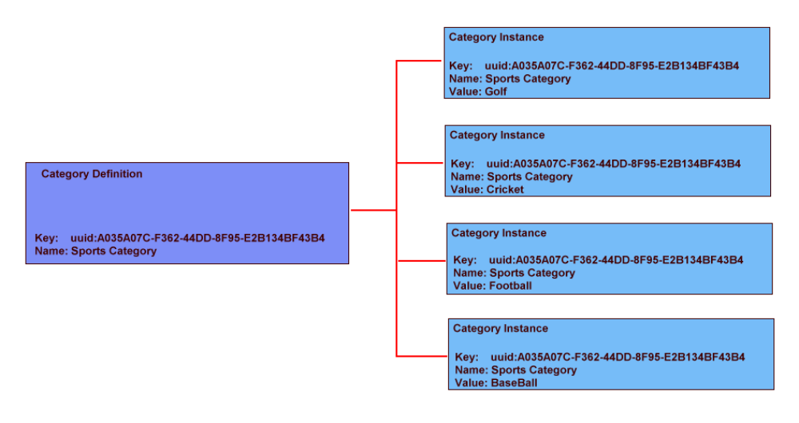
The JAFER API will define the following Category Definitions available for use by the caller. The caller can define and register as many different category instances as they wish. These instances can then be used to locate their own and other similar services through the JAFER API.

Category Name | Description
LCSH | Library of congress subject headings. The client can define values on this category. A predefined value of ALL will automatically be registered by the API.
DDC | Dewey decimal characterisation. The caller can define values on this category. A predefined value of ALL will automatically be registered by the API.
General Keyword | This is any single keyword. Phrases are not allowed.

TModels

A TModel can be attached to one or more Binding Templates. Its primary use is to allow a caller to browse the registry to locate all the JAFER enabled services. However, they can also be used for locating Business entities and Binding Templates. A TModel instance comprises of the following main attributes:

- TModelKey – Unique to the registry and generally automatically generated by UDDI if not supplied by the publisher. The JAFER API will allow the registry to assign keys after first searching for the existence of an appropriately named key.

- Name – This is a text name assigned to describe the TModel. The JAFER API should search via this name to see if the TModel has already been created and to obtain the TModelKey to use during the lifetime of its connection. This name should not be allowed to be changed through the JAFER api.

- Description – This is a textual description of the TModel

The JAFER API will define the following TModels available for use by the caller:

TModel Name | Description
JAFER | Binding template supports
ISO23950 | ISO equivalent of Z3950
Z3950 | Standard Z3950 support
SRW | Supports Search / Retrieve Web Service

