JAFER Registry
Web Design Document



Version 1.0 draft

Copyright Oxford University and the JISC

Version History

Version | Comments
1.0 Draft | Initial version for review

Changes since last version

- None

Omissions

- None

Document Details

Author | Andrew Foster
Owner | Matthew Dovey
Distribution

References

ID | Description | Reference
Table of Contents

1. Introduction 4
1.1. Purpose of Document 4
1.2. Scope 4
1.3. JAFER Overview 4
1.3.1. Registration / Maintenance 5
1.3.2. Discovery 5
1.3.3. Client 5
1.3.4. Server 6
1.4. Terminology 7
2. Requirements 8
2.1. Locating providers and services 8
2.1.1. Finding Providers 8
2.1.2. Finding services 8
2.1.3. Invoking services 8
2.2. Managing providers and services 9
2.2.1. Managing Providers 9
2.2.2. Managing Services 9
3. Design 10
3.1. Issues & Assumptions 10
3.2. Screen Design 11
3.2.1. General 12
3.2.2. Welcome screen 12
3.2.3. Search service 12
3.2.4. Search provider 13
3.2.5. Provider summary 14
3.2.6. Service summary 14
3.2.7. Create provider 15
3.2.8. Edit provider 16
3.2.9. Provider services 16
3.2.10. Add services 17
3.2.11. Create service 17
3.2.12. Edit service 18
3.2.13. Add access point 18
3.2.14. Edit access point 19
3.2.15. Add category 19
3.2.16. Logon page 19
3.2.17. Error page 20

Introduction

Purpose of Document

The purpose of this document is to:

- Define the web screens to support the JAFER registry
- Outline the technology that will be used

Scope

This document is intended to provide all the information required for the designers to build the web screens to support the JAFER registry.

JAFER Overview

The ANSI/NISO Z39.50 defines a standard protocol for communication and information retrieval between computers, typically over a network. It provides standard ways to search distributed databases, and to retrieve full-text documents, bibliographic data, images and multimedia, and can be implemented on any computer platform.

The JAFER Project (Java Access For Electronic Resources) aims to produce an easy to use, visual toolkit, which will allow users to build portals and information sources without having to deal with the technical intricacies of Z39.50.

JAFER is broken down into three main categories:

- Registration / Maintenance
- Discovery
- Client
- Server

Registration / Maintenance

This category is all about registering new JAFER and Z39.50 services on the internet and allowing information on already registered JAFER services to be updated. Registration is implemented in JAFER by utilising the UDDI standard.

Discovery

This category is all about discovering JAFER and Z39.50 services that have been registered. Discovery is implemented in JAFER by utilising the UDDI standard.

Client

The client is all about providing a mechanism to easily access a Z39.50 server and retrieve records. The JAFER client is designed to work using XML to allow it to integrate easily with web applications. It uses a JAFER XML based query to create Z39.50 request to search for records and then converts the retrieved binary records into the MARC XML format. The client can then be configured to apply transformations on the base MARC XML format to the integrating applications desired format.

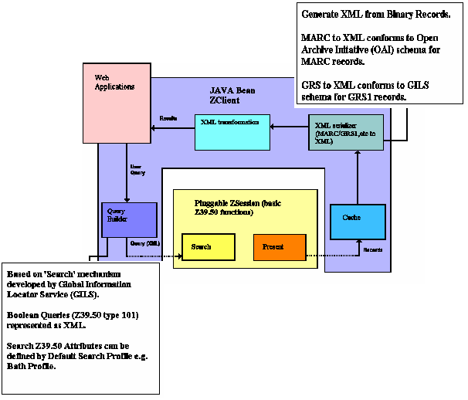

Server

The server is about providing a mechanism to service Z39.50 requests and map them onto an existing database. It provides an XML Query interface that must be implemented to obtain the desired records in the MARC format. The server then converts this to a Z39.50 binary reply to send back to the caller. This allows the interface to be implemented, for example:

- to interact with an XML database
- transform the XML query to JDBC to interact with a relational database
- to even interact with a JAFER client

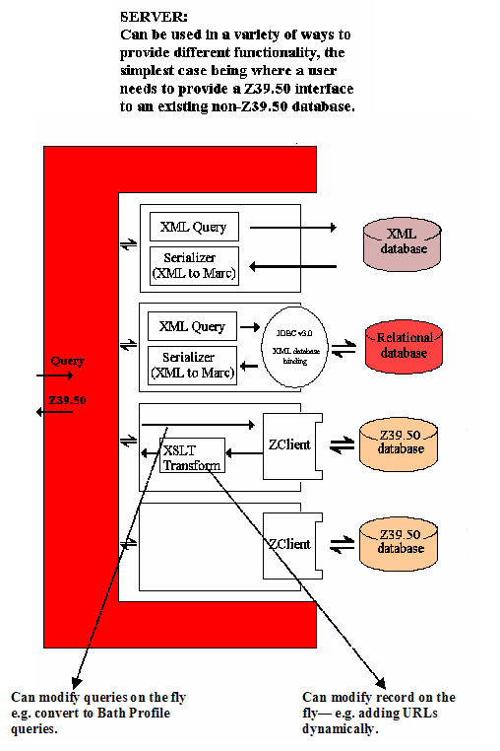

Terminology

The following acronyms are used in this document

API | Application Programming Interface
GUI or UI | Graphical User Interface
J2SE | Java 2 Standard Edition
JAFER | Java Access For Electronic Resources
JDBC | Java Database Connectivity
JVM | Java Virtual Machine
MARC | http://www.loc.gov/marc standard
MDC | Middleware for Distributed Cognition
UDDI | Universal Description, Discovery and Integration
WC | The web client
XML | Extensible Mark-up Language
XSLT | Extensible Stylesheet Language Transformation
Z39.50 | Refers to International Standard, ISO 23950

Requirements

The JAFER registry provides users the ability to create and locate JAFER service providers and the services that they offer. The web screens are required to facilitate the use of this registry in a simple to use interface. The requirements are separated into two sections:

- Locating providers and services
- Managing providers and services

Locating providers and services

A set of screens are required to support locating providers and services. These screens do not require the user to logon to the system. The user should have the option to perform the search as follows (all parameters are optional and can be mixed)

Finding Providers

- By name
- By one or more categories
- By protocol

The results should be returned in a list which shows the name and description of the provider found. The user should then have the ability to view any found provider in detail.

Finding services

- By name
- By one or more categories
- By protocol

The results should be returned in a list which shows the name of the service found. The user should then have the ability to view any found service in detail.

Invoking services

MATTHEW – WHAT ARE YOUR IDEAS HERE

Managing providers and services

A set of screens are required to support maintaining providers and services. These screens require the user to logon to the system in order to update data. Logon details should only be requested the first time a user enters a maintenance screen. The screens should allow:

Managing Providers

- Creating new providers
- Updating basic provider information
- Deleting providers
- Adding and deleting categories against a provider
- Adding services to providers
- Deleting services from providers

Managing Services

- Creating new services on providers
- Updating basic service information
- Deleting services
- Adding and deleting categories against a service

Design

This section defines the web screens that will make up the JAFER registry. The registry web screens will sit on top of the JAFER UDDI support classes that will be configured to use the Microsoft UBR.

They are intended to meet the requirements specified in the previous section.

Issues & Assumptions

Issue, Assumption or key Design Decision | Description
Design Decision | Logon details are for the UBR registry not the JAFER registry  Users will have the ability to redirect to the Microsoft UBR to register an account from the logon screen.  Using this approach means users are only allowed to create 1 provider with no more than 2 services unless they have obtained level 2 access.  Otherwise we would need to use our own level 2 UBR id and password to facilitate operations on the UDDI registry and implement our own security model to avoid the risk of users using our website to bring down the Microsoft UBR by automating multiple provider registrations.
Design Decision | Apache Struts will be used to implement the page navigation in order to separate display logic from business logic and to ease the expansion of the site later.  The screens will be designed to make the integration as simple as possible. Hence the following will be applied:  - A screen will either provide editable fields or buttons to perform operations on the underlying model. The two will never coincide on the same screen.  - Multiple selections from lists will not be provided  This means you can not edit a service’s description and click a link to delete a category against that service on the same page. This avoids the complication of deciding whether the description should be updated when the link is clicked or not and removes the need for any temporary data to be stored during operations.
Issue | To facilitate a stateless web design it is normal that a unique identifier is stored in the page to allow quick retrieval of the object by the server at a later date.  The current registry does not expose unique identifiers to the user and encapsulates them away in side the provider and service objects.  Hence the registry interfaces will be updated to provide the following extra methods to provide an ID: (Note the ID can never be set or updated by the user only referenced)  - a getIID() method on the service provider and service interfaces  - a getServiceProvider(id) and getService(id) on the service locator to quickly retrieve the service provider or service
Assumption | Java script is allowed and required to use the screens
Assumption | Requirement for IE specific browser controls will be avoided unless specific justification can be found.

Screen Design

This section details the screens that have been designed to facilitate the registry requirements. The following navigation diagram defines the major pages and shows the major flows between these pages.

All screens will have a link to the welcome page and to logout of the registry which have been excluded to simplify the diagram. It is also possible that any page can navigate to the error page should a critical error occur.

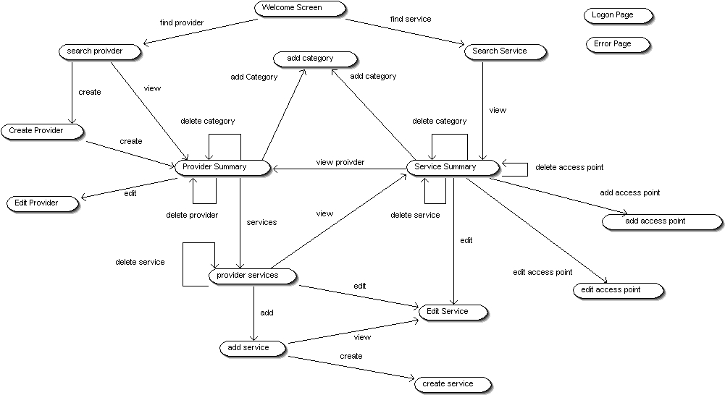

General

All screens other than the welcome screen have a menu bar that contains the following information and links:

Field ID | Type | Description
Username | Text (RO) | The name of the logged on user

Button / Link | Action ID | Next Page | Comments
Link | HOME | welcome
Link | logon | logon | Only shown if the user is logged on
Link | Logoff | welcome | Only shown if the user is logged on

Underneath the menu bar will be a message text line for business and registry specific error messages to be displayed.

Welcome screen

This screen is the home page for the registry. It introduces JAFER and describes what the web site provides. If the user is currently logged on then there user name will be displayed.

Field ID | Type | Description
Username | Text (RO) | The name of the logged on user

Button / Link | Action ID | Next Page | Comments
Link | SEARCH_PROVIDER | search_provider
Link | SEARCH_SERVICE | search_service
Link | LOGON | logon | Only displayed if no user logged on
Link | LOGOFF | welcome | Only displayed if user logged on
Link | REGISTER | Microsoft UBR | Redirects to the Microsoft UBR register page

Search service

This screen allows the user to search for services that have been registered into the registry. When the user presses search the results are displayed in the results grid. The search will return a predefined maximum that the user can not alter. Restricting the number of returned rows or providing paging functionality will be provided later.

Validation Rules

- At least one search criteria (name, protocol or category) must be entered or selected

Search Panel

Field ID | Type | Description
searchName | Edit (255) | Editable field for user to enter name of service looking for % is wildcard character
searchProtocol | Combo | Lists all the available protocols. Only single selection allowed
searchCategory | Combo | Lists all the available categories. Only single selection allowed
searchCategoryVal | Edit (255) | Editable field for the user to enter value for the category chosen. Value will be ignored if no category is selected

Button / Link | Action ID | Next Page | Comments
Button | SEARCH | search_service | Performs a search and refreshes the screen

Results Panel Gird

Field ID | Type | Description
serviceID | Text | HIDDEN FIELD
serviceName | Text | Editable field for user to enter name of service looking for % is wildcard character

Button / Link | Action ID | Next Page | Comments
Link in grid | VIEW | service_summary | View the service summary details
Link | DELETE |  | CONSIDERING DELETE OPTION

Search provider

This screen allows the user to search for providers that have been registered into the registry. When the user presses search the results are displayed in the results grid. The search will return a predefined maximum that the user can not alter. Restricting the number of returned rows or providing paging functionality will be provided later.

Validation Rules

- At least one search criteria (name, protocol or category) must be entered or selected

Search Panel

Field ID | Type | Description
searchName | Edit (255) | Editable field for user to enter name of provider looking for % is wildcard character
searchProtocol | Combo | Lists all the available protocols. Only single selection allowed
searchCategory | Combo | Lists all the available categories. Only single selection allowed
searchCategoryVal | Edit (255) | Editable field for the user to enter value for the category chosen. Value will be ignored if no category is selected

Button / Link | Action ID | Next Page | Comments
Button | SEARCH | search_provider | Performs a search and refreshes the screen
Button | CREATE | create_provider | shows the create provider screen (logon required)

Results Panel Gird

Field ID | Type | Description
providerID | Text | HIDDEN FIELD
providerName | Text | Editable field for user to enter name of service looking for % is wildcard character
providerDescription | Text | The description for the provider

Button / Link | Action ID | Next Page | Comments
Link in grid | VIEW | provider_summary | View the provider summary details
Link | DELETE |  | CONSIDERING DELETE OPTION

Provider summary

This screen shows a summary of the service provider, the primary contact and the attached categories. These values can not be directly altered from the summary but actions can be performed by selecting the buttons and links.

Provider Summary Panel

Field ID | Type | Description
providerID | Text | HIDDEN FIELD
providerName | Text | Editable field for user to enter name of service looking for % is wildcard character
providerDescription | Text | The description for the provider
providerHomepage | Text | The home page for the provider
contactName | Text | The providers contact name
contactDescription | Text | The providers contact names description
contactEmail | Text | The providers contact email address
ContactPhone | Text | The providers contact phone number

Category Grid

Field ID | Type | Description
categoryType | Text | HIDDEN FIELD
categoryName | Text | The name of the attached category
categoryValue | Text | The value assigned to the attached category

Button / Link | Action ID | Next Page | Comments
Link in grid | DELETE | provider_summary | Deletes the category from the provider (logon required)
Button | ADD | add_category | Opens the screen to select and add a new category to the provider (logon required)

Actions

Button / Link | Action ID | Next Page | Comments
Button | SERVICES | provider_services | Opens the providers services view
Button | EDIT | edit_provider | Opens the edit provider details view (logon required)
Button | DELETE | welcome | Deletes the provider (logon required)

Service summary

This screen shows a summary of the service, its access points and the attached categories. These values can not be directly altered from the summary but actions can be performed by selecting the buttons and links.

Service Summary Panel

Field ID | Type | Description
serviceID | Text | HIDDEN FIELD
serviceName | Text | Editable field for user to enter name of service looking for % is wildcard character
serviceDescription | Text | The description for the service

Access Point Grid

Field ID | Type | Description
accessPointProtocol | Text | The protocol type for access point
accessPointType | Text | Whether the access point is a service point or WSDL file location
accessPointURL | Text | The name of the access point

Button / Link | Action ID | Next Page | Comments
Link in grid | DELETE | service_summary | Deletes the access point from the service (logon required)
Link in grid | EDIT | edit_access_point | Edits the access point on the service (logon required)
Button | ADD | add_ access_point | Opens the screen to select and add a new access point to the service (logon required)

Category Grid

Field ID | Type | Description
categoryType | Text | HIDDEN FIELD
categoryName | Text | The name of the attached category
categoryValue | Text | The value assigned to the attached category

Button / Link | Action ID | Next Page | Comments
Link in grid | DELETE | service_summary | Deletes the category from the service (logon required)
Button | ADD | add_category | Opens the screen to select and add a new category to the service (logon required)

Actions

Button / Link | Action ID | Next Page | Comments
Button | VIEW_PROVIDER | provider_summary | Opens the provider summary for the services owner
Button | EDIT | edit_service | Opens the edit service details view (logon required)
Button | DELETE | welcome | Deletes the service (logon required)

Create provider

This screen allows the user to create a new provider. It is identical to the edit provider screen other than the action performed.

Validation Rules

- A provider name must be entered
- If any contact details are entered then a contact name must be supplied

Field ID | Type | Description
providerName | Edit (255) | Editable field for user to enter name of service looking for % is wildcard character
providerDescription | Edit (255) | The description for the provider
providerHomepage | Edit (4096 | The home page for the provider
contactName | Edit (255) | The providers contact name
contactDescription | Edit (255) | The providers contact names description
contactEmail | Edit (255) | The providers contact email address
ContactPhone | Edit (255) | The providers contact phone number

Button / Link | Action ID | Next Page | Comments
Button | CREATE | provider_summary | Opens the provider summary for the newly created provider
Button | CANCEL | search_provider | Cancels the create and returns to the provider search screen

Edit provider

This screen allows the user to update the provider’s basic details. It is identical to the create provider screen other than the action performed.

Validation Rules

- A provider name must be entered
- If any contact details are entered then a contact name must be supplied

Field ID | Type | Description
providerID | Text | HIDDEN FIELD
providerName | Edit (255) | Editable field for user to enter name of service looking for % is wildcard character
providerDescription | Edit (255) | The description for the provider
providerHomepage | Edit (4096) | The home page for the provider
contactName | Edit (255) | The providers contact name
contactDescription | Edit (255) | The providers contact names description
contactEmail | Edit (255) | The providers contact email address
ContactPhone | Edit (255) | The providers contact phone number

Button / Link | Action ID | Next Page | Comments
Button | UPDATE | provider_summary | Opens the provider summary for the newly created provider
Button | CANCEL | provider_summary | Cancels the update and returns to the provider summary screen

Provider services

This screen displays all the services that are currently owned by or attached to the provider. It allows the user to manage the current service and to create new ones. It may get merged into the provider summary screen if enough room exists on the screen.

Provider Summary Panel

Field ID | Type | Description
providerID | Text | HIDDEN FIELD
providerName | Text | Editable field for user to enter name of service looking for % is wildcard character
providerDescription | Text | The description for the provider
providerHomepage | Text | The home page for the provider

Services Grid

Field ID | Type | Description
serviceID | Text | HIDDEN FIELD
serviceName | Text | The name of the service
serviceDescription | Text | The description of the service

Button / Link | Action ID | Next Page | Comments
Link in grid | DELETE | provider_services | Deletes the service from the provider (logon required)
Link in grid | EDIT | edit_service | edits the service from the provider (logon required)
Link in grid | VIEW | service_summary | Opens the service summary screen
Button | CREATE | create_service | Creates a new service on the provider (logon required)
Button | ADD | add_service | Adds an existing service to the provider (logon required)

Actions

Button / Link | Action ID | Next Page | Comments
Button | CLOSE | provider_summary | Closes the services screen and returns to the sumary screen

Add services

This screen allows the user to search for a service and add it to the provider. It is identical to the service search screen except the results grid provides an add link. Only one service can be added at a time.

Validation Rules

- At least one search criteria (name, protocol or category) must be entered or selected

Search Panel

Field ID | Type | Description
searchName | Edit (255) | Editable field for user to enter name of service looking for % is wildcard character
searchProtocol | Combo | Lists all the available protocols. Only single selection allowed
searchCategory | Combo | Lists all the available categories. Only single selection allowed
searchCategoryVal | Edit (255) | Editable field for the user to enter value for the category chosen. Value will be ignored if no category is selected

Button / Link | Action ID | Next Page | Comments
Button | SEARCH | search_service | Performs a search and refreshes the screen

Results Panel Gird

Field ID | Type | Description
serviceID | Text | HIDDEN FIELD
serviceName | Text | Editable field for user to enter name of service looking for % is wildcard character

Button / Link | Action ID | Next Page | Comments
Link in grid | ADD | provider_services | Adds the selected service to the provider and returns

Create service

This screen allows the user to create a new service and attach it to the provider. It is identical to the edit service screen other than the action performed.

Validation Rules

- A service name must be entered

Field ID | Type | Description
serviceName | Edit (255) | Editable field for user to enter name of service looking for % is wildcard character
serviceDescription | Edit (255) | The description for the service

Button / Link | Action ID | Next Page | Comments
Button | CREATE | provider_services | Creates and attaches the service to the provder
Button | CANCEL | provider_services | Cancels the create and returns to the provider services screen

Edit service

This screen allows the user to edit a service. It is identical to the create service screen other than the action performed.

Validation Rules

- A service name must be entered

Field ID | Type | Description
serviceName | Edit (255) | Editable field for user to enter name of service looking for % is wildcard character
serviceDescription | Edit (255) | The description for the service

Button / Link | Action ID | Next Page | Comments
Button | UPDATE | provider_services or service_summary | Updates the service and returns to the window that called it
Button | CANCEL | provider_services or service_summary | Cancels the update and returns to the window that called it

Add access point

This screen allows the user to add an access point to the service as long as it has not already been added for the protocol already.

Validation Rules

- An access point must be entered
- An protocol must be selected

Field ID | Type | Description
seviceID | Text | Hidden field
accessPointProtocol | Combo | Drop down list of the supported protocols
accessPointType | Radio | Allows the user to choose between service point and wsdl file
accessPointURL | Edit (4096) | The URL to the access point

Button / Link | Action ID | Next Page | Comments
Button | CREATE | service_summary | Creates and attaches the access point to the service returning to the summary screen
Button | CANCEL | service _summary | Cancels the create and returns to the service summary screen

Edit access point

This screen allows the user to add an access point to the service as long as it has not already been added for the protocol already.

Validation Rules

- An access point must be entered

Field ID | Type | Description
seviceID | Text | Hidden field
accessPointProtocol | Text | Displays the access points protocol
accessPointType | Text | Shows service point or wsdl file
accessPointURL | Edit (4096) | The URL to the access point

Button / Link | Action ID | Next Page | Comments
Button | UPDATE | service_summary | Updates the access point returning to the service summary screen
Button | CANCEL | service _summary | Cancels the create and returns to the service summary screen

Add category

This screen allows the user to add a category to the service. It can be called from either the provider or service summary screen so needs to know what object it is operating on.

Validation Rules

- A category must be selected
- A category value must be entered

Field ID | Type | Description
sproviderID | Text | Hidden field
seviceID | Text | Hidden field
category | Combo | Lists all the available categories. Only single selection allowed
categoryVal | Edit (4096) | Editable field for the user to enter value for the category chosen.

Button / Link | Action ID | Next Page | Comments
Button | ADD | provider_summary or service_summary | Adds the category to the service or provider and returns to the calling summary screen
Button | CANCEL | provider_summary or service_summary | Cancels the opertaion and returns to the calling summary screen

Logon page

The logon page allows the user to enter their registry credentials. These credentials are matched against the Microsoft UBR. The screen provides a hyper link to the Microsoft site to allow the user to register if required. This screen has extra logic to know where to return to once the user logs in successfully. The credential needs to be encrypted when sent to the server or we need to consider using https for this screen.

Field ID | Type | Description
username | Edit | Allows the user to enter their username
credential | Password Edit | Allows the user to enter their credential masking it with stars and encrypting when sent

Button / Link | Action ID | Next Page | Comments
Button | LOGON | Page came from or logon on error | Tries to log the user on returning an error if the user does not have permission
Link | REGISTER | Microsoft UBR | Redirect to microsoft register site

Error page

The error page will be displayed when a critical non-expected error occurs. It will display a standard message to the user and provide a link back to the welcome page.

Button / Link | Action ID | Next Page | Comments
Link | HOME | welcome

