Project 1

DCT and FFT implementations

Jafet Morales

Digital Signal Processing
Instructor: Dr. Agaian
Fall 2011

University of Texas at San Antonio

Discrete Cosine Transform II (DCT-II)

DCT-II was implemented as part of this project. The equations for the forward and inverse DCT-II transforms are
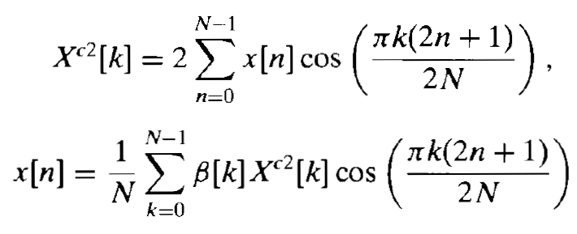

The code for our implementation of the forward and inverse DCT-II transforms in one dimension is shown below

% FORWARD DCT
function [X]=ourDCT(x)

N=length(x);
k=0:(N-1);
n=0:(N-1);

X=2*double(x)*cos(pi/N*(n'+1/2)*k);

% INVERSE DCT
function [x]=ourDCTi(X)

N=length(X);
k=0:(N-1);
n=0:(N-1);

Bk=ones(1,N);
Bk(1)=1/2;
x=1/N*(Bk.*X)*cos(pi/N*(n'+1/2)*k)';

Although the implementation above looks fairly simple, it took time to figure out since it is all done with matrices. Notice that it does not use a single for loop, except for for loops that might be used in MatLab's implementation of its native functions.
Some of the properties of the DCT-II transform were tested with specific sequences. First, we tested that the inverse DCT transform of the forward transform of a sequence returns the original sequence. This is shown in Figures 1, 2, and 3 for the sequence x[n].

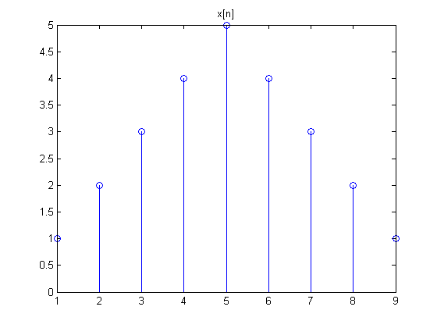

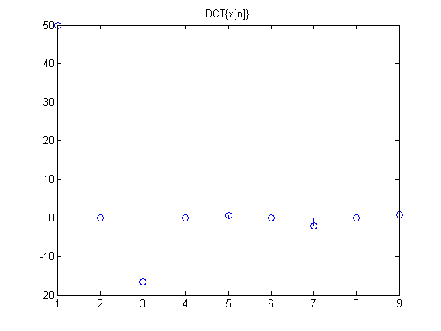

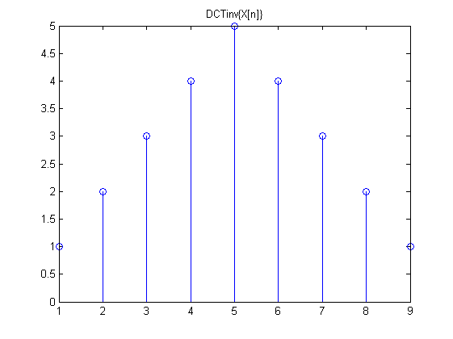
Linearity of the transform was also tested by checking homogeneity and superposition. A test for homogeneity is shown below in Figures . When the original sequence is multiplied by a constant, its DCT transform gets multiplied by the same constant.

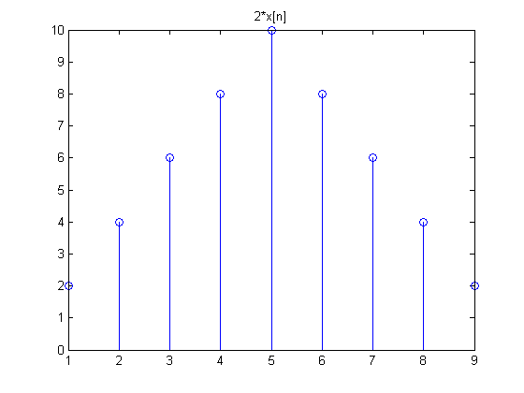
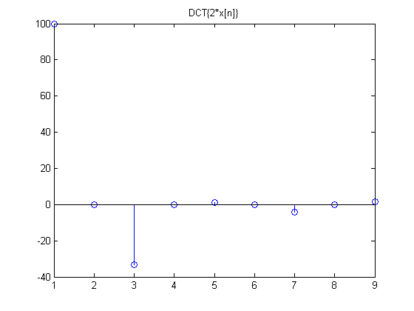
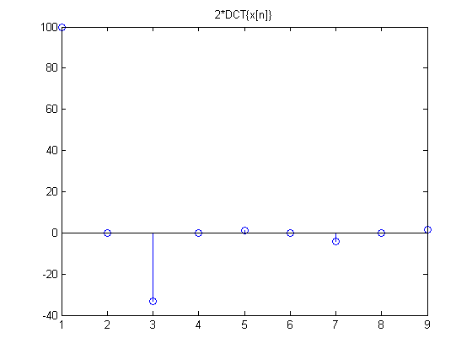
Superposition was tested by adding two sequences and then verifying that the DCT transform of the result is the sum of the DCT transform of the two sequences. This is shown in the figures below.

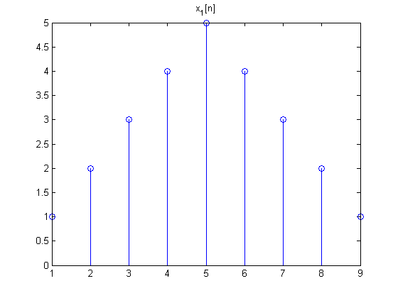
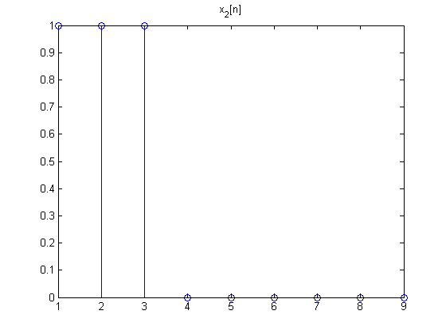
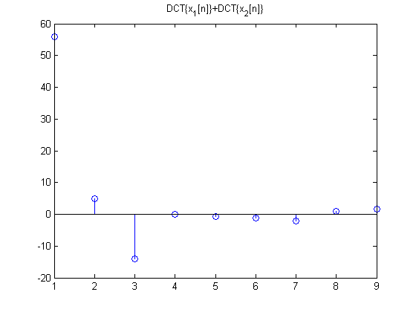
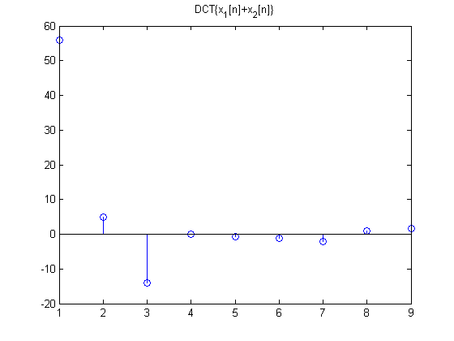
In our last test, we tried to verify linear convolution. But we realized that you cannot get linear convolution through point-wise multiplication of the DCT transform of the two sequences. This is shown below for the sequences x[n] and h[n]. When point-wise multiplication is used, the resulting sequence after transformation back to time domain is not the same as the linear convolution of the sequences in time domain.

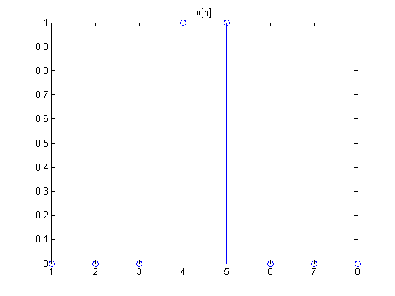

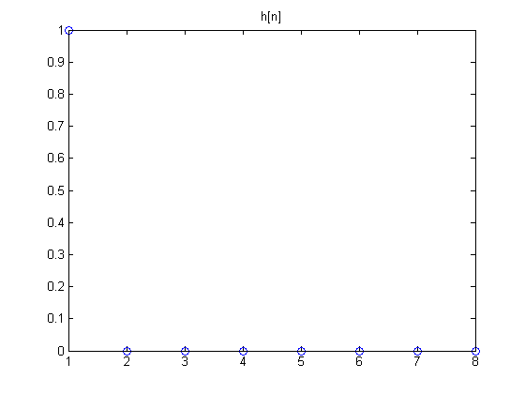

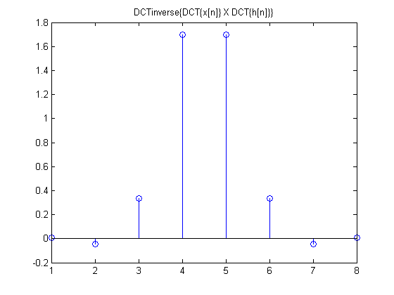
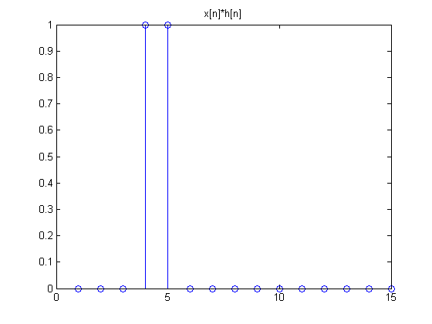

We also implemented the DCT transform in two dimensions. The code for our implementation is shown below.

% DCT TRANSFORM IN TWO DIMENSIONS
% USES OUR FUNCTION FOR DCT-II IN ONE DIMENSION
function [img2]=ourDCT2D(img)

for row=1:size(img,1)
img2(row,:)=ourDCT(img(row,:));
end
for col=1:size(img,2)
img2(:,col)=ourDCT(img2(:,col)')';
end

% INVERSE DCT TRANSFORM IN TWO DIMENSIONS
% USES OUR FUNCTION FOR INVERSE DCT-II IN ONE DIMENSION
function [img2]=ourDCT2Di(img2)

for col=1:size(img2,2)
img2(:,col)=ourDCTi(img2(:,col)')';
end
for row=1:size(img2,1)
img2(row,:)=ourDCTi(img2(row,:));
end

The implementation above was tested to verify that the original image could be recovered after applying forward DCT-II transform in two dimensions and then inverse DCT-II transform in two dimensions. This is shown in the images below.



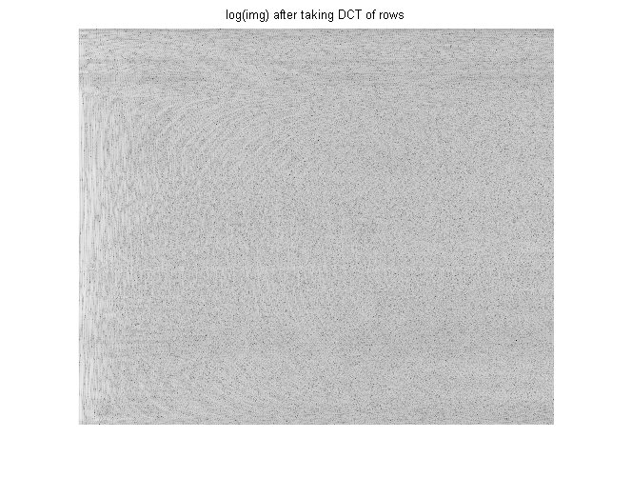

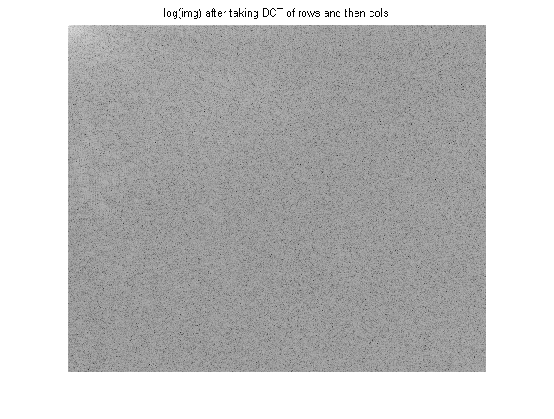

CONCLUSION

The forward and inverse DCT were implemented successfully. As shown by the tests, the original signal was recovered after taking the forward and inversed DCT transform. It was also shown that the DCT is a linear transform, since it passed the superposition and homogeneity tests. Additionally, it was shown that linear convolution of two signals cannot be obtained by point-wise multiplication of the signals in the DCT domain.

