Homework 5 – Filter Banks

Figure 1 shows an example of a wavelet decomposition.
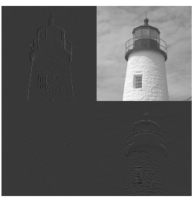
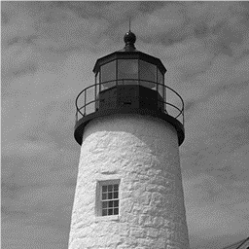

Figure 1. Tower image and its 1-level wavelet decomposition

Wavelet decomposition of an image is done with filter banks. First, the columns of the image are filtered, subsampled, and concatenated. The same is then done for the rows of the resulting image.

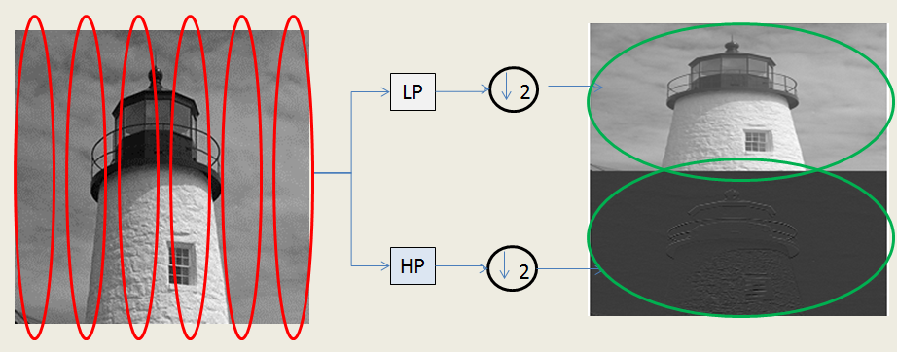
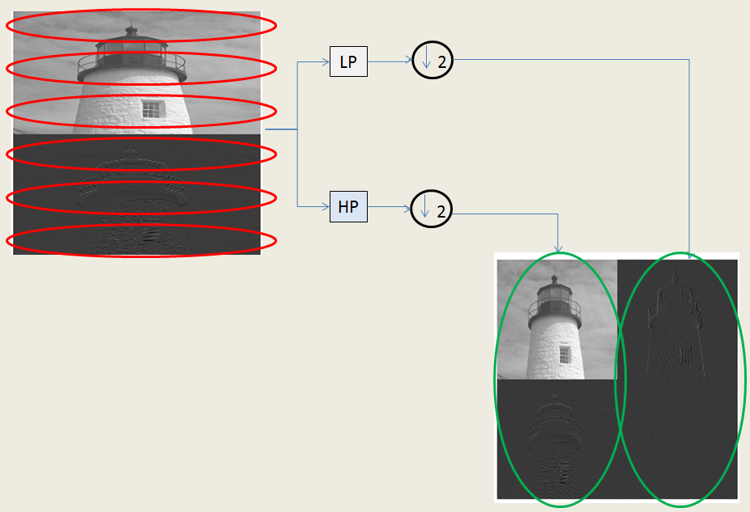
Figure 2. 1-level decomposition steps

The resulting image will be a one level wavelet decomposition of the original image. For a multiple level decomposition we keep decomposing a smaller image that holds the aproximation coefficients. Such an image is positioned on the top left and it has half the dimensions of the image that was decomposed. 2-level decomposition is depicted in Figure 3.

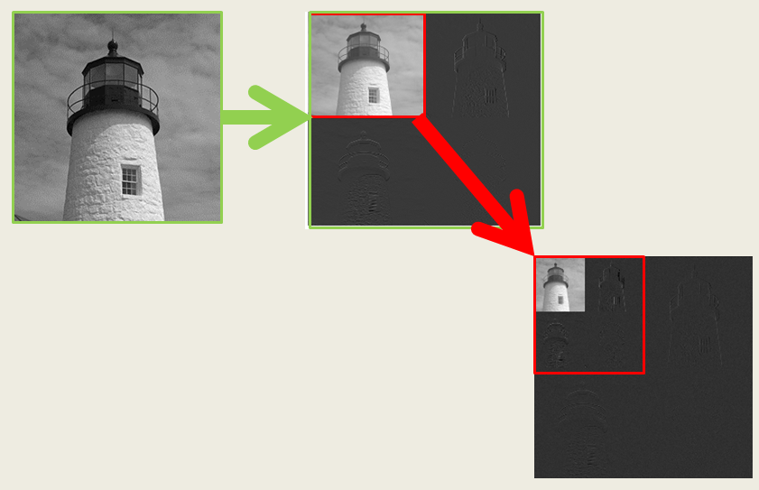
Figure 3. Multiple level decomposition steps

After processing the image, we transform it back to the spatial domain by taking its inverse wavelet transform, as shown in Figure 5.

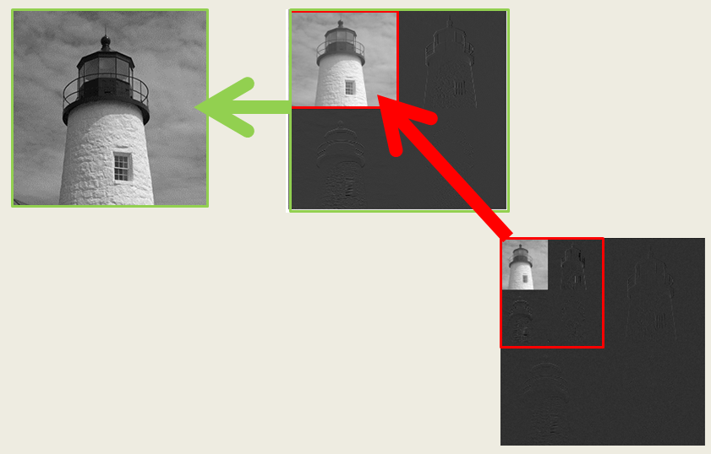
Figure 4. Multiple level wavelet transform inversion of an image

Source Code
% Author: Jafet Morales
% THIS PROGRAM PERFORMS A WAVELET DECOMPOSITION OF
% AN IMAGE BY USING FILTER BANKS
clear all
close all
clc

ic=double(imread('tower.tif'));

levs=5;
[wc]=haarWavelet(ic,levs);
figure(70);imshow(wc,[])

ic=haarWaveletInv(wc,levs);
figure(11);imshow(ic,[0 255])

function [decomp]=haarWavelet(img,levOut)

dummy=img;
for m=1:(levOut)
dummy=haarWavelet_incrementLevel(dummy,m-1);
end
decomp=dummy;

function [img]=haarWaveletInv(decomp,levIn)

% [decomp]=haarWavelet_oneLevel(img);
dummy=decomp;
for m=levIn:-1:1
dummy=haarWavelet_decreaseLevel(dummy,m);
end
img=dummy;

function [decomp]=haarWavelet_incrementLevel(decomp,levIn)

aprox=decomp(1:(size(decomp,1)/2^levIn),1:(size(decomp,1)/2^levIn));
[decomp2]=haarWavelet_oneLevel(aprox);
% [decomp2]=haarWavelet_oneLevel(decomp);
decomp(1:(size(decomp,1)/2^levIn),1:(size(decomp,1)/2^levIn))=decomp2;

function [decomp]=haarWavelet_decreaseLevel(decomp,levIn)

N=size(decomp,1);
quad_dec=decomp(1:(N/2^(levIn-1)),1:(N/2^(levIn-1)));
quad_rec=haarWaveletInv_oneLevel(quad_dec);
decomp(1:(N/2^(levIn-1)),1:(N/2^(levIn-1)))=quad_rec;

function [decomp]=haarWavelet_oneLevel(img)

% h=[1 1]/sqrt(2);
% g=[1 -1]/sqrt(2);
% % WE PAD THE INPUT SEQUENCE WITH ZEROS
% x=[zeros(1,length(h)-1) x zeros(1,length(h)-1)];

N=size(img,1);

lp=getLowPassFilter(N);
hp=getHighPassFilter(N);

img=double(img);

aproxVert=lp*img;
aproxVert=aproxVert(2:2:end,:);
detVert=hp*img;
detVert=detVert(2:2:end,:);

partVert=[aproxVert;detVert];

aproxHorz=partVert*lp';
aproxHorz=aproxHorz(:,2:2:end);
detHorz=partVert*hp';
detHorz=detHorz(:,2:2:end);

decomp=[aproxHorz,detHorz];
% figure(1);imshow(decomp,[]);

function [recomp]=haarWaveletInv_oneLevel(decomp)

N=size(decomp,1);

aproxHorz=decomp(:,1:(N/2));
detHorz=decomp(:,(N/2+1):end);

aproxHorz=kron(aproxHorz,[1 0]);
detHorz=kron(detHorz,[1 0]);

lpInv=getLowPassFilterInv(N);
% lpInv=lp(:,length(lp):-1:1);
hpInv=getHighPassFilterInv(N);
% hpInv=hp(:,length(hp):-1:1);

aproxHorz=aproxHorz*lpInv';
detHorz=detHorz*hpInv';

partVert=aproxHorz+detHorz;

aproxVert=partVert(1:(N/2),:);
detVert=partVert((N/2+1):end,:);

aproxVert=kron(aproxVert,[1;0]);
detVert=kron(detVert,[1;0]);

aproxVert=lpInv*aproxVert;
detVert=hpInv*detVert;

recomp=aproxVert+detVert;

function [hp]=getHighPassFilter(N)

hp=circshift(eye(N,N),[0,-1])-eye(N,N);
hp(1,end)=0;
hp=hp/sqrt(2);

function [hpInv]=getHighPassFilterInv(N)

hpInv=circshift(-eye(N,N),[0,-1])+eye(N,N);
hpInv(1,end)=0;
hpInv=hpInv/sqrt(2);

function [lp]=getLowPassFilter(N)

lp=circshift(eye(N,N),[0,-1])+eye(N,N);
lp(1,end)=0;
lp=lp/sqrt(2);

function [lpInv]=getLowPassFilterInv(N)

lpInv=circshift(eye(N,N),[0,-1])+eye(N,N);
lpInv(1,end)=0;
lpInv=lpInv/sqrt(2);

