Can you give a clear instruction in the document showing how to test for random new cow and pig images? Where to download python and how to run it in a laptop and test for the images. Your instructions are not clear.

Go to this link , you will find how to install python and how to install necessary packages.

**Install python:**

<https://www.youtube.com/watch?v=SZUNUB6nz3g>

**install numpy package**

<https://www.simplilearn.com/tutorials/python-tutorial/pycharm#:~:text=To%20install%20NumPy%20on%20PyCharm,time%20that%20it%20executed%20successfully.>

(please keep in mind only to follow the tutorial up to installing numbly package)

**Installing opencv**

<https://www.youtube.com/watch?v=u6IncyEm080>

**install argparse packages**

It is similar to above two steps. You just only have to search for the name “argparse” then install it

NOW YOU ALL SET UP!

Go to the file directory (to pig or cow folder where you download it). And go to the address bar and type “cmd” then the cmd prompt window will be open.

Then type this:

**python test.py –n cow.jpg**

(cow.jpg means the image you want to test)

Also how many images did you use for training? There are only 7 cropped images in the cow and pig folder? What is the test accuracy for each?

I have trained almost all the images except some images which were not good match for the cause( there was images which is showing back side of the cow. So from such a image we cannot detect anything. So I only used face images which were included the clear sight of eyes and ears.

I just have checked the accuracy only for 7 images. Those are the tested images.(Not trained images. NOTE: we cannot have a model trained with 7 images)

You can check for any image you want by using the code.

Test accuracy is shown when an image is tested. For example you can see the below terminal image. Ther are number infront of each detection. So those are the prediction accuracy.

EX: ear type

(‘eyer down’ , 0.9993)

So her the accuracy of showing year down is 99.93%

So this is a good accuracy. And almost every test has a good accuracy. (this accuracy means the how much that the model sure that the prediction is correct)

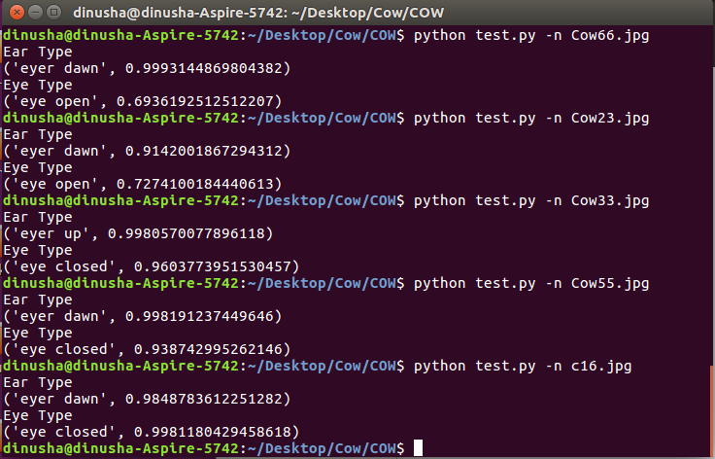

Check July 11th message. Clear details are missing. We will be testing new images that were not given to you and the program should be able to detect the emotions with highest accuracy.

I thought you might have some understanding about the coding. Sorry for misunderstand. Any way I have provide you now, the clear details.

You can test what ever image (make sure those images have clear view of the cow or pigs face. Especially clear view of eye or ear positions). I told you before the order proceed, I cannot give you a solid answer about the accuracy until im running tests but I could guaranty an accuracy around 60-70%. Anyway, for all tested images accuracy more than 95%. Which is actually more than 60-70% as I promised and this is a best value for a model. For any other image it also may be in that rage. And this is the best accuracy that we can achieve for a such a small data set.

Did you use the same cropping window size for all the images? The cow face pic attached above shows the ears are outside your cropping window.

I didn’t crop the images because there was no need of cropping them since I have used YOLO annotations. And this is because I have taken just screen shots of the results. That screen shot the one I have cropped, the test image. So don’t get it misunderstand. Once you run the code you will see how the out put is and will have a answer for this question.

I want to test 100 images of cow and 100 images of pig using a single command. Your instructions says 'There are two separate test codes for cow and pig. You need to run these python test code with the image name you need to test. Eg: python test.py –n cow.jpg'. Do I need to type in each image in the command to test for these? How to do batch processing with varying cropping window sizes?

You didn’t mention that first that you want to run the multiple images at once. Normally ML codes tested for one by one image. That’s the way we doing it because running multiple images at once may be take hours to do the predictions. This will make sure that the code will test the image smoothly. So will have to test images one by one.

How to do batch processing with varying cropping window sizes?

Why do you need to do a batch processing for a test code? There are no cropping in this system. Because the method I have use is nothing has to do with whether cropping the image or not. (simply I have trained the code using YOLO which will give us the freedom to get the feature on custom object in image (like ears/eyes). So this was the best approach we could have to get a good accuracy using a such small dataset

**Hope I have give you a clear idea about the code and other question you had. Hope I has delivered the requirements as we discussed. Thank you! Good luck.**